Bank system

Analysis and Design Document

Student:Petrusel Diana

**Group:30231**

Table of Content

1. Requirements Analysis 3

1.1 Assignment Specification 3

1.2 Functional Requirements 3

1.3 Non-functional Requirements 3

2. Use-Case Model 3

3. System Architectural Design 3

4. UML Sequence Diagrams 3

5. Class Design 3

6. Data Model 3

7. System Testing 3

8. Bibliography 3

1. Requirements Analysis Chira2018

# Assignment Specification

Aplicatia este una desktop, care incorporeaza un sistem de gestionare pentru o banca, unde exista doua tipuri de utilizatori: user simplu sau administrator.

# Functional Requirements

*User=Employee:*

* *Add/update/view client information (name, identity card number, personal numerical code, address, etc.).*
* *Create/update/delete/view client account (account information: identification number, type, amount of money, date of creation).*
* *Transfer money between accounts.*
* *Process utilities bills.*

*Admin:*

* *CRUD on employees’ information.*

# Non-functional Requirements

* *Generate reports for a particular period containing the activities performed by an employee.*

2. Use-Case Model

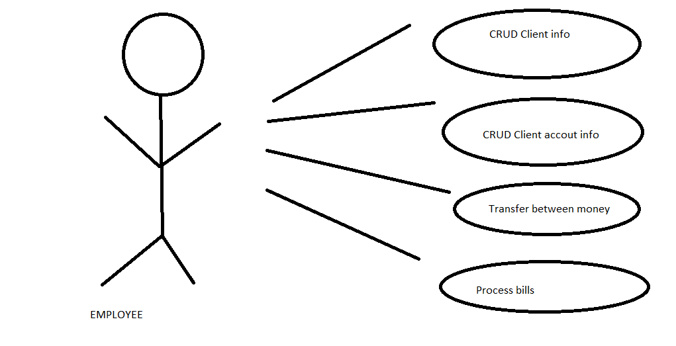

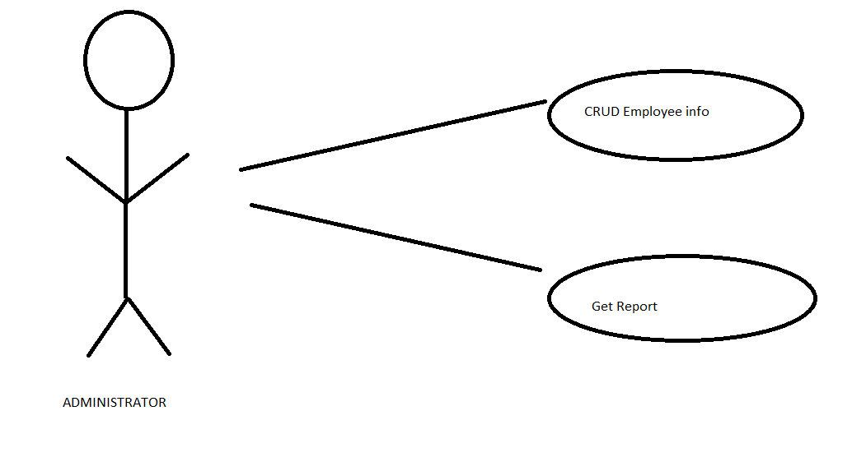

3. System Architectural Design

**3.1 Architectural Pattern Description**

*Am folosit Layerd Architecture si JDBC pentru baza de date.*

**3.2 Diagrams**

*[Create the system’s conceptual architecture; use architectural patterns and describe how they are applied. Create package, component and deployment diagrams]*

4. UML Sequence Diagrams

*[Create a sequence diagram for a relevant scenario.]*

5. Class Design

**5.1 Design Patterns Description**

*[Describe briefly the used design patterns.]*

**5.2 UML Class Diagram**

*[Create the UML Class Diagram and highlight and motivate how the design patterns are used.]*

6. Data Model

*[Present the data models used in the system’s implementation.]*

7. System Testing

*[Present the used testing strategies (unit testing, integration testing, validation testing) and testing methods (data-flow, partitioning, boundary analysis, etc.).]*

8. Bibliography