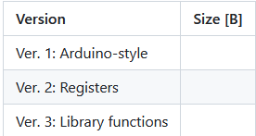

508

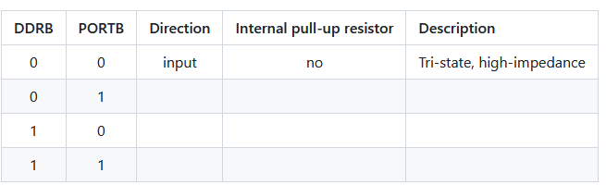

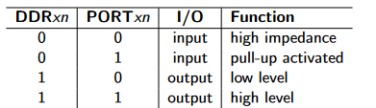

0 1 input yes pull-up activated

1 0 output low level

1 1 output high level