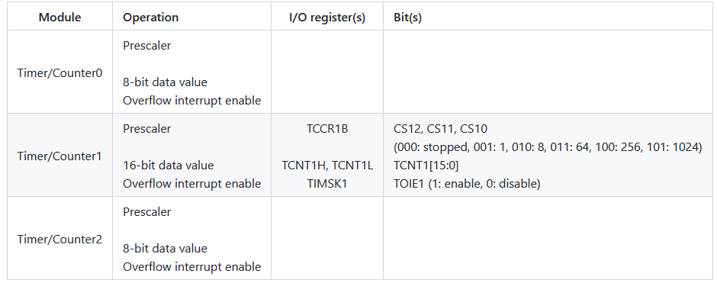

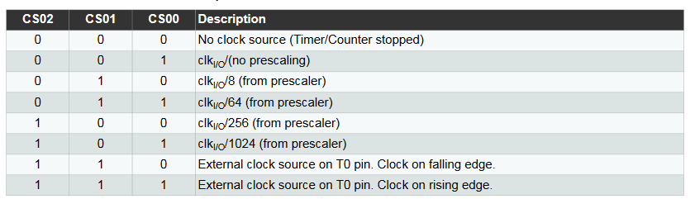

I/0 register for counter 0

TCCR0A

TCCR0B

TCNT0

TIMSK0

TIFR0

Timercounter 2 register

