Technical Test

Notes

You should spend no more than one hour working through this exercise, and should aim to get as far as you can within that time. Completion of the test is not expected. Please endeavor to submit functioning code where possible, and document within a README file where improvements may be made, had you more time.

You may complete this test in any one of:

* Perl
* Java
* C++

Whichever language you choose, you should assume that a standard installation is available, and may use core libraries/modules only – for the purposes of this exercise, modules from CPAN (for example) may not be used.

Background Information

A deck of cards consists of 52 individual cards, divided into four sets of thirteen cards. These four sets are known as suits, and are given names: spades, clubs, hearts and diamonds. With each set, the same set of numbered cards appears, running from two to 10, alongside four “special” cards, the ace, jack, queen and king, each represented by the first letter of their name, as shown below.

Fig 1: An example deck of cards (source: Wikipedia/Wikimedia Commons)

A deck of cards may be used to play a large number of games, involving a variety of rules and scoring mechanisms.

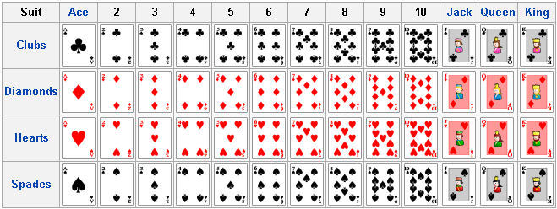

For this task, we shall make use of the game of rummy. This game is typically played with between two and four players. Each player is initially dealt seven cards from the deck, the remaining cards forming a stock from which additional cards may be drawn as the game progresses.

To win the game, a player must form a hand comprising of two “melds” of cards, one of three cards, one of four, both consisting of either of:

* a sequential run of numbers of the same suit, e.g. the ace, two, three and four of clubs, or the seven, eight and nine of spades.
* a collection of cards of the same face value from differing suits, e.g. all four sixes, or three eights.  An example winning hand is shown below:  Fig 2: An example winning hand for rummy, comprising of the seven to ten of diamonds and the aces of clubs, hearts and spades. (source: Wikipedia/Wikimedia Commons)  On each player’s turn, they must draw a card either from the draw deck or by taking the top card from the discard pile, if one is available. The player uses this card to improve his hand, aiming to build up a valid meld over a number of turns. To complete his turn, the player must discard one of his cards onto a discard pile, leaving him with exactly seven cards in his hand.  Task 1  Write a class to describe a playing card. The class should be able to represent the suit and face value of the card suitably, and should have functions to display the card correctly.  Secondly, write a class to describe a deck of cards, as described above. This class should have functions to allow the cards to be shuffled, to allow hands of varying sizes to be dealt to a varying number of players and to allow further cards to be drawn from it as a game is played. In addition, it should provide for support for a discard pile of cards thrown away by players, as described above, to be tracked.  Task 2



Write a script or application, making use of your classes, above to play a game of rummy between a number of players (between 2 and 4). The script/application should allow for a hand to be dealt to each player, and for play to commence, each player taking turns to draw a card from the deck and attempt to improve their hand. Suitable output should be provided to show the progress of the game. The game ends when one of the players wins.

Task 3 Two simple variants of the game of rummy exist:

1. Two additional special cards, jokers, are added to the deck. Should a player draw a joker, he must miss two turns when he discards the card before being allowed to continue.
2. A scoring mechanism is added, whereby the face values of the losing players’ cards that do not form a valid meld are added together at the end of the game. The ace is assumed to score one point, jokers, if in play, score 25 points, and all other special cards score ten points. New hands are dealt when each is completed until one of the players exceeds 101 points, at which point they are declared the loser.

Extend your script/application and classes to optionally support these two variants of the game. You should make use of command-line switches to allow the variant of the game being played to be specified when the script is run.