BI_PR1
Practical 1:
Aim:- Import Data from different Sources such as (Excel, Sql Server, Oracle etc.) and load in targeted system.

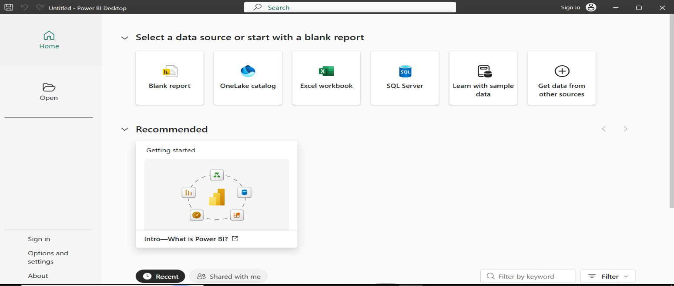
Step 1:- Open Power BI

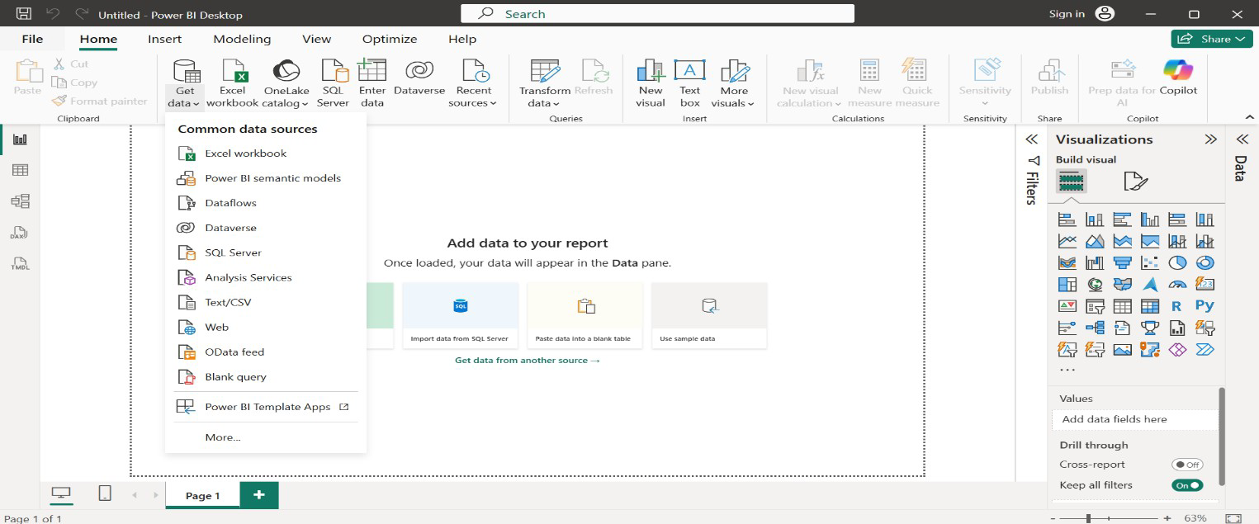
Step 2:- Open Blank Report and select Get Data
Step 3:- Select the dataset in form of excel csv etc.

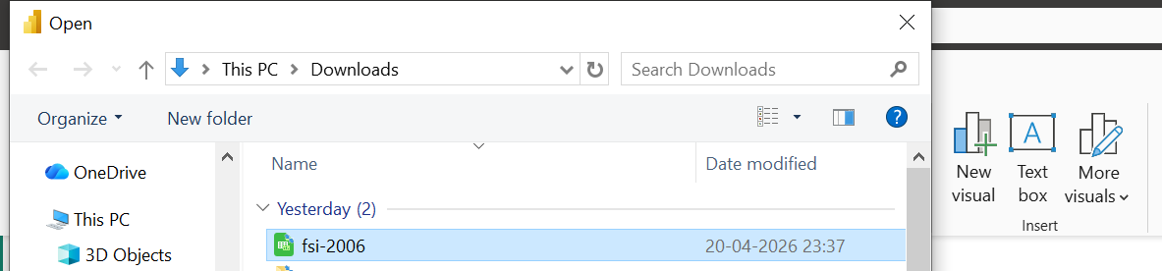

Step 4:- Select the proper data from Navigator window and load it

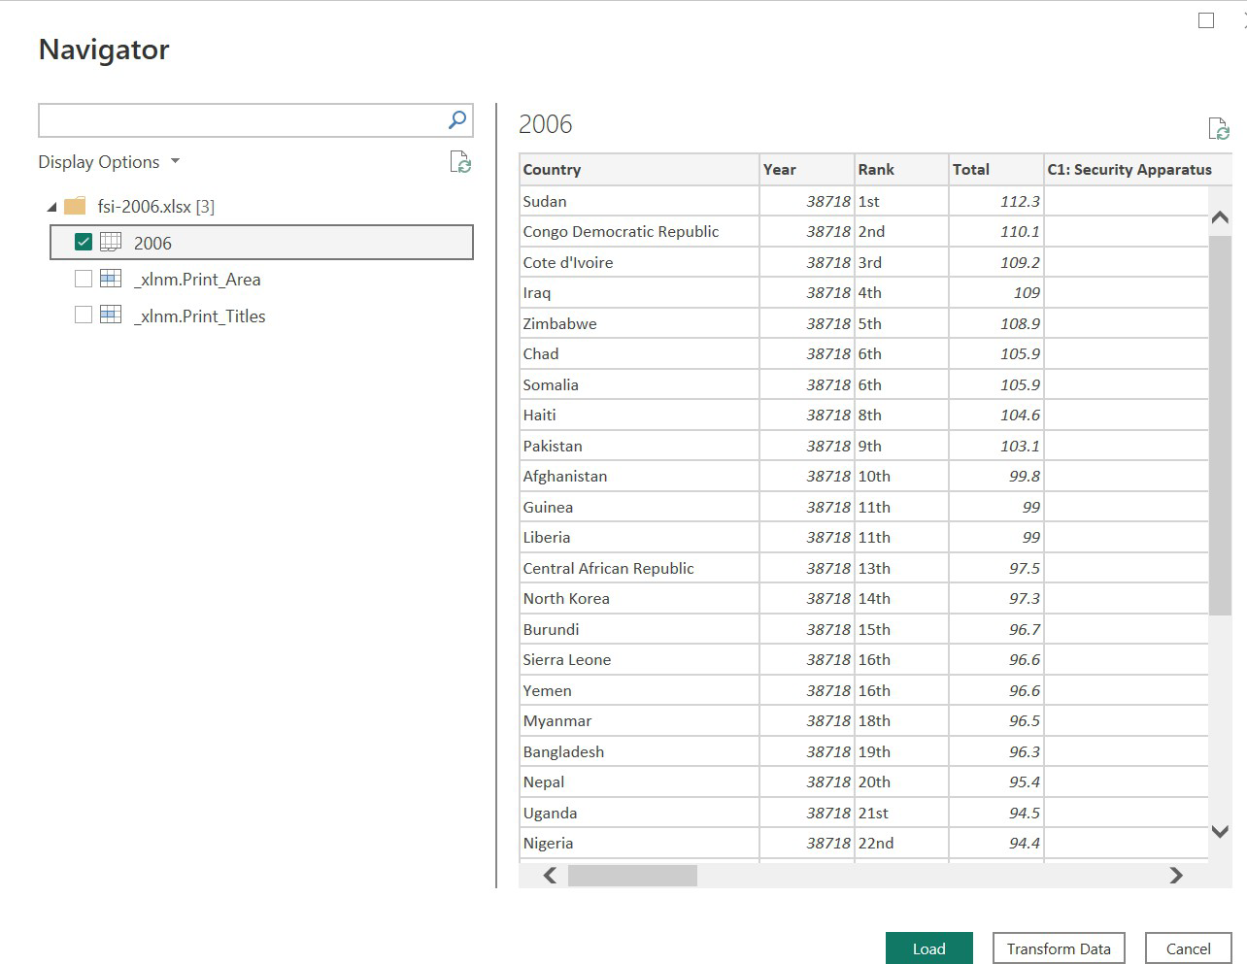
Step 5:- Right Click on dataset and select edit query option
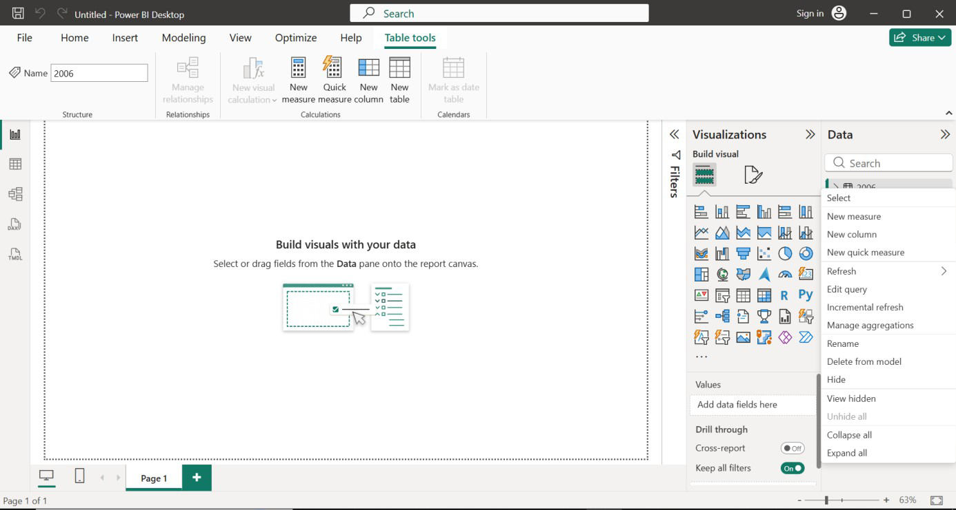

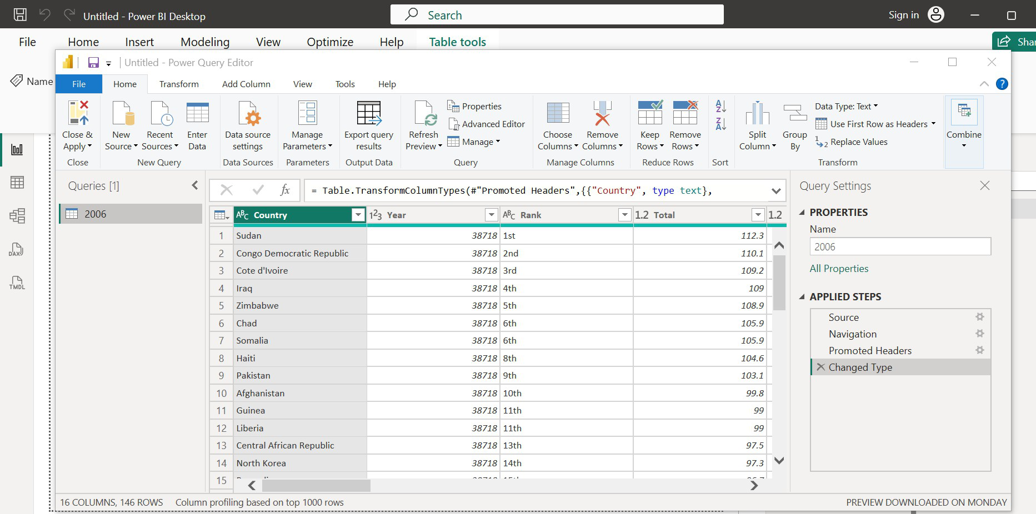
Step 6:- Right Click on any column or row and then modify data as well as perform operation or queries on data like replacing & finding null value etc.

