Prepocessing and training phase

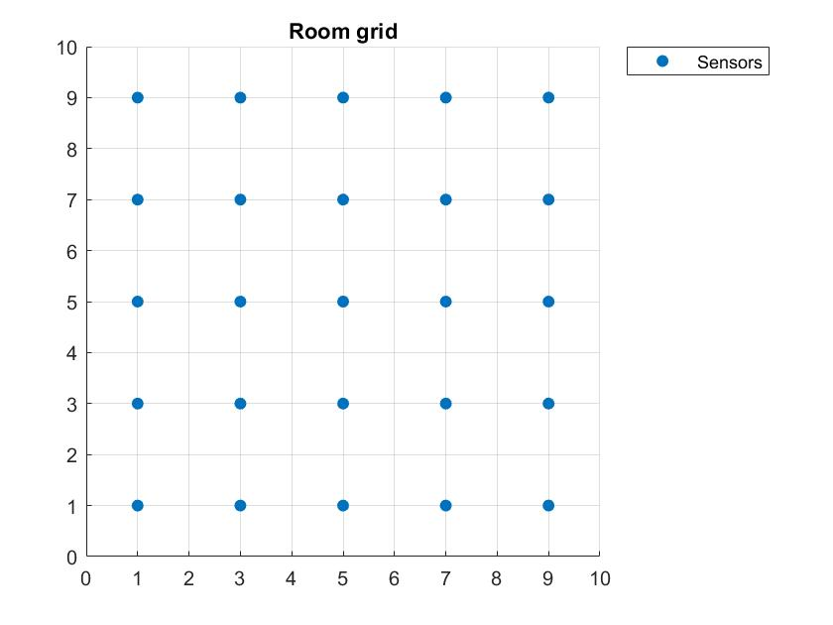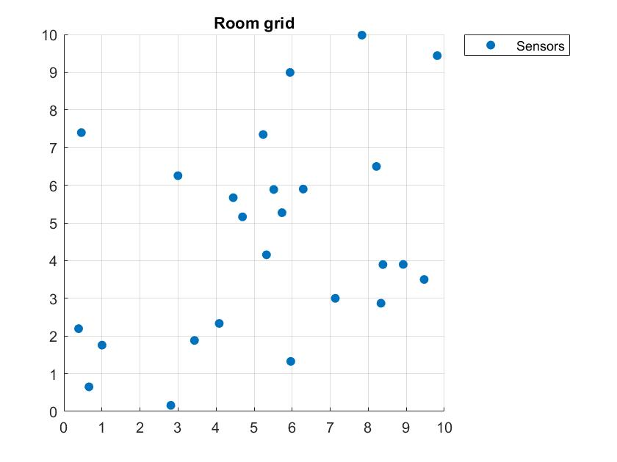The script that is in charge of preparing the data structure for the correct execution of the project is ‘buil_data.m’ that let also the user to choose wether to use a random topology for the sensors or a grid one. For completeness we have performed the experiments using both the topologies.

Figura - uniform topoogy

Figura - grid topology

IST

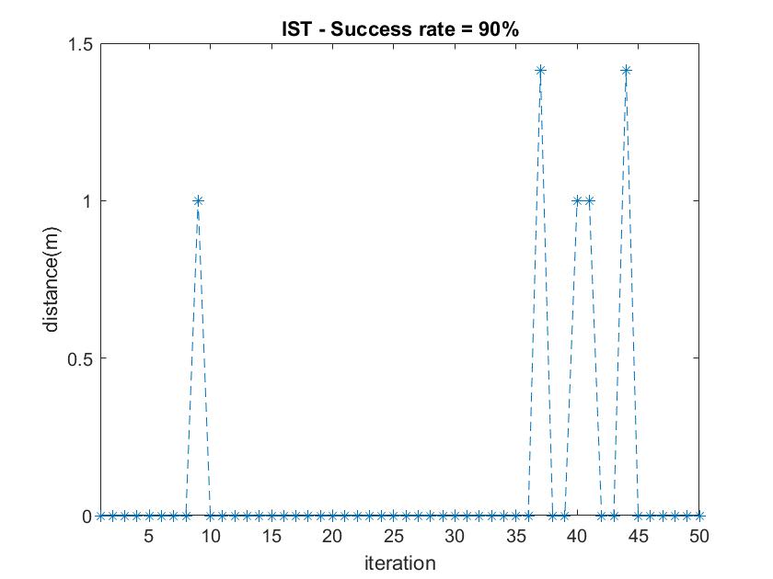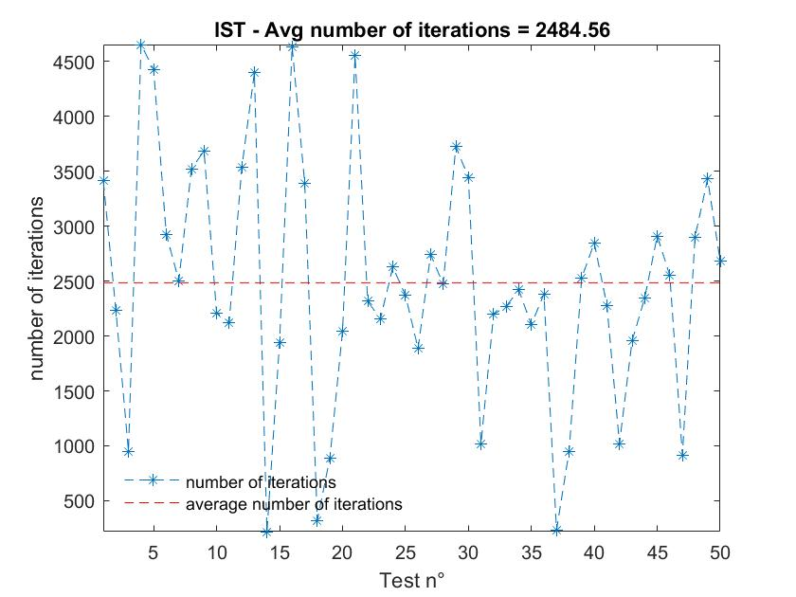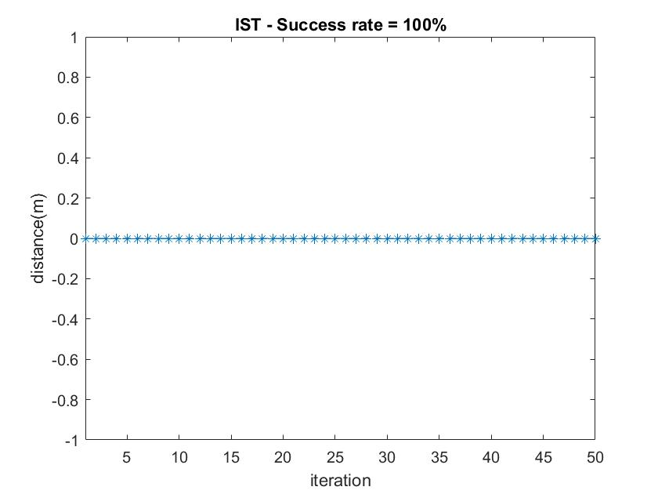We run the iterative soft tresholding alghoritm and we got the following results

Figura /4 - grid topology (lambda=1e-4, tau=0.7, min_eps=1e-4)

Figura 5/6 - uniform topology (lambda=1e-4, tau=0.7, min_eps=1e-4)

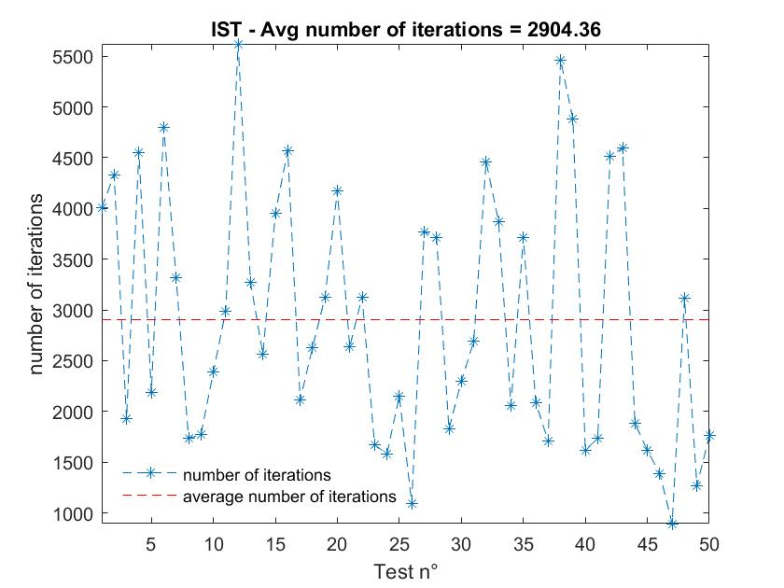

We noticed that the accuracy is better with the grid topology because the room is uniformly covered by the sensors, while the uniform topology leavs some uncovered spaces, where the localization is not precise, on avg the stimated target is an adjacent cell respect the correct one. The average number of iterations is quite the same, in the uniform topology there are more errors that can cause more iterations to reach a stable result.

DIST

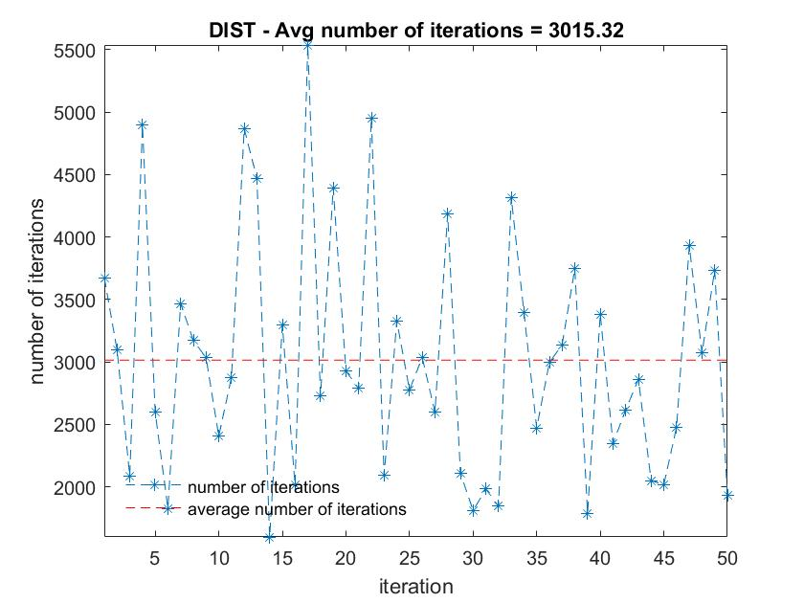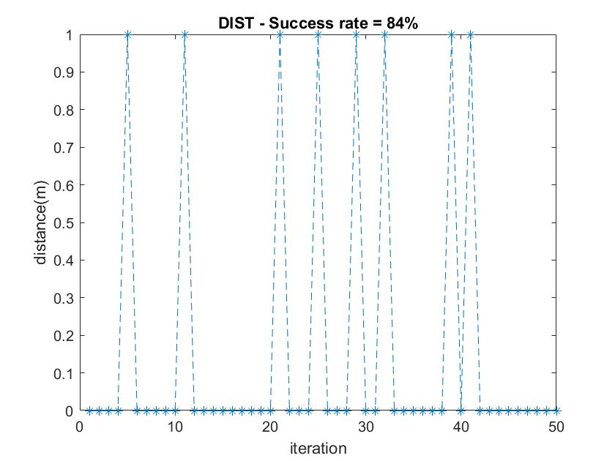For the distributive soft tresholding alghoritm we made some more experiments changing the min_eps and we got the following results

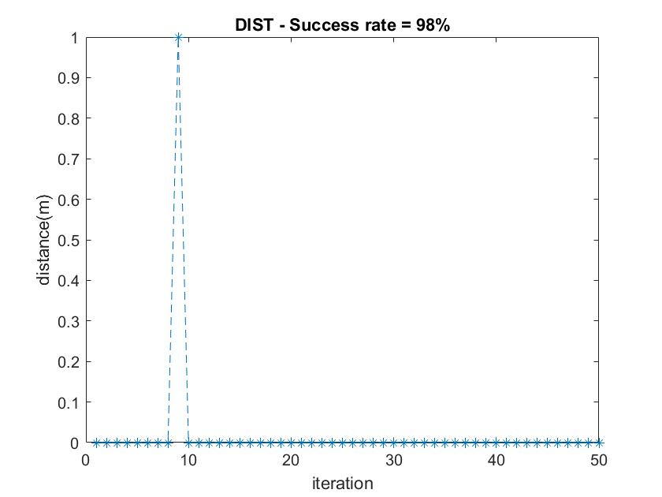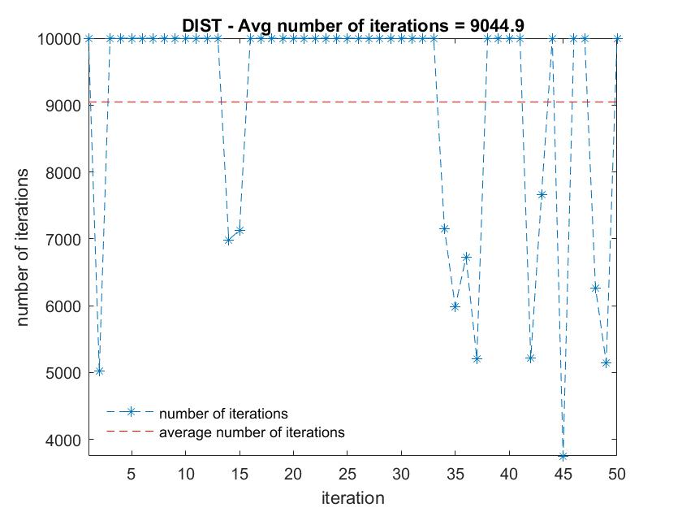

Figura 9/10 - grid topology (lambda=1e-4, tau=0.7, min_eps=1e-5)

Figura 7/8 - grid topology (lambda=1e-4, tau=0.7, min_eps=1e-4)

We noticed that with min_eps=1e-4, actually the alghoritm was not stopped, so we reduce it to 1e-5 and we improve a lot the accuracy but on the other hand we increased even the average number of iterations. For the uniform topology we only did the experiment with min_eps=1e-5 to compare it with the grid one.

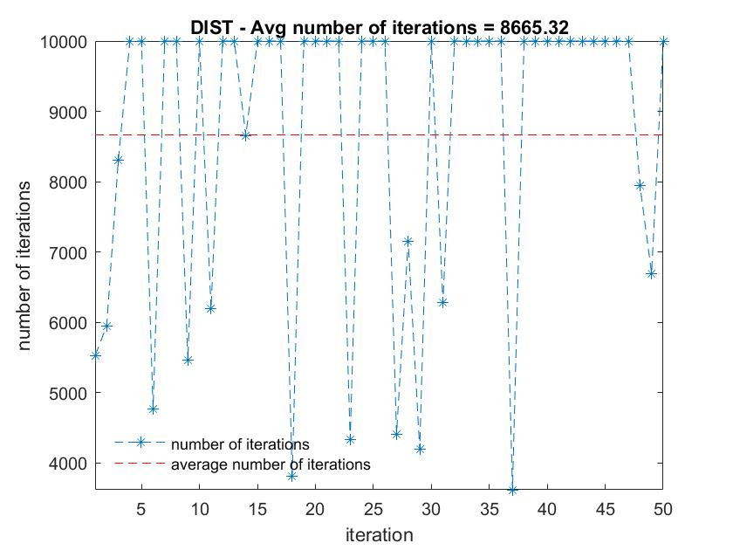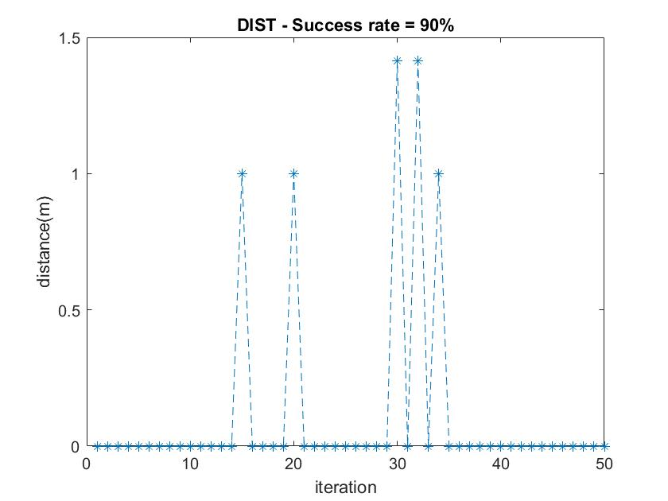

Figura 11/12 – uniform topology (lambda=1e-4, tau=0.7, min_eps=1e-5)

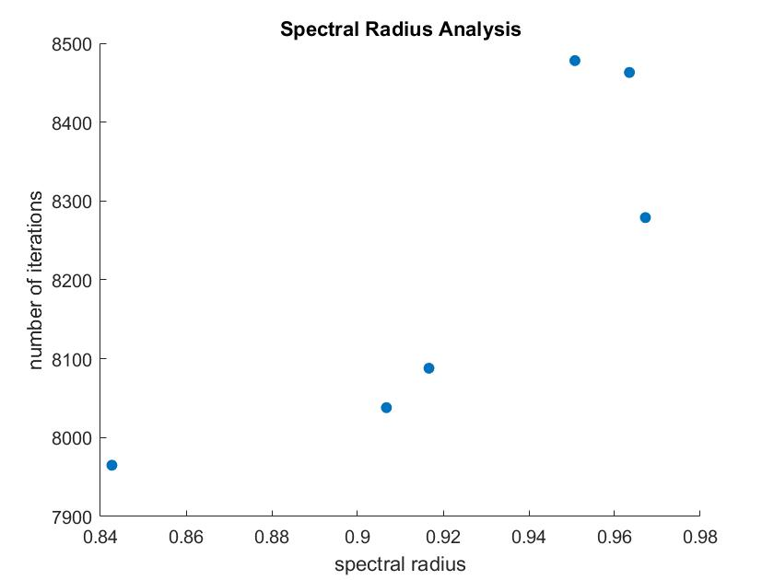Even in this case the accuracy is better with the grid topology, while the number of iterations is similar. Moreover if we compare the number of iterations of the DIST alghoritm (min_eps=1e-4) with the IST one, we can notice that locally, the sensors do less cycles to get a stable state, but since we waited for the last sensor to be stable to terminate the alghoritm, globally the number of iterations is bigger.

Making more runs of different uniform topologies we have performed an analysis of the convergence time with respect to the spectral radius of the matrix Q, and as we can see from the plot, when the spectral radius gets bigger, we need more number of iterations to reach convergency. So we can conclude that the convergence time grows with the spectral radius of the matrix Q.

Figura 13 – uniform topology (lambda=1e-4, tau=0.7, min_eps=1e-5)

Tracking

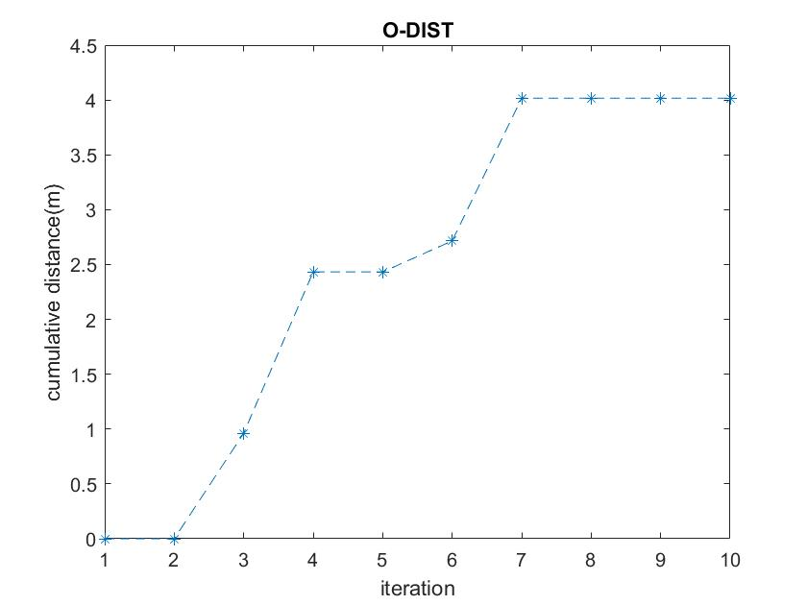We have performed this activity using only the grid topology becasue, in general, it produces better results. We made two different experiments, one with the target moving onto the diagonal of the square room, and one with the target that, at every step, changes its position randomly.

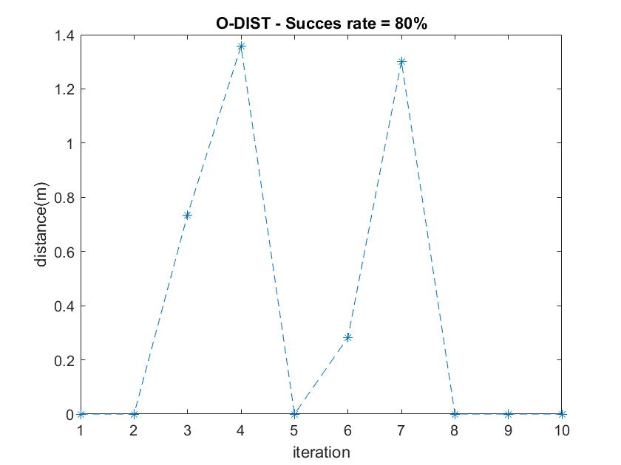

Figura 14/15 – diagonal movement (min_eps= 1e-5, maxT=1e2)

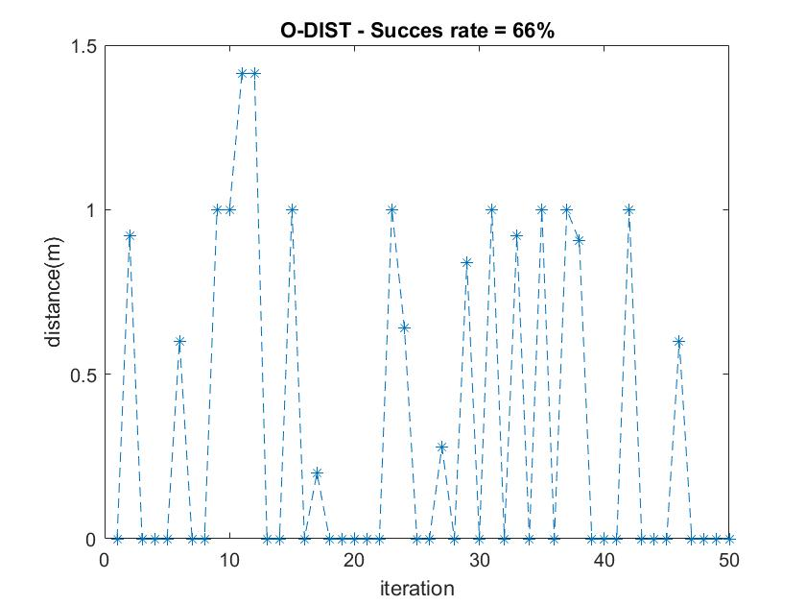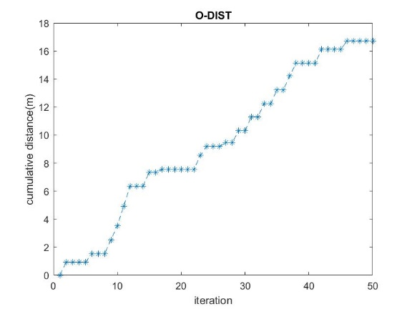

Figura 16/17 – casual movement (min_eps=1e-5, maxT=1e2)

The alghoritm is not precise but the distance and its cumulative are not so big, because we can see that the predicted cell is often near the correct one and actually some node predicts the correct one but there is not convergence, so to improve the accuracy we aumented the maxT to 5e2 and we get better results.

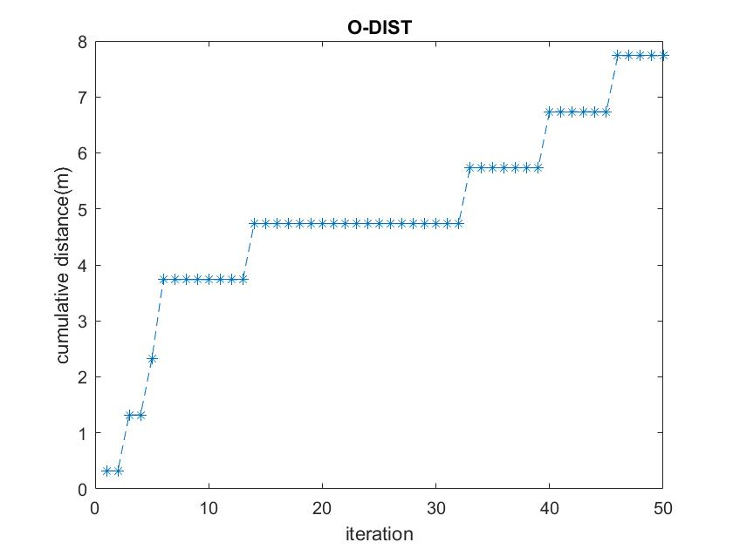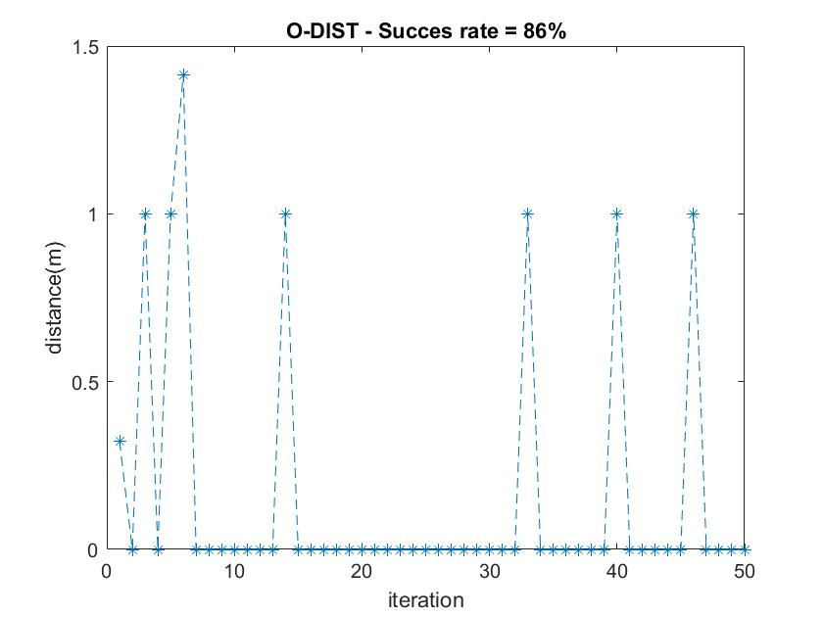

Figura 16/17 – casual movement (min_eps=1e-5, maxT=5e2)