Inspur Group Digital Certificate Application Process
浪潮数字证书申请流程

Version 1.1
Information management center of Inspur Group Co.,Ltd
Dec. 18, 2018
Contents
I. Download and install the digital certificate chain 1
II. Apply for personal digital certificate 6
Revision History 12

Please note that in principle one person can only have one application chance (multiple applications will result in that encrypted email could not be opened), please derive and back up the certificate after application.
请不要重复申请证书，否则会导致加密邮件打不开的情况。

I. Download and install the digital certificate chain下载安装证书链
- Login VPN client (easy connect) first, then refer to documents to apply for the certificate. Input https://ca2012.inspur.com in IE browser's address bar. If the following hint pops up when you open the webpage, select "Continue to browse this website", as shown in Figure 1:
如果在公司外办公，请先登录VPN。证书下载地址是https://ca2012.inspur.com，如下弹出框选择继续浏览。
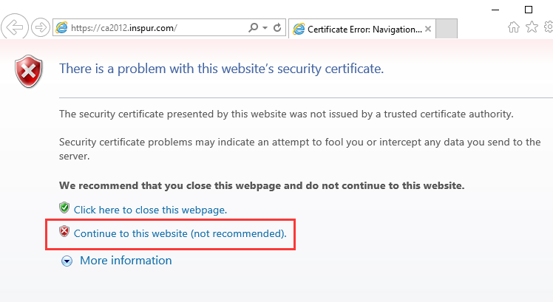
Figure 1
- Input “home\user name” in the login window, for example, if your e-mail address is xxx@inspur.com, you should input "home\xxx" and the password is mailbox’s password, as shown in Figure 2:
弹出框账号名输入home\邮箱前缀（@之前的部分），密码输入邮箱密码。
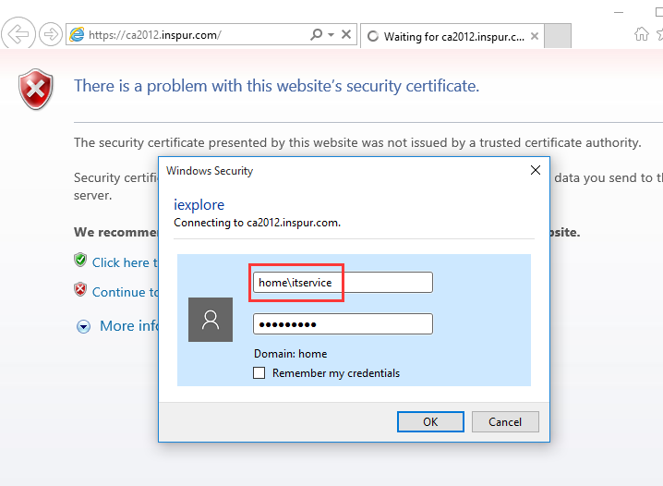
Figure 2
- On the "Welcome" page, click on the link "Download a CA certificate chain, or CRL ", as shown in Figure 3:
进入欢迎页，点击下载浪潮证书链，如下图标红位置。
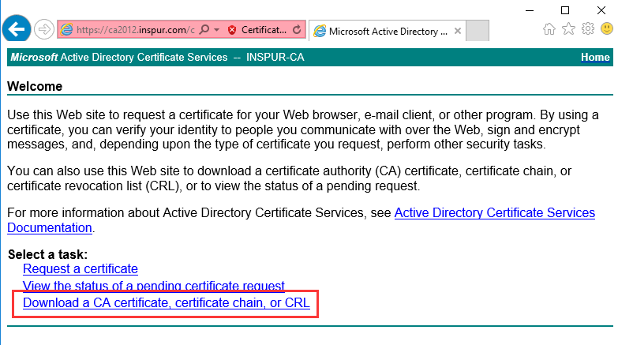
Figure 3
- The page may pop up the following warning window. Please select "Yes", as shown in Figure 4:
弹出的确认页，选择yes。
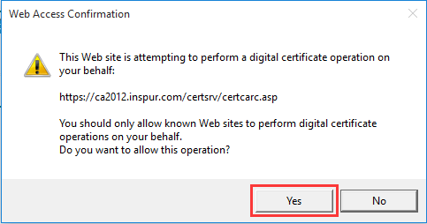
Figure 4
- Select "Download CA certificate chain", as shown in Figure 5:
点击“Download CA certificate chain”
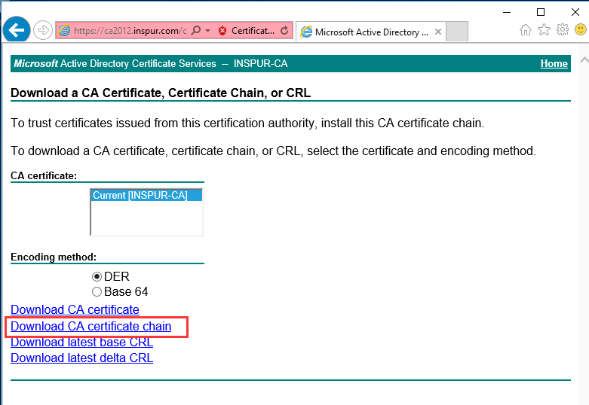
Figure 5
- Save the certificate chain file to a suitable location (such as Desktop), the file name of certificate chain is certnew.p7b. Open IE browser, select Tool --- Internet Options --- Contents --- Certificate --- Trusted Root Certificate Authorities one by one and select Import, as shown in Figure 6:
保存证书链文件到某个指定路径下（比如桌面）。打开IE浏览器—工具—Internet选项—内容—证书—受信任的根证书颁发机构，点击导入。
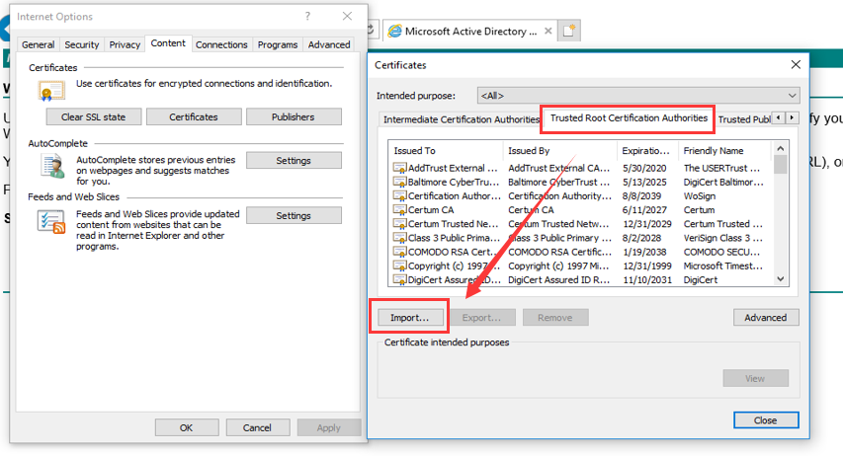
Figure 6
- Enter Certificate Import Wizard, select Next. Select Browse, change the file format into All Files, find the downloaded certificate chain file certnew.p7b, select Next, as shown in Figure 7:
进入导入页面，选择下一步。改变文件类型为所有文件，找到保存的证书链文件（.p7b后缀的），点击下一步。
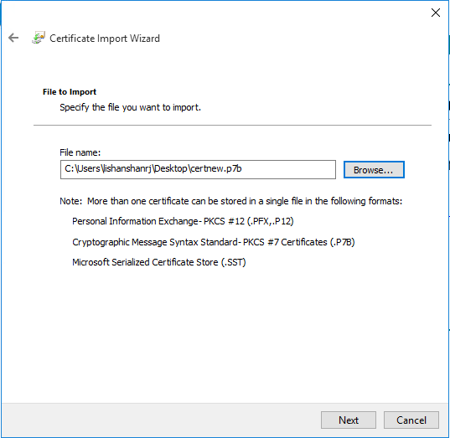
Figure 7
- The system will save the certificate chain in Trusted Root Certificate Authorities by default, as shown in Figure 8:
系统将会默认保存到受信任的根证书颁发机构。
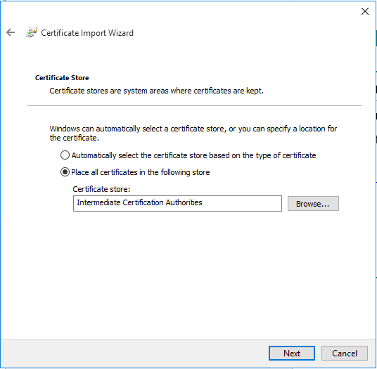
Figure 8
- Select Complete, Select Yes in the pop-up security warning page to complete the installation of the certificate chain, as shown in Figure 9:
弹出警示框，选择yes
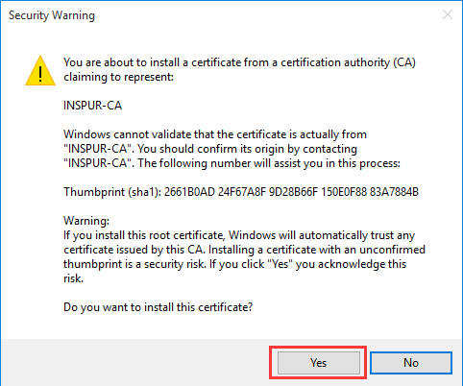
Figure 9
- Hint that the import was successful, as shown in Figure 10;
证书链导入完成，如下图所示
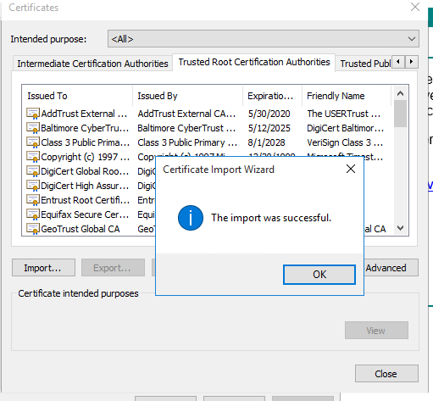
Figure 10

II. Apply for personal digital certificate申请个人证书
- Input https://ca2012.inspur.com in IE browser's address bar. Input “home\user name” in the login window, for example, if your e-mail address is xxx@inspur.com, you should input "home\xxx", as shown in Figure 11:
登录https://ca2012.inspur.com，账户名输入home\邮箱前缀，如下图所示
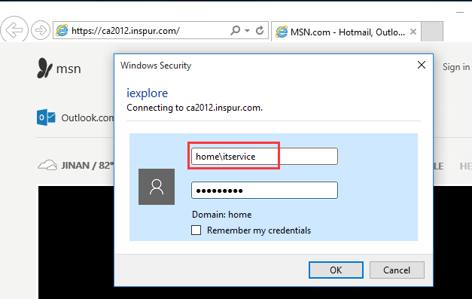
Figure 11
- On the "Welcome" page, click on the link Request a certificate, as shown in Figure 12:
进入欢迎页，点击“Request a certificate” 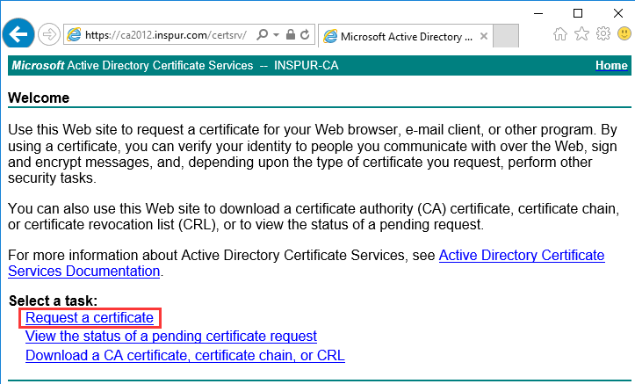
Figure 12

- Select Create and submit a request to this CA, as shown in Figure 13:
点击“Create and submit a request to this CA”
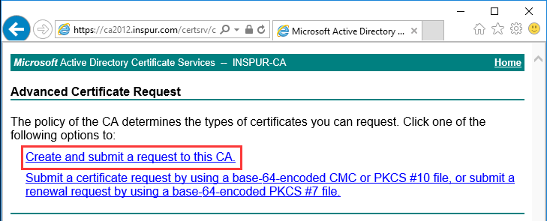
Figure 13
- The page may pop up the following warning window. Please select Yes, as shown in Figure 14:
弹出框选择Yes
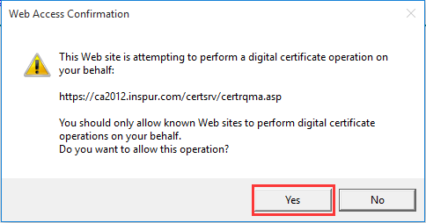
Figure 14
- Choose default SHA2 option as certificate template. Click Submit. Please use the default settings for other options, as shown in Figure 15: Note: if the submit button for this step is grey and the CSP shows "loading", please add compatibility view and trusted site, and then login again to download the personal certificate, as shown in Figure 16/17.
项目选择默认，不用更改，直接提交，选择Submit。注意：如果该步骤的提交按钮是灰色的，且CSP显示“loading正在加载”，请添加兼容性视图和可信站点，再重新登录进行下载个人证书。
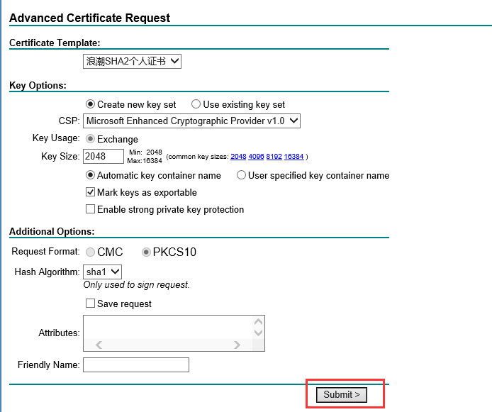
Figure 15
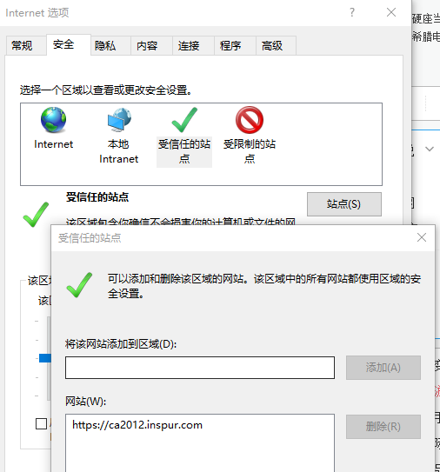
Figure 16
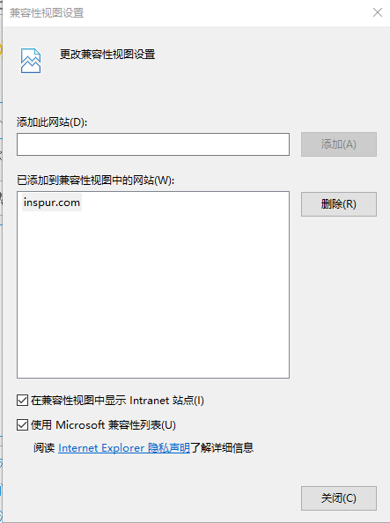
Figure 17
- In the pop-up warning dialog box, click Yes, as shown in Figure 18:
下图提示框选择Yes
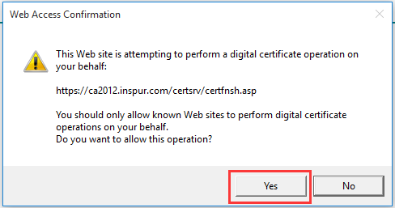
Figure 18
- Click on Install this certificate on page and the installation is complete, as shown in Figure 19 and Figure 20:
点击安装证书，安装成功如下图所示
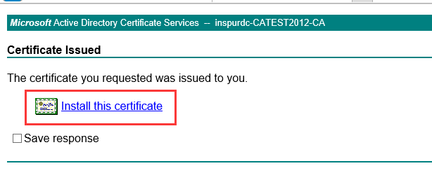
Figure 19
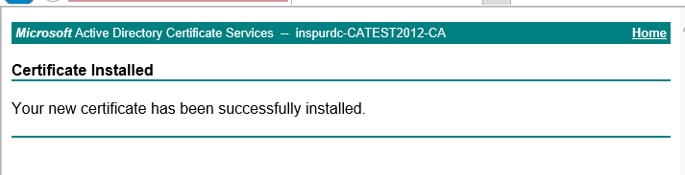
Figure 20
- Check whether the certificate has been installed correctly: Open IE browser, select Internet Options --- contents --- certificate, check that digital certificate issued by INSPUR-CA and saying your name after individual will appear. Double click the certificate and you can view the state of the certificate. The normal state is as shown in Figure 21:
检查确认是否已正确安装，路径为IE浏览器—工具—Internet选项—内容—证书，检查确认是否有颁发者为INSPUR-CA颁发给您的证书。如下图所示
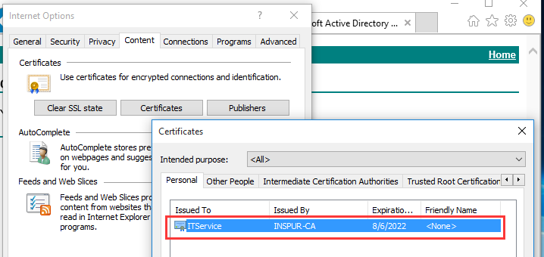
Figure 21
If you have any question about downloading certificate, please mail to itservice@inspur.com.如有问题请发邮件至itservice@inspur.com

Revision History
Revision date | Vision number | Revised personnel | Audit personnel | Revision history
2017.07 | V1.0 | Clare Lee | Samuel Hu | Basic version
2018.12 | V1.1 | Clare Lee | Samuel Hu | Updated the content of personal certificate application

