CONTROL IN TECHNICAL SYSTEMS

Kozlov Oleg Stepanovich

Shchekaturov Alexander Mikhailovich

REVISION 1.1

2014/02/17

**LABORATORY WORK No. 1**

**USE OF SIMINTECH**

**FOR ANALYZE OF DYNAMICS OF LINEAR AND LINEARIZED ACS**

**DESCRIBED VIA "INPUT-OUTPUT" VARIABLES**

Moscow, 2014

# TABLE OF CONTENTS

TABLE OF CONTENTS 2

INTRODUCTION 3

1 GENERAL INFORMATION ON SIMINTECH 4

1.1 Purpose, mode of operation, peculiarities and advantages of SimInTech 4

1.2 SimInTech Start-up 5

1.3 SimInTech structure and composition 6

1.4 "Line" of typical units 7

2 SIMINTECH OPERATIONAL PROCEDURE BRIEF DESCRIPTION 10

2.1 Main stages of operation in SimInTech environment 10

2.2 Demonstrative example of nuclear reactor ACS dynamics 10

2.3 Demonstrative-familiarizing task 14

2.3.1 Initial data for familiarizing task 14

2.3.2 Input of structural diagram and initial data 14

2.3.3 Transient processes modeling and variants calculations 21

**PURPOSE OF THE PAPER**

* familiarization with capabilities of SimInTech software, version 1.1;
* mastering of procedures for formation of ACS structural diagram and its properties;
* mastering of procedures for operation in "SIMULATION" mode including: selection of a method and parameters for integration; outputting of calculation data, etc.;
* generation of ACS structural diagram for the simplest model of a nuclear reactor described via "input-output" variables;
* determination of nuclear reactor ACS stability via direct simulation of transient processes at the moment of delivery of control and disturbing input.

# INTRODUCTION

High rates of development of computer hardware during last 15-20 years provided an actual opportunity for creation of effective CAD software including both traditional CAD facilities for designing (EUCLID, AutoCAD, Kompas, etc.) and intellectual CADs, which are intended for automation of knowledge-intensive computations to substantiate basic parameters of a plant being designed such as safety, reliability, etc.

"Intellectual" CADs include programming tools for dynamic calculation automation. Comfortable "assemblability" from different modules, every one of which is to solve a particular minor task of an integral system, which is to solve a higher level task, is the most important sign of automation. Ideally a full dynamics calculation program is a multidimensional network, nodes of which are automatically delivered with required software modules from library of simulator programs. It provides an option for expansion, replacements and improvement of the general structure and individual modules as well.

Programming tools for automation of dynamic calculations of complex technical systems enable: ten-fold reduction of time required for development of mathematical representation of an object prior to obtaining any simulation results; improvement of reliability of calculation results; optimization of an obtained solution using multi-variant analysis, etc. Dynamic calculation automation facilities allow the Designer to be concentrated at solving the basic task and not to digress on designing programs and algorithms. Actual opportunity of clear interference into some or other fragments of the process of calculation and its modification in accordance with the Researcher’s wish (including ones in on-line mode) appears particularly in dynamic calculation automation systems.

Development of methods of structural modeling should be considered as the most common approach to the creation of DYNAMIC CALCULATION AUTOMATION systems covering a very wide spectrum of application fields (from technical to organizational ones). By now a number of programming tools for computer modeling and analysis of dynamic systems based on structural modeling method have been developed abroad. Those are mostly universal software systems with libraries of typical general engineering modules (most known of those are SIMULINK, VisSim, MATRIXx, CTRL-C, EYSI-5).

Simulation in Technical Systems (SimInTech) software system developed by Bauman Moscow State Technical University at "Nuclear Power Plants" Chair is presently the most developed dynamic calculation automation domestic programming tools. SimInTech is a good (and the best one in many instances) alternative to the above mentioned foreign dynamic calculation automation software in terms of a number new analysis methods, User interface and, in particular, in terms of numerical algorithms of integration of rigid dynamic systems of differential equations.

Effectiveness of SimInTech was demonstrated both during the academic activity of Bauman Moscow State Technical University and a number of other technical universities (during virtual laboratory works, in term and graduation designing) and in a number of actual designs performed by Rosatom (development of mathematical representation for Automatic Process Control System of Bushehr Nuclear Power Plant Unit, calculation substantiation for nuclear safety of small nuclear power reactors for floating NPPs in transient modes and in designed emergency situations; development of mathematical representation for the dynamics of a pilot demonstrative reactor unit ODU BREST-300).

# 1 GENERAL INFORMATION ON SIMINTECH

## 1.1 Purpose, mode of operation, peculiarities and advantages of SimInTech

"Simulation In Technical Systems" (SimInTech) is a modern environment of intellectual CAD intended for detailed study and analysis of dynamic processes in nuclear and thermal power plants, in automatic control systems, in servo drives and robots, in any engineering systems, whose description of dynamics can be implemented via the method of structural modeling.

It can be used for modeling non-stationary processes in physics, in electrical engineering, in dynamics of machinery and machines, in astronomy, etc., and for solving non-stationary boundary-value problems (thermal conductivity, hydrodynamics, etc.).  
 It can function in multi-computer modeling systems including operations in mode of remote access to process and informational resources.

SimInTech implements the following modes of operation:

* MODELING, providing for:
  + modeling of non-stationary processes in continuous, discontinuous and hybrid engineering systems including operations in the presence of data exchange (synchronous or asynchronous) with external programs and devices;
  + edition of parameters of structural diagram and calculation in on-line mode;
  + real-time or zoom mode calculation for simulated time;
  + restart, archiving and reproduction of modeling results.
* OPTIMIZATION allowing the following problems to be solved:
  + parametric optimization of automatic control system and identification of experimental data;
  + synthesis of optimal regulators and optimal control in multi-criteria statement in the presence of restrictions for dynamic variable values, controlling actions, parameters of automatic control system components, quality functionals.
* ANALYZIS providing for:
  + calculation of amplitude-phase-frequency characteristics for any linear and for most non-linear systems (gain-frequency characteristic, Phase Characteristic, different hodographs, etc.);
  + calculation of coefficients, poles and zero transfer functions.
* MONITORING AND CONTROL enabling:
  + creation of electronic equivalents of measuring instruments and control devices for real-time monitoring and control of transient processes;
  + statistic processing of signals (including external ones) based on fast Fourier transformation.
* SYNTHESIS[1] enabling:
  + synthesizing regulators with preset characteristics using frequency and root methods.

SimInTech has the following advantages:

* **openness** – due to implementation of several data exchange mechanisms with external calculation programs in SimInTech and also due to mathematical function interpreter built in the software system;
* **principle of nested structures** (depth of nesting is unlimited), which is especially actual for modeling complex dynamic systems;
* **vectorization** of data transmission and processing due to implementation of communication lines of data "busbar" type and vectorization of inputs/outputs for all typical units;
* availability of **most complete** General-Engineering and a number of Specialized libraries of typical units including the library of thermal-physical properties of main working agents;
* availability of **Monitoring** and control library, which allows panels (boards) of instruments to be generated in SimInTech for displaying and real-time controlling a simulated system in the process of calculation;
* **16 integration algorithms** including 10 new effective algorithms (5 explicit and 5 implicit ones) for **rigid** systems of differential equations;
* functioning in **any** Windows version, availability of detailed context reference system, effectiveness in branch-wise developments and in academic activities.

## 1.2 SimInTech Start-up

SimInTech is started up in Windows environment by means of: **Start** button and **Programs** or **Run** menu specially generated for starting up a pictogram on desktop. More detailed information on methods of program start-up can be found in Windows User’s Manual…

In 1-2 seconds after start-up an icon with identifications of SimInTech authors will appear on the monitor screen (see fig. 1.1).

SIMINTECH TITLE SCREEN COPY



Fig. 1.1

In 2-4 seconds SimInTech **Main Window** will appear on the monitor screen (see fig. 1.2) where there is *Command menu bar* in the upper portion of **Main Window**, *Toolbar* (command buttons) in the central portion and *typical blocks "line"* under that containing corresponding pictograms and tabs for names of individual libraries generated in accordance with functional principle.

SIMINTECH MAIN WINDOW SCREEN COPY

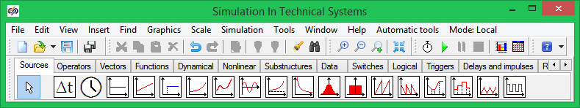

Fig 1.2

## 1.3 SimInTech structure and composition

Different versions of SimInTech (professional, demonstrative, training, restricted training) have an integral file structure. Fig. 1.3 represents the structure of SimInTech catalogue. The core is located in **bin** sub-catalogue. **Demo** sub-catalogue incorporates several sub-catalogues with a set of demonstrative examples from different engineering divisions. **doc** sub-catalogue contains WinWord text document with a Brief User’s Manual. **Project**  sub-catalogue is intended for storing projects (tasks), which will be created by a novice User (for example, at the stage of mastering the procedures of work in SimInTech environment).

**Note:** it is allowable (but not desirable) to rename or copy a catalogue created during SimInTech installation on your computer to a catalogue under another name.

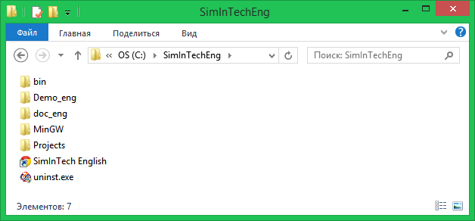

Fig. 1.3

For all SimInTech versions (starting with 1.0) **bin** sub-catalogue has practically the same file structure (see fig. 1.4). In professional version the list of files with **.dll** extension is more complete due to inclusion of additional Specialized libraries of typical units into SimInTech.

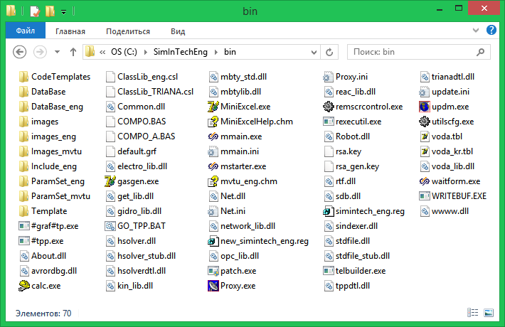  
Fig. 1.4

Note: more details about SimInTech composition and structure can be found in User’s manual.

## 1.4 "Line" of typical units

The SimInTech library of typical units consists (conventionally) from "General Engineering" library and a number of "Specialized" libraries, which are accessible from the "line" of typical units. The line is located on the monitor screen under the toolbar ("line" of command buttons, see fig. 1.5).

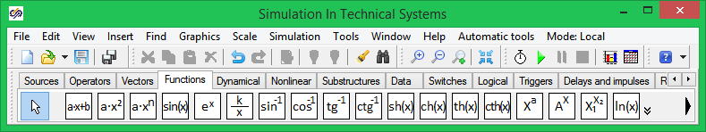Fig 1.5.

"Line" of typical units consists of separate catalogues (libraries), which are switched over by a single click with the left mouse key in the field of "tab" under a proper name. Considering that all "tabs" cannot find a room along the length of the "Line" of typical units special buttons are provided in the right top corner of the "Line" of typical units; a single click with the left mouse key on those will shift the "tabs" to the right – to the left by one position.

Each library included into the Line of typical units consists of 2…22 units. Those libraries, which cannot be placed along the length of the "Line" can be scrolled left-right by clicking the left mouse key on special buttons (in the beginning and end of the "Line").

In training versions of SimInTech the "Line" of typical units consists of 14 separate libraries grouped together, generally, in accordance with function attribute.

General Engineering library of typical units is fully included into the complete set of any SimInTech version and contains the following libraries.

- ***Sources*** *of input actions* (18 typical units);

*-* ***Data*** (9 typical units)*;*

**- *Operations*** *mathematical*(11 typical units);

**- Vector** *operations*(13 typical units);

**- *Substructures*** (13 typical units);

**- *Dynamical*** *links* (14 typical units);

**- *Non-linear*** *links* (20 typical units);

**- *Logical*** *links*(17 typical units);

**-** *Mathematical* ***functions*** (20 typical units);

**- *Keys*** (10 typical units);

**- *Discontinuous*** *links* (9 typical units);

Table 1.1 represents the composition of the General Engineering library of typical units. Detailed description of units belonging to the General Engineering Library and their mathematical models are given in APPENDIX "Libraries of typical units and their algorithms".

Standard complete set of training versions of SimInTech usually includes the following Specialized Libraries of typical units:

**- *Kinetics*** *of neutrons*(3 typical units);

**- *Properties*** (2 typical units);

**- *Statistics*** (9 typical units);

Libraries External (11 typical units), Monitoring and control (12 simulators of instruments and control devices) and Heat conductivity (4 typical units) are included into SimInTech when required or on a request of an institution (university) or a specific User, who have officially purchased SimInTech and been registered in the Designer’s database.

Beside the above mentioned other Specialized Libraries are available in SimInTech as follows:

*-* ***Reactor*** *units;*

*-* ***Automatic process control system Logic*** *water-cooled power reactor;*

***- Robots;***

***- UGS Components*** (UGS – underground gas storage).

A number of fragments of structural diagrams arranged by the Designer in the process of SimInTech debugging and performance of applied researches and development works have been stored in separate catalogues as sub-models (with .sub extension). Actually these catalogues are additional Specialized Libraries, whose components can be used via standard procedure "Insert sub-model from Additional command menu" to arrange considerable fragments of structural diagrams.

##### COMPOSITION OF GENERAL ENGINEERING LIBRARY OF TYPICAL UNITS

Note: only main typical SimInTech units are listed below. Alternative names of units (or names of units in previous SimInTech versions) are given in brackets.

**Library *"Input signal source"***

- Integration step (current integration step)

- Clock (simulated time)

- Constant

- Linear source (linear action)

- Step (step-wise action)

- Parabola (quadratic action)

- n-th power polynomial (polynomial action)

- Sine curve (sine action)

- Exponential curve (exponential action)

- Hyperbolic curve (hyperbolic action)

- Normal noise

- Steady state Noise

- Saw tooth

- Inverse saw tooth

- Piecewise linear (random piecewise linear action)

- Piecewise constant (piecewise constant linear action)

- Triangular signal (triangular action)

- Meander

**Library *"Mathematical operators"***

- Adder

- Comparison Device

- Addition of vector with number

- Vector adder

- Multiplier (multiplication)

- Multiplication of vector elements

- Multiplication of vector by number

- Divider (scalar/ vector)

- Division of scalar by vector

- Amplifier

- Vector amplifier

- Absolute value (module)

- Manifolder

- Sign

- Dynamic selection (numerical operator "Case")

- Table function integral

- Initial value compensation

- Non-linear equation y = F(y)

- Non-linear equation F(y) = 0

- Stop-calculation

- Linear transformer

- Selection by active element

- Integral part

- Fractional part

- Round-off

**Library *"Vector operations"***

- Multiplexer

- Demultiplexor

- Input signal matrix unpacking

- Input signal matrix packing

- Selection from input vector

- Solution of system of Linear algebraic equations

- Multiplication of matrix by vector

- Matrix transposition

- Interpolation

- LS method - approximation

**Library *"Substructures"***

- SimInTech Sub-model ("macro unit")

- SimInTech input port

- SimInTech output port

- To memory ("Transmitter")

- From memory ("Receiver")

- Note - Comment

- Total memory (3 units)

- NLAE system (2 units)

- External inputs (2 units)

**Library *"Mathematical functions"***

- Linear Function

- Parabolic (quadratic) function

- Polynomial function

- Sine

- Exponent

- Hyperbolic function

- Inverse trigonometric functions (4 units)

- Hyperbolic functions (4 units)

- Power function

- Exponential function

- Exponential-power function

- Exponential function with variable amplitude

- Natural logarithm

- Common logarithm

- Quadratic root

**Library *"Dynamic links"***

- Programming language

- Integrator (ideal integrating link)

- First-order relaxation (aperiodic) link

- Variable states

- Oscillation link

- Ideal lagging link

- General type dynamic link

- Relaxation-differentiating link

- Derivative

- Relaxation-forcing link

- Relaxation-forcing link

- Quadratic functional

- Integrator with saturation

- Integrator with variable initial conditions

- Variable transport lag

- First order aperiodic (analytical) link

- First order aperiodic (discontinuous) link

- Integrator on amplifiers

- DIF-derivative

- Signal filtration

**Library *"Data"***

- Graphic window 1 (time curve)

- Graphic window 2 (phase plane)

- Graphic window 3 (space curve)

- Record to file

- Read-out from file (3 units)

- Read-out from table

**Library *"Non-linear links"***

- Quadratic performance functional merit functional

- Linear with saturation

- Linear with dead zone

- Linear with saturation and dead zone

- Relay ambiguous

- Relay ambiguous with dead zone

- Gap

- Play

- Break

- Random single-valued non-linearity

- Minimum storage

- Maximum storage

- Max/min storage of 2 scalar signals

- Max/min storing of 2 scalar signals

- Variable transport lag

- Differentiation

- Limit of rate of change

- "Delta" - function

- Signal/time storage (2 units)

**Library *"Logic links"***

- General-purpose Boolean logic unit

- Logic "AND"

- Logic "OR"

- Logic "NOT"

- Logic "EQUAL TO"

- Logic "NON EQUAL TO"

- Logic "MORE THAN"

- Logic "MORE THAN-EQUAL TO"

- Logic "LESS THAN"

- Logic "LESS THAN-EQUAL TO"

- Xor / nxor

- Time confirmation

- M from N (event logic)

- Flip-flop

**Library *"Keys"***

- Controllable key (in "on-line" mode)

- Amplitude keys (4 units);

- Time keys (4 units);

- Integrator key

**Library *"Discontinuous links"***

- Delay for an integration step

- Zero order extrapolator

- Discontinuous lag

- Discontinuous differentiation

- Zero order difference

- General-type transfer function

- Inverse argument transfer function

- Variable states

- PID-regulator

# 2 SIMINTECH OPERATIONAL PROCEDURE BRIEF DESCRIPTION

## 2.1 Main stages of operation in SimInTech environment

This subsection describes only basic procedures of operation, which are to be mastered as an obligatory condition for independent work in the software environment.

Commands and options are carried out via Main Window menu or via command buttons, whose purposes are explained in subsections 1.5, 1.6.

Generation, edition of project (task) structural diagram, entering unit properties and initial conditions, selection of integration method and parameters are carried out using both special graphic procedures and via commands or command buttons.

Structural diagram of a task under consideration is recommended to be previously rough-drafted about with the same appearance you wish to see it on the monitor screen.

Generation of structural diagram and its parameters, selection of integration method and parameters, etc. are advisably to be carried out as follows:

* use **Line** of typical units to fill **Diagram Window** with required units approximately in the same way those are expected to be arranged in the structural diagram;
* use procedures for "dragging" units and changing their orientation and sizes to provide "meaningful" appearance for the structural diagram;
* use the computer mouse to interconnect units with communication links;
* move left-to right and up-to-down (along units if **Diagram Window**) to set unit parameters on the structural diagram (amplification factors, time constants, initial conditions, etc.);
* use **Calculation parameters** button to set final integration time, to select required integration method and other calculation parameters;
* store the produced diagram (project) under an individual name on the hard disk (e.g., task_1 or, e.g., proba);
* activate the calculation task, see current results in graphic windows and analyze those… It is recommended to carry out the procedure of storage on the hard disk after each above mentioned stage but not after entering all conditions of the task.

The first stage – entering the structural diagram (filling with typical units) – can be started immediately after starting the software in the empty **Diagram Window** (click twice with the left mouse key on the **New** command button to create that).

## 2.2 Demonstrative example of nuclear reactor ACS dynamics

In order to quickly familiarize mathematical and service capabilities of "Simulation In Technical Systems" software let us consider a demonstrative example wherein nuclear reactor ACS dynamics is carried out.

Enter the Windows environment, find a file wherein SimInTech has been installed, and click twice with the mouse left button (herein referred to as "mouse"). Find SimInTech pictogram, shift the cursor at that and double-click with the left mouse key (software is started). In 1...2 seconds SimInTech icon and then **Main Window** appears on the screen.

Shift the cursor on **Open** button and single-click it with the left mouse key. Windows dialog window will be opened with the list of all project-files with .prt extension and located in "Projects" sub-catalogue relative to SimInTech installation catalogue. Open "..\Demo\Automatic" sub-catalogue, Shift the cursor on "reactor with relay regulators.ptr" file and click it with the left mouse key, then Shift the cursor on "Open" and click the left button again. In few seconds **Diagram Window** will be filled with structural diagram (see. Fig. 2.1) and graphic window under name of "reactiveness in fractions b_эфф and relative deviations of neutron power" will be opened.

On doing the above said, you will have loaded a task corresponding to research of self-oscillations mode in relay automatic power regulator of High Power Channel-type Reactor to PC RAM.

Let us consider first an off-line ACS (control action from **Power selector** is equal to zero), which is removed from equilibrium (initial reactiveness of temperature inverse link at t = 0 is not zero, but is equal to 1 % of (ßeff ). Shift the cursor on **Initialization** button in the "line" of command buttons and click it with the left mouse key: the task will be initialized, which will be "indicated" by **Stop** command button – pictogram will get highlighted (red). Shift the cursor on **Start** button and single-click that with the left mouse key: modeling process in this ACS will be started.

DIAGRAM WINDOW SCREEN COPY  
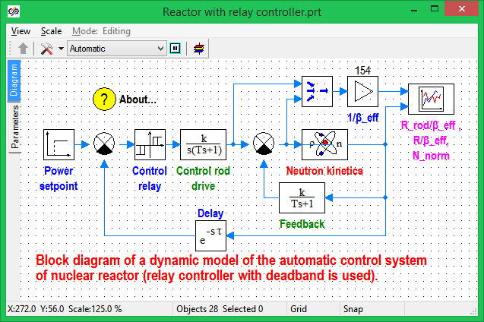  
Fig. 2.1

Received results witness (see the transient process curve in the upper part of figure 2.2) that high-frequency power self-oscillation mode has established in the reactor with the amplitude of self-oscillations twice exceeding the "setting" for dead zone in **Control relay** (1 %). Self-oscillations are caused by a narrow dead zone in the Control relay and relatively high speed effectiveness of ACS drive as well.

Modeling process can be implemented not in two stages (**Initialization button** first and then **Start** button) but in one by single-clicking on **Start** button with the left mouse key.

Shift the cursor on the *Command relay* unit and double-click that with the *left* mouse key: dialog window of the unit will be opened (relay ambiguous with dead zone). Using first six dialog lines (**a1, a2, b1, b2, Y1, Y2**) change the unit parameters for a more wide dead zone, i.e.: enter **-0.02 -0.016 0.016 0.02 -1 1** (by one number for each line), which corresponds to a dead zone for relative deviation of neutron power ±**2 %**, return factor **0.8** and value of "jump" on relay actuation **±1.0**. Initial condition of relay at t = 0 is to be set in the seventh dialog line: **Y(0) = 0**. Shift the cursor on **Ok** button and click it with the lift mouse key: dialog window will be closed. Restart the calculation task (on completion of calculation the graphic window can be rescaled by double-clicking it with the left mouse key in the graphic window field). Behavior of curves witness (see transient process curves in the lower part of fig. 2.2) **that high-frequency self-oscillations are not available (!!!) and ACS is asymptotically returns to equilibrium (stationary) state.**

COPIES OF GRAPHIC WINDOWS

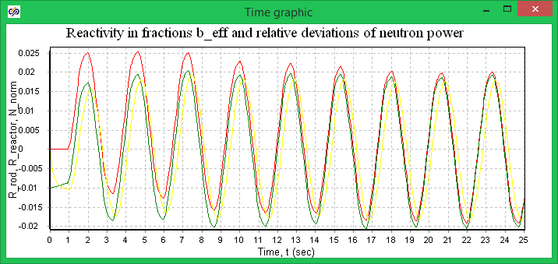

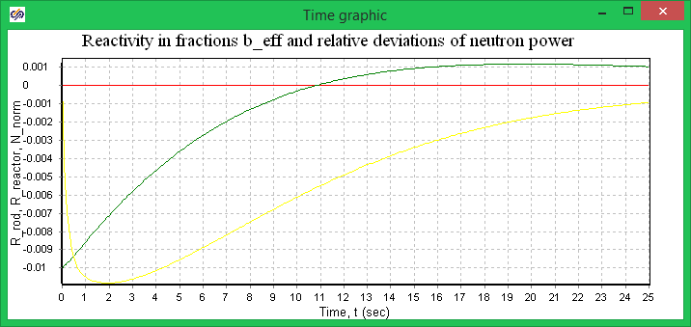

Fig. 2.2

Return the initial value of parameters in dialog window lines of *Control Relay* unit (**-0.01 -0.008 0.008 0.01 -1 1**). Shift the cursor on the *Control and protection system drive* unit and double-click that with the *left* mouse key: Dialog window will be opened of this unit, which is a typical linear dynamic link, i.e.: relaxation-integrating. Initialize the input field (dialog line) of amplification factor **K** and enter the lesser value: **1e-4.**

Close the dialog window and start up the calculation task. On completion of the calculation, rescale the graphic window: **high-frequency self-oscillations will not occur.**

Let us consider *on-line* ACS, which, until t <= 10s, is in equilibrium, and, when t >10 s, control action is delivered to transfer the nuclear reactor to a higher level of power (+10 %). Shift the cursor on *Feed back* unit and double-click it with the *left* mouse key, and change the initial condition over to zero one in the opened dialog window. Close this dialog window and Shift the cursor on *Power selector* unit. Open its dialog window and set in parameter values **10 0 0.1** its dialog lines (one number per a line), which corresponds to the following algorithm of operation of this unit: before t <= 10 s the output signal is zero and when t >10 s step-wise action **0.1*1(t)** will be delivered to the input of *the Main comparison device.*  Shift the cursor on**Calculation parameters** command button and single-click it with the left mouse key.

Change the "final calculation time" over from **25** s to **100** s. Close this dialog window, start the changed calculation task and, on completion of calculation, rescale graphic windows.

Analysis of obtained results (see fig. 2.3) demonstrates that the nuclear reactor has been changed over to a set level of power with the accuracy up to the dead zone width; the regulating core introduced an additional positive reactivity ~ 6...7 % from *ßэфф,* while the nuclear reactor reactivity in transition process in maximum reaches~ 6 % from *ßэфф*  and is tending towards zero when t → **infinity**.

ACS PARAMETERS WHEN TRANSFERRING TO INCREASED LEVEL OF POWER

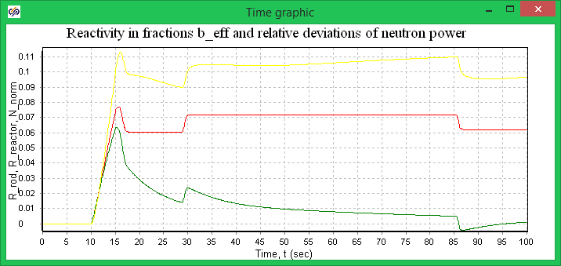

Fig. 2.3

Overview dialog windows of other units of this task (a reference for every unit can be called up by pressing keys **Сtrl+F1 together).**

We should note that for displaying calculation results *vectorized* processing of signals: signals of regulating core and reactor reactivity are "convolved" into **one vector** signal (2-cored) by means of multiplexer and then, using *Amplifier* typical unit are vectorially normalized as per the value of effective fraction of lagging neurons (*ßeff*. *Time curve* typical unit in this task has 2 inputs (1st input is vector, 2nd one is scalar). "Nuances" and peculiarities of other units you can find by yourself...

Close this task by means of system button in the right upper corner of **Diagram Window**, meanwhile answering **No** on the request to save the current project (task).

On performing procedures similar to the ones described in this subsection, you can overview other demonstrative examples as well. All examples are completely ready for demonstration and can be started in the same manner as the example described above.

## 2.3 Demonstrative-familiarizing task

### 2.3.1 Initial data for familiarizing task

To obtain experience in independent work in SimInTech environment let us carry out all stages recommended in subsection 2.1 for modeling ACS dynamics, the structural diagram, of which is given in figure 2.4.

ACS STRUCTURAL DIAGRAM

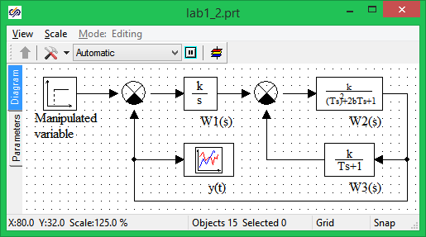

Fig. 2.4

Controllable object with transfer function *W2(s)* corresponds to a typical (oscillating) link with parameters: *k2*= 1.0; *T2* = 1 s; damping parameter *b* = 0.5; initial conditions are zero.

Local feed back with transfer function *W3 (s)* corresponds to a typical aperiodic 1st order link with parameters: *k3* = 0.6; *T3* = 5 s.

Local comparison device provides negative feed back, i.e., "works" in the mode of simple subtraction.

It is necessary to select an amplification factor *k1* of integrating regulator (*W1(s)*) so that, when step-wise control action *u(t)* = 0.8*1(t) is delivered, there would be no overshoot

(i.e., *ymax* <= 0.8) and transient process time does not exceed 20 s.

To display calculation results use *Time curve* typical unit from **Data** library.

### 2.3.2 Input of structural diagram and initial data

Input of structural diagram and initial data is practicable following the procedure recommended in subsection 2.1.

**Stage 1** – **Diagram window** *filling with required typical units.*

Make sure that all demonstrative examples, which were overviewed by you in subsection 2.2, are closed and **Diagram Window** is not available. Shift the cursor on **New** button and single-click it with the *left* mouse key and then single-click **Automation** item: empty **Diagram Window** will be opened. Shift the cursor on ***Sources*** *of input actions*"tab" and single-click it with the left mouse key. You have initialized a corresponding library consisting of typical units. Shift the cursor on *Step-wise action* unit (subscribed as *step*) and single-click it with the left mouse key: background in "Line" has been changed. It means that the unit can be "carried" to **Diagram window**. Shift the cursor on the upper left corner of **Diagram Window** and single-click it with the *left* mouse key. **Step** unit to be transferred has appeared in the **Diagram window** field.

Shift the cursor on ***Mathematical operations*** "tab" and single-click that with the *left* mouse key. You have initialized a corresponding typical library. Shift the cursor on *Comparison device* unit and single-click it: unit background has changed. Shift the cursor to **Diagram window**field onto a point you desire to place *Main comparison device* and single-click it with the left mouse key: *Comparison device* unit has been shifted to **Diagram window.** Redo the above mentioned actions and also shift the 2nd *Comparison device* unit, which is required for modeling *Local comparison device*, to a free location in **Diagram window** (lower and to the left).

Shift the cursor on ***Dynamic*** *links* "tab", initialize that, shift required units (*Integrator, Aperiodic and Oscillatory* links) to **Diagram window** following the above described procedure to approximate desired locations. Carry out the last transfer of the unit to Diagram Window: Shift the cursor on **Data** "tab", initialize this library of typical units, transfer *Time Curve* unit to **Diagram Window** to an approximate desired location. Finally Shift the cursor on the large button (with a white arrow – mouse pointer) in the left part of *"Line" of typical units* and single-click that: You have temporarily "switched off" the procedure for transferring units to the diagram window.

**Stage 2** – *plotting communication lines on structural diagram*

Shift the cursor to any of *Comparison device* units (future *Main Comparison device*), press the mouse left button and, while holding that, "drag" the unit in a way to ensure for its upper input port (hereinafter referred as just an input) horizontally to be at the same level with the output port of *Control action* unit.

To simplify this procedure *Mesh* option in the **Diagram Window** should be advisably switched on. *Mesh* option can be switched on in two ways:

- Shift the cursor on *Mesh* button at the bottom of **Diagram Window** (on the status line) and single-click it with the *left* mouse key;

- Shift the cursor on "View" menu item in the **Diagram Window** and single-click is with the *left* mouse key - select *Mesh* item in the appeared menu;

Then Shift the cursor on the output port of *Control action* unit, make a click with the left mouse key and, on releasing the mouse key, "drag" a horizontal line to the upper input port of the *Main comparison device*. Again make a single click with the *left* button: a typical *input arrow* will appear at the upper input. If you clicked with the left mouse before the link being dragged was "attracted" by the input port, reach the communication link to a desired input port and male a click with the left mouse key.

If a turn by (± 90 degrees in the communication line is required make a click with the *left* mouse key and continue drawing the communication line in a new direction. If you wish to interrupt the procedure of communication line drawing (for example, due to its "bad" appearance), press an empty space in the **Diagram Window** with the right mouse key: the line will be interrupted (its generation will be completed). The this line can be deleted: highlight it (single-clicking the line with the *left* mouse key) and then delete the line using **Cut** command button ("scissors" pictogram) or by pressing Delete button on the computer keyboard.

Use the same procedures to specify the location of units in the direct circuit of structural diagram *(W1(s), Local comparison device and W2(s))* and draw up communication lines.

Specify the location of unit with *W3(s)* using the procedure for "dragging" units in Diagram Window. Change the location of its ports using the properties window of this unit. Draw communication lines from unit with *W2(s)* to unit with *W3(s)* and from that to the 2nd (lower) input port of *Local comparison device*.

Shift the cursor on the communication line from unit with *W2(s)* to unit with *W3(s)* (preferably at the angle of the last turn of the communication line), press the right mouse key and select *Actions → Add branch* item in the displayed menu; a new point will appear on the line and drawing of a branch-line from this point will be enabled*.* Draw a communication line (minor length): You have obtained **"branches"** from the existing communication line (compare with fig. 2.4). Use the above described procedures elongate the line of *Main feed back* to the 2nd input port of *Main comparison device.*

Shift *Time curve* unit, produce a "branch" from the Main feed back and elongate that to the *Time curve* unitinput (see fig. 2.4).

Save inputted part of the task. To this end open **File** menu and shift the cursor on **Save as...** option in **Main window** and single-click it with the left mouse key: initialize the input line in the displayed dialog window and type an original name of your task, e.g., **lesson1** (any extension allowed). Close **Project saving** window by clicking **OK** button.

Shift the cursor to the left lower corner of the **Diagram Window** border (a special *tilted* double-sided arrow will appear) and change the size of **Diagram Window** so that its right and lower fields would be 4…5 cm at least.

If the arranged structural diagram is not "inscribed" within the Diagram Window dimensions shift the cursor on **Show all** button in *Additional tool panel* and single-click it with the *left* mouse key: the structural diagram will be rescaled and it will become completely visible in the Diagram Window.

Resave the task by clicking **Save** button with the *left* mouse key.

**Stage 3** – *inputting structural diagram parameters*

Shift the cursor on the *Command action* unit and double-click that with the *left* mouse key: Dialog window with active **Parameters** "tab" will be opened (see fig. 2.5).

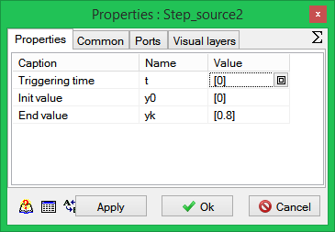

Fig. 2.5

Initialize the dialog line, enter values **0 0 0.8** (3 numerals, one per a line) and press **Ok** button. Redo the same procedures for units with ***W2(s)*** and ***W3(s),*** and enter corresponding values for k, T and initial conditions.

**Ports** "tab" enables changes in arrangement of input and output ports (see fig. 2.6).

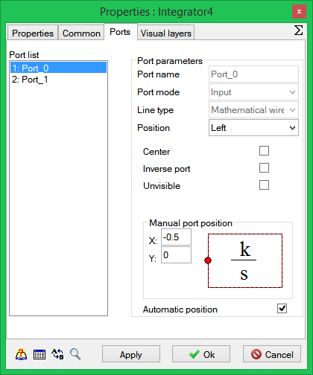

Fig. 2.6

***Common*** "tab" (see fig. 2.7) enables:

- changes in the object/ unit name (novice User wouldn’t advisably do this);

- entering explanation subscription under a unit in special *Unit subscription* field;

- changes in unit colors via *Color* option;

- changes in type and color of unit subscription font via *Unit subscription font* option;

- many other options, which can be changed, when required.

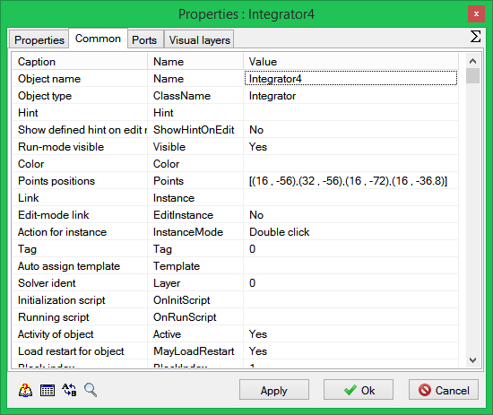

Fig. 2.7

**Note.** Dialog window of any unit can be also opened *in the other way*. Shift the cursor on a unit to be edited and single-click that with the *right* mouse key: a "pop-up" window of the unit will appear (see fig. 2.8), the dialog window of the unit can be called up by single-clicking its *Properties* line with the *left* mouse key. *Cut* and *Copy* options of the unit pop-up menu duplicate the buttons under the same names belonging to *Additional command menu*, while the inactive *Save sub-model* option on fig. 2.8 can be activated only on clicking *Sub-model* unit with the right mouse key.

DIAGRAM WINDOW WITH UNIT POP-UP MENUS

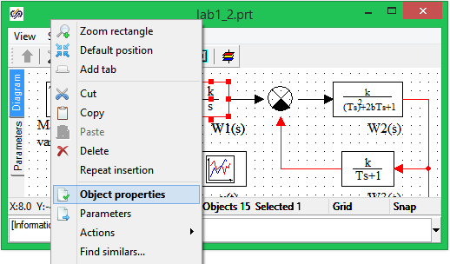

Fig. 2.8

Let us return to structural diagram parameters entry. Open *Main comparison device* dialog window and make sure that required parameters have been already entered in the dialog line (by default): **1** (plus 1) and **-1** (minus 1). In the course of modeling the *Comparison device* implements *algebraic addition* of two signals as per an entered weight factor, i.e., 1st – with the weight factor **1 (+1)** and 2nd – with the weight factor **-1 (**minus 1**)**.

If 3 signals need to be algebraically added together, e.g., with weight factors **0.8, -1.2** and **2.5** applied then the correspondent parameters are to be entered in the entry line (comma separated: [**0.8, -1.2, 2.5])**. When closing the dialog window of *Comparison device* unit, this unit will be redrawn and it will have 3 input ports, where the upper left input port (when the unit is arranged left-to-the-right) is for the 1st signal (factor is equal to **0.8**), the lower input is for the 2nd signal (factor is equal to **-1.2**) and the lower left input is for the 3rd signal (factor is equal to **2.5**). Redo the same procedures for *Local comparison device*.

*Main comparison device* and *Local comparison device* can be implemented also using *Adder* typical unit from *Mathematical* ***Operation*** library since the algorithm of operation of this unit is similar to the algorithm of *Comparison Device* unit and differs from the latter only due to the unit pictograms and arrangement of the 2nd input port. Make sure of it yourself...

Open the unit dialog window with *W1(s)*, enter a guess value for amplification factor *k1* = 1. Initial condition has been already set up (by default). Close the dialog window.

Resave the task by clicking the **Save** command button.

**Stage 4** – *setting integration parameters.*

Shift the cursor on**Calculation parameters** command button and single-click it with the *left* mouse key: ***Solver Properties*** dialog window with active **Calculation parameters** "tab" will be opened (see fig. 2.9).

Other "tabs" of this dialog window are intended as follows:

* ***View*** "tab" - for setting the appearance of **Diagram Window** by default;
* ***Synchronization*** "tab" – for calculation in a preset time scale (with *Time scaling mode* activated, value **1** in *Acceleration Multiplier* field corresponds to the calculation in real-time scale);
* ***Project Restart*** "tab" – for periodical (e.g., every 1 second) saving basic calculation data, which can be used for modeling procedure after completion of calculations in binary format (file with **.rst** extension); also for saving all calculation data, which can be used for expedited reproduction of modeling process via *Calculation emulation from file* in ***Modeling***  menu calculations in binary format (file with **.rez** extension);

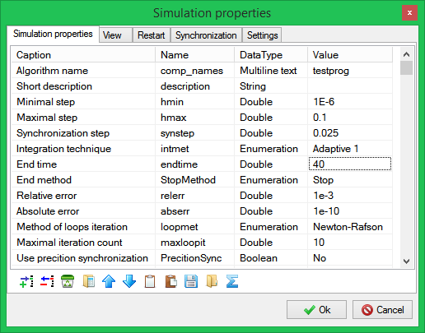

Fig. 2.9

*Calculation at remote server* mode (not indicated in fig. 2.9) is implemented in network version of SimInTech operation. User generates a task structural diagram at a client computer, sets parameters of structural diagram units, sets integration method and parameters. Then the "client" variant of SimInTech (typical software version or software graphic shell without calculation core) generates initial data on the task to be modeled, which via one of network protocols (e.g., TCP/IP) are transmitted to the server-computer (having only calculation core), where the dynamic mode itself is calculated. Calculation results according the same network protocol are transmitted back to the client-computer, where calculation results are displayed and then analyzed...

Let us return to the setting stage for basic integration parameters. With ***Calculation Parameters*** "tab" active select a numeric procedure, e.g., **Active 1**. Then insert as follows: Final calculation time – **40** (seconds); Minimum step – **0.001** (sec.); Maximum step - **0.1** (sec.). Accuracy parameter (relative error) can be left the same (**0.001** by default). Close the dialog window by clicking the **OK** button with the *left* mouse key.

Resave the task (**Save** button).

**Stage 5** – *explanatory subscription execution*

Let us execute **Diagram Window** as it is shown in fig. 2.4. Shift the cursor under the *Command action* unit and double-click that with the *left* mouse key: a temporary window will appear for entering a text. Shift the cursor into this window and make a click with the left mouse key and then enter the mane for this unit (into two lines). Shift the cursor to an empty space in **Diagram Window** and make a single click with the *left* mouse key: the temporary window will be closed and the desired subscription will appear under the unit. If the subscription appears "poor" (with errors) reopen the temporary window fro entering the text (double-clicking the text under the unit with the *left* mouse key) and use edition keys (Backspace, Del, etc.) to correct the subscription.

Subscription under an object can be also carried out in another way: as show in fig. 2.7…

SimInTech interface allows the subscription font type, size and color to be changed. Highlight the unit, open **Properties** menu and select *Unit subscription font* option. ***Font selection*** dialog window will be opened where you can set desired parameters pf the subscription, e.g.: font - **MS Sans Serif**; style - **Semibold**; color - **Red**; size - **8**. When closing **Font Selection window** (clicking **ОК** button), automatic return to SimInTech environment occurs.

**View** menu (in calculation parameters) and its options can be used to change the unit background, whole **Diagram Window** background, color of communication lines (after highlighting previously the unit or communication line to be edited by a single click with the *left* mouse key). Carry out the color distribution in the structural diagram independently…

Also, independently find out purposes of other options in View menu…

On executing the procedures described above for all units, make the entered structural diagram appear similar to the one in fig. 2.4.

Save made changes using **Save** command button.

**Stage 6** – *opening Graphic window and changing its sizes*

Shift the cursor on *Curve y(t)* unit, make a single click with the *right* mouse key and select *Properties* line in the unit "pop-up" menu by means of the *left* mouse key. First line (*Number of input ports*) in the dialog window does not require any edition since there is value 1 set by default in it.

Close the dialog window of *Time curve* units (a click on Yes button) and double-click the icon of this unit in Diagram Window with the *left* mouse key: graphic window titled as **Curve y(t)** will be opened. If the graphic window title is different close the graphic window (mouse-clicking the system button in the upper right corner of the graphic window) and then open it again… To transfer the graphic window to another location shift the cursor on its title, then press the *left* mouse button and, while holding it, "drag" the window to a desired location. Change in its sizes is carried out in the same way as for other windows in Windows environment. Use procedures for changing window sizes to provide a desired size for the window (~ 1/4 of **Diagram Window** area).

***Other parameters of graphic windows will be set up on completion of modeling of transient processes.***

Save made changes using **Save** command button.

### 2.3.3 Transient processes modeling and variants calculations

Shift the cursor on **Start** command button and click that with the *left* mouse button. You have started the created task for calculation. On completion of calculation a special ***Messages*** window with information will appear: **"Error: Specified accuracy is not ensured".**

Rescale the graphic window by double-clicking it with the mouse. Shift the cursor on **Calculation parameters** button and change the minimum integration step for a new value

(**1e-10**), and redo the modeling process.

Calculation data indicate that, first, appearance of the transient process has not been changed after abrupt change of a minimum integration step, and, besides, at the initial integration step (**0.001**) the specified accuracy was not provided only at the 1st step of modeling (i.e., during processing of step-wise action). Thus, the message on accuracy could be ignored… Second, calculation data witness that when k1 = 1 the initial ACS is unstable and the transient process is divergent (see fig. 2.12 below).

Let us carry out procedures of graphic window edition interrupted in subsection 2.3.2. Shift the cursor into the central part of the graphic window and male a single click with the right mouse key: command menu of graphic window will appear (see fig. 2.10).

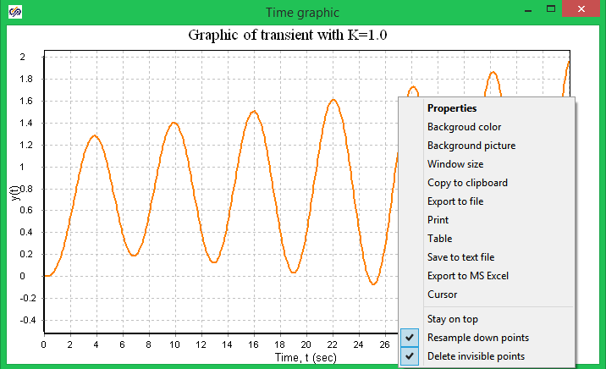

Fig. 2.10

A number of command menu options of *Time curve* unit are common and do not require any special clarifications (*Autoscale, Cursor, Always in-front*).

*Copy to buffer* option in context menu implements the operation of curve image copying to the buffer for next following pasting it into relevant report documents, into Word text document, for example… Click *Properties* line with the *left* mouse button: a special dialog window under title of ***Setting*** will be opened (see fig. 2.11).

Shift the cursor to ***Title*** dialog window and enter a new name – **Transient process curve at K = 1.** First three buttons in ***Title*** line are intended for "binding" the title text (along the left border, to the center, along the right border) and the last one (lettered pictogram) is intended for setting parameters for curve title fonts.

Add the subscription under **X**-axis in the same manner (middle dialog field **Axis name: Time, s)**. Then delete the subscription (**value of a quantity)** for **Y**-axis in the right dialog field **Axis name** and enter a new subscription: **y(t)**. Buttons in both lines are intended for setting font parameters of these subscriptions (rightmost button).

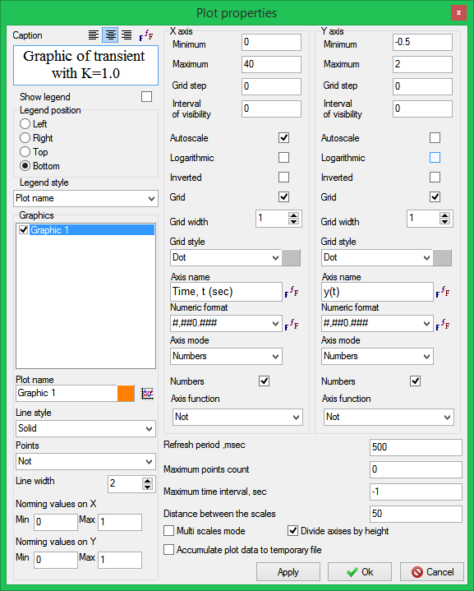

Fig. 2.11

Via this dialog field one can change: color and type of a line; color and type of a mesh line on the curve; color of curve field and border. Independently study the curve edition capabilities by means of other options of ***Curve properties*** dialog window…

On completion of procedure for graphic window edition, shift the cursor on **Ok** button and close this dialog window. Graphic window will appear as shown in fig. 2.12.

Change value ***k1*** for a new one: **0.2**. Redo the modeling process, rescale the curve window on completion of calculation. The data give evidence that in spite of no transient overshoot, but the transient process time considerably exceeds 20 seconds. If you change value K in the curve title in the graphic window dialog then the graphic window with calculation data will appear as shown in fig. 2.13.

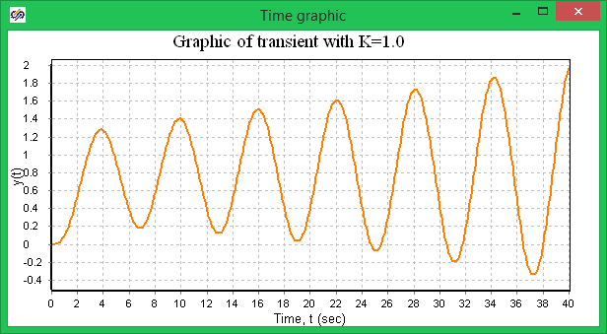

Fig. 2.12

Change again value k1 for a new one: 0.35. Redo the above described procedures. Analysis of obtained data shows that you have reached required characteristics for the transient process: overshoot is not available; time of entering to 5-percent "tube" does not exceed 20 seconds (see. fig. 2.14).

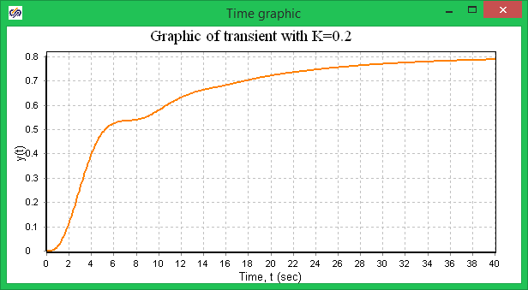

Fig. 2.13

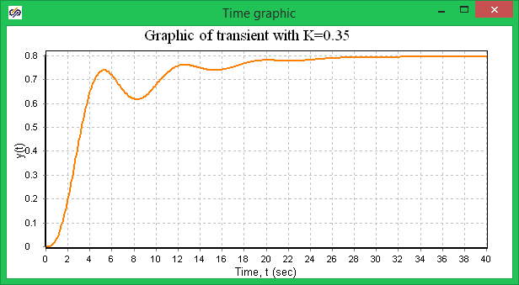

Fig. 2.14

Demonstrative-familiarizing task is over. Save the task in the disk…

Generated ACS structural diagram (see fig. 2.4) will be used below for mastering procedures for other modes of operation of SimInTech software system, i.e.: ANALYZE mode and OPTIMIZATION mode in the next "term".

1. Presently (May 2012) the SYNTHESIS mode is under internal testing and in the future will be included into mass-market SimInTech version.