# Creation of a Thermohydraulics Model for the Flowing Part

## Creation of a New Thermohydraulics Model

To create a thermohydraulics diagram in SimInTech proceed as follows:

1. Select **“New Project”** button in the toolbar.

Select “TPP Diagram” item from a pop-up menu (see Figure 1. New Thermohydraulics Project Creation Menu

1. ).

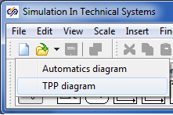

Figure 1. New Thermohydraulics Project Creation Menu

Then a new diagram window will be opened, in which a thermohydraulics block diagram will be generated (see Figure 2. Thermohydraulics Diagram Creation Window

).

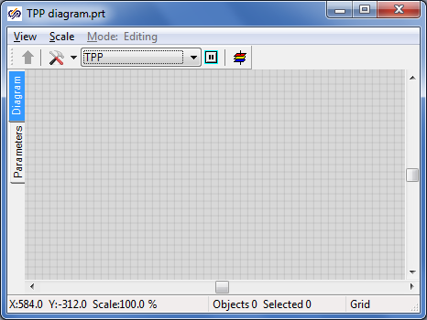

Figure 2. Thermohydraulics Diagram Creation Window

To proceed with the work save the given diagram in a file under a new name (e.g., “Flowing part”). To that end, perform the following operations:

1. Select item **“File”** in the main menu and then select **“Save project as...”** item from the pop-up list.
2. Use the standard “save file” dialog to select a new name and catalog for saving. “C:\KTZ\Turbine\Flowing part\Flowing part.prt”.

When the file has been saved, its name and full path are displayed in the diagram window title (see Figure 4. Diagram Window with New and Saved Projects

).

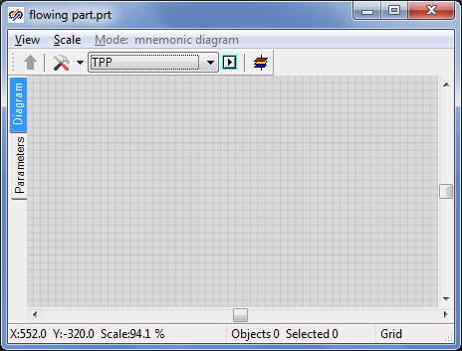

Figure 4. Diagram Window with New and Saved Projects

## Check for Connection to Signal Database

Then, after completion of debugging of all parts of the turbine model, we will need to combine separate parts in an integral project (besides, the model of automatics system shall be engaged in the hydraulic calculation). To ensure a common operation of several calculation codes it is necessary that those use the same signal database. Thus, it would be advisable to make provision for a database under the same name and uniform signal names to be used for all projects. By default, database with file name “tpp.db” is used in TPP project. The file is located in the current directory of the project. This file name is quite good for us and we will use it.

To check the connection of the database in a newly generated thermohydraulics project switch over the software system to the developer mode, for which purpose select “File” item in the main program menu and then “Parameters” sub-item. Go to “View” tab in the displayed “Parameters” dialog window and tick “Developer mode” option (see Figure 5. “Parameters” Dialog Window for Activation of Developer Mode

).

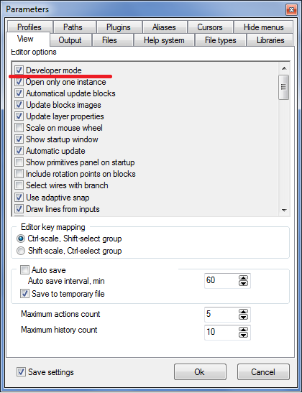

Figure 5. “Parameters” Dialog Window for Activation of Developer Mode

Signal database is connected to the thermohydraulics diagram in the following manner:

1. Press button **“Simulation properties”** in the diagram window:

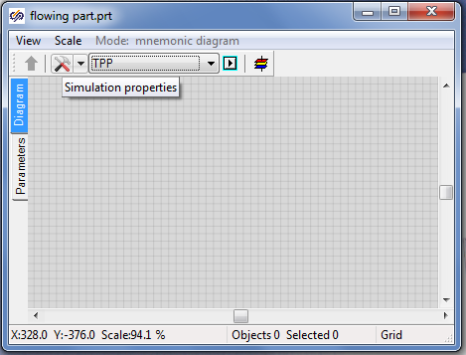

Figure 6. Simulation Properties Access Button

Go to “Settings” tab in the popped up setting dialog (see Figure 7. Project Database Setting Tab

1. ).
2. Enter the following text in **“Project database module”** edit bar: “$(Root)\sdb.dll” (to be entered without quotation marks; sdb.dll is for the name of dynamic library of database program module).

Enter a random file name for saving the database in “Project database name” bar. In our case we just make sure that everything is correctly filled, and leave the default file name (“tpp_eng.db”, see Figure 7. Project Database Setting Tab

1. ).

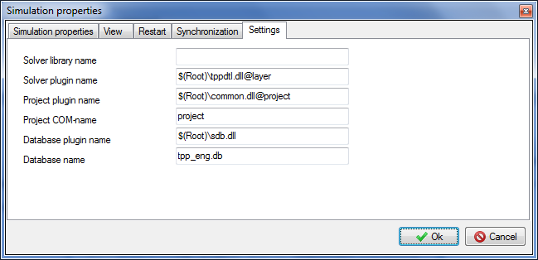

Figure 7. Project Database Setting Tab

1. Close the dialog window by pressing **“Ok”** button (see Figure 7. Project Database Setting Tab
2. ).

## Setting the Flowing Part Diagram

Blocks located in **“TPP process blocks”** tab of the blocks template are used to create the diagram. (see Figure 8. Thermohydraulics Blocks Pop-up List

).

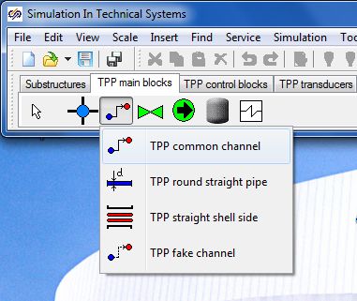

Figure 8. Thermohydraulics Blocks Pop-up List

For modeling the flowing part we will need 9 channels of common type, 5 internal TPP nodes, 4 boundary nodes of G type, one boundary node of P type and some other elements…

The sequential operations are executed:

1. Arrange the following design thermohydraulics blocks in the diagram window:

– “Boundary node P” (in the right-hand part of the calculation diagram).

– “Boundary node G” (at the left on the calculation diagram).

– “Internal node” (4 nodes in series).

– “Boundary node G” (three nodes at the bottom under TPP internal nodes).

– “Internal node” (one more, next to the internal node of P type).

– “Common type channel” (9 pipes in series).

The pipes are advisably to be arranged separately, do not connect those to the nodes. This will allow those to be more accurately connected to the nodes and, thus, no “problem” points will occur (sometimes a gap between a node and a pipe cannot be seen). After completion of all arrangements, we will obtain a picture the same as the figure below:

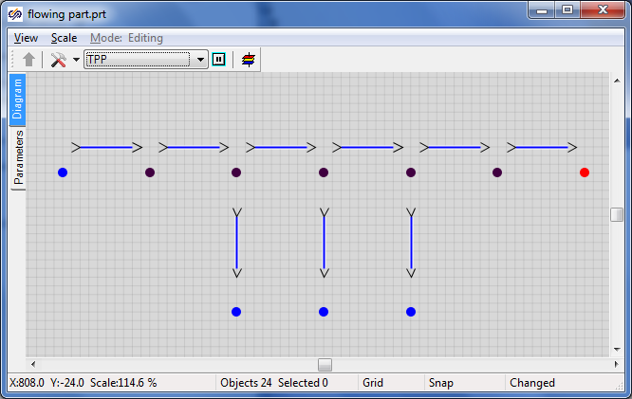

Figure 9. Initial Step for Setting the Flowing Part Thermohydraulics Diagram

Link successively the elements so that “Common type channels” elements generate one hydraulic line with internal nodes. In our model boundary nodes “G” will define the steam flow at the inlet to the flowing part and in steam extractions, while boundary node “P” – the pressure at the boundary with the condenser (see Figure 10. Generation of a Common Hydraulic Line

1. ).
2. Place one **“Remotely operated manual gate”** element of TPP code in each one of the four intermediate (not connected to boundary condition) channels. Change the name of each gate for a new one: z1, z2, z3 and z4, correspondingly.
3. Shift the gates just below the channels on the diagram for convenience.

Place “Active TPP element” element from “Turbo-pump plant elements” tab on each one of these channels (with manual gates) (see Figure 11. Addition of Gates and Turbine Active Elements

1. ).

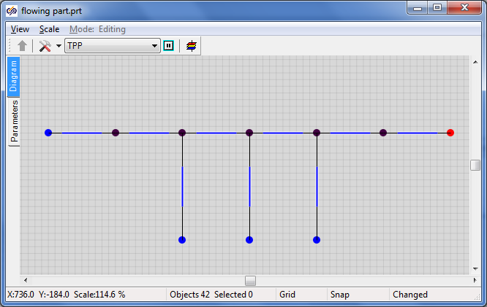

Figure 10. Generation of a Common Hydraulic Line

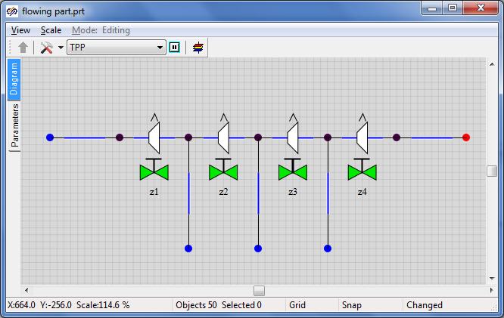

Figure 11. Addition of Gates and Turbine Active Elements

1. Add **“TPP rotor”** element and change the value of its **“Number of mechanical ports”** property for **“5”**. Place the fifth port from the right in “Ports” tab (the others will remain at the bottom).
2. Link the rotor ports with four bottom extraction ports. Set the **“Show the frame”** rotor property to **“Yes”**.
3. Place the **“TPP generator”** element at the right from the rotor. Link the generator to the rotor with a junction line. The diagram can be executed in a prettier manner – work with that will be more pleasant and modeling quality will be enhanced. For example, the rotor size can be increased considering the extractions.

As a result, thermohydraulics model diagram shall resemble the Figure 12. Completion of Setting of the Turbine Flowing Part Hydraulics Diagram

:

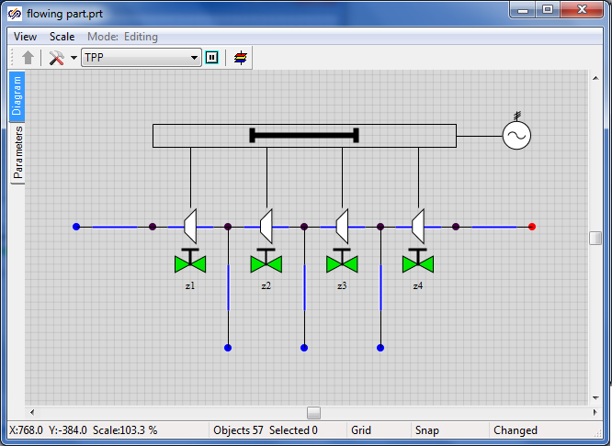

Figure 12. Completion of Setting of the Turbine Flowing Part Hydraulics Diagram

## Adjustment of Calculation Model Parameters and Element Properties

### Boundary Node P

To ensure correct calculation of thermohydraulics model, properties of each diagram element shall be set in the **“Properties”** dialog window next to each element. Dialog window for **“Boundary node P”** object is presented below (see Figure 13. “Properties” Dialog Window for Boundary Node P

).

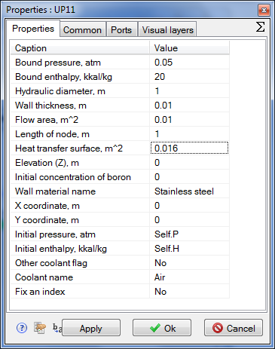

Figure 13. “Properties” Dialog Window for Boundary Node P

Set new values for the properties in the boundary node of **“P”** type:

Pressure: 0.05

Enthalpy: 20

Flow area: 1

Heat transfer surface: 1

Leave the other properties by default, i.e., unchanged. Thus, we have set the constant rated value in the turbine condenser, which will be then relied upon in the process of debugging of the flowing part model.

### Global Project Signals

To set global project constants the signal mechanism will be used. Go to **“Graphics”** → “Signals…” item via the main SimInTech menu.

In a window activated you will see ten signals (constants) set by default and used in scripts of a number of standard TPP elements (see Figure 14. “Project Signals Editor” Dialog Window with Signals by Default

). We will have to set three new constants (signals) – pressure, flow and temperature for steam supplied to the turbine: “Pstg”, “Gstg” and “Tstg”. Set their values as per Figure 15. “Project Signals Editor” Dialog Window with Three New Signals

:

Pstg – Pressure of main steam upstream of the turbine – Real – Input – 35

Gstg – Flow of main steam for the turbine – Real – Input – 220

Tstg – Temperature of main steam upstream of STP – Real – Input – 285

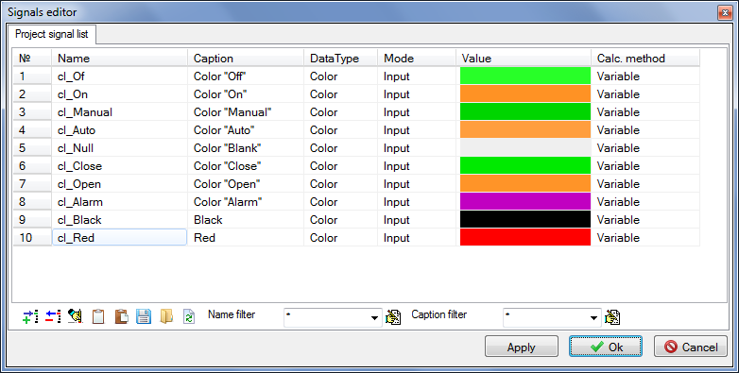

Figure 14. “Project Signals Editor” Dialog Window with Signals by Default

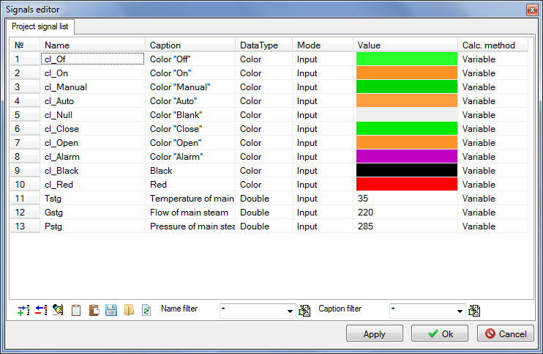

Figure 15. “Project Signals Editor” Dialog Window with Three New Signals

### Boundary Node G

Set the following values of properties in the very first (to the left) boundary node **“G”** (see Figure 16. “Properties” Dialog Window for Boundary Node G

):

Flow: **“Gstg/3.6”** – conversion from t/h to kg/s.

Enthalpy: “steampt(Pstg*1e5,Tstg,3)/4182” – kcal is obtained from pressure and temperature.

Hydraulic diameter: 1

Flow area: 1

Length of node: 1

Heat transfer surface: 1

Initial pressure: “Pstg” – is to be taken from the signal list.

Initial enthalpy: “Self.H” – enthalpy has been calculated earlier.

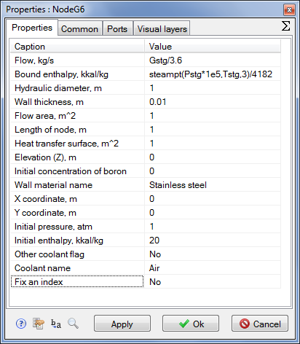

Figure 16. “Properties” Dialog Window for Boundary Node G

### Nodes G Corresponding to Steam Extractions

Set the following properties in nodes G corresponding to steam extractions (see also Figure 17. “Properties” Dialog Window for Boundary Node G (Steam Extraction I)

, Figure 18. “Properties” Dialog Window for Boundary Node G (Steam Extraction II)

and Figure 19. “Properties” Dialog Window for Boundary Node G (Steam Extraction III)

):

**Steam extraction I:**

Flow: **“**-18.4/3.6**”** – conversion from t/h to kg/s.

Enthalpy: “steamps(9.2e5,3)/4182” – steam enthalpy in kcal on saturation line.

Hydraulic diameter: “1”

Flow area: “1”

Length of node: “1”

Heat transfer surface: “1”

Initial pressure: **“9.2”** – steam pressure in the first extraction.

Initial enthalpy: **“Self.H”** – from the node properties (enthalpy has been calculated earlier).

Steam extraction II:

Flow: **“**-66.6/3.6**”** – as per initial data, conversion from t/h to kg/s.

Enthalpy: “steamps(3.64e5,3)/4182” – steam enthalpy in kcal on saturation line.

Hydraulic diameter: “1”

Flow area: “1”

Length of node: “1”

Heat transfer surface: “1”

Initial pressure: **“3.64”** – steam pressure in the second extraction.

Initial enthalpy: **“Self.H”** – from the node properties (enthalpy has been calculated earlier).

Steam extraction III:

Flow: **“**-10.0/3.6**”** – conversion from t/h to kg/s.

Enthalpy: “steamps(0.96e5,3)/4182” – steam enthalpy in kcal on saturation line.

Hydraulic diameter: “1”

Flow area: “1”

Length of node: “1”

Heat transfer surface: “1”

Initial pressure: **“0.96”** – steam pressure in the third extraction.

Initial enthalpy: **“Self.H”** – from the node properties (enthalpy has been calculated earlier).

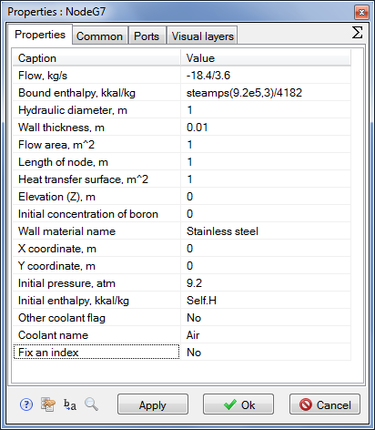

Figure 17. “Properties” Dialog Window for Boundary Node G (Steam Extraction I)

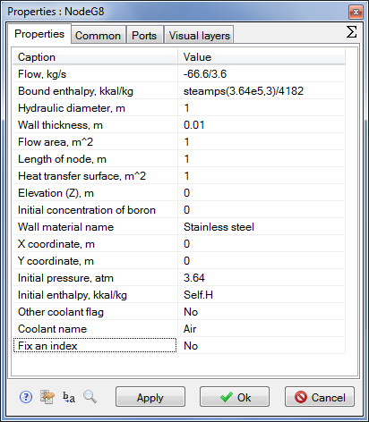

Figure 18. “Properties” Dialog Window for Boundary Node G (Steam Extraction II)

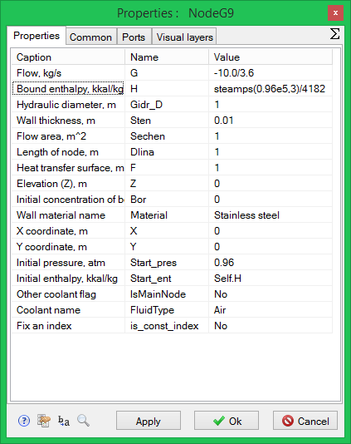

Figure 19. “Properties” Dialog Window for Boundary Node G (Steam Extraction III)

Thus, we have set all necessary properties in all boundary nodes of the task. Now let us go to setting properties in internal TPP nodes.

### Internal Nodes of Flowing Part Model

Internal TPP node has a set of properties similar to the one for boundary nodes. Let us set the following values for every internal node from left to right:

|  |  |
| --- | --- |
| Internal node No. 1 | Initial enthalpy: **“702.25”**  Hydraulic diameter: **“1.2”**  Flow area: **“4.521”**  Length of node: **“0.2”**  Heat transfer surface: **“1.508”**  Initial pressure: **“10.47”** |
| Internal Node No. 2 (to steam extraction I) | Initial enthalpy: **“676.06”**  Hydraulic diameter: **“0.1313”**  Flow area: **“0.7904”**  Length of node: **“0.1”**  Heat transfer surface: **“0.041”**  Initial pressure: **“5.879”** |
| Internal Node No. 3 (to steam extraction II) | Initial enthalpy: **“651.36”**  Hydraulic diameter: **“0.2”**  Flow area: **“0.9126”**  Length of node: **“0.1”**  Heat transfer surface: **“0.0628”**  Initial pressure: **“3.162”** |
| Internal Node No. 4 (to steam extraction III) | Initial enthalpy: **“532”**  Hydraulic diameter: **“0.4367”**  Flow area: **“0.9766”**  Length of node: **“0.1”**  Heat transfer surface: **“0.1371”**  Initial pressure: **“0.867”** |
| Internal node No. 5 | Initial enthalpy: **“532”**  Hydraulic diameter: **“0.4367”**  Flow area: **“0.9766”**  Length of node: **“0.1”**  Heat transfer surface: **“0.1371”**  Initial pressure: **“0.867”** |

### Rotor

Let us set the following values in the rotor properties:

Rotor inertia moment: “625878.0”

Rated rotation speed: “50.0”

Initial rotation speed: “50.0”

Dependency table for moment of resistance: “[[28000,28000],[28000,28000]]”

Note that the fractional part of the number is separated from the integral part with a dot, while groups are set by means of commas.

### Generator

Let us set the value in the generator properties:

Rotation speed: “50.0”

### Diagram Debugging Elements

In order to simplify and accelerate the debugging process for the flowing part diagram we will need to arrange 8 elements more on the diagram: four buttons and four text elements for controlling boundary conditions in terms of steam temperature and flow at STP.

In the process of calculation we will increment and decrement the values of global constants (variables) “Gstg” and **“**Tstg”. Two buttons will be used to increment the variables and two others to decrement those.

Arrange four buttons “Button” and four text elements of “TextLabel” type on the calculation diagram:

1. Select **“Insert”** → **“Primitives panel”** → **“Button”** item in the main menu.
2. Put our such buttons appearing as a table 2x2 onto the diagram (see ).
3. Set names for the buttons: “Bdec1”, “Bdec2” (for the first column), “Binc1”, “Binc2” (for the second column) – acronyms from button decrement, button increment.
4. Select **“Insert”** → **“Primitives panel”** → **“Text”** item in the main menu.
5. Put four such text elements onto the diagram – two ones above the buttons, and two others at the right from the buttons.
6. Write **“-”** and **“+”** in text elements above the buttons, correspondingly.
7. Write texts **“Gstg, t/h =”** and **“Tstg, C=”** in text elements at the right from the buttons, correspondingly (**“Text”** property).
8. Set **“Display the number”** property value to **“Yes”** in the same text elements (at the right from the buttons). Also change **“Displayed value”** property for **“Gstg”** and **“Tstg”**, correspondingly.
9. Increase the font of text notations (using the element property) to 16-20 to mark those out on the calculation diagram.
10. Go to **“Parameters”** tab (at the left from the calculation diagram below **“Diagram”** tab) and set the following four rows there:

if Binc1.Down then Gstg = Gstg + 0.1;

if Bdec1.Down then Gstg = Gstg - 0.1;

if Binc2.Down then Tstg = Tstg + 0.02;

if Bdec2.Down then Tstg = Tstg - 0.02;

These rows will be executed at every step of calculation and, on pressing one or another button, the value of **“Gstg”** variable will be changed by ±0.1 or **“Tstg”** – by ±0.02, which will result in a change in the conditions in the boundary node G and in parameters of steam flow by channels.

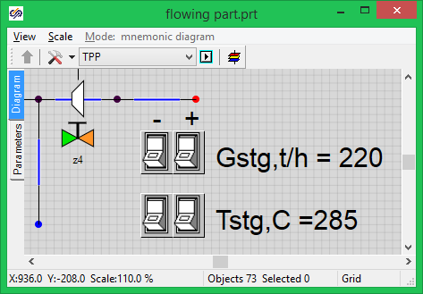

Figure 20. Arrangement of Buttons on the Diagram for Further Debugging of the Model

### Pipelines

To ensure correct operation of the calculation diagram properties of every portion of the pipeline (flowing part) shall be first set, as well as the initial position of all gates. The diagram is still operated independently, without automatics, and, thus, gates can be controlled only manually – either before calculation, on setting the initial position, or in the process of calculation, by manually changing the values of variables storing the positions of the gates.

There are totally nine pipeline portions on the diagram – six alongside of the flowing part, and three others for steam extractions. Set successively the following properties in each common type channel (see an example for the first portion of the flowing part in Figure 21. Channel Parameters at STP Flowing Part Inlet

):

|  |  |
| --- | --- |
| Channel No. 1 | Hydraulic diameter: **“0.3”**  Flow area: **“0.070686”**  Heat transfer surface: **“4.712”**  Length. **“5.0”**  Wall thickness: **“0.01”** |
| Channel No. 2 | Hydraulic diameter: **“0.5317”**  Flow area: **“0.5673”**  Wall thickness: **“0.01”**  Heat transfer surface: **“1.0”** |
| Channel No. 3 | Hydraulic diameter: **“0.5794”**  Flow area: **“1.1805”**  Wall thickness: **“0.01”**  Heat transfer surface: **“1.0”** |
| Channel No. 4 | Hydraulic diameter: **“1.3885”**  Flow area: **“2.0766”**  Wall thickness: **“0.01”**  Heat transfer surface: **“1.0”** |
| Channel No. 5 | Hydraulic diameter: **“1.3885”**  Flow area: **“2.0766”**  Wall thickness: **“0.01”**  Heat transfer surface: **“1.0”** |
| Channel No. 6 | Hydraulic diameter: **“9.9”**  Flow area: **“19.98”**  Wall thickness: **“0.01”**  Heat transfer surface: **“1.0”** |

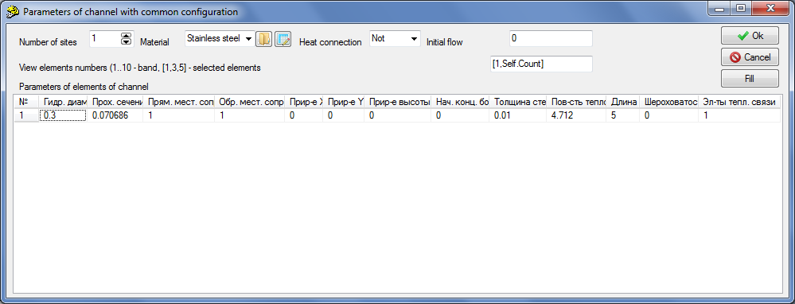

Figure 21. Channel Parameters at STP Flowing Part Inlet

Now it is important for us to set correct hydraulic diameters, flow areas and heat transfer surfaces, the other parameters can still be neglected. Set flowing part piping material as “St20”. It will have effect upon heat transfer.

Set the following properties for extraction pipes:

|  |  |
| --- | --- |
| Extraction channel No. 1 | Hydraulic diameter: **“0.25”**  Flow area: **“0.049087”**  Heat transfer surface: **“3.927”**  Length. **“5.0”**  Wall thickness: **“0.002”** |
| Extraction channel No. 2 | Hydraulic diameter: **“0.5”**  Flow area: **“0.1963”**  Wall thickness: **“0.002”**  Heat transfer surface: **“3.927”** |
| Extraction channel No. 3 | Hydraulic diameter: **“0.35”**  Flow area: **“0.096211”**  Wall thickness: **“0.002”**  Heat transfer surface: **“5.4978”** |

### Gates

Now set the initial position for all gates in percents as equal to 5. File name with “Linear” characteristic, see Figure 22. Synchronous Selection of all Gates on the Diagram

and Figure 23. Synchronous Setting of Properties for all Four Gates

.

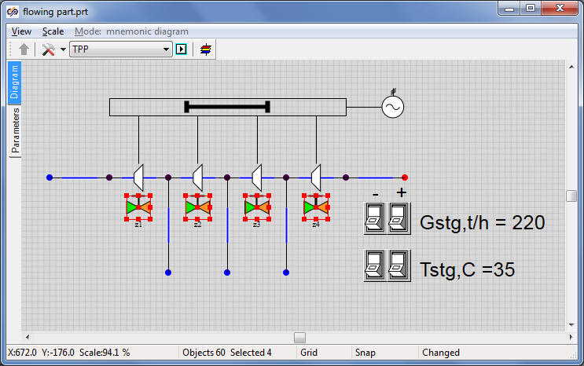

Figure 22. Synchronous Selection of all Gates on the Diagram

In many cases the same values (the same properties) shall be set for several elements of the diagram. In our example the same initial position and the same characteristic shall be set for four gates. Of course, required values can be set for each gate in turn. Nevertheless it is better (quicker) to select all the gates and, on pressing the right-hand button and activating the “Properties” dialog window, to set 5% position and linear characteristic for all the gates at once (see Figure 22. Synchronous Selection of all Gates on the Diagram

and Figure 23. Synchronous Setting of Properties for all Four Gates

). Note that when selecting simultaneously four gates and setting their properties, the “Properties” dialog window display the names of all selected gates.

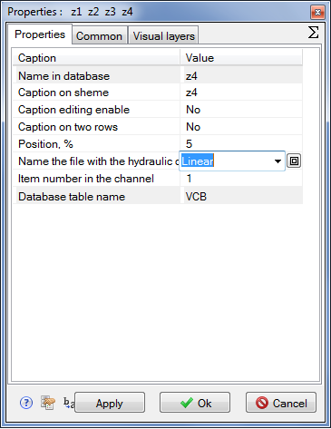

Figure 23. Synchronous Setting of Properties for all Four Gates

### Control of TPP Parameters

Now, provided that you have completed all correctly and without errors, the diagram is ready for normal operation and calculation of the turbine flowing part model. Nevertheless, to view values of particular parameters in the process of calculation, we will need to display these parameters on graphs and/or on the diagram window. Let us use elements of **“TPP parameters control”** tab.

Select “G control in channel” element (control of mass flow in channel), place that on the diagram on the first TPP channel. At the same time make sure that namely this channel is an owner of the newly placed “G control in channel” element (see Figure 24. G Control in the First Channel

).

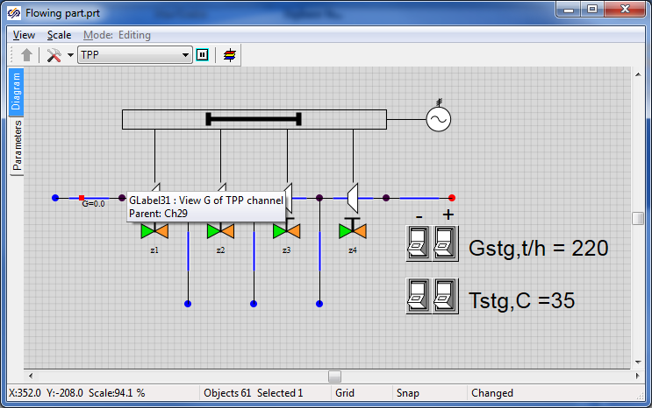

Figure 24. G Control in the First Channel

Go to the element properties and change its two parameters: replace “Text” with “G[t/h]” and “Names of displayed parameters” with “g*3.6”. Thus we have changed measurement units to the mass flow display. Inside the TPP code the flow will be counted in kilograms per second, while the value will be displayed on the diagram window with coefficient 3.6 s/(kg/t) = 3600 s/ 1000 kg/t (see Figure 25. Conversion to Tons per Hour, “G Control in Channel”

).

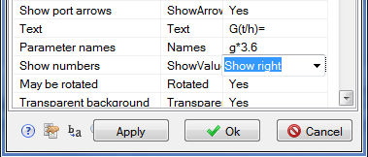

Figure 25. Conversion to Tons per Hour, “G Control in Channel”

Redo the same for all channels; it can be done by copying a newly placed element. Watch correctness of setting of owners of elements being placed. The result shall be as depicted in Figure 26. Arrangement of “G Control in Channel” Elements on Diagram

.

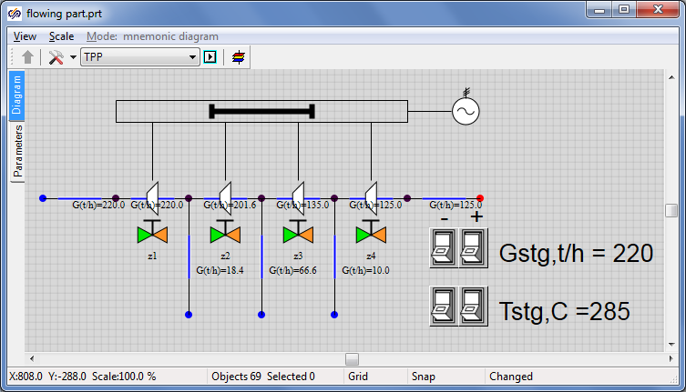

Figure 26. Arrangement of “G Control in Channel” Elements on Diagram

Then, remove pressure and temperature sensors from the diagram in **“P nodes”** (that have been automatically arranged on the diagram on adding the nodes). We will not need those.

We will use “P, H, T control in node” element for all boundary and internal nodes. Arrange 10 such elements on the diagram, see Figure 27. Arrangement of “P, H, T Control in Node” Elements on Diagram

. Pressure, enthalpy and temperature in boundary TPP nodes will be displayed there in the process of calculation. Place the elements with care, watch the owners of these elements. Only one element shall correspond to each point.

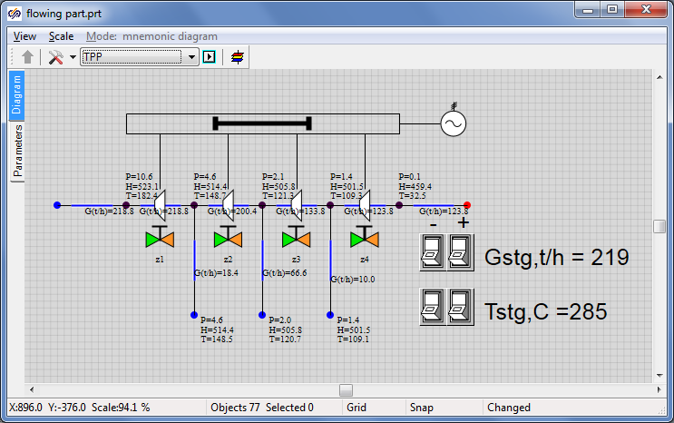

Figure 27. Arrangement of “P, H, T Control in Node” Elements on Diagram

Let us display the rotor rotation speed and generator actual power using the same mechanism but using the **“Parameters”** menu for each element.

Click the mouse left button on the rotor and select “Object parameters” item in a pop-up window. A small dialog window will be displayed, in which a row with “n_ (Rotation speed)” parameter shall be selected, then press “Create caption” button (with “A” character, see Figure 28. “Rotor” Object Parameters

).

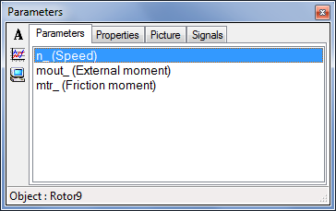

Figure 28. “Rotor” Object Parameters

Leave all unchanged in the next window, as an example the caption can be changed for “Speed =”, see Figure 29. Window for Creation of Animated Caption for Object

:

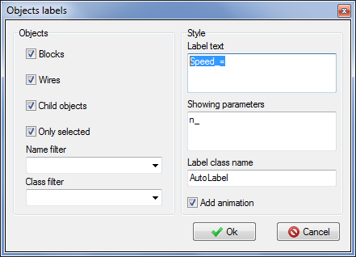

Figure 29. Window for Creation of Animated Caption for Object

As a result we will obtain a new caption on the diagram that will display an actual rotation speed of **“Rotor”** element. Redo the same manipulations and display the electric generator power on the diagram. Go to the properties of the electric generator power caption and change the format of a displayed number for **“Integral”** to avoid any exponent appearing in power displayed on the diagram, see Figure 30. Window for Creation of Animated Caption for “Electric Generator” Object

. Start the diagram for calculation and make sure that newly created caption can work.

Arrange the captions on the diagram as convenient, see Figure 31. Diagram Window (Rotor Speed and Electric Generator Power are Displayed)

.

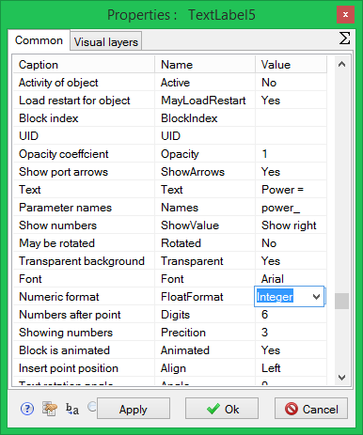

Figure 30. Window for Creation of Animated Caption for “Electric Generator” Object

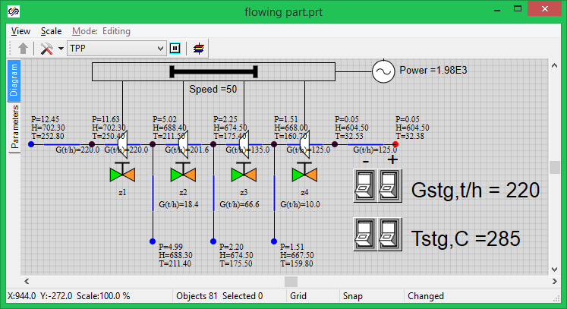

Figure 31. Diagram Window (Rotor Speed and Electric Generator Power are Displayed)

Now the setting of the turbine flowing part is completed, then we will deal with the debugging process for the diagram and rated state of the flowing part considering the initial data.

## Rated State

### General Principles for Debugging the Thermohydraulics Diagram

Prior to starting the work with dynamic modes or connecting regulators and automatics algorithms to the calculation thermohydrulics model, in the general case the diagram shall be debugged so that it ensures a standard and stable calculation and work in rated mode.

To set the rated state we have already taken several important steps, i.e., set parameters for practically all elements (those parameters that we know for sure by their initial data; know that those are required and we are confident about those). In particular, we have set pressure in the condenser and flows in four boundary conditions from the five ones. We have also set steam enthalpies in boundary conditions and geometrical parameters of the channels.

If the diagram is started for calculation we will see that the normal (rated) state has been established in terms of flows: 18.4 t/h, 16.6 and 10.0 t/h is supplied for extraction, 220 t/h of main steam is supplied at the inlet. In this tutorial example we have already set more or less correct values for the channels and have obtained a plausible pressure distribution. In the general case, if we are short of initial data we often have to select hydraulic circuit parameters in order to obtain correct pressures, flows and/or temperatures in reference points of the thermohydraulic path.

If we had not set parameters for the channels (see above) and left the default values, i.e. similar and small flow areas for all channels, then pressure distribution via internal nodes would have been incorrect and practically “arbitrary”.

### Methods for Selecting Flowing Part Parameters

In this tutorial example the turbine flowing part is modeled by equivalent channels. Such a model has right to exist provided that steam parameters in extraction points comply with rated STP parameters. Let us select required drops on the channels and set up the diagram to the rated mode by adjusting pressure drop (loss) on the nodes with gates and moving from the condenser to main steam.

Start the diagram for calculation and set gate **“z4”** in such a position, when pressure in the third extraction point (extraction on PLP No. 1) is equal to 0.96 kg/cm2. To prevent strong jumps and changes of parameters during calculation change the position of the gate gradually with a small increment, e.g., 0.1% or 0.5%. Watch a change of pressure in the third extraction node by setting successively values 5.5, 5.6, 5.7% etc., and restarting the system with every new position of the gate. Proceed with that until a required position of the gate for setting the rated pressure in the node is found. In our case position **“8.1%”** for gate **“z4”** has been obtained.

Then let us go to gate **“z3”** and watch pressure in extraction No. 2. It shall be 3.6 kgf/cm2 when in rated mode. In our example gate **“z3”** shall be set to position “2.35%”.

After that we are selecting the position of gate **“z2”** in the same way. Pressure of 9.2 kgf/cm2 shall be obtained in the first extraction. In our example gate **“z2”** shall be set to position “2.69%”.

Set gate **“z1”** to a position known from the initial data (35 kgf/cm2) for main steam pressure in **“boundary node G”**. In our example gate **“z2”** shall be set to position “1.525%”.

Thus, we have set the rated mode against thermohydraulics parameters of STP flowing part in a first approximation, see Figure 32. Diagram Window with Rated Mode

. Then let us go to power-related (active) elements of the turbine and to setting those to the rated mode.

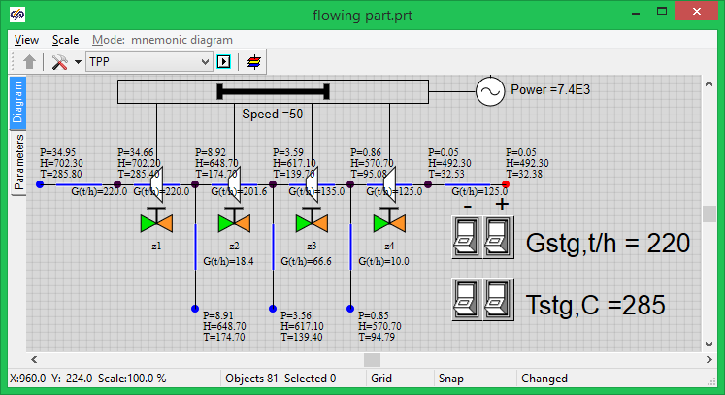

Figure 32. Diagram Window with Rated Mode

### Active Elements, Rotor and Generator

Active elements “pick up” power from hydraulic channels and transmit that to the turbine (generator) rotor.

Set “Mass” flow type for every active element (in properties), and set element characteristic – “tk-35-38-3-st1”, “tk-35-38-3-st2”, “tk-35-38-3-st3”, “tk-35-38-3-st4”, correspondingly, for element 1, 2, 3 and 4, see Figure 33. Properties of Active Element No. 1

. More details about active element characteristic can be found in TPP code documentation. Generally speaking, the characteristic appears as 3 tables, where hydraulic resistance of the channel, efficiency of an element and moment of resistance is set by points depending on the flow (mass flow, in our case) and shaft rotation speed. In our files a constant efficiency is set (equal to 90% or 0.9) for all rotation speeds and flows.

Actual characteristics of equipment can be set in the SimInTech table editor either pinned together in points, or using built-in programming language with the use of cycles, formulas, etc.

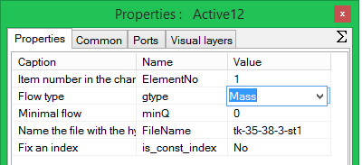

Figure 33. Properties of Active Element No. 1

When properties of active elements are set and the flowing part is debugged for the rated mode, the calculation task can be started and power produced by the electric generator can be seen. In our case the power has been obtained as equal to 7400 kcal ≈ 31000 kW that is in compliance with the initial data.