# Creation of feed water heater models

We will create thermohydraulics models of three feed water heaters: PND-1 (corresponds to PN‑100), PVD-2 (corresponds to PV-280-1) and PVD-3 (corresponds to PV-280).

## Creation of PND-1 model as a basis for all heaters

### New TPP diagrams

Create three new catalogues: “C:\KTZ\Turbine\PND-1”, “C:\KTZ\Turbine\PVD-2”, “C:\KTZ\Turbine\PVD-3”.

Generate a new TPP project (design), **“New project”** → **“TPP diagram”** (see Figure 1). Using a standard “save file” dialog save the diagram under a new name in a newly created catalog: “C:\KTZ\Turbine\PND-1\PN-100.prt”.

Use “**Save as…**” dialog to save the same (empty) project under a new name: “C:\KTZ\Turbine\PVD-2\PV-280-1.prt”.

Use “**Save as…**” dialog to save the same (empty) project under a new name: “C:\KTZ\Turbine\PVD-3\PV-280.prt”.

Figure 56 presents a common diagram for creation (development) of a new thermohydraulics model in SimInTech. Model of condenser in the previous section has been created in accordance with that; models of heaters will be created in the same way. Besides, since models of heaters look like each other then it would be quicker in practice to create one model, completely debug that and, after saving that under another name, introduce minor changes into its structure and/or names of model variables, and, thus, to relatively quickly obtain a ready, about debugged model of new equipment in the end.

Sometimes it happens that a whole system can be taken from previous designs and used as a basis for a new calculation diagram. This also accelerates the process of development of a new model.

For the purpose of training we will create PND-1 model completely (from zero) in **“**C:\KTZ\Turbine\PND-1\PN-100.prt” file, then copy (save) that into “**PV-280-1.prt”** file and, after introducing required minimum changes, debug that and obtain PVD-2 model; then, after saving that model under **“PV-280.prt”** name and introducing changes into boundary conditions and properties of some elements, we will obtain a model of the third heater PVD-3. It can be done faster than creation of a model for every heater every time from zero since the models are different due to names of some variables and values of properties of some blocks. Models PVD-2 and PVD-3 are different only by values of properties and initial conditions.

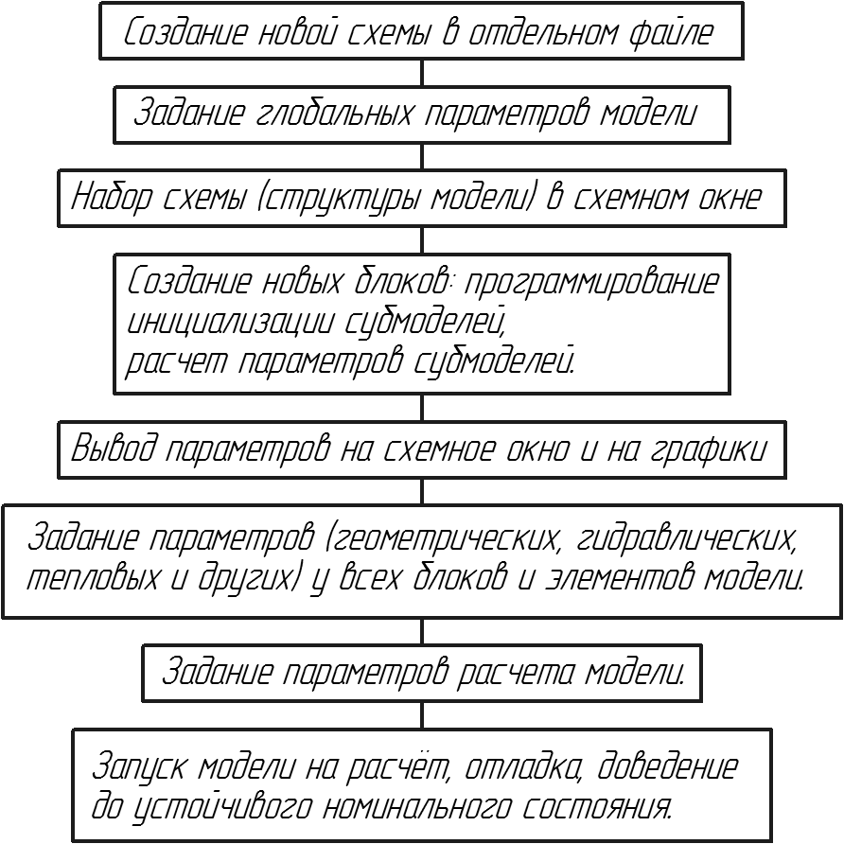

*Display of parameters in diagram window and on graphs*

*Start-up of the model for calculation, debugging, conditioning to obtain stable nominal state.*

*Setting of parameters (geometrical, hydraulic, thermal ones and others) for all model blocks and elements.*

*Setting model calculation parameters.*

*Creation of new blocks: programming of  
submodel initialization,  
calculation of submodel parameters.*

*Setting of diagram (model structure) in diagram window*

*Setting of model global parameters*

*Creation of a new diagram in a separate file*

Figure 56. General diagram for creation of new hydraulic model in SimInTech

Structure of heater models is the same and is very similar to the condenser – it is a 3V TPP tank with inside heat exchange between flows of steam supplied to the tank from the top and drained from the bottom as condensate and flow of water that is heated when passing through the tank. The condenser is different due to the fact that there is only one heat exchanger and the process of heat exchange is considered from the different point of view and is differently named – steam heats water instead of water cooling steam.

### Setting of model PND-1 global parameters

Open “**C:\KTZ\Turbine\PND-1\PN-100.prt**” file (with a still empty diagram) and set the following global parameters: “**Tplp**” and “**Gplp**”, see Figure 57:

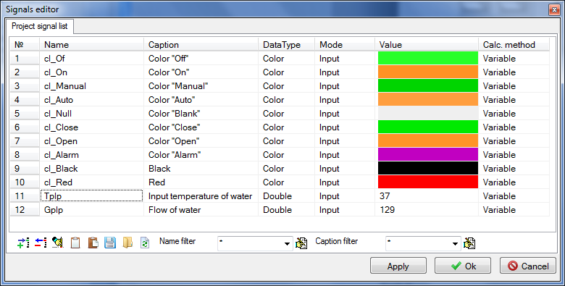

Figure 57. Heater PND-1 model global parameters

Create 4 buttons to control global parameters in the diagram window, see Figure 59. Those will be useful for model debugging. Set the following text in “Parameters” tab to ensure operability of the buttons:

|  |
| --- |
| **if** Binc1.Down **then** Gplp = Gplp+0.1;  **if** Bdec1.Down **then** Gplp = Gplp-0.1;  **if** Binc2.Down **then** Tplp = Tplp+0.02;  **if** Bdec2.Down **then** Tplp = Tplp-0.02; |

### Setting of PND-1 model structure

Open **“**C:\KTZ\Turbine\PND-1\PN-100.prt” file (with a still empty diagram) and set the following elements on the diagram:

1. **“Boundary node G”**, to be used for setting heated water flow.
2. **“Boundary node G”**, to be used for setting flow of steam extraction.
3. **“SimInTech Submodel”**, name of object: **“PN_100”**, element type (ClassName): **“TPP surface-type heater”** (instead of **“SimInTech submodel”**). Submodel icon is not to be changed, just write **“PN-100”** name for the submodel.
4. **“Boundary node P”** describing parameters of steam in extraction, to be placed above the heater on the diagram.
5. **“Boundary node P”** describing parameters of water supplied to PND-1.
6. **“Common-mode channels”**, 4 elements between each one of boundary nodes and PND-1.

Go inside the submodel and create a model using TPP standard elements:

1. Place 4 elements there – two TPP input ports and two output ports. Rename those as: **“Input of heated water”**, **“Heating steam”**, **“Output of heated water”**, **“Output of steam”**. Change location of ports so that water flows from right to left and steam – from top downward.
2. Place the 3V compenser in the center of the submodel and add one more node (from the top) for steam supply and one thermal port. Rename that as **“Bak”**.
3. Link up input-output ports for water with a common-mode channel and add a heat link to this channel. Rename that as **“Tube”**.
4. Link up the channel and tank with a heat link.
5. Link up the steam inlet to the top tank hole, link up the condensate drain to the bottom tank hole.

The result can be seen in Figure 58.

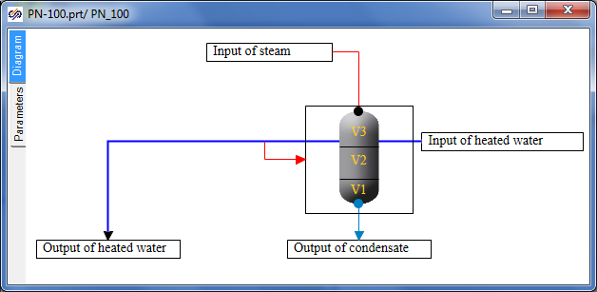

Figure 58. PND-1 heater submodel structure

1. Return to the top level and change the position of appeared submodel ports for a required one (water from left to right, steam from top downward).
2. Link up all elements, compare the diagram obtained with Figure 59.

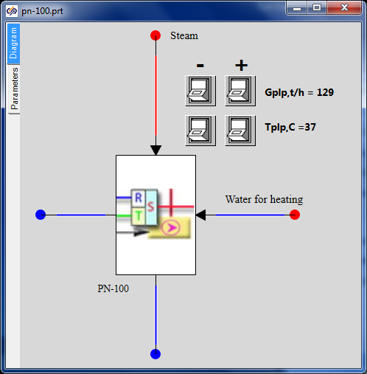

Figure 59. PND-1 heater diagram

### Programming of PND-1 (PN-100) heater submodel

Now, after setting global parameters and the model structure, let us proceed with creation of a new PND-1 block (submodel) and programming of submodel nested level (in a similar way as we have programmed initialization of the turbine condenser in the previous section).

While remaining at the top level of the submodel, select it and use “**Correction**” **→** “**Change block…**” menu item: enter the next 21 properties and 15 parameters for PN-100 submodel, see Figure 60 and Figure 61.

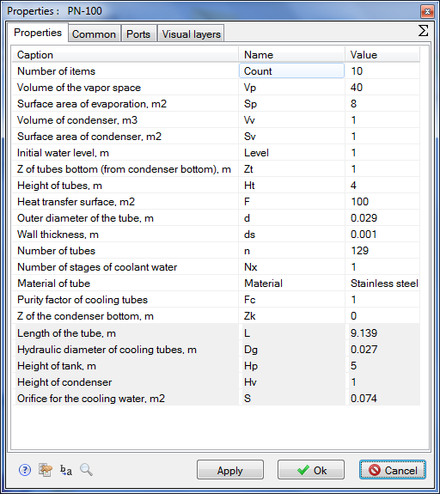

Figure 60. PND-1 heater submodel properties

Do not forget to enter the length, hydraulic diameter of tubes, flow area for cooling water, height of the tank and height of condenser into **“Read-only properties”** field. Enter the parameters and properties carefully and attentively.

After setting the submodel properties and parameters, enter the submodel and go to “Parameters” tab; enter the following code in the initialization block there (try to understand the meaning of every code string by yourself):

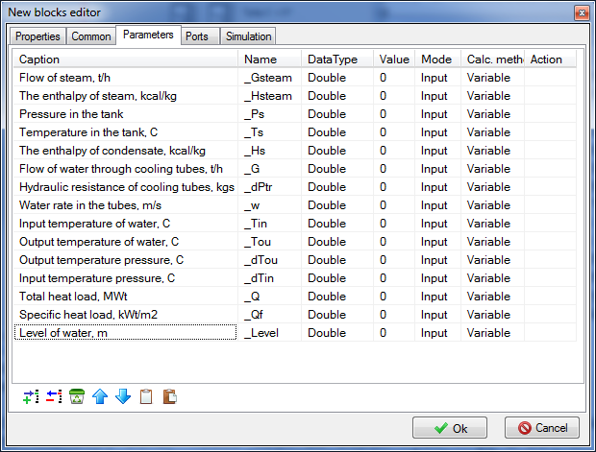

Figure 61. PND-1 heater submodel parameters

|  |
| --- |
| **initialization**  Tube.Material=Material;  submodel.Dg = submodel.d-2*submodel.ds;  **setpropevalstring**(submodel,"Dg",submodel.dg);  submodel.S = pi*submodel.dg*submodel.dg*n/4;  **setpropevalstring**(submodel,"S",submodel.S);  **setpropevalstring**(submodel,"L",submodel.F/(pi*submodel.dg*submodel.n));  **setpropevalstring**(Tube,"Count",submodel.Count);  **setpropevalstring**(Tube,"Gidr_D","["+Count#submodel.Dg+"]");  **setpropevalstring**(Tube,"Sechen","["+Count#submodel.S+"]");  **setpropevalstring**(Tube,"Dlina","["+Count#(submodel.L/Count)+"]");  **setpropevalstring**(Tube,"Soprot","["+Count#0.0+"]");  **setpropevalstring**(Tube,"InvSopr","["+Count#0.0+"]");  **setpropevalstring**(Tube,"Z","["+Count#0+"]");  **setpropevalstring**(Tube,"X","["+Count#0+"]");  **setpropevalstring**(Tube,"Y","["+Count#0+"]");  **setpropevalstring**(Tube,"Bor","["+Count#0+"]");  **setpropevalstring**(Tube,"Sten","["+Count#(submodel.ds/2/submodel.Fc)+"]");  **setpropevalstring**(Tube,"F","["+Count#(submodel.F/Count)+"]");  **setpropevalstring**(Tube,"Rz1","["+Count#0+"]");  **setpropevalstring**(Tube,"HeatElements","["+Count#3+"]");  InitObject(Tube);    submodel.Hp = submodel.Vp/submodel.Sp;  **setpropevalstring**(submodel,"Hp",submodel.Hp);  submodel.Hv = submodel.Vv/submodel.Sv;  **setpropevalstring**(submodel,"Hv",submodel.Hv);  **if** submodel.Level > submodel.Hp+submodel.Hv  **then** submodel.Level = submodel.Hp+submodel.Hv;  **if** submodel.Zt > submodel.Hp **then** submodel.Zt = submodel.Hp;  **if** submodel.Zt+submodel.Ht > submodel.Hp  **then** submodel.Ht = submodel.Hp-submodel.Zt;  **setpropevalstring**(submodel,"Zt",submodel.Zt);  **setpropevalstring**(submodel,"Ht",submodel.Ht);  **setpropevalstring**(submodel,"Level",submodel.Level);  sko1=[0,submodel.Vv,submodel.Vv+submodel.Sp*submodel.Zt,submodel.Vv+submodel.Sp*(submodel.Zt+submodel.Ht),submodel.Vv+submodel.Vp];  **setpropevalstring**(Bak,"SKO1","["+sko1+"]");  sko2=[0,submodel.Hv,submodel.Hv+submodel.Zt,submodel.Hv+(submodel.Zt+submodel.Ht),submodel.Hv+submodel.Hp];  **setpropevalstring**(Bak,"SKO2","["+sko2+"]");  sko3=[0,0,0,1,1];  **setpropevalstring**(Bak,"SKO3","["+sko3+"]");  sko4=[1,1,1,0,0];  **setpropevalstring**(Bak,"SKO4","["+sko4+"]");  tmp = **min**(submodel.Level,submodel.Hv)*submodel.Sv +  **max**(0,submodel.Level-submodel.Hv)*submodel.Sp;  **setpropevalstring**(Bak,"V1",0.2*tmp);  **setpropevalstring**(Bak,"V2",0.8*tmp);  **setpropevalstring**(Bak,"V3",submodel.Vv+submodel.Vp-tmp);    InitObject(Bak);  **end;** |

Enter the following strings for calculation of submodel parameters after the initialization block:

|  |
| --- |
| submodel._G = Tube.G*3.6;  submodel._w = Tube.q[1]/submodel.S;  submodel._Tin = Tube._Tvh;  submodel._Tou = Tube._Tvyh;  submodel._dPtr = **abs**(Tube._Pvh-Tube._Pvyh);  submodel._Q = Tube._Qto*4.182e-3;  submodel._Qf = submodel._Q/submodel.F;  submodel._dTou = Bak.Tpar_-Tube._Tvyh;    submodel._Level = Bak.L;  submodel._Ts = Bak.Tpar_;  submodel._Ps = Bak.P_;  submodel._Ts = Bak.Tpar_;  submodel._Ts = Bak.Tpar_; |

If everything has been correctly set the submodel has been programmed at that.

### Display of parameters in diagram window

Display pressure and level in the tank, flow for heated water channel at the nested level. Enter P, H, T parameters for nodes, G – for channels and most parameters for the tank, see Figure 62.

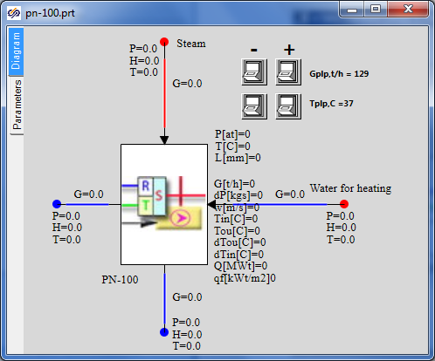

Figure 62. Parameters on PND-1 heater diagram

### Properties of boundary nodes, channels and other elements of PND-1 model

Initialize the diagram in order to check correctness of the entered code and set values for properties of elements inside the submodel (those ones which are set programmatically in the initialization block).

Set the following properties manually for elements of PND-1 model:

|  |  |
| --- | --- |
| Steam supply channel | Hydraulic diameter: **“0.4”**  Flow area: **“0.12567”**  Direct local resistance: **“10”**  Reverse local resistance: **“10”**  Wall Thickness: **“0.005”**  Heat transfer surface: **“6.28319”**  Length: **“5.0”** |
| Condensate drain channel | Hydraulic diameter: **“0.1”**  Flow area: **“0.007854”**  Direct local resistance: **“1”**  Reverse local resistance: **“1”**  Wall thickness: **“0.001”**  Heat transfer surface: **“0.31416”**  Length: **“1.0”** |
| Water supply channel (right of the heater) | Hydraulic diameter: **“0.1”**  Flow area: **“0.007854”**  Direct local resistance: **“1”**  Reverse local resistance: **“1”**  Wall thickness: **“0.001”**  Heat transfer surface: **“0.31416”**  Length: **“1.0”** |
| Water supply channel (right of the heater) | Hydraulic diameter: **“0.1”**  Flow area: **“0.007854”**  Direct local resistance: **“1”**  Reverse local resistance: **“1”**  Wall thickness: **“0.001”**  Heat transfer surface: **“0.31416”**  Length: **“1.0”** |
| Steam extraction node | Pressure: **“0.96”**  Enthalpy: **“573”** |
| Node for water supply for heating | Pressure: **“10.0”**  Enthalpy: **“waterpt(1e6,Tplp,3)/4182”** |
| Heated water extraction node | Flow: **“-Gplp/3.6”**  Enthalpy: **“Tplp”**  Initial pressure: “**10”**  Initial enthalpy: **“self.h”** |
| Condensate extraction node | Flow: **“-ch30.g”** (**“ch30”** – steam supply channel name) |
| Tank | Pressure: **“0.96”**  1st volume enthalpy: **“59.52”**  1st and 2nd volumes dispersion coefficient: **“0.2”**  Section area: **“Sp”**  Valve section area: **“1”**  Fluid volume hydraulic diameter: **“Dg”**  Gas volume hydraulic diameter: **“Dg”**  Z of condenser bottom: **“Zk”**  Number of vertical tubes: **“n”** |
| Top tank node | Initial pressure: **“0.96”**  Initial enthalpy: **“565.8”**  Hydraulic diameter: **“1.4”**  Wall thickness: **“0.014”**  Flow area: **“1.5394”**  Length of node: **“0.5”**  Heat transfer surface: **“2.2”**  Elevation: **“Zk+Hv+Hp”**  Material: **“Ст20”**  No. of volume: **“Steam”** |
| Bottom tank node | Initial pressure: **“0.96”**  Initial enthalpy: **“59.52”**  Hydraulic diameter: **“0.975”**  Wall Thickness: **“0.013”**  Flow area: **“0.7466”**  Length of node: **“0.2”**  Heat transfer surface: **“0.2”**  Elevation: **“Zk”**  Material: **“Ст20”**  No. of volume: **“Lower water”** |

After carefully setting these properties, we have completed creation of PND-1 (PN-100) model. The only thing remained to be done is to set calculation parameters, start up the diagram for calculation and debug the diagram, i.e., to achieve the nominal state of PN-100.

### Parameters of PND-1 calculation

Go to “Calculation parameters” tab and change the following parameters:

|  |  |
| --- | --- |
| Calculation parameters | TPP project name: **“pn_100”**  Continuation code: **“From the beginning”**  Integration step for energy equations: **«0.125/4»**  Integration step for motion equations: **«0.125/16»** |

Remove the tick from real time synchronization and remove project restart.

### PND-1 nominal state

Now PN-100 model can be started for calculation. If everything has been correctly done, then in 100-300 seconds the state shown in Figure 63 will be set.

Feed water is supplied at +37°С with 129 t/h flow and is heated up to +80°С. At the same time steam (+98°С temperature, 0.96 kgf/cm2 pressure and 11.6 t/h flow) delivers 6.44 MW to the heater. Steam parameters still do not meet nominal values of initial data but at this stage it is important for us to set a correct nominal for feed water line, while steam extractions will be corrected at the stage of integration of individual models into an integral calculation diagram for STP.

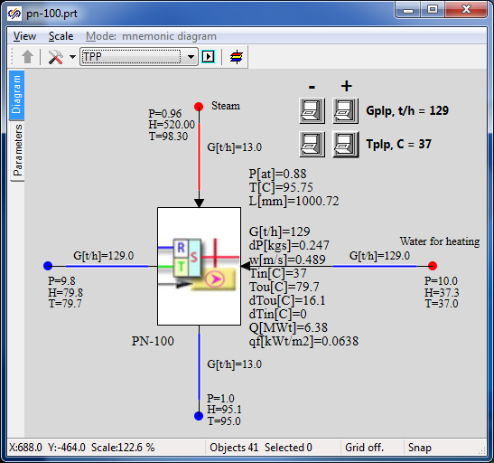

Figure 63. PND-1 nominal state

## Creation of PVD-2 model on the basis of PND-1

### Project copying, calculation parameters

Open the file with PND-1 model created in the previous section and save it into **“**C:\KTZ\Turbine\PVD-2\PV-280-1.prt” file after re-writing the previous file.

Let us begin with renaming the project descriptive parameters: changeTPP project name in the calculation parameters for: **“pv_280_1”**, and the submodel name for **“PV_280_1”**, and rename the submodel caption as **“PV-280-1”**. Save the project (again).

Thus, we have just created a second heater model in the new file as a copy of the PND-1 model. Further we will proceed with transformation of this model, i.e., we will change only those parts of the model we need to change. Most part will remain the same as in PND-1.

### Global parameters

There will be three global parameters in PVD-2 model: steam pressure in extraction, cooling (heated) water flow and temperature. Create those as per Figure 64. We have changed names of variable a little in order to make sure that the old code will not work with those and, besides, it is more reliable for complete re-checking and changing the model – thus, we will be sure that we have not forgotten to change anything.

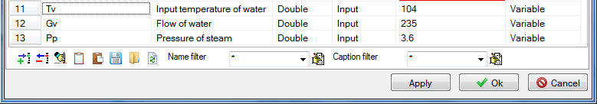

Figure 64. PVD-2 global parameters

When saving these parameters, SimInTech display a warning that Gplp symbol cannot be used. Replace the code in “Parameters” tab with the following strings:

|  |
| --- |
| **if** Binc1.Down **then** Pp = Pp+0.001;  **if** Bdec1.Down **then** Pp = Pp-0.001;  **if** Binc2.Down **then** Gv = Gv+0.1;  **if** Bdec2.Down **then** Gv = Gv-0.1;  **if** Binc3.Down **then** Tv = Tv+0.02;  **if** Bdec3.Down **then** Tv = Tv-0.02; |

Those mean the same but under different names of parameters. In the process of debugging we will change three parameters for PVD-2. In the model of heater we have used the same global parameters in other several places: if you try now to start the diagram for calculation or, at least, to initialize that, SimInTech will display a message about errors in the model since there are still old names **“Gplp”** and **“Tplp”** prescribed in boundary nodes for heated water.

Try to do this and then wherever it is required change the names of parameters for proper ones. I.e., change flow and enthalpy in boundary node G for water and change enthalpy calculation in boundary node P.

### PVD-2 model structure

PVD-2 model structurally does not differ from PND-1 model: the same principle for setting a constant heated water flow with constant parameters at the heater inlet. Steam flow is determined via steam supply and steam parameters set in extraction. Heater heats water and condensates steam along with steam-to-water energy transfer.

PVD-2 model has the same number of boundary nodes, channels and other elements as the model PND-1 has; therefore, we will not structurally change anything.

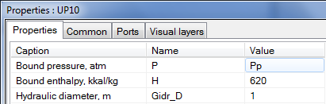

Figure 65. Use of global parameter Pp in PVD-2

The only new thing in the model is another global parameter added, i.e., pressure of extracted steam. Set that, i.e., “**Pp**” instead of **“0.96”**, as a value of parameter for the top boundary node, see Figure 65. Redo the same for the top node in the tank. It could be done also in the properties setting section, but global parameters are a part of the model structure since those can be used to control the model from the very top level.

### PVD-2 submodel

PVD-2 submodel, as well as the structure, has no serious difference from PND-1 submodel and, thus, we will not produce any principle changes here.

As an independent task, change the submodel appearance to make it like depicted in Figure 66 – to that end use **“C:\Program Files\SimInTech\bin\images\Bak-2.gif”** gif-file from the SimInTech delivery set and graphical primitives.

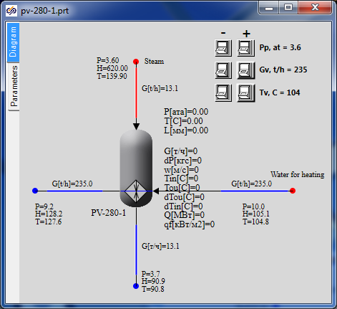

Figure 66. New appearance of PVD-2 submodel

Difference of PND-1 is that some properties of this submodel have other values. Go to **“Change block”** menu item, **“Properties”** tab and change the following parameters:

|  |  |
| --- | --- |
| Submodel properties | Height of tubes, m, “Ht”: **“2”**  Heat transfer surface, m2, “F”: **“280”**  Outer diameter of the tube, m, “d”: **“0.06”** |

An error has been detected in the process of preparation of the training model – in calculation of tubes wall thickness. Correct that and remove division by 2 in the following string:

|  |
| --- |
| **setpropevalstring**(Tube,"Sten","["+Count#(submodel.ds/2/submodel.Fc)+"]"); |

### Display of parameters in diagram window

Since the model structure is the same, all parameters we are interested in have been already displayed in the diagram window, so nothing is to be changed.

### Properties of boundary nodes, channels and other elements of PVD-2 model

Initialize the diagram in order to check correctness of the entered code and reset values for properties of elements inside the submodel (those ones which are set programmatically in the initialization block). Note that the properties marked as “read-only” are also changed since these ones depend on other properties that are also changed.

Now, since steam in PVD-2 is supplied with different parameters and heated water also has different temperature, and diameters of inlet-outlet pipelines are different, change the following properties in the model elements:

|  |  |
| --- | --- |
| Steam supply channel | Hydraulic diameter: **“0.25”**  Flow area: **“0.04909”**  Direct local resistance: **“1”**  Reverse local resistance: **“1”**  Wall thickness: **“0.002”**  Heat transfer surface: **“3.927”**  Length. **“5.0”** |
| Condensate outlet channel, water supply channel (right to the heater), water outlet channel (left to the heater) | The parameters will remain the same as for PND-1. |
| Steam extraction node | Pressure: **“Pp” (has been already set)**  Enthalpy: **“620”** |
| Node for water supply for heating | Pressure: **“50.0”**  Enthalpy: **“waterpt(5e6,Tv,3)/4182”** |
| Heated water intake node | Consumption: **“-Gv/3.6”**  Enthalpy: **“Tv”**  Initial pressure: **“10”**  Initial enthalpy: **“self.h”** |
| Condensate intake node | Consumption: **“-ch30.g”** (**“ch30”** – steam supply channel name) |
| Tank | Pressure: **“Pp”**  The other parameters will remain the same as for PND-1. |
| Top tank node | Initial pressure: **“Pp”**  Initial enthalpy: **“620”**  The other parameters will remain the same as for PND-1. |
| Bottom tank node | All parameters may remain the same as for PND-1. |

### Parameters of PVD-2 calculation

We have already changed calculation parameters (project name) in the very beginning, when copying the model. Nothing more is to be changed.

### PVD-2 nominal state

Now, after entering these minimum changes, we can start the diagram for calculation. Nominal state similar to the one depicted in Figure 67 can be set after 200-400 seconds of calculation.

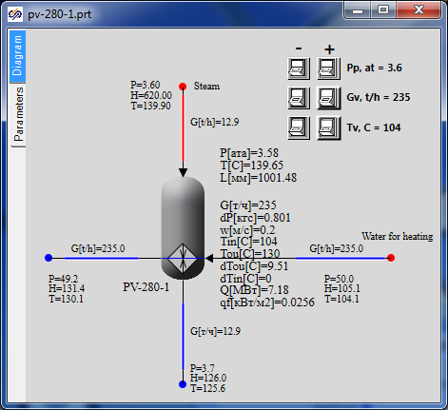

Figure 67. PVD-2 nominal state

Feed water is supplied at +104°С with 235 t/h flow and is heated up to +130°С. At the same time steam (+140°С temperature, 3.6 kgf/cm2 pressure and 13.0 t/h flow) is condensed and delivers 7.18 MW to the heater.

## Creation of PVD-3 model on the basis of PVD-2

### Project copying, calculation parameters

Open the file with PVD-2 model created in the previous section and save it into **“**C:\KTZ\Turbine\PVD-3\PV-280.prt” file after re-writing the previous file.

Let us begin with renaming the project descriptive parameters: changeTPP project name in the calculation parameters for: **“pv_280”**, and the submodel name for **“PV_280”**, and rename the submodel caption as **“PV-280”**. Save the project (again).

Thus, we have just created a model of the third heater in a new file as a copy of the model of the second one (PVD-2). Further we will again proceed with transformation of the model, i.e., change of those parts of the model, which shall be changed. Most part will remain the same as in PVD-2.

### Global parameters

There will be three global parameters in PVD-3 model, the same as for PVD-2: steam pressure in extraction, cooling (heated) water flow and temperature. Change their values as per Figure 68. Steam is supplied to PVD-3 under pressure of 9.2 atm and water for heating is supplied with the same flow of 235 t/h and with higher temperature of 130°С.

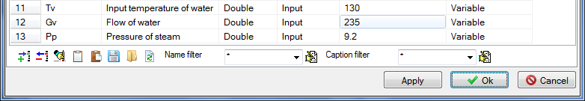

Figure 68. PVD-3 global parameters

Code in “Parameters” tab shall not be changed since the names of global parameters have remained the same. I.e., 6 strings will remain:

|  |
| --- |
| **if** Binc1.Down **then** Pp = Pp+0.001;  **if** Bdec1.Down **then** Pp = Pp-0.001;  **if** Binc2.Down **then** Gv = Gv+0.1;  **if** Bdec2.Down **then** Gv = Gv-0.1;  **if** Binc3.Down **then** Tv = Tv+0.02;  **if** Bdec3.Down **then** Tv = Tv-0.02; |

Since the name of global parameters has not been changed, new values will be automatically assigned for properties in those nodes wherein the parameters are used.

### PVD-3 model structure

PVD-3 model structurally does not differ from PVD-2 model: the same principle for setting a constant heated water flow with constant parameters at the heater inlet. Steam flow is determined via steam supply and steam parameters set in extraction. Heater heats water and condensates steam along with steam-to-water energy transfer.

### PVD-3 submodel

PVD-3 submodel, as well as the structure, has no serious difference from PVD-2 submodel and, thus, we will not produce any principle changes here.

Its difference from PVD-2 is that one property (outer diameter of tubes) of this submodel has another value. Go to **“Change block”** menu item, **“Properties”** tab and change the following parameters:

|  |  |
| --- | --- |
| Submodel properties | Outer diameter of the tube, m, “d”: **“0.044”** |

### Display of parameters in diagram window

Since the model structure is the same, all parameters we are interested in have been already displayed in the diagram window, so nothing is to be changed.

### Properties of boundary nodes, channels and other elements of PVD-2 model

Initialize the diagram in order to check correctness of the entered code and reset values for properties of elements inside the submodel (those ones which are set programmatically in the initialization block).

Now, since steam in PVD-3 is supplied with different parameters and heated water also has different temperature, and diameters of inlet-outlet pipelines are different, change the following properties in the model elements:

|  |  |
| --- | --- |
| Steam inlet channel, condensate outlet channel, water supply channel (right to the heater), water outlet channel (left to the heater) | The parameters will remain the same as for PVD-2. |
| Steam extraction node | Enthalpy: **“650”** |
| Node for water supply for heating | Pressure: **“50.0*1.02”**  Enthalpy: **“waterpt(50e5,Tv,3)/4182”** |
| Heated water intake node | The parameters will remain the same as for PVD-2. |
| Condensate intake node | The parameters will remain the same as for PVD-2. |
| Tank | The parameters will remain the same as for PVD-2. |
| Top tank node | The parameters will remain the same as for PVD-2. |
| Bottom tank node | The parameters will remain the same as for PVD-2. |

### Parameters of PVD-2 calculation

We have already changed calculation parameters (project name) in the very beginning, when copying the model. Nothing more is to be changed.

### PVD-2 nominal state

Now, after entering these minimum changes, we can start the diagram for calculation: Nominal state similar to the one depicted in Figure 69 can be set after 200-400 seconds of calculation.

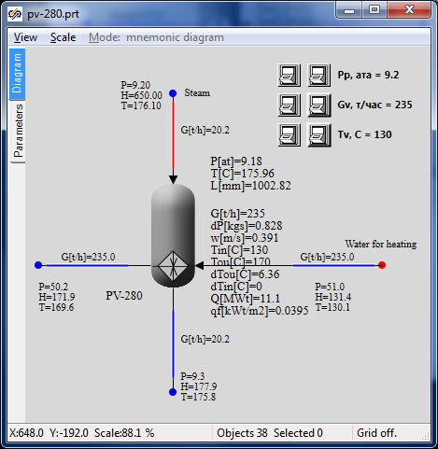

Figure 69. PVD-3 nominal state

Feed water is supplied at +130°С with 235 t/h flow and is heated up to +170°С. At the same time steam (+176°С temperature, 9.2 kgf/cm2 pressure and 21 t/h flow) is condensed and delivers 11.1 MW to the heater.