# Creation of models of intermediate circuit heaters

## Creation of model of PS-450 network water heater

### Project copying, calculation parameters

Create “C:\KTZ\Turbine\Network water heater” new catalog.

Open the file with PVD-3 model created in the previous section and save it into **“**C:\KTZ\Turbine\Network water heater\ПС-450.prt” file.

Rename the project descriptive parameters: change TPP project name in the calculation parameters for: **“pv_450”**, and the submodel name for **“PV_450”**, and rename the submodel caption as **“ПС‑450”**. Save the project.

Thus, we have just created a network water heater model in the new file as a copy of the PVD-3 model. Further we will proceed with transformation of this model, i.e., we will change only those parts of the model we need to change. Most part will remain the same as in PVD-3.

### Global parameters

There will be three global parameters in PS-450 model: heated water flow and temperature. Change their values as per Figure 70. In PS-450 water for heating is supplied with flow of 420 t/h and temperature of +70°С.

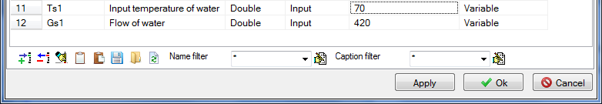

Figure 70. PS-450 global parameters

Code in “Parameters” tab shall be changed since the names of global parameters have been changed (also leave only 4 buttons on the diagram instead of six):

|  |
| --- |
| **if** Binc1.Down **then** Gс1 = Gс1+0.1;  **if** Bdec1.Down **then** Gс1 = Gс1-0.1;  **if** Binc2.Down **then** Tс1 = Tс1+0.02;  **if** Bdec2.Down **then** Tс1 = Tс1-0.02; |

Since the names of global parameters have been changed SimInTech will display an error in those nodes where such names are used. Correct the value of temperature and flow in boundary node G, and set steam pressure to 3.6 kgf/cm2 and enthalpy to 620 in the steam supply node.

### PS-450 model structure

PS-450 model structurally does not differ from PVD-3 model: heated water flow is constant with constant parameters at the heater inlet. Steam flow is determined via steam supply and steam parameters set in extraction. Heater heats water and condensates steam along with steam-to-water energy transfer.

### PS-450 submodel

PS-450 submodel, as well as the structure, has no difference from PVD-3 submodel and, thus, we will not produce any principle changes here.

Its difference from PVD-3 is that one property (outer heat transfer surface) of this submodel has another value. Go to **“Change block”** menu item, **“Properties”** tab and change the following property:

|  |  |
| --- | --- |
| Submodel properties | Heat transfer surface, m2, “F”: **“450”** |

### Display of parameters in diagram window

Since the model structure is the same, all parameters we are interested in have been already displayed in the diagram window, so nothing is to be changed.

### Properties of boundary nodes, channels and other elements of PS-450 model

Initialize the diagram in order to check correctness of the entered code and reset values for properties of elements inside the submodel (those ones which are set programmatically in the initialization block).

Now, since steam in PS-450 is supplied with different parameters and heated water also has different temperature, and diameters of inlet-outlet pipelines are different, change the following properties in the model elements:

|  |  |
| --- | --- |
| Steam supply channel | Hydraulic diameter: **“0.5”**  Flow area: **“0.19635”**  Direct local resistance: “**1”**  Reverse local resistance: **“1”**  Wall Thickness: **“0.005”**  Heat transfer surface: **“7.85398”**  Length. **“5.0”** |
| Condensate outlet channel, water supply channel (right to the heater), water outlet channel (left to the heater) | The parameters will remain the same as for PVD-3. |
| Steam extraction node | Pressure: **“3.6”**  Enthalpy: **“620”** |
| Node for water supply for heating | Pressure: **“25”**  Enthalpy: **“Tc”** |
| Heated water intake node | The parameters will remain the same as for PVD-3. |
| Condensate intake node | The parameters will remain the same as for PVD-3. |
| Tank | Pressure: **“3.6”** |
| Top tank node | The parameters will remain the same as for PVD-3. |
| Bottom tank node | The parameters will remain the same as for PVD-3. |

### PS-450 calculation parameters

We have already changed calculation parameters (project name) in the very beginning, when copying the model. Nothing more needs to be changed.

### PS-450 nominal state

Now, after entering these minimum changes, we can start the diagram for calculation: Nominal state similar to the one depicted in the Figure can be set after 200-400 seconds of calculation.

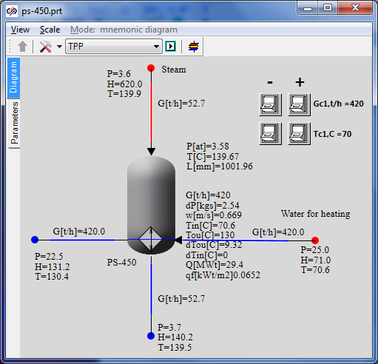

Figure 71. PS-450 nominal state

Network water is supplied at +70°С with 420 t/h flow and is heated up to +130°С. At the same time steam (+140°С temperature, 3.6 kgf/cm2 pressure and 53 t/h flow) is condensed and delivers 29.5 MW to the heater. Steam flow will be adjusted in accordance with rated initial data at the following stages of integration of models into an integrated calculation diagram.

## Creation of model of PS-450P peak heater

### Project copying, calculation parameters

Create “C:\KTZ\Turbine\Peak heater” new catalog.

Open the file with PS-450 model created in the previous section and save it into **“**C:\KTZ\Turbine\Peak heater\PS-450.prt” file.

Rename the project descriptive parameters: change TPP project name in the calculation parameters for: **“pv_450p”**, and the submodel name for **“PV_450P”**, and rename the submodel caption as   
**“PS-450P”**. Save the project.

Thus, we have just created a network water heater model in the new file as a copy of the PS-450 model. Further we will proceed with transformation of this model, i.e., we will change only those parts of the model we need to change. Most part will remain the same as in PS-450.

### Global parameters

There will be two global parameters in PS-450P model: heated water flow and temperature. Change their values as per Figure 72. In PS-450P water for heating is supplied with 840 t/h flow and +130°С temperature.



Figure 72. PS-450P global parameters

Change the code in “Parameters” tab since the names of global parameters have been changed.

|  |
| --- |
| **if** Binc1.Down **then** Gpeak = Gpeak+0.1;  **if** Bdec1.Down **then** Gpeak = Gpeak-0.1;  **if** Binc2.Down **then** Tpeak = Tpeak+0.02;  **if** Bdec2.Down **then** Tpeak = Tpeak-0.02; |

Since the names of global parameters have been changed, correct values of temperature and flow in those nodes where such names are used.

### PS-450P model structure

PS-450P model structurally does not differ from PS-450 model. Heated water flow is constant with constant parameters at the heater inlet. Steam flow is determined via steam supply and steam parameters set in extraction. Heater heats water and condensates steam along with steam-to-water energy transfer.

### PS-450P submodel

PS-450P submodel, as well as the structure, has no difference from PS-450 submodel and, thus, we will not produce any principle changes here.

Its difference from PVD-3 is that one property (diameter of tubes) of this submodel has another value. Go to **“Change block”** menu item, **“Properties”** tab and change the following property:

|  |  |
| --- | --- |
| Submodel properties | Outer diameter of the tube, m, “d”: **“0.036”** |

### Display of parameters in diagram window

Since the model structure is the same, all parameters we are interested in have been already displayed in the diagram window, so nothing is to be changed.

### Properties of boundary nodes, channels and other elements of PS-450P model

Initialize the diagram in order to check correctness of the entered code and reset values for properties of elements inside the submodel (those ones which are set programmatically in the initialization block).

Now, since steam in PS-450P is supplied with different parameters and heated water also has different temperature, and diameters of inlet-outlet pipelines are different, change the following properties in the model elements:

|  |  |
| --- | --- |
| Steam supply channel | Hydraulic diameter: **“0.25”**  Flow area: **“0.04909”**  Direct local resistance: **“1”**  Reverse local resistance: **“1”**  Wall thickness: **“0.005”**  Heat transfer surface: **“3.927”**  Length: **“5.0”** |
| Condensate outlet channel, water supply channel (at the right), water outlet channel (at the left) | The parameters will remain the same as for PS-450. |
| Steam extraction node | Pressure: **“9.5”**  Enthalpy: **“650”** |
| Node for water supply for heating | Pressure: **“25”**  Enthalpy: **“Tpeak”** |
| Heated water intake node | The parameters will remain the same as for PS-450. |
| Condensate intake node | Enthalpy: **“150”** |
| Tank | Pressure: **“9.5”**  1st volume enthalpy, kkal/kg: **“150”** |
| Top tank node | Initial pressure: **“9.5”**  Initial enthalpy: **“650”**  Hydraulic diameter: **“1”**  Flow area: **“1”**  Heat transfer surface: **“1”** |
| Bottom tank node | The parameters will remain the same as for PS-450. |

### PS-450P calculation parameters

We have already changed calculation parameters (project name) in the very beginning, when copying the model. Nothing more needs to be changed.

### PS-450P nominal state

Now, after entering these minimum changes, we can start the diagram for calculation: Nominal state similar to the one depicted in Figure 73 can be set after 200-400 seconds of calculation.

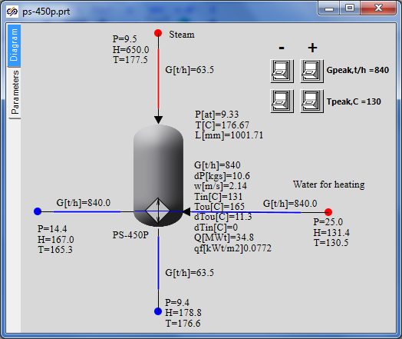

Figure 73. PS-450P nominal state

Network water is supplied at +130°С with 420 t/h flow and is heated up to +165°С. At the same time steam (+170°С temperature, 9.5 kgf/cm2 pressure and 64 t/h flow) is condensed and delivers 35 MW to the heater. Steam flow will be adjusted in accordance with rated initial data at the following stages of integration of models into an integrated calculation diagram.