# Creation of models of pump blocks

## Creation of model of condensate pump block

### New TPP diagram

Create a new TPP project (diagram). Using a standard “save file” dialog save the diagram under a new name in a newly created catalog: “C:\KTZ\Turbine\Condensate pumps\EKN-150-110.prt” (create the catalog in advance).

### EKN-150-110 global parameters

Model of condensate pump blocks is simple, it does not require any global parameters.

### Setting of EKN-150-110 model structure

Structure of condensate pump model is as follows: totally three single-type pumps, common suction for all pumps, upstream of each pump there is a pneumatically driven gate valve, downstream of each pump there is a check valve, a common control valve is fitted on common pressure pipeline.

Place the following elements on the diagram:

1. “**TPP submodel**”, see Figure 74, place all other elements inside that. Rename the submodel as **“MCP”** and caption as **“Condensate pump block”**.

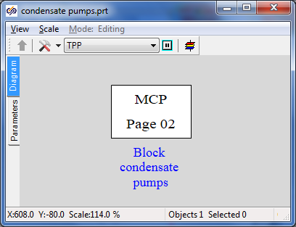

Figure 74. TPP submodel for condensate pump block

1. **“Boundary node P”** to be used for setting pressure in the condenser, i.e., at the pump suction. Place that at the left of the diagram.
2. **“Boundary node P”**, this node is needed just for water outlet, there we will set a random minor pressure (about 10 kgf/cm2) downstream of control valves. Place that at the right of the diagram.
3. “**Internal node TPP**”, place 8 nodes on the diagram – two nodes are common for all pumps and the other six ones shall be placed on three lines for each pump, see Figure 75.
4. **“Common-mode channel”**, 11 elements.

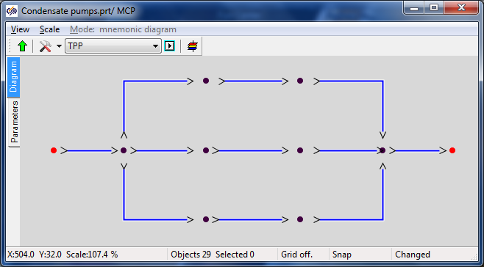

Figure 75. Structure of pipelines and nodes for condensate pumps

1. Link up all channels with the nodes.
2. Place **“Pump without TPP drive”** element (totally three pcs.) on each middle channel.
3. Place **“Gate with TPP pneumatic drive”** elements (totally 4 pcs.) on channels upstream of the pumps and on channel upstream of the right boundary condition.
4. Place **“TPP (typical) check valve”** element (totally three pcs.) on middle channels downstream of the pumps.
5. Compare the result with Figure 76.

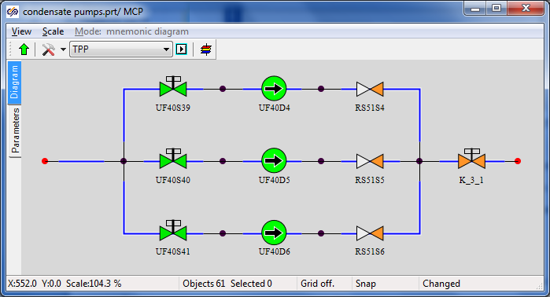

Figure 76. Structure of condensate pump model

1. To test and debug the model we will change the position of the common gate (which is located upstream of the output boundary node). Rename that as **“K_3_1”**, set initial position **“100%”** and add two buttons to the diagram to control the gate. Place the following code in “Parameters” tab”:

|  |
| --- |
| **if** Binc.Down **then** K_3_1.state = K_3_1.state+1;  **if** Bdec.Down **then** K_3_1.state = K_3_1.state-1; |

1. Rename the pumps as **“MCP-11”**, **“MCP-21”**, **“MCP-31”**.
2. Rename the gates as **“K_60_1”**, **“K_61_1”**, **“K_62_1”**.
3. Rename the check valves as **“K_63_1”**, **“K_64_1”**, **“K_65_1”**.

### Display of parameters in diagram window

1. Display P, H, T parameters (totally 9 pcs.) for all nodes except for the right boundary node.
2. Display the value of flows in t/h (totally 4 pcs.) for all channels downstream of the pumps.
3. Display the current value of control valve in %.

Compare the result with Figure 77.

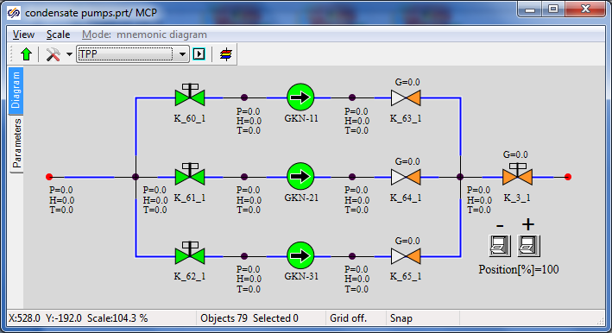

Figure 77. Display of parameters on diagram of model of condensate pumps

### Properties of nodes, channels, pumps and other elements of EKN-150-110 model

For the considered model it is important to correctly set the pump suction pressure, head-capacity characteristics for pumps, correctly set channel diameters and select the line hydraulic resistance with the preset flow.

Set the following properties manually for elements of the condensate pump model (for convenience 3 channels with the same properties can be selected in the beginning to edit their properties together):

|  |  |
| --- | --- |
| Condensate inlet channel | Hydraulic diameter: **“0.5”**  Flow area: **“0.007854”**  Direct local resistance: **“0”**  Reverse local resistance: **“0”**  Wall thickness: **“0.001”**  Heat transfer surface: **“0.31416”**  Length: **“1.0”** |
| Condensate outlet channel (with adjustable gate) | Hydraulic diameter: **“0.15”**  Flow area: **“0.01767”**  Direct local resistance: **“1”**  Reverse local resistance: **“1”**  Wall thickness: **“0.002”**  Heat transfer surface: **“2.3562”**  Length: **“5.0”** |
| Water supply channel (3 channels, their properties are the same) | Number of sections: **“2”**  Hydraulic diameter: **“0.2”, “0.2”**  Flow area: **“0.03146”, “0.03146”**  Direct local resistance: **“1”, “1”**  Reverse local resistance: **“1”, “1”**  Wall thickness: **“0.002”, “0.002”**  Heat transfer surface: **“3.1416”, “1.5708”**  Length. **“5.0”, “2.5”** |
| Channel, in which pump is fitted (3 channels, their properties are the same) | Hydraulic diameter: **“0.15”**  Flow area: **“0.01767”**  Direct local resistance: **“25”**  Reverse local resistance: **“25”**  Wall thickness: **“0.002”**  Heat transfer surface: **“1.1781”**  Length: **“2.5”** |
| Pressure channel (3 pcs, downstream of the pump) | Number of sections: **“2”**  Hydraulic diameter: **“0.15”, “0.15”**  Flow area: **“0.01767”, “0.01767”**  Direct local resistance: **“1”, “1”**  Reverse local resistance: **“1”, “1”**  Wall Thickness: **“0.002”, “0.002”**  Heat transfer surface: **“1.1781”, “1.1781”**  Length: **“2.5”, “2.5”** |
| Water supply boundary node (the node describes the condenser) | Pressure: **“0.05”**  Enthalpy: **“32”** |
| Water outlet node (to be left as by-default since water properties are not a matter of interest for us here) | Pressure: **“10”**  Enthalpy: **“30”** |
| Internal nodes (common upstream of pumps, 3 nodes upstream of every pump, 3 nodes downstream of every pump and common node downstream the pumps) | Initial enthalpy: **“30”**  Elevation: **“-20”** |
| Gate “K_60_1” | Position: **“100%”** |
| Gate “K_61_1” | Position: **“100%”** |
| Gate “K_62_1” | Position: **“0%”** |
| Gate “K_3_1” | Position: **“100%”** |
| Check valve “K_63_1” | Element No. in channel: **“2”**  Pressure drop, at which the channel is open: **“0.01”**  Open channel resistance factor: **“3”**  Closed channel resistance factor: **“1e8”**  Deadband: **“0.001”** |
| Check valve “K_64_1” | Element No. in channel: **“2”**  Pressure drop, at which the channel is open: **“0.01”**  Open channel resistance factor: **“3”**  Closed channel resistance factor: **“1e8”**  Deadband: **“0.001”** |
| Check valve “K_65_1” | Element No. in channel: **“2”**  Pressure drop, at which the channel is open: **“0.01”**  Open channel resistance factor: **“3”**  Closed channel resistance factor: **“1e8”**  Deadband: **“0.001”** |
| Pump “MCP-11” | Characteristics of pump: **“EKN_150-110”**  Rotation frequency: **“1”** |
| Pump “MCP-21” | Characteristics of pump: **“EKN_150-110”**  Rotation frequency: **“1”** |
| Pump “MCP-31” | Characteristics of pump: **“EKN_150-110”**  Rotation frequency: **“0”** |

Note the setting of pump characteristics – this is a text file name  
“**C:\Program Files\SimInTech\bin\DataBase\Simple pumps\EKN_150-110.tbl**”. On using the SimInTech tool by selecting “**Tool**” → “**Tables editor**” item menu and opening the file there, one can see (see Figure 78) that the pump head characteristic has been set there: pressure head depending on rotation frequency and volume flow of pumped water. This file has been deliberately created for this model of pumps.

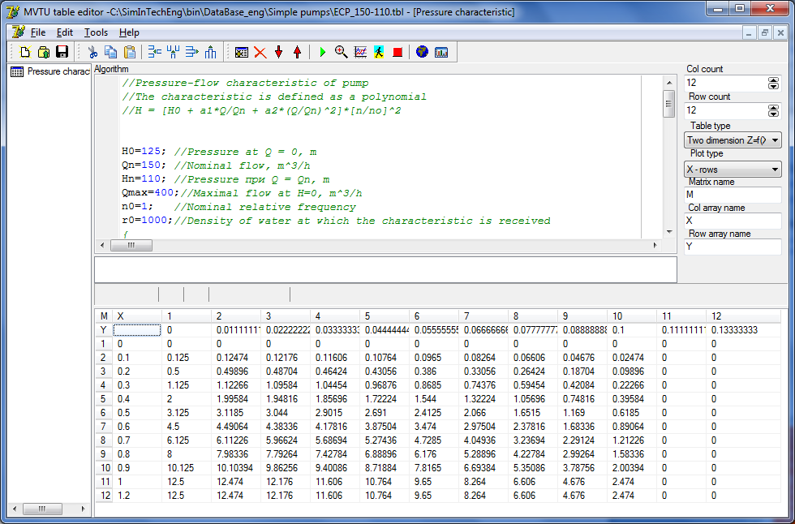

Figure 78. Setting of pump head capacity characteristics

### Nominal state of condensate pump model

On carefully setting these properties, we have completed creation of EKN-150-110 model. Now, if the model is started for calculation, then pressure about 2 kgf/cm2 will be set in nodes upstream of the pumps due to -20 m elevation; two active pumps will be running and create 300 t/h total flow under 12.2 kgf/cm2 pressure at the pump head, see Figure 79. By adjusting the position of the gate at the pump outlet, one can change hydraulic line resistance and debug the pump head capacity characteristics.

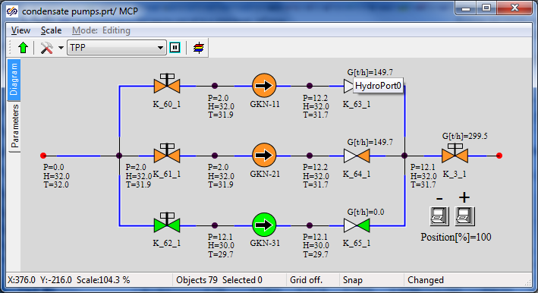

Figure 79. Nominal state of condensate pump block

## Creation of model of feed pump block

### New TPP diagram

Open the project containing the condensate pump model **“**C:\KTZ\Turbine\Condensate pumps\EKN-150-110.prt”. Using a standard “save file” dialog save the diagram under a new name in a newly created catalog: “C:\KTZ\Turbine\Feed pumps\EPN-150-75.prt” (create the catalog in advance).

### EPN-150-75 global parameters

Model of condensate pump blocks is simple; it does not require any global parameters.

### Setting of EPN-150-75 model structure

The structure of feed pump model is very similar to the structure of condensate pump model: totally three single-type pumps, common suction for all pumps, upstream of each pump there is a pneumatically driven gate valve, downstream of each pump there is a check valve and one more pneumatically driven gate (this is a difference from condensate pumps), a common control valve is fitted on common pressure pipeline.

Change the following elements on the diagram:

1. Rename the submodel as “**MFP**” and caption as “**Feed pump block**”, see Figure 80.

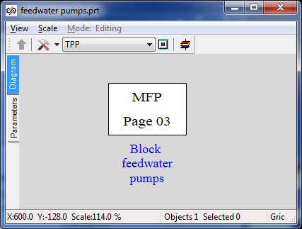

Figure 80. TPP submodel for feed pump block

1. Place additionally three internal nodes inside the submodel.
2. Place additionally three common-mode channels, see Figure 81.
3. Link up all channels with the nodes.

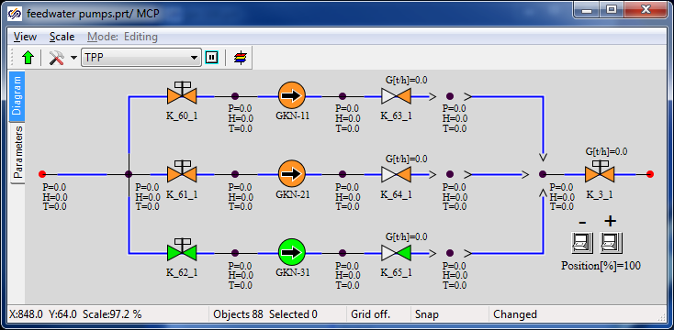

Figure 81. Structure of pipelines and nodes for feed pumps

1. Place **“Pneumatically driven TPP gate”** elements on new channels and name those as **“PV_14_1”, “PV_15_1”, “PV_16_1”**.
2. Place one more pneumatically driven gate **“К_51_1”** on the water supply channel.
3. Rename the pumps as **“EPN-11”**, **“EPN-21”**, **“EPN-31”**.
4. Rename the gates as **“K_53_1”**, **“K_54_1”**, **“K_55_1”**.
5. Rename the check valves as **“K_56_1”**, **“K_57_1”**, **“K_58_1”**.

### Display of parameters in diagram window

1. Display P, H, T parameters (totally 3 pcs.) for new nodes.

Compare the result with Figure 82.



Figure 82. Structure and display of parameters of feed pump model

### Properties of nodes, channels, pumps and other elements of EPN-150-75 model

For the model of pumps it is important to correctly set the pump suction pressure, head-capacity characteristics for pumps, correctly set channel diameters and select the line hydraulic resistance with the preset flow.

Set the following properties manually for elements of the feed pump model (for convenience 3 channels with the same properties can be selected in the beginning to edit their properties together):

|  |  |
| --- | --- |
| Water supply channel | Hydraulic diameter: **“0.25”**  Flow area: **“0.04909”**  Direct local resistance: **“1”**  Reverse local resistance: **“1”**  Wall thickness: **“0.01”**  Heat transfer surface: **“3.927”**  Length: **“5.0”** |
| Condensate outlet channel (with adjustable gate) | Hydraulic diameter: **“0.15”**  Flow area: **“0.01767”**  Direct local resistance: “**1”**  Reverse local resistance: **“1”**  Wall thickness: **“0.002”**  Heat transfer surface: “**2.3562”**  Length: **“5.0”** |
| Water supply channel (3 channels, their properties are the same) | Hydraulic diameter: **“0.25”**  Flow area: **“0.04909”**  Direct local resistance: **“1”**  Reverse local resistance: **“1”**  Wall thickness: **“0.01”**  Heat transfer surface: **“3.927”**  Length: **“5.0”** |
| Channel in which pump is fitted (3 channels, their properties are the same) | Hydraulic diameter: **“0.15”**  Flow area: **“0.01767”**  Direct local resistance: **“25”**  Reverse local resistance: **“25”**  Wall thickness: **“0.005”**  Heat transfer surface: **“2.356”**  Length: **“5”** |
| Pressure channel (6 pcs., downstream of the pumps, with check valves and gates) | Hydraulic diameter: **“0.15”**  Flow area: **“0.01767”**  Direct local resistance: **“1”**  Reverse local resistance: **“1”**  Wall thickness: **“0.002”**  Heat transfer surface: **“1.1781”**  Length: **“2.5”** |
| Water supply boundary node (the node describes the deaerator) | Pressure: **“1.2”**  Enthalpy: **“104”** |
| Water outlet node | Pressure: **“10”**  Enthalpy: **“30”** |
| Internal nodes (common upstream of pumps, 3 nodes upstream of every pump, 6 nodes downstream of every pump and common node downstream the pumps) | Initial enthalpy: **“30”**  Elevation: **“0”** |
| Gate “K_51_1” | Position: **“100%”** |
| Gate “K_53_1” | Position: **“100%”** |
| Gate “K_54_1” | Position: **“100%”** |
| Gate “K_55_1” | Position: **“0%”** |
| Gate “PV_14_1” | Position: **“100%”** |
| Gate “PV_15_1” | Position: **“100%”** |
| Gate “PV_16_1” | Position: **“0%”** |
| Gate “K_3_1” | Position: **“2.987%”** |
| Check valve “K_63_1” | Element No. in channel: **“1”** |
| Check valve “K_64_1” | Element No. in channel: **“1”** |
| Check valve “K_65_1” | Element No. in channel: **“1”** |
| Pump “EPN-11” | Characteristics of pump: **“EPN-150-75”**  Rotation frequency: **“1”** |
| Pump “EPN-21” | Characteristics of pump: **“EPN-150-75”**  Rotation frequency: **“1”** |
| Pump “EPN-31” | Characteristics of pump: **“EPN-150-75”**  Rotation frequency: **“0”** |

Note the setting of pump characteristics – this is a text file name  
“**C:\Program Files\SimInTech\bin\DataBase\Simple pumps\ЭПН_150-75.tbl**”. On using the SimInTech tool by selecting “**Tool**” → “**Tables editor**” item menu and opening the file there, one can see (see Figure 83) that the pump head characteristic has been set there. Pressure head depending on rotation frequency and volume flow of pumped water. This file has been deliberately created for this model of pumps.

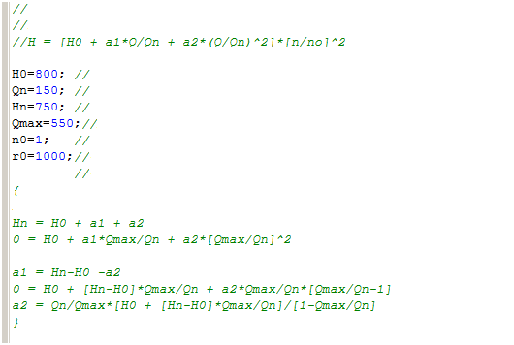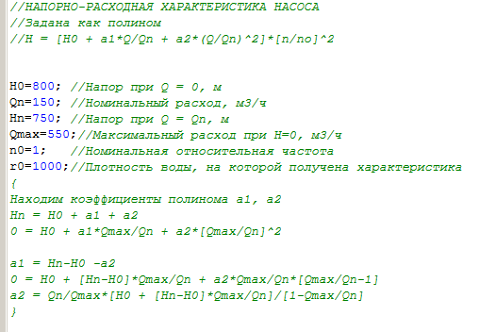

***PUMP HEAD-DISCHARGE CHARACTERISTICS***

***set as polynom***

***Let us find the polynom factors а1, а2***

***Water density, with which the characteristic has been obtained***

***Nominal relative frequency***

***Max. capacity H=0, m3/h***

***Head with Q = Qn, m***

***Nominal capacity, m3/h***

***Head with Q = 0, m***

Figure 83. Fragment of setting of feed pump head capacity characteristic

### Nominal state of condensate pump model

After carefully setting these properties, we have completed creation of EPN-150-75 model. Now, if the model is started for calculation, then due to careful setting of control gate position (2.987%) two active pumps will create 220 t/h total flow, see Figure 84. By adjusting the position of the gate at the pump outlet, one can change hydraulic line resistance and debug the pump head capacity characteristics and the model of feed pump block in general.

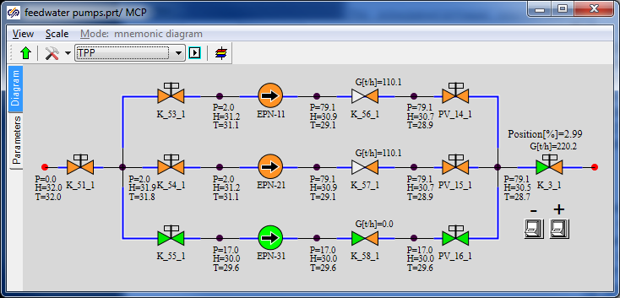

Figure 84. Nominal state of main feed pump block