# Creation of deaerator model

## Description of deaerator model

Aerator model is very simple: this is a 3V TPP tank (compensator) with connected piping for steam supply (from the second extraction) to the deaerator and holes for condensate supply from heaters and hot steam condensate supply from heaters. Water is supplied from the deaerator to the feed pump suction.

## Creation of deaerator model

### Project copying, calculation parameters

Open the file with the feed pump model created in one of the previous section and save it into **“**C:\KTZ\Turbine\Deaerator\Deaerator.prt” file.

Rename the project descriptive parameters: rename TPP project in calculation parameters as “**deair”,** TPP page as **“Deaerator”**, system as **“deair”**, page as **“04”.** Go into the TPP page and, on selecting all that is available inside (except the frame), delete all page content, i.e., remove the feed pump model from there.

Save the project (again). Thus, you have just created a blank for a deaerator model, see  
Figure 85.

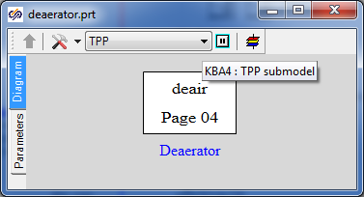

Figure 85. Deaerator model page

### Global parameters of deaerator model

There will be no global parameters in the deaerator model, nothing is to be set.

### Structure of deaerator model

Deaerator model structurally is a 3V TPP compensator with 4 internal holes: two holes in steam zone, one in top water and one in bottom water zone. Piping consisting of three common-mode channels, two internal nodes and one boundary condition is connected to the top hole. Each channel is fitted by one gate – the gate that is closer to the boundary condition is a check valve.

Set such a model yourself according to Figure 86.

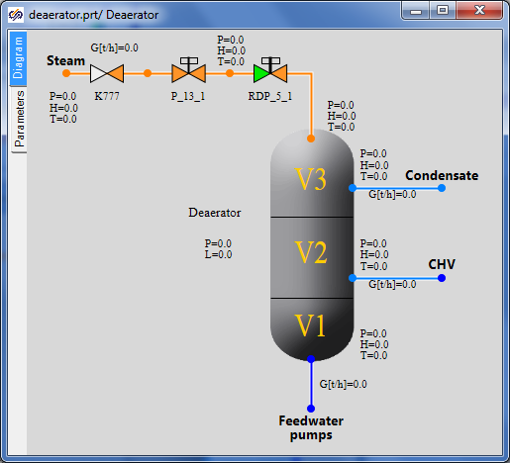

Figure 86. Structure of deaerator model

### Display of parameters in diagram window

Display parameters in the diagram window in accordance with Figure 86.

### Properties of deaerator model elements

At this stage we will accomplish the deaerator model (bring it up to some nominal state) since at the next stage of integration of diagrams into an integral calculation diagram we will connect outputs from other diagrams with parameters that will be there to the deaerator instead of the boundary conditions and channels. Now it is important to set properties of the tank and piping for steam supply to that.

|  |  |
| --- | --- |
| Steam supply channels (3 “common-mode channels” elements) | Hydraulic diameter: **“0.15”**  Flow area: **“0.01767”**  Direct local resistance: **“1”**  Reverse local resistance: **“1”**  Wall thickness: **“0.002”**  Heat transfer surface: **“2.3562”**  Length: **“5.0”** |
| Deaerator tank | 1st part volume: **“1”**  2nd part volume: “**9”**  3rd part volume: **“40”**  Pressure: **“1.2”**  1st volume enthalpy **“104”**  Section area: **“10”**  Valve section area: **“1”**  Valve opening rate: **“0.01”**  Fluid volume hydraulic diameter: **“1”**  Gas volume hydraulic diameter: **“1”**  Number of vertical tubes: “**1”** |
| Top tank node and 2 tank nodes at the middle level (for condensate intake) | Initial pressure: **“7.7”**  Initial enthalpy: **“165.46”**  Hydraulic diameter: **“0.022”**  Wall thickness: **“0.022”**  Flow area: **“0.3848”**  Length of node: **“0.2”**  Heat transfer surface: **“0.44”**  Material: **“Ст20”**  No. of volume: **“Steam”, “Steam”, “Top water”** |
| Bottom tank node | Initial pressure: **“7”**  Initial enthalpy: **“165.8”**  Hydraulic diameter: **“0.7”**  Wall Thickness: **“0.02”**  Flow area: **“1.53938”**  Length of node: **“0.1”**  Heat transfer surface: **“0.2198”**  Elevation: **“-12.7”**  Material: **“Ст20”**  No. of volume: **“Lower water”** |
| Valve K777 | Element No. in channel: **“1”**  Pressure drop, at which the channel is open: **“0.01”**  Open channel resistance factor: **“3”**  Closed channel resistance factor: **“1e8”**  Deadband: **“0.001”** |
| Gate P_13_1 | Position: **“100%”** |
| Gate RDP_5_1 | Position: **“2%”** |

### Parameters of deaerator calculation

We have already changed calculation parameters (project name, etc.) in the very beginning, when copying the model. Nothing more is to be changed.

### Nominal state of deaerator

On creating the deaerator model, we could have got a nominal state if we had correctly set boundary conditions. Nevertheless, since it is hard to say what nominal water flows and properties will be at deaerator inlets, then we have to be limited with creation of a model – its debugging will be done later at the process of integration of models, that is, in the process of creation of a full thermohydraiulic diagram of STP.

When writing the technique and starting the deaerator model, the lower boundary condition was replaced with a node of G-type with “-220/3.6” kg/s flow, while properties of boundary conditions of P‑type were selected for one of the states of the deaerator; the following result was obtained: see Figure 87.

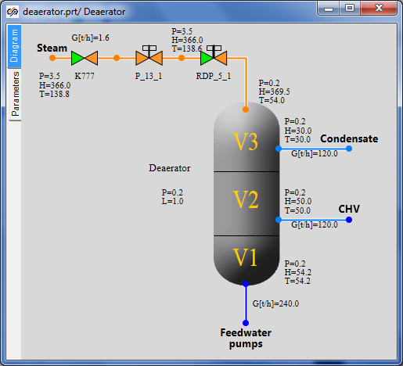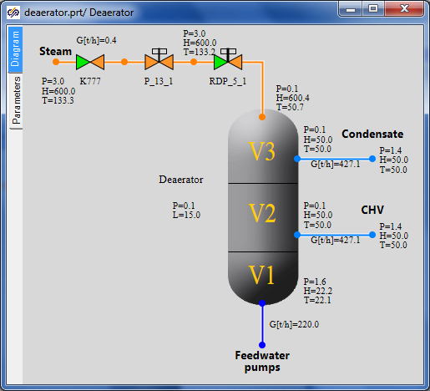

Figure 87. State of deaerator model