# INSTALLATION of SimInTech

This section presents the procedure of actions to be followed for installation of SimInTech dynamic modeling environment for technical systems.

To install SimInTech software (SW) complex proceed as follows:

1. start file mbtyprotect_eng.exe from setup disc. Setup file is also available at the official web-site of 3V Services, LLC. URL: <http://3v-services.com/update/mbtyprotect_eng.exe>

File launches the installation wizard and opens the dialog window as depicted in Fig.1.1.

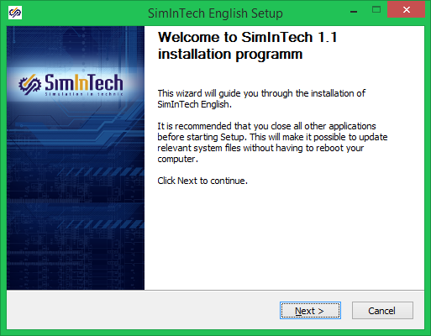

Figure 1.1

1. left-click the “Next” (Figure 1.1.), then SimInTech software complex license agreement window will be displayed. The desktop window is shown in Figure 1.2.

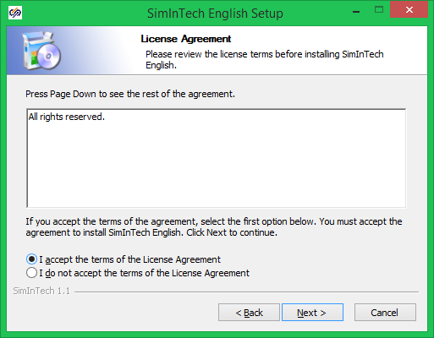

Figure 1.2

1. left-click to activate the “I accept the terms in the license agreement” field and then click the “Next” button (Figure 1.2.). As a result of the actions the selection window for SimInTech software complex components to be installed will be activated as shown in Figure 1.3.

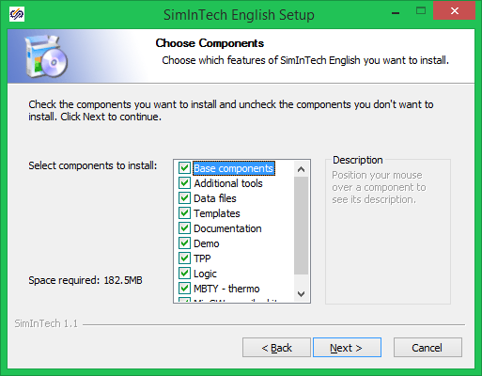

Figure 1.3

Note – In case “I do not accept terms in the license agreement” filed is activated, “Next” button and any further installation of SimInTech software complex will become inaccessible.

1. on selecting necessary components, click the “Next” with the left mouse button (Figure 1.3.). On doing that, “SimInTech Installation” window will be displayed as shown in Figure 1.4.

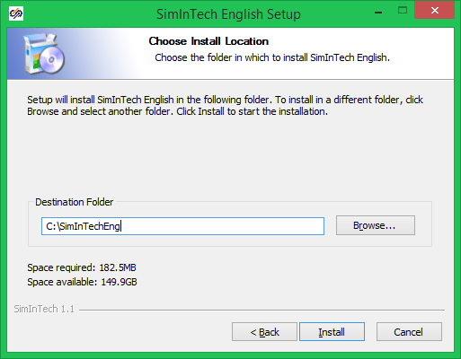

Figure 1.4

Record the folder path to install SimInTech software complex in “Destination folder” field (Figure 1.4). One may use Explorer that can be activated by left-clicking the “View…” button.

Note – If installation is running with a version of SimInTech software complex already installed, then the existing folder with the software complex will be advised by default.

1. left-click the “Install” button, then copying (unpacking) of files into a directory specified by user will be initiated. Figure 1.5 depicts the file copying process.

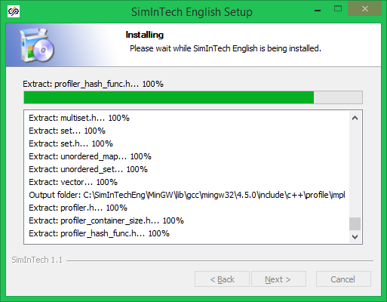

Figure 1.5

1. if installation is successively completed a window suggesting to finish the installation program by licking “Ready” button will appear as shown in Figure 1.6.

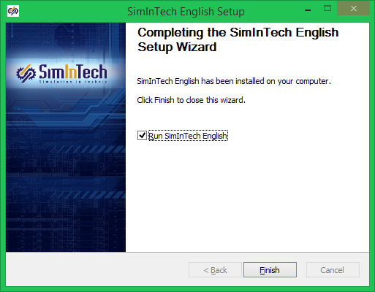

Figure 1.6

On selecting “Start SimInTech” field in the installation window after completion of the installation process (after clicking the “Ready” button), SimInTech SW will be started.

# REGISTRATION of SimInTech

“SimInTech dynamic modeling environment for technical systems” software complex can run in two modes:

1. Demo – reduced functionality mode. It is accessible when any license key (license file) is not available. This mode implies some restrictions for size and complexity of models and algorithms created in SimInTech, as well as for a number of typical blocks and variables applicable in projects;
2. Full-function – mode for full-range operation of the software complex. To work in this mode a license key (license file) is required.

To obtain a license key file a request shall be sent to 3V Services, LLC that is generated at the user’s work place – the place of installation of SimInTech software complex. The request can be generated in two ways:

1. using SimInTech software complex;
2. using request generation utility.

## obtaining license key using simintech

This way to obtain a license key is used in case SimInTech software complex is installed as per the process described in Section 1 of this Abstract.

After activation of an unregistered version of SimInTech software complex, proceed as follows:

1. select “File -> New Project -> Automatics Diagram” submenu in the main menu of SimInTech software complex with the left mouse button, as shown in Figure 2.1.1.

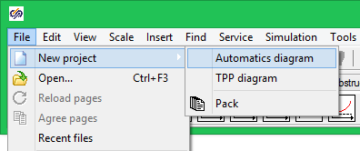

Figure 2.1.1

After that the “Program registration” window will be displayed as shown in Figure 2.1.2.

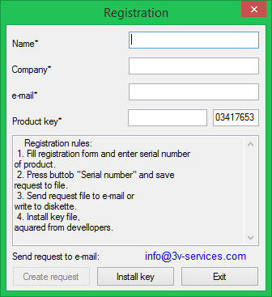

Figure 2.1.2

Note – If “Exit” button is left-clicked (Figure 2.1.2) SimInTech software complex will be activated in demo mode.

1. fill the fields of “Program registration” window as per the following recommendations:

Rules for filling the fields:

|  |  |  |
| --- | --- | --- |
| Name | – | SimInTech software complex user’s surname and initials at the user’s work place; |
| Company | – | Name of organization that uses SimInTech software complex.  Note – quotation marks shall not be used, when indicating the name of organization; |
| E-mail address | – | E-mail address of user or organization that has installed SimInTech software complex; |
| Product key | – | A set of symbols generated by user and comprising two parts:   1. C30D946058D – serial number of software complex that is delivered along with distributive and is specified at official web-site of 3V Services, LLC [www.3v‑services.com/ru/](http://www.3vservices.com/ru/) in section “Download SimInTech (MITD SWC)”. 2. XXX – three or more signs determining the sequence number of license installed within the organization. These are required for identification of SimInTech software complex by the technical support service of 3V Services LLC. |

Example for filling “Program registration” window is given in Figure 2.1.3.

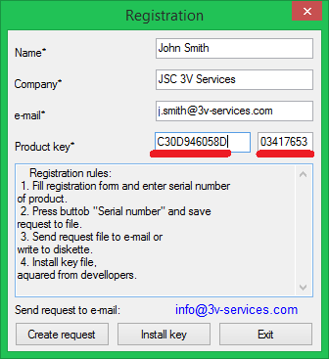

Figure 2.1.3

1. left-click the “Create request” button (Figure 2.1.3). When the above steps are executed “Save as” window will be displayed for generating a text file for the request as presented in Figure 2.1.4.

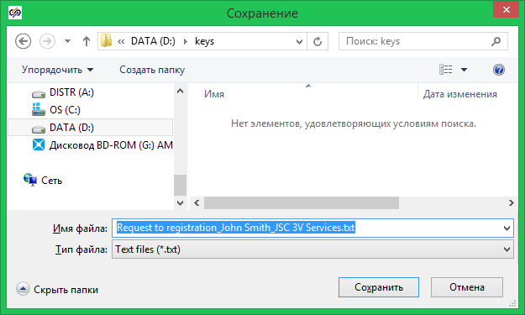

Figure 2.1.4

1. left-click the “Save” button and save the file on the user’s work place. By default the file will be saved in the “My documents” folder. When the file has been saved the “Confirm” window to confirm the request sending will be displayed on the user’s screen, as shown in Figure 2.1.5.

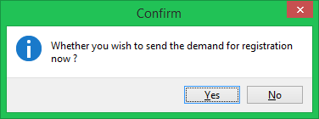

Figure 2.1.5

File with user’s request is confirmed for sending by left-clicking the “Yes” button (Figure 2.1.5). As a result of above actions the user’s E-mail client will be activated for sending the generated file to 3V Services, LLC.

1. user's request file shall be sent to the E-mail address of 3V Services, LLC:   
   [info@3v-services.com](mailto:info@3v-services.com)
2. receive a license key file with .key extension – it will be delivered by the technical support service of 3V Services, LLC shortly after the user’s request file is received.

Example of license key file content:

John Smith

JSC 3V Services

j.smith@3v-services.com

C30D946058D

5EF3CB81E906C7B517A68AB63A99F4CC

03417653

Note – If a request file is generated by a company that has not purchased SimInTech software complex, any license key file will not be provided.

## obtaining license key using request generation utility

To generate a request for obtaining a license key file at the user’s work place without SimInTech software complex installed, the special “Request generator” utility shall be used, whose executable qrgen.exe file is to be acquired in 3V Services, LLC at E-mail address: [info@3v‑services.com](mailto:info@3vservices.com) or is downloaded from the official web-site [www.3v‑services.com/ru/](http://www.3vservices.com/ru/). This utility is built into the software and is automatically started in case of any attempt to use the functional, the license for which has not been installed on the computer.

To generate a request for obtaining a SimInTech software complex license key file proceed as follows:

1. start the qrgen.exe file, as a result the “Program registration” window will be displayed on the user’s screen, as presented in Figure 2.2.1.



Figure 2.2.1

1. fill the fields of “Program registration” window as per the following recommendations:

Rules for filling the fields:

|  |  |  |
| --- | --- | --- |
| Surname and initials | – | SimInTech software complex user’s surname and initials at the user’s work place; |
| Organization | – | Name of organization that uses SimInTech software complex.  Note – quotation marks shall not be used, when indicating the name of organization; |
| E-mail address | – | E-mail address of user or organization that has installed SimInTech software complex; |
| Product code | – | A set of symbols generated by user and comprising two parts:   1. C30D946058D – serial number of software complex that is delivered along with distributive and is specified at official web-site of 3V Services, LLC [www.3v‑services.com/ru/](http://www.3vservices.com/ru/) in section “Download SimInTech (MITD SWC)”. 2. XXX – three or more signs determining the sequence number of license installed within the organization. These are required for identification of SimInTech software complex by the technical support service of 3V Services, LLC. |

Example for filling “Program registration” window is given in Figure 2.2.2.



Figure 2.2.2

1. left-click “Generate request” button (Figure 2.2.2). As a result of this step the “Save as…” window will be displayed for generation of a request text file as shown in Figure 2.2.3.



Figure 2.2.3

1. left-click the “Save” button and save the file on the user’s work place. By default the file will be saved in the “My documents” folder. When the file has been saved, the “Confirm” window to confirm the request sending will be displayed on the user’s screen, as shown in Figure 2.2.4.



Figure 2.2.4

File with user’s request is confirmed for sending by left-clicking the “Yes” button (Figure 2.2.4). As a result of above actions the user’s E-mail client will be activated for sending the generated file to 3V Services, LLC.

1. user's request file shall be sent to E-mail address of 3V Services, LLC:  
    [info@3v-services.com](mailto:info@3v-services.com)
2. receive a license key file with .key extension – it will be delivered by the technical support service of 3V Services, LLC shortly after the user’s request file is received.

Example of license key file content:

John Smith

JSC 3V Services

j.smith@3v-services.com

C30D946058D

5EF3CB81E906C7B517A68AB63A99F4CC

03417653

Note – If a request file is generated by a company that has not purchased SimInTech software complex, any license key file will not be provided.

# simintech license key registration

License key file received from 3V Services, LLC shall be registered, to that end proceed as follows:

1. start SimInTech software complex and select the “New project -> Automatics diagram” sub-item in the main menu, as shown in Figure 3.1.



Figure 3.1

After that the “Program registration” window will be displayed on the user’s screen as shown in Figure 3.2.



Figure 3.2

|  |  |
| --- | --- |
| Note | 1) If the license key request has been generated from SimInTech software complex (item 2.1 of this Abstract) then the “Program registration” window shown in Figure 3.2 will contain information entered during generation of the request file;  2) If the license key request is generated using the request generation utility (item 2.2 of this Abstract), then the fields shall be filled by yourself. The content shall match information sent in the request file. |

1. left-click the “Set up key” button (Figure 3.2). After that the “Open” window for searching the license key file will be displayed on the user’s screen as shown in Figure 3.3.

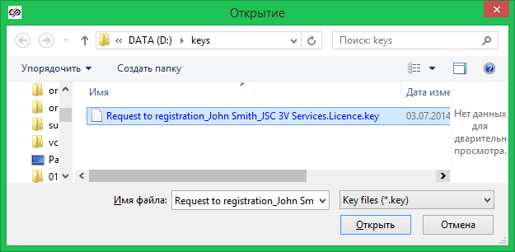

Figure 3.3

1. find and select the license key file with .key extension obtained from 3V Services, LLC in the “Open” window (Figure 3.3).
2. register the SimInTech license key by left-clicking the “Open” button (Figure 3.3).

If the license key is successfully registered the full functional of SimInTech software complex will become accessible, as well as all upgrades of the software complex for the whole period of licensing.

# simintech code generator license key registration

This section describes the procedure of actions to install the SimInTech software complex code generator license key. For registration proceed as follows:

1. start SimInTech software complex and select the “Tools -> Generate program” sub-item in the main menu, as shown in Figure 4.1.

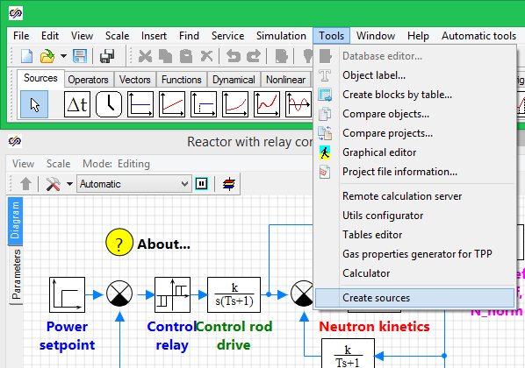

Figure 4.1

After that the “Code generator registration” window will be displayed on the user’s screen as shown in Figure 4.2.

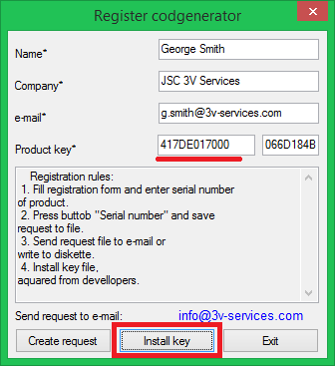

Figure 4.2

Unlike the registration procedure presented in Section 2 of this Abstract there is “Set up key” button in the window.

To set up the key proceed as follows:

1. left-click the “Set up key” button (Figure 4.2). After that the “Open” window for searching the license key file will be displayed on the user’s screen as shown in Figure 4.3;

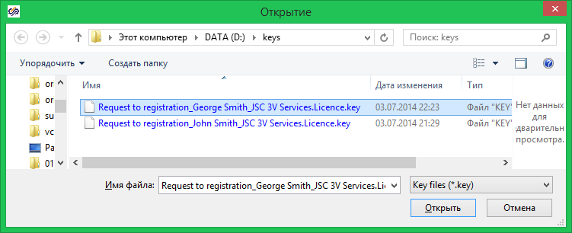

Figure 4.3

1. find and select the license key file with .key extension obtained from 3V Services, LLC in the “Open” window (Figure 4.3);
2. register the SimInTech license key by left-clicking the “Open” button (Figure 3.3.).

After successful registration of the license key, the SimInTech software complex code generator will become accessible.