**erf**

*Function of Gaussian errors.*

**Syntax:**

*y* **= erf***(x);*

**Arguments:**

*x* – function argument.

**Description:**

Function of Gaussian errors is determined as

$$y\left(x\right)=\frac{2}{\sqrt{π}}\int_{0}^{x}{e^{-t^{2}}}dt$$

Graphic of the function:

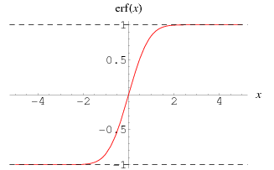

Function calculates the function of Gaussian errors from argument *x*.

**Result:**

*y* – value of the function of Gaussian errors from argument *x*.