**erfc**

*Additional function of Gaussian errors.*

**Syntax:**

*y* **= erfc***(x);*

**Arguments:**

*x* – function argument.

**Description:**

Additional Gaussian function is determined through the function of Gaussian errors.

$$y\left(x\right)=1-\operatorname{erf}\left(x\right)= \frac{2}{\sqrt{π}}\int_{x}^{∞}{e^{-t^{2}}}dt$$

Graphic of the function:

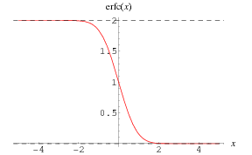

Function calculates the additional function of Gaussian errors from argument *x*.

**Result:**

*y* – value of the additional function of Gaussian errors from argument *x*.