**gamma**

*Full Gamma-function.*

**Syntax:**

*y* **= gamma***(x);*

**Arguments:**

*x* – function argument.

**Description:**

Full Gamma-function is a function expanding the notion of factorial on the field of complex numbers.

$$y\left(x\right)= \int_{0}^{∞}{e^{-t}t^{x-1}dt}$$

Graphic of the function:

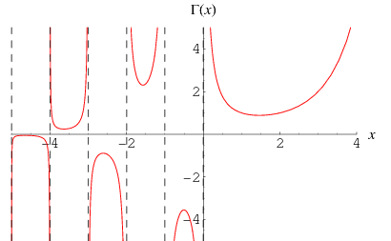

Function calculates the full Gamma-function from argument *x*. Argument *x* shall be a real number, vector or matrix.

**Result:**

*y* – value of the full Gamma-function from argument *x*.