Петухов Кирилл

Вариант 6

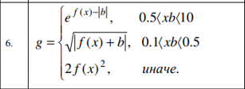

Скриншот:

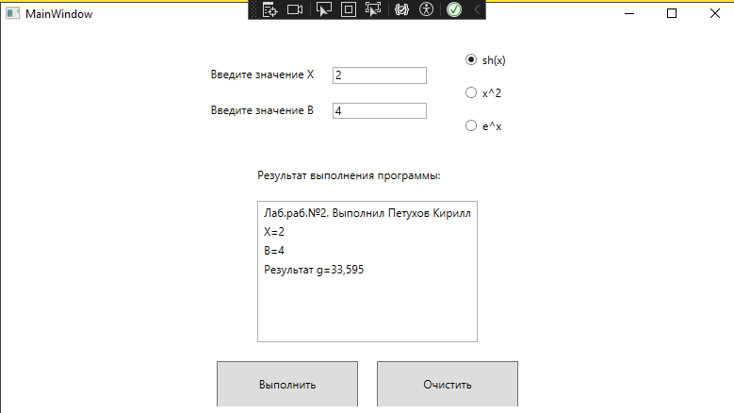

xaml:

<Window x:Class="WpfApp2.MainWindow"

xmlns="http://schemas.microsoft.com/winfx/2006/xaml/presentation"

xmlns:x="http://schemas.microsoft.com/winfx/2006/xaml"

Title="MainWindow" Height="450" Width="800">

<Grid>

<Grid.RowDefinitions>

<RowDefinition Height="2*"/>

<RowDefinition Height="3*"/>

<RowDefinition Height="1*"/>

</Grid.RowDefinitions>

<StackPanel Grid.Row="0"

Orientation="Horizontal"

HorizontalAlignment="Center">

<StackPanel Orientation="Vertical"

VerticalAlignment="Center">

<StackPanel Orientation="Horizontal"

HorizontalAlignment="Center">

<TextBlock Text="Введите значение X"

Margin="10"/>

<TextBox Name="txtX"

Margin="10"

Width="100"/>

</StackPanel>

<StackPanel Orientation="Horizontal"

HorizontalAlignment="Center">

<TextBlock Text="Введите значение B"

Margin="10"/>

<TextBox Name="txtB"

Margin="10"

Width="100"/>

</StackPanel>

</StackPanel>

<StackPanel Orientation="Vertical"

VerticalAlignment="Center"

Margin="20">

<RadioButton GroupName="Function"

Name="rbtSinh"

Content="sh(x)"

IsChecked="True"

Margin="10"/>

<RadioButton GroupName="Function"

Name="rbtSquare"

Content="x^2"

Margin="10"/>

<RadioButton GroupName="Function"

Name="rbtExp"

Content="e^x"

Margin="10"/>

</StackPanel>

</StackPanel>

<StackPanel Grid.Row="1"

Orientation="Vertical"

HorizontalAlignment="Center">

<TextBlock Text="Результат выполнения программы:"

Margin="10"/>

<ListBox Name="lstResult"

Margin="10"

Height="150"/>

</StackPanel>

<DockPanel Grid.Row="2"

HorizontalAlignment="Center">

<Button Name="btnCalc"

Height="50"

Width="150"

Content="Выполнить"

Margin="10"

Click="btnCalc_Click"/>

<Button Name="btnClear"

Height="50"

Width="150"

Content="Очистить"

Margin="10"

Click="btnClear_Click"/>

</DockPanel>

</Grid>

</Window>

cs:

using System.Text;

using System.Windows;

using System.Windows.Controls;

using System.Windows.Data;

using System.Windows.Documents;

using System.Windows.Input;

using System.Windows.Media;

using System.Windows.Media.Imaging;

using System.Windows.Navigation;

using System.Windows.Shapes;

namespace WpfApp2

{

public partial class MainWindow : Window

{

public MainWindow()

{

InitializeComponent();

}

/// <summary>

/// Ввод исходных данных и выполнение расчёта.

/// </summary>

/// <param name="sender"></param>

/// <param name="e"></param>

private void btnCalc_Click(object sender, RoutedEventArgs e)

{

lstResult.Items.Clear();

double x = double.Parse(txtX.Text);

double b = double.Parse(txtB.Text);

double g;

lstResult.Items.Add("Лаб.раб.№2. Выполнил Петухов Кирилл");

lstResult.Items.Add($"X={x}");

lstResult.Items.Add($"B={b}");

int n = 0;

if (rbtSquare.IsChecked == true) n = 1;

else if (rbtExp.IsChecked == true) n = 2;

switch (n)

{

case 0:

if (x * b > 0.5 && x * b < 10)

g = Math.Exp(Math.Sinh(x)) - Math.Abs(b);

else if (x * b > 0.1 && x * b < 0.5)

g = Math.Sqrt(Math.Abs(Math.Sinh(x) + b));

else

g = 2 * Math.Pow(Math.Sinh(x), 2);

lstResult.Items.Add($"Результат g={Math.Round(g, 3)}");

break;

case 1:

if (x * b > 0.5 && x * b < 10)

g = Math.Exp(Math.Pow(x, 2)) - Math.Abs(b);

else if (x * b > 0.1 && x * b < 0.5)

g = Math.Sqrt(Math.Abs(Math.Pow(x, 2) + b));

else

g = 2 * Math.Pow(Math.Pow(x, 2), 2);

lstResult.Items.Add($"Результат g={Math.Round(g, 3)}");

break;

case 2:

if (x * b > 0.5 && x * b < 10)

g = Math.Exp(Math.Exp(x)) - Math.Abs(b);

else if (x * b > 0.1 && x * b < 0.5)

g = Math.Sqrt(Math.Abs(Math.Exp(x) + b));

else

g = 2 * Math.Pow(Math.Exp(x), 2);

lstResult.Items.Add($"Результат g={Math.Round(g, 3)}");

break;

}

}

/// <summary>

/// Очистить поля

/// </summary>

/// <param name="sender"></param>

/// <param name="e"></param>

private void btnClear_Click(object sender, RoutedEventArgs e)

{

txtX.Clear();

txtB.Clear();

lstResult.Items.Clear();

}

}

}