

Team 1

The Great Escape

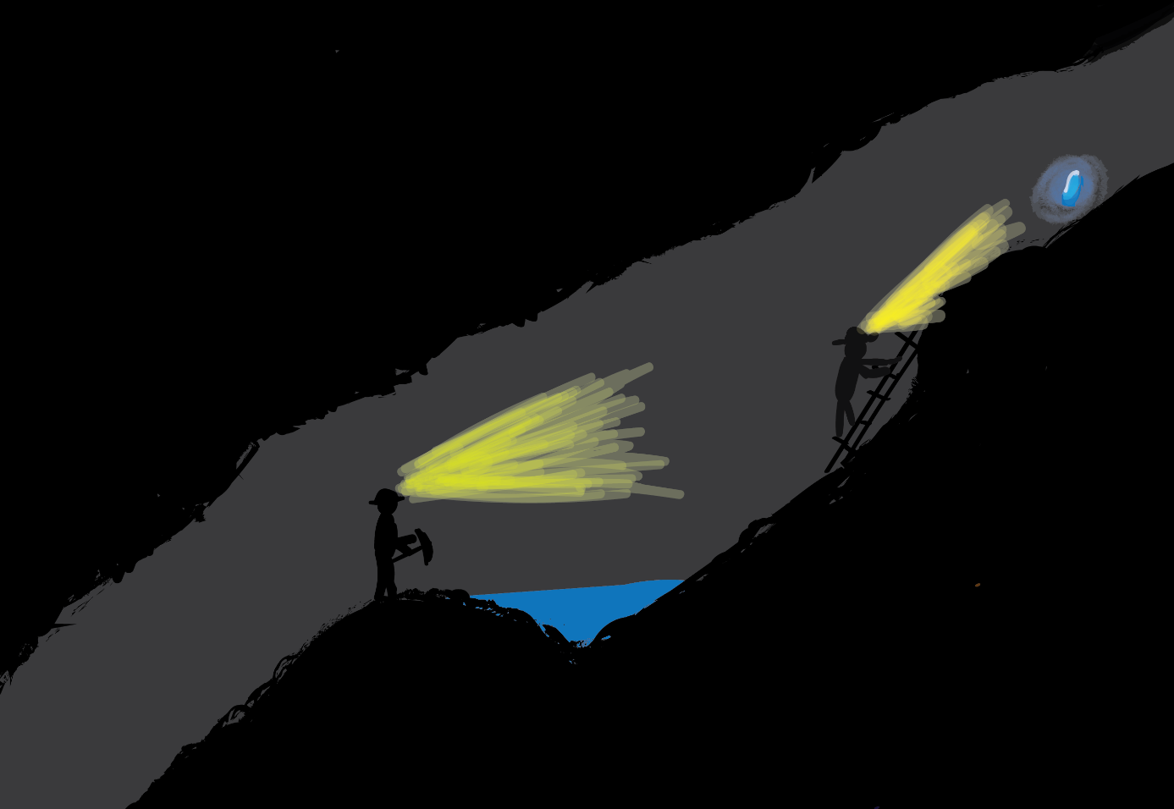„The Pursuit of Freedom “

Simon Ringeisen – Producer, Programmer, Designer

Nicolas Mesot – Programmer, Designer, Visual Artist

Andreea Radoescu – Programmer, Designer, Visual Artist

Petur Helgi Einarsson – Programmer, Designer, Sound Effects

Bjarni Hannesson – Programmer, Designer, QA Engineer

Contents

Chapter 1. Formal Project Proposal 4

1.1. Game Description 4

1.1.1. Overview 4

1.1.2. Background Story 4

1.1.3. Design Decisions 4

1.2. ‚Big Idea‘ Bullseye 6

1.3. Technical Achievement 7

1.4. Development Schedule 8

1.4.1. Layered Task Breakdown 8

1.4.1.1. Functional Minimum 8

1.4.1.2. Low Target 8

1.4.1.3. Desired Target 8

1.4.1.4. High Target 8

1.4.1.5. Extras 8

1.4.2. Task List 9

1.4.3. Timeline 11

1.5. Assessment 13

Chapter 2. Prototype 14

2.1. Prototype Setup 14

2.2. Playing Experience 14

2.3. Findings and Conclusion 14

Chapter 3. Interim Report 14

3.1. Progress 14

3.2. Challenges 14

3.3. Future Work 14

Chapter 4. Alpha Release 15

4.1. Progress 15

4.2. Challenges 15

4.3. Future Work 15

Chapter 5. Playtest 15

5.1. Playtesting Session 15

5.2. Questions and Comments 15

5.3. Design Revisions 15

Chapter 6. Conclusion 15

6.1. Final Results 16

6.2. Experience 16

6.2. Personal Impressions 16

Chapter 1. Formal Project Proposal

* 1. Game Description
     1. Overview

Our game is a 2D-multiplayer platformer, where the players are supposed to escape from a dark cave within the Gotthard massif. On their way out, the players need to solve puzzles and can collect points. To solve the puzzles, the players must interact with different elements, like levers, buttons, boxes etc.

There are more miners then players. The players can therefore switch between miners. Miners can die and when there aren’t any miners left, the game is lost. The game is won, as soon as all players escape the cave.

Another highlight of the game is the level editor, where new obstacles/tracks can be created. This will give freedom to the player to design new challenges that he can play out with his friends.

* + 1. Background Story

The action takes place in 1878, during the excavation-works for the Gotthard tunnel. It turned out that the project was more complex than expected, and the allocated funds would not suffice for a successful completion. There were a lot of stakes involved in this ambitious project and unfortunately some unexpected complications have appeared. Morale was running low among the miners who stood to lose their jobs. Alfred Escher was battling on many fields, trying to keep this operation alive, but his proposals kept getting rejected.

One day, a group of miners made an astounding discovery. By mistakenly digging into an unplanned area of the tunnel, they came upon a natural cave flush with gold. This unexpected chance would give them the possibility to financially salvage the entire project; however, only hours after the incident, a nearby tunnel and left them trapped inside the mountain.

Their mission is to get out of the tunnels to inform everybody else of the stroke of luck, but most importantly to save their lives. This very thing could greatly help Escher regain the favor of other parties and their support in seeing this project to the very end. Or will the miners be greedy and keep the gold?

* + 1. Design Decisions

There are more miners than players in the cave. When the miners spawn, they get tools (e.g. pick-axes, hammers, buckets, shovels, …). The players can switch between miners with the click of a button.

Miners can be killed in different ways (e.g. drown, being hit by a stone, …). When killed, a miner drops his tool, which can be collected by the remaining miners. If a player doesn’t swap out his tool for the one of the dead miner, he can always go back later and pick it up afterwards. The player whose miner has been killed can choose one of the remaining miners. When the last miner has been killed, the game is lost.

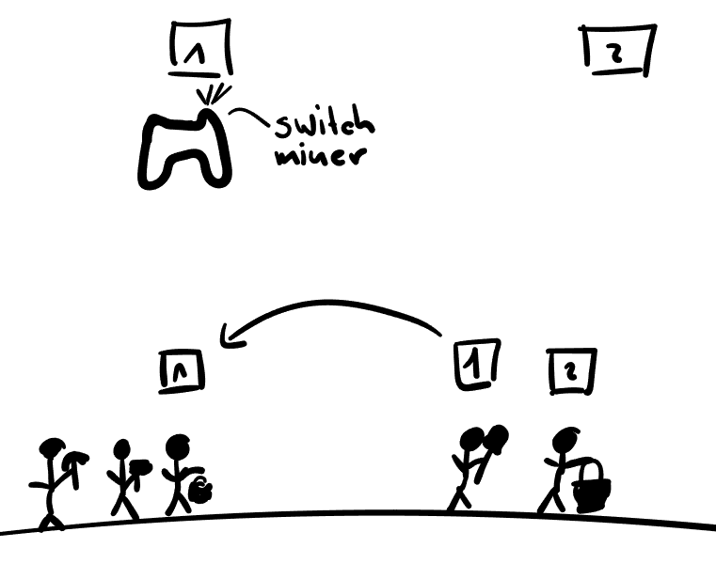

The route is a continuous cave, which is divided by checkpoints (e.g. separated by doors), at which the miners can re-equip themselves with tools.

There is a fixed number of two players which need to help each other to unlock the pathway towards freedom and to escape the cave. The players will play on a shared screen, i.e. not split screen. Furthermore, the screen has a fixed view in the sense that players are not able to pan the camera or zoom out to see more of the level.

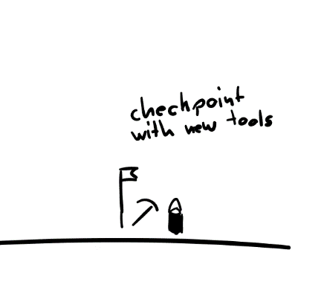 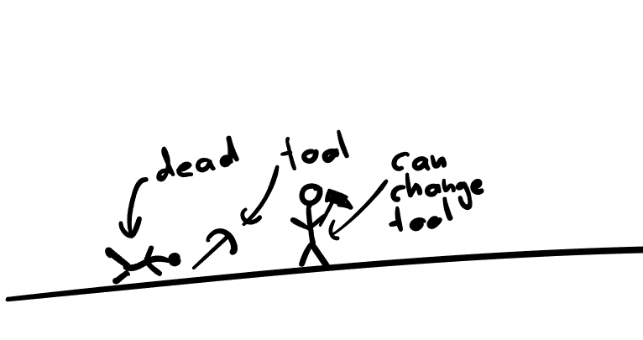

The style of the game will be very dark, as there is basically no light in the cave. The cave is only lit by the miners’ flash lights, lights on walls or on the ceiling, in addition to torches carried by the miners. The graphics are done in 2D and the players can move in any direction their environment allows them to, i.e. there is no forced scrolling.

There can also some doors that will either lead towards the right path or get the player to a dead end. Sometimes more paths can conjoin and become one. This will give the game a labyrinth feeling which can add even more to the suspense of trying to escape from the caves.

Additional effects:   
- Gas leaks which make players dizzy, hallucinate, become weak or powerless  
- Add a treasure-hunt, where one has to defeat demonic  
- Give names to the tunnel sections   
- Create a side-story, possibly including local stories

* 1. ‚Big Idea‘ Bullseye

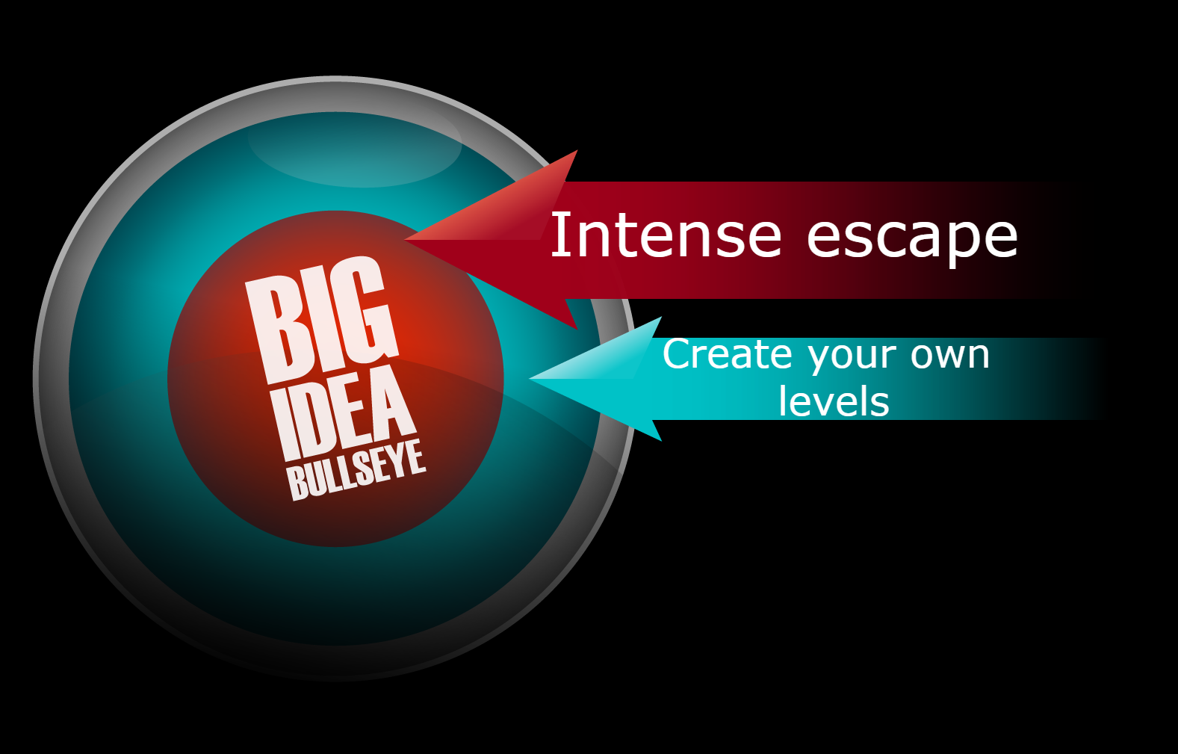

Intense running through a deep, dark cave with soothing water/lightning effects. The technical component is achieved through the implementation of level designer.

* 1. Technical Achievement - Level Editor

We want to build a level editor that can be used on the console. This will not only greatly increase the appeal of our game, it will also streamline the creation of interesting parts of the game and engaging levels.

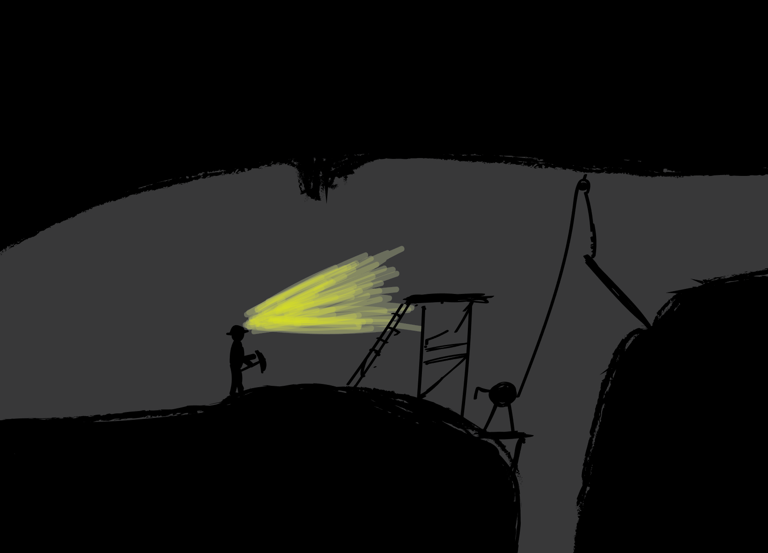

As stated, the aim is to make the editor usable on the console. This means working with a restricted set of input possibilities. Another challenge will be to include an option to save created levels.

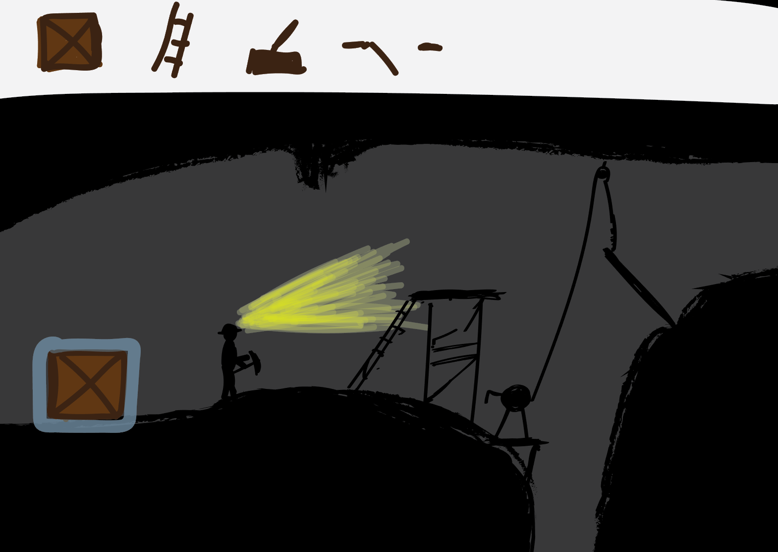

* 1. Development Schedule
     1. Layered Task Breakdown
        1. Functional Minimum

Control over one player which has to go through only one checkpoint, get over one simple obstacle and escape the caves. The characters each have one single tool and the challenge reflects that.   
The game will be 2D, simplistic drawings and renderings.

* + - 1. Low Target

Add a game menu (continue, start new game, simple settings).   
Introduce more obstacles (locked doors, getting gravel out of way, etc).  
Add shadows and torches.

* + - 1. Desired Target

Add voices and/or sound effects.   
Implement level editor that can be used on the computer.  
Possibility of choosing the tools for the characters in the game menu.  
Multiplayer (two-player) mode.  
Also add a background story, the introduction of the game and narration.   
Add animations and more visual effects.

* + - 1. High Target

Add a possibility for the characters to go treasure hunting instead of a direct escape attempt.   
Upgrade level editor to be usable on the console.  
Implement visualization for hallucinating effects due to gas exposure.   
Demonic creatures guarding the treasures.

* + - 1. Extras

Fluid simulation based puzzles.  
Online mode.   
Use higher dimension (2.5D or 3D) assets.

* + 1. Task List

|  |  |  |  |
| --- | --- | --- | --- |
| Topic | What? | Who? | How long? [hours] |
| Game proposal | Rough proposal | Everybody | 15 |
| Final proposal | Everybody | 10 |
| Physical prototype | Everybody | 15 |
| **Functional minimum** | | | |
| Setup | Setup Mono-Game project, install tools etc. | Everybody | 15 |
| Player | Player entity | Andreea, Simon | 10 |
| Basic Player controlling | Bjarni, Petur | 15 |
| Tool (only one) | Nicolas | 20 |
| Map | Simple static map | Simon, Nicolas | 30 |
| Interactive elements (checkpoints, escape, …) | Simon, Petur | 20 |
| Technical | Camera | Bjarni, Petur | 10 |
| Mechanics | Collision detection | Andreea | 15 |
| **Low target** | | | |
| Technical | Game Menu | Nicolas | 10 |
| Mechanics | Basic level editor | Petur, Andreea | 30 |
| Design level components | Bjarni | 10 |
| Map | Dynamic maps (load game map from file) | Simon, Bjarni | 30 |
| **Desired Target** | | | |
| Sound | Music | Petur | 15 |
| Sound effects | Petur | 15 |
| Player | Add multiplayer (incl. Controlling, swapping players, …) | Bjarni | 25 |
| Tools | More tools | Nicolas | 20 |
| Technical | Multiplayer camera constraint | Bjarni | 20 |
| Visuals | Use nice visuals / animations | Andreea, Simon | 35 |
| Storytelling | Narration | Andreea | 20 |
| Tutorial | Nicolas, Simon | 30 |
| **High Target** | | | |
| Mechanical | Fancier level editor. | Petur, Andreea | 40 |
| Gas (hallucination, distortion…) | Simon, Bjarni | 40 |
| Fun | Treasure hunting | Nicolas, Petur | 30 |
| Demonic Creatures | Nicolas, Andreea, Bjarni, Simon | 40 |
| **Extras** | | | |
| Mechanics | Fluid Mechanics | Simon | 40 |
| Fun | Online mode | Nicolas | 1000 |
| Visuals | 2.5D / 3D assets | Andreea | 25 |

* + 1. Timeline

The public link to the gantt chart is

https://app.teamweek.com/#pg/rXDJbrPWGcHY6nWfog2FrtfkeUBUvSNF

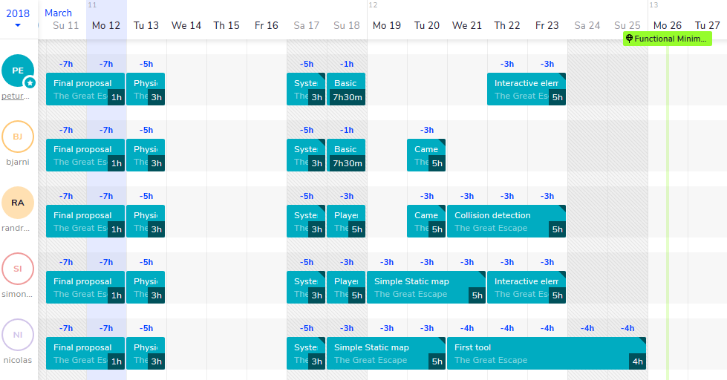

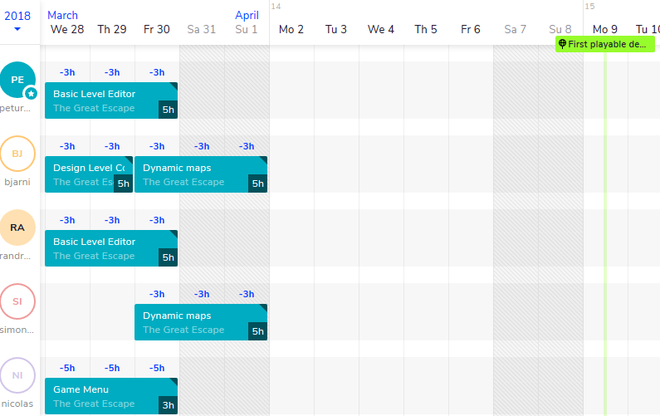

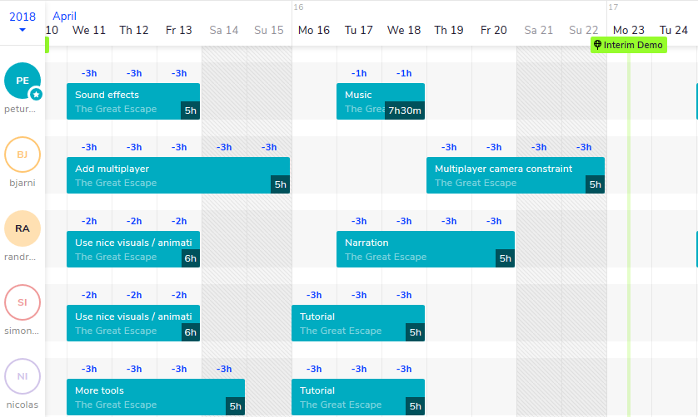

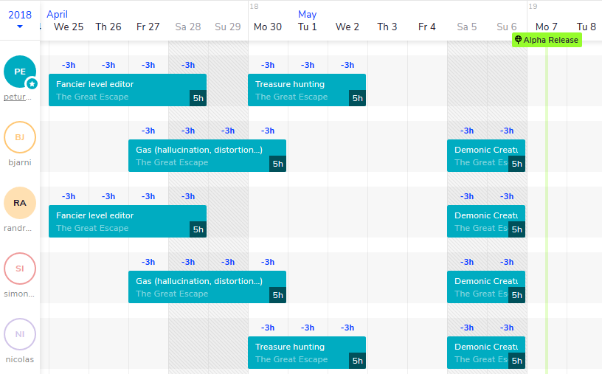

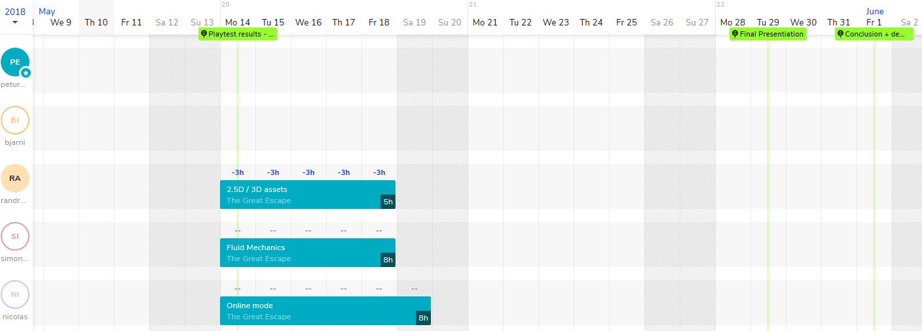

* 1. Assessment

The most fun part playing the game will be getting over the obstacles together. Some competitive elements (like collecting treasures) could lead to interesting combinations, where the players want to ‘kill’ each other, while still escaping the cave.

The game might be played at parties or when meeting up with friends for a gaming session.

Chapter 2. Prototype

(Min 3, Max 5 pages)

@Note: The key goal of this part of the project is to develop a prototype of your game that distills out the core game play. The prototype should incorporate the game mechanics while providing only a crude approximation of other features like artwork.

2.1. Prototype Setup

@Note: Include sketches and photos of your prototype in such a way that you can demonstrate how the prototype works and how the gameplay is modeled. How did you model environment, characters, and other features of the game?

2.2. Playing Experience

@Note: your experience playing the game. Was it fun?

2.3. Findings and Conclusion

@Note: Explain what you have learn from creating the prototype. What has proved to be harder (or easier) than expected? What design revisions have you made to your game based on your experience creating the prototype?

Chapter 3. Interim Report

(Max 5 pages)

3.1. Progress

@Note: Describe how many layers you have finished. You can include screen shots to help explain your game so far, and text to describe how a user would interact with it. Our hope is that you have completely finished layer 2 and are well into layer 3.

3.2. Challenges

@Note: Explain what has proved to be harder (or easier) than expected. What design revisions have you made to your game as a result of what you've learned with the implementation? Discuss the implementation challenges you faced. Were there aspects that you wanted to build but were unable to do so?

3.3. Future Work

@Note: What are the planned tasks that will be implement next? Shortly explain.

Chapter 4. Alpha Release

(Max 5 pages)

@Note: Follows the same guidelines as the interim report chapter.

4.1. Progress

@Note: Comment on how far you have progressed and show us what is exciting about your game. Ideally, you will have met the goals outlined in layer 3 (your desired target) and possibly part or all of layer 4 (your high target). You can include screen shots.

4.2. Challenges

@Note: Explain what has proved to be harder (or easier) than expected. What design revisions have you made to your game as a result of what you've learned with the implementation? Discuss the implementation challenges you faced. Were there aspects that you wanted to build but were unable to do so?

4.3. Future Work

@Note: What are the planned tasks that will be implement next? Shortly explain.

Chapter 5. Playtest

(Max 5 pages)

5.1. Playtesting Session

@Note: Describe who you recruited for playtesting and how you organized the playtesting sessions. If possible, include some photos.

5.2. Questions and Comments

@Note: List the questions you chose to ask the testers. Summarize their answers. Comment on overall trends you learned from the exercise, as well as any specific suggestions that were particularly useful.

5.3. Design Revisions

@Note: Finally, describe any changes you made to your game based on the playtesting.

Chapter 6. Conclusion

(Max 5 pages)

6.1. Final Results

@Note: In this chapter, first provide a summary of your final results including screenshots from your final game. Comment on any significant changes from the alpha release.

6.2. Experience

@Note: Here you should provide commentary about your experience during the class. How well did your initial design ideas materialize into the final game. Were you able to follow your development schedule, or did you deviate significantly from it? How did the different elements of the project structure (development schedule, prototype, playtesting, etc.) contribute to or hinder your progress?

Rough draft of the project proposal

6.2. Personal Impressions

@Note: Did it meet your expectations? Are you happy and proud of your game? Do you feel there wasn't enough time or that the schedule was too compressed?

@Note: You might also consider these questions:

* What was the biggest technical difficulty during the project?
* What was your impression of working with the theme?
* Do you think the theme enhanced your game, or would you have been happier with total freedom?
* What would you do differently in your next game project?
* What was your greatest success during the project?
* Are you happy with the final result of your project?
* Do you consider the project a success?
* To what extend did you meet your project plan and milestones (not at all, partly, mostly, and always)?
* What improvements would you suggest for the course organization? (Perhaps in D1 evaluation)?
* Did you like using MonoGame?