Slow Light via Resonant-tunneling Induced
Transparency in Quantum Well Heterostructures

Petar Tzenov^{1*} and Christian Jirauschek¹,
¹Institute for Nanoelectronics, Technical University of Munich, D-80333 Munich, Germany
*petar.tzenov@tum.de

1 Introduction
We present a theoretical and computational investigation of the possibility of achieving slow and superluminal terahertz light in suitably engineered quantum well heterostructures, by exploiting the tunneling induced transparency effect [1]. Our calculations show that for optimal system parameters a slow-down factor larger than 10 could be possible and we also derive necessary conditions for achieving superluminal light.
2 Model
In our model, we consider a periodic structure consisting of two quantum wells per module, in which the lowest energy eigenstate of module I, couples via resonant tunneling to the excited state of period II, and the resulting triplet jsi ; jei and jgi forms a _􀀀type system (see Fig. 3a). At optimal bias, the electron levels spanning an inter-module barrier energetically align to form a strongly coupled pair of dressed states, which results in splitting of the absorption spectrum of the sample. Such an effect is familiar to the quantum cascade laser community [2, 3], however until this point it has not yet been considered in the context of slow light.
For our investigation we couple our Schrödinger-Poisson/ensemble Monte-Carlo [4] and Maxwell-Bloch simulation codes, which enables us to self-consistently design and analyze various systems with the desired properties. Simulations with suitably chosen, but still realistic, parameters show the possibility of a group velocity delay by a factor of 10 with respect to the velocity of light in vacuum.

3 Results
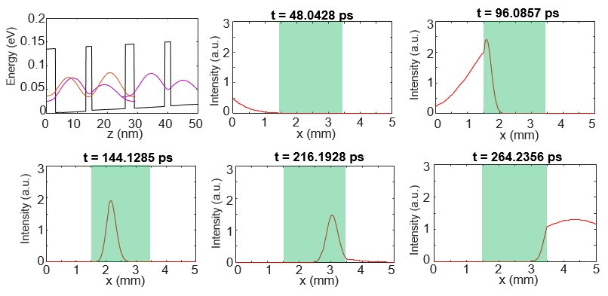
Fig. 1b-e illustrates preliminary results from simulations of the propagation of a 20 ps pulse through a 2 mm long active region, where the propagation direction is denoted by x and the light-matter coupling axis is set to z. In Fig. 3c, we see strong compression of the pulse upon its incidence on the active region. This is followed by reduction in its overall intensity due to the fact that photons are being expended to drive the coherent oscillations in the atomic system. Upon leaving the interaction medium, the pulse is again broadened, as can be seen in Fig. 3f, as this time its front travels faster than its tail.
Our proof of concept simulations, show that the community can exploit the recent development in growth and processing technologies for

References :

- H. Borges, L. Sanz, J. Villas-Bôas, O. D. Neto, and A. Alcalde, “Tunneling induced transparency and slow light in quantum dot molecules,” Physical Review B, vol. 85, no. 11, p. 115425, 2012
- J. Faist, F. Capasso, C. Sirtori, K. W. West, and L. Pfeiffer, “Controlling the sign of quantum interference by tunnelling from quantum wells,” Nature, vol. 390, no. 6660, pp. 589–591, 1997.
- D. Burghoff, T.-Y. Kao, N. Han, C. W. I. Chan, X. Cai, Y. Yang, D. J. Hayton, J.-R. Gao, J. L. Reno, and Q. Hu, “Terahertz laser frequency combs,” Nat. Photonics, vol. 8, no. 6, pp. 462–467, 2014.
- C. Jirauschek and T. Kubis, “Modeling techniques for quantum cascade lasers,” Applied Physics Reviews, vol. 1, no. 1, p. 011307, 2014.

