Silicon Jackets Physical
Design Onboarding Project

Name:
Discord ID:
GT Email:

1. Introduction to Physical Design: OpenLane Colab Notebook
In this section, you will follow along with the Physical Design flow to generate physical IC layouts from RTL using OpenLane.
OpenLane is an open-source toolchain for physical design. At SiliconJackets, we use the Cadence suite, not OpenLane. However, following along with this flow is a good way to get an idea of what the Physical Design team does.
i. Follow this link to create a copy of the OpenLane Colab Notebook.
For in-depth information about the OpenLane flow, refer to the OpenLane reference manual.
ii. Run all the steps in the OpenLane Colab Notebook. Make sure to read each part thoroughly so you understand what the Notebook is actually doing.
iii. Take screenshots of your Notebook after completing each of the following steps and paste them into the answer box on the next page.
- Floorplan
- PDN Generation
- GDS Streamout
iv. Describe in your own words what the following flow steps do.
a. Floorplanning

b. Clock Tree Synthesis

c. Global Route

d. Signoff Static Timing Analysis (Post-PnR STA)

2. Clocking a Sequential Circuit
In this section, you’ll get an introduction to critical paths, setup times, and identifying viable clock frequencies.
Performing timing analysis on an IC with millions of transistors requires many of the same essential skills as performing timing analysis on a breadboard circuit diagram — just on a much different scale.
This section requires knowledge of some Static Timing Analysis concepts you may not be familiar with.
To learn about Setup and Hold times, see this resource.
To learn about Static Timing Analysis, see this resource or this more comprehensive resource.

Consider the following Sequential Circuit.
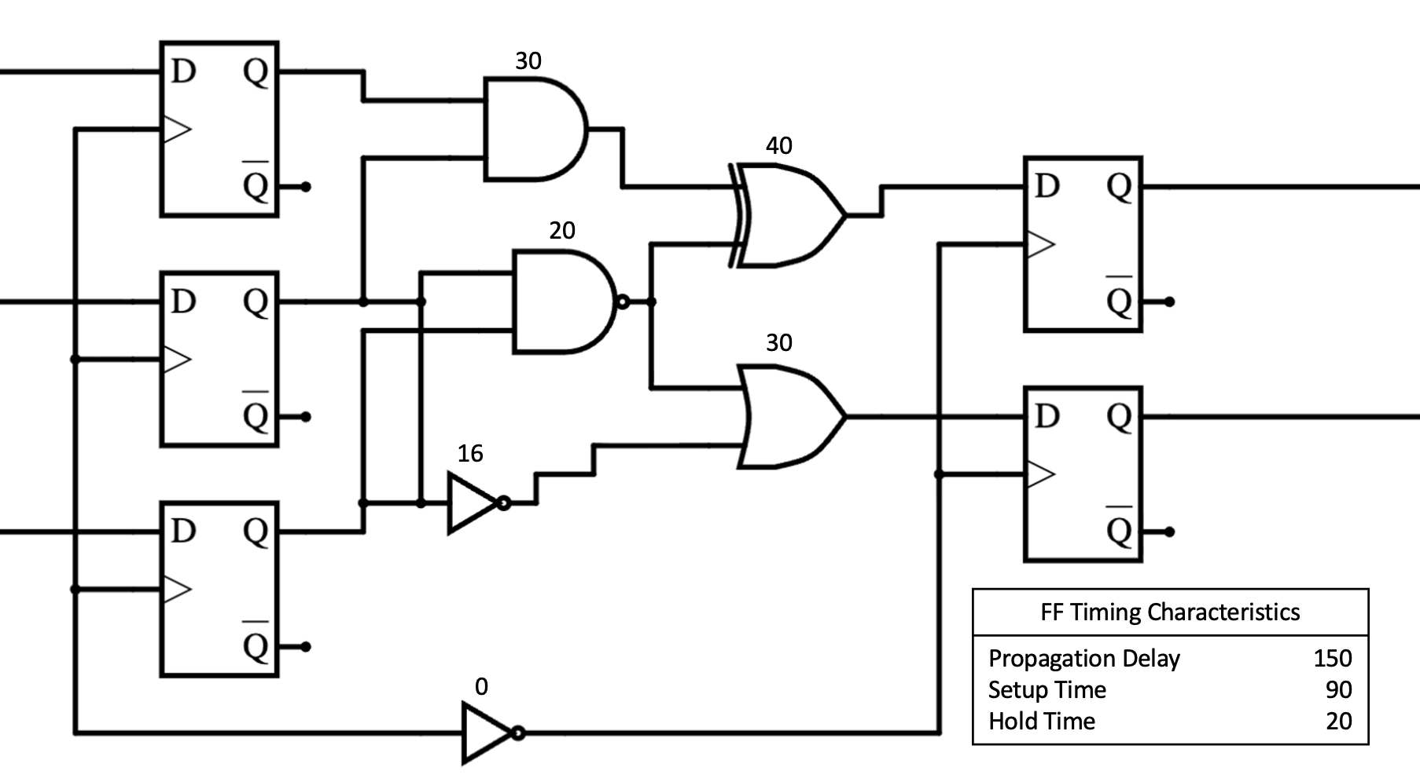

i. Identify the worst case timing path in this circuit (e.g FF -> INV -> AND -> OR -> FF). Calculate the worst negative slack (WNS) if the clock period here is 500 ps. Assume all units are picoseconds.
Ii. Given this critical path, what is the maximum viable clock frequency?

iii. Explain the concepts of setup slack and hold time. Why is a negative slack value problematic?

3. Python Timing Report Analysis
In this section, you’ll get an introduction to the analysis of timing reports generated by our EDA tools using Python.
We’ve provided a sample timing report (full_paths.max.rpt) for you to analyze.
The report is too large to analyze by hand, so you’ll have to write a Python script to help parse the file data. You can use the provided template.py if you’d like.
This guide on File I/O and this guide on String processing might be good places to start if you don’t have any Python experience.
i. How many paths violated timing constraints (i.e., have negative slack)?

ii. What is the average depth (or number of gates) of paths with the smallest positive slack?
Hint: In this context, “smallest positive slack” refers to paths that are passing timing, but just barely.
Answering this question might involve creating a script that extracts tuples containing each path’s slack and gate depth, then sorting the tuples by slack.

iii. What clock speed was the design run at when this timing report was generated?
Does the report allow us to calculate a better clock speed for this design? If so, please calculate it.

4. Flow Debugging
If you haven’t already, run the flow according to the directions in RTL2GDS/README.md. You may notice that the flow fails! Read the flowtool.log file (or the output directly to your terminal; its the same thing) to find the source of the error.
Unless you know what to look for, the log does a pretty poor job telling you what’s wrong. To deduce the source of the error, look at the name of the flow step that fails. You should be able to find this flow setup in scripts/flow.yaml. Flow steps in flow.yaml correspond to actual Tcl code in certain places in the scripts directory.
For example, run_syn_generic in flow.yaml corresponds to a flow step in genus_steps.tcl that runs a single command (this is not the failing flow step):
##############################################################################
# STEP run_syn_generic
##############################################################################
create_flow_step -name run_syn_generic -owner cadence {
#- Synthesize to generic gates
syn_generic
}
The failing flow step is referenced in flow.yaml, but it is defined somewhere else. You’ll have to edit the definition of the failing flow step in another file to resolve this issue.
Once you’ve fixed it, rerun the flow, and it should run to completion.
No submission required for this section.

5. Tcl Procedures
This section focuses on the Tool Command Language (Tcl), which we use to write scripts that automate aspects of running the flow. Use the template file scripts/onboarding.tcl for this section.
You need to run the flow to completion before answering problems in this section. See the README inside the flowtool directory for instructions on running the flow and complete part 4 before attempting this part.
You will also have to use Cadence Innovus. For information on using Cadence Innovus, read Using-Innovus.md in docs/

i. Navigate to the design/scripts directory. Choose a .tcl script in this directory and explain what it does.
ii. We want to highlight an SRAM block in our design.
a. Consult the Cadence Support website to identify the Innovus commands to dim the foreground and highlight an object.
Use these commands in the Innovus shell to highlight an SRAM block and paste a screenshot in the box below.

b. Let's automate that process. Complete the Tcl proc in scripts/onboarding.tcl to take an SRAM’s name as an input and invoke these two commands to highlight it in Innovus.
Paste or screenshot your Tcl proc code here, and show the file being sourced in the Innovus shell.

ii. We can also use Tcl to highlight paths in our design. This is especially useful for highlighting paths that fail timing to help us decide how to optimize our layout to improve timing.
Find and use Innovus commands that read a timing debug report and highlight the paths in the GUI. Paste a screenshot of the GUI showing failed paths in the box below.

iii. Let’s automate this too. Complete the Tcl proc that takes in a path number as an input and highlights in the GUI.
Paste or screenshot your Tclproc code here, as well as the file being sourced in the Innovus shell.

iv. The command get_db is an extremely powerful command that gives you information about anything in the design. For example, the command

get_db insts

Returns a list of every instance in the design. As you can imagine, it’s going to be a very long list.
Some arguments also have attributes. For example, if I want a list of the pins of every instance, we can write

get_db insts .pins

If I want to know the library cell of some instances, we can write

get_db insts .lib_cell

Write a proc that uses get_db to return the fanout of every buffer in the clock tree.

It is recommended to useget_db in the terminal and press tab so to see a list of valid attributes.

6. Static Timing Analysis on our 32-bit Adder
The questions in this section involve analyzing the timing reports generated by running the flowtool in Github repository on the 32-bit adder design.
You should have already run the flow once, and you will have to run it a few more times. In case you haven’t run it yet, please complete

i. Identify the Worst Negative Slack (WNS) from the timing summary for both setup and hold in the current design.
Hint: There are multiple ways to find this information. The file qor.html may be a good place to start.

ii. Using the WNS and the clock frequency (set in the file resources/sdcpipeline_src/base.sdc), calculate the max frequency that the current design can theoretically run at.
Hint: Frequency is the reciprocal of period.

iii. Modify the current design SDC file and rerun the flow to make the WNS at least +0.01ns. Include the screenshot of the flow summary or qor.html showing your positive WNS.

7. Investigating DRCs with the ChipFoundry SRAM
At this point, our design is meeting timing!
Does that mean our chip is ready for tape-out? No, unfortunately not.
This section will familiarize you with Design Rule Checking (DRC), another challenge we have to consider in the Physical Design process.
In this section, you will be implementing and understanding the importance of macros in VLSI design. Within your Verilog design, you instantiate SRAMs to use as memory blocks. These cannot be implemented with RTL; instead, we have to instantiate them as design macros.
For help using Innovus, see the Using Innovus guide in the docs/ directory.
i. Using the Cadence Support website, look for a command to be able to manually place these SRAM instances in the design.
In the box below, provide these commands. Explain why we might be manually placing them.

ii. Do a run through to floorplan to verify that you’ve placed the SRAMs in the design. To save time, you can run flowtool -verbose -from floorplan -to floorplan and open that database.
NOTE: Unless you run make clean between flows, the outputs of your most recent flow will be in, for example dbs/postroute.enc_2 (or higher if you have run more than 2 flows). If you run make clean, you will have to run through synthesis again. Keep that in mind!
Once you’ve verified that the macros have been placed in the floorplan, you can go ahead and run the flow all the way to postroute. Open the design in Innovus, and you’ll see a bunch of white markers!
The white markers in the design are what are known as DRC violations. DRC stands for Design Rule Checking.
Foundries supply chip designers with design rules that specify requirements the design must meet for it to be taped out. Design libraries often have hundreds of rules. Some examples are minimum spacing between elements, layer overlap, and area limitations.
These are rules the foundry supplies us with allowing us to know whether a chip can actually be manufactured. Your goal as a PD engineer should be to create a manufacturable design, and in doing so you have to correct the DRC violations you've found. Provide an image of the design with the DRCs.

We will spend some time understanding why these DRCs occurred and brainstorming some possible fixes. Do to so, it’s good to understand how Innovus sees these macros first.
Innovus instantiates these macros as a blackbox. It cannot see what’s inside the macro. In this case, Innovus cannot see the bit cells, bit lines, sense amplifiers, etc. that an SRAM generally has. All innovus knows is the size of the blackbox, where its placed, and where the pins are, so Innovus can interface with the macro.
The ChipFoundry SRAM’s pins are at the bottom of the macro. That’s where all the DRCs are as well! We can reasonably infer that the cause of the DRCs come from how the pins are connected.
iii. Use Innovus to zoom in to a couple of the DRCs (can be done by scrolling) and click on a few of the markers. Innovus will show you the reasons for the DRCs. Paste or summarize what Innovus had to say about these DRCs.

As you can see, Innovus doesn’t have much to say about them. From here, knowing what specifically happened is a big jump, so we’ll give you a hint!

iv. Open the file flowtool/resources/CF_SRAM_1024x32/lef/CF_SRAM_1024x32.lef in a text editor.

This LEF file describes the physical dimensions of the SRAM, the dimensions of the pins, and a bunch of other useful information/properties about the SRAM. Look through the LEF and indicate the metal layer that most of the pins are on in the macro.

v. Scroll to the very bottom of the file. Here, you will see an OBS block with a few metal layers within the block. What’s the physical meaning of this block? Describe what this block does for each metal layer.

vi. Use Innovus to find the inherent cause of the DRC violations by looking at how the tool decided to connect the nets to the pins. Describe what causes these DRC violations and prove it with a screenshot of what’s going on. Remember what layer most of the pins are on.

vii. Propose a solution to fix the DRCs. Don’t overthink it. Remember what the OBS block defines for each metal layer.

viii. To fix these DRC violations, you will need to make two changes:
1. Make the appropriate change (just 1 change) in setup.yaml to fix the DRC violations. Once again, remember the layer most of the pins are on in the LEF and why the DRCs occurred. Most importantly, use the solution in question 7 to help decide what change you need to make.
2. This second one is a bit hard to figure out by yourselves right now, so here’s a hint: You will need to define a keep-out margin around the SRAMs such that no standard cells can be placed there. Find a command on Cadence Support that does this and include it in floorplan.tcl.

Iv. State the changes you made and paste a picture of your DRC clean design!

This is actually one of the problems we fixed very recently! If you think this section felt a bit pedantic, that’s because we went through this exact process to figure out how to get a DRC clean design. The point is to expose to you an example of what we regularly do.

