**HackZurich, Alpiq Energy Task**

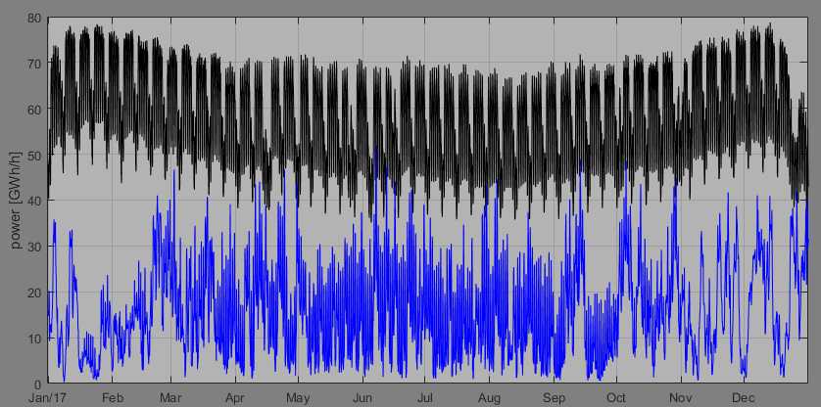  
*Figure: Energy consumption and production from wind and solar, for Germany. In the challenge described below, the production from wind and solar has been scaled up to better match the demand.*

**Wind + Solar Production**

**Power Consumption**

**The energy task**Global warming is one of the most severe problems we are facing right now. The main cause is the burning of fossil fuels like coal, gas and oil, to produce power. Trying to reduce the co2-emission, we are replacing coal and gas plants with wind and solar parks. At the same time we are getting more and more electric cars on the streets and the expected increase in the coming 5-10 years is dramatic. To orchestrate the production and consumption of power, such that supply always meets demand, is a challenge.

Your task is to provide power to a country. The only source of power production you have is from wind and solar. At your disposal you also have a battery, that we assume is composed of so-called second-life batteries from electric cars. The task is to balance, as far as possible, the discrepancy between the power production and the power demand.

**The details**You are given a set of time series: power consumption (=demand), and power production (=supply) from wind and solar parks. You also have various time series with weather forecasts. Data covers the period 2012-2016, hourly values.

In a power grid, power supply must meet power demand every second. Sometimes you will have more supply than you need, sometimes too little, to fulfill the demand. Your task is to use the battery specified to charge in times of oversupply, and discharge in times of undersupply, in the best possible way. The best possible way is defined by minimizing the imbalance. The imbalance is defined as demand minus supply.

With a big enough battery you could do this perfectly, but the battery at hand is too small to avoid imbalances. On top of this you will not have perfect foresight, meaning you do not know exactly how much the demand will be, nor how much supply from wind and solar we will have.

Every day at 09:00 a.m. you have to make a forecast of next day (24 hours) demand and supply, and based on that optimize how to use your battery. Also, every day at 09:00 a.m. you will have the actual demand and supply from the previous day.

One year of data (2017) will be left out to check the performance of your algorithm.

**Your Goal:**

To reach minimum imbalance cost in terms of costs of energy [MWh] and power peak [MW]

**Cost information**

Energy cost is 40 EUR/MWh

Power peak is 80 EUR/MW that is paid only once per day for the peak. In case of several peaks (with the same magnitude), it is paid only once.

**Technical feature of the battery**

Energy capacity of the battery = 16 MWh

Maximum power allowed for charging and discharging = 10 MW

Number of batteries = 3

Number of cycles for each battery = 1000 ( a cycle is equal to fully charging and discharging the battery)

Battery can be charged up to 90% of its energy capacity and can be discharged at 10% of its energy capacity (i.e., state of charge is between 10%-90%).

**What you have to hand in**

An algorithm doing the forecasting and optimization.

A script that loops over 2017, day-by-day.

In each loop, you read from two csv-files, one with actuals of demand and supply, and the other with weather forecasts.

In each loop you also write the output of your algorithm, which is how the battery(s) should be charged/discharged hour by hour, the next day.