**THE PROCESS - Custom Word Press Theme – Pre-Production**

1. **Install WordPress locally**
2. **Install WordPress theme**

**2.0 Structure of WordPress Folder**

* -> wp-content -> themes -> *<place your theme here>*
* Name your theme
* Inside the named theme is where you will create the folder structure used by WordPress
* Assets
* css
* images
* js
* fonts
* classes
* inc
* templates
* theme-templates
* template-parts
* 404.php
* archive.php
* comments.php
* footer.php
* functions.php
* header.php
* index.php (required file)
* page.php
* README.txt
* search.php
* single.php
* style.css (required tile)
* screenshot.png
* front-page.php

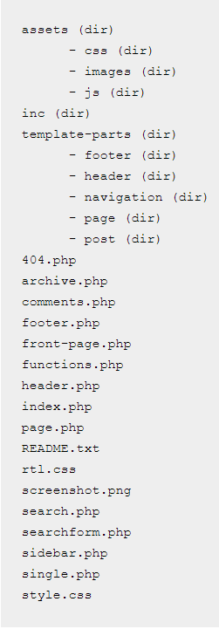

**3.0**