Experiment 3: Applying DFT to Organic Chemistry – Part A
  - Rotational barriers, conformers and cis–trans isomers
At a glance. 8 molecules × 16 methods = 128 jobs with the def2-TZVP basis, from a few seconds to about 3 minutes each (the diol and pentene with hybrid meta-GGAs are the slowest). Plan to submit them in batches (see working on a shared machine). You will learn how methods on different rungs of Jacob’s ladder perform for “easy” organic reactions, what dispersion corrections do, and what each functional costs.

Background
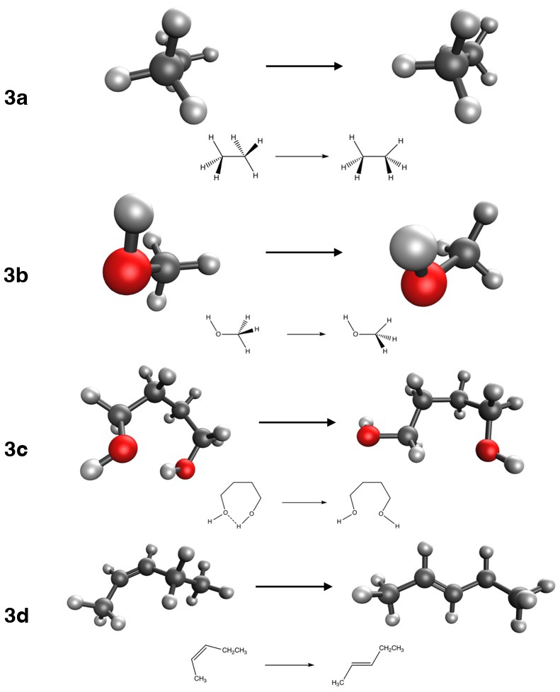
Reactions studied in Experiment 3: rotational barrier of ethane (3a) and methanol (3b), a conformational change of butane-1,4-diol (3c), and the cis–trans isomerization of pent-2-ene (3d). Carbon is black, oxygen red, hydrogen white; dotted lines are hydrogen bonds.
In this experiment you will analyze four reactions found in most introductory organic chemistry textbooks. For 3a you will calculate the energy difference between the staggered and eclipsed conformations of ethane. For 3b you will do the same for methanol. For 3c you will look at a change of conformation in butane-1,4-diol, which breaks an intramolecular hydrogen bond. 3d is the isomerization of cis-pent-2-ene to trans-pent-2-ene. The molecules come from the BHROT27 (Goerigk et al. 2017), BUT14DIOL (Kozuch et al. 2014) and FH51 (Friedrich and Hänchen 2013; Friedrich 2015) subsets of the GMTKN55 database (Goerigk et al. 2017).
The methods are:
- LSDA: SPW92 (Slater 1951; Perdew and Wang 1992, 2018)
- GGA: BP86 (Becke 1988; Perdew 1986a, 1986b), BLYP (Becke 1988; Lee et al. 1988), PBE (Perdew et al. 1996) and PBE-D4 (Perdew et al. 1996; Caldeweyher et al. 2017, 2019)
- meta-GGA: SCAN (Sun et al. 2015) and B97M-V (Mardirossian and Head-Gordon 2015; Vydrov and Van Voorhis 2010)
- hybrid GGA: B3LYP (Vosko et al. 1980; Becke 1988; Lee et al. 1988; Becke 1993; Stephens et al. 1994), B3LYP-D4 (Caldeweyher et al. 2017, 2019), B3PW91 (Perdew and Wang 1992, 2018; Becke 1988; Becke 1993; Perdew et al. 1992) and PBE0 (Adamo and Barone 1999; Ernzerhof and Scuseria 1999)
- hybrid meta-GGA: M06-2X (Zhao and Truhlar 2008), M11 (Peverati and Truhlar 2011), MN15 (Yu et al. 2016) and ωB97M-V (Vydrov and Van Voorhis 2010; Mardirossian and Head-Gordon 2016)
- Hartree–Fock (Hartree 1928b, 1928a; Fock 1930; Slater 1930)
Use the def2-TZVP basis set (Weigend and Ahlrichs 2005) for every calculation.
The reference energies are:
Reaction | 3a | 3b | 3c | 3d
ΔE_{ref} (kcal/mol) | 2.73 | 1.01 | 3.29 | –1.15
Compute each reaction energy as ΔE = Σ ν_{i} E_{i}, with ν_{i} > 0 for products and ν_{i} < 0 for reactants (units guide), then the signed error ε = ΔE_{comp} − ΔE_{ref} and the absolute error |ε|.

Enter your results
For every job, record the total energy, the number of SCF cycles and the wall time (where to find them). The page computes the time per SCF cycle for you in the explore section. Then enter your reaction energies in the last tab.
We will discuss these results more extensively after Experiment 5, when you have seen “easy”, “medium” and “hard” reactions.

Go further (optional)
Scan the full ethane rotation. Reaction 3a compares just two points on a curve. In this Colab notebook you rotate one methyl group from 0° to 120°, compute the whole torsional profile with PySCF, and see where the barrier comes from. Open in Colab
Adamo, C., and V. J. Barone. 1999. Chem. Phys. 110: 6158–70.
Becke, A. D. 1988. Phys. Rev. A 38: 3098–100.
Becke, A. D. J. 1993. Chem. Phys. 98: 5648–52.
Caldeweyher, E., C. Bannwarth, and S. Grimme. 2017. J. Chem. Phys. 147: 034112.
Caldeweyher, E., S. Ehlert, A. Hansen, et al. 2019. Chem. Phys. 150: 154122.
Ernzerhof, M., and G. E. J. Scuseria. 1999. Chem. Phys. 110: 5029–36.
Fock, V. Z. 1930. Phys. 61: 126–48.
Friedrich, J. J. 2015. Chem. Theory Comput. 11: 3596–609.
Friedrich, J., and J. J. Hänchen. 2013. Chem. Theory Comput. 9: 5381–94.
Goerigk, L., A. Hansen, C. Bauer, S. Ehrlich, A. Najibi, and S. Grimme. 2017. Phys. Chem. Chem. Phys. 19: 32184–215.
Hartree, D. R. 1928a. Math. Proc. Camb. Philos. Soc. 24: 111–32.
Hartree, D. R. 1928b. Math. Proc. Camb. Philos. Soc. 24: 89–110.
Kozuch, S., S. M. Bachrach, and J. M. L. J. Martin. 2014. Phys. Chem. A 118: 293–303.
Lee, C., W. Yang, and R. G. Parr. 1988. Phys. Rev. B 37: 785–89.
Mardirossian, N., and M. J. Head-Gordon. 2015. Chem. Phys. 142: 074111.
Mardirossian, N., and M. J. Head-Gordon. 2016. Chem. Phys. 144: 214110.
Perdew, J. P. 1986a. Phys. Rev. B 33: 8822–24.
Perdew, J. P. 1986b. Phys. Rev. B 34: 7406.
Perdew, J. P., K. Burke, and M. Ernzerhof. 1996. Phys. Rev. Lett. 77: 3865–68.
Perdew, J. P., J. A. Chevary, S. H. Vosko, et al. 1992. Phys. Rev. B 46: 6671–87.
Perdew, J. P., and Y. Wang. 1992. Phys. Rev. B 45: 13244–49.
Perdew, J. P., and Y. Wang. 2018. Phys. Rev. B 98: 079904.
Peverati, R., and D. G. J. Truhlar. 2011. Phys. Chem. Lett. 2: 2810–17.
Slater, J. C. 1930. Phys. Rev. 35: 210–11.
Slater, J. C. 1951. Phys. Rev. 81: 385–90.
Stephens, P. J., F. J. Devlin, C. F. Chabalowski, and M. J. J. Frisch. 1994. Phys. Chem. 98: 11623–27.
Sun, J., A. Ruzsinszky, and J. P. Perdew. 2015. Phys. Rev. Lett. 115: 036402.
Vosko, S. H., L. Wilk, and M. Nusair. 1980. Can. J. Phys. 58: 1200–1211.
Vydrov, O. A., and T. J. Van Voorhis. 2010. Chem. Phys. 133: 244103.
Weigend, F., and R. Ahlrichs. 2005. Phys. Chem. Chem. Phys. 7: 3297–305.
Yu, H. S., X. He, S. L. Li, and D. G. Truhlar. 2016. Chem. Sci. 7: 5032–51.
Zhao, Y., and D. G. Truhlar. 2008. Theor. Chem. Acc. 120: 215–41.

