Experiment 10: Final Review
  - You are the consultant
At a glance. Three species, and every choice is yours. You will show that you can choose and justify a method, set up the calculations properly, and report the results the way a computational paper would.

The request
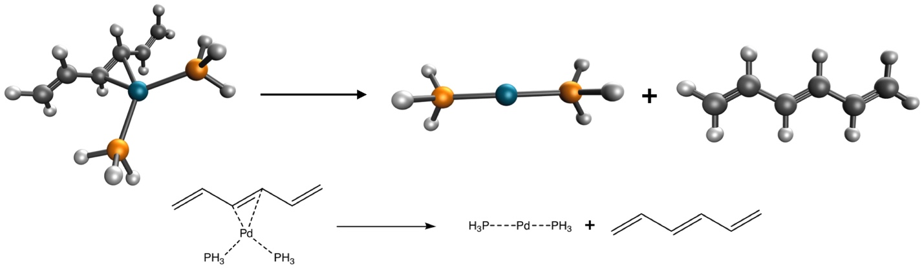
Dissociation of the diphosphinohexatrienepalladium(0) complex. Carbon is black, phosphorus orange, hydrogen white and palladium light blue; dotted lines are dative bonds.
Imagine that a colleague in your department is studying this palladium complex (the structures come from the PdBE2 subset [1] of the Minnesota 2015B database [2]) and asks you to calculate the bond dissociation energy of the reaction above. You are in charge of setting up the calculations.
Choose the functional and basis set based on:
- the published literature, for instance these recent benchmarks [2–11];
- the functionals available in Q-Chem;
- what you learned in Experiments 1–9: basis-set convergence, dispersion, grids, stability analysis.
Remember that every calculation is a compromise between accuracy and computational cost, and the free server stops jobs after 10 minutes. Pd needs an effective core potential (ECP = def2-ECP with the def2 basis sets).

Your method card
Choose every setting and write down why. The card warns you about common pitfalls (double-counting dispersion, grid-sensitive functionals) and estimates whether each job fits in the free server’s 10-minute limit. It then gives you the three Q-Chem inputs for your choice.

Enter your results
Record the three total energies, SCF cycles and wall times from your outputs, then your bond dissociation energy ΔE = E(Pd(PH₃)₂) + E(C₆H₈) − E(complex).

Your report
Write a short report (about 300 words) that:
- has a title;
- states the method you chose and why, citing the literature;
- describes the computational setup completely (program, functional, basis set, ECP, grid, stability analysis, convergence criteria), enough for someone else to reproduce your numbers;
- presents your results and compares them with the reference value of 16.20 kcal/mol;
- ends with an appropriate reference section.
 | Peer review. Your instructor may ask you to review two classmates’ reports on Canvas with a short rubric: is the method justified, is the setup reproducible, is the comparison with the reference honest?
[1] B. B. Averkiev, Y. Zhao, and D. G. Truhlar, J. Mol. Catal. A: Chem. 324, 80 (2010).
[2] H. S. Yu, X. He, S. L. Li, and D. G. Truhlar, Chem. Sci. 7, 5032 (2016).
[3] L. Goerigk, A. Hansen, C. Bauer, S. Ehrlich, A. Najibi, and S. Grimme, Phys. Chem. Chem. Phys. 19, 32184 (2017).
[4] N. Mardirossian and M. Head-Gordon, Mol. Phys. 115, 2315 (2017).
[5] H. S. Yu, W. Zhang, P. Verma, X. He, and D. G. Truhlar, Phys. Chem. Chem. Phys. 17, 12146 (2015).
[6] H. S. Yu, X. He, and D. G. Truhlar, J. Chem. Theory Comput. 12, 1280 (2016).
[7] N. Mehta, M. Casanova-Páez, and L. Goerigk, Phys. Chem. Chem. Phys. 20, 23175 (2018).
[8] R. Peverati and D. G. Truhlar, Philos. Trans. R. Soc. A 372, 20120476 (2014).
[9] B. Chan, P. M. W. Gill, and M. Kimura, J. Chem. Theory Comput. 15, 3610 (2019).
[10] B. Chan, J. Phys. Chem. A 123, 5781 (2019).
[11] S. Dohm, A. Hansen, M. Steinmetz, S. Grimme, and M. P. Checinski, J. Chem. Theory Comput. 14, 2596 (2018).

