Experiment 4: Applying DFT to Organic Chemistry – Part B
  - Diels–Alder, alkane isomers and dispersion-bound dimers
At a glance. 10 molecules × 16 methods = 160 jobs with def2-TZVP. Most take seconds; the two hexanes with hybrid functionals take up to about 5 minutes each. You will learn when error cancellation stops helping, and what dispersion corrections (-D4) and nonlocal correlation (VV10) actually fix.

Background
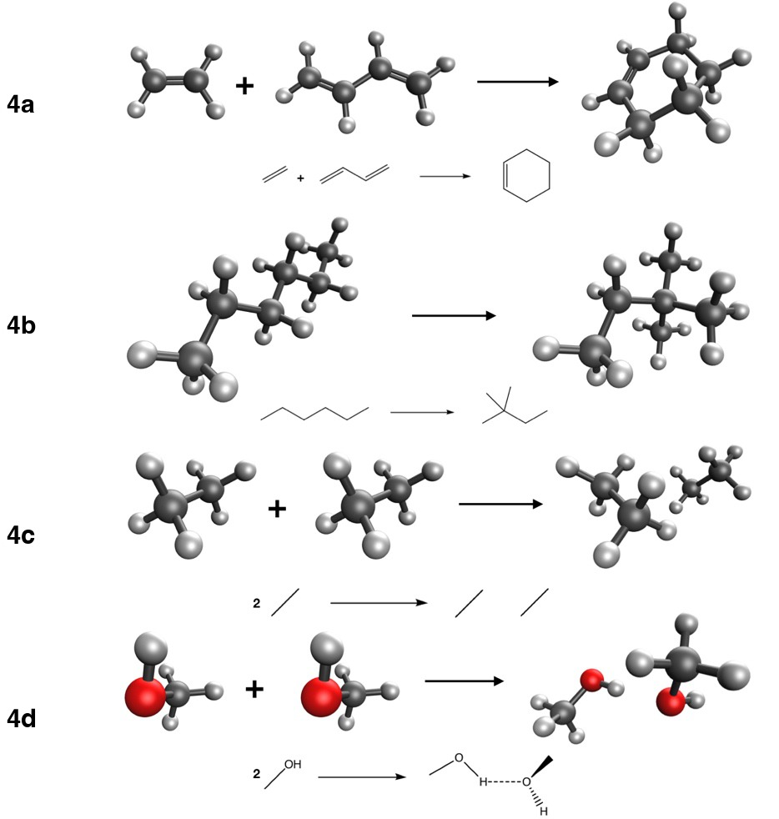
Reactions studied in Experiment 4: Diels–Alder reaction of ethene and butadiene (4a), isomerization of n-hexane to neohexane (4b), and formation of the ethane (4c) and methanol (4d) dimers. Carbon is black, oxygen red, hydrogen white; the dotted line is a hydrogen bond.
In this experiment you will deal with four more organic reactions commonly found in textbooks:
- 4a: the Diels–Alder reaction between ethene and butadiene to give cyclohexene, ΔE_{ref} = –45.40 kcal/mol.
- 4b: the isomerization of n-hexane to neohexane (2,2-dimethylbutane), ΔE_{ref} = –2.49 kcal/mol.
- 4c: the formation of the ethane dimer, held together only by van der Waals (dispersion) interactions, ΔE_{ref} = –1.34 kcal/mol.
- 4d: the formation of the methanol dimer, held together by a hydrogen bond, ΔE_{ref} = –5.81 kcal/mol.
These structures come from the DARC (Goerigk et al. 2017; Goerigk and Grimme 2010; Johnson et al. 2008) and ADIM6 (Goerigk et al. 2017; Grimme et al. 2010) subsets of the GMTKN55 database (Goerigk et al. 2017), and from the AlkIsomer11 (Curtiss et al. 1997; Karton et al. 2009) and S66 (Řezáč et al. 2011a, 2011b) subsets of the MGCDB84 database (Mardirossian and Head-Gordon 2017).
As in Experiment 3, use SPW92, BP86, BLYP, PBE, PBE-D4, SCAN, B97M-V, B3LYP, B3LYP-D4, B3PW91, PBE0, M06-2X, M11, MN15, ωB97M-V and Hartree–Fock (references in Experiment 3), all with the def2-TZVP basis set (Weigend and Ahlrichs 2005). For each functional, compute the reaction energies and the errors with respect to the reference.
 Note
For the dimers (4c, 4d) the reaction is monomers → dimer, so a negative ΔE means the dimer is bound. In 4d the two methanol monomers have slightly different geometries (they are cut from the dimer), so compute both.

Enter your results
For every job, record the total energy, the number of SCF cycles and the wall time (where to find them), then enter your reaction energies in the last tab. Reactions 4a and 4d involve three species each, and in 4c the ethane monomer counts twice (ν = −2): mind the coefficients.
Curtiss, L. A., K. Raghavachari, P. C. Redfern, and J. A. J. Pople. 1997. Chem. Phys. 106: 1063–79.
Goerigk, L., and S. J. Grimme. 2010. Chem. Theory Comput. 6: 107–26.
Goerigk, L., A. Hansen, C. Bauer, S. Ehrlich, A. Najibi, and S. Grimme. 2017. Phys. Chem. Chem. Phys. 19: 32184–215.
Grimme, S., J. Antony, S. Ehrlich, and H. J. Krieg. 2010. Chem. Phys. 132: 154104.
Johnson, E. R., P. Mori-Sánchez, A. J. Cohen, and W. J. Yang. 2008. Chem. Phys. 129: 204112.
Karton, A., D. Gruzman, and J. M. L. J. Martin. 2009. Phys. Chem. A 113: 8434–47.
Mardirossian, N., and M. Head-Gordon. 2017. Mol. Phys. 115: 2315–72.
Řezáč, J., K. E. Riley, and P. J. Hobza. 2011a. Chem. Theory Comput. 7: 2427–38.
Řezáč, J., K. E. Riley, and P. J. Hobza. 2011b. Chem. Theory Comput. 7: 3466–70.
Weigend, F., and R. Ahlrichs. 2005. Phys. Chem. Chem. Phys. 7: 3297–305.

