Statistical Inference Project - Part 1

Peter Warren

Saturday, January 24, 2015

# Overview

In a few (2-3) sentences explain what is going to be reported on.

E[X] = 1 / $lamba$

Var[X] = 1 / $lamba$ ^2

Let $X_{i}$ be the outcome for die $i$ Then note that $μ=E[X_{i}]=3.5$ $Var(X_{i})=2.92$

# Simulations

Include English explanations of the simulations you ran, with the accompanying R code. Your explanations should make clear what the R code accomplishes.

# Sample Mean versus Theoretical Mean

Include figures with titles. In the figures, highlight the means you are comparing. Include text that explains the figures and what is shown on them, and provides appropriate numbers.

# Sample Variance versus Theoretical Variance:

Include figures (output from R) with titles. Highlight the variances you are comparing. Include text that explains your understanding of the differences of the variances.

# Distribution:

Via figures and text, explain how one can tell the distribution is approximately normal.

set.seed(1819)  
library(ggplot2)  
  
numSims <- 1000  
  
lambda <- 0.2  
#hist(rexp(1000, 0.2), breaks = 25)  
  
df1 <- as.data.frame(rexp(1000, lambda))  
names(df1) <- "randExp"  
  
g1 <- ggplot(df1, aes(randExp))  
g1 <- g1 + geom_histogram(binwidth=1, aes(y = ..density..), fill="blue", col="black")  
g1

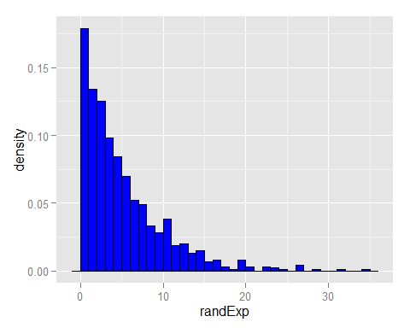

You can also embed plots, for example:

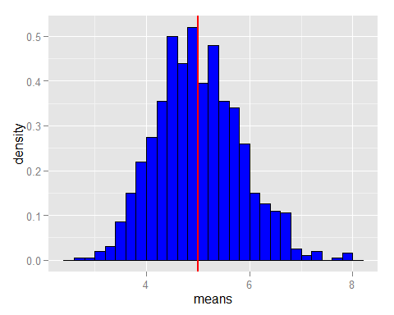

Note that the echo = FALSE parameter was added to the code chunk to prevent printing of the R code that generated the plot.