BadAPU
Miller Paule
The BadApu in all its glory
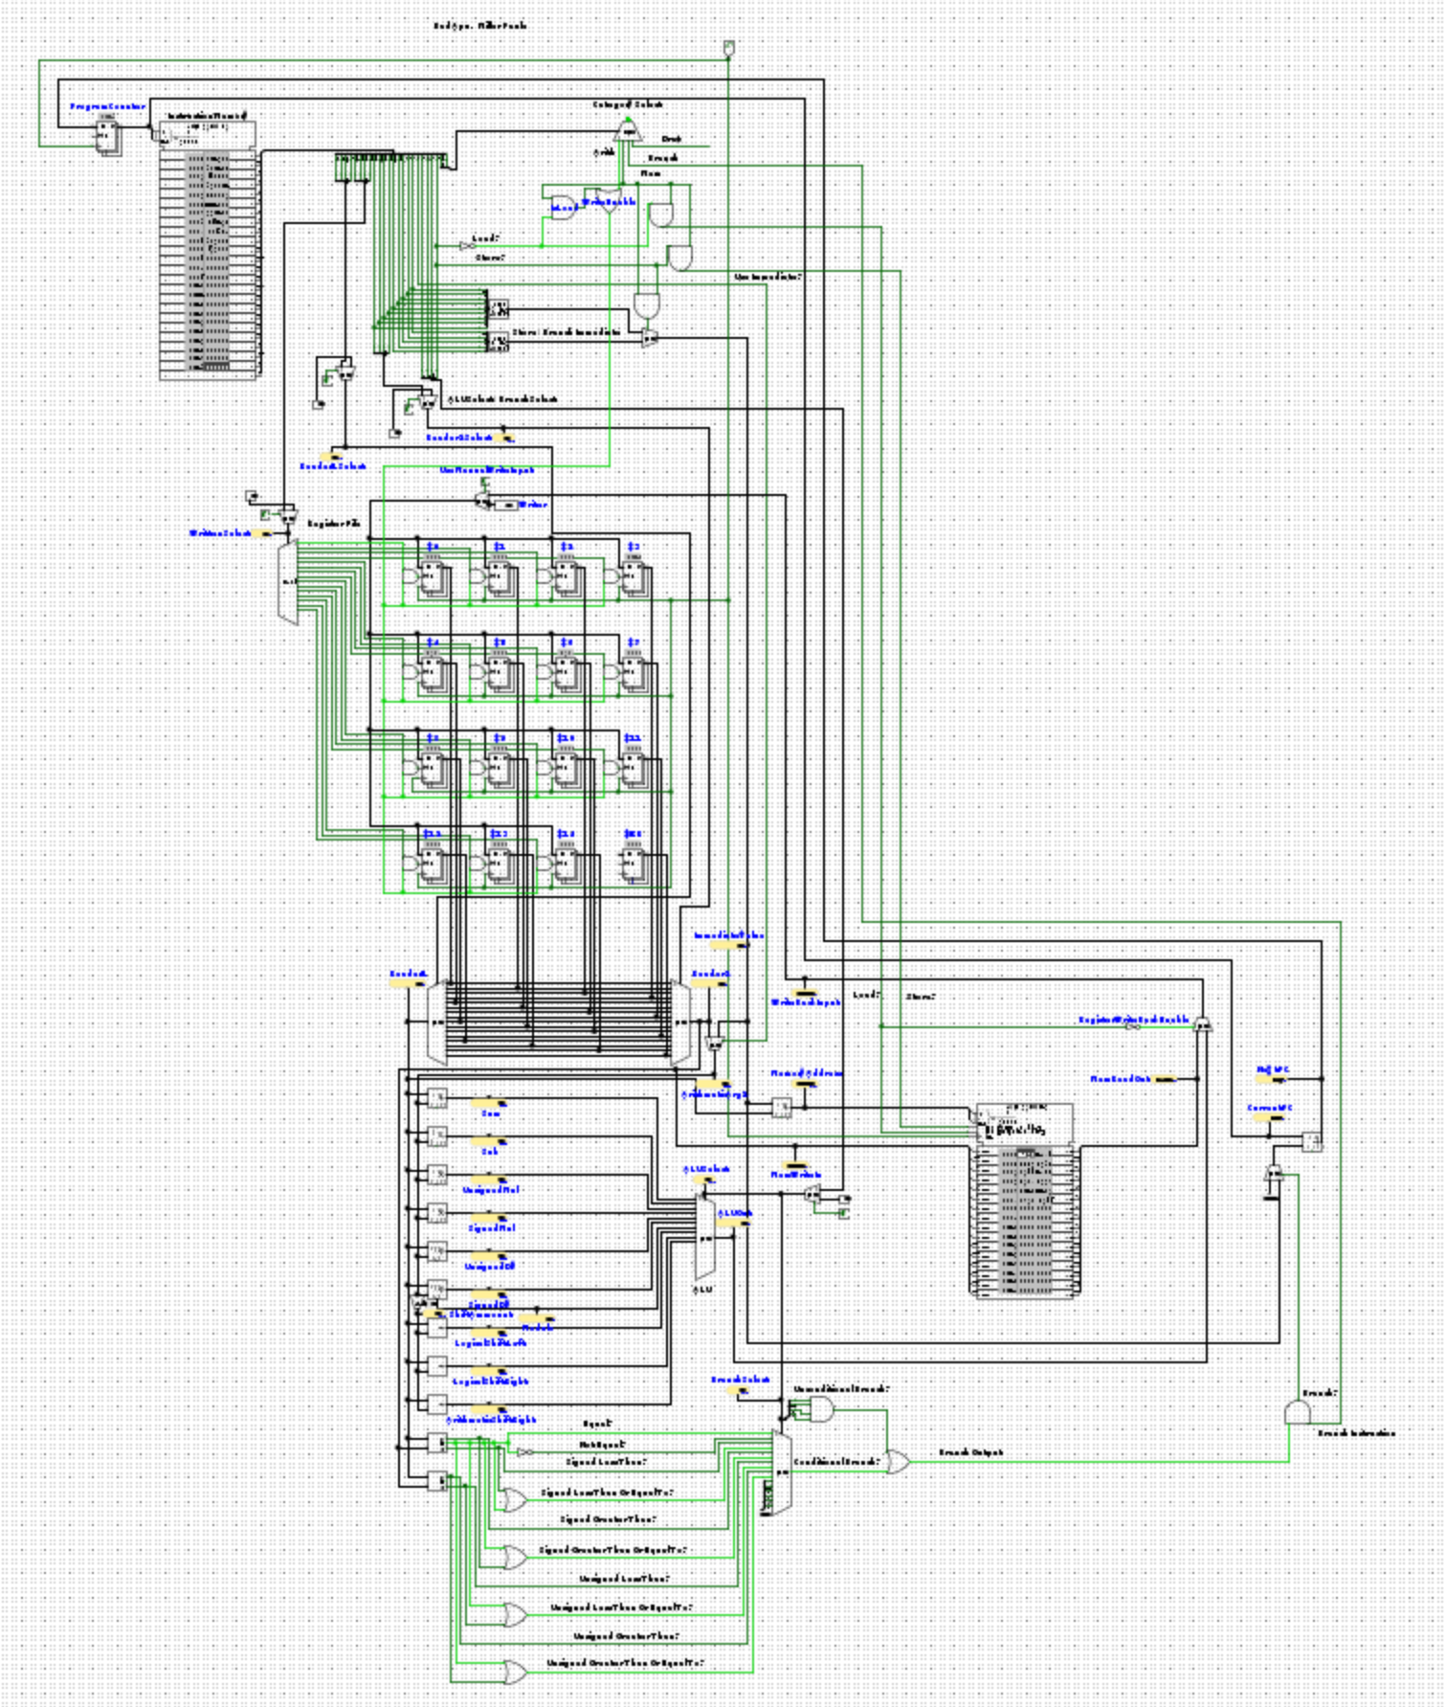
Congratulations on your purchase of the near future in computing and technology. The BadApu is a combined computational-graphical unit capable of performing typical CPU operations and displaying a programmable video output. Or at least, that’s what it was supposed to do, but due to tight time constraints, budget cuts, mass layoffs, change in ownership, general shenanigans and a legal fight with AMD, it is only a CPU with the title of “APU”. The bad APU is home to 16 16 bit registers, the 16th of which is a dedicated zero register (referred to with “XZERO”) that cannot be written to and always outputs 0. For arithmetic, the BadAPU is capable of addition, subtraction, multiplication, division, modulo, logical shifts left and right and arithmetic shift right. For comparisons, you have access to equal to, not equal to, less than, less than or equal to, their greater than counterparts and unsigned versions of these comparisons. BadAPU comes with 2¹⁶ 24 bit words of ROM and 2¹⁶ 16 bit words of RAM. The addresses to both of these are 16 bits wide. ROM is for instructions only and cannot be directly read from. Memory can be read and stored as 16 bit words.

To program this APU, will with have to use BadAPU’s instruction set. Included with this manual is an example program, “test_prog.instr”. “.instr” stands for “instertions”. You probably thought it stood for “instructions”. You thought wrong. This file is actually the list of things that are “introduced” to and then “stirred” into the APU. Never assume anything. This example program should be a good demonstration of the instruction syntax, but to give specific rules:

- Data sections are entirely optional.
- Data sections are headed with “--DATA--”
  - You write to this data section by giving that buffer a name. BadAPU will actually let you name that buffer whatever (continuous string with no whitespace) you want, even if it’s a really terrible name. Go nuts.
  - Following the buffer name, you write a “<-“ to show you are assigning to it.
  - You then fill in the contents of the buffer with comma separated values placed between [] brackets.
  - Example: DATA <- [1, 2, 4, 8, 15, 32]
- Instruction sections are headed with “--INSTRUCT--”
  - You can try to start them with something else as much as you want, but it will probably not work ever
  - Instructions follow the formula of XN <- OP(XM, XP), where…
    - XN is the register that is written back to
      - In branching instructions, this is instead the label that is jumped to
    - OP is the operation being performed
    - XM and XP are the instructions arguments. There might be 1 or 2, but never 3.
  - The arithmetic instructions are ADD, SUB, UMULT, MULT, UDIV, MODU, LSL, LSR and ASR
    - UMULT and UDIV are unsigned versions of MULT and DIV
    - The shifting operations truncate the 12 most significant bits of their second operand.
    - The second operand of these instructions can be either a register or a 9 bit signed immediate
      - For example, X1 <- MODU(X1, 5)
  - The Memory instructions are LOAD and STORE
    - Memory addresses are represented as a register holding the address and an immediate offset surrounded by brackets
      - For example, [X5, -4]
    - LOAD is written as XN <- LOAD([XM, A])
    - STORE is written as [XM, A] <- STORE(XN)
      - STORE is special in that unlike most other instruction’s 9 bit immediates, STORE can only use 5 bit immediates
        - If you take issue with this, please forward all complaints to millerp2006@gmail.com
  - The branching instructions are (sit down for this one) B, BEQ, BNEQ, BLT, BLTEQ, BTG, BGTEQ, BULT, BULTEQ, BUGT, and BUGTEQ
    - B is an unconditional jump
    - BEQ and BNEQ are for equal and not equal respectively
    - “LT” and “GT” mean less than and greater than respectively
    - “EQ” after “LT” or “GT” means “or equal to”
    - A “U” in the instruction name indicates it operates on unsigned values
    - As explained before, branch instructions point to the label they jump to
      - For example, LABEL <- BGTEQ(X8, X6)
    - Branch instructions can only take registers as their arguments
    - Branch instructions use a 5 bit immediate for their jumping offset meaning they can only jump by 2⁵ instructions
      - The assembler will not let you assemble programs where you make too big of a jump
    - There are two other miscellaneous instructions, ADDR and MOVE
      - Both of these are secretly just ADD and XZERO in a trench coat
        - It’s a secret though so shhhhhhh
      - MOVE will simply assign the value in the argument register or immediate to a register
        - For example, X5 <- MOVE(43)
      - ADDR will move the starting address of a data section into a register
        - For example, X13 <- ADDR(BUFFER)
    - Comments are made by starting a line with “||”
      - For example, ||This is a comment

The encoding of these instructions is as follows:
Instruction | First Argument Register Select | Write Back Register Select | 9 Bit Immediate |  | Use Immed-iate Enable | Opcode |  |  | Instruction Type Select
Instruction | First Argument Register Select | Write Back Register Select | 15<->7 |  | Use Immed-iate Enable
Instruction | First Argument Register Select | Write Back Register Select | Second Argument Register Select | 5 Bit Immedia-te (STORE and branch only) | Use Immed-iate Enable
Instruction | 23<->20 | 19<->16 | 15<->12 | 11 <-> 7 | 6 | 5 <-> 3 |  |  | 2 <-> 0
RD <- ADD(RN, RM) | RN | RD | RM/IMMED |  | 0/1 | 0 | 0 | 0 | 0 | 0 | 0
RD <- SUB(RN, RM) |  |  |  |  |  | 0 | 0 | 0 | 1 | 0 | 0
RD <- UMULT(RN, RM) |  |  |  |  |  | 0 | 0 | 1 | 0 | 0 | 0
RD <- MULT(RN, RM) |  |  |  |  |  | 0 | 0 | 1 | 1 | 0 | 0
RD <- UDIVI(RN, RM) |  |  |  |  |  | 0 | 1 | 0 | 0 | 0 | 0
RD <- DIVI(RN, RM) |  |  |  |  |  | 0 | 1 | 0 | 1 | 0 | 0
RD <- MODU(RN, RM) |  |  |  |  |  | 0 | 1 | 1 | 0 | 0 | 0
RD <- LSL(RN, RM) |  |  |  |  |  | 0 | 1 | 1 | 1 | 0 | 0
RD <- LSR(RN, RM) |  |  |  |  |  | 1 | 0 | 0 | 0 | 0 | 0
RD <- ASR(RN, RM) |  |  |  |  |  | 1 | 0 | 0 | 1 | 0 | 0
RD <- LOAD([RN, IMMED]) | N/A | RD | RM | IMMED | 1 | 0 | 0 | 0 | 0 | 0 | 1
[RN, IMMED] <- STORE(RM) | RN | N/A | RM | IMMED | 1 | 0 | 0 | 0 | 1 | 0 | 1
LABEL <- B | N/A | N/A | N/A | Offs-et from LABEL | 1 | 1 | 1 | 1 | 1 | 1 | 0
LABEL <- BEQ(RN, RM) | RN | N/A | RM | Offs-et from LABEL | 1 | 0 | 0 | 0 | 0 | 1 | 0
LABEL <- BNEQ(RN, RM) |  |  |  |  |  | 0 | 0 | 0 | 1 | 1 | 0
LABEL <- BLT(RN, RM) |  |  |  |  |  | 0 | 0 | 1 | 0 | 1 | 0
LABEL <- BLTEQ(RN, RM) |  |  |  |  |  | 0 | 0 | 1 | 1 | 1 | 0
LABEL <- BTG(RN, RM) |  |  |  |  |  | 0 | 1 | 0 | 0 | 1 | 0
LABEL <- BGTEQ(RN, RM) |  |  |  |  |  | 0 | 1 | 0 | 1 | 1 | 0
LABEL <- BULT(RN, RM) |  |  |  |  |  | 0 | 1 | 1 | 0 | 1 | 0
LABEL <- BULTEQ(RN, RM) |  |  |  |  |  | 0 | 1 | 1 | 1 | 1 | 0
LABEL <- BUGT(RN, RM) |  |  |  |  |  | 1 | 0 | 0 | 0 | 1 | 0
LABEL <- BUGTEQ(RN, RM) |  |  |  |  |  | 1 | 0 | 0 | 1 | 1 | 0

To assemble these instructions, you will need the BadAPU assembler which is bundled alongside your APU. To use the BadAPU assembler, you will need the Rust language’s toolchain. This can be installed by running
$ curl --proto '=https' --tlsv1.2 https://sh.rustup.rs -sSf | sh

in your terminal. It can also be installed via your package manager if you prefer but you may need to do a bit more to install the Cargo build system. Once all of that is prepared, from the same directory as the “Cargo” files that should be named “cargo” but for some reason they don’t let you call them that and it is really annoying like there’s no good reason for it and the GutHub issue about it has made no progress and the “src” directory, simply run
$ cargo run -- your_program.instr

If you’re still alive by the time the Rust toolchain and program finish compiling, you will see either an error message or nothing if assembling was successful. This specific example will generate “your_program_instruct.vci” and “your_program_data.vci”. As you know, “vci” stands for “video compute information”. From Logisim, load the file with “_instruct” into the ROM in the top left corner. Be sure the file format is set to “Binary” and endianness is set to “big-endian”. Next, load the file with “_data” into the RAM that’s in the middle bottom-ish area of the APU, you can’t miss it. Load the file with “Binary” and “big-endian” options as before. From there, simply hit ctrl + k (or go to “Simulate -> Auto-Tick Enabled” if you aren’t a level 5000 pro Logisim power user). You’ll probably want to lower the auto tick frequency so you can actually see what your program is doing. After that, sit back and enjoy. With enough abstractions and elbow grease, you could easily write a program for the BadAPU to surf the web, do your taxes, or send nasty emails, the world is your oyster with the BadAPU at your side.

