### FINAL TEST – Final – Afternoon Session

Student: ______________________

**Be sure to read the following general instructions carefully:**

* This assignment test must be completed individually by all the students.
* You should submit a **VIDEO** demo and the entire project through dropbox link on eCentennial immediately after demonstration. Without submitting a video demo you will be penalized at least 30 percent of the total grade even if everything works well.

##### Exercise 1

Start a new Java project. Name the project: **YourFullName_COMP228_SecXX_TestFall2021**. For example: JohnSmith_COMP228_Sec012_TestFall2016. **DO NOT** create a package in this project. Let IntelliJ or Eclipse create the default package.

Write a GUI application in Java using JavaFX that allows user to add 1) car information to a database, 2) delete selected cars from the database, and 3) filter table of cars by selecting make, model, year, and price. The user should be able to filter the cars table for a range of years. The user should be able to select the price range as well. If all conditions are provided regarding make, model, year, and price, all of them should be applied to the filter function.

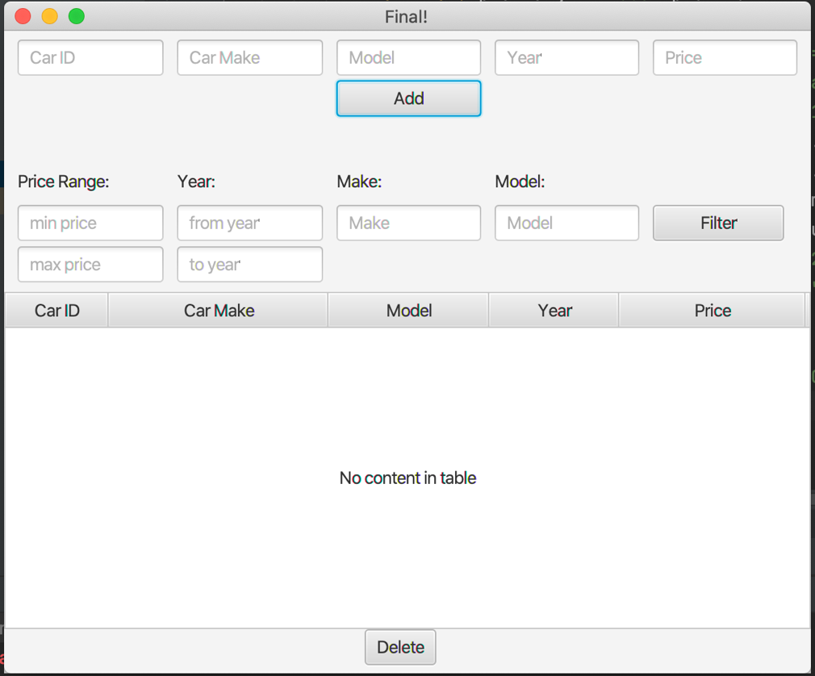

The application should retrieve the books information from an Oracle table named **Book**. Here is the definition of the table:

CREATE TABLE Car (

carID integer NOT NULL,

make varchar (20) NOT NULL,

model varchar (100) NOT NULL,

b_year integer NOT NULL,

price integer NOT NULL,

PRIMARY KEY (carID)

);

Populate the table with several rows as below:

INSERT INTO Car VALUES(1, 'BMW', 'X4',2019, 40000);

…

commit;

Use the most appropriate layout manager classes to implement the layout of this GUI. (100 marks)

**Evaluation:**

|  |  |
| --- | --- |
| **Functionality** |  |
| Correct implementation of UI (using JavaFX components, event handling) | 35% |
| Correct implementation of data access using JDBC (connecting with server, executing a prepared statement, displaying results) | 50% |
| Comments, correct naming of variables, methods, classes, etc. | 5% |
| **Friendly input/output** | 10% |
| **Total** | 100% |
| **Without Video Demo** | -30% |