**Centennial College**

**COMP 228: Java Programming**

**LAB #5 - Developing Database Applications using JDBC.**

**Student:** ______________________________________________________________________

Due Date: Week 12.

Purpose: The purpose of this Lab assignment is to:

1. Practice JDBC in Java Applications
2. Develop a GUI Java application with data access capabilities

References: Read the textbook, ppt slides, and consult references (if any).

This material provides the necessary information you need to complete the exercises.

Instructions: Be sure to read the following general instructions carefully:

* Students can work in pairs for this assignment using **pair programming** technique (https://en.wikipedia.org/wiki/Pair_programming).
* You will have to demonstrate your solution in a scheduled lab session and submitting the project through the **dropbox link on eCentennial**.
* You must name your Eclipse project according to the following rule:

**YourFullName_COMP228Labnumber**

Example: **JohnSmith_COMP228Lab5**

Each exercise should be placed in a separate package named *exercise1*, *exercise2*, etc.

Submit your assignment in a **zip file** that is named according to the following rule:

**YourLastName_COMP228Labnumber.zip**

Example: **JohnSmith_COMP228Lab5.zip**

**For a pair submission include both full names. Example: JohnSmith_JaneSmith_COMP228Lab5**

Apply the naming conventions for variables, methods, classes, and packages:

- *variable names* start with a *lowercase* character

- *classes* start with an *uppercase* character

- **packages** use only *lowercase* characters

- *methods* start with a *lowercase* character

### **Exercise 1:**

Develop a GUI Java application that will allow the players to submit information about themselves and the games that they are playing on-line. The information will be stored in a simple Oracle database. The database tables are shown in the following picture:

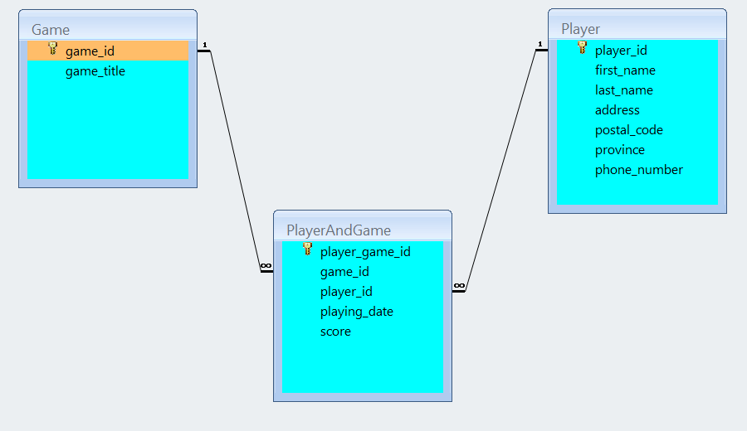

You can use SQL Developer to create your database in Oracle server.

You should populate the table *Game* with titles of games that you have "played" during this semester.

Your GUI should provide the necessary SWING or JavaFX components that will allow the user to enter and display the data. You will use JDBC to provide the following operations:

1. *Insert* game and player information into the database.
2. *Update* the existing player information.
3. *Display* reports with player and played games information. You may use a *JTable or other components to display the reports. Allow the user to select player_id*.

Use prepared statements to implement all database operations.

(10 marks)

**Evaluation:**

|  |  |
| --- | --- |
| **Functionality** |  |
| Correct implementation of UI and event handling. | 35% |
| Correct implementation of JDBC | 50% |
| Comments, correct naming of variables, methods, classes, etc. | 5% |
| **Friendly input/output** | 10% |
| **Total** | 100% |