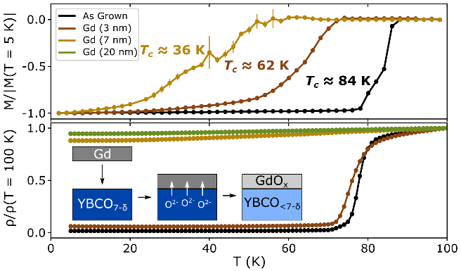

*(A) Superconducting transition measured by normalized magnetization (top) and resistivity (bottom). (B,C) Cross-sectional HAADF-STEM images of the Gd/YBCO interface for the Gd (3nm) sample (B) and the Gd (20nm) sample (C). The crystal structure is depicted with Cu, Ba, and Y atoms highlighted in yellow, red, and blue, respectively. Inset depicts oxygen depletion process: a Gd metal capping layer chemically induces oxygen migration at the YBCO/Gd interface, leaching oxygen from deep within the film; as a result, the YBCO layer is reduced to an oxygen-deficient state.*