**Supporting Information**

Title:

Interfacial-Redox-Induced Tuning of Superconductivity in YBa2Cu3O7-δ

**Authors:**

*Peyton D. Murray, Dustin A. Gilbert, Alexander J. Grutter, Brian J. Kirby,*

*David Hernandez-Maldonado, Maria Varela, Zachary E. Brubaker,* *W.L.N.C. Liyanage,Rajesh V. Chopdekar, Valentin Taufour, Rena J. Zieve, Jason R. Jeffries, Elke Arenholz, Yayoi Takamura, Julie A. Borchers, Kai Liu*

The nuclear SLD profiles presented in Fig. 4 of the main text correspond to the models which best fit the specular reflectivities of the as-grown and Gd-capped samples measured at 6 K, shown in Fig. S1. The data was fitted in parallel with the $ρ_{N}^{STO}$, $ρ_{N}^{GdO}$, $ρ_{N-imag}^{GdO}$, $ρ_{N}^{Au}$ strictly coupled such-that is it the same in every model. The non-spin-flip reflectivities of the as-grown and Gd (3 nm and 7 nm) YBCO samples show minimal spin asymmetry, indicating that little to no magnetism is present in either the YBCO or the Gd layer, even without fitting. Thus, the possibility of magnetic proximity effects playing a role in the suppression of superconductivity of these samples can be ruled out. Magnetometry of the Gd(20 nm) sample - which is most-likely to possess residual, un-oxidized Gd - in a 10 Oe out-of-plane field shows no evidence for magnetism in the range from 100 K to 5 K (Fig. S2), indicating that the Gd has likely oxidized.

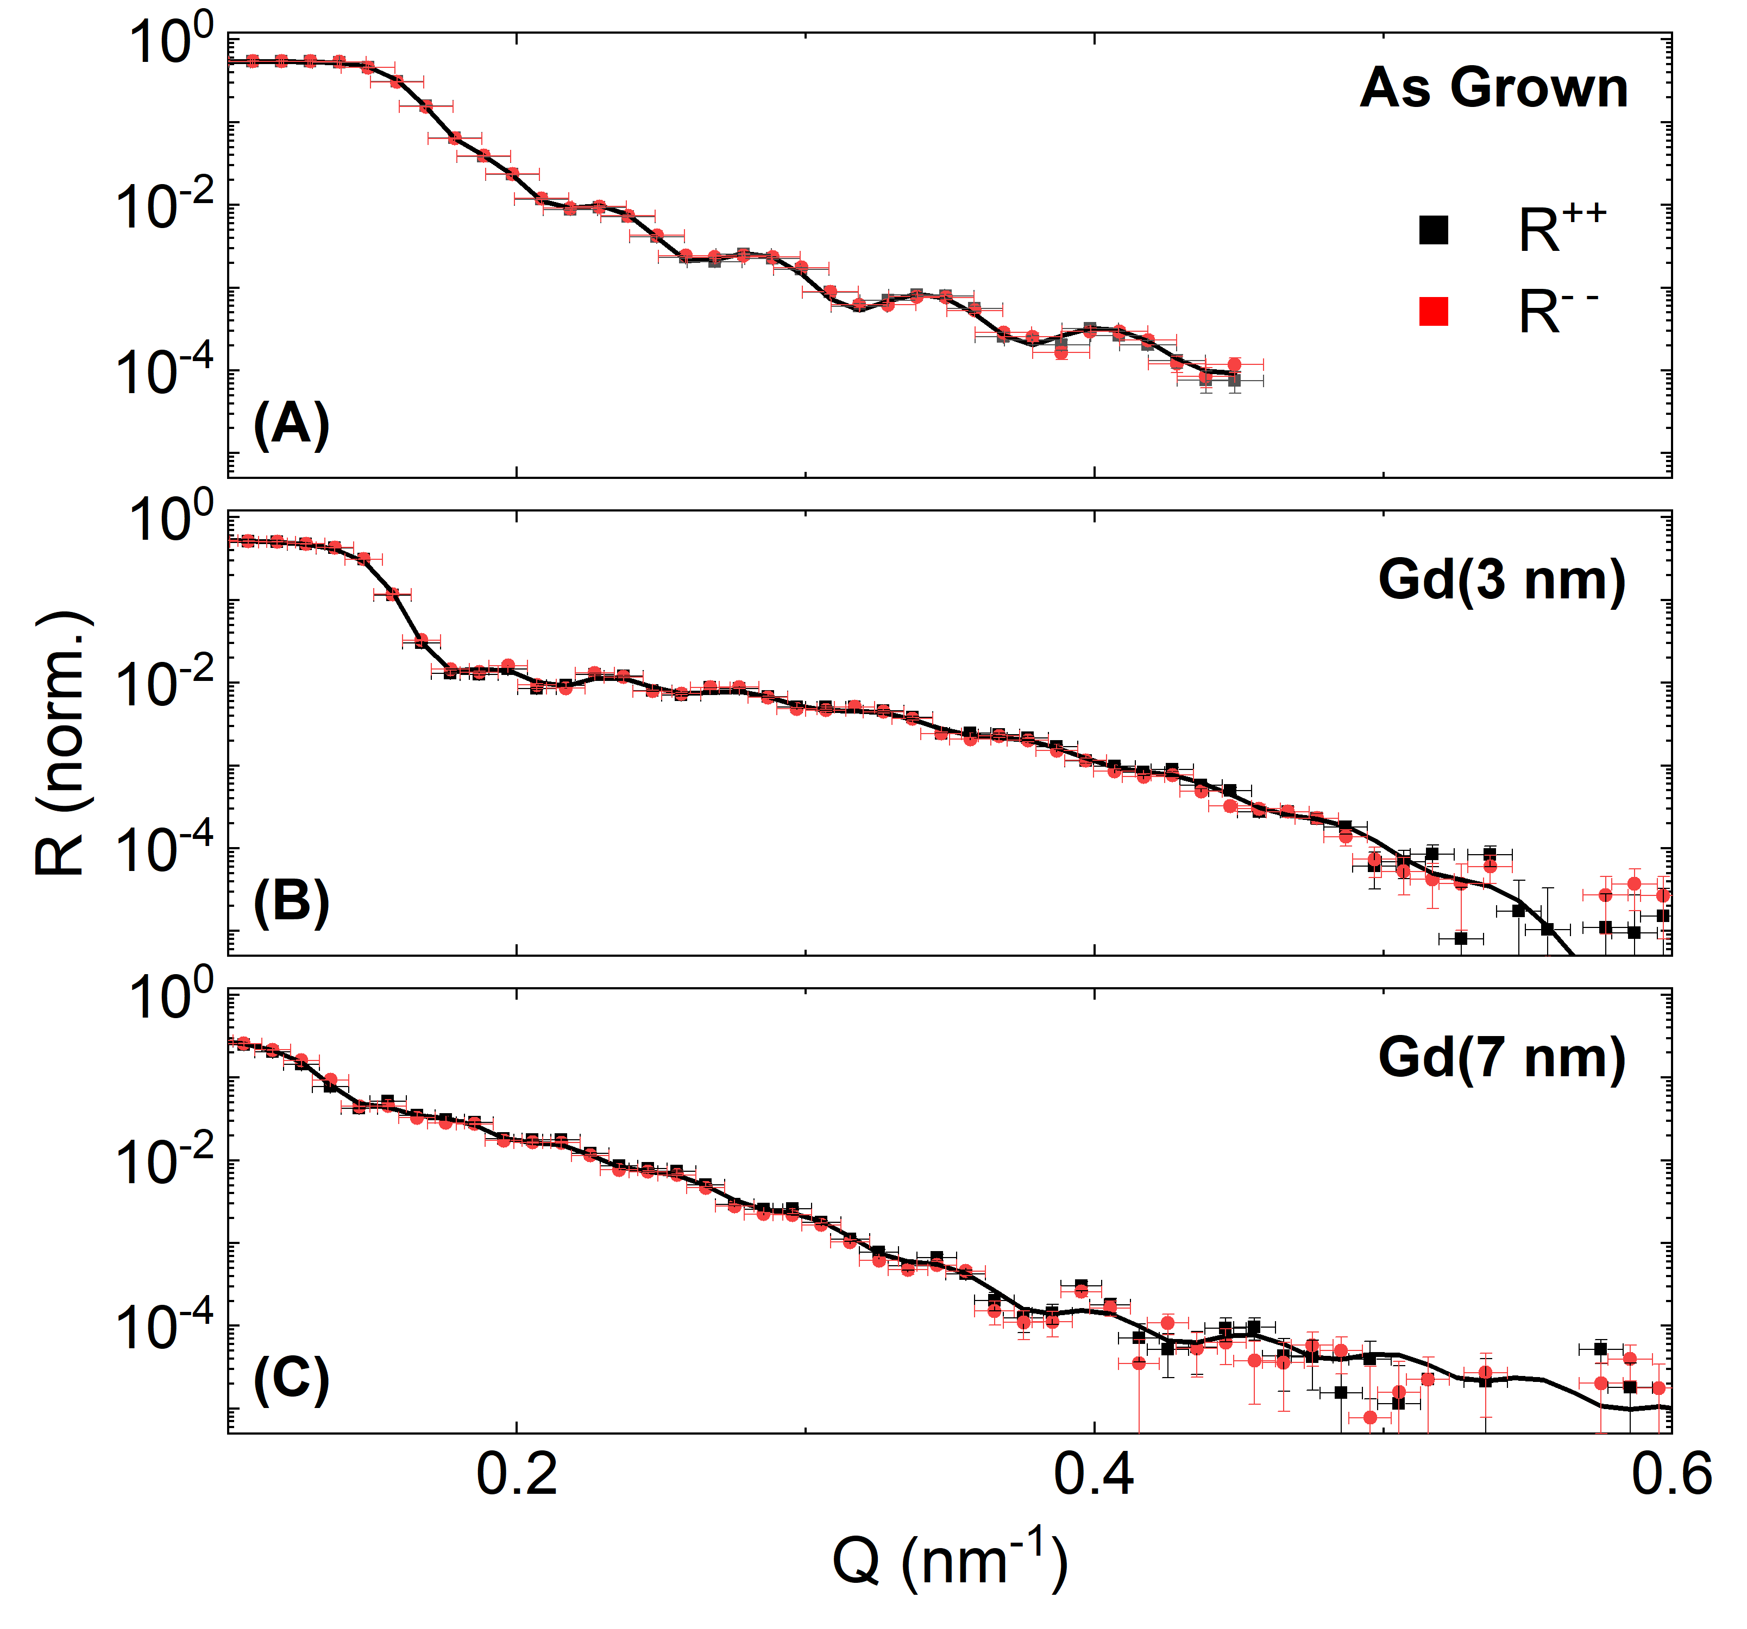

**Fig. S1.** **Neutron reflectometry profiles.** Specular neutron reflectivities of the non-spin-flip channels ( $R++$ and $R--$) shown as a function of scattering vector $Q_{Z}$ for (**A**) the as-grown, (**B**) Gd (3 nm), and (**C**) Gd (7 nm) samples. In all panels, symbols denote experimental data with uncertainty, with fits corresponding to the models from Fig. 4 of the main text shown as red and black lines.

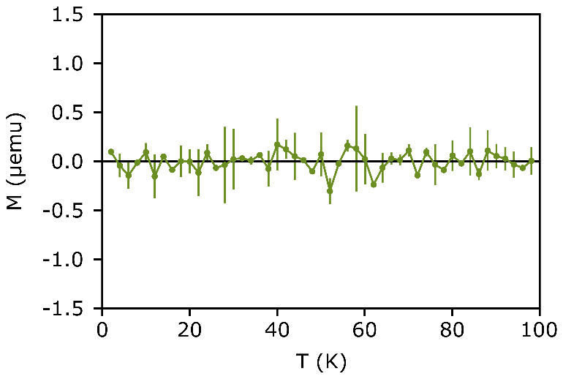

**Fig. S2.** **Magnetometry of $t_{Gd}=20$ nm sample.** Magnetic moment shown as a function of temperature in the range from 5 – 100 K, indicated by symbols with uncertainty.