FORCIT Software Users’ Guide

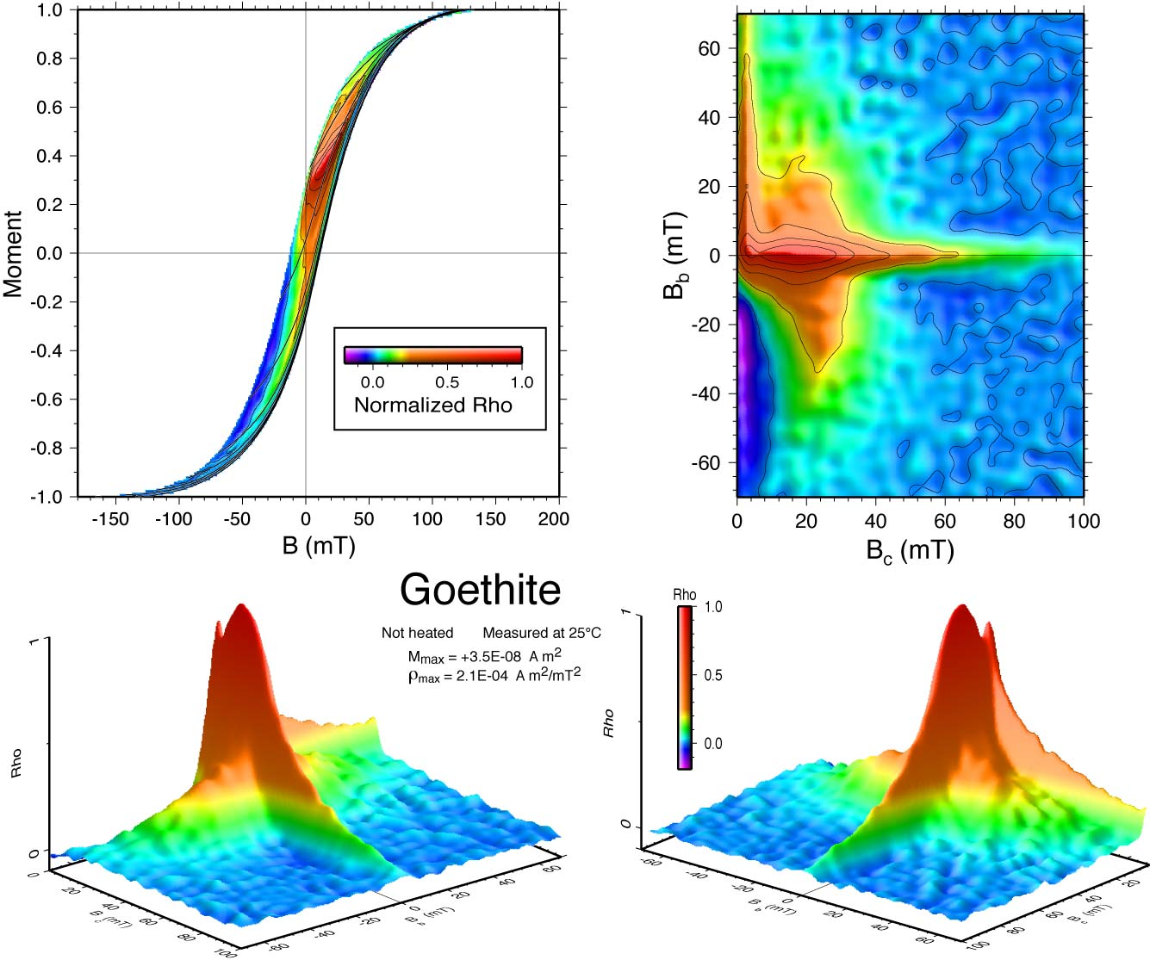

Gary Acton
One Shields Avenue
Department of Geology
University of California, Davis
Davis, CA 95616

Version 2007-05-22

FORCIT Software Users’ Guide: A description of how to install
and use program FORCIT to produce first-order
reversal curve (FORC) and related diagrams.

Copyright © 2007, Gary Acton

All rights reserved.

Copyright Information

Copyright © 2007 Gary Acton.
All rights reserved.
Redistribution and use in source and binary forms, with or without modification, are permitted provided that the following conditions are met:
- Redistributions of source code must retain the above copyright notice, this list of conditions and the following disclaimer.
- Redistributions in binary form must reproduce the above copyright notice, this list of conditions and the following disclaimer in the documentation and/or other materials provided with the distribution.
- Neither the name of the University of California, Davis nor the names of its contributors may be used to endorse or promote products derived from this software without specific prior written permission.

THIS SOFTWARE IS PROVIDED BY THE COPYRIGHT HOLDERS AND CONTRIBUTORS "AS IS" AND ANY EXPRESS OR IMPLIED WARRANTIES, INCLUDING, BUT NOT LIMITED TO, THE IMPLIED WARRANTIES OF MERCHANTABILITY AND FITNESS FOR A PARTICULAR PURPOSE ARE DISCLAIMED. IN NO EVENT SHALL THE COPYRIGHT OWNER OR CONTRIBUTORS BE LIABLE FOR ANY DIRECT, INDIRECT, INCIDENTAL, SPECIAL, EXEMPLARY, OR CONSEQUENTIAL DAMAGES (INCLUDING, BUT NOT LIMITED TO, PROCUREMENT OF SUBSTITUTE GOODS OR SERVICES; LOSS OF USE, DATA, OR PROFITS; OR BUSINESS INTERRUPTION) HOWEVER CAUSED AND ON ANY THEORY OF LIABILITY, WHETHER IN CONTRACT, STRICT LIABILITY, OR TORT (INCLUDING NEGLIGENCE OR OTHERWISE) ARISING IN ANY WAY OUT OF THE USE OF THIS SOFTWARE, EVEN IF ADVISED OF THE POSSIBILITY OF SUCH DAMAGE.

Citation Information

If you use the software to generate figures for publications, the contributors would appreciate a citation to:

Acton, G., Roth, A., and Verosub, K. L, Analyzing Micromagnetic Properties With FORCIT Software. Eos, 2007 (in press).

Table of contents
Copyright Information
Citation Information
Introduction
Units and Nomenclature
FORC Defined
FORC Measurements
Instrument Settings
FORC Analysis
Installing FORCIT and Associated Software
Installing Unix Developer Tools (Xcode)
Installing Fink
Installing TextWrangler
Downloading FORCIT
Opening a terminal Window
Creating a .cshrc profile
Installing GMT and Fortran77 Compilers
Installing FORCIT
Running FORCIT
Examples
FORCIT Help
FORCIT Defaults
FORCIT Output
Storing FORCIT Plots
Analyzing Multiple FORCs Sequentially
Running TRACKIT
Interpreting FORC Diagrams
Acknowledgements
References Cited and FORC Bibliography

Introduction

This document is intended to be a quick reference for installing and using program FORCIT, which produces a variety of diagrams related to first-order reversal curves (FORCs) (Mayergoyz, 1986, 2003; Pike et al., 1999).

The use of FORCs has grown rapidly since the late 1990’s when C. Pike, K. L. Verosub, and their colleagues and students in the Department of Geology and the Department of Physics at University of California, Davis, in conjunction with Princeton Measurement Corporation, improved experimental methods for making FORC measurements (e.g., Pike et al., 1999, 2001a,b; Pike and Fernandez, 1999; Roberts et al., 2000). Since then, the FORC analysis method has continued to evolve rapidly, although analyzing the data and producing plots has remained time consuming, difficult, and relatively expensive as the available FORC software required the use of commercial graphical software packages. Most importantly, the number of FORC measurements being made in labs around the world was growing rapidly and, as a result, fast efficient methods were needed for processing and displaying the results.

The FORCIT software package was developed to overcome these problems and to make it easy for researchers, visitors, and students in our lab and elsewhere to quickly and independently produce FORC diagrams. The software is a combination of Unix shell scripts, Fortran77, and Generic Mapping Tool (GMT; Wessel and Smith, 1998) commands, all of which are available free of charge. FORCIT is executed from a standard Unix terminal window and generates two- and three-dimensional graphics that display the FORC distribution in a variety of coordinate spaces as well as other related graphics.

Units and Nomenclature

Magnetic units have become complicated by the required conversion from the cgs system often used in laboratories to the SI system used by journals and by the somewhat interchangeable usage of the magnetic induction field (B) and the magnetizing field (H) and of the magnetization polarization (J) and magnetization (M). Similarly, the nomenclature for FORC diagrams has varied both in interchanging the units and the abbreviations used for coercivities and interactions.

Because most journals now require the use of SI units, we follow the nomenclature advocated by Shive [1986], in which the magnitude of B and M are used to describe hysteresis loops. Thus, for a hysteresis loop, the saturation magnetization is M_{s}, the saturation remanent magnetization is M_{rs}, the bulk coercivity or coercivity is B_{c}, and the bulk coercivity of remanence is B_{cr}. The units for B are in Tesla (T) or milliTesla (mT) and the units for magnetization are A/m. The usage for magnetization is somewhat imprecise because typically the volume of the sample is unknown for the small samples that are analyzed. Instead, one often uses M, the magnetic moment, which can be normalized by the volume to become the magnetization if the volume is known. More commonly mass normalization is used in micromagnetic analyses because mass is more easily determined. We will simply give M as the magnitude of the magnetic moment of the sample in units of A m². In the plots generated by FORCIT, the moment axis is normalized and the normalization value used (the maximum moment) is printed on the plots along with the units.

To complicate matters, many laboratories, including ours, still output data in cgs units. For FORC measurements, the data are generally given with the magnetic field in Oersted (Oe) or Gauss (G) and with the moment in emu. We use the conversion method #2 describe by Shive (1986), in which the field in Oe is converted to mT, where 1 mT = 10 Oe, and the moment in emu is converted to A m², where1 A m² = 1000 emu.

For FORC diagrams and measurements, we will refer to the magnetic field as the applied field (B_{a}), the reversal field (B_{r}), the micro-coercivity or coercivity (B_{c}), and the interaction or bias (B_{b}), depending on the type of plot generated and the type of measurement made. This differs from the original nomenclature used by Pike et al. (1999), in which the applied field was given by H_{b}, the reversal field by Ha, the coercivity by H_{c}, and the bias by H_{u}. As in past publications, we refer to the FORC distribution as rho ().

FORC Defined

A FORC is essentially a single curve or path along or inside the major hysteresis loop (Fig. 1). It is obtained by first placing a sample (natural or man-made) in a magnetic field large enough to saturate the sample. Usually the applied fields are about 1 T or larger, which is at or near the limit of most laboratory electromagnets. The field is then decreased to some value lower than the saturating field. This new field is referred to as the reversal field (, see Fig. 1), which may be the same or opposite sign as the saturating field. The applied field () is then progressively increased in small steps while measuring the moment (M) of the sample.

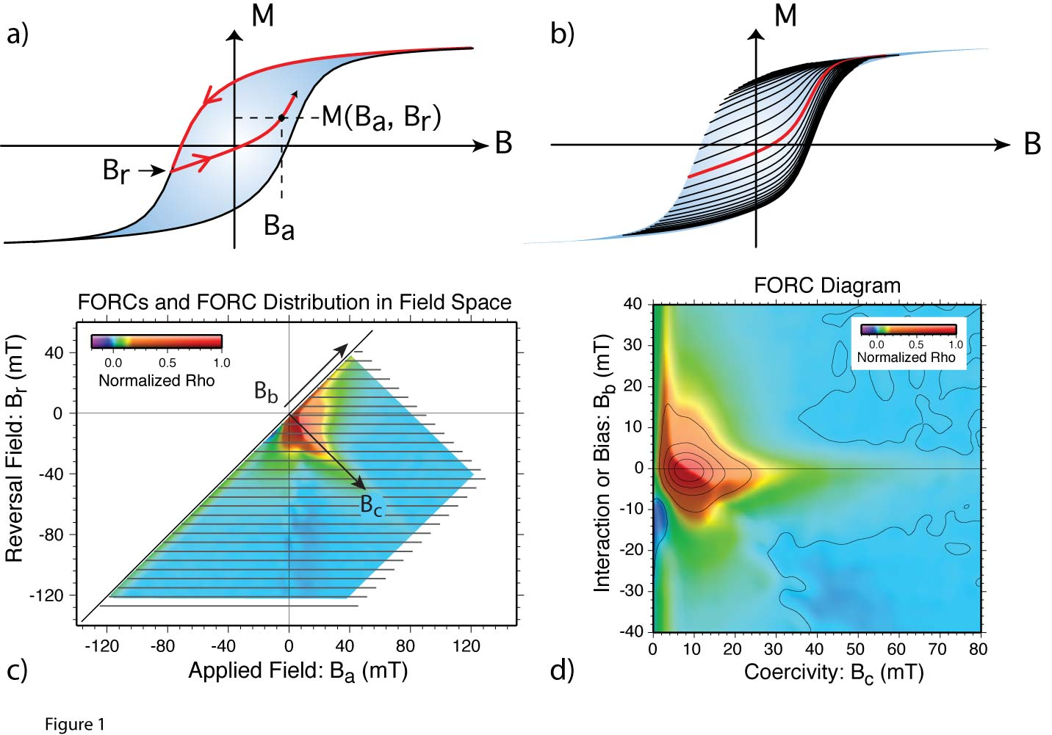

Figure 1. Construction of a FORC diagram is illustrated. (a) Schematic diagram defining variables for a FORC (see text). (b) Multiple FORCs, illustrated by the black and red lines in and along the hysteresis loop, are needed to construct a FORC diagram. The red line is a single FORC similar to that shown in panel a. (c) The FORCs are transformed into the applied-vs.-reversal (B_{a}-vs.-B_{r}) field space and the FORC distribution, referred to as rho (ρ), is computed from a mixed partial derivative (see text). (d) A coordinate transformation results in a FORC diagram in which the FORC distribution is plotted in coercivity-vs.-bias (B_{c}-vs.B_{b}) space.

To produce a FORC diagram, this process is repeated multiple times with the first FORC starting at a reversal field below the saturating field and each additional FORC generally starting at a reversal field slightly lower than that of the previous FORC, until the reversal field has been decreased to the negative saturating field (Fig. 1). A FORC diagram, such as that shown in Figure 1, is constructed from the multiple FORCs for a single sample. The details of the calculations are discussed in the “FORC Method” section below.

FORC Measurements

Although a variety of instruments may be used to acquire FORCs, FORCIT is written specifically to read the output from various models of the MicroMag instrument produced by Princeton Measurements Corporation (PMC). Data acquired from other instruments can be converted to the format used by PMC and, as other formats are identified, FORCIT can be updated to read them.

The standard measurement sequence involves first determining a conventional hysteresis loop, followed by the collection of a suite of FORCs. In general, a sample that is a few milligrams (mg) or tens of milligrams in mass is mounted on the probe tip of either the PMC alternating field gradient magnetometer (AGM) or for the PMC vibrating sample magnetometer (VSM). The bulk coercivity and high-field slope are determined from the hysteresis loop. The user then defines several parameters that specify the FORC measurement sequence. The relevant parameters are listed in Table 1.

The output from a MicroMag instrument with recent PMC software contains multiple header lines that give the above parameters (Fig. 2). Subsequent output lines contain the data, which are typically given as comma-separated pairs of values representing the applied magnetic field and the measured magnetic moment. Before each FORC is measured for a given sample, an initial value is measured at a common field in order to track the instrument drift. This measurement is separated by a blank line followed by the data for the FORC, with the first datum of each FORC giving the reversal field and moment at the reversal field. Subsequent values give the applied field and moment along the FORC. A blank line occurs at the end of each FORC, followed by the next drift estimate and so on (Fig. 2). A typical measurement consists of 50-150 FORCs resulting in about 2000-10000 lines of data.

Table 1. Typical parameters for FORC measurements
Parameter | Description of Parameter
Averaging time | Amount of time over which a measurement is made.
Bb1 or Hb1 | The minimum biasing field
Bb2 or Hb2 | The maximum biasing field
Bc1 or Hc1 | The minimum coercivity
Bc2 or Hc2 | The maximum coercivity
BCal or HCal | Before each FORC, the moment of the sample is measured at an applied field of Hcal in order to monitor the instrument drift.
Bncr or HNcr | The field increment between measurements.
BSat or HSat | Saturation field
Ncrv | Number of FORCs
PauseCal | Time to pause at drift calibration point
PauseNtl | Time to pause at start of each FORC
PauseSat | Time to pause at saturation
SlewRate | Slew rate
Smoothing | A factor used in Roberts et al. (2000) for smoothing the FORC distributions (see Section 5 below).
Field range | Field range for on screen plot, generally it is = Hcal
Moment range | Moment range for on screen plot
Temperature | Temperature if the cryostat or furnace is in operation
Orientation | Orientation if the rotating head is in use
Elapsed time | Measurement time in seconds
Slope corr. | High-field slope correction input by user
Saturation | Currently a redundant unused input (= BSat)
Ndata | Number of data

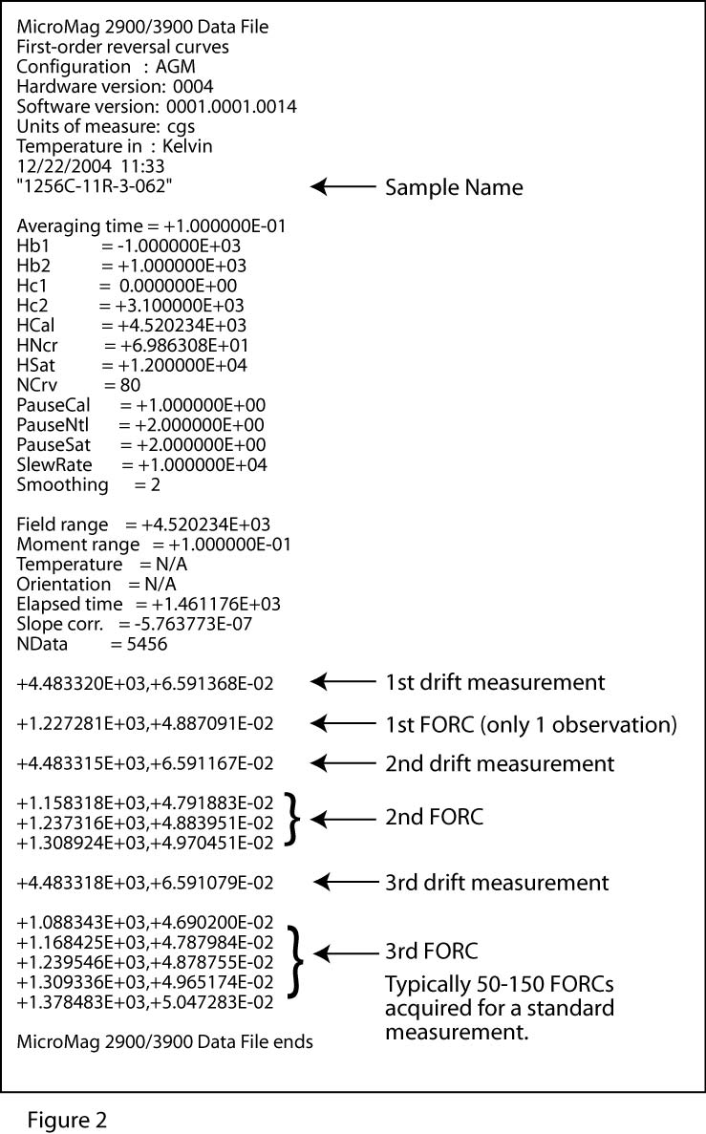
Figure 2. Example of the data format for a typical MicroMag data file.

The format in which the data is acquired has changed several times over the past several years and will likely evolve further. The original format did not contain all the relevant parameters needed for defining the limits of the FORC diagrams. Program FORCIT is capable of reading any of the older formats so far encountered, although the program has to make educated guesses about some of the parameters needed for the plots because that information is not included in some of the older data formats. MicroMag instruments with cryostats and furnaces and the most recent versions of PMC software output data in formats similar to that shown in Figure 2 with the exception that a third column of data is included that gives the temperature. FORCIT reads these files and ignores the third column of data.

Instrument Settings
FORC measurements can be made for a broad range of coercivities and interactions, particularly for artificial materials, but also for naturally occurring materials. Even so, most rocks, sediments, and magnetic minerals span relatively well-defined coercivity distributions and so only rather narrow coercivity ranges commonly need to be investigated. Instrument limitations further limit the range of coercivities that can be investigated, particularly for very high coercivities (> 1 T; >10 kOe). Examining the high-resolution details of low coercivity distributions (<10 mT; <100 Oe) by collecting densely spaced grids of data is also difficult owing to instrument limitations. Currently, collecting data at a grid spacing less than about 0.5 mT (5 Oe) does not improve the resolution because instrument noise is sufficiently large, particularly given that even small amounts of noise are amplified by taking derivatives for FORC distributions. With these limitations in mind, typical instrument settings for most rocks, sediments, and minerals will fall into the ranges given in Table 2.

Table 2. Typical parameter settings for MicroMag measurements.
Averaging time | 100 to 300 ms
Bb1 or Hb1 | -150 to 10 mT (-1500 to –100 Oe)
Bb2 or Hb2 | +150 to + 10 mT (+1500 to +100 Oe)
Bc1 or Hc1 | 0 mT (0 Oe)
Bc2 or Hc2 | 10 to 800 mT (100 to 8000 Oe); typically ≤ 300 mT (≤ 3000 Oe) for titanomagnetite and magnetite and higher values for higher coercivity minerals.
BSat or HSat | 500 to 1400 mT (5000 to 14000 Oe), where the upper size is limited by the instrument)
NCrv | 80 to 200
PauseCal | 100 to 1000 ms (Usually 1 s)
PauseNtl | 100 to 1000 ms (Usually 1 s)
PauseSat | 100 to 1000 ms (Usually 1 s)
Smoothing | 2 (Program FORCIT does not use this value although other software packages do).

Running a FORC measurement with some of the above settings will result in about 10,000 to 50,000 lines of data, where the data are listed as comma delimited values with each line containing the applied field and the moment. Together these comprise an evenly spaced grid of data, which, for example, would lie along the horizontal lines (i.e., the FORCs) in Figure 1c.

FORC Analysis

The basics of FORC analysis are describe in Pike et al. (1999). The main idea is to obtain a FORC distribution from the multiple FORCs and then to transform the FORC distribution into Coercivity vs. Interaction (or Bias) space as illustrated in Figure 1.

The FORC distribution is defined as

where M is the moment, B_{a} is the applied field that increases along each FORC, and B_{r} is the reversal field for each FORC. The 1/2 factor was not included in the original FORC definition as given by Pike et al. (1999) but was later added by Katzgraber et al. (2002) to equate FORC distributions to Preisach distributions for hysterons.

Several methods can be used to compute this mixed partial derivative from a gridded FORC data set. For example, Roberts et al. (2000) use a polynomial surface fit through multiple data centered at each observation. For a smoothing factor (SF) of 2, they would use (2 SF +1) 2 = 25 data for fitting a polynomial surface and then extract the FORC distribution from the sixth polynomial term.

In contrast, program FORCIT first filters the gridded data using a Gaussian filter that is part of GMT and then takes the derivatives using the grdmath function of GMT, where “all the derivatives are based on central finite differences, with natural boundary conditions” (Wessel and Smith, 2004). The Gaussian filtering is necessary to remove noise inherent in the data, which is amplified when the derivatives are taken. The full width of the default Gaussian filter used by FORCIT is ≤ 6 times the grid spacing. This smoothes the data comparable to what a smoothing factor of 2 would in the polynomial surface fit method. As will be discussed below, the Gaussian filter size can be adjusted by the user within a forcit.default parameter file.

After the FORC distribution has been computed, the distribution is transformed from B_{a} vs. B_{r} (Applied Field vs. Reversal Field) space to B_{c} vs. B_{b} (Coercivity vs. Interaction) space using:

The FORC distribution is most commonly displayed in the B_{c}-vs.-B_{b} space, but additional insights can be gained from different perspectives. By default, FORCIT also produces plots of the FORC distribution in B-vs.-M space, in B_{a}-vs.-B_{r} space, and with two 3-D perspectives in B_{c}-vs.-B_{b} space.

Computing and displaying the FORC distribution is complicated for B_{a} ~ B_{r} or similarly for B_{c} ~ 0. Given the discrete rather than continuous nature of the data, the FORC distribution cannot be calculated from the observations for B_{a} = B_{r} without making assumptions about the nature of the reversible magnetization and the lowest coercivity component (i.e., the coercivity distribution that is less than the grid spacing of the data). The reversible part of the magnetization is essentially the part that follows the major hysteresis loop. For most real systems, the reversible and irreversible magnetizations are coupled (Pike, 2003). They are further coupled because FORC observations are collected on an evenly spaced grid. We use the term “quasi-reversible” to denote the fact that it is not possible to decouple the reversible and irreversible parts of the FORC distribution for real systems. This quasi-reversible part of the FORC distribution, when calculated in past studies, often forms a ridge in FORC diagrams that runs along the Bc ~ 0 axis. The magnitude of the ridge is often several times larger than the rest of the FORC distribution. As a result it swamps much or all of the irreversible part of the FORC distribution, which is the primary part that most studies seek to understand.

In order to decouple the quasi-reversible and irreversible parts, we do two steps. First, for the irreversible part, we set the FORC distribution to zero for prior to applying the Gaussian filter. X is the grid spacing of the data and n is set to five by default in FORCIT, but can be adjusted by the user as discussed below. This effectively filters out the quasi-reversible ridge. We then plot this irreversible FORC distribution in the 2D and 3D FORC diagrams. Second, to calculate the quasi-reversible FORC distribution, i.e. the “reversible ridge” of Pike (2003), we use extended FORCs as advocated by Pike (2003), in which case the partial derivatives are:

and:

where is the FORC distribution at (i.e., at the reversal field of the jth FORC), and M(1,j) and M(2,j) are the first and second observations made along the jth FORC, respectively. We then create a separate 1-D plot of the quasi-reversible ridge.

Installing FORCIT and Associated Software

Before FORCIT can be installed it is necessary to have associated software installed. The installation is described for Mac computers with MacOS X but can be extended to any Unix platform. Many geoscience departments have Unix workstations that have GMT and Fortran compilers already installed. In that case, installing FORCIT is simple, as described below.

The first part of the installation instructions is aimed at getting Unix functionality on a Mac. You will need to have administrator privileges on the Mac you are using in order to install Unix Developer Tools, Fink, GMT, and Fortran compilers.

Installing Unix Developer Tools (Xcode)
When MacOS X (10.1, 10.2, 10.3, and 10.4) is installed, most of the Unix applications that are typically part of Unix computers are not included. Instead the user needs to download and install what is referred to as “Developer Tools”, which currently are in a package called Xcode. The applications include awk, grep, make, and many more along with c compilers. To find out more about Developer Tools and Xcode, see the Web sites at:
http://www.apple.com/macosx/developertools/
http://www.apple.com/macosx/features/xcode/
http://developer.apple.com/tools/xcode/index.html

To download the latest version of Xcode, you will probably be required to become a member of the Apple Developers Connection (ADC) at:
http://developer.apple.com/tools/download/

The latest version of Xcode as of January 2006 was Xcode2.2.1. Note, however, that the Fink project indicates that Xcode2.2 has difficulties compiling some of the Fink programs. You can download older versions of Xcode but these may take some searching on the web. I found Xcode2.1 at
Source Location = https://connect.apple.com/cgi-bin/WebObjects/MemberSite.woa/wa/getSoftware?fileID=19729&source=VSPA_PROD-DEV&code=VSPA_2005-01
File name = xcode_tools2.1.dmg

One you have downloaded Xcode, install it by double clicking on the xcode*.dmg file (where the * will depend on the version you downloaded), if it hasn't already opened automatically. Note it is suppose to open automatically after download. If you still have problems mounting, use DiskImageMounter or the Disk Utility in the /Application/Utilities folder. You will be required to give a computer administrator password to install Xcode.

The whole installation process will take about 30 minutes.

Installing Fink
Fink is a project aimed at providing Unix software for Macs. See the Fink homepage at http://fink.sourceforge.net/ for more information. Click on the Download link to get the Fink software.

Downloaded the latest version of Fink from
Source location = http://fink.sourceforge.net/
File name = Fink-0.8.0-Installer.dmg (as of April 2006)

Note, the above version if for MacOS 10.4. Other versions of Fink can be used for older versions of MacOS. The Fink homepage gives the pertinent information. Once the file Fink-0.8.0-Installer.dmg has been downloaded, it will open automatically. To install, simply double click on Fink 0.8.0 Installer.pkg. This will create a directory /sw with the pertinent files.

The whole installation process will take you about 10 minutes.

Installing TextWrangler
TextWrangler is a free text-editing program with a lot of power. It is similar to BBEdit and it is free. You will likely need to use it unless you can edit with vi or some other text editor in a Unix terminal window.

Download the latest copy
Source Location = http://www.barebones.com/products/textwrangler/download.shtml
File name = TextWrangler_2.1.2.dmg (as of April 2006)

To install TextWrangler, you simply follow the instruction and drag the TextWrangler icon to the directory of your choice (I typically keep it in the Applications folder). The download and installation will take about 5 minutes.

Downloading FORCIT
The program FORCIT, its subroutines, and Makefile are in a file called forcit.tar.gz, which is available at the Web site

http://paleomag.ucdavis.edu/software/forcit/forcit.tar.gz

Simply download it from the web page (Option click for Macs). The file will likely automatically uncompress if you are using a Mac. If it does not automatically uncompress, then uncompress it using Stuffit Expander or the gunzip command in a terminal window by typing:

% gunzip forcit.tar

If you are unfamiliar with terminal windows, then see the next section (Opening a terminal window). Next, extract the folder called “forc” from the tar file called “forc.tar”. On a Mac, you can simply double click on “forc.tar”. Alternatively, you can extract the folder from a terminal window by typing:

% tar –xvf forcit.tar

Opening a terminal window
Program FORCIT is run from a terminal window. If you have never used the Unix terminal application, it’s a great time to start. The terminal application is located in the /Application/Utilities folder for MacOS X. In the following and above, I assume the terminal window has a prompt of %. Commands are typed into the terminal window after the prompt (%).

After you have opened a terminal window, you will likely get a prompt ($), which is the prompt for the bash shell. I mainly use the csh and tcsh and so the following discussion will be based on using either of those Unix shells from the terminal application. You can switch shells from the default MacOS 10.4 shell, which is the bash shell, in two ways. You can do a temporary switch by opening a terminal window and typing either /bin/csh or /bin/tcsh. Either shell is fine. If you want a more permanent switch, open the Terminal → preferences window. Click on the “Execute this command (specify complete path):” button and type either /bin/csh or to /bin/tcsh over the existing /bin/bash. Finally click the red button to close the preferences window. The next terminal window you open will be in the shell of your choice.

Creating a .cshrc profile
After opening a terminal window using the csh shell or tcsh shell, a file called .cshrc is read. This file must reside in your home directory. The .cshrc contains the paths (path = the directory where something exists) for executable programs, libraries, and manual pages, along with aliases and other user-defined preferences.

To create a .cshrc profile, first open a terminal window. Make sure you are using the csh (type /bin/csh). List the contents of your home directory. The terminal window automatically opens in your home directory, so you only need type:

% ls –a

Your home directory (which is /Users/acton for me) will need to have a file called .cshrc, which it will not have if you have never used the terminal application. If you commonly use terminal window and already have a .cshrc file, then you will understand how to edit your .cshrc file to include the lines listed below. If you have don’t have a .cshrc, I have included a file in the forc folder, called forcit-cshrc. Copy the forcit-cshrc file to you home directory and then type:

% mv forcit-cshrc .cshrc

To activate your .csrhc file, which you should do now and after all the rest of the software is installed, type:

% source .cshrc

Note, any time you open a terminal window in the csh or tcsh shells, it automatically sources (reads) the contents of the .cshrc file. If you ever make a change to the .cshrc file, you need to run “source .cshrc” from a terminal window while in your home directory.

You can list the contents of the .cshrc file by typing:

% more .cshrc

or you could open it with TextWrangler (use “Open Hidden” from the File menu). The .cshrc file contains the following:

# @(#)Cshrc 1.6 91/09/05 SMI
#################################################################
# .cshrc file
#################################################################

source /sw/bin/init.csh
set path = (/bin /sbin /sw/bin /sw/sbin /usr/bin /usr/sbin .)
set path = ($path /usr/local/bin)
set path = ($path /usr/local/lib)
set path = ($path /usr/libexec)
set path = ($path /Applications/Local/bin)
setenv MANPATH .:/sw/share/man:/usr/share/man:/usr/local/man:/usr/local/share/man
setenv INFOPATH /sw/share/info:/sw/info:/usr/local/share/info:/usr/local/lib/info:/usr/local/info:/usr/share/info

#####################################################################
#My personal favorite aliases, etc. - Gary Acton ########
#####################################################################
set history=40 # save last 40 commands
.
.
.
and so on

In the above, the paths of the Fink software, GMT, compilers, etc. are listed (they reside in /sw …) as is the path for FORCIT (it resides in /Applications/Local/bin). If you place the source code in some other folder, then you will need to change the path or add an additional path. Below the paths, I have included some examples of setting aliases in the .cshrc file.

Installing GMT and Fortran Compilers on MacOS X
Now that you have the developer tools and Fink, you can install GMT and Fortran compilers, which are part of the Fink project along with many other programs. To install just those programs needed by FORCIT, do the following:
- Open a terminal window.
- Type the following
% /bin/tcsh
- Type
% /sw/bin/pathsetup.sh
This command fixes the paths in your .cshrc file, which actually
should already have been done when you created the .cshrc profile
above.
- Now type the following (wait while each command is executed)
% sudo apt-get update
% sudo apt-get install gmt ← YES, you must install the associated packages (netcdf, etc.) when asked
% sudo apt-get install g77
% sudo apt-get install fort77
% rehash ← this will allow all recently compiled
programs to be found when you attempt to execute them.

I prefer to use the fort77 Fortran compiler as the g77 compiler has been a bit more finicky with other programs. Either should work for FORCIT, although I have set the default as fort77.

Installing FORCIT
The last step is to compile FORCIT. For the novice Unix user, please simply follow these commands exactly. The more experienced user may wish to change the directory in which the program and executables are installed. If you do that, then you must understand how to change path names in the .cshrc file and in the Makefile. If you don’t want to hassle with that and you are using a Mac, do the following

- Create a folder called “Local” in the main “Applications” folder.
- Create a folder called “src” in the “Local” folder.
- Move or copy the forc folder into the “/Applications/Local/src” folder.
- In a terminal window, change directories by typing:
% cd /Applications/Local/src/forc
5. Compile the program by typing:
% make all
6. Rehash the list of executable programs
% rehash

This should have installed various executables (FORCIT and its subroutines) within a folder /Applications/Local/bin. Now you are ready to give it a test run.

If you want to install FORCIT elsewhere and/or want to store the forc folder elsewhere, then you should change paths that are listed at the top of the following files:

Makefile (change the BIN parameter to the appropriate directory)
forcit (change the APPL parameter to the appropriate directory)
trackit (change the APPL parameter to the appropriate directory)

Running FORCIT

FORCIT is run from a terminal window. If you have a FORC data file (lets assume a file exists and is named sample.frc), simply change directories to where the file resides and type “forcit sample.frc”. For example, if the file was on your desktop, you would type:

% cd Desktop ← if you were in your home directory or
% cd ~/Desktop ← does the same as above regardless of
what directory you are currently in.
Then run FORCIT
% forcit sample.frc

On MacIntosh computers with G5 processors, FORCIT typically takes about 1 to 5 minutes to process and create diagrams for a single data file with about 100 FORCs. FORCIT will create several files as it runs. When it is done, it cleans up its mess and stores all the graphic files (PostScript files with a .ps suffix) in a folder called ForcPlots (Fig. 3). You can open these with most standard graphics program (I use Adobe Illustrator) or with the Mac preview. I associate all my .ps files with Illustrator, which means each time I double click on them they open automatically with Illustrator.
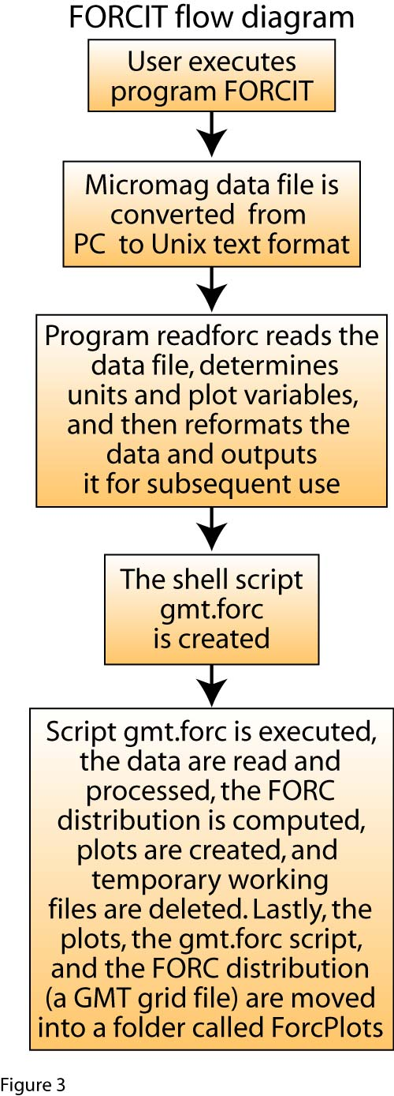

Figure 3. Flow diagram for program FORCIT.

Examples
If you don’t have a FORC data file or just want to test the software, there are five example data files in the Examples folder:

1256D-24R-1-128.frc A basalt sample from Ocean Drilling
Program (ODP) Leg 206.
1256D-49R-2-099b.frc A basalt sample from Ocean Drilling
Program (ODP) Leg 206.
Alvin-dive-3935b.frc Basaltic glass from the East Pacific
Rise
Hematite-298-F A hematite sample after being
heated.
Karoonda-10d.frc A single chondrule from a chondritic
meteorite.

To test that your installation worked, do the following:

% cd /Applications/Local/src/forc/Examples
% forcit Karoonda-10d.frc

After the program is done, you can compare the images created in the ForcPlots directory to those I created, which are in the ForcPlots_Karoonda-10d directory.

FORCIT Help
To learn more about the options available for FORCIT, type

% forcit –h

FORCIT Defaults
The most common option I use is the –d option (forcit –d sample.frc) in which FORCIT reads the contents for the file forcit.defaults. This file overrides the generic defaults. For example, if you want to filter the data less or more, you could create a forcit.defaults file that contained one line:

set filt = 10

where 10 mT is the Gaussian filter to be used by FORCIT. If the generic default was 20, then this new filter would smooth the data much less. To have this change affect FORCIT, you would type:

% forcit –d sample.frc

where the sample.frc and forcit.defaults files would have to reside in the directory in which you are executing program FORCIT.

I typically create the forcit.defaults file after running FORCIT with the generic defaults. To do this, I copy the top part of the ForcPlots/gmt.forc file to forcit.defaults. The top 50 or so lines of gmt.forc file give the values used for the generic defaults. Simply copy and change those parameters that you are interested in controlling. Some common parameters changed are the borders for plots and the filters. By using the same forcit.defaults file when processing a bunch of samples, you can assure all samples were processed similarly.

As an example of this, I copied the contents of the gmt.forc file from the Examples/ ForcPlots_Karoonda-10d folder to a file called forcit.defaults, which I placed in the Examples folder. I deleted all the lines except for some of the parameters that I wanted to change. I then changed the filter parameter (set filt) to 14 (it was 18). This reduces the smoothing some for the Karoonda sample as it appeared to be very smooth (perhaps smoother than one might want). Also, the upper boundary of the FORC diagram (see the plot Examples/ ForcPlots_Karoonda-10d/forc2d.ps) contains edge effects from processing the data. This artifact normally occurs outside the region in which the data were collected and normally is not visible in the plots. It is just barely visible in the forc2D.ps plot. Rarely, owing to data grid spacing and user defined MicroMag settings, FORCIT chooses boundaries for the FORC diagram that includes the artifact. To remove any trace of this artifact, all the user needs to do is redefine the boundaries for the FORC plots. In this case, I redefined Hb1 and Hb2 to –50 and 50 from their prior values of –55 and 55 in the forcit.defaults file. I also redefined Hc2 to 100 from its prior value of 110. To see the effect, run FORCIT again using the –d option:

% cd /Applications/Local/src/forc/Examples
% forcit –d Karoonda-10d.frc

After the program is done, you can compare the forc2D.ps plot in the ForcPlots directory to that in the ForcPlots_Karoonda-10d directory.

The plot of the FORC distribution inside the hysteresis loop (B-vs-M_forc2D.ps) sometimes contains white areas, which result from insufficient data being available to in the white areas. Generally this happens when very few FORCs (<70) are collected for a sample. Fewer FORCs means a larger grid spacing between observations. In such cases, the which areas can normally be filled by setting stepM in the forcit.defaults file to 0.02 rather than 0.01.

WARNING: the boundaries for the plots should be multiples of the step size (step1 in the forcit.defaults file) and similarly the filter should be set to be a multiple of step1. To understand why this is so, you will need to understand how GMT works. GMT comes with its own set of very useful manuals and man pages. It is a very powerful and useful program for all kinds of graphics and has a great users manual. If you want to get fancy with your plots, then read the manual. If you get an error like,

% surface: GMT ERROR: (x_max-x_min) must equal (NX + eps) * x_inc), where
NX is an integer and |eps| <= 0.0001.
% surface: GMT ERROR: Please select compatible -R and -I values.

then you have probably reset one of the grid intervals (like step1 or stepM), to a value that is not a multiple of the plot boundaries.

FORCIT Output

FORCIT creates several files as it runs, some of which are temporary working files. When it is done, it cleans up its mess and stores all the graphic plot files (PostScript files with a .ps suffix) in a folder called ForcPlots, along with a Unix shell script (gmt.forc) and a GMT grid file (rhodydyrn.grd). The plots (Table 3) can be opened with most standard graphics program (e.g., Adobe Illustrator or Mac preview). The script gmt.forc is that used in creating the plots and contains information about parameters that were set (plot borders, filters, sample name, and more) for calls to the GMT routines. The GMT grid file (rhodydyrn.grd) contains the FORC distribution as a function of coercivity and interaction. It can be read by TRACKIT, a program that extracts and plots the FORC distribution along a user-defined profile, or can be reused for generating additional plots in GMT.

Table 3. Plots created by FORCIT
drift.ps | The instrument drift plotted vs. FORC number
Ba-vs-Br.ps | The FORC paths plotted in vs. space.
susc.ps | The micro-susceptibility, which is the first partial derivative, plotted in vs. space.
B-vs-M.ps | The FORC curves plotted inside the hysteresis loop (only every 5th curve is plotted by default but this can be changed in the forcit.defaults file).
Ba-vs-Br_moment.ps | Moment plotted in vs. space.
B-vs-M_forc2D.ps | A 2-d FORC diagram with the FORC distribution plotted inside the hysteresis loop (B vs. M space).
Ba-vs-Br_forc2D.ps | A 2-d FORC diagram plotted in vs. space.
forc2D.ps | The standard 2-d FORC diagram plotted in vs. space.
forc3D-a.ps | A 3-d FORC diagram (view angle 135°) plotted in vs. space.
forc3D-b.ps | A 3-d FORC diagram (view angle 45°) plotted in vs. space.
reversible-ridge.ps | The FORC distribution along a profile where = 0. This gives the part of the distribution referred to as reversible (Pike, 2003). Given the discrete nature of the data, this is the reversible and lowest coercivity component combined.

Examples of these plots are shown in Fig. 4a-l, with additional plots available in the Examples folder, /Applications/Local/src/forc/Examples.

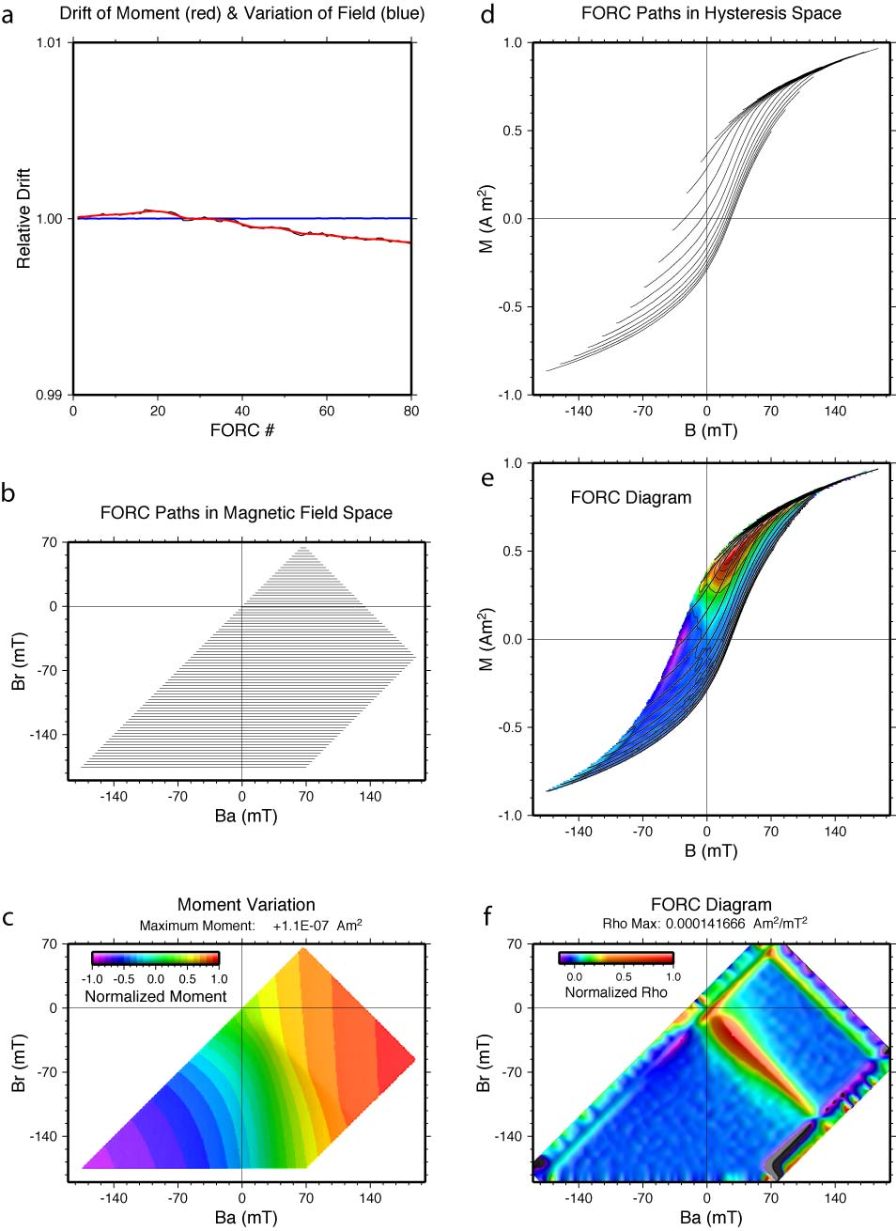

Figure 4 (part 1)
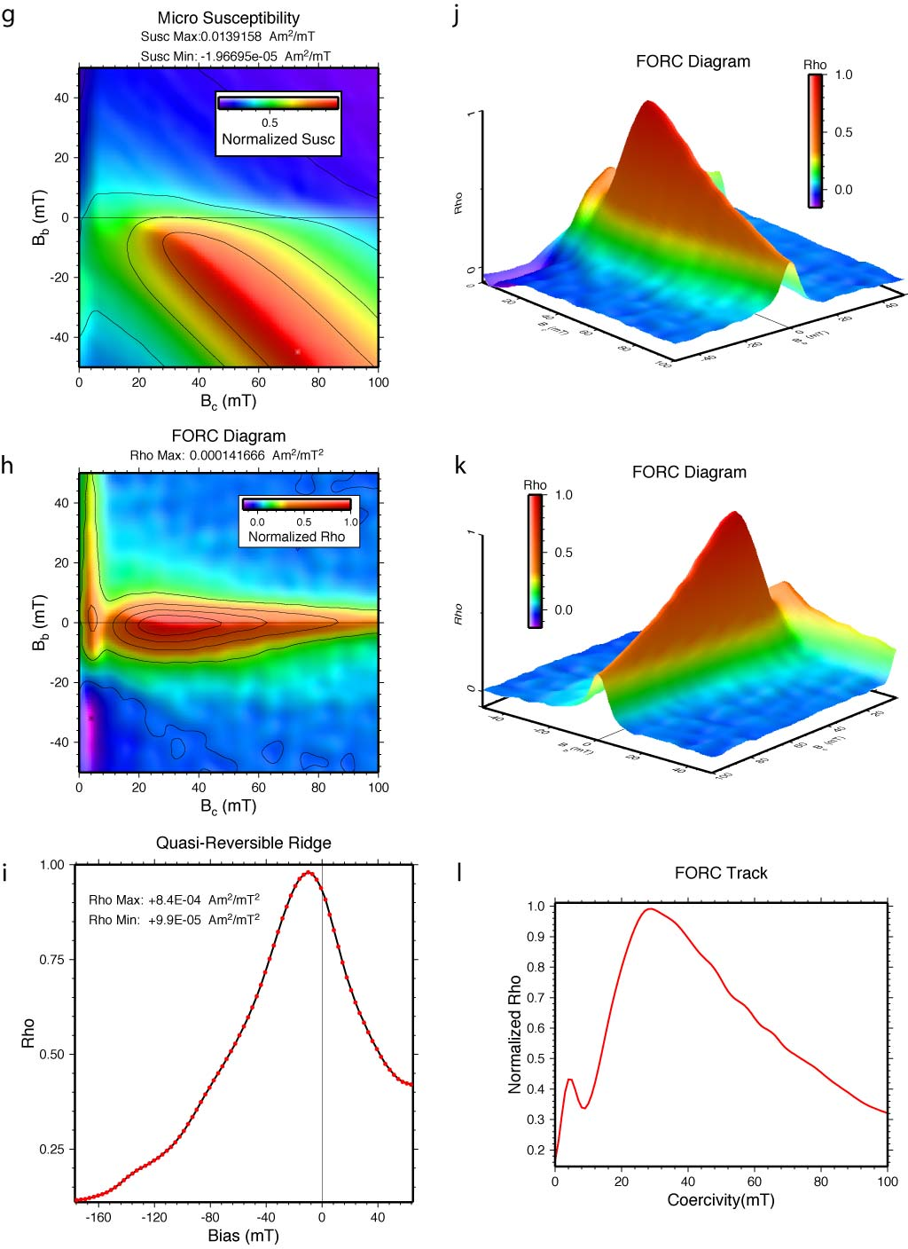
Figure 4 (part 2)

Figure 4. The plots created by FORCIT and TRACKIT are illustrated for a ocean crust basalt sample (1256D-49R-2, 99 cm) from Hole 1256D cored on Ocean Drilling Program Leg 206. a) The instrument drift curve. b) The FORC paths plotted in vs. space. c) The moment plotted in vs. space. d) The FORC paths plotted in vs. space. e) A 2-d FORC diagram with the FORC distribution plotted inside the hysteresis loop (B vs. M space). f) A 2-d FORC diagram plotted in vs. space. g) The micro-susceptibility, which is the first partial derivative, plotted in vs. space. h) The standard 2-d FORC diagram plotted in vs. space. i) The FORC distribution along a profile where = 0, referred to as the quasi-reversible ridge. Note that the peak magnitude is about eight times larger than the maximum value in the standard 2-d FORC diagram. This high magnitude quasi-reversible ridge is thus removed from the 2-d and 3-d FORC diagrams in order to accentuate the irreversible magnetization. j) A 3-d FORC diagram (view angle 135°) plotted in vs. space. k) A 3-d FORC diagram (view angle 45°) plotted in vs. space. l) A 1-d plot of the FORC distribution produced by program TRACKIT. The profile goes from (, ) = (0, 0) to (, ) = (100, 0). Generally each plot also gives the sample name, data file name, and other information, but these have been removed from this figure for space reasons.

Storing FORC Plots
Each time you run FORCIT, it deletes any existing ForcPlots folders within the directory in which you are working. Hence you will want to save the ForcPlots folder using other names. I simply add an underscore and then the sample name, e.g., if I had just ran FORCIT for sample 1313A-02H-1-022.frc, I would rename the ForcPlots folder to ForcPlots_1313A-02H-1-022.

The plots are generally large, ranging from about 20 kb for the drift.ps plot to >10 Mb for some of the FORC diagrams. Given the size of most hard disks, these are insignificant. If you have limited space, however, you can always delete those plots you don’t want or just save the data and forcit.default file and later regenerate the plots when you want to view them.

Analyzing Multiple FORCs Sequentially
If you have many FORC data files and would like to analyze them while you are doing other tasks, then you can create a short shell script to do the task. For example, consider the case where you have 20 data files called sample01.frc, sample02.frc, sample03.frc, … sample20.frc all stored in one folder. Using TextWrangler or vi, create a file called run. The contents of run might look like this:

#! /bin/sh
forcit sample01.frc
mv ForcPlots ForcPlots_sample01
forcit sample02.frc
mv ForcPlots ForcPlots_sample02
.
.
.
forcit sample20.frc
mv ForcPlots ForcPlots_sample20

Once this shell script is created, change the mode to executable by typing:
% chmod a+x run
Then execute the sequential FORC analyzes by typing
% run
Given that each analysis may take 5 minutes or so, the user can simply return a couple hours later and have the FORC diagrams completed for each sample.

An example shell script of this type, called run-all, is provided in the Examples folder.

Running TRACKIT
TRACKIT is also run from a terminal window. It requires that you first run FORCIT to generate the rhodxdyrn.grd file. Once you have created that file, move to the directory where the file exists to run TRACKIT. For example, to plot a profile of the FORC distribution of the Karoonda-10d sample, change directories to Examples/ForcPlots_Karoonda-10d and then type.

% trackit 0 -40 40 20 0.1

In this example, the profile goes from (coercivity, bias) = (0, -40) to (coercivity, bias) = (40, 20) with observations every 0.1 mT (Fig. 5). To get TRACKIT help, type

% trackit -h

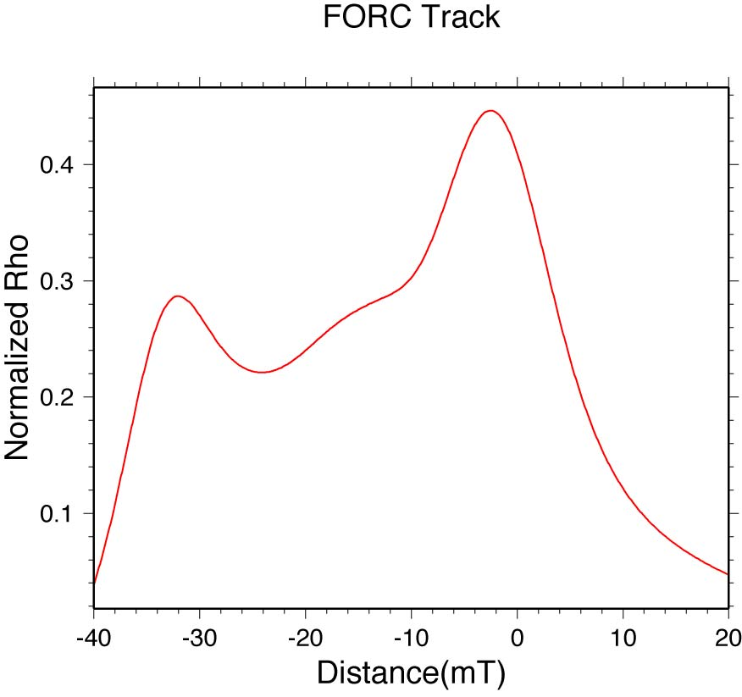
Figure 5. A profile from the FORC distribution created by TRACKIT.

Interpreting FORC Diagrams

The interpretation of FORC diagrams is still developing. Various aspects of interpreting and using FORC diagrams are covered in recent publications (e.g., Acton et al., 2007; Carvallo et al., 2003, 2004, 2005, 2006; Chimpoesu et al., 2006; Davies et al., 2004, 2005, 2006; Enachescu et al., 2004, 2005; Heslop and Muxworthy, 2005; Mayergoyz, 2003; Muxworthy and Dunlop, 2002; Muxworthy and Williams, 2005; Muxworthy et al., 2004, 2005, 2006; Pan et al., 2005; Pike et al., 2001a, b; Pike, 2003; Roberts et al., 2000; Sagnotti et al., 2005; Spinu et al., 2004; Stancu and Andrei, 2006; Stancu et al., 2003a, b, 2006; Tanasa et al., 2005, 2006; van Oorschot et al., 2002; Wehland et al., 2005a, b; Winklhofer and Zimanyi, 2006; Yongxin et al., 2005).

Here we provide two very simple models to illustrate the basic concept of coercivity distributions and interactions between magnetic grains. In the first model, a discrete FORC distribution is produced at a coercivity of B_{SD} by a single hysteron with a coercivity of B_{SD} or by a population of non-interacting magnetic particles, all of which have a coercivity of B_{SD} (Fig. 6). On a FORC diagram, the distribution would be a single peak, whose diameter would be a function of the spacing between measurements and the smoothing or filtering that is done in computing the FORC distribution.

In the second model, two populations of magnetic particles exist with different coercivities and the particles interact with each other (Fig. 7). In this case, the FORC distribution exists not only at the true coercivities of the two populations but also along a ridge that trends ~135° across the lower portion of the FORC diagram due to the interactions between the low- and high-coercivity particles. The FORC distribution for the low-coercivity population is also displaced off the B_{b} = 0 axis due to interactions between particles. Ultimately, much more complex interactions can occur than illustrated by these two models but the models do illustrate at least some basic features of assessing FORC diagrams.

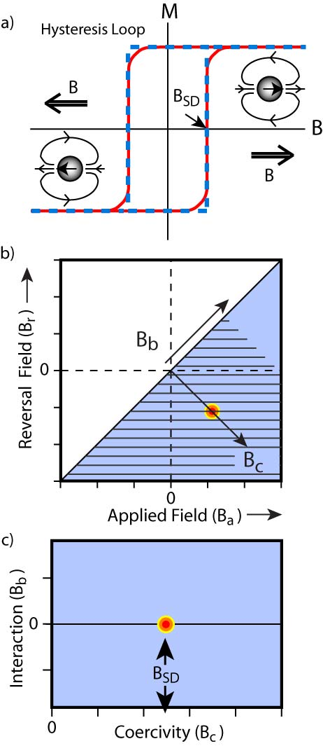

Figure 6. Schematic model illustrating the FORC distribution for a single hysteron with a coercivity of BSD or for a population of non-interacting magnetic particles, all of which have a coercivity of BSD. a) The hysteresis loops for the hysteron (dashed line) and population of non-interacting particles (solid line) are shown with insets that illustrate the orientation of the magnetic moments for a particle for two instances along the hysteresis curve. For each inset, the applied field, B (i.e., the field of the electromagnet), is shown as an arrow with double lines. For a single magnetic particle, the coercivity of the particle and the applied field are what determine when the moment of the particle will flip or switch. b) The resulting FORC distribution is shown relative to the applied field (Ba) and reversal field (Br) and c) the FORC distribution transformed into the standard coordinate system of FORC diagrams.

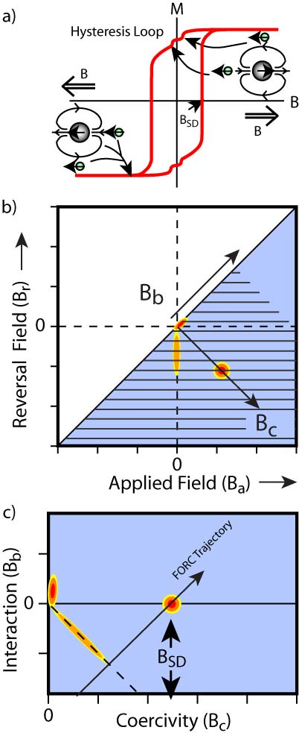

Figure 7. Schematic model illustrating how interactions between particles with different coercivities produce FORC distributions with positive bias (in this case a positive low-coercivity ridge) and interaction ridges that trend ~135° across the lower portion of the FORC diagram. In the model, the small particles have very low-coercivity (nearly super paramagnetic, SP) and interact with the larger single-domain (SD) particle. a) The hysteresis loop is shown with insets that illustrate the orientation of the moments for three magnetic grains for two instances along the hysteresis curve. For each inset, the applied field, B (i.e., the field of the electromagnet), is shown as an arrow with double lines. For a magnetic particle, the particle’s coercivity, the applied field, and the field of neighboring magnetic particles are what determine when the moment of the particle will flip or switch. b) The resulting FORC distribution is shown relative to the applied field (B_{a}) and reversal field (B_{r}) and c) the FORC distribution transformed into the standard coordinate system of FORC diagrams. The switching of the low coercivity particles normally would only produce a FORC distribution at the true coercivity of the particles, which would be near zero B_{b} (the bias or interaction) and B_{c} (the coercivity) in this example. Owing to the interactions, which depend on the position of the low-coercivity particles relative to the high-coercivity particles, the low coercivity component forms a low-coercivity ridge for positive B_{b} and a ridge that trends ~135° across the lower half of the FORC diagram. This ridge at 135° forms near where the applied field changes sign.

Acknowledgments

We thank Chris Pike for his assistance and insightful discussions. We also thank Durin Linderholm, Laura Wetter, Luigi Jovane, Brian Lum, Jesse Unger, Chris Scudder, and Carrie Beatty for the many measurements and tests of the software that they conducted. This research used samples provided by the Ocean Drilling Program (ODP). ODP is sponsored by the U.S. National Science Foundation (NSF) and participating countries under management of Joint Oceanographic Institutions (JOI), Inc. Funding for this project was provided by NSF proposals OCE-0549676 to Acton, JOI/USSSP proposals for ODP Legs200 and 206 to Acton, and EAR-0136498 to Verosub. Any opinions, findings, conclusions, or recommendations expressed in this document are those of the author and do not reflect the views of the funding agencies.

References Cited and FORC Bibliography

Acton, G., A. Roth, and K. L. Verosub, 2007. Analyzing micromagnetic properties with FORCIT software, Eos, (in press).
Acton, G., Yin, Q.-Z., Verosub, K. L., Jovane, L., Roth, A., Jacobsen, B., and Ebel, D. S., 2007. Micromagnetic coercivity distributions and interactions in chondrules with implications for paleointensities of the early Solar System, J. Geophys. Res., 112, 1-19, doi:10.1029/2006JB004655.
Carvallo, C., Dunlop, D.J. and Ozdemir, O., 2005. Experimental comparison of FORC and remanent Preisach diagrams. Geophysical Journal International 162, 747-54.
Carvallo, C., Muxworthy, A.R. and Dunlop, D.J., 2006. First-order reversal curve (FORC) diagrams of magnetic mixtures: Micromagnetic models and measurements. Physics of the Earth and Planetary Interiors 154, 308-22.
Carvallo, C., Muxworthy, A.R., Dunlop, D.J. and Williams, W., 2003. Micromagnetic modeling of first-order reversal curve (FORC) diagrams for single-domain and pseudo-single-domain magnetite. Earth and Planetary Science Letters 213, 375-90.
Carvallo, C., Ozdemir, O. and Dunlop, D.J., 2004. First-order reversal curve (FORC) diagrams of elongated single-domain grains at high and low temperatures. Journal of Geophysical Research 109, 8.
Cimpoesu, D., L. Spinu, and A. Stancu (2006. Temperature dependence of FORC diagrams in nanostructured materials, IEEE Trans. Magn., 42, 3165–3167.
Davies, J.E., Hellwig, O., Fullerton, E.E., Denbeaux, G., Kortright, J.B. and Kai, L., 2004. Magnetization reversal of Co/Pt multilayers: microscopic origin of high-field magnetic irreversibility. Physical Review B (Condensed Matter and Materials Physics) 70, 224434-1-8.
Davies, J.E., Hellwig, O., Fullerton, E.E., Jiang, J.S., Bader, S.D., Zimanyi, G.T. and Kai, L., 2005. Anisotropy dependence of irreversible switching in Fe/SmCo and FeNi/FePt exchange spring magnet films. Applied Physics Letters 86, 262503-1-3.
Davies, J.E., Wu, J., Leighton, C. and Kai, L., 2005. Magnetization reversal and nanoscopic magnetic-phase separation in La1xSrxCoO3. Physical Review B (Condensed Matter and Materials Physics) 72, 134419-1-8.
Enachescu, C., Tanasa, R., Stancu, A., Codjovi, E., Linares, J. and Varret, F., 2004. FORC method applied to the thermal hysteresis of spin transition solids: first approach of static and kinetic properties. Physica B 343, 15-19.
Enachescu, C., Tanasa, R., Stancu, A., Varret, F., Linares, J. and Codjovi, E., 2005. First-order reversal curves analysis of rate-dependent hysteresis: the example of light-induced thermal hysteresis in a spin-crossover solid. Physical Review B (Condensed Matter and Materials Physics) 72, 54413-1-7.
Heslop, D. and Muxworthy, A.R., 2005. Aspects of calculating first-order reversal curve distributions. Journal of Magnetism and Magnetic Materials 288, 155-67.
Katzgraber, H.G., Pazmandi, F., Pike, C.R., Kai, L., Scalettar, R.T., Verosub, K.L. and Zimanyi, G.T., 2002. Reversal-field memory in the hysteresis of spin glasses. Physical Review Letters 89, 257202(1-4).
Mayergoyz, I.D., 1986. Mathematical models of hysteresis. IEEE Trans. Magn. MAG-22, 606-608.
Mayergoyz, I.D., 2003. Mathematical Models of Hysteresis and Their Applications, Academic Press, 300pp.
Muxworthy, A.R. and Dunlop, D.J., 2002. First-order reversal curve (FORC) diagrams for pseudo-single-domain magnetites at high temperature. Earth and Planetary Science Letters 203, 369-82.
Muxworthy, A.R. and Williams, W., 2005. Magnetostatic interaction fields in first-order-reversal-curve diagrams. Journal of Applied Physics 97, 63905-1-5.
Muxworthy, A.R., Heslop, D. and Williams, W., 2004. Influence of magnetostatic interactions on first-order-reversal-curve (FORC) diagrams: a micromagnetic approach. Geophysical Journal International 158, 888-97.
Muxworthy, A.R., King, J.G. and Heslop, D., 2005. Assessing the ability of first-order reversal curve (FORC) diagrams to unravel complex magnetic signals. Journal of Geophysical Research 110, 11.
Muxworthy, A.R., King, J.G. and Odling, N., 2006. Magnetic hysteresis properties of interacting and noninteracting micron-sized magnetite produced by electron beam lithography [DATA BRIEF]. Geochem. Geophys. Geosyst. 7, Q07009.
Pike, C.R., 2003. First-order reversal-curve diagrams and reversible magnetization. Physical Review B (Condensed Matter and Materials Physics) 68, 104424-1-5.
Pike, C.R. and Fernandez, A., 1999. An investigation of magnetic reversal in submicron-scale Co dots using first order reversal curve diagrams. Journal of Applied Physics 85, 6668-76.
Pike, C. R., A. P. Roberts, and K. L. Verosub, 1999. Characterizing interactions in fine magnetic particle systems using first order reversal curves, J. Appl. Phys., 85, 6660-6667.
Pike, C.R., Roberts, A.P., Dekkers, M.J. and Verosub, K.L., 2001. An investigation of multi-domain hysteresis mechanisms using FORC diagrams. Physics of the Earth and Planetary Interiors 126, 11-25.
Pike, C.R., Roberts, A.P. and Verosub, K.L., 2001. First-order reversal curve diagrams and thermal relaxation effects in magnetic particles. Geophysical Journal International 145, 721-30.
Roberts, A.P., Pike, C.R. and Verosub, K.L., 2000. First-order reversal curve diagrams: a new tool for characterizing the magnetic properties of natural samples. Journal of Geophysical Research 105, 28461-75.
Roberts, A. P., Q. Liu, C. J. Rowan, L. Chang, C. Carvallo, J. Torrent, and C.-S. Horng, 2006. Characterization of hematite (a-Fe2O3), goethite (a-FeOOH), greigite (Fe3S4), and pyrrhotite (Fe7S8) using first-order reversal curve diagrams, J. Geophys. Res., 111, B12S35, doi:10.1029/2006JB004715.
Sagnotti, L., Roberts, A.P., Weaver, R., Verosub, K.L., Florindo, F., Pike, C.R., Clayton, T. and Wilson, G.S., 2005. Apparent magnetic polarity reversals due to remagnetization resulting from late diagenetic growth of greigite from siderite. Geophysical Journal International 160, 89-100.
Shive, P.J., 1986. Suggestions for the use of SI units in magnetism. Eos 67, 25.
Spinu, L., Stancu, A., Radu, C., Feng, L. and Wiley, J.B., 2004. Method for magnetic characterization of nanowire structures. IEEE Transactions on Magnetics 40, 2116-18.
Stancu, A. and Andrei, P., 2006. Characterization of static hysteresis models using first-order reversal curves diagram method. Physica B 372, 72-5.
Stancu, A., Mitoseriu, L., Stoleriu, L., Piazza, D., Galassi, C., Ricinschi, D. and Okuyama, M., 2006. Investigation of the switching characteristics in ferroelectrics by first-order reversal curve diagrams. Physica B 372, 226-9.
Stancu, A., Pike, C., Stoleriu, L., Postolache, P. and Cimpoesu, D., 2003a. Micromagnetic and Preisach analysis of the first order reversal curves (FORC) diagram. Journal of Applied Physics 93, 6620-2.
Stancu, A., Postolache, P. and Stoleriu, L., 2004. Nonparametric identification algorithm of the Preisach distribution based on the first order reversal curves (FORC) diagram. International Journal of Applied Electromagnetics and Mechanics 19.
Stancu, A., Ricinschi, D., Mitoseriu, L., Postolache, P. and Okuyama, M., 2003b. First-order reversal curves diagrams for the characterization of ferroelectric switching. Applied Physics Letters 83, 3767-9.
Tanasa, R., Enachescu, C., Stancu, A., Linares, J., Codjovi, E., Varret, F. and Haasnoot, J., 2005. First-order reversal curve analysis of spin-transition thermal hysteresis in terms of physical-parameter distributions and their correlations. Physical Review B (Condensed Matter and Materials Physics) 71, 14431-1-9.
Tanasa, R., Linares, J., Enachescu, C., Varret, F.F. and Stancu, A., 2006. Determination of the physical parameters distribution in spin transition compounds using experimental FORC diagram. Physica B 372, 215-18.
van Oorschot, I.H.M., Dekkers, M.J. and Havlicek, P., 2002. Selective dissolution of magnetic iron oxides with the acid-ammonium-oxalate/ferrous-iron extraction technique. II. Natural loess and palaeosol samples. Geophysical Journal International 149, 106-17.
Wehland, F., Leonhardt, R., Vadeboin, F. and Appel, E., 2005. Magnetic interaction analysis of basaltic samples and pre-selection for absolute palaeointensity measurements. Geophysical Journal International 162, 315-20.
Wehland, F., Stancu, A., Rochette, P., Dekkers, M.J. and Appel, E., 2005. Experimental evaluation of magnetic interaction in pyrrhotite bearing samples. Physics of the Earth and Planetary Interiors 153, 181-90.
Wessel, P. and Smith, W.H.F., 1998. New, improved version of the Generic Mapping Tools released. Eos 79, 579.
Wessel, P. and Smith, W.H.F., 2004. The Generic Mapping Tools (GMT) version 4 Technical Reference and Cookbook. Available at: http://gmt.soest.hawaii.edu/gmt/gmt_services.htmlSOEST/NOAA.
Winklhofer, M., and G. T. Zimanyi, 2006. Extracting the intrinsic switching field distribution in perpendicular media: A comparative analysis, J. Appl. Phys., 99, 08E710, doi:10.1063/1.2176598.
Yongxin, P., Petersen, N., Winklhofer, M., Davila, A.F., Qingsong, L., Frederichs, T., Hanzlik, M. and Rixiang, Z., 2005. Rock magnetic properties of uncultured magnetotactic bacteria. Earth and Planetary Science Letters 237, 311-25.

