Question 3:
Asked ChatGPT the following:
1. Construct the SVD in python without numpy of the image,
which you can treat as a matrix 𝐴, with the SVD decomposition given by 𝐴 = 𝑈Σ𝑉⊤
2. Plot the singular values of the image, which should be a decreasing function.
For each image, determine a reasonable location (call this 𝑘) at which the singular values level off
and are no longer decreasing rapidly.
3. Construct two matrices, 𝐴̃3 and 𝐴̃𝑘 𝐴̃3 = ∑ 𝒖𝑖𝝈𝑖𝒗𝒊 ⊤ 3 𝑖=1 and 𝐴̃𝑘 = ∑ 𝒖𝑖𝝈𝑖𝒗𝒊 ⊤ 𝑘 𝑖=1 where 𝑘 is the cutoff you
found for the image. 4. Visualize and compare 𝐴̃3 and 𝐴̃𝑘 to the full image, 𝐴.
Also generate the errors, 𝐸3 = 𝐴̃3 − 𝐴 and 𝐸𝑘 = 𝐴̃𝑘 − 𝐴 and comment on where the errors are located.

Repeated the same for image 1 and image 2 in blackboard
Image 1:

Singular Value Graph:

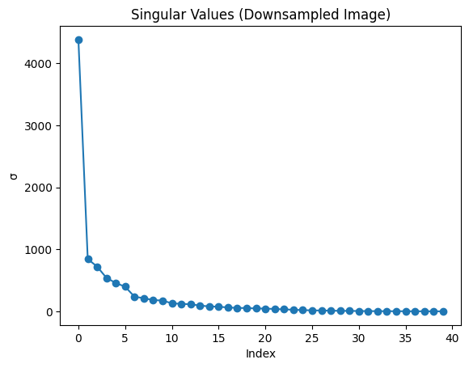
Original vs. Rank-3 vs. Rank-k
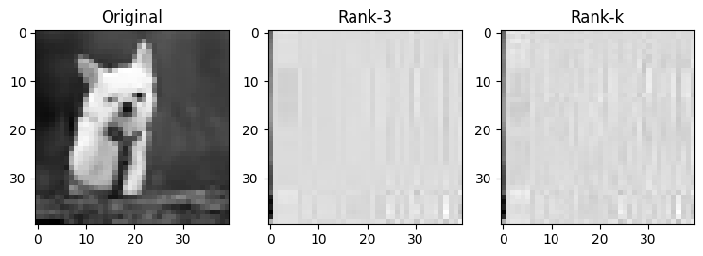

Image 2:
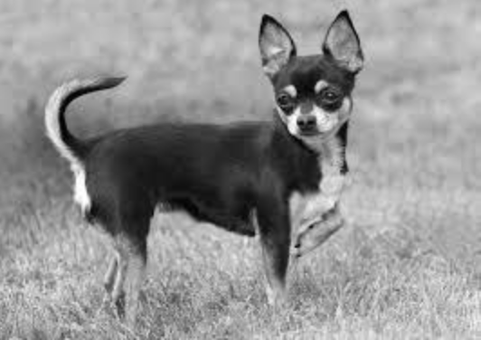

Singular Value Graph:
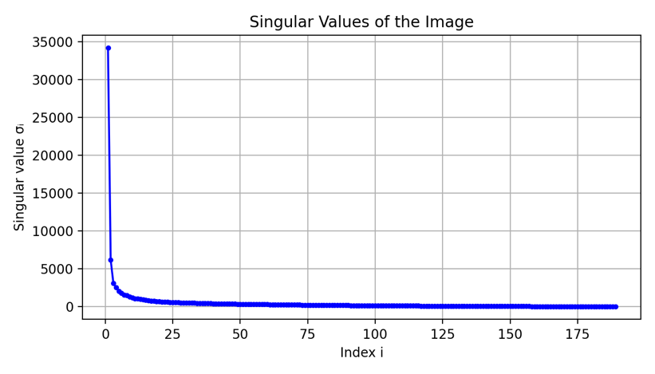

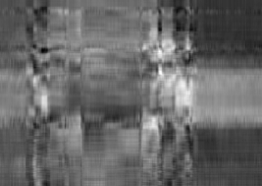
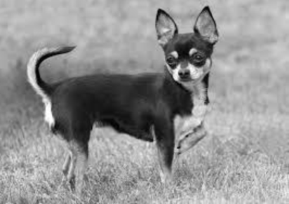
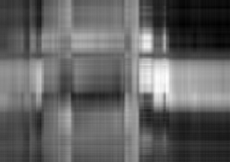
Original vs. Rank-3 vs. Rank-k:

