Part 1: Simulation extents and particle insertion volume

- Create a box for the sediment – a virtual sediment tray, and call this SIMINS1 (this is where the sediment will be inserted and held. Delete the top face(s) of the cube – you want the sediment tray to be open.
Play animation through and check that the foot is always well within the SIMINS1 box, but that it is sufficiently large to avoid most edge effects. At small particle sizes, even a tiny increase in tray size will significantly increase computational requirements.
- Create a box to define the simulation domain, and call this SIMBOX1. Similar to above, make sure the foot and tray never leave this volume, if they do the simulation will stop with an error.
NOTE: the simulation domain is only used for max X/Y/Z corrdinates, and so should be aligned to world axes. Similarly, while the tray is exported as an STL for liggghts, it’s also used as max/min XYZ extents for particle insertion volume, so it too should be square to world space.

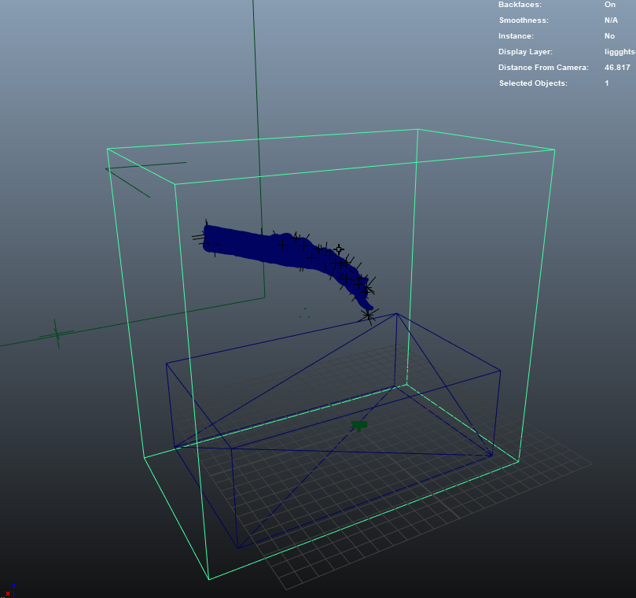
Figure 1 - Simbox1 is the highlighted cube, simins1 is the unselected cube.
Figure 2 - left, SIMBOX1, right, foot and SIMINS1 (SIMBOX1 hidden)

Part 2a (optional), If working with bones and needing to create cylinders:

Create locators at each joint (or use a jointed system). I find that parenting locators to proximal/distal ends of bones works fine.
Then run genCylinder, and it’ll create a cylinder over this distance. It should be scaled in diameter differently depending on length (so leg bones/MT will be fatter than digit phalanges), but keep an eye on it.
NOTE: It used to matter whether a cylinder was created from joints selected proximal-distal vs distal-proximal (this flipped the coordinate system used for calculating the rotations) – last I checked I think this was fixed and selection order shouldn’t matter anymore (thanks to Quaternions).
Figure 3 1. (left) knee joint selected, 2. (middle) ankle joint selected, 3.(right) genCylinder command called, and cylinder generated

Part 2b: Select bones and create liggghts files.

Select all objects of the foot you want in the simulation (cylinders/skin models etc), but not the two cubes. Selection order shouldn’t matter:
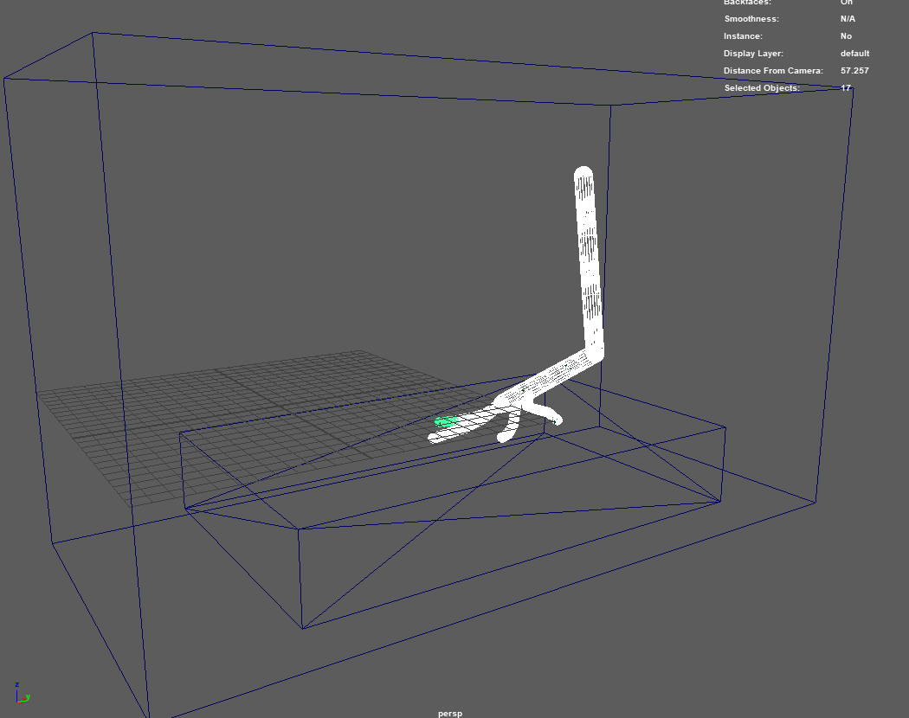
Figure 4 - Foot objects selected
Then run plfExport_Liggghts. This will cause everything to jitter as it moves the timeline slider forward then back for each bone (I tried to streamline this but when I did, things broke, so it’s staying like this for now). This script calls three others that a) create a set-up file for liggghts, b) create a run file for liggghts, and c) exports each selected object, plus sediment tray, as an STL. plfmaya_liggghts_part2 is the only part that does any real heavy lifting, converting rotations to quaternions, then to axis-angle for liggghts.
The outputted files will be wherever your maya scene is. Depending on number of bones, there could be a lot.

Part 3: Assign variables in liggghts scripts and run simulation
Open up run.liggghts and setup.liggghts and alter the variables as necessary at the top in both files:
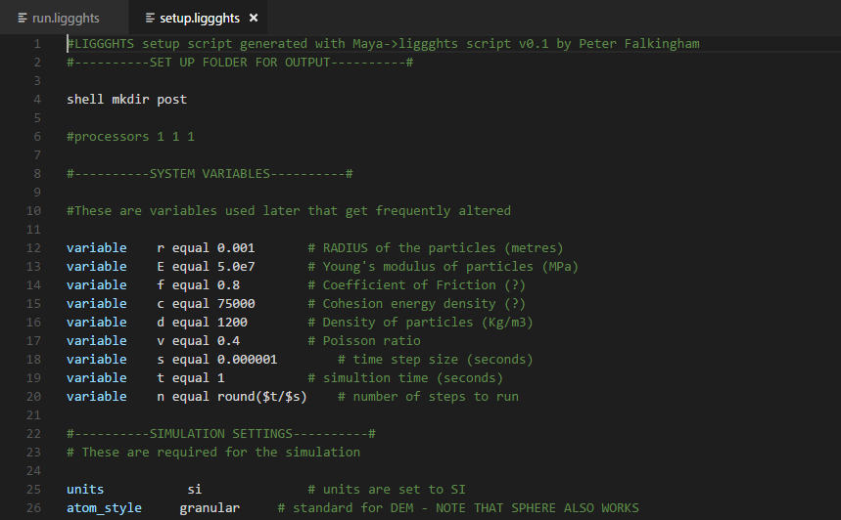
Figure 5 - the variables at the top control particle behaviour. Radius is the most important one, here set to 1 mm

Congratulations, you now have a bunch of liggghts input files that may or may not work first time. Run the ‘setup.liggghts’ file first, and it will pour particles into the tray and let them settle, then produce a restart.res file. ‘Run.liggghts’ reads the restart.res file, imports the foot models, then moves them through. In this way a single sediment set-up be made, and tweaks to motion or sediment parameters don’t require a full sediment set-up again (which can take quite a while itself).

