ComPulse

ComPulse is a simple Windows program, which toggles one of the handshake lines of a serial COM port. (http://en.wikipedia.org/wiki/RS-232) The DTR handshake line will be alternated between active and inactive states (positive and negative voltages), at the configured interval. The application was developed to simulate the behaviour of the MRI trigger sequence of a Siemens Avanto scanner. By using a so called null modem cable (http://en.wikipedia.org/wiki/Null_modem), it is possible to make a connection between two serial ports and test stimulus software (such as E-Prime and Presentation) in a test environment without requiring the scanner itself. It is not necessary to connect two separate computers because it is also possible to connect the null modem cable between two serial ports on the same computer system. If there are insufficient ports available, it is also possible to use a USB-RS232 converter cable (mind the port assignments in that case).

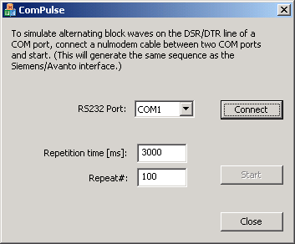

Paul F.C. Groot
© 2010 - AMC Amsterdam, dept. Radiology.

