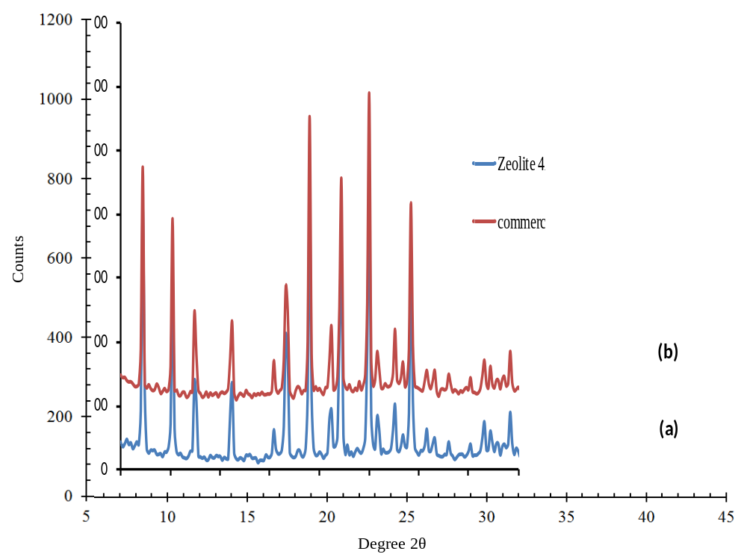
Online resource 1: XRD of synthesized (blue) and commercial (red) zeolite 4A.

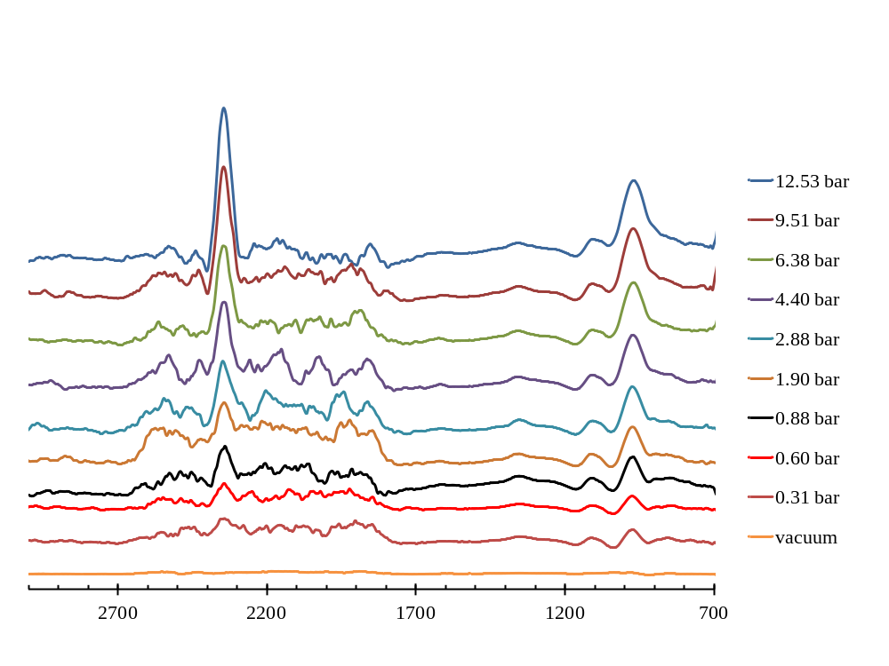
Online resource 2: FT-IR spectra of adsorbed species formed by contact of CO₂ at 298.15 K.

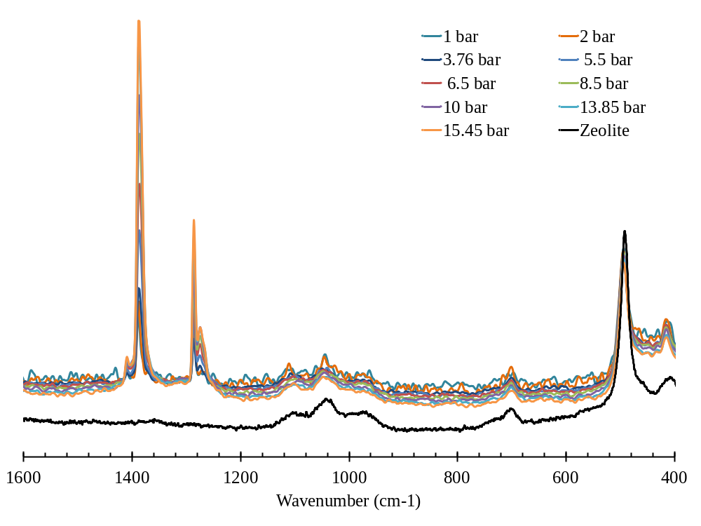
Online resource 3: FT-Raman spectra of adsorbed species formed by contact with CO₂.

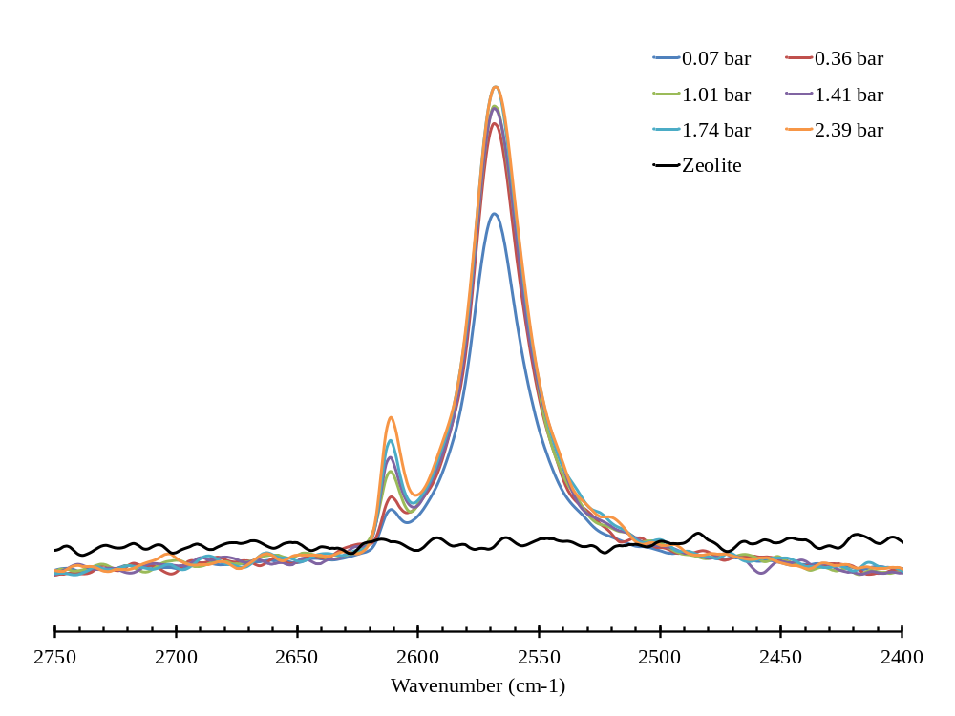
Online resource 4: FT-Raman spectra of adsorbed species formed by contact with H₂S.

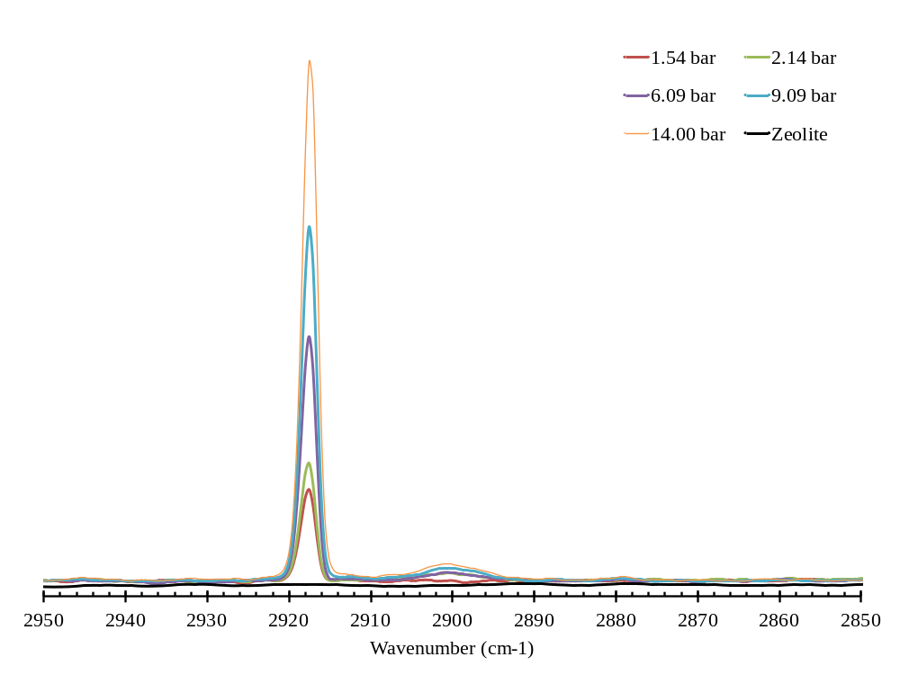
Online resource 5: FT-Raman spectra of adsorbed species formed by contact with CH₄.

Online resource 6: Absolute and excess CO₂ adsorption on zeolite 4A at 0.008, 25.009, 50.011 ºC
p | n^{exc} (Helium) |  |  | nª
/(bar) | /(mmol∙g⁻¹) |  |  | /(mmol∙g⁻¹)
T = 0.008 ± 0.005 ºC
0.0000 | 0.0000 | ± | 0.0000 | 0.0000
0.0274 | 3.3558 | ± | 0.0086 | 3.3564
0.1455 | 3.9710 | ± | 0.0100 | 3.9745
0.3902 | 4.3867 | ± | 0.0103 | 4.3960
0.7214 | 4.6510 | ± | 0.0154 | 4.6682
1.0933 | 4.8222 | ± | 0.0166 | 4.8483
1.4730 | 4.9429 | ± | 0.0203 | 4.9782
1.8409 | 5.0401 | ± | 0.0228 | 5.0843
2.1999 | 5.1117 | ± | 0.0258 | 5.1647
2.5292 | 5.1880 | ± | 0.0287 | 5.2491
2.8614 | 5.2269 | ± | 0.0313 | 5.2962
3.1642 | 5.2739 | ± | 0.0373 | 5.3507
3.4553 | 5.3074 | ± | 0.0379 | 5.3914
3.7324 | 5.3319 | ± | 0.0381 | 5.4228
3.9881 | 5.3596 | ± | 0.0440 | 5.4568
4.2258 | 5.3873 | ± | 0.0442 | 5.4906
4.4491 | 5.4118 | ± | 0.0497 | 5.5207
4.6664 | 5.4233 | ± | 0.0521 | 5.5377
4.8645 | 5.4407 | ± | 0.0519 | 5.5601
5.0525 | 5.4533 | ± | 0.0522 | 5.5775
5.2286 | 5.4651 | ± | 0.0557 | 5.5938
5.3936 | 5.4758 | ± | 0.0655 | 5.6087
5.5424 | 5.5016 | ± | 0.0622 | 5.6383
5.8941 | 5.5477 | ± | 0.0579 | 5.6935
6.2468 | 5.5563 | ± | 0.0606 | 5.7112
6.5675 | 5.5758 | ± | 0.0650 | 5.7390
6.8752 | 5.5821 | ± | 0.0657 | 5.7534
7.1526 | 5.6023 | ± | 0.0668 | 5.7809
7.4229 | 5.6051 | ± | 0.0756 | 5.7908
7.6653 | 5.6213 | ± | 0.0764 | 5.8135
7.8941 | 5.6333 | ± | 0.0785 | 5.8315
8.1166 | 5.6317 | ± | 0.0882 | 5.8358
8.3198 | 5.6367 | ± | 0.0878 | 5.8462
8.5289 | 5.6129 | ± | 0.0828 | 5.8281
8.7101 | 5.6109 | ± | 0.0951 | 5.8309

Online resource 6: continued.
p | n^{exc} (Helium) |  |  | nª
/(bar) | /(mmol∙g⁻¹) |  |  | /(mmol∙g⁻¹)
T = 0.008 ± 0.005 ºC
8.8743 | 5.6164 | ± | 0.0984 | 5.8409
9.0300 | 5.6180 | ± | 0.0918 | 5.8467
9.1730 | 5.6230 | ± | 0.1010 | 5.8556
9.3033 | 5.6335 | ± | 0.1119 | 5.8697
9.4309 | 5.6346 | ± | 0.1187 | 5.8742
9.5480 | 5.6389 | ± | 0.1294 | 5.8817
9.6583 | 5.6419 | ± | 0.1320 | 5.8877
10.6985 | 5.6645 | ± | 0.1031 | 5.9391
11.3147 | 5.6707 | ± | 0.1073 | 5.9626
11.8926 | 5.6650 | ± | 0.1109 | 5.9732
12.4268 | 5.6629 | ± | 0.1155 | 5.9863
12.9189 | 5.6658 | ± | 0.1206 | 6.0036
13.3787 | 5.6640 | ± | 0.1256 | 6.0151
13.7956 | 5.6786 | ± | 0.1321 | 6.0420
14.1998 | 5.6654 | ± | 0.1374 | 6.0408
14.5625 | 5.6740 | ± | 0.1446 | 6.0602
14.9091 | 5.6672 | ± | 0.1509 | 6.0638
15.2281 | 5.6655 | ± | 0.1488 | 6.0717
15.5322 | 5.6528 | ± | 0.1543 | 6.0683
15.8042 | 5.6590 | ± | 0.1604 | 6.0828
16.0628 | 5.6561 | ± | 0.1646 | 6.0879
16.2990 | 5.6615 | ± | 0.1724 | 6.1006
16.5294 | 5.6490 | ± | 0.1797 | 6.0952
16.7349 | 5.6533 | ± | 0.1879 | 6.1059
16.9321 | 5.6475 | ± | 0.1838 | 6.1063
17.1070 | 5.6575 | ± | 0.1830 | 6.1219
17.2785 | 5.6531 | ± | 0.1867 | 6.1228
17.4444 | 5.6385 | ± | 0.2097 | 6.1135
17.5858 | 5.6470 | ± | 0.2095 | 6.1265
17.7190 | 5.6543 | ± | 0.2147 | 6.1380
17.8540 | 5.6422 | ± | 0.2320 | 6.1303
17.9737 | 5.6424 | ± | 0.2130 | 6.1343
18.0852 | 5.6434 | ± | 0.2237 | 6.1389
18.1848 | 5.6518 | ± | 0.2377 | 6.1505
18.2825 | 5.6523 | ± | 0.2314 | 6.1541
18.3740 | 5.6515 | ± | 0.2590 | 6.1563
Online resource 6: continued.
p | n^{exc} (Helium) |  |  | nª
/(bar) | /(mmol∙g⁻¹) |  |  | /(mmol∙g⁻¹)
T = 0.008 ± 0.005 ºC
18.4622 | 5.6469 | ± | 0.3052 | 6.1546
18.5410 | 5.6491 | ± | 0.3146 | 6.1593
18.6114 | 5.6566 | ± | 0.3012 | 6.1691
18.6849 | 5.6497 | ± | 0.3036 | 6.1646
18.7546 | 5.6415 | ± | 0.3217 | 6.1587
18.8105 | 5.6523 | ± | 0.3308 | 6.1713
18.8709 | 5.6458 | ± | 0.3298 | 6.1668
18.9251 | 5.6452 | ± | 0.3702 | 6.1680
18.9670 | 5.6601 | ± | 0.3596 | 6.1843
19.0223 | 5.6446 | ± | 0.3117 | 6.1706
T = 25.009 ± 0.005 ºC
0.0000 | 0.0000 | ± | 0.0000 | 0.0000
0.1819 | 3.5531 | ± | 0.0051 | 3.5570
0.3016 | 3.7492 | ± | 0.0087 | 3.7558
0.4437 | 3.9017 | ± | 0.0125 | 3.9114
0.5944 | 4.0273 | ± | 0.0136 | 4.0403
0.7542 | 4.1254 | ± | 0.0156 | 4.1418
0.9175 | 4.2032 | ± | 0.0175 | 4.2232
1.0784 | 4.2681 | ± | 0.0165 | 4.2917
1.2323 | 4.3265 | ± | 0.0194 | 4.3534
1.3904 | 4.3654 | ± | 0.0173 | 4.3958
1.5274 | 4.4163 | ± | 0.0190 | 4.4497
1.6705 | 4.4468 | ± | 0.0214 | 4.4835
1.8045 | 4.4761 | ± | 0.0217 | 4.5157
1.9277 | 4.5070 | ± | 0.0244 | 4.5493
2.0492 | 4.5289 | ± | 0.0257 | 4.5740
2.1568 | 4.5577 | ± | 0.0296 | 4.6051
2.2594 | 4.5832 | ± | 0.0330 | 4.6329
2.3608 | 4.6009 | ± | 0.0340 | 4.6529
2.4624 | 4.6096 | ± | 0.0323 | 4.6638
2.5424 | 4.6368 | ± | 0.0298 | 4.6928
2.6375 | 4.6381 | ± | 0.0316 | 4.6962
2.7159 | 4.6522 | ± | 0.0359 | 4.7121
2.7893 | 4.6661 | ± | 0.0411 | 4.7276
2.8562 | 4.6815 | ± | 0.0476 | 4.7445
Online resource 6: continued.
p | n^{exc} (Helium) |  |  | nª
/(bar) | /(mmol∙g⁻¹) |  |  | /(mmol∙g⁻¹)
T = 25.009 ± 0.005 K
2.9280 | 4.6851 | ± | 0.0487 | 4.7497
2.9859 | 4.7001 | ± | 0.0496 | 4.7660
3.0462 | 4.7071 | ± | 0.0560 | 4.7743
3.0986 | 4.7187 | ± | 0.0574 | 4.7872
3.1572 | 4.7182 | ± | 0.0551 | 4.7880
3.2063 | 4.7248 | ± | 0.0586 | 4.7957
3.2476 | 4.7371 | ± | 0.0553 | 4.8089
3.2901 | 4.7462 | ± | 0.0507 | 4.8189
3.7444 | 4.7872 | ± | 0.0450 | 4.8702
4.1701 | 4.8238 | ± | 0.0347 | 4.9164
4.5704 | 4.8550 | ± | 0.0386 | 4.9567
4.9467 | 4.8816 | ± | 0.0410 | 4.9919
5.3203 | 4.8784 | ± | 0.0440 | 4.9973
5.6522 | 4.8969 | ± | 0.0454 | 5.0234
5.9633 | 4.9129 | ± | 0.0481 | 5.0466
6.2597 | 4.9206 | ± | 0.0519 | 5.0612
6.5290 | 4.9375 | ± | 0.0532 | 5.0844
6.7882 | 4.9442 | ± | 0.0541 | 5.0971
7.0255 | 4.9568 | ± | 0.0581 | 5.1152
7.2595 | 4.9529 | ± | 0.0605 | 5.1168
7.4651 | 4.9661 | ± | 0.0656 | 5.1349
7.6653 | 4.9684 | ± | 0.0667 | 5.1419
7.8456 | 4.9794 | ± | 0.0690 | 5.1571
8.0186 | 4.9845 | ± | 0.0718 | 5.1663
8.1800 | 4.9896 | ± | 0.0725 | 5.1752
8.3309 | 4.9948 | ± | 0.0756 | 5.1840
8.4718 | 4.9999 | ± | 0.0785 | 5.1924
8.6033 | 5.0051 | ± | 0.0770 | 5.2008
8.7352 | 4.9984 | ± | 0.0783 | 5.1972
8.8429 | 5.0129 | ± | 0.0791 | 5.2143
8.9551 | 5.0114 | ± | 0.0883 | 5.2155
9.0605 | 5.0094 | ± | 0.0970 | 5.2160
9.1531 | 5.0153 | ± | 0.1051 | 5.2241
9.2476 | 5.0110 | ± | 0.1063 | 5.2221
9.3249 | 5.0215 | ± | 0.1048 | 5.2344
9.4092 | 5.0153 | ± | 0.1064 | 5.2303
Online resource 6: continued.
p | n^{exc} (Helium) |  |  | nª
/(bar) | /(mmol∙g⁻¹) |  |  | /(mmol∙g⁻¹)
T = 25.009 ± 0.005 ºC
9.4819 | 5.0178 | ± | 0.1074 | 5.2345
9.5446 | 5.0276 | ± | 0.1093 | 5.2458
9.6095 | 5.0287 | ± | 0.1178 | 5.2485
9.6749 | 5.0235 | ± | 0.1143 | 5.2449
9.7282 | 5.0292 | ± | 0.1225 | 5.2518
9.7758 | 5.0379 | ± | 0.1424 | 5.2617
9.8282 | 5.0358 | ± | 0.1485 | 5.2609
9.8780 | 5.0326 | ± | 0.1549 | 5.2589
9.9189 | 5.0371 | ± | 0.1660 | 5.2644
10.0038 | 5.0310 | ± | 0.1539 | 5.2603
11.4140 | 5.0526 | ± | 0.2379 | 5.3164
12.5098 | 5.0591 | ± | 0.0986 | 5.3500
13.5327 | 5.0514 | ± | 0.1076 | 5.3680
14.4776 | 5.0460 | ± | 0.1157 | 5.3867
15.3572 | 5.0337 | ± | 0.1229 | 5.3970
16.1648 | 5.0331 | ± | 0.1299 | 5.4173
16.9125 | 5.0332 | ± | 0.1365 | 5.4371
17.6192 | 5.0141 | ± | 0.1431 | 5.4368
18.2719 | 5.0008 | ± | 0.1493 | 5.4409
18.8704 | 4.9994 | ± | 0.1554 | 5.4557
19.4326 | 4.9883 | ± | 0.1609 | 5.4598
19.9497 | 4.9859 | ± | 0.1654 | 5.4716
20.4378 | 4.9730 | ± | 0.1700 | 5.4722
20.8904 | 4.9629 | ± | 0.1749 | 5.4747
21.3002 | 4.9712 | ± | 0.1790 | 5.4945
21.6887 | 4.9680 | ± | 0.1829 | 5.5022
22.0557 | 4.9574 | ± | 0.1868 | 5.5020
22.3950 | 4.9510 | ± | 0.1911 | 5.5052
22.7089 | 4.9488 | ± | 0.1937 | 5.5120
23.0036 | 4.9433 | ± | 0.1985 | 5.5150
23.2858 | 4.9261 | ± | 0.2022 | 5.5060
24.0010 | 4.9163 | ± | 0.2114 | 5.5170
24.2011 | 4.9251 | ± | 0.2181 | 5.5316
24.3903 | 4.9306 | ± | 0.2202 | 5.5427
24.5801 | 4.9134 | ± | 0.2267 | 5.5311
24.7466 | 4.9150 | ± | 0.2324 | 5.5376
Online resource 6: continued.
p | n^{exc} (Helium) |  |  | nª
/(bar) | /(mmol∙g⁻¹) |  |  | /(mmol∙g⁻¹)
T = 25.009 ± 0.005 ºC
24.9077 | 4.9079 | ± | 0.2317 | 5.5353
25.0542 | 4.9062 | ± | 0.2431 | 5.5379
25.1906 | 4.9069 | ± | 0.2507 | 5.5427
25.3197 | 4.9048 | ± | 0.2506 | 5.5444
25.4365 | 4.9092 | ± | 0.2526 | 5.5523
25.5554 | 4.8973 | ± | 0.2513 | 5.5439
25.6562 | 4.9024 | ± | 0.2772 | 5.5521
25.7557 | 4.8997 | ± | 0.2937 | 5.5524
25.8488 | 4.8970 | ± | 0.2963 | 5.5525
25.9363 | 4.8929 | ± | 0.3021 | 5.5510
26.0110 | 4.9019 | ± | 0.3085 | 5.5623
26.0886 | 4.8975 | ± | 0.3588 | 5.5602
26.1574 | 4.8995 | ± | 0.3822 | 5.5643
26.2214 | 4.9022 | ± | 0.3838 | 5.5690
26.2824 | 4.9034 | ± | 0.3891 | 5.5720
26.3400 | 4.9027 | ± | 0.3589 | 5.5731
26.3987 | 4.8953 | ± | 0.3636 | 5.5674
26.4419 | 4.9069 | ± | 0.4116 | 5.5804
26.4928 | 4.9002 | ± | 0.4291 | 5.5752
26.5355 | 4.9029 | ± | 0.4817 | 5.5792
26.5764 | 4.9041 | ± | 0.4937 | 5.5816
26.6114 | 4.9110 | ± | 0.5213 | 5.5896
26.6537 | 4.9027 | ± | 0.5312 | 5.5826
27.7826 | 4.8620 | ± | 0.3807 | 5.5767
28.8080 | 4.8450 | ± | 0.2520 | 5.5918
29.7688 | 4.7985 | ± | 0.2619 | 5.5760
30.6386 | 4.7796 | ± | 0.2710 | 5.5853
31.4454 | 4.7539 | ± | 0.2806 | 5.5862
32.1947 | 4.7199 | ± | 0.2899 | 5.5773
32.8807 | 4.6986 | ± | 0.2990 | 5.5793
33.5214 | 4.6663 | ± | 0.3055 | 5.5691
34.1035 | 4.6550 | ± | 0.3128 | 5.5780
34.6451 | 4.6380 | ± | 0.3196 | 5.5801
35.1496 | 4.6171 | ± | 0.3258 | 5.5771
35.6128 | 4.6058 | ± | 0.3316 | 5.5824
36.0464 | 4.5860 | ± | 0.3366 | 5.5784
Online resource 6: continued.
p | n^{exc} (Helium) |  |  |  |  |  | nª
/(bar) | /(mmol∙g⁻¹) |  |  |  |  |  | /(mmol∙g⁻¹)
T = 298.159 ± 0.005 K
36.4522 | 4.5629 |  | ± |  | 0.3418 |  | 5.5702
36.8197 | 4.5565 |  | ± |  | 0.3507 |  | 5.5773
37.1642 | 4.5461 |  | ± |  | 0.3596 |  | 5.5797
37.4841 | 4.5366 |  | ± |  | 0.3666 |  | 5.5823
37.7834 | 4.5218 |  | ± |  | 0.3701 |  | 5.5788
38.0629 | 4.5074 |  | ± |  | 0.3737 |  | 5.5750
38.3234 | 4.4926 |  | ± |  | 0.3765 |  | 5.5702
38.5567 | 4.4978 |  | ± |  | 0.3839 |  | 5.5844
38.7808 | 4.4876 |  | ± |  | 0.3908 |  | 5.5828
38.9924 | 4.4728 |  | ± |  | 0.3896 |  | 5.5763
39.1777 | 4.4841 |  | ± |  | 0.3926 |  | 5.5949
39.3623 | 4.4665 |  | ± |  | 0.4169 |  | 5.5846
39.5302 | 4.4632 |  | ± |  | 0.4309 |  | 5.5878
39.6885 | 4.4509 |  | ± |  | 0.4270 |  | 5.5819
39.8304 | 4.4535 |  | ± |  | 0.4446 |  | 5.5900
39.9574 | 4.4648 |  | ± |  | 0.4474 |  | 5.6065
40.0869 | 4.4548 |  | ± |  | 0.4496 |  | 5.6016
T = 323.161 ± 0.005 K
0.0000 | 0.0000 |  | ± | 0.0000 |  |  | 0.0000
0.2141 | 3.1481 |  | ± | 0.0051 |  |  | 3.1524
1.0682 | 3.7926 |  | ± | 0.0098 |  |  | 3.8141
2.1916 | 4.0457 |  | ± | 0.0165 |  |  | 4.0901
3.3186 | 4.1970 |  | ± | 0.0244 |  |  | 4.2645
4.4188 | 4.2853 |  | ± | 0.0317 |  |  | 4.3755
5.4671 | 4.3444 |  | ± | 0.0388 |  |  | 4.4564
6.4542 | 4.3903 |  | ± | 0.0458 |  |  | 4.5231
7.3863 | 4.4216 |  | ± | 0.0525 |  |  | 4.5741
8.2625 | 4.4442 |  | ± | 0.0590 |  |  | 4.6155
9.0862 | 4.4595 |  | ± | 0.0648 |  |  | 4.6485
9.8573 | 4.4725 |  | ± | 0.0705 |  |  | 4.6782
10.5759 | 4.4867 |  | ± | 0.0755 |  |  | 4.7080
11.2526 | 4.4942 |  | ± | 0.0804 |  |  | 4.7304
11.8918 | 4.4928 |  | ± | 0.0856 |  |  | 4.7430
12.4813 | 4.5011 |  | ± | 0.0900 |  |  | 4.7644
13.0427 | 4.4974 |  | ± | 0.0946 |  |  | 4.7731
Online resource 6: continued.
p | n^{exc} (Helium) |  |  |  | nª
/(bar) | /(mmol∙g⁻¹) |  |  |  | /(mmol∙g⁻¹)
T = 323.161 ± 0.005 K
13.5651 | 4.4964 | ± | 0.0994 | 4.7838
14.0501 | 4.4994 | ± | 0.1026 | 4.7977
14.5115 | 4.4916 | ± | 0.1068 | 4.8003
14.9335 | 4.4958 | ± | 0.1106 | 4.8141
15.3319 | 4.4949 | ± | 0.1129 | 4.8222
15.7133 | 4.4821 | ± | 0.1171 | 4.8181
16.0637 | 4.4778 | ± | 0.1205 | 4.8219
16.3828 | 4.4837 | ± | 0.1211 | 4.8351
16.6911 | 4.4769 | ± | 0.1252 | 4.8354
16.9849 | 4.4625 | ± | 0.1292 | 4.8278
17.2378 | 4.4768 | ± | 0.1302 | 4.8480
17.4889 | 4.4712 | ± | 0.1348 | 4.8482
17.7218 | 4.4685 | ± | 0.1418 | 4.8509
17.9353 | 4.4711 | ± | 0.1471 | 4.8585
20.5753 | 4.4120 | ± | 0.1620 | 4.8617
22.1780 | 4.3756 | ± | 0.1647 | 4.8640
23.6482 | 4.3548 | ± | 0.1767 | 4.8792
25.0164 | 4.3217 | ± | 0.1887 | 4.8800
26.2805 | 4.2915 | ± | 0.1993 | 4.8817
27.4503 | 4.2630 | ± | 0.2088 | 4.8829
28.5315 | 4.2383 | ± | 0.2185 | 4.8861
29.5399 | 4.2057 | ± | 0.2284 | 4.8799
30.4689 | 4.1823 | ± | 0.2372 | 4.8810
31.3396 | 4.1474 | ± | 0.2445 | 4.8692
32.1377 | 4.1301 | ± | 0.2525 | 4.8734
32.8828 | 4.1063 | ± | 0.2594 | 4.8698
33.5676 | 4.0964 | ± | 0.2653 | 4.8786
34.2130 | 4.0744 | ± | 0.2719 | 4.8744
34.8160 | 4.0484 | ± | 0.2781 | 4.8651
35.3695 | 4.0350 | ± | 0.2842 | 4.8672
35.8861 | 4.0201 | ± | 0.2917 | 4.8669
36.3663 | 4.0082 | ± | 0.2990 | 4.8686
36.8135 | 3.9949 | ± | 0.3006 | 4.8679
38.1274 | 3.9565 | ± | 0.3126 | 4.8673
38.9459 | 3.9284 | ± | 0.3185 | 4.8631
39.6994 | 3.9133 | ± | 0.3251 | 4.8702
40.4089 | 3.8807 | ± | 0.3321 | 4.8587

Online resource 7: Absolute and excess COS adsorption on zeolite 4A at 0.012, 24.994, 49.997 ºC
p | n^{exc} (Helium) |  |  | nª
/(bar) | /(mmol∙g⁻¹) |  |  | /(mmol∙g⁻¹)
T = 0.012 ± 0.005 ºC
0.0000 | 0.0000 | ± | 0.0000 | 0.0000
0.0565 | 0.3330 | ± | 0.0007 | 0.3342
0.0758 | 0.4426 | ± | 0.0009 | 0.4442
0.0819 | 0.5523 | ± | 0.0011 | 0.5540
0.0864 | 0.6560 | ± | 0.0013 | 0.6578
0.0918 | 0.7526 | ± | 0.0015 | 0.7546
0.0997 | 0.8416 | ± | 0.0017 | 0.8437
0.1079 | 0.9247 | ± | 0.0019 | 0.9270
0.1252 | 0.9968 | ± | 0.0021 | 0.9994
0.1358 | 1.0676 | ± | 0.0022 | 1.0704
0.1506 | 1.1310 | ± | 0.0024 | 1.1341
0.1576 | 1.1945 | ± | 0.0025 | 1.1978
0.1595 | 1.2567 | ± | 0.0027 | 1.2601
0.1641 | 1.3136 | ± | 0.0028 | 1.3171
0.1724 | 1.3646 | ± | 0.0029 | 1.3682
0.1831 | 1.4106 | ± | 0.0030 | 1.4145
0.1994 | 1.4528 | ± | 0.0031 | 1.4570
0.2493 | 1.5492 | ± | 0.0033 | 1.5544
0.2827 | 1.6464 | ± | 0.0036 | 1.6524
0.3110 | 1.7387 | ± | 0.0038 | 1.7453
0.3333 | 1.8273 | ± | 0.0041 | 1.8343
0.3565 | 1.9083 | ± | 0.0043 | 1.9159
0.3804 | 1.9826 | ± | 0.0045 | 1.9906
0.4074 | 2.0489 | ± | 0.0046 | 2.0575
0.4468 | 2.1019 | ± | 0.0048 | 2.1113
0.4816 | 2.1519 | ± | 0.0050 | 2.1621
0.5124 | 2.1992 | ± | 0.0052 | 2.2101
0.5393 | 2.2441 | ± | 0.0054 | 2.2556
0.5549 | 2.2915 | ± | 0.0055 | 2.3032
0.5622 | 2.3400 | ± | 0.0057 | 2.3519
0.5714 | 2.3839 | ± | 0.0058 | 2.3960
0.5902 | 2.4186 | ± | 0.0059 | 2.4311
0.6223 | 2.4418 | ± | 0.0060 | 2.4550
0.6441 | 2.4680 | ± | 0.0061 | 2.4817
0.6615 | 2.4938 | ± | 0.0063 | 2.5079
0.6677 | 2.5179 | ± | 0.0065 | 2.5321
Online resource 7: continued
p | n^{exc} (Helium) |  |  | nª
/(bar) | /(mmol∙g⁻¹) |  |  | /(mmol∙g⁻¹)
T = 0.012 ± 0.005 ºC
0.6710 | 2.5454 | ± | 0.0067 | 2.5597
0.6718 | 2.5785 | ± | 0.0066 | 2.5928
0.6728 | 2.6093 | ± | 0.0066 | 2.6236
0.6748 | 2.6340 | ± | 0.0068 | 2.6483
0.6979 | 2.6455 | ± | 0.0070 | 2.6603
0.8199 | 2.6951 | ± | 0.0070 | 2.7125
0.9078 | 2.7544 | ± | 0.0072 | 2.7738
0.9784 | 2.8148 | ± | 0.0075 | 2.8357
1.0474 | 2.8675 | ± | 0.0078 | 2.8899
1.1172 | 2.9118 | ± | 0.0081 | 2.9356
1.2015 | 2.9394 | ± | 0.0085 | 2.9652
1.2887 | 2.9579 | ± | 0.0088 | 2.9855
1.3646 | 2.9761 | ± | 0.0091 | 3.0054
1.4303 | 2.9944 | ± | 0.0093 | 3.0251
1.4811 | 3.0162 | ± | 0.0096 | 3.0480
1.5224 | 3.0388 | ± | 0.0099 | 3.0715
1.5663 | 3.0552 | ± | 0.0101 | 3.0890
1.6132 | 3.0655 | ± | 0.0102 | 3.1002
1.6631 | 3.0722 | ± | 0.0104 | 3.1080
T = 24.994 ± 0.005 ºC
0.0000 | 0.0000 | ± | 0.0000 | 0.0000
0.0598 | 0.5069 | ± | 0.0008 | 0.5080
0.0870 | 0.7375 | ± | 0.0012 | 0.7392
0.1191 | 0.9505 | ± | 0.0015 | 0.9528
0.1528 | 1.1485 | ± | 0.0018 | 1.1514
0.1851 | 1.3338 | ± | 0.0022 | 1.3374
0.2197 | 1.5052 | ± | 0.0025 | 1.5094
0.2571 | 1.6630 | ± | 0.0027 | 1.6680
0.2945 | 1.8096 | ± | 0.0030 | 1.8153
0.3368 | 1.9428 | ± | 0.0033 | 1.9493
0.3773 | 2.0762 | ± | 0.0035 | 2.0835
0.5125 | 2.2636 | ± | 0.0041 | 2.2735
0.6452 | 2.4307 | ± | 0.0046 | 2.4433
0.7814 | 2.5757 | ± | 0.0051 | 2.5908
0.9299 | 2.6946 | ± | 0.0056 | 2.7127
Online resource 7: continued
p | n^{exc} (Helium) |  |  | nª
/(bar) | /(mmol∙g⁻¹) |  |  | /(mmol∙g⁻¹)
T = 24.994 ± 0.005 ºC
1.0877 | 2.7900 | ± | 0.0061 | 2.8112
1.2558 | 2.8623 | ± | 0.0067 | 2.8868
1.4283 | 2.9157 | ± | 0.0073 | 2.9436
1.6028 | 2.9526 | ± | 0.0079 | 2.9840
1.7789 | 2.9742 | ± | 0.0085 | 3.0092
1.9549 | 2.9890 | ± | 0.0090 | 3.0275
2.4210 | 3.0132 | ± | 0.0106 | 3.0611
2.8470 | 3.0277 | ± | 0.0121 | 3.0844
3.2371 | 3.0335 | ± | 0.0135 | 3.0982
3.5906 | 3.0338 | ± | 0.0148 | 3.1059
T = 49.997 ± 0.005 ºC
0.0000 | 0.0000 | ± | 0.0000 | 0.0000
0.0513 | 0.2428 | ± | 0.0004 | 0.2437
0.1021 | 0.4700 | ± | 0.0008 | 0.4718
0.1545 | 0.6813 | ± | 0.0012 | 0.6841
0.2143 | 0.8747 | ± | 0.0016 | 0.8785
0.2741 | 1.0544 | ± | 0.0019 | 1.0593
0.3295 | 1.2233 | ± | 0.0023 | 1.2292
0.3859 | 1.3794 | ± | 0.0026 | 1.3862
0.4472 | 1.5214 | ± | 0.0029 | 1.5294
0.5085 | 1.6523 | ± | 0.0032 | 1.6614
0.5706 | 1.7724 | ± | 0.0035 | 1.7826
0.6321 | 1.8828 | ± | 0.0037 | 1.8941
0.6932 | 1.9840 | ± | 0.0040 | 1.9964
0.7539 | 2.0766 | ± | 0.0043 | 2.0901
0.8147 | 2.1607 | ± | 0.0045 | 2.1753
0.8767 | 2.2362 | ± | 0.0048 | 2.2519
0.9397 | 2.3037 | ± | 0.0050 | 2.3205
1.0007 | 2.3651 | ± | 0.0052 | 2.3830
1.0612 | 2.4200 | ± | 0.0055 | 2.4390
1.1217 | 2.4684 | ± | 0.0057 | 2.4886
1.1845 | 2.5098 | ± | 0.0060 | 2.5311
1.2508 | 2.5436 | ± | 0.0062 | 2.5660
1.3123 | 2.5744 | ± | 0.0064 | 2.5980
1.5944 | 2.7122 | ± | 0.0072 | 2.7410
Online resource 7: continued
p | n^{exc} (Helium) |  |  | nª
/(bar) | /(mmol∙g⁻¹) |  |  | /(mmol∙g⁻¹)
T = 49.997 ± 0.005 ºC
1.8966 | 2.7578 | ± | 0.0081 | 2.7921
2.1829 | 2.7920 | ± | 0.0090 | 2.8315
2.4522 | 2.8168 | ± | 0.0099 | 2.8613
2.7047 | 2.8336 | ± | 0.0107 | 2.8828
2.9379 | 2.8451 | ± | 0.0115 | 2.8987
3.1536 | 2.8516 | ± | 0.0122 | 2.9093
3.3510 | 2.8551 | ± | 0.0128 | 2.9164
3.5304 | 2.8564 | ± | 0.0135 | 2.9211
3.6945 | 2.8551 | ± | 0.0140 | 2.9230
3.8428 | 2.8526 | ± | 0.0146 | 2.9233
3.9746 | 2.8502 | ± | 0.0151 | 2.9234
4.0933 | 2.8469 | ± | 0.0155 | 2.9224

Online resource 8: Absolute and excess H₂S adsorption on zeolite 4A at 0.004, 25.007, 49.976 ºC
p | n^{exc} (Helium) |  |  | nª
/(bar) | /(mmol∙g⁻¹) |  |  | /(mmol∙g⁻¹)
T = 0.004 ± 0.005 ºC
0.0000 | 0.0000 | ± | 0.0000 | 0.0000
0.0533 | 3.9896 | ± | 0.0077 | 3.9907
0.0585 | 4.1228 | ± | 0.0080 | 4.1241
0.0682 | 4.2450 | ± | 0.0083 | 4.2465
0.0828 | 4.3564 | ± | 0.0085 | 4.3581
0.1034 | 4.4566 | ± | 0.0087 | 4.4587
0.1309 | 4.5452 | ± | 0.0090 | 4.5480
0.1652 | 4.6227 | ± | 0.0092 | 4.6262
0.2059 | 4.6895 | ± | 0.0094 | 4.6938
0.2529 | 4.7457 | ± | 0.0095 | 4.7511
0.3042 | 4.7930 | ± | 0.0097 | 4.7994
0.3591 | 4.8319 | ± | 0.0099 | 4.8394
0.4156 | 4.8639 | ± | 0.0100 | 4.8727
0.4993 | 4.9328 | ± | 0.0102 | 4.9433
0.7688 | 5.0028 | ± | 0.0108 | 5.0191
1.0281 | 5.0564 | ± | 0.0115 | 5.0782
1.2773 | 5.0950 | ± | 0.0122 | 5.1222
1.5127 | 5.1224 | ± | 0.0129 | 5.1547
1.7303 | 5.1427 | ± | 0.0136 | 5.1798
1.9316 | 5.1566 | ± | 0.0142 | 5.1980
2.1175 | 5.1650 | ± | 0.0148 | 5.2105
2.2840 | 5.1718 | ± | 0.0154 | 5.2210
2.4363 | 5.1752 | ± | 0.0159 | 5.2278
2.5756 | 5.1756 | ± | 0.0164 | 5.2312
2.7006 | 5.1748 | ± | 0.0168 | 5.2332
2.8129 | 5.1730 | ± | 0.0172 | 5.2339
2.9149 | 5.1693 | ± | 0.0176 | 5.2325
3.0069 | 5.1647 | ± | 0.0181 | 5.2300
T = 25.007 ± 0.005 ºC
0.0000 | 0.0000 | ± | 0.0000 | 0.0000
0.1064 | 3.4350 | ± | 0.0064 | 3.4371
0.1560 | 3.9067 | ± | 0.0074 | 3.9097
0.2663 | 4.3138 | ± | 0.0083 | 4.3189
0.5122 | 4.6141 | ± | 0.0092 | 4.6240
0.9090 | 4.7964 | ± | 0.0102 | 4.8140
Online resource 8: continued.
p | n^{exc} (Helium) |  |  | nª
/(bar) | /(mmol∙g⁻¹) |  |  | /(mmol∙g⁻¹)
T = 25.007 ± 0.005 ºC
1.3823 | 4.8997 | ± | 0.0113 | 4.9266
1.8682 | 4.9598 | ± | 0.0124 | 4.9963
2.3310 | 4.9986 | ± | 0.0135 | 5.0443
2.7679 | 5.0205 | ± | 0.0146 | 5.0750
3.1727 | 5.0468 | ± | 0.0157 | 5.1094
3.8386 | 5.0531 | ± | 0.0174 | 5.1293
4.4303 | 5.0576 | ± | 0.0191 | 5.1460
4.9650 | 5.0553 | ± | 0.0206 | 5.1548
5.4438 | 5.0495 | ± | 0.0220 | 5.1591
5.8767 | 5.0386 | ± | 0.0233 | 5.1573
6.2670 | 5.0240 | ± | 0.0245 | 5.1510
T = 49.976 ± 0.005 ºC
0.0000 | 0.0000 | ± | 0.0000 | 0.0000
0.0607 | 3.1484 | ± | 0.0061 | 3.1494
0.0796 | 3.2386 | ± | 0.0061 | 3.2400
0.0995 | 3.3226 | ± | 0.0064 | 3.3244
0.1214 | 3.4002 | ± | 0.0065 | 3.4024
0.1433 | 3.4727 | ± | 0.0067 | 3.4752
0.1648 | 3.5404 | ± | 0.0069 | 3.5434
0.1875 | 3.6030 | ± | 0.0071 | 3.6063
0.2127 | 3.6598 | ± | 0.0072 | 3.6636
0.2400 | 3.7149 | ± | 0.0074 | 3.7192
0.4681 | 4.0438 | ± | 0.0075 | 4.0521
0.8221 | 4.2779 | ± | 0.0081 | 4.2925
1.2691 | 4.4319 | ± | 0.0091 | 4.4547
1.7570 | 4.5318 | ± | 0.0103 | 4.5633
2.2456 | 4.5986 | ± | 0.0115 | 4.6391
2.7140 | 4.6450 | ± | 0.0128 | 4.6940
3.1558 | 4.6764 | ± | 0.0142 | 4.7336
3.5676 | 4.6971 | ± | 0.0155 | 4.7619
3.9461 | 4.7108 | ± | 0.0167 | 4.7827
4.2939 | 4.7187 | ± | 0.0178 | 4.7971
4.6147 | 4.7206 | ± | 0.0189 | 4.8050
4.9125 | 4.7163 | ± | 0.0199 | 4.8063
5.1797 | 4.7114 | ± | 0.0209 | 4.8064
Online resource 9: Absolute and excess CH₄ adsorption on zeolite 4A at −0.160, 24.841, 49.839 ºC
p | n^{exc} (Helium) |  |  | nª
/(bar) | /(mmol∙g⁻¹) |  |  | /(mmol∙g⁻¹)
T = −0.160 ± 0.005 ºC
0.0000 | 0.0000 | ± | 0.0000 | 0.0000
0.1525 | 0.2561 | ± | 0.0036 | 0.2620
0.3096 | 0.5081 | ± | 0.0079 | 0.5201
0.4777 | 0.7509 | ± | 0.0126 | 0.7693
0.6580 | 0.9834 | ± | 0.0174 | 1.0085
0.8525 | 1.2041 | ± | 0.0223 | 1.2362
1.0629 | 1.4117 | ± | 0.0273 | 1.4513
1.2915 | 1.6043 | ± | 0.0324 | 1.6518
1.5389 | 1.7813 | ± | 0.0376 | 1.8371
1.8057 | 1.9422 | ± | 0.0429 | 2.0068
2.0907 | 2.0877 | ± | 0.0483 | 2.1617
2.3933 | 2.2183 | ± | 0.0538 | 2.3021
2.7113 | 2.3356 | ± | 0.0593 | 2.4295
3.0433 | 2.4406 | ± | 0.0650 | 2.5451
3.3871 | 2.5349 | ± | 0.0708 | 2.6503
3.7416 | 2.6196 | ± | 0.0766 | 2.7461
4.1046 | 2.6963 | ± | 0.0825 | 2.8342
4.4753 | 2.7657 | ± | 0.0884 | 2.9151
4.8518 | 2.8292 | ± | 0.0944 | 2.9904
5.2343 | 2.8871 | ± | 0.1005 | 3.0601
5.6211 | 2.9405 | ± | 0.1066 | 3.1256
6.0111 | 2.9905 | ± | 0.1127 | 3.1877
6.4049 | 3.0362 | ± | 0.1189 | 3.2457
7.1619 | 3.0979 | ± | 0.0506 | 3.3267
7.9196 | 3.1578 | ± | 0.0728 | 3.4054
8.6885 | 3.2106 | ± | 0.0772 | 3.4774
9.4649 | 3.2579 | ± | 0.0815 | 3.5441
10.2447 | 3.3011 | ± | 0.0858 | 3.6069
11.0306 | 3.3390 | ± | 0.0901 | 3.6646
11.8188 | 3.3733 | ± | 0.0943 | 3.7188
12.6082 | 3.4043 | ± | 0.0986 | 3.7699
13.3980 | 3.4323 | ± | 0.1028 | 3.8180
14.1867 | 3.4580 | ± | 0.1070 | 3.8639
14.9745 | 3.4813 | ± | 0.1112 | 3.9074
15.7601 | 3.5027 | ± | 0.1154 | 3.9492
16.5428 | 3.5226 | ± | 0.1196 | 3.9894
Online resource 9: continued.
p | n^{exc} (Helium) |  |  | nª
/(bar) | /(mmol∙g⁻¹) |  |  | /(mmol∙g⁻¹)
T = −0.160 ± 0.005 ºC
17.3232 | 3.5408 | ± | 0.1237 | 4.0278
18.1001 | 3.5576 | ± | 0.1279 | 4.0649
18.8740 | 3.5730 | ± | 0.1320 | 4.1006
19.6444 | 3.5872 | ± | 0.1361 | 4.1350
20.4111 | 3.6004 | ± | 0.1402 | 4.1684
21.1742 | 3.6124 | ± | 0.1442 | 4.2006
21.9358 | 3.6225 | ± | 0.1483 | 4.2310
22.6969 | 3.6303 | ± | 0.1523 | 4.2591
23.4483 | 3.6397 | ± | 0.1563 | 4.2887
24.1945 | 3.6489 | ± | 0.1603 | 4.3179
24.9369 | 3.6572 | ± | 0.1643 | 4.3463
25.6734 | 3.6656 | ± | 0.1683 | 4.3746
26.4172 | 3.6679 | ± | 0.1722 | 4.3972
27.1288 | 3.6815 | ± | 0.1762 | 4.4302
27.8471 | 3.6895 | ± | 0.1801 | 4.4579
28.5622 | 3.6963 | ± | 0.1840 | 4.4843
29.2739 | 3.7020 | ± | 0.1879 | 4.5096
29.9803 | 3.7075 | ± | 0.1917 | 4.5346
30.6822 | 3.7124 | ± | 0.1956 | 4.5590
31.3790 | 3.7171 | ± | 0.1994 | 4.5832
32.0716 | 3.7211 | ± | 0.2032 | 4.6066
32.7594 | 3.7248 | ± | 0.2070 | 4.6296
33.4419 | 3.7285 | ± | 0.2108 | 4.6525
34.1202 | 3.7316 | ± | 0.2145 | 4.6748
34.7941 | 3.7343 | ± | 0.2183 | 4.6966
35.4628 | 3.7370 | ± | 0.2220 | 4.7183
36.1272 | 3.7393 | ± | 0.2257 | 4.7395
36.7857 | 3.7418 | ± | 0.2294 | 4.7609
37.4401 | 3.7439 | ± | 0.2331 | 4.7817
38.0904 | 3.7455 | ± | 0.2367 | 4.8021
38.7361 | 3.7469 | ± | 0.2404 | 4.8222
39.3773 | 3.7481 | ± | 0.2440 | 4.8420
40.0136 | 3.7493 | ± | 0.2476 | 4.8617
40.6448 | 3.7506 | ± | 0.2512 | 4.8815
41.2732 | 3.7510 | ± | 0.2548 | 4.9002
41.8948 | 3.7523 | ± | 0.2583 | 4.9198
Online resource 9: continued.
p | n^{exc} (Helium) |  |  | nª
/(bar) | /(mmol∙g⁻¹) |  |  | /(mmol∙g⁻¹)
T = −0.160 ± 0.005 ºC
42.5142 | 3.7524 | ± | 0.2619 | 4.9381
43.1288 | 3.7526 | ± | 0.2654 | 4.9564
43.7386 | 3.7528 | ± | 0.2689 | 4.9748
44.3441 | 3.7529 | ± | 0.2724 | 4.9929
44.9451 | 3.7530 | ± | 0.2759 | 5.0108
45.5424 | 3.7527 | ± | 0.2794 | 5.0284
46.1353 | 3.7524 | ± | 0.2828 | 5.0459
46.7248 | 3.7517 | ± | 0.2862 | 5.0629
47.3089 | 3.7515 | ± | 0.2897 | 5.0803
47.8894 | 3.7509 | ± | 0.2931 | 5.0973
48.4662 | 3.7500 | ± | 0.2965 | 5.1139
49.0383 | 3.7495 | ± | 0.2998 | 5.1308
49.6077 | 3.7482 | ± | 0.3032 | 5.1469
50.1731 | 3.7469 | ± | 0.3065 | 5.1629
50.7335 | 3.7460 | ± | 0.3099 | 5.1792
51.2914 | 3.7445 | ± | 0.3132 | 5.1948
51.8453 | 3.7429 | ± | 0.3165 | 5.2103
52.3953 | 3.7414 | ± | 0.3198 | 5.2257
52.9408 | 3.7402 | ± | 0.3230 | 5.2414
53.4825 | 3.7389 | ± | 0.3263 | 5.2570
54.0205 | 3.7376 | ± | 0.3295 | 5.2725
54.5547 | 3.7364 | ± | 0.3327 | 5.2879
55.0854 | 3.7350 | ± | 0.3360 | 5.3032
55.6130 | 3.7333 | ± | 0.3392 | 5.3180
56.1369 | 3.7315 | ± | 0.3423 | 5.3327
56.6568 | 3.7299 | ± | 0.3455 | 5.3475
57.1734 | 3.7281 | ± | 0.3487 | 5.3621
57.6868 | 3.7262 | ± | 0.3518 | 5.3764
58.1975 | 3.7238 | ± | 0.3549 | 5.3902
58.7037 | 3.7219 | ± | 0.3580 | 5.4044
59.2079 | 3.7193 | ± | 0.3611 | 5.4179
59.7076 | 3.7172 | ± | 0.3642 | 5.4318
60.2044 | 3.7149 | ± | 0.3673 | 5.4455
60.6960 | 3.7135 | ± | 0.3703 | 5.4599
61.1873 | 3.7106 | ± | 0.3734 | 5.4728
61.6746 | 3.7081 | ± | 0.3764 | 5.4860
Online resource 9: continued.
p | n^{exc} (Helium) |  |  | nª
/(bar) | /(mmol∙g⁻¹) |  |  | /(mmol∙g⁻¹)
T = −0.160 ± 0.005 ºC
62.1579 | 3.7060 | ± | 0.3794 | 5.4995
62.6397 | 3.7029 | ± | 0.3824 | 5.5121
63.1172 | 3.7005 | ± | 0.3854 | 5.5252
63.5907 | 3.6986 | ± | 0.3884 | 5.5387
64.0622 | 3.6960 | ± | 0.3913 | 5.5515
64.5302 | 3.6937 | ± | 0.3943 | 5.5645
T = 24.841 ± 0.005 ºC
0.0000 | 0.0000 | ± | 0.0000 | 0.0000
0.1971 | 0.1696 | ± | 0.0033 | 0.1741
0.4008 | 0.3340 | ± | 0.0071 | 0.3433
0.6110 | 0.4936 | ± | 0.0113 | 0.5076
0.8273 | 0.6471 | ± | 0.0155 | 0.6661
1.0510 | 0.7952 | ± | 0.0198 | 0.8194
1.2833 | 0.9369 | ± | 0.0242 | 0.9664
1.5246 | 1.0715 | ± | 0.0286 | 1.1066
1.7745 | 1.1993 | ± | 0.0330 | 1.2402
2.0333 | 1.3200 | ± | 0.0375 | 1.3669
2.3005 | 1.4339 | ± | 0.0421 | 1.4870
2.5763 | 1.5409 | ± | 0.0467 | 1.6004
2.8600 | 1.6415 | ± | 0.0513 | 1.7075
3.1514 | 1.7358 | ± | 0.0560 | 1.8086
3.4507 | 1.8237 | ± | 0.0607 | 1.9035
3.7564 | 1.9062 | ± | 0.0655 | 1.9931
4.0684 | 1.9833 | ± | 0.0703 | 2.0775
4.3862 | 2.0555 | ± | 0.0751 | 2.1570
4.7091 | 2.1231 | ± | 0.0800 | 2.2321
5.0369 | 2.1863 | ± | 0.0849 | 2.3030
5.3686 | 2.2458 | ± | 0.0898 | 2.3702
5.7044 | 2.3015 | ± | 0.0947 | 2.4339
6.0431 | 2.3540 | ± | 0.0997 | 2.4943
6.3849 | 2.4035 | ± | 0.1047 | 2.5518
6.7291 | 2.4506 | ± | 0.1097 | 2.6070
7.0756 | 2.4949 | ± | 0.1147 | 2.6594
7.7665 | 2.5434 | ± | 0.0787 | 2.7235
8.4238 | 2.6028 | ± | 0.0655 | 2.7976
Online resource 9: continued.
p | n^{exc} (Helium) |  |  | nª
/(bar) | /(mmol∙g⁻¹) |  |  | /(mmol∙g⁻¹)
T = 24.841 ± 0.005 ºC
9.0903 | 2.6573 | ± | 0.0690 | 2.8671
9.7663 | 2.7067 | ± | 0.0726 | 2.9318
10.4937 | 2.7354 | ± | 0.0761 | 2.9770
11.1941 | 2.7715 | ± | 0.0797 | 3.0290
11.8862 | 2.8083 | ± | 0.0832 | 3.0816
12.5790 | 2.8429 | ± | 0.0866 | 3.1319
13.2738 | 2.8747 | ± | 0.0901 | 3.1796
13.9700 | 2.9041 | ± | 0.0936 | 3.2250
14.6672 | 2.9312 | ± | 0.0970 | 3.2681
15.3649 | 2.9563 | ± | 0.1004 | 3.3093
16.0624 | 2.9796 | ± | 0.1038 | 3.3487
16.7594 | 3.0013 | ± | 0.1072 | 3.3865
17.4552 | 3.0215 | ± | 0.1106 | 3.4229
18.1494 | 3.0406 | ± | 0.1140 | 3.4581
18.8425 | 3.0582 | ± | 0.1173 | 3.4919
19.5368 | 3.0736 | ± | 0.1207 | 3.5235
20.2297 | 3.0879 | ± | 0.1240 | 3.5540
20.9197 | 3.1017 | ± | 0.1273 | 3.5840
21.6126 | 3.1129 | ± | 0.1306 | 3.6116
22.2788 | 3.1330 | ± | 0.1339 | 3.6473
22.9171 | 3.1624 | ± | 0.1372 | 3.6918
23.5906 | 3.1770 | ± | 0.1405 | 3.7224
24.2620 | 3.1900 | ± | 0.1437 | 3.7513
24.9338 | 3.2011 | ± | 0.1470 | 3.7784
25.5941 | 3.2149 | ± | 0.1502 | 3.8079
26.2569 | 3.2257 | ± | 0.1534 | 3.8346
26.9184 | 3.2350 | ± | 0.1566 | 3.8597
27.5775 | 3.2433 | ± | 0.1598 | 3.8839
28.2333 | 3.2510 | ± | 0.1630 | 3.9074
28.8854 | 3.2584 | ± | 0.1661 | 3.9305
29.5345 | 3.2653 | ± | 0.1693 | 3.9530
30.1796 | 3.2719 | ± | 0.1724 | 3.9753
30.8218 | 3.2780 | ± | 0.1755 | 3.9970
31.4605 | 3.2838 | ± | 0.1786 | 4.0183
32.0956 | 3.2893 | ± | 0.1817 | 4.0393
32.7272 | 3.2945 | ± | 0.1847 | 4.0600
Online resource 9: continued.
p | n^{exc} (Helium) |  |  | nª
/(bar) | /(mmol∙g⁻¹) |  |  | /(mmol∙g⁻¹)
T = 24.841 ± 0.005 ºC
33.3557 | 3.2993 | ± | 0.1878 | 4.0801
33.9801 | 3.3041 | ± | 0.1908 | 4.1002
34.6012 | 3.3085 | ± | 0.1939 | 4.1199
35.2201 | 3.3122 | ± | 0.1969 | 4.1389
35.8341 | 3.3163 | ± | 0.1999 | 4.1581
36.4451 | 3.3200 | ± | 0.2029 | 4.1769
37.0529 | 3.3234 | ± | 0.2058 | 4.1953
37.6563 | 3.3269 | ± | 0.2088 | 4.2139
38.2559 | 3.3305 | ± | 0.2118 | 4.2324
38.8525 | 3.3336 | ± | 0.2147 | 4.2504
39.4457 | 3.3366 | ± | 0.2176 | 4.2681
40.0363 | 3.3390 | ± | 0.2205 | 4.2853
40.6230 | 3.3415 | ± | 0.2234 | 4.3025
41.2069 | 3.3436 | ± | 0.2263 | 4.3193
41.7870 | 3.3457 | ± | 0.2292 | 4.3360
42.3636 | 3.3478 | ± | 0.2320 | 4.3526
42.9365 | 3.3499 | ± | 0.2349 | 4.3692
43.5069 | 3.3515 | ± | 0.2377 | 4.3852
44.0740 | 3.3530 | ± | 0.2405 | 4.4011
44.6373 | 3.3546 | ± | 0.2433 | 4.4170
45.1969 | 3.3563 | ± | 0.2461 | 4.4329
45.7543 | 3.3574 | ± | 0.2489 | 4.4482
46.3087 | 3.3583 | ± | 0.2517 | 4.4633
46.8595 | 3.3594 | ± | 0.2544 | 4.4784
47.4069 | 3.3604 | ± | 0.2572 | 4.4935
47.9504 | 3.3616 | ± | 0.2599 | 4.5086
48.4915 | 3.3624 | ± | 0.2626 | 4.5234
49.0293 | 3.3633 | ± | 0.2653 | 4.5381
49.5639 | 3.3641 | ± | 0.2680 | 4.5526
50.0957 | 3.3647 | ± | 0.2707 | 4.5670
50.6243 | 3.3653 | ± | 0.2734 | 4.5812
51.1486 | 3.3663 | ± | 0.2760 | 4.5958
51.6708 | 3.3668 | ± | 0.2787 | 4.6099
52.1899 | 3.3672 | ± | 0.2813 | 4.6238
52.7050 | 3.3680 | ± | 0.2840 | 4.6380
53.2186 | 3.3681 | ± | 0.2866 | 4.6515
Online resource 9: continued.
p | n^{exc} (Helium) |  |  | nª
/(bar) | /(mmol∙g⁻¹) |  |  | /(mmol∙g⁻¹)
T = 24.841 ± 0.005 ºC
53.7299 | 3.3679 | ± | 0.2892 | 4.6646
54.2380 | 3.3677 | ± | 0.2918 | 4.6777
54.7426 | 3.3678 | ± | 0.2943 | 4.6910
55.2453 | 3.3674 | ± | 0.2969 | 4.7038
55.7451 | 3.3669 | ± | 0.2994 | 4.7164
56.2413 | 3.3668 | ± | 0.3020 | 4.7294
56.7353 | 3.3663 | ± | 0.3045 | 4.7419
57.2252 | 3.3665 | ± | 0.3070 | 4.7550
57.7138 | 3.3659 | ± | 0.3095 | 4.7673
58.1984 | 3.3659 | ± | 0.3120 | 4.7801
58.6815 | 3.3653 | ± | 0.3145 | 4.7923
59.1616 | 3.3647 | ± | 0.3170 | 4.8045
59.6391 | 3.3642 | ± | 0.3195 | 4.8166
60.1132 | 3.3638 | ± | 0.3219 | 4.8289
60.5855 | 3.3631 | ± | 0.3244 | 4.8407
61.0565 | 3.3617 | ± | 0.3268 | 4.8519
61.5275 | 3.3593 | ± | 0.3292 | 4.8620
61.9964 | 3.3567 | ± | 0.3316 | 4.8720
62.4595 | 3.3557 | ± | 0.3340 | 4.8834
62.9193 | 3.3551 | ± | 0.3364 | 4.8951
63.3773 | 3.3541 | ± | 0.3388 | 4.9064
63.8405 | 3.3499 | ± | 0.3412 | 4.9146
64.2878 | 3.3515 | ± | 0.3436 | 4.9282
64.7388 | 3.3504 | ± | 0.3459 | 4.9393
65.1894 | 3.3484 | ± | 0.3483 | 4.9495
65.6317 | 3.3491 | ± | 0.3506 | 4.9621
66.0693 | 3.3506 | ± | 0.3529 | 4.9754
66.5062 | 3.3511 | ± | 0.3552 | 4.9877
66.9430 | 3.3505 | ± | 0.3575 | 4.9989
67.3763 | 3.3501 | ± | 0.3598 | 5.0104
67.8083 | 3.3493 | ± | 0.3621 | 5.0212
68.2369 | 3.3488 | ± | 0.3644 | 5.0324
68.6638 | 3.3478 | ± | 0.3666 | 5.0431
69.0881 | 3.3470 | ± | 0.3689 | 5.0538
69.5099 | 3.3462 | ± | 0.3711 | 5.0645
69.9298 | 3.3452 | ± | 0.3733 | 5.0750
Online resource 9: continued.
p | n^{exc} (Helium) |  |  | nª
/(bar) | /(mmol∙g⁻¹) |  |  | /(mmol∙g⁻¹)
T = 24.841 ± 0.005 ºC
70.3476 | 3.3440 | ± | 0.3755 | 5.0852
70.7627 | 3.3430 | ± | 0.3777 | 5.0955
71.1796 | 3.3402 | ± | 0.3799 | 5.1042
71.5956 | 3.3370 | ± | 0.3821 | 5.1123
T = 49.839 ± 0.005 ºC
0.0000 | 0.0000 | ± | 0.0000 | 0.0000
0.2073 | 0.1007 | ± | 0.0028 | 0.1051
0.4170 | 0.1985 | ± | 0.0059 | 0.2073
0.6290 | 0.2937 | ± | 0.0093 | 0.3070
0.8430 | 0.3859 | ± | 0.0127 | 0.4038
1.0595 | 0.4753 | ± | 0.0161 | 0.4978
1.2789 | 0.5623 | ± | 0.0195 | 0.5894
1.5019 | 0.6463 | ± | 0.0230 | 0.6782
1.7278 | 0.7281 | ± | 0.0265 | 0.7648
1.9568 | 0.8074 | ± | 0.0299 | 0.8490
2.1891 | 0.8841 | ± | 0.0334 | 0.9307
2.4249 | 0.9582 | ± | 0.0370 | 1.0098
2.6634 | 1.0302 | ± | 0.0405 | 1.0868
2.9050 | 1.0997 | ± | 0.0441 | 1.1615
3.1505 | 1.1666 | ± | 0.0476 | 1.2337
3.3987 | 1.2318 | ± | 0.0512 | 1.3041
3.6508 | 1.2946 | ± | 0.0549 | 1.3724
4.0979 | 1.3788 | ± | 0.0390 | 1.4657
4.5339 | 1.4662 | ± | 0.0339 | 1.5620
4.9809 | 1.5492 | ± | 0.0367 | 1.6541
5.4331 | 1.6296 | ± | 0.0394 | 1.7438
5.8967 | 1.7050 | ± | 0.0422 | 1.8285
6.3725 | 1.7753 | ± | 0.0449 | 1.9086
6.8591 | 1.8410 | ± | 0.0476 | 1.9843
7.3547 | 1.9028 | ± | 0.0504 | 2.0563
7.8587 | 1.9610 | ± | 0.0531 | 2.1248
8.3720 | 2.0151 | ± | 0.0558 | 2.1895
8.8912 | 2.0663 | ± | 0.0584 | 2.2515
9.4166 | 2.1146 | ± | 0.0611 | 2.3106
9.9475 | 2.1600 | ± | 0.0638 | 2.3669
Online resource 9: continued.
p | n^{exc} (Helium) |  |  | nª
/(bar) | /(mmol∙g⁻¹) |  |  | /(mmol∙g⁻¹)
T = 49.839 ± 0.005 ºC
10.4885 | 2.2012 | ± | 0.0665 | 2.4194
11.0348 | 2.2401 | ± | 0.0691 | 2.4696
11.5809 | 2.2782 | ± | 0.0718 | 2.5190
12.1316 | 2.3138 | ± | 0.0744 | 2.5661
12.6873 | 2.3470 | ± | 0.0771 | 2.6108
13.2431 | 2.3792 | ± | 0.0797 | 2.6547
13.7964 | 2.4111 | ± | 0.0823 | 2.6981
14.3524 | 2.4405 | ± | 0.0849 | 2.7391
14.9103 | 2.4680 | ± | 0.0875 | 2.7783
15.4680 | 2.4944 | ± | 0.0901 | 2.8164
16.0296 | 2.5184 | ± | 0.0927 | 2.8522
16.5915 | 2.5413 | ± | 0.0953 | 2.8868
17.1532 | 2.5632 | ± | 0.0978 | 2.9206
17.7163 | 2.5835 | ± | 0.1004 | 2.9528
18.2750 | 2.6042 | ± | 0.1029 | 2.9853
18.8374 | 2.6226 | ± | 0.1055 | 3.0155
19.4016 | 2.6396 | ± | 0.1080 | 3.0445
19.9724 | 2.6535 | ± | 0.1105 | 3.0704
20.5311 | 2.6705 | ± | 0.1130 | 3.0993
21.0969 | 2.6840 | ± | 0.1155 | 3.1248
21.6573 | 2.6982 | ± | 0.1180 | 3.1509
22.2133 | 2.7148 | ± | 0.1205 | 3.1794
22.7685 | 2.7310 | ± | 0.1230 | 3.2074
23.3270 | 2.7449 | ± | 0.1255 | 3.2333
23.8892 | 2.7567 | ± | 0.1280 | 3.2571
24.4451 | 2.7697 | ± | 0.1304 | 3.2820
25.0034 | 2.7810 | ± | 0.1329 | 3.3052
25.5598 | 2.7919 | ± | 0.1353 | 3.3281
26.1151 | 2.8023 | ± | 0.1378 | 3.3504
26.6665 | 2.8129 | ± | 0.1402 | 3.3729
27.2132 | 2.8241 | ± | 0.1427 | 3.3959
27.7638 | 2.8329 | ± | 0.1451 | 3.4165
28.3092 | 2.8424 | ± | 0.1475 | 3.4378
28.8525 | 2.8515 | ± | 0.1499 | 3.4587
29.3961 | 2.8595 | ± | 0.1523 | 3.4785
29.9348 | 2.8681 | ± | 0.1546 | 3.4988
Online resource 9: continued.
p | n^{exc} (Helium) |  |  | nª
/(bar) | /(mmol∙g⁻¹) |  |  | /(mmol∙g⁻¹)
T = 49.839 ± 0.005 ºC
30.4720 | 2.8762 | ± | 0.1570 | 3.5185
31.0107 | 2.8826 | ± | 0.1594 | 3.5367
31.5443 | 2.8899 | ± | 0.1617 | 3.5556
32.0755 | 2.8971 | ± | 0.1641 | 3.5743
32.6067 | 2.9033 | ± | 0.1664 | 3.5921
33.1337 | 2.9100 | ± | 0.1687 | 3.6103
33.6582 | 2.9164 | ± | 0.1710 | 3.6282
34.1815 | 2.9223 | ± | 0.1733 | 3.6456
34.7026 | 2.9278 | ± | 0.1756 | 3.6625
35.2191 | 2.9338 | ± | 0.1779 | 3.6798
35.7361 | 2.9385 | ± | 0.1802 | 3.6959
36.2467 | 2.9443 | ± | 0.1824 | 3.7130
36.7555 | 2.9497 | ± | 0.1847 | 3.7295
37.2641 | 2.9540 | ± | 0.1869 | 3.7450
37.7678 | 2.9588 | ± | 0.1891 | 3.7610
38.2701 | 2.9630 | ± | 0.1914 | 3.7763
38.7801 | 2.9636 | ± | 0.1936 | 3.7882
39.2763 | 2.9680 | ± | 0.1958 | 3.8035
39.7724 | 2.9715 | ± | 0.1979 | 3.8181
40.2629 | 2.9760 | ± | 0.2001 | 3.8335
40.7561 | 2.9786 | ± | 0.2023 | 3.8470
41.2407 | 2.9833 | ± | 0.2044 | 3.8625
41.7224 | 2.9882 | ± | 0.2066 | 3.8781
42.2065 | 2.9912 | ± | 0.2087 | 3.8919
42.6876 | 2.9943 | ± | 0.2108 | 3.9058
43.1681 | 2.9968 | ± | 0.2130 | 3.9189
43.6409 | 3.0009 | ± | 0.2151 | 3.9336
44.1100 | 3.0052 | ± | 0.2172 | 3.9484
44.5820 | 3.0075 | ± | 0.2193 | 3.9613
45.0612 | 3.0065 | ± | 0.2213 | 3.9710
45.5251 | 3.0100 | ± | 0.2234 | 3.9850
45.9938 | 3.0106 | ± | 0.2255 | 3.9960
46.4545 | 3.0112 | ± | 0.2275 | 4.0070
46.8997 | 3.0165 | ± | 0.2295 | 4.0223
47.3406 | 3.0227 | ± | 0.2315 | 4.0384
47.7842 | 3.0271 | ± | 0.2335 | 4.0528
Online resource 9: continued.
p | n^{exc} (Helium) |  |  | nª
/(bar) | /(mmol∙g⁻¹) |  |  | /(mmol∙g⁻¹)
T = 49.839 ± 0.005 ºC
48.2406 | 3.0261 | ± | 0.2355 | 4.0622
48.6844 | 3.0290 | ± | 0.2375 | 4.0751
49.1258 | 3.0318 | ± | 0.2395 | 4.0879
49.5688 | 3.0332 | ± | 0.2415 | 4.0993
50.0081 | 3.0349 | ± | 0.2434 | 4.1110
50.4418 | 3.0378 | ± | 0.2454 | 4.1237
50.8720 | 3.0412 | ± | 0.2473 | 4.1369
51.3078 | 3.0418 | ± | 0.2493 | 4.1474
51.7431 | 3.0419 | ± | 0.2512 | 4.1573
52.1848 | 3.0384 | ± | 0.2531 | 4.1638
52.6053 | 3.0415 | ± | 0.2550 | 4.1766
53.0301 | 3.0423 | ± | 0.2569 | 4.1871
53.4566 | 3.0418 | ± | 0.2588 | 4.1963
53.8710 | 3.0452 | ± | 0.2607 | 4.2091
54.3028 | 3.0425 | ± | 0.2626 | 4.2162
54.7199 | 3.0437 | ± | 0.2644 | 4.2270
55.1212 | 3.0503 | ± | 0.2663 | 4.2428
55.5247 | 3.0555 | ± | 0.2682 | 4.2572
55.9323 | 3.0585 | ± | 0.2700 | 4.2695
56.3514 | 3.0567 | ± | 0.2719 | 4.2773
56.7590 | 3.0583 | ± | 0.2737 | 4.2883
57.1615 | 3.0612 | ± | 0.2755 | 4.3004
57.5616 | 3.0641 | ± | 0.2774 | 4.3125
57.9610 | 3.0667 | ± | 0.2792 | 4.3243
58.3700 | 3.0649 | ± | 0.2810 | 4.3320
58.7686 | 3.0664 | ± | 0.2828 | 4.3426
59.1597 | 3.0700 | ± | 0.2846 | 4.3552
59.5538 | 3.0717 | ± | 0.2864 | 4.3660
59.9403 | 3.0756 | ± | 0.2882 | 4.3788
60.3337 | 3.0761 | ± | 0.2900 | 4.3884
60.7316 | 3.0742 | ± | 0.2917 | 4.3957
61.1411 | 3.0671 | ± | 0.2935 | 4.3981
61.5213 | 3.0707 | ± | 0.2952 | 4.4104
61.9153 | 3.0687 | ± | 0.2970 | 4.4176
62.3068 | 3.0670 | ± | 0.2987 | 4.4249
62.6820 | 3.0704 | ± | 0.3005 | 4.4370
Online resource 9: continued.
p | n^{exc} (Helium) |  |  | nª
/(bar) | /(mmol∙g⁻¹) |  |  | /(mmol∙g⁻¹)
T = 49.839 ± 0.005 ºC
63.0610 | 3.0715 | ± | 0.3022 | 4.4469
63.4399 | 3.0719 | ± | 0.3039 | 4.4562
63.8168 | 3.0698 | ± | 0.3056 | 4.4628
64.1827 | 3.0716 | ± | 0.3073 | 4.4731
64.5398 | 3.0764 | ± | 0.3090 | 4.4861
64.9005 | 3.0792 | ± | 0.3106 | 4.4974
65.2649 | 3.0802 | ± | 0.3123 | 4.5068
65.6274 | 3.0813 | ± | 0.3140 | 4.5164
65.9877 | 3.0827 | ± | 0.3156 | 4.5262
66.3427 | 3.0855 | ± | 0.3173 | 4.5373
66.6957 | 3.0884 | ± | 0.3189 | 4.5485
67.0524 | 3.0893 | ± | 0.3205 | 4.5577
67.4174 | 3.0864 | ± | 0.3222 | 4.5633
67.7657 | 3.0892 | ± | 0.3238 | 4.5743
68.1166 | 3.0904 | ± | 0.3254 | 4.5836
68.4717 | 3.0893 | ± | 0.3270 | 4.5908
68.8163 | 3.0916 | ± | 0.3286 | 4.6012
69.1581 | 3.0943 | ± | 0.3303 | 4.6119

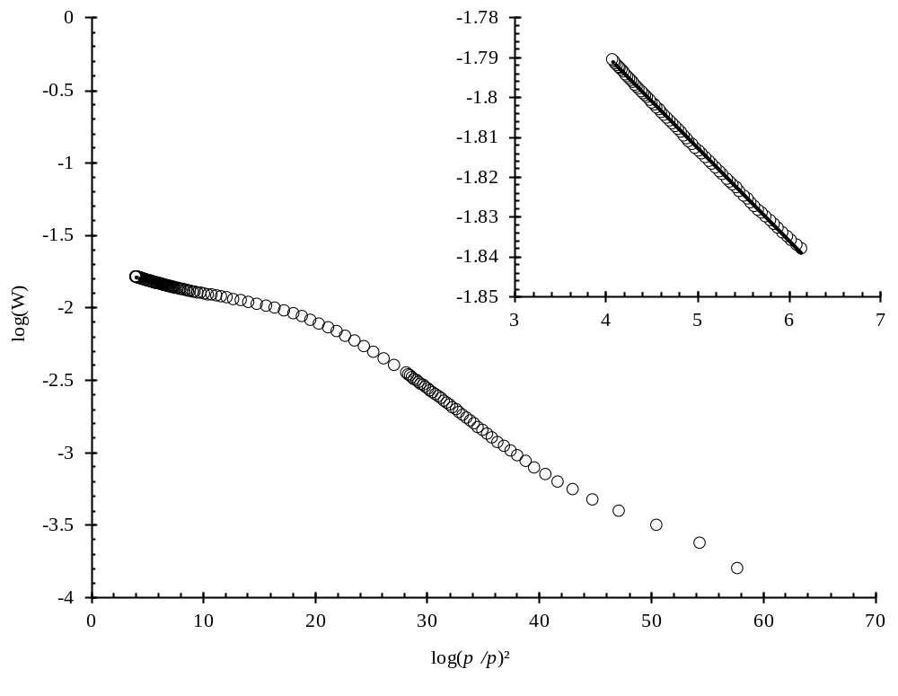
Online resource 10: Dubinin-Radushkevich transformed isotherm of CO₂ adsorption on zeolite 4A at 0°C (inset: linear portion from p°/p = 3.33 ∙ 10⁻³ – 9.58 ∙ 10⁻³).
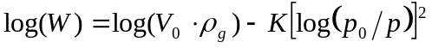 (11)
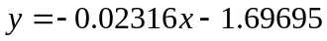 (12)
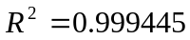. (13)
Online resource 14: Micropore volume and surface area calculation values
Description | Value | Literature
Mass of adsorbent | 0.0886 g | Measured
Density of adsorbed phase | 0.92743 g ∙ cm⁻³ | (Span and Wagner 1996)
Molecular cross section | 1.70 ∙ 10⁻¹⁹ m² | (McClellan and Harnsberger 1967)
Bering, B., Dubinin, M., Serpinsky, V.: Theory of volume filling for vapor adsorption. Journal of colloid
and interface science 21(4), 378-393 (1966)
Dubinin, M.: Adsorption in micropores. Journal of Colloid and Interface Science 23(4), 487-499 (1967)
McClellan, A.L., Harnsberger, H.F.: Cross-sectional areas of molecules adsorbed on solid surfaces.
Journal of Colloid and Interface Science 23(4), 577-599 (1967)
Span, R., Wagner, W.: A new equation of state for carbon dioxide covering the fluid region from the
triple‐point temperature to 1100 K at pressures up to 800 MPa. Journal of physical and chemical reference data 25(6), 1509-1596 (1996)

W is the amount of CO₂ adsorbed in units of grams.

