**Target coverage app tutorial**

Eric Greenwald

6/23/2025

Target Coverage App Version 1.0

# Background

This MATLAB based application was developed to assist in the analysis of in vitro washout assay data that was designed to aid in the identification of a mechanisms PK driver. A brief description of the experiment is below (Text extracted from associated publication):

“To differentiate the different PK drivers, an in vitro anti-proliferation study design was developed where the AUC was held constant while the maximal concentration and the duration of exposure were varied (Fig. 1). Drug was applied to cells at 5 different concentrations and then washed out at different times such that the AUC of exposure over the entire length of the study was matched. Cell growth was measured in all groups at the end of the experiment (3–10 days after drug was added). To design the experiment for each cell type and compound tested, a standard continuous exposure anti-proliferation experiment is run to define the in vitro potency as measured by an endpoint assay (Fig. 2a). Additionally, a time course of the cells in the absence of drug is needed to define the cellular growth kinetics. The continuous exposure potency data is then used to define the experimental conditions for multiple AUC matched sets to explore a range of concentrations and durations of exposures (Fig. 2b-c). As a general rule of thumb, 4 different AUC matched sets, where the average concentration for the different sets are , , , and , were found to be sufficient to differentiate the PK driver for all compounds tested. Using these experimental designs the AUC matched washout experiment (Fig. 1) was run and the proliferation was assessed at the endpoint of the assay to explore the PK driver (Fig. 2c). The benefit of this experimental design is that when cellular growth is plotted as response vs duration of exposure (Fig. 2e), an AUC-driven process will yield a straight horizontal line, a threshold-driven process will exhibit a greater effect for a longer duration of coverage, and a Cmax-driven process will have a greater effect in the groups with a higher concentration and shorter exposure duration. Finally, to aid in the identification of the PK driver from the experimental data the three different PK driver models, described below, were fit to the data and model agreement was used to discriminate the dominant PK driver (Fig. 2d).”

# Minimal technical requirements

* MATLAB 2023b
  + The app and models were developed in MATLAB 2023b, and it has not been tested in other versions of MATLAB.
* MATLAB simbiology toolbox license

# Using the app

## Starting the app

1. Save the folder with the app and its associated files somewhere that is accessible to MATLAB (e.g. somewhere on your local hard drive)
2. Start MATLAB
3. Either set the MATLAB working directory to the folder with the Target Coverage App or add the folder to the working path
4. On the command line type the command:  
   >> TargetCoverage
5. The app should now open up and look something like the image below:

1. Shortly after a wait bar should pop up and display the progress while different aspects of the model load (example image of the wait bar shown below). Please wait for the app to fully load before trying to use it.  
   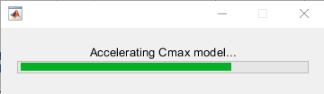
2. Once finished, the wait bar will disappear. The “Generate Models” button is red and several tabs are greyed out because the base model parameters (growth rate, seeding density Carrying Capacity and Simulation end time) have not been defined.

## Defining the base model parameters

### Option 1 – Fitting from growth data

1. Go to “Growth Parameter Fitting” tab
2. Import growth data from excel spreadsheet by clicking “Import from Excel” button and then selecting the growth data spreadsheet from the directory.
   1. Excel spreadsheet format: 2 Columns where column A is the time of measurements in hours and column B is whatever the cell confluence measurement is (e.g. CTG or cyquant). Also, the format assumes there is a title row.
   2. The data can be longer than the washout experiment timeframe and adjusted on the home tab.
   3. Example dataset included with tutorial “Example_GrowthData_2kCellsPerWell.xlsx” 
3. Both the graph and the data table should update after loading the data to look something like this:

1. Push the “Fit Growth Parameters” button to fit the growth model to the data. The iteration details of the fit should appear in the command window and when completed, the plot should update with the fitted line. And the fitting parameters table should update with the fitted model parameters.

1. Finally, if you are happy with the fit push the “Apply Fitted Parameters to Model” button and those parameters will be applied to the model and the sim functions will be generated using those parameters. After pushing this button the “Generate Models” button on the “Home” tab should turn green and the tabs that used to be greyed out should now become black.
2. If the time frame of the washout experiment is different than the final timepoint in the growth data then the simulation end time will need to be changed. Go to the “Home” tab and change the value in the “Simulation end time” box. For this example dataset the washout experiment duration was 72 hours so change the number in that box to 72. The “Generate Models” button will turn red indicating that the base model growth parameters have not been set. Click the “Generate Models" button to update the base model growth parameters and the button should turn green.
3. Now would be **a good point to save the app state**. I would recommend updating the “Cell Type” and “Source” fields in the “Report” tab and then saving this ‘Growth Data’ app state by pushing the “Save App State” button on the “Home” tab. See **Section 3.8.1** for more detail.

### Option 2 – Defining parameters directly

1. If you know the growth parameters, either from a previous fit or fitting data outside of the app, those values can be entered into the fields in the “Base model parameters” box on the “Home” tab.
2. With the parameters entered, press the “Generate Models” button and those parameters will be applied to the model and the sim functions will be generated using those parameters. After pushing this button the “Generate Models” button on the “Home” tab should turn green and the tabs that used to be greyed out should now become black.
3. Now would be **a good point to save the app state**. I would recommend updating the “Cell Type” and “Source” fields in the “Report” tab and then saving this ‘Base’ app state by pushing the “Save App State” button on the “Home” tab. See **Section 3.8.1** for more detail.

## Loading experimental Data

### Go to the “Data” Tab

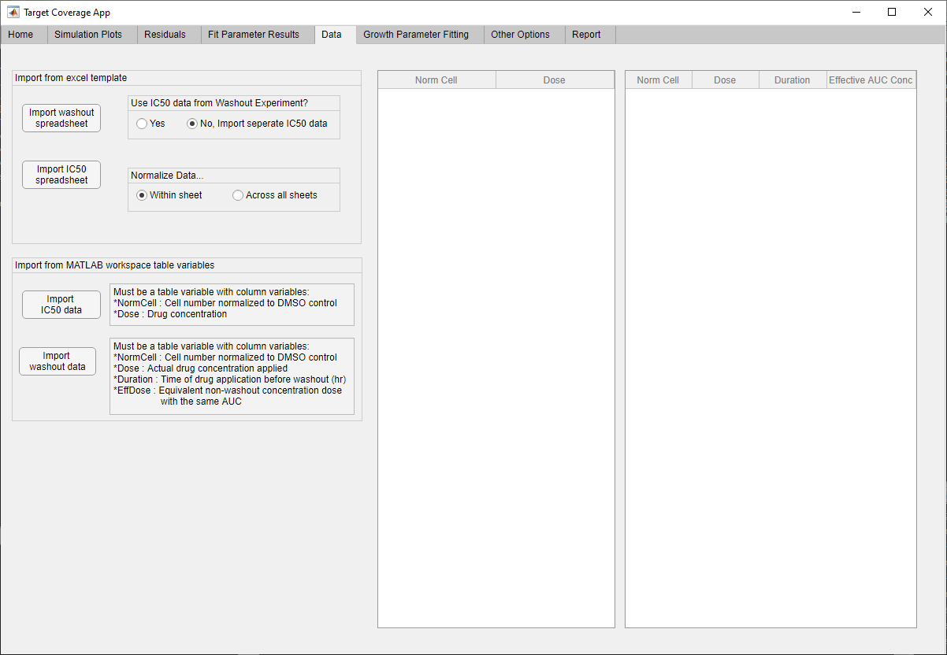

### Option 1 – Loading both Washout (WO) and IC50 data via Excel templates

1. The Excel template can be used for both Washout experiment data and IC50 experiment data. The data import excel template can be found with the other app files “WashoutDataTemplate.xlsx”. Excel template requirements
   1. Only data from one compound allowed in a given spreadsheet
   2. Replicates or experiments that extend beyond a single 96 well plate need to be compiled into one workbook, where the template sheet can be copied as a second sheet within the workbook
   3. A vehicle control well should be included with the non-washout wells (for IC50 generation) for normalization if these data are to be used as the IC50 data.
2. Specify import options
   1. If you want to use the non-washout wells from a washout experiment for your IC50 data, select “Yes” under “Use IC50 data from Washout Experiment?” and a separate IC50 spreadsheet of data should not be uploaded. Otherwise, leave the option as “No, Import separate IC50 data”.
   2. If you have more than one sheet of data, e.g. plate replicates or experimental designs that span more than one plate, the data can either be normalized within sheet (option selected: “Normalize Data…” 🡪 “Within sheet”) or all the data can be lumped together and normalized as one (option selected: “Normalize Data…” 🡪 “Across all sheets”).
3. Import the Washout spreadsheet data
   1. Click the “Import washout spreadsheet” button and select the excel spreadsheet with the Washout data. The data table may not update until both the washout and IC50 data have been uploaded.
   2. Example data: For this tutorial example datasets are included, where a separate IC50 dataset is used so the options selected is “No, Import separate IC50 data” and “Normalize Data…” 🡪 “Within sheet”. For this example the washout data is in the excel file “Example -Raw data - WO.xlsx” and the IC50 data is in the excel file “Example -Raw data - IC50.xlsx”
4. Import the IC50 spreadsheet data – *Skip if using the IC50 data from the washout experiment.*
   1. Click the “Import IC50 spreadsheet” button and select the excel spreadsheet with the IC50 experimental data. Both data tables to the right should update.
   2. If using the example dataset the “Data” tab should now look like this:

### Option 2 – Import from MATLAB workplace variables.

1. Import IC50 data – Push the “Import IC50 data” from the “Import from MATLAB workspace table variables” box. Select the variable from the workplace of the IC50 data. Variable requirements:
   1. Must be a MATLAB table type of variable
   2. One column must be named “NormCell” and contain the IC50 data normalized to the vehicle control.
   3. Another column must be named “Dose” and contain the concentration of the compound that is associated with each IC50 NormCell datapoint.
   4. Any other columns will be ignored
2. Import Washout data – Push the “Import IC50 data” from the “Import from MATLAB workspace table variables” box. Select the variable from the workplace of the IC50 data. Variable requirements:
   1. Must be a MATLAB table type of variable
   2. One column must be named “NormCell” and contain the washout data normalized to the vehicle control.
   3. One column must be named “Dose” and contain the concentration of the compound that is associated with each washout NormCell datapoint.
   4. One column must be named “Duration” and contain the duration of exposure before washout, in the units of hours, that is associated with each washout NormCell datapoint.
   5. One column must be named “EffDose” and contain the non-washout AUC matched dose that corresponds to that data point.
   6. Any other columns will be ignored
3. Once both the IC50 and Washout data are uploaded the data tables will update.

## Data and plots update

1. After both the IC50 and Washout data have been imported, the tables on the “Data” tab will update with the data. Also, the data will appear on the plots on the “Simulation Plots” tab.
2. The appearance of the data can be changed on the “Other Options” tab
   1. Individual data points or mean and SEM: Toggle buttons in the “Data Plot Format” box. Select how you want to view the data points on the plot
   2. Marker size: Change the value to change the size of the data points on the graph.
   3. Washout Colormap: select the colormap used to color the different AUC matched groups. The default is “copper” that has an even gradient that changes in the order of the “Effective dose” AUC group value whereas the “lines” option uses the standard plot color order. After making your choices, push the “Update Plot Display” button.
3. Now would be **a good point to save the app state**. I would recommend adding the compound metadata (Compound number, Name, Target) and experimental metadata (Cell Type, Source, Dates, Number of Replicates) on the “Report” tab. Then save this ‘Compound Base’ app state by pushing the “Save App State” button on the “Home” tab. Saving after uploading the experimental data allows you to load the app state with all the data before making any assumptions or doing any fits. See **Section 3.8.1** for more detail.

## Exploring data and model results

1. Visualization of both the data and model predictions can be seen in the “Simulation Plots” tab.

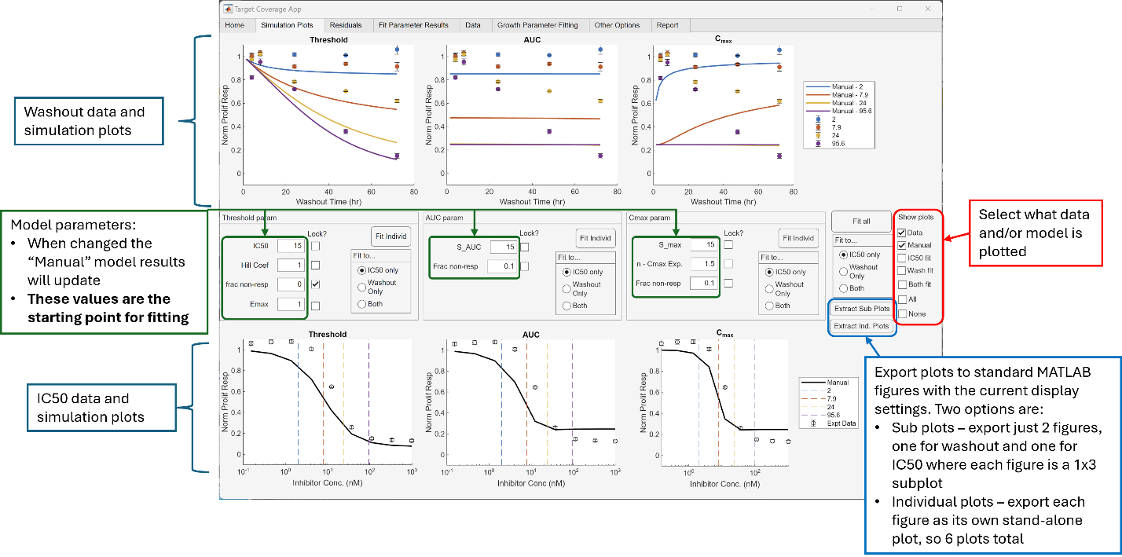

1. On this tab, when you change the model parameters, the “Manual” model simulation results will update in the plots. This can be useful to explore how the model changes for different model parameters as well as refining initial estimates before fitting.
2. These plots can be exported to standard MATLAB plots for saving and sharing.
   1. The plots can be exported as 2 figures, one for washout data and models and one for IC50 data and models, where each has 3 subplots for the 3 different models by pushing the “Extract Sub Plots” button
   2. Alternatively, all of the plots can be exported as individual plots (6 total) by pushing the “Extract Ind Plots” button.

## Fitting the models to the data

### Setting initial parameters

1. Now that the model base parameters have been fitted and both the washout and IC50 data have been uploaded, we can begin to fit the three models to these data.
2. First, the initial parameter estimates need to be set. Often the defaults from the app are sufficient to converge on a result but in some cases a different initial estimate will help the fitting converge to the best fit.
   1. 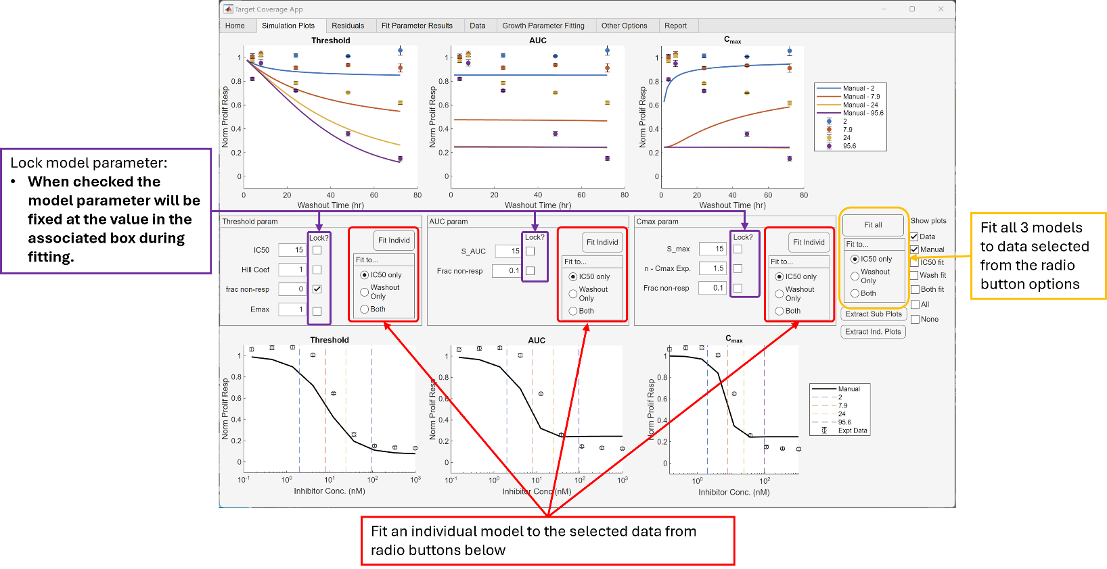Manually setting the parameters – As stated before (3.5), the parameter values in the editable boxes in the center of the “Simulation Plots” tab not only change the manual simulation estimates but serve as the initial values for the fitting algorithm. Therefore, to manually set the initial estimate change these values to the ones desired.
   2. Using values from previous fitting runs – Either the initial estimates of a fit or the final fitted values from the previous fit can be quickly be assigned to the manual parameter values (and thus the initial conditions for the next fitting run) in the “Fit Parameter Results” tab.
      1. For example, if I have fit all 3 models to the IC50 data only, the “Fit Parameter Results” tab would look like the image below.

* + 1. If you wanted to use the same initial parameter values that were used for a previous fit, you would make sure the “initial Param” option was selected in the middle row, and that all of the models were selected in the middle row. Then you would push the “Set Current Params as…” button and then the parameter values on the “Simulation Plots” tab would be set to the values under “Init param” in the middle row table.
    2. Similarly, if “Bounded Fit” were chosen as the “param type” then the parameter values would be set to the values of the “Fit Value” column in the middle table. Also, by using the check boxes on the right, the values can be applied to a subset of the models.

1. Next, if you would like to have any parameters fixed instead of fitted during the fitting algorithm, you need to check the checkbox next to that parameter on the “Simulation Plots” tab. For example, the fraction non-responder parameter under the Threshold model is checked by default because the Emax parameter can have an overlapping effect on the max response, so the check box next to frac non-resp. under Threshold is checked.

### Running the fit

1. The models can be fit to either the IC50 data alone, the washout data alone or simultaneously to both the IC50 and the washout data. Additionally, all 3 models can be fit to these data or the fitting can be run for one model at a time
   1. Fitting all 3 models – Select which data to fit to on the right side of the “Simulation Plots” tab, under the “Fit all” button. After selecting the data to fit to, push the “Fit all” button and each of the models will be fitted to that data. A wait bar will appear and indicate witch model is being fitted. Also, the iteration results of the fit will display in the command line.
   2. Fitting individual models – Under each model there is a separate “Fit to…” box and “Fit Individ” button. Under the model you wish to fit, select the data you wish to fit to in “Fit to…” and push the associated “Fit Individ” button. The iteration results of the fit will display in the command line, but no wait bar will appear.
2. After the fit has completed, the plots should update with a line associated with that fit. You can control which lines are displayed using the checkboxes on the far right of the “Simulation Plots” tab. For details on exporting the plots see **section 3.5**.
3. After fits have been performed for each of the models against a given data type the fitted parameters will be displayed on the “Fit Parameter Results” tab and the residuals can be viewed on the “Residuals” tab. These are discussed further in the next section.

## Evaluating the goodness of fit

1. Visual evaluation of the fit – The first step to determining the most likely model is to visually evaluate the fit against the data. Again, after the fit is finished the graphs on the “Simulation Plots” should update with the fitted model results and you can compare the results for a given fit across the different models. The display of the fit results for fitting to different datasets can be changed by changing the selections on the right side of the “Simulation Plots” tab.
2. Visual evaluation of the residuals – The residuals of the fit can be viewed on the “Residuals” tab. The residuals for fits to different data sets can be viewed by selecting the dataset from the “Show residuals from…” box. Additionally, the residual plots can be exported to a regular MATLAB figure by pushing “Extract Sub Plots” to get a single figure with 3 subplots of the residuals on it or pushing “Extract Ind. Plots” to get 3 separate figures for each of the models.

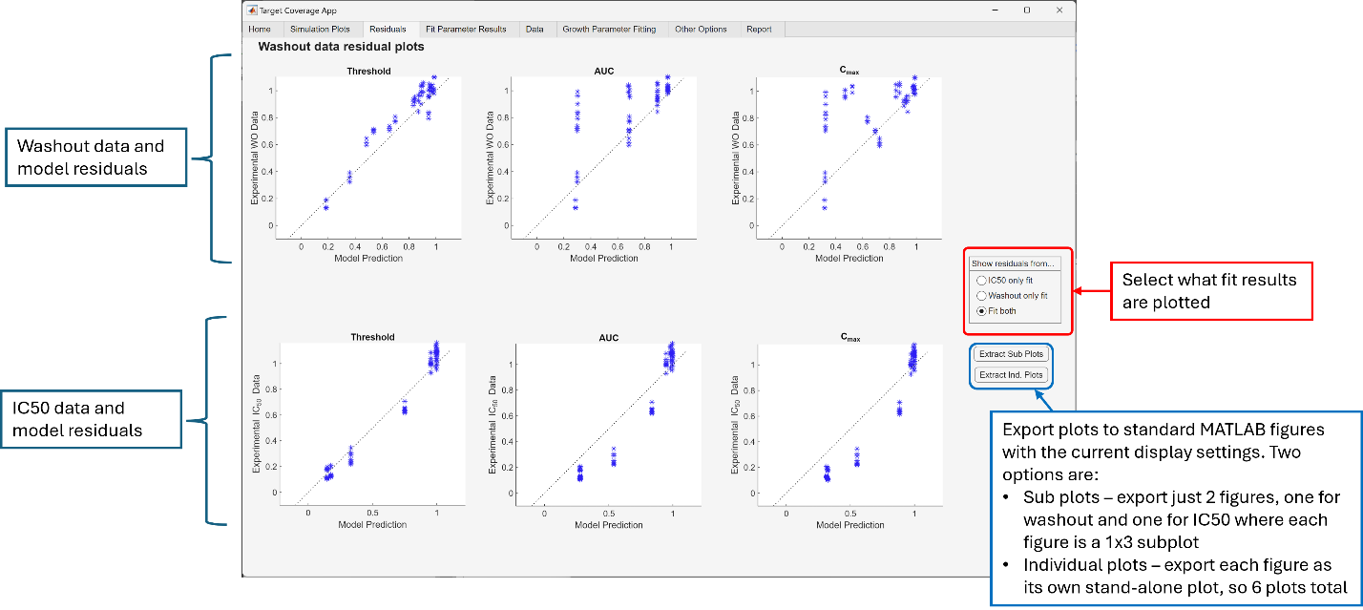

1. Quantitative measures – Finally, if the best fit model is not clearly apparent the Akaike Information Criteria, AIC, and Bayesian Information Criteria, BIC, are calculated for each of the fits and can be viewed on the “Fit Parameter Results” tab. Generally, the model with the lowest (i.e. closest to negative infinity) AIC/BIC value is indicative of the best model with the fewest needed parameters. For example, in the screen shot below the AIC and BIC values indicate that the threshold model is a better fit than the AUC and Cmax models.

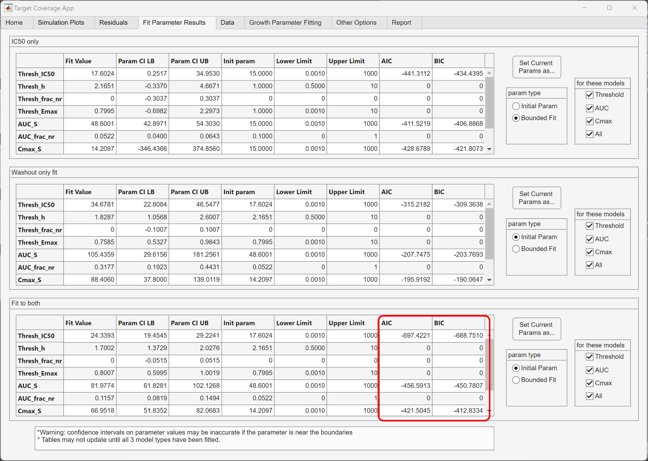

1. After you have run all the fits and evaluated them, now would be **a good point to save the app state**. I would recommend adding the compound metadata (Compound number, Name, Target) and experimental metadata (Cell Type, Source, Dates, Number of Replicates) on the “Report” tab, if you haven’t already done so.
   1. Also, if you believe that these fits are the best fits to the data and allow you to make a determination on the PK driver you should also complete the fields in the “Analysis Outcome” section on the “Report” tab.
   2. Then save this ‘Fit result’ app state by pushing the “Save App State” button on the “Home” tab. Saving after completing all of the fits allows you to restore the app to this final state or to change the assumptions (e.g. include compound carry over) while starting from the previous fit. See **Section 3.8.1** for more detail.

## Generating a report

1. After defining the base model parameters, loading the experimental data, fitting the models to these data and determining which PK driver is most likely based on the model agreement, you can generate a report for easier retrieval and documentation of the results. This report is an excel spreadsheet that includes the washout and IC50 data, fit results (including the parameters and the simulation results), experimental metadata, and analysis outcome annotations.
2. The report is generated using the app in the state that it is currently in, so make sure you have the app in the state which you want to record. Also, you should fill out the compound and experimental metadata, and analysis outcome sections on the “Report” tab so that these are included in the report.

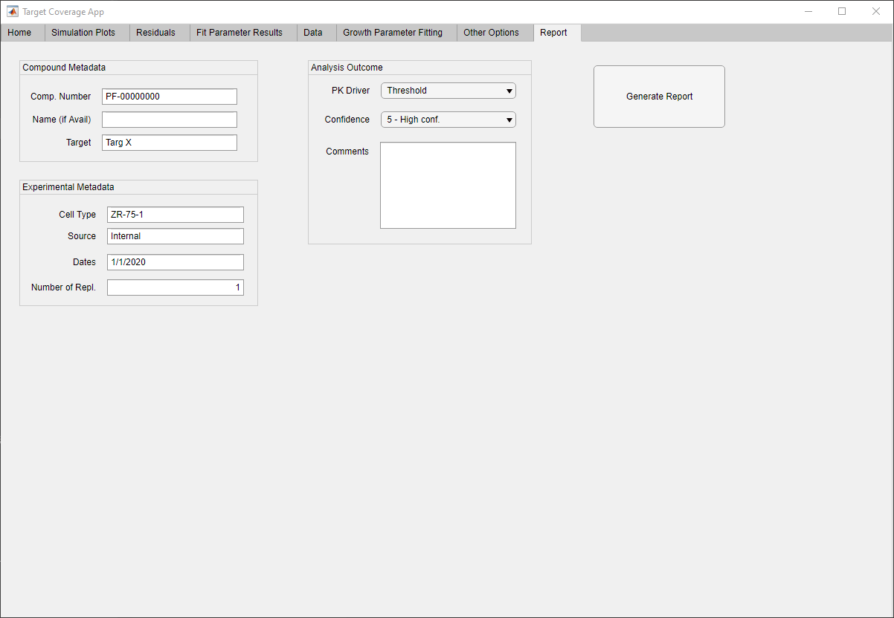

1. When ready, push the “Generate Report” button on the “Report” tab. A file navigator panel will appear and allow you to select the name and the location to save the report.

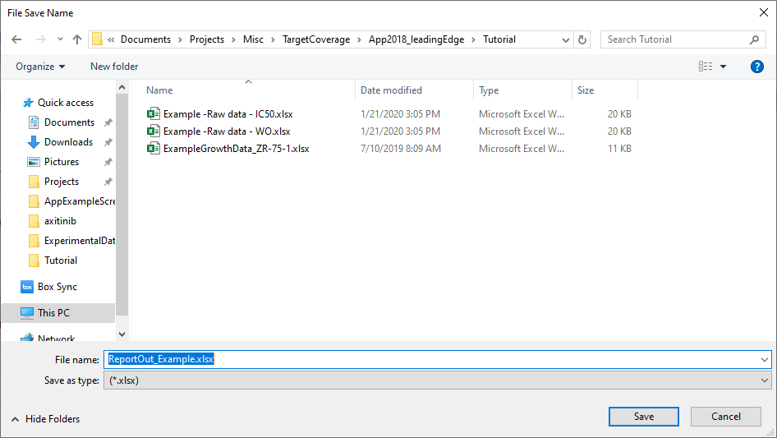

### Example report

## Saving and loading app states

1. Saving app state - You can save the current state of the app, including (if in the app) the growth data, model base parameters, washout and IC50 data, model fits, experimental and compound metadata and analysis outcome decisions, by pushing the “Save App State” button on the “Home” tab. This will open a file browser window where you can select where and what name to save your app state as.
2. Loading app state – You can load a previously saved app state by going to the “Home” tab and pushing the “Load App State” button. *Warning* – this will overwrite anything that is currently in the app including data, parameters, fit results and metadata.

## Other options

1. In the “Other Options” tab there are some additional changes that can be made.
2. Plot options – See **section 3.4**.
3. Situations where washout exposure may be different than expected –
   1. “First order degradation rate” – If a compound undergoes hydrolysis (or other unspecified degradation) in the cell culture media, an estimated 1st order degradation rate can be applied to the model and then the model can be fit to the data.
   2. “Frac carry over after washout” – this is the fraction of the original dose that is still in the media after the washout occurs. With an incomplete washout, there is still the possibility of a continued effect especially at the doses with high exposure during a short duration. (Value should be between 0-1)
   3. You must click the “Update model settings” button after changing these values to apply them to the model.
4. Fit parameter limits
   1. The upper and lower bounds of the parameter values are shown in this section and can be changed to alter the bounds applied to the fitting.