BiSNP: A Biclustering Method for Finding Higher-Order Combinations of SNPs that are Associated with Complex Diseases

Abstract
Finding higher-order combinations of SNPs that are associated with complex traits is of great interest for discovering the underlying causes and mechanisms, and giving diagnosis and prognosis of diseases such as cancer, diabetes and many more. The mathematical problem is of a combinatorial nature and thus does not lend itself easily to efficient optimal solutions. Here I propose an approximate algorithm based on an adaptation of the biclustering paradigm combined with a preprocessing routine that reduces dramatically the search space in a subclass of realistic scenarios. The method can be implemented on current hardware in a very efficient way with respect to running time and memory footprint.

Introduction
Genome-wide association studies (GWAS) provide a powerful way to investigate genetic causes of complex diseases such as cancer, type II diabetes, and inflammatory bowel disease. In a typical GWAS thousands of affected and control individuals are genotyped for millions of single nucleotide polymorphism (SNP) markers. Frequencies of occurrence for all SNPs in the two groups are compared and significant differences are said to be associated with the phenotype in question. Despite the fact that the number of associated SNPs in these studies grows exponentially with every year, two alarming observations have long disturbed scientists. First, the effect sizes of individual SNPs tend to be extremely small. And second, the total fraction of the estimated heritability explained by all found associated SNPs remains fairly low in the vast majority of the cases [1].

There are numerous possible explanations for these findings. It was suggested that, because SNPs are tested independently, interactions among genes may not be accounted for and thus wrong conclusions may be drawn [2]. Higher order combinations of SNPs may possess greater explanatory power. However, due to the combinatorial complexity of the problem existing methods that consider epistatic interactions usually focus only on interactions between pairs or triplets of SNPs [3][4][5]. Here I propose a computational framework, BiSNP, based on biclustering combined with a preprocessing technique that can reduce dramatically the search space for detection of potentially interesting higher order combinations of SNPs that occur in different proportions in subgroups of cases and controls. The method does not test explicitly all possible configurations. Instead, it aims to identify only those that are overrepresented in the set of cases as compared to the set of controls.

In the field of bioinformatics biclustering was first utilized by Cheng and Church for the task of gene expression analysis [6]. Currently, it encompasses a multitude of algorithms that aim to cluster simultaneously rows and columns which follow similar patterns in a given input matrix [7]. It was shown that in real settings this problem is NP-complete and therefore only approximate solutions are available at the present time. To adapt the biclustering paradigm to the problem of finding higher-order combinations of SNPs one has to overcome several additional obstacles imposed by the nature of genotypic data. Among them are the very large input size, the presence of linkage disequilibrium (LD) and the low signal-to-noise ratio. The BiSNP algorithm addresses each of them.

Methods
In nature, a single phenotype can be often times achieved through multiple different genotypes. Medical conditions in humans are an excellent example of this. One person may have a mutation in her BRCA1 gene, whereas another may have a mutation in her BRCA2 gene. Both individuals, however, will have substantially increased risk of developing breast cancer [8][9]. Furthermore, the risk may be significantly affected by sequence polymorphisms in their AIB1 genes and by their reproductive history [10]. In the case of rheumatoid arthritis gene expression profiles from individual patients tend to cluster in groups that define different disease subtypes [11][12]. This suggests that patients' genotypes may also cluster together so that each group represents a different combination of genetic factors that increase the risk of developing the disease. With complex diseases it is rather the rule than the exception that they comprise of heterogeneous phenotypes that can be explained by interactions between possibly overlapping sets of genetic and environmental factors.

Let us consider the case of a heterogeneous disorder that consists of several subtypes. Suppose that the risk of developing one of these subtypes increases only if the minor alleles of two loci are present on both chromosome copies of an individual. If we collect a sample of patients without knowing which subtype of the disease they have we expect that a fraction of them will be homozygous for the minor alleles at both of those loci. Assuming uniform sampling, the size of this subgroup of individuals will be proportional to the rate of incidence of the disease subtype. It is worth noting also that the expected number of individuals with the same combination of genotypes in a sample of controls is obviously smaller. Although useful, the algorithm proposed in this work does not utilize directly this information for reasons that will be discussed later. Genotype data from controls will be used in a different way to reduce the noise due to statistical correlations between neighboring alleles. More importantly, the above concept generalizes easily in the case when the risk of the subtype increases only if an individual is homozygous for the minor alleles at more than two loci. Then, in the sample of affecteds we will expect to observe a fraction of individuals, all of whom are homozygous for the minor alleles at each of those loci. If the genotype information is encoded simply with Boolean values, this fraction will manifest itself as a bicluster that is scattered across the rows and the columns of a binary matrix. Figure 1 shows an example of that. The goal of my method is to detect efficiently such biclusters in very large and noisy data sets.

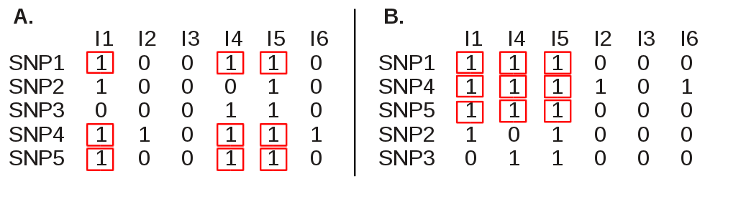Figure 1: We can represent the genotype data from a set of case individuals as a binary matrix, where each row corresponds to one SNP and each column corresponds to one individual. A cell in the matrix with coordinates [i,j] has a value of 1 if individual j has the minor allele of SNP i on both of his or her chromosome copies and 0, otherwise. Here, five SNPs (ordered from SNP1 to SNP5) were genotyped in six cases (ordered from I1 to I6). Individuals I1, I4 and I5 are assumed to have the same subtype of the disease. The risk of developing this subtype is increased by the presence of the minor alleles of SNPs 1, 4, and 5 on both chromaspiriosome copies. Thus, individuals I1, I4, and I5 all have that combination. As a result, the columns corresponding to I1, I4, and I5 and the rows corresponding to SNP1, SNP4, and SNP5 form a bicluster in the binary matrix. Part A and part B of the figure show the matrix before and after a proper reordering of the rows and the columns, respectively. The goal of this reordering is to detect the bicluster that consists of individuals I1, I4, and I5 and SNPs 1, 4, and 5. The cells that belong to the bicluster are marked in red.

To define the problem in precise mathematical terms, let us assume that we have a group of n affected individuals who were genotyped for m SNPs. We can construct an m by n binary matrix M, where rows correspond to SNPs and columns correspond to affected individuals. Each cell M[i,j] is set to 1 if SNP i is observed in individual j and 0, otherwise. For the purposes of this work we will consider only homozygous SNPs (i.e. we will say that an individual has a particular SNP if that SNP's minor allele is present on both copies of his or her chromosomes). Biclusters are defined as subsets of rows and columns that after proper reordering form a homogenous submatrix (i.e. all cells in the block are equal to 1). Each bicluster represents a subgroup of affected individuals who all have a subset of the genotyped SNPs, and thus can be related to a subtype of the disease in question. Our ultimate goal will be to discover significantly large biclusters in the matrix M.

Current biclustering algorithms suffer from several limitations that prevents us to apply them directly to the problem described above. First, they work well only if the input binary matrix is sparse (i.e. it is populated primarily with zeros). Conversely, if the input matrix is dense they tend to either consume unacceptable amounts of computational time and/or produce vastly inaccurate results. Second, they are not suited for analysis of very large data sets. Most of the methods were developed for the purpose of gene expression studies, where input dimensions are in the order of several thousand conditions on the first axis by 20-30 thousand genes on the second axis. In contrast, the problem of biclustering SNPs requires algorithms that can handle matrices at least as large as several thousand individuals by several hundred of thousands of SNPs. Thus, the second dimension of the input matrix here represents a major obstacle for existing solutions. Furthermore, SNPs that are in linkage disequilibrium will be a significant source of false positive findings. Each of those issues will be addressed separately in the next paragraphs.

Dense binary matrices are hard to deal with. They tend to biclusters of moderate size, just because rows that have high frequencies of 1's have overlap more often with each other. One way to resolve this problem in our case is to restrict the algorithms to search only for biclusters that contain a large number of individuals. However this may limit their statistical power to recover true combinations. We will discuss these limitations in more detail in the Discussion section. On the other hand, the problem that arises from the very large size of the input matrix is solvable by utilizing a preprocessing procedure that aims to reduce the search space. To the best of my knowledge, it has not been applied before to the problem of biclustering. The basic idea behind it is to divide the input into a fixed amount of chunks and iterate over each of them by gradually enhancing the real signal. Since the first dimension of the input matrix (the number of affected individuals) does not pose a problem by itself, we need to reduce only the number of SNPs that are analyzed at a time. For this purpose, the original matrix M is divided into k submatrices of size n by l, where l = m/k for some integer k. We will denote the i-th such submatrix by S_{i}. Initially all submatrices are of equal size with the possible exception of the last submatrix, S_{k}, the size of which is m modulo k. The parameter l should be chosen to be small enough so that an average-case O(log₂(n)l²) algorithm is able to process each S_{i} in reasonable time and large enough so that the probability that S_{i} contains a detectable fraction of the original signal remains high. We will discuss later in this section how to pick an optimal value for k. During the preprocessing each submatrix is scanned for triplets of SNPs that share a predefined minimum number of carriers, μ. Converting the rows of each submatrix to arrays of integers where bits are set to 1 if an individual has the SNP and 0, otherwise, enables performing such calculations rapidly on current hardware. To determine all shared carriers between two SNPs we just need to count the number of set bits in the result of a bitwise AND operation on their bit-encoded vectors. To find all triplets, the algorithm scans first for pairs of SNPs that share at least μ carriers. Then all pairs are compared against each other and those that share at least μ carriers are kept. In theory, the worst-case for this procedure is O(log₂(n)l⁴), but under certain circumstances it behaves more like a quadratic algorithm, because the actual number of SNP pairs that share at least μ carriers is much lower than l. To prevent the O(log₂(n)l⁴) worst-case from happening, the algorithm observes the number of pairs found after each iteration, and it gives up if that number increases above a multiple of l. Finally, after all triplets that pass the check are determined their genotypes are appended to the next submatrix, S_{i+1}, and the whole procedure is repeated. This last step is essential to improve the chance of finding all SNPs that belong to biclusters by the end of preprocessing. It strengthens gradually the real signal after each iteration. In fact, once a triplet that belongs to a given bicluster is found all the rest of the SNPs in it that are scattered across subsequent submatrices will be collected even if those submatrices contain two or less SNPs from that bicluster (i.e. do not pass the minimum carrier triplet check).

The optimal value of k depends on the size of the biclusters we are aiming to find. More precisely, it depends on the minimum number of SNPs that we require for a bicluster. Let us denote that number by B. Intuitively, if B is large then large values of k (i.e. smaller values of l) will work. In this case we can afford to slice the initial input into many small pieces and process them quickly with the minimum carrier triplet check (or even with a more stringent criterium). Conversely, if B is small, the original signal is very diluted and the algorithm will need bigger submatrices (i.e. smaller values of k) to recover it. Obviously, if B > 2k then at least one submatrix will contain minimum three SNPs from the bicluster. If this is the case, two full iterations over the original matrix will be enough to collect all bicluster SNPs from it. However, if B is less or equal to 2k, this algorithm cannot guarantee that there will be at least one submatrix with minimum three causal SNPs. In either case, it is better to apply a probabilistic solution that samples random submatrices from the initial input matrix until a desired confidence is achieved that at least one of them contains minimum three SNPs from the bicluster. After that, the algorithm needs to perform one full iteration over all S_{i} as already described to recover all SNPs that belong to the bicluster. Suppose we want to achieve a confidence level of α that at least one of the random submatrices we sampled so far contains minimum three causal SNPs (i.e. SNPs that are part of the bicluster). The question is how many times do we need to sample to reach that level. To answer that, we will calculate first the probability, P_{c,} that any single submatrix contains minimum three SNPs from the bicluster. This probability can be derived from the binomial distribution with n = B and p=1/k, so that

where X is the number of causal SNPs in the submatrix. Now, the probability that at least one out of t randomly chosen submatrices has minimum three causal SNPs, α, can also be derived from the binomial distribution this time with n = t and p = P_{c} . It is equal to

where X denotes the number of submatrices that have at least three causal SNPs. To find the minimum value of t in order to achieve a given confidence level of α, we need to solve the following inequality for t:

Thus, for any given α, B and k we can find t_{min} that satisfies the desired requirements. Moreover, the sampling procedure provides a more efficient solution even in the case where the existence of at least one submatrix with minimum three causal SNPs is guaranteed (i.e. when B > 2k), because as the total number of SNPs, m, is usually very large performing one full initial iteration over all submatrices may add too much noise and be too time consuming. For example, if m = 500,000 and B = 100 we need to sample just 3 submatrices of size 20,000 instead of iterate over all 25 to be more than 98% confident that at least one of them contains minimum three causal SNPs.

Another problem is caused by the fact that single nucleotide polymorphisms are known to exhibit linkage disequilibrium in practice. Different pairs of alleles are transmitted together more often if the physical distance between them is short. Moreover, the non-uniform nature of recombination events creates a complex correlation structure among SNPs. Such statistical dependencies between rows cause biclustering algorithms to choke and/or produce huge numbers of false positive results. On the other hand, it is exactly what we are interested in, because SNPs in biclusters will show increased LD in cases, but lower LD in controls. This observation yields a natural solution for the problem. In the preprocessing routine we will discard comparisons between SNPs that are in strong LD in the control group. LD can be measured in various ways [13][14][15]. In this work I will use the normalized difference between observed and expected joint allele frequencies, also known as the correlation coefficient r, between pairs of loci:

where A and B are two SNPs, P_{a} and P_{b} are their minor allele frequencies respectively, and P_{ab} is the frequency of their joint occurrence in the control group. During the preprocessing pairs of SNPs are considered only if they have LD in the group of controls that is less than a predefined parameter, λ.

The set of SNPs from the triplets that pass the minimum carrier check in the last iteration of the preprocessing routine is fed as an input to a biclustering procedure for binary matrices. For the purposes of this work, I implemented the BiBit algorithm which is a greedy cubic-time solution [16]. In theory, any of the existing biclustering algorithms can be used.

Results

All of the procedures described in the previous section were implemented in the Python programming language and run using PyPy on a quad-core 2.3 GHz laptop with 16 GB RAM. The source code is freely available on Github at https://github.com/pfiziev/bi-gwas.

The algorithm was tested on several different data sets. Due to access restrictions enforced by the Wellcome Trust Case Control Consortium on public GWAS data I used simulated data by running the SIMLD software [17]. The generated SNPs have similar minor allele frequencies and LD structure as the CEU population from the HapMap project [18]. Due to practical limitations of the software the SNPs were generated in batches of 10,000 and no particular adjustments of MAFs or LD levels were made across batches. Each data set contains 2,000 individuals and either 100,000 or 300,000 SNPs. One disease subtype was simulated in each data set. To do that the 2,000 individuals were divided randomly into two equally sized groups, termed cases and controls respectively, and a subtype of the disease was implanted into the group of cases. The genotype data for the carriers of the disease subtype was simulated by choosing randomly a predefined number of cases, B_{ind}, and a predefined number of SNPs, B_{SNPs}, and setting m[i,j] = 1 for all i in B_{SNPs} and j in B_{ind} in the binary matrix M. Technically, B_{SNPs} and B_{ind} define a bicluster in M. As this procedure alters the minor allele frequencies of all SNPs from B_{SNPs} in the group of cases, it is necessary to compensate for it by adjusting the genotypes of the rest of the case individuals. This was done by choosing randomly an equal number of case individuals who were carriers before the implantation and setting their genotypes to 0 in the binary matrix. Nevertheless, it needs to be noted that this approach can introduce a small bias in the LD structure of the data that has an effect beyond the SNPs that were picked for the bicluster. The different data sets vary by the number of SNPs and individuals in B_{SNPs} and B_{ind} , respectively.
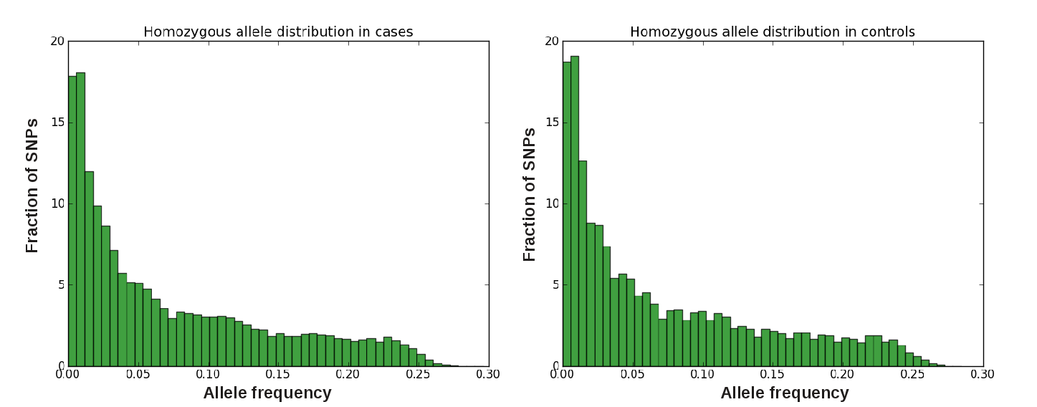Figure 2: Allele distribution in the groups of cases and controls in a simulated data set with 300,000 SNPs and 1,000 individuals in each group. A bicluster of size 100 by 100 was implanted in the group of cases, which corresponds to a disease subtype that affected 100 case individuals who are all homozygous for the minor allele of the same 100 SNPs. Both distributions have nearly equal means and standard deviations of 0.073 and 0.07, respectively. Allele distributions in other data sets are very similar to the ones shown in this figure.

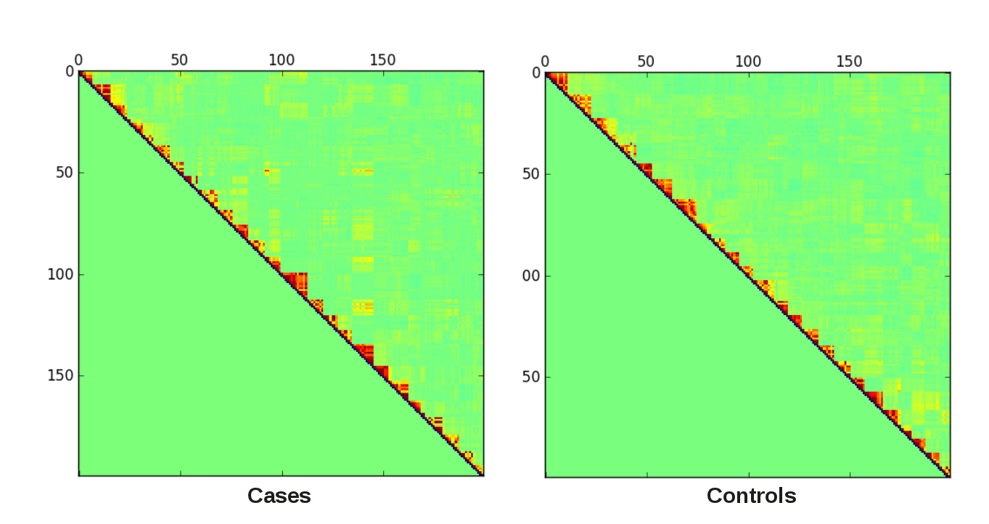Figure 3: A snapshot of the linkage disequilibrium structure between the first 200 SNPs of the 300k data set in the group of cases (left) and controls (right). Since the LD measure is commutative, values are calculated and shown only above the main diagonal. Colors are used as follows: red indicates LD close to 1, green indicates LD close to 0, and blue indicates LD close to -1.
A classic GWAS approach that looks for significant differences between the frequencies of individual SNPs in the groups of cases and controls will miss all of implanted SNPs, because their frequencies are maintained unchanged by the implanting procedure. On the other hand, most current algorithms for epistatic interactions can handle only two-way or three-way interactions [19][5]. Methods that are able to detect higher-order interactions usually are not applicable to such large data sets [20][21][22] or do it at the cost of substantial computational time (up to several weeks for data sets of the size discussed here) [23][24]. Other algorithms, like the BOOST algorithm [25], that were recommended as efficient and effective methods [26], failed to analyze properly data sets of even only 10,000 SNPs yielding an enormous amount of false positives (data not shown). For this reason, I compare the performance of BiSNP to an estimated lower bound of the number of false positive findings by a naive brute-force algorithm that considers all three-way interactions that are in higher LD in cases versus controls. In fact, such algorithm would output at least as many SNPs as there are candidate SNPs after the final iteration of the preprocessing routine, assuming that the LD threshold is the same. Therefore, we can use this number to estimate the minimal false positive rate of the naive algorithm.

SNPs in the implanted bicluster | Individuals in the implanted bicluster | True SNPs recovered | False positve SNPs | False negative SNPs | Running Time | Min. False positive count for naive LD
100,000 simulated SNPs in total
30 | 100 | 30 | 0 | 0 | 32 min | 81
30 | 100 | 30 | 0 | 0 | 38 min | 1061
15 | 100 | 15 | 0 | 0 | 1 h | 83
15 | 100 | 15 | 0 | 0 | 1 h 8 min | 1117
10 | 100 | 10 | 0 | 0 | 1h | 83
30 | 80 | 30 | 0 | 0 | 41 min | 2080
30 | 70 | 0 | 0 | 30 | 1 h 17 min | 5946
30 | 60 | 0 | 0 | 30 | 4 h 50 min | 7407
300,000 simulated SNPs in total
100 | 100 | 100 | 0 | 0 | 2 h 46 min | 174
100 | 80 | 100 | 0 | 0 | 3 h 15 min | 8229
100 | 70 | 0 | 0 | 100 | 4 h 33 min | 11351
30 | 100 | 30 | 0 | 0 | 2 h 46 min | 84
Table 1: Results from analysis of different data sets with BiSNP. The first part of the table shows results on data sets that contain 100,000 SNPs in total, and the second part shows results on data sets that contain 300,000 SNPs in total. The confidence level, α, was set to 95% in all runs. The minimum number of affected individuals per bicluster and the minimum number of SNPs per bicluster were set to the dimensions of the implanted bicluster. In all tests, the size of the submatrices was chosen to be 1,000 individuals by 10,000 SNPs. The cutoff for minimum LD in controls, λ, was set to 0.2, except for the two gray rows, where it was set to 0.5. The rows marked with red show cases where BiSNP failed to recover any of the true SNPs.

The tests show that setting the LD cutoff, λ, to a value lower than 0.5 has a very positive effect on reducing the number of pairs to consider. Without that and in the presence of even small amounts of LD the algorithm becomes infeasible. Also, the number of causal SNPs in the implanted bicluster seems to play role only in the number of random submatrices than need to be sampled in the beginning of the preprocessing procedure. The BiBit algorithm was able to reconstruct the original bicluster correctly even in the case where there were only 10 causal SNPs in it. The crucial parameter that determines the success of BiSNP is the number of shared carriers in the bicluster. For values lower than 70 it was unable to detect any of the causal SNPs. In all tests the RAM consumption never peaked above 500MB.

Discussion

Finding combinations of SNPs that are overrepresented among affected individuals is a needle-in-a-haystack type of problem. Taking into account all possibilities results in a combinatorial explosion. The algorithm presented in this work tries to find an approximate solution to it by relying on several assumptions. First, the input binary matrix has to be relatively sparse. The percentage of ones in the input data from Table 1 was 7.3%. In other tests BiSNP was able to analyze input matrices where all SNPs have the same probability to occur on both chromosome copies being equal to 15% and are statistically independent (data not shown). The algorithm failed, however, to process a data set produced by SIMLD in which not only homozygous but also heterozygous SNPs were encoded as ones. There, the percentage of ones was 37.4%. This is the reason why a simplified disease model that considers only homozygous SNPs was adopted here. The number of SNPs with high minor allele frequencies that can be included in the analysis remains limited too. More effort is needed to find a working solution for other disease models and inputs consisting of common genetic variations. Nevertheless, the method can still be useful for the analysis of data sets of rare SNPs even if heterozygous variations are encoded as ones as long as the binary matrices are within the current constraints.

The overall success of BiSNP relies heavily on the proposed preprocessing procedure. It reduces substantially the search space and makes further biclustering feasible. Interestingly, the BiBit algorithm, although fast, performed exceptionally badly on unfiltered data, producing results close to random. Its efficiency improved vastly after narrowing down the set of potential input SNPs. In itself, the preprocessing makes a couple of important assumptions, too. The first one is that there are enough causal SNPs per submatrix on average, so that the number of randomly sampled submatrices is not too large. However, that may not always be the case. For example, if we have 500,000 genotyped SNPs and we are looking for a bicluster with 20 causal SNPs, we need to sample 423 submatrices of size 10,000 SNPs to be 95% confident that at least one of them contains minimum three causal SNPs. After scanning all of them, the amount of noise that accumulates may dominate over the signal and thus render any further analysis fruitless. The second implicit assumption is directly related to this fact. Each of the submatrices is scanned for a triplet of SNPs that share at least the minimum number of required carriers. If that number is too low, the noise will accumulate very quickly. For example, if the minimum number of individuals in a bicluster is 50 and the data set contains 100,000 SNPs in total, the probability to find three SNPs that share that number of carriers by chance is fairly high. The current implementation of BiSNP was not able to handle such scenarios. Potentially, it may be helpful to apply periodically garbage collection techniques to the set of candidate SNPs to prune triplets that do not appear promising (for example, triplets that did not expand to quartets within some predefined number of iterations). Another requirement for the success of the preprocessing procedure is that the submatrices are small enough to be processed by a quadratic-time algorithm. The current implementation was able to handle submatrices with dimensions of up to 25,000 by 1,000 in reasonable time. A more efficient implementation in C may push those limit further, but the benefits will remain bounded due to the asymptotic behavior of the algorithm.

In addition to that, the current version of BiSNP assumes that biclusters are exact. Affected individuals that carry less than all SNPs in a bicluster will be missed, which could weaken the signal-to-noise ratio. To alleviate this problem, one could decrease the minimum number of individuals required for the triplet check in the preprocessing (e.g. to 90% of the size of the true expected clusters) and later feed the results to a biclustering algorithm that can handle a certain degree of fuzziness in the biclusters. For example, the DeBi algorithm [22] tries to extend seed biclusters by finding significantly similar rows and columns in the input matrix. Alternatively, other algorithms may be utilized that look for more complex patterns than just stretches of bits that are set to 1. However, special care should be taken to control for the false discovery rate in such cases.

In conclusion, it is interesting to investigate the potential of biclustering to extract biologically relevant information from genotype data as nobody to my knowledge has applied this methodology on this problem. Clearly, the current approach has many limitations. Nevertheless it was able to recover the signal in many special cases that may occur in data from real genome-wide association studies. Another advantage is that it can be implemented in a very efficient way in terms of running time and memory footprint. Furthermore, the preprocessing routine provides a general strategy to distill signals in large scale data sets, thus making further analysis by more sophisticated, but computationally intense, algorithms feasible. Therefore, it would be worth exploring other applications of it and possible ways to improve on its current limitations.

Bibliography
1. Five Years of GWAS Discovery. Visscher et al.. The American Journal of Human Genetics, January 2012..
2. The mystery of missing heritability: Genetic interactions create phantom heritability. Zuk et al.. PNAS, December 2011..
3. Genome-wide association studies: Detecting gene-gene interactions that underlie human diseases.. Cordell, H.J. . Nat. Rev. Genet. 10, 392–404, 2009.
4. Prioritizing GWAS Results: A Review of Statistical Methods and Recommendations for Their Application.. Cantor et al.. .
5. Ultrafast genome-wide scan for SNP-SNP interactions in common complex disease.. Prabhu S, Pe'er I.. Genome Res. 2012 Jul 5. .
6. Biclustering of expression data. Cheng Y, Church GM. Proceedings of the 8th International Conference on Intelligent Systems for Molecular Biology: 93–103..
7. Biclustering algorithms for biological data analysis: a survey . Sara C. Madeira, Arlindo L. Oliveira . Computational Biology and Bioinformatics, IEEE/ACM Transactions. 2004.
8. Cancer incidence in BRCA1 mutation carriers.. Thompson D, Easton DF, the Breast Cancer Linkage Consortium.. Journal of the National Cancer Institute 2002; 94(18):1358–1365..
9. Cancer risks in BRCA2 mutation carriers.. The Breast Cancer Linkage Consortium.. Journal of the National Cancer Institute 1999; 91(15):1310–1316..
10. Modification of BRCA1- and BRCA2-associated breast cancer risk by AIB1 genotype and reproductive history.. Rebbeck TR, Wang Y, Kantoff PW, Krithivas K, Neuhausen SL, Godwin AK, Daly MB, Narod SA, Brunet JS, Vesprini D, Garber JE, Lynch HT, Weber BL, Brown M.. Cancer Res. 2001 Jul 15;61(14):5420-4..
11. Rheumatoid arthritis is a heterogeneous disease: evidence for differences in the activation of the STAT-1 pathway between rheumatoid tissues.. van der Pouw Kraan TC, van Gaalen FA, Kasperkovitz PV, Verbeet NL, Smeets TJ, Kraan MC, Fero M, Tak PP, Huizinga TW, Pieterman E, Breedveld FC, Alizadeh AA, Verweij CL.. Arthritis Rheum. 2003 Aug;48(8):2132-45..
12. Gene expression analysis of rheumatoid arthritis synovial lining regions by cDNA microarray combined with laser microdissection: up-regulation of inflammation-associated STAT1, IRF1, CXCL9, CXCL10, and CCL5. Yoshida S, Arakawa F, Higuchi F, Ishibashi Y, Goto M, Sugita Y, Nomura Y, Niino D, Shimizu K, Aoki R, Hashikawa K, Kimura Y, Yasuda K, Tashiro K, Kuhara S, Nagata K, Ohshima K.. Scand J Rheumatol. 2012 May;41(3):170-9. Epub 2012 Mar 9..
13. Some applications of mathematics to breeding problems III. Robbins, R.B.. Genetics 3 (4): 375–389..
14. A Comparison of Linkage Disequilibrium Measuresfor Fine-Scale Mapping. B. DEVLIN, N. RISCH. GENOMICS 29, 311–322 (1995).
15. The Evolutionary Dynamics of Complex Polymorphisms. R. C. Lewontin and Ken-ichi Kojima. EvolutionVol. 14, No. 4 (Dec., 1960), pp. 458-472.
16. A biclustering algorithm for extracting bit-patterns from binary datasets. Domingo S. Rodriguez-Baena, Antonio J. Perez-Pulido and Jesus S. Aguilar−Ruiz. Bioinformatics (2011) 27 (19): 2738-2745. .
17. Simulating linkage disequilibrium structures in a human population for SNP association studies.. Yuan X, Zhang J, Wang Y.. Biochem Genet. 2011 Jun;49(5-6):395-409. Epub 2011 Jan 14..
18. A second generation human haplotype map of over 3.1 million SNPs. . The International HapMap Consortium.. Nature 449, 851-861. 2007.
19. High-throughput analysis of epistasis in genome-wide association studies with BiForce.. Gyenesei A, Moody J, Semple CA, Haley CS, Wei WH.. Bioinformatics. 2012 Aug 1;28(15):1957-64. Epub 2012 May 21..
20. A Novel Bayesian Graphical Model for Genome-Wide Multi-SNP Association Mapping.. Zhang Y. Genet Epi, 36:36-37..
21. Bayesian inference of epistatic interactions in case-control studies.. Zhang Y, Liu J. Nat Genet 39:1167-1173..
22. DeBi: Discovering Differentially Expressed Biclusters using a Frequent Itemset Approach. Serin A, Vingron M. Algorithms for Molecular Biology 2011, 6:18.

