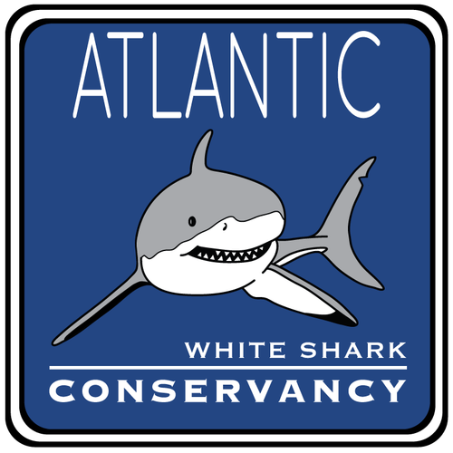

Proposal Seeking $14,700 for Implementation of Drone-Based Great White Shark Spotting Program on Nauset Light Beach Submitted on Behalf of Atlantic White Shark Conservancy

Submitted to: Save Our Seas Foundation

Date: 12/15/2015

Paul Flamburis

59 Birch Road

Westford, MA 01886

[pflamburis@gmail.com](mailto:pflamburis@gmail.com)

978 – 654 - 2923

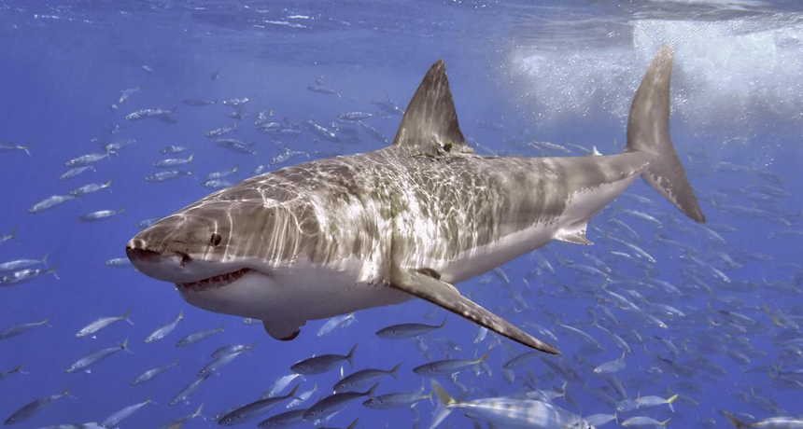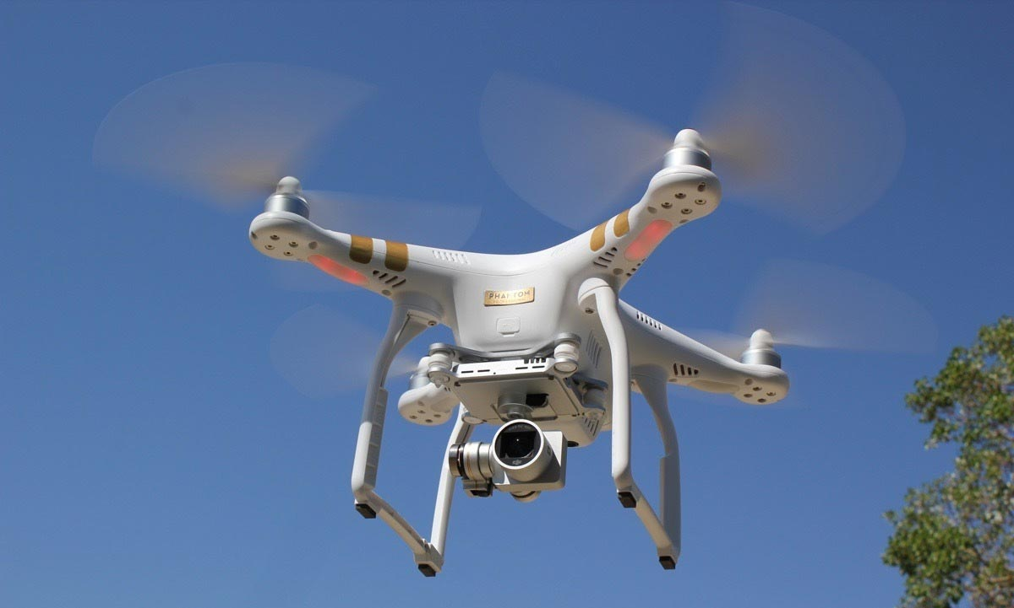

Paul Flamburis – Principle Investigator

59 Birch Road, Westford, MA 01886 | 978 – 654 - 2923 | pflamburis@gmail.com

December 15, 2015

Steven Gilman

Director

Save Our Seas Foundation

22 Ammonite Way

Dania Beach, FL, 33004

Dear Mr. Gilman:

The purpose of this report is to outline a great white shark attack prevention program on Nauset Light Beach in Eastham, Massachusetts that would employ the usage of aerial drones.

The great white shark is classified as vulnerable by the IUCN Red List. Despite its conservation status, great white sharks have been the target of illegal hunting and government-sanctioned shark culls due to a negative public image. A recent sharp increase in great white shark activity off the coast of Cape Cod has turned the area into a hotspot for human-shark interactions that, in addition to threatening public safety, could further threaten the public image of great white sharks.

This proposal outlines a program that would utilize an aerial drone to spot great white sharks off Nauset Light Beach. The Town of Eastham temporarily closed Nauset Light Beach last year in response to a great white shark attacking and killing a seal in view of beachgoers. Drone-operating shark spotters, in coordination with Nauset Light Beach lifeguards, could keep swimmers away from shark-inhabited areas in order to improve public safety and preserve the public image of great white sharks. This program could be implemented with partial funding from the Save Our Seas Foundation in the amount of $14,700.

If you have any questions about the program I am proposing, please feel free to contact me at the phone number or email above.

Respectfully yours,

Paul Flamburis – Principle Investigator

Table of Contents

1. **Project Summary 4**
2. **Problem and Background 5**
3. **Executive Summary 8**
4. **Description of Proposed Work 9**
   1. **End Goal 9**
   2. **Objectives 9**
   3. **Methods to Complete Objectives 10**
   4. **Schedule 14**
   5. **Alternative Options 15**
5. **Available Facilities 15**
6. **Personnel 16**
7. **Budget 18**
8. **Benefits 19**
9. **Conclusion 21**
10. **Appendix 22**
    1. **Glossary of Acronyms ………………………………………………... 22**
    2. **Bibliography ………………………………………………………….... 22**
    3. **Image Credits ….……………………………………………………… 24**

Cover Page:

Figure 1. (Top). Atlantic White Shark Conservancy Logo.

Figure 2. (Bottom Left). Great White Shark (*Carcharodon carcharias*).

Figure 3. (Bottom Right). DJI Phantom 3 Professional Drone in Flight.

1. **Project Summary**

Project Title: Drone-Based Great White Shark Spotting Program on Nauset Light Beach

SOSF Primary Focus: Conservation and Public Safety

Species Concerned: Great White Shark (*Carcharodon carcharias*)

Species Status:

* IUCN Red List: Vulnerable
* CITES: Appendix II (permit required for international trade)

Project Location: Nauset Light Beach, Eastham, MA 02642, United States

1. **Problem and Background**

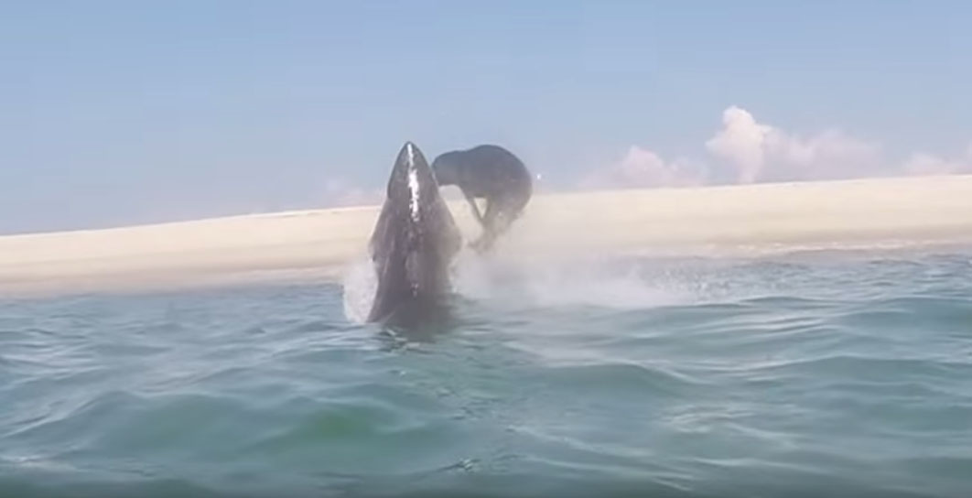Great white shark sightings along shorelines in the Cape Cod area have increased dramatically over recent years. In 2014, Atlantic White Shark Conservancy identified 68 individual great white sharks swimming in the region. This year, the group has identified over 120 individual white sharks thus far, with two thirds of those being new sharks (Wicksell). The extreme unforeseen efficacy of the U.S. Marine Mammal Protection Act of 1972 is likely responsible for this sharp increase in great white shark sightings in Massachusetts. The Marine Mammal Protection Act prevents the killing or harassment of all marine mammals, including seals, and has resulted in a massive boom in the Cape Cod gray seal population. Gray seals are a primary food source for great white sharks, and their increasing numbers have drawn large amounts of great white sharks closer to the coast (Crawford). Great white sharks are classified by the IUCN as vulnerable, and although it is generally a good sign to see this species thriving, the sharks’ increasing numbers and proximity to the coast could be detrimental to them in the long run.

Figure 4. Great White Shark Breaching to Attack Seal on Cape Cod.

Increased great white shark activity in close proximity to public beaches necessarily increases the likelihood of direct human-shark interaction. According to the International Shark Attack File (ISAF), the only two unprovoked great white shark attacks to be recorded in Massachusetts since 1936 both occurred within the last five years, with one in 2012 and another in 2014 ("United States [incl. Hawaii] Confirmed Unprovoked Shark Attacks”). In August 2015, the Town of Eastham temporarily closed 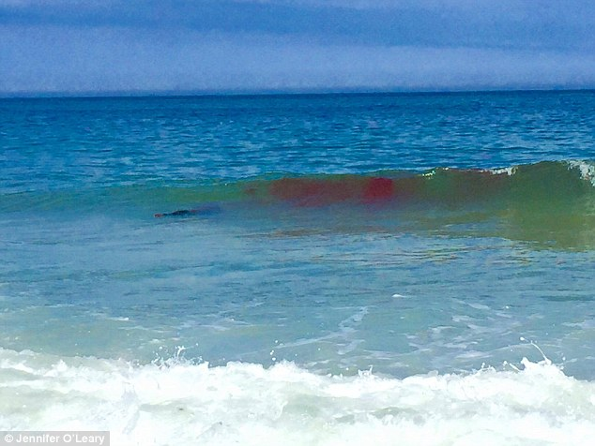Nauset Light Beach when a great white shark killed and ate a seal (Figure 5) in close proximity to a number of swimmers, a mere 10 feet offshore, and spat the carcass back onto the public beach. (Schworm and Gans).

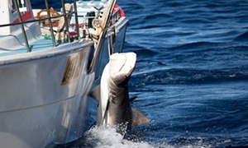Great white shark attacks are detrimental to both public safety and the public image of sharks. In Western Australia, a string of seven shark attack fatalities between 2010 and 2013 resulted in the implementation of a three-month shark cull program in 2014. This program rendered great white sharks, tiger sharks, and bull sharks temporarily exempt from the Environment Protection and Biodiversity Conservation Act, thereby allowing fishermen to kill them with impunity. Participants caught 172 sharks over the course of the cull, killing 50 of the largest specimens and sending the rest into a temporary state of stress-induced tonic immobility (Wahlquist).

Figure 6. Tiger Shark Caught During Western Australian Shark Cull.

Figure 5. Aftermath of a Great White Shark Killing a Seal off Nauset Light Beach.

The Atlantic White Shark Conservancy (AWSC) mission is to “increase knowledge of Atlantic white sharks and change public perception to conserve the species and ensure biologically diverse marine ecosystems,” (“Our Mission”). The best way to protect great white sharks is to preserve their public image by keeping them out of direct contact with surfers and beachgoers. Effective shark attack mitigation methods prevent illegal hunting and retaliatory shark culls, government-sanctioned or otherwise, such as the one that recently occurred in Western Australia.

Aerial drone surveillance could provide an effective and cost-efficient solution to the problem of human-shark interaction on Cape Cod. A 2013 study on the use of unmanned aerial vehicles for surveying marine fauna claimed that an aerial drone was able to spot dugongs in Shark Bay, Western Australia with a 95% certainty rate, meaning 95% of sightings were easily identifiable as dugongs. Whales, dolphins, turtles, rays, sea snakes, schools of fish, and sharks were also identifiable in the drone images, sometimes down to the species (Hodgson, Kelly, and Peel). In June 2015, the Seal Beach Marine Safety and Lifeguard Department trialed the usage of an aerial drone to survey shark activity off Seal Beach in Orange County, California with promising results. The drone spotted sharks during almost every flight, sometimes as many as 10 at a time (Carpio). In November 2015, the New South Wales Government announced that it is planning to test the efficacy of aerial drones in shark attack prevention as part of a $16 million mass trial of various shark attack mitigation methods (New South Wales Government). Aerial drone footage is also useful in the acquisition of data on great white shark movement patterns, population density, behavior, and physical traits.

1. **Executive Summary**

Atlantic White Shark Conservancy is seeking $14,700 as partial funding for the implementation of a drone-based great white shark spotting program on Nauset Light Beach in Eastham, Massachusetts. Due to a steady rise in the local gray seal population, great white sharks are appearing off the coast of Cape Cod with increasing frequency and proximity. Based on its recent shark-induced temporary closing, Nauset Light Beach is a particular problem area for human-shark interactions. Increased human-shark interactions may result in shark attacks, which are detrimental to both public safety and the public image of great white sharks.

The implementation of a drone-based great white shark spotting program on Nauset Light Beach would minimize human-shark interactions and mitigate great white shark attacks in the area. Effective drone spotting programs are also cheaper than alternative shark-spotting methods such as spotter planes and acoustic tracking buoys. With your support, we would purchase 1 DJI Phantom 3 Professional drone kit, 1 Goal Zero Yeti 400 Solar Generator power pack, 1 iPad Air 2, 2 Cobra Electronics CXT 1035R FLT radios, and drone/UAV pilot training for 3 shark spotters. These shark spotters would work in coordination with on-duty lifeguards at Nauset Light Beach for the 2016 summer season, here defined as 21 June 2016 to 1 September 2016, to keep swimmers away from shark-inhabited areas and make decisions about whether to close the beach. AWSC would also regularly submit aerial drone footage of great white sharks to the Massachusetts Shark Research Program (MSRP) to aid great white shark research.

1. **Description of Proposed Work**
   1. **End Goal**

* Reduce interactions between humans and great white sharks off Nauset Light Beach by the use of an aerial drone to spot sharks.
  1. **Objectives**
* Facilitate the training of 3 shark spotters in the operation of an aerial drone for the purpose of shark spotting and attack mitigation.
* Use drone to monitor great white shark activity off Nauset Light Beach during peak swimming hours from 21 June 2016 to 1 September 2016.
* Facilitate communication between shark spotters and active lifeguards in order to keep swimmers out of shark-inhabited areas and determine whether the beach should be closed.
* Obtain data on great white population density and movement patterns for the MSRP.
  1. **Methods to Complete Objectives**

The federal government restricts public aircraft operations over U.S. airspace to certain government activities. The principle investigator would therefore apply for a Certificate of Waiver or Authorization (COA) from the Federal Aviation Administration (FAA) on behalf of AWSC. The certificate would allow AWSC to pilot a drone within a defined block of airspace over Nauset Light Beach and off the coast of Nauset Light Beach from 21 June 2016 to 1 September 2016. The application approval process should be expected to take up to 60 business days (“Public Operations [Governmental]”).

All hired shark spotters would undergo a 3-phase drone pilot training program from the Unmanned Vehicle University (UVU). Phase 1 would consist of 16 hours of online training. Phase 2 would consist of 10 hours of drone simulation on a personal computer. Both Phase 1 and Phase 2 could be completed at the shark spotters’ respective homes. Phase 3 would require that they travel to a UVU training center in Danbury, Connecticut to complete 16 hours of hands-on flight training over the course of two days (“UAV Pilot Training Certificate”). Funding in the amount of $1,000 would be allocated to travel and accommodations during Phase 3 of the training.

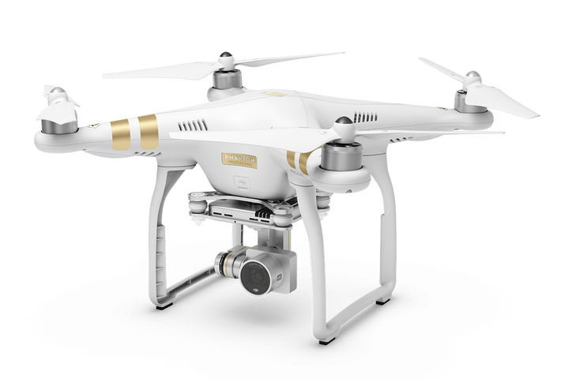For the purposes of this program, AWSC would purchase a DJI Phantom 3 Professional kit. The DJI Phantom 3 Professional (Figure 7) is suitable for this program because of its attached 4K video camera, integrated 3-axis stabilization gimbal, and ability to transmit live HD video footage to an Apple iPad attached to the drone’s controller. The DJI Phantom 3 also includes a failsafe which causes the drone to return to its point of takeoff automatically in the event of low battery. This eliminates the possibility of the drone falling into the water, which would pose a danger to swimmers and result in the loss of expensive equipment. The DJI Phantom 3’s 5 kilometer maximum video transmission distance is more than enough to cover the entirety of Nauset Light Beach. In addition to the Phantom 3 drone, the kit includes 1 flight controller, 3 DJI Phantom 3 Intelligent Flight Batteries, 1 battery charging hub, 2 spare propellers, and 1 spare propeller guard (“Phantom 3 Series”). AWSC would also purchase an Apple iPad Air 2 for the purpose of viewing live HD footage from the drone during surveys.

Figure 7. DJI Phantom 3 Professional Drone at Rest.

From 21 June 2016 to 1 September 2016, shark spotters would perform hourly drone surveys off Nauset Light Beach during swimming hours using the DJI Phantom 3 Professional drone. These hours would be defined as 8:00 AM to 6:00 PM each day. Because shark spotting requires high levels of alertness and attentiveness, spotters would only work 5 hour shifts. One spotter would work from 8:00 AM to 1:00 PM, while another spotter would work from 1:00 PM to 6:00 PM. Three spotters would work in rotation for 6 days per week. For the purposes of this program, there will be no spotting on Sundays. Sundays will provide a break for spotters and serve as a control group. At the end of the 1-year program, the average number of sharks detected on days with drone spotting would be compared to the average number of sharks detected on days without drone spotting in order to evaluate the efficacy of the program. A detailed weekly spotting schedule is included in Table 1 in the Personnel section of this proposal.

The spotters would send out the drone, which has a 23 minute battery life, for 20 minutes of surveillance at the top of each hour. Three minutes would be devoted to allowing the drone to safely return to the launching platform at the conclusion of each survey. During surveys, the drone camera would transmit a high definition live video feed, along with the drone’s current GPS coordinates, to the spotter’s iPad. The spotter would have an aerial view of any great white sharks below the drone, along with the exact GPS coordinates of each shark. The on-duty shark spotter would be in constant 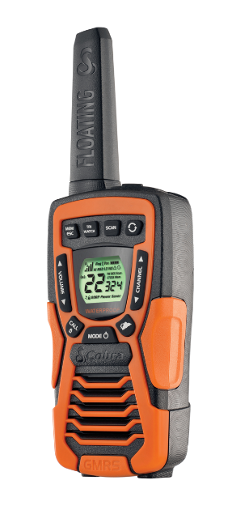contact with the on-duty lifeguard by means of a two-way radio. For this purpose, AWSC would purchase a set of Cobra Electronics CXT 1035R FLT radios. The CXT 1035R FLT (Figure 8) is suitable for this program primarily because of its capacity for voice-activated transmission. Hands-free radio operation would allow the shark spotter to communicate with the active lifeguard and operate the drone simultaneously. In addition, the radio’s bright orange color scheme and floating ability would make it easy to reclaim in the event that a lifeguard drops it in the water during a moment of confusion (“CXT 1035R FLT”).

Figure 8. CXT 1035R FLT Radio.

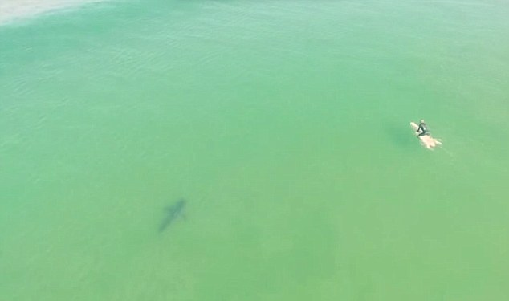Upon detection of a shark (as pictured in Figure 9), the spotter would relay the shark’s exact location to the on-duty life guard by radio. The life guard would then warn beachgoers to avoid the area, and relay information about the shark’s position and behavior to town officials. The town of Eastham would then decide whether Nauset Light Beach should be temporarily closed. When convenient, the shark spotter would also record video footage of any great white sharks spotted with the drone. This footage would be regularly sent to the MSRP to aid in its research on great white shark movement patterns and population density, especially in relation to the local gray seal population. The MSRP would use this research to develop more long-term responses to great white shark population anomaly occurring on Cape Cod.

Figure 9. Drone Image of Great White Shark Swimming Near Surfer at Pismo State Beach, CA.

At the conclusion of each drone survey, the spotter would change the drone battery, allow the spent battery to cool, and plug the spent battery into a charging station once it has reached a reasonable temperature. A high capacity portable power pack would be used as a charging station for the purposes of this program. The Goal Zero Yeti 400 Solar Generator power pack would be suitable because of its multiple power output options, lack of exhaust production, and ability to be recharged (“Goal Zero Yeti 400 Solar Generator”). The spotter would also utilize this time to recharge any other vital electronic equipment, such as the drone controller or the iPad. The DJI Phantom 3 Intelligent Flight Battery can be charged in 1 to 1.5 hours. Assuming each charge would take 1.5 hours, and allowing 30 minutes for each spent battery to cool, each spent battery could be charged in 2 hours. Therefore, a spent battery would be fully charged after 2 subsequent hourly drone surveys. With 3 batteries in rotation throughout the day, the drone could be sent out for 20 minutes at the top of every hour without exception.

* 1. **Schedule**

28 March 2016: Principle investigator requests COA from FAA. Application process must be initiated far in advance of the spotting program itself, as application processing may take up to sixty days.

4 April 2016: Spotters begin Phase 1 of UVU drone pilot training.

8 April 2016: Spotters complete Phase 1 of UVU drone pilot training.

11 April 2016: Spotters begin Phase 2 of UVU drone pilot training.

15 April 2016: Spotters complete Phase 2 of UVU drone pilot training.

18 April 2016: Spotters arrive in Danbury, CT.

19 April 2016: Spotters complete Day 1 of Phase 3 of UVU drone pilot training.

20 April 2016: Spotters complete Day 2 of Phase 3 of UVU drone pilot training.

21 April 2016: Spotters return from Danbury, CT.

14 June 2016: Principle investigator purchases drone, power pack, iPad, and radios.

21 June 2016: First day of drone surveillance on Nauset Light Beach.

1 July 2016: First delivery of drone footage to the MSRP.

15 July 2016: Second delivery of drone footage to the MSRP.

29 July 2016: Third delivery of drone footage to the MSRP.

1 September 2016: End of drone surveillance on Nauset Light Beach.

* 1. **Alternatives**

Instead of hiring 3 shark spotters to work in coordination with Nauset Light Beach lifeguards, it may be possible to arrange for Nauset Light Beach lifeguards to undergo drone pilot training directly. UVU offers training on-location and discounted rates for groups of over five people, so it would not be financially unreasonable to train the entire Nauset Light Beach lifeguard staff in drone operation. However, such a program would require close coordination with the Town of Eastham, as Nauset Light Beach lifeguards work on the payroll of the Town of Eastham. In addition, it would be dangerous to have one person serve as both a lifeguard and a shark spotter at a single location. Drone flight controllers are bulky, and in case of an emergency, a lifeguard should be unencumbered and prepared to launch into action at any given moment.

It may also be possible to simply hire two professional drone pilots to work as shark spotters on Nauset Light Beach, which would eliminate the need for drone pilot training through UVU. However, since the FAA may take up to 60 days to process the COA request, and drone pilot training is scheduled to occur during this time, eliminating drone pilot training would not likely save any time. In addition, shark spotting requires attentiveness, alertness, and familiarity with shark traits and behaviors, which can only be acquired through years of experience. Drone operation skills, on the other hand, can be acquired relatively quickly and easily through intensive training programs such as the one offered at UVU.

1. **Available Facilities**

For the purposes of the proposed program AWSC does not possess, nor does it require, any facilities or equipment other than those that will be purchased with funds from SOSF as described in the Budget section of this proposal.

1. **Personnel**

Drone operation skills can be acquired quickly through intensive training programs, while great white shark identification skills can only be acquired through years of experience. Therefore, potential candidates for spotters have been evaluated with preference for spotting skills and experience working with great white sharks rather than drone operation skills. Ideal shark spotters should have at least 1 to 2 years of lifeguard experience, and some degree of experience studying great white sharks. In particular, ideal shark spotters should be able to recognize aggressive great white shark behaviors, which would be grounds for temporarily closing Nauset Light Beach. Ideal spotters should also be able to distinguish adult great white sharks from juvenile great white sharks and other sharks. Many sharks, including juvenile great white sharks, do not pose a threat to swimmers. Cape Cod residents are preferred due to their familiarity with the area.

Principle Investigator – would write proposals, apply for COAs, arrange for transportation and accommodations, and purchase equipment. ($30 per hour, 50 hours)

* Paul Flamburis – has completed a Bachelor of Arts in English with a specialization in Professional Writing and Technical Communication at the University of Massachusetts Amherst. He is competent with Microsoft Office Suite. He lived on Cape Cod for 5 years and currently resides in Westford, Massachusetts.

Shark Spotters – would conduct hourly drone surveys, communicate with active lifeguards about great white shark activity on Nauset Light Beach, and record footage of offshore great white shark activity for analysis at the MSRP. ($20 per hour, 20 hours per week)

* Craig Zissou – Has 2 years of lifeguard experience and has conducted research on great white shark feeding habits off Cape Town, South Africa in 2013. He participated in the Cape Town Sharp Spotter Program in 2014 and currently resides in Duxbury, Massachusetts.
* Finley Hooper – Has 3 years of lifeguard experience and has conducted research on great white shark growth rates in the North Atlantic Ocean in 2012. He is currently employed as a marine biologist at the MSRP and resides in Chatham, Massachusetts.
* Quin Nemo – Has 6 years of lifeguard experience and is currently employed as a marine biologist at the Massachusetts Division of Marine Fisheries. She currently resides in Eastham, Massachusetts.

Table 1. Weekly Shark Spotting Schedule, In Effect 21 June 2016 – 1 September 2016

|  |  |  |  |  |  |  |  |
| --- | --- | --- | --- | --- | --- | --- | --- |
| Shift | Monday | Tuesday | Wednesday | Thursday | Friday | Saturday | Sunday |
| 8:00 AM – 1:00 PM | Craig Zissou | Craig Zissou | Quin Nemo | Quin Nemo | Finley Hooper | Finley Hooper | No Shifts |
| 1:00 PM – 6:00 PM | Finley Hooper | Finley Hooper | Craig Zissou | Craig Zissou | Quin Nemo | Quin Nemo | No Shifts |

1. **Budget**

Table 2. SOSF Project Budget

|  |  |  |
| --- | --- | --- |
| Description | Quantity | Price |
| DJI Phantom 3 Professional Kit ($2,080) | 1x | $2,100.00 |
| Goal Zero Yeti 400 Solar Generator Power Pack ($390) | 1x | $400.00 |
| Apple iPad Air 2 ($500) | 1x | $500.00 |
| Cobra Electronics CXT 1035R FLT ($130) | 1x | $200.00 |
| UVU Drone/UAV Pilot Training Certificate ($3,500) | 3x | $10,500.00 |
| Travel & Accommodations | N/A | $1,000.00 |
| Total |  | $14,700.00 |

For the purposes of this budget, in order to account for any changes in the costs of the included items and services between the time of submission of this proposal and the time of implementation of the program it describes, all costs have been rounded up to the next $100. Worker salaries are not included in Table 2 and will be covered by a separate revenue source. However, the principle investigator should expect to receive $30 per hour for an estimated 50 total hours of work. Shark spotters should expect to receive $20 per hour for 20 hours of work per week. Since shark spotting will occur over a beach season lasting about 11 weeks, $5,900 from a separate revenue source will cover worker salaries. SOSF funding in the amount of $14,700 will cover equipment and services. This makes the total cost of the project $20,600.

1. **Benefits**

The usage of aerial drones for the purpose of great white shark spotting and attack mitigation is both more effective and more cost-efficient than other shark spotting programs. Cape Cod beaches currently spot great white sharks using acoustic tracker buoys, plane spotting, and jet ski spotting. Acoustic tracker buoys contain acoustic receivers that work in coordination with acoustic transmitter tags which can be placed onto great white sharks. When a tagged shark approaches a buoy, the tag transmits an acoustic signal to the receiver on the buoy. The buoy then sends a ping to researchers on the mainland, notifying them that a great white shark is nearby. AWSC spends $600 on each buoy, $1500 on each acoustic receiver, and $400 on each acoustic tag. An acoustic tracker buoy program could spot up to 47 different tagged sharks (21 less than the number of distinct great whites spotted off Cape Cod in 2014) for $20,900. Under such a program, any untagged great white sharks could approach the shore undetected. Alternatively, the proposed drone-based spotting program could spot any number of sharks, with no need for shark tagging (a time-consuming process), for only $20,600. SOSF would only provide $14,700 of this funding.

Plane spotting is similar to aerial drone surveillance in that both depend on making visual contact with great white sharks, but plane spotting is also more expensive. AWSC typically pays $250 per hour to charter spotter planes. The proposed aerial drone surveillance program would allow for 20 minutes of surveillance at the top of every hour for 10 hours per day and 6 days per week. This equates to 220 total hours of drone surveillance for a beach season lasting about 11 weeks. In comparison, 220 total hours of plane spotting at $250 per hour would cost $55,000, more than double the total cost of implementing the proposed drone-based spotting program. In addition, the DJI Phantom 3 Professional’s 3-axis stabilization gimbal would provide a much more stable view of the ocean below than that which a moving plane would provide.

Although jet ski or boat spotting is cheap, it brings lifeguards away from the shore where they may be needed for other emergencies. An aerial drone spotting program enables lifeguards to focus on non-shark-related emergencies unless the spotter determines that direct intervention is required. Jet ski spotting is also highly dependent on ocean conditions, while aerial drones can operate unaffected by factors such as wave crest height. In addition, it is more difficult to spot sharks at sea level than it is above sea level.

“Smart buoys” are another emerging shark attack mitigation technology worthy of consideration. These are acoustic tracker buoys that do not rely on sharks being tagged. Instead, they emits sonar to detect objects in their vicinity and determine whether each object is a shark. If a smart buoy spots a shark, it sends a ping to a 4G network, notifying researchers anywhere in the world that a shark is near the buoy and providing information on the shark’s size and location. Like the proposed drone-based spotting program, smart buoys could detect any great white sharks approaching coast. However, according to a 2015 review of bather protection technologies prepared for the New South Wales Department of Principle Industries, the acoustic sonar emissions from this system (and other acoustic buoys) may interfere with the navigation of cetaceans (dolphins and whales) and other marine organisms that rely on sonar for navigation. The review also states that each unit would cost $70,000, and 5 units would be required to cover a 1 kilometer stretch of ocean (*Shark Deterrents and Detectors - Review of Bather Protection Technologies*). The proposed drone surveillance program would be both cheaper and less invasive to marine ecosystems.

1. **Conclusion**

Direct contact with humans is detrimental to great white shark, which are listed as vulnerable by the IUCN Red List. Although shark attacks are rare, each attack has the potential to to encourage illegal hunting or government-sanctioned shark culls. As Cape Cod gray seal populations steadily rise, great white sharks will swim closer to tourist-filled shores, opening the possibility for more attacks. Even attacks on seals, the natural prey of great white sharks, can hurt the public image of great white sharks if they occur in close proximity to humans. Swimmers at Nauset Light Beach recently witnessed firsthand an alarming natural encounter between a great white shark and a seal that generated considerable media coverage. In light of these facts, it is crucial to implement new programs to minimize unintended human-shark interactions.

The implementation of a drone-based great white shark spotting program on Nauset Light Beach would allow swimmers to enjoy the beach with hourly updates on the location of any great white sharks. Lifeguards would make sure that swimmers avoid shark-inhabited areas, without having to devote their own valuable time and attention to shark spotting. Aerial drones are also the most cost efficient and ecologically friendly solution to the problem of human-shark interaction. In addition, the footage collected by the drones and sent to the MSRP would be of great benefit to research on great white shark movement patterns, population density, behavior, and physical traits. If successful, future developments of this program could be up-scaled to feature simultaneous surveillance from multiple drones, improved drones with extended battery lives or solar-powered batteries, and integration with social media in order to provide Eastham locals with direct updates on great white shark activity. The program could also easily be replicated on beaches along the entire East and West Coasts, and, for that matter, around the globe.

1. **Appendices**
   1. **Glossary of Acronyms**

**AWSC –** Atlantic White Shark Conservancy

**COA –** Certificate of Waiver or Authorization

**FAA –** Federal Aviation Administration

**ISAF –** International Shark Attack File

**MSRP –** Massachusetts Shark Research Program

**SOSF –** Save Our Seas Foundation

**UVU –** Unmanned Vehicle University

* 1. **Bibliography**

Carpio, Anthony. "Seal Beach Uses Drone to Track Young Great White Sharks." *Los Angeles Times*.

Los Angeles Times, 20 June 2015. Web. 14 Dec. 2015.

Crawford, Amy. "Great White Sharks are Back." *Slate*. N.p., 4 July 2013. Web. 14 Dec. 2015.

"CXT 1035R FLT." *Cobra Electronics*. N.p., n.d. Web. 14 Dec. 2015.

"Goal Zero Yeti 400 Solar Generator." *Goal Zero*. N.p., n.d. Web. 14 Dec. 2015.

Hodgson, Amanda, Natalie Kelly, and David Peel. "Unmanned Aerial Vehicles (UAVs) for

Surveying Marine Fauna: A Dugong Case Study." *PLOS ONE* (2013): n. pag. 4 Nov. 2013. Web. 15 Dec. 2015.

New South Wales Government. Department of Primary Industries. *First Shark Technology Trial*

*Underway.* N.p., 25 Nov. 2015. Web. 14 Dec. 2015.

"Our Mission." *Atlantic White Shark Conservancy*. N.p., n.d. Web. 14 Dec. 2015.

"Phantom 3 Series." *DJI*. N.p., n.d. Web. 14 Dec. 2015.

"Public Operations (Governmental)." *Public Operations (Governmental)*. Federal Aviation

Administration, 11 Sept. 2015. Web. 14 Dec. 2015.

Schworm, Peter, and Felicia Gans. "Cape Beaches Close after Great White Shark Bites Seal, Spits It

out on Beach." *Boston Globe*. N.p., 13 Aug. 2015. Web. 14 Dec. 2015.

*Shark Deterrents and Detectors - Review of Bather Protection Technologies*. Rep. no. 59916026. Cardno, Oct.

2015. Web. 14 Dec. 2015.

"UAV Pilot Training Certificate." *Unmanned Vehicle University*. N.p., n.d. Web. 14 Dec. 2015.

"United States (incl. Hawaii) Confirmed Unprovoked Shark Attacks." *International Shark Attack File*.

Florida Museum of Natural History, 11 Feb. 2015. Web. 14 Dec. 2015.

Wahlquist, Calla. "Western Australia's 'Serious Threat' Shark Policy Condemned by Senate."

*Guardian*. N.p., 12 Feb. 2015. Web. 14 Dec. 2015.

Wicksell, Dustin. "The Comeback of the Atlantic Great White Shark." *Earth Island Journal*. N.p., 4

Nov. 2015. Web. 14 Dec. 2015.

* 1. **Image Credits**

Figure 1. Atlantic White Shark Conservancy Logo; Digital Image. *Atlantic White Shark Conservancy*.

N.p., n.d. Web. 14 Dec. 2015

Figure 2. Great White Shark (*Carcharodon carcharias*); Gross, Terry. *Great white shark at Isla Guadalupe,*

*Mexico.* Digital Image. *ScienceNews*. 12 Aug. 2006. Web. 14 Dec. 2015.

Figure 3. DJI Phantom 3 Professional Drone in Flight; Digital Image. *Engadget.* N.p., n.d. Web. 14

Dec. 2015.

Figure 4. Great White Shark Breaching to Attack Seal on Cape Cod; Skomal, Greg. *Failed predation*

*attempt off Monomoy, Cape Cod..* Digital Image. *National Geographic.* 17 Aug. 2015. Web. 14 Dec. 2015.

Figure 5. Aftermath of Great White Shark Killing Seal off Nauset Light Beach; O’Leary, Jennifer.

*The water off the coast of Nauset Light was stained red after the predator took a bite out of its prey.* Digital Image. *Daily Mail.* 14 Aug. 2015. Web. 14 Dec. 2015.

Figure 6. Tiger Shark Caught During Western Australian Shark Cull; Sea Shepard. *A male tiger shark is*

*caught off the West Australian coast.* Digital Image. *Guardian.* 12 Feb. 2015. Web. 14 Dec. 2015.

Figure 7. DJI Phantom 3 Professional Drone at Rest. *Phantom 3 Series.* Digital Image. *DJI.* N.p., n.d.

Web. 14 Dec. 2015.

Figure 8. CXT 1035R FLT Radio. *CXT 1035R FLT.* Digital Image. *Cobra Electronics.* N.p., n.d. Web.

14 Dec. 2015.

Figure 9. Drone Image of Great White Shark Swimming Near Surfer at Pismo State Beach, CA;

McCaslin, Dustin. *Silhouette of the great white shark.* Digital Image. *Daily Mail.* 10 Aug. 2015. Web. 14 Dec. 2015.