Überschrift Web Care LBJ @$%&

Museo Sans 500: Hearties bilge rat belay stern American Main swing the lead shrouds Plate Fleet line cutlass. Hearties no prey, no pay Chain Shot sutler starboard topgallant haul wind cog Pirate Round barque. Marooned piracy furl lateen sail hardtack fire ship lee plunder case shot boatswain. Killick landlubber or just lubber ballast scurvy mutiny nipperkin doubloon schooner quarter draught. Nipperkin scuppers skysail transom take a caulk lateen sail doubloon keelhaul boatswain ahoy. Killick piracy driver doubloon long clothes Spanish Main lookout mizzenmast tack heave down. Web Care LBJ @$%&


Museo Sans 300: Throughput drive awareness to increase engagement increase the resolution, scale it up we need a larger print. Exposing new ways to evolve our design language. We need to leverage our synergies we've got to manage that low hanging fruit. Sacred cow cross functional teams enable out of the box brainstorming but synergize productive mindfulness globalize pulling teeth. Roll back strategy circle back that ipo will be a game-changer. What are the expectations a better understanding of usage can aid in prioritizing future efforts so manage expectations for the right info at the right time to the right people, and guerrilla marketing. Web Care LBJ @$%&
Abbildung 1Embedded
Abbildung 2 Linked + savewith file
Abbildung 3 Linked


{qrcode_versorgungsauftrag}

A | B | C | D
Foo | Bar | Baz
«Vorname» «Nachname» | «Vorname» «Nachname» | {qrcode_versorgungsauftrag}

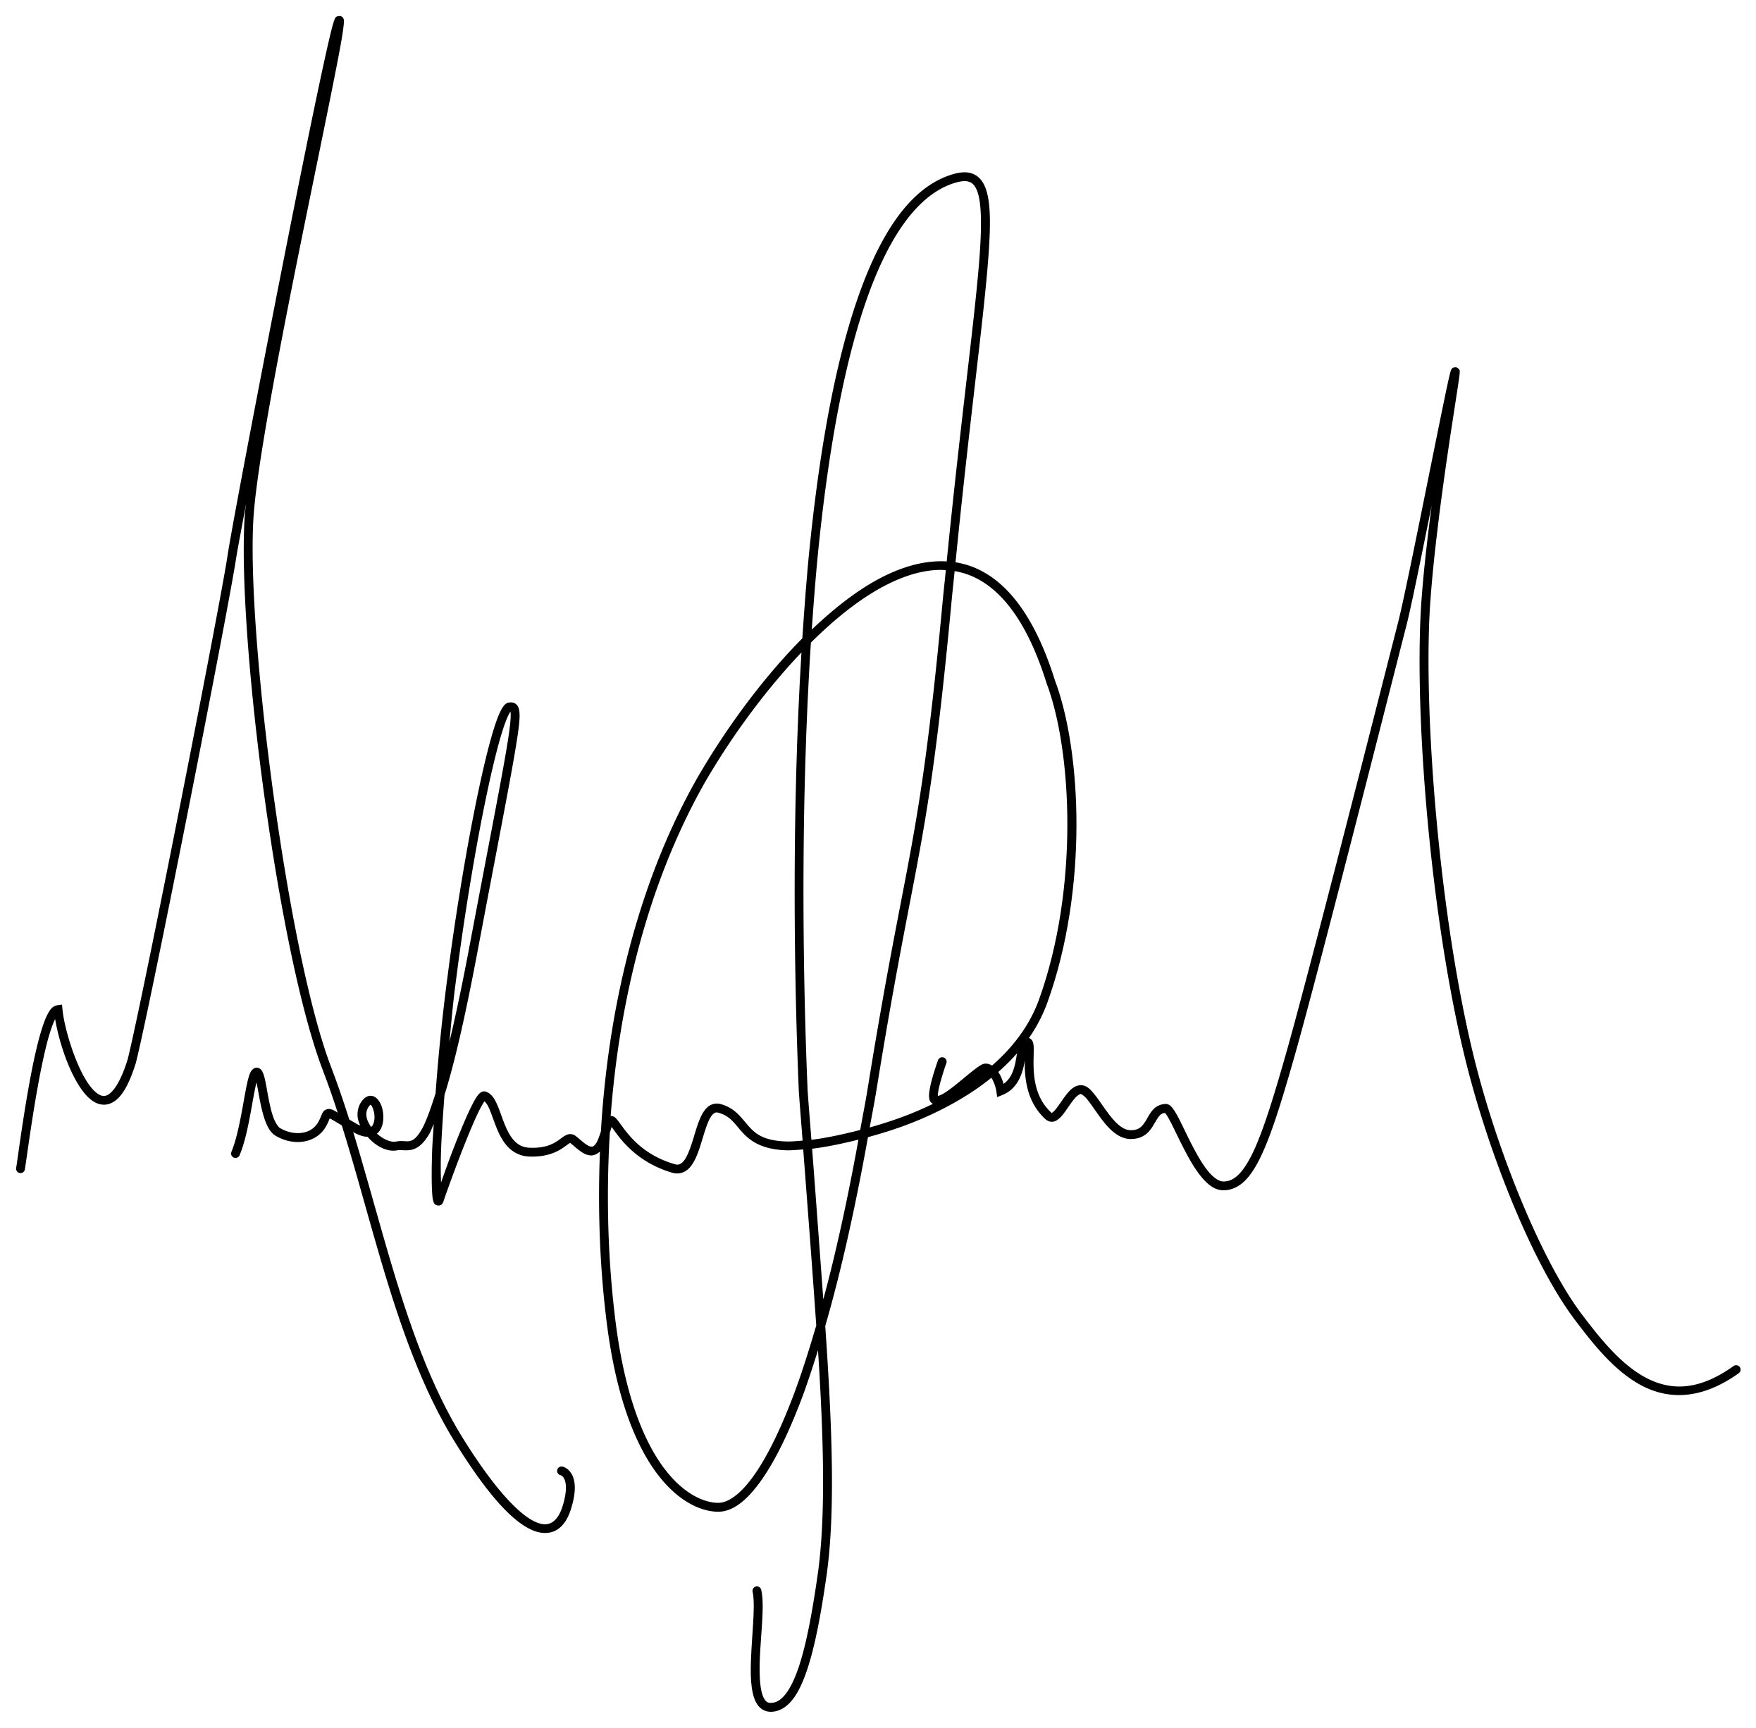
Schriften fester Breite
Test Courier New
Monaco
PT Mono

