Design Based Estimates for the Triennial Survey
Allan Hicks
18 March 2009

I wrote a function in R to calculate the design-based estimates of biomass and length frequencies for the triennial survey. The user has full control over the stratification. Stratified random sampling theory is used to calculate the estimates and variances.

Biomass

The function to estimate the biomass is called DesignBasedEstBiomass.fn and takes three arguments.

dat A dataframe with columns labeled
- year
- catchPerArea
- names of the strata variables
strat.vars: A vector of the strata variable names. These names must be exactly the same as the names of the strata variables in the dataframe.
strat.df A dataframe of the stratum boundaries. The first column is the name of the stratum. The second column is the area of the stratum. The third and fourth columns are the low and high boundaries of the first stratum in strat.vars. The fifth and sixth columns are the low and high boundaries of the second stratum in strat.vars, etc. The columns are named using the name of the strata variable followed by a “.1” for the low boundary and “.2” for the high boundary.This dataframe must be like a design matrix showing all stratum. See the example below.

The following is a hypothetical example. The object called dat may look like this:

BOTTOM_DEPTH START_LATITUDE year catchPerArea
90 36.5 2000 1
90 36.5 2000 3
90 38.0 2000 5
90 38.0 2000 7
200 36.5 2000 9
200 36.5 2000 11
200 38.0 2000 13
200 38.0 2000 13
90 36.5 2001 21
90 36.5 2001 23
90 38.0 2001 25
90 38.0 2001 27
200 36.5 2001 29
200 36.5 2001 111
200 38.0 2001 113
200 38.0 2001 113

I usually read in dat from a csv file using read.csv.

The strat.vars may then be a vector indicating that latitude and depth are the variables of interest. For example,

strat.vars <- c("START_LATITUDE","BOTTOM_DEPTH")

The strata definitions are a bit more difficult to enter. I suggest entering them in a table in Excel and reading them in. Excel will allow you to see the table more easily. A strat.df object may look like,

name area BOTTOM_DEPTH.1 BOTTOM_DEPTH.2 START_LATITUDE.1 START_LATITUDE.2
shallowS 1200 55 100 36 37
shallowN 1400 55 100 37 49
deepS 2000 100 1000 36 37
deepN 2500 100 1000 37 49

Simply call the function and save the output to an object. This saved object is a list containing the following elements:

Strata This is a list of years with strata specific estimates. The name and area are given followed by the number of tows, the average catch rate, the estimate of biomass, and the variance of the biomass.

Total The total biomass for each year as well as the standard error and cv. These estimates are given in normal space.

LNtons These are the yearly estimates of biomass in tons assuming a lognormal distribution. The meanBhat is the mean of the biomass as given in the Total list. The medianBhat is the median of the biomass corrected by the variance. The SElogBhat is the standard error of the log of the biomass and is what would be given in SS3.

The equations for the calculation of the biomass and its variance follow Cohrane (19??). First, the catch per area must be calculated before calling the function. For kg/km² the catch in tow i would be divided by the area swept (a_{i}) by tow i, where the area swept is the net width times the distance towed (make sure these are in the same units). The CPUE (called catchPerArea in the dataframe) for tow i in stratum h is

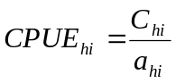

and the mean catch rate is stratum h is

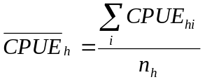

This is the average catch per area in stratum h, and to estimate the total biomass in stratum h you simply multiply by the area of the stratum (A) keeping in mind the units used in the catch rate calculation.

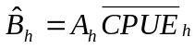

The total biomass is then simply the sum of the stratum specific biomass estimates.

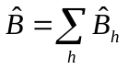

The variance calculations follow from this. First, calculate the variance of the catch rates in each stratum.

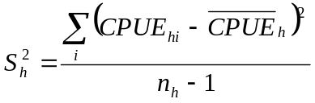

Then, the variance of the mean catch rate is calculated by dividing by the number of tows followed by multiplying by the area squared to get the variance of the stratum specific biomass.

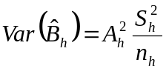

Finally, the variance of the total biomass is the sum of the stratum specific biomass variances.

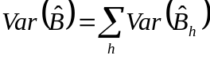

Length Compositions
The length compositions can be built up in two different ways. The first and recommended way is called the Mean Ratio Estimate and follows the equations in Hamel (2007). The alternative method is called the Total Ratio Estimate and was done for the 2005 Petrale sole assessment. The Mean Ratio Estimate is recommended because it matches with the biomass approach and it is the method used to calculate the length compositions from the NWFSC survey.

Mean ratio estimate

The mean ratio estimate calculates the number of fish of a certain length in each tow before expanding up to the total area in the stratum. The equations below produce the same result as the equations in Hamel (2007), but are simplified to use fewer calculations. The sample expansion per tow is first calculated.

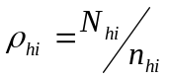

where 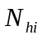 is the total number of fish of the particular species in the tow and 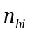 is the number of fish that were lengthed. Notating the number of sampled fish in the j^{th} length class, from stratum h, tow i, and of sex s as l_{jhis}, the total number of fish of length j, in stratum h, and of sex s is

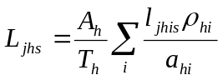

where A_{h} is the area of the stratum, T_{h} is the total number of tows (positive and non-positive) in the stratum, and a_{hi} is the swept area of tow i in stratum h. The expanded lengths are weighted up to the stratum area to give the sex specific total number of length j fish in stratum h. The stratum specific numbers can then be summed to arrive at a total length composition for the entire area.

Total ratio estimate

The sample expansion per tow is first calculated.

where is the total number of fish of the particular species in the tow and is the number of fish that were lengthed. Notating the number of sampled fish in the j^{th} length class, from stratum h, tow i, and of sex s as l_{jhis}, the total number of fish of length j, in stratum h, and of sex s is

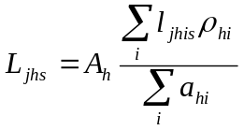

The expanded lengths are weighted up to the stratum area to give the sex specific total number of length j fish in stratum h. The stratum specific numbers can then be summed to arrive at a total length composition for the entire area.

An R function called TriennialSurveyLFs.fn was written to calculate the length compositions for a species from the triennial survey. The function takes the following arguments.

datL A dataframe with columns labeled
- HAULJOIN
- WEIGHT
- NUMBER_FISH
- DISTANCE_FISHED
- NET_WIDTH
- year
- names of the strata variables
strat.vars A vector of the strata variable names. These names must be exactly the same as the names of the strata variables in the dataframe.
strat.df A dataframe of the stratum boundaries. The first column is the name of the stratum. The second column is the area of the stratum. The third and fourth columns are the low and high boundaries of the first stratum in strat.vars. The fifth and sixth columns are the low and high boundaries of the second stratum in strat.vars, etc. The columns are named using the name of the strata variable followed by a “.1” for the low boundary and “.2” for the high boundary.This dataframe must be like a design matrix showing all stratum. See the example below.
femaleMale a vector of codes for female then male (in that order)
lgthBins Can be a single number indicating the increment between length bins, or can be a vector of the lower bound of the specific length bins. This is only pertinent to the yearly comps summed over strata. Each strata will have all observed lengths.
SS3out A logical. FALSE gives detailed year specific length comps as well as year and strata specific length comps. TRUE returns a dataframe formatted for direct input into SS3 (uses female and male length comps).

If SS3out=F, then the output will contain the following lists

L.year A list of the year specific length comps.
L.year.str Lists of year and strata specific length compositions.

Note that if there are the length class 0 is all lengths between 0 and the first positive length. And, the last length group is a plus group indicating the number of lengths greater than the last bin.

