Decision table including overfishing limits for the assessment of sablefish in 2025

Table 1: Decision table summary of 10 year projections beginning in 2027 for alternative states of nature based on an axis of uncertainty about natural mortality for the base model. Columns range over low, base, and high states of nature and rows range over different catch level assumptions. The base model estimated natural mortality of 0.088 yr$^{-1}$ for females and males. The low state of nature assumed a natural mortality of 0.095 yr$^{-1}$ and the high state of nature assumed a natural mortality of 0.070 yr$^{-1}$ for both sexes. Catch in 2025 and 2026 were based upon removal assumptions provided by the GMT.

| Mgmt | Year | Catch | Low OFL | Low Fraction of Unfished | Base OFL | Base Fraction of Unfished | High OFL | High Fraction of Unfished |
| --- | --- | --- | --- | --- | --- | --- | --- | --- |
| A | 2025 | 19,114 | 9,974 | 0.237 | 13,584 | 0.339 | 17,945 | 0.436 |
| A | 2026 | 19,082 | 10,463 | 0.259 | 14,293 | 0.369 | 18,850 | 0.466 |
| A | 2027 | 13,964 | 10,938 | 0.285 | 14,935 | 0.405 | 19,676 | 0.506 |
| A | 2028 | 15,103 | 12,088 | 0.319 | 16,240 | 0.448 | 21,091 | 0.548 |
| A | 2029 | 14,720 | 11,808 | 0.341 | 15,896 | 0.473 | 20,794 | 0.576 |
| A | 2030 | 14,094 | 11,312 | 0.354 | 15,287 | 0.490 | 20,192 | 0.597 |
| A | 2031 | 13,437 | 10,844 | 0.358 | 14,654 | 0.498 | 19,453 | 0.610 |
| A | 2032 | 12,755 | 10,344 | 0.349 | 13,970 | 0.489 | 18,653 | 0.604 |
| A | 2033 | 12,172 | 9,948 | 0.339 | 13,390 | 0.477 | 17,936 | 0.596 |
| A | 2034 | 11,749 | 9,705 | 0.334 | 12,997 | 0.470 | 17,429 | 0.593 |
| A | 2035 | 11,273 | 9,436 | 0.328 | 12,526 | 0.462 | 16,744 | 0.585 |
| A | 2036 | 10,918 | 9,259 | 0.325 | 12,186 | 0.455 | 16,230 | 0.578 |
| B | 2025 | 19,114 | 9,974 | 0.237 | 13,584 | 0.339 | 17,945 | 0.436 |
| B | 2026 | 19,082 | 10,463 | 0.259 | 14,293 | 0.369 | 18,850 | 0.466 |
| B | 2027 | 13,039 | 10,938 | 0.285 | 14,935 | 0.405 | 19,676 | 0.506 |
| B | 2028 | 14,084 | 12,152 | 0.322 | 16,300 | 0.450 | 21,143 | 0.550 |
| B | 2029 | 13,713 | 11,938 | 0.346 | 16,019 | 0.478 | 20,901 | 0.580 |
| B | 2030 | 13,115 | 11,502 | 0.362 | 15,466 | 0.498 | 20,348 | 0.602 |
| B | 2031 | 12,500 | 11,085 | 0.369 | 14,881 | 0.508 | 19,651 | 0.617 |
| B | 2032 | 11,842 | 10,625 | 0.362 | 14,234 | 0.501 | 18,884 | 0.614 |
| B | 2033 | 11,275 | 10,262 | 0.354 | 13,683 | 0.491 | 18,194 | 0.607 |
| B | 2034 | 10,880 | 10,051 | 0.351 | 13,317 | 0.486 | 17,712 | 0.605 |
| B | 2035 | 10,407 | 9,807 | 0.347 | 12,864 | 0.479 | 17,041 | 0.599 |
| B | 2036 | 10,045 | 9,654 | 0.345 | 12,541 | 0.474 | 16,541 | 0.593 |

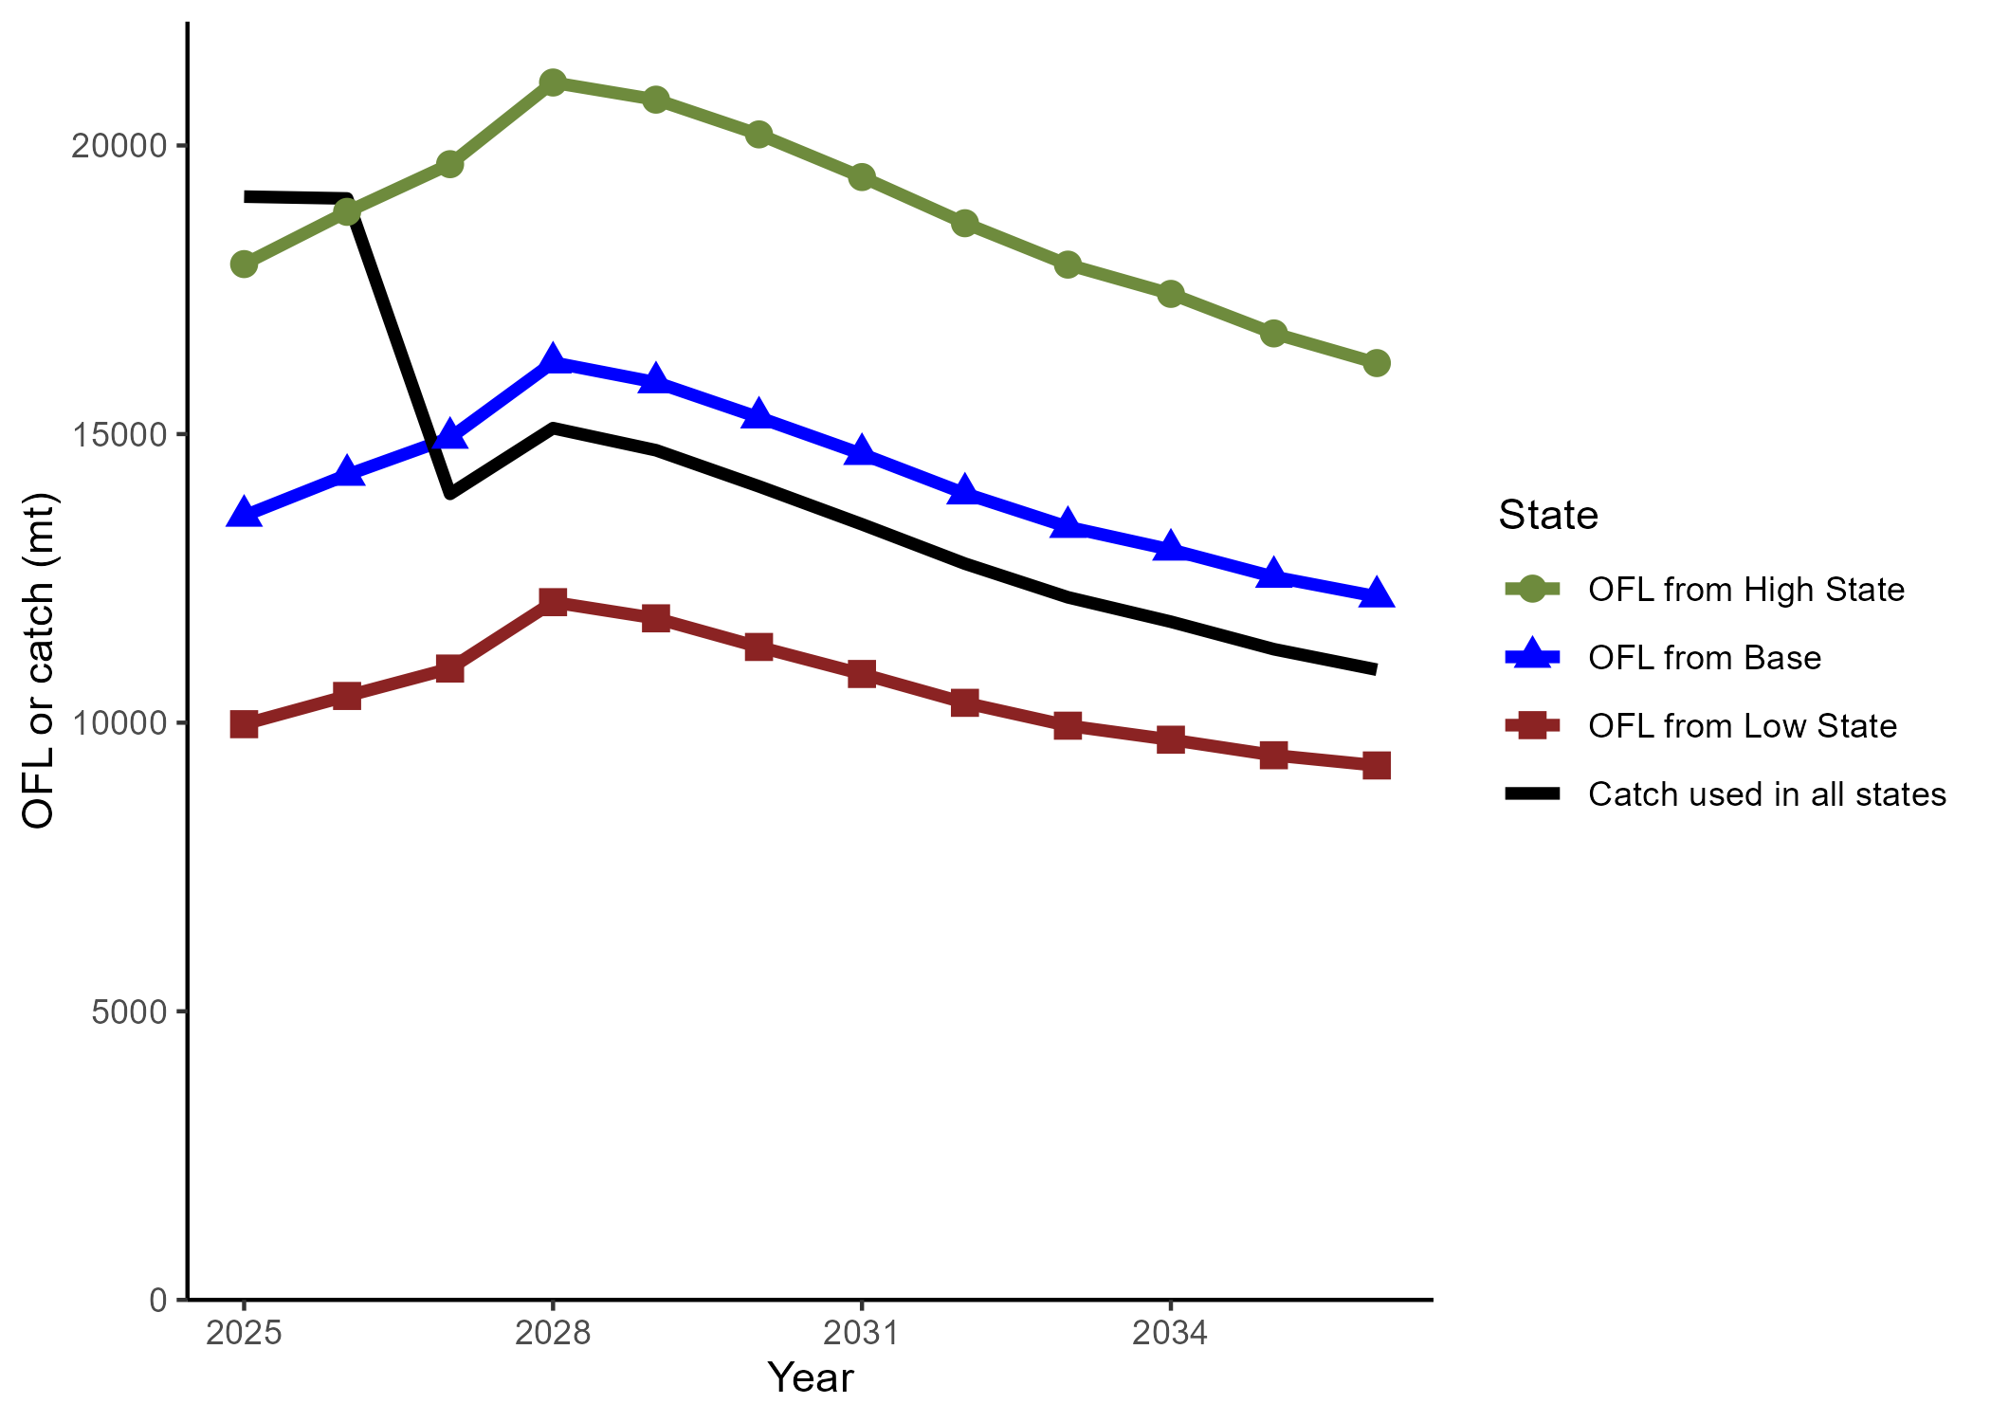

The GMT provided removals for 2025-206 and ACLs for 2027-2036 with a P* = 0.45 and sigma = 0.5 (black line) and the model estimated OFLs for 2025-2036 from the base model (blue line), low state of nature (red line), and high state of nature (green line).

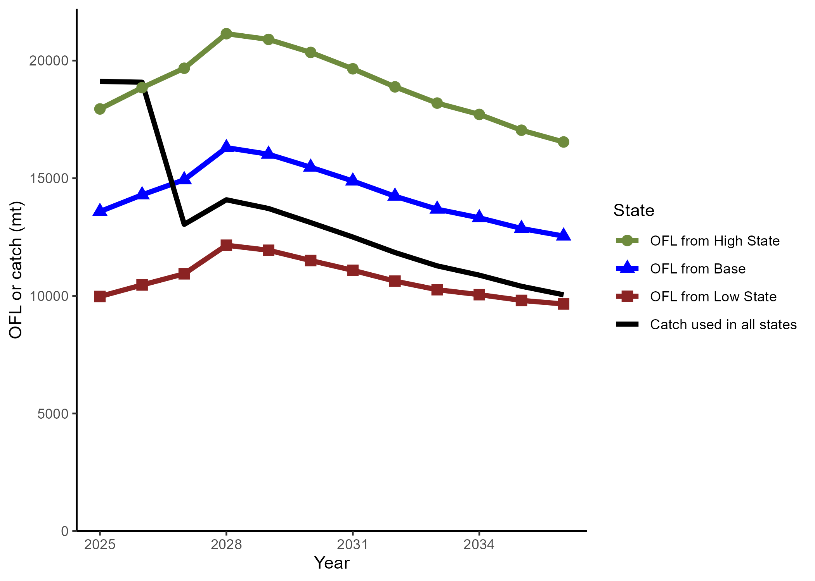

The GMT provided removals for 2025-206 and ACLs for 2027-2036 with a P* = 0.40 and sigma = 0.5 (black line) and the model estimated OFLs for 2025-2036 from the base model (blue line), low state of nature (red line), and high state of nature (green line).