

SILESIAN UNIVERSITY OF TECHNOLOGY
FACULTY OF AUTOMATIC CONTROL, ELECTRONICS AND
COMPUTER SCIENCE

Master Thesis

Statistical, real-time classification of IP traffic in Linux operating system

Author: Paweł Foremski
Supervisor: dr inż. Arkadiusz Biernacki

Gliwice, September 2011

Table of Contents
Chapter 1: INTRODUCTION 3
1.1. The problem of Internet traffic classification 4
1.2. Thesis goals 7
1.3. Review of existing solutions 8
1.3.1 Simple methods 8
1.3.2 Deep Packet Inspection 9
1.3.3 Modern approaches 9
1.4. Thesis contents 11
Chapter 2: SYSTEM DESCRIPTION 12
2.1. Main algorithm 13
2.1.1 Feature extraction 14
2.1.2 Decision process 15
2.1.3 Modifications 15
2.2. System architecture 17
2.2.1 Signature database 18
2.2.2 Training signatures and SVM model 18
2.2.3 Traffic sources 19
2.2.4 Endpoint table 19
2.2.5 Feature extraction and the decision process 20
2.2.6 Classification results 20
2.3. Methodology 20
Chapter 3: IMPLEMENTATION 23
3.1. Implementation design 24
3.2. External libraries and facilities 25
3.3. Main program: the libspi library 26
3.3.1 File list 26
3.3.2 Data structures, their instances and events 27
3.3.3 Program functions 29
3.3.4 Application Programming Interface 29
3.3.5 Internal specification 29
3.4. Front-end: the spid program 30
3.4.1 File list 30
3.4.2 Program description 30
3.4.3 Communication with libspi 30
3.4.4 User interface 30
3.4.5 Internal specification 30
Chapter 4: EVALUATION 31
4.1. Datasets 32
4.2. Results 32
4.3. Discussion 32
Chapter 5: CONCLUSIONS 33
Chapter 6: SUMMARY 34
Chapter 7: LITERATURE 35
Chapter 8: SUMMARY IN POLISH 37

INTRODUCTION
The Internet has been constantly evolving since its inception. For more than a decade it has been growing in capacity and versatility with a great pace, often requiring the Internet Service Providers to update and extend their infrastructure in a timely manner.
These changes are connected with the inventions of new kinds of computer software, which in turn generate new kinds of network traffic. However, the fundamental protocol of the Internet – the IP protocol – does not provide a robust and universal mean to tell one traffic kind from another. Thus, identification of a particular application in Internet transmissions is not a trivial task, yet its very important.
For instance, a typical Internet end-user demands a safe and fast Internet access. An Internet Service Provider which is to fulfil such a requirement must be able monitor the traffic for potential threats and to impose a proper prioritization on the traffic. Moreover, there are political and research organizations which monitor the global Internet. Observing the share of P2P traffic in all Internet transmissions of a particular country could reveal trends in its society. Work of these groups of people cannot be done without a reliable source of information.
This Thesis brings a practical implementation of a possible solution to this problem and presents its performance evaluation results.
This chapter introduces the problem of traffic classification (section 1.1), reviews its existing solutions (section 1.3), and formulates Thesis goals (section 1.2).

The problem of Internet traffic classification
Communication in the Internet follows the Internet Protocol (IP) [RFC791]. Basically, on top of IP, there are User Datagram Protocol (UDP) [RFC768] and Transmission Control Protocol (TCP) [RFC793], both of which being Transmission Protocols (TP). A single IP transmission connects two application processes, often running on two distant hosts (general concept presented on Fig. 1.1). Between these two hosts there is the Internet, comprised of intermediary hosts, called routers.

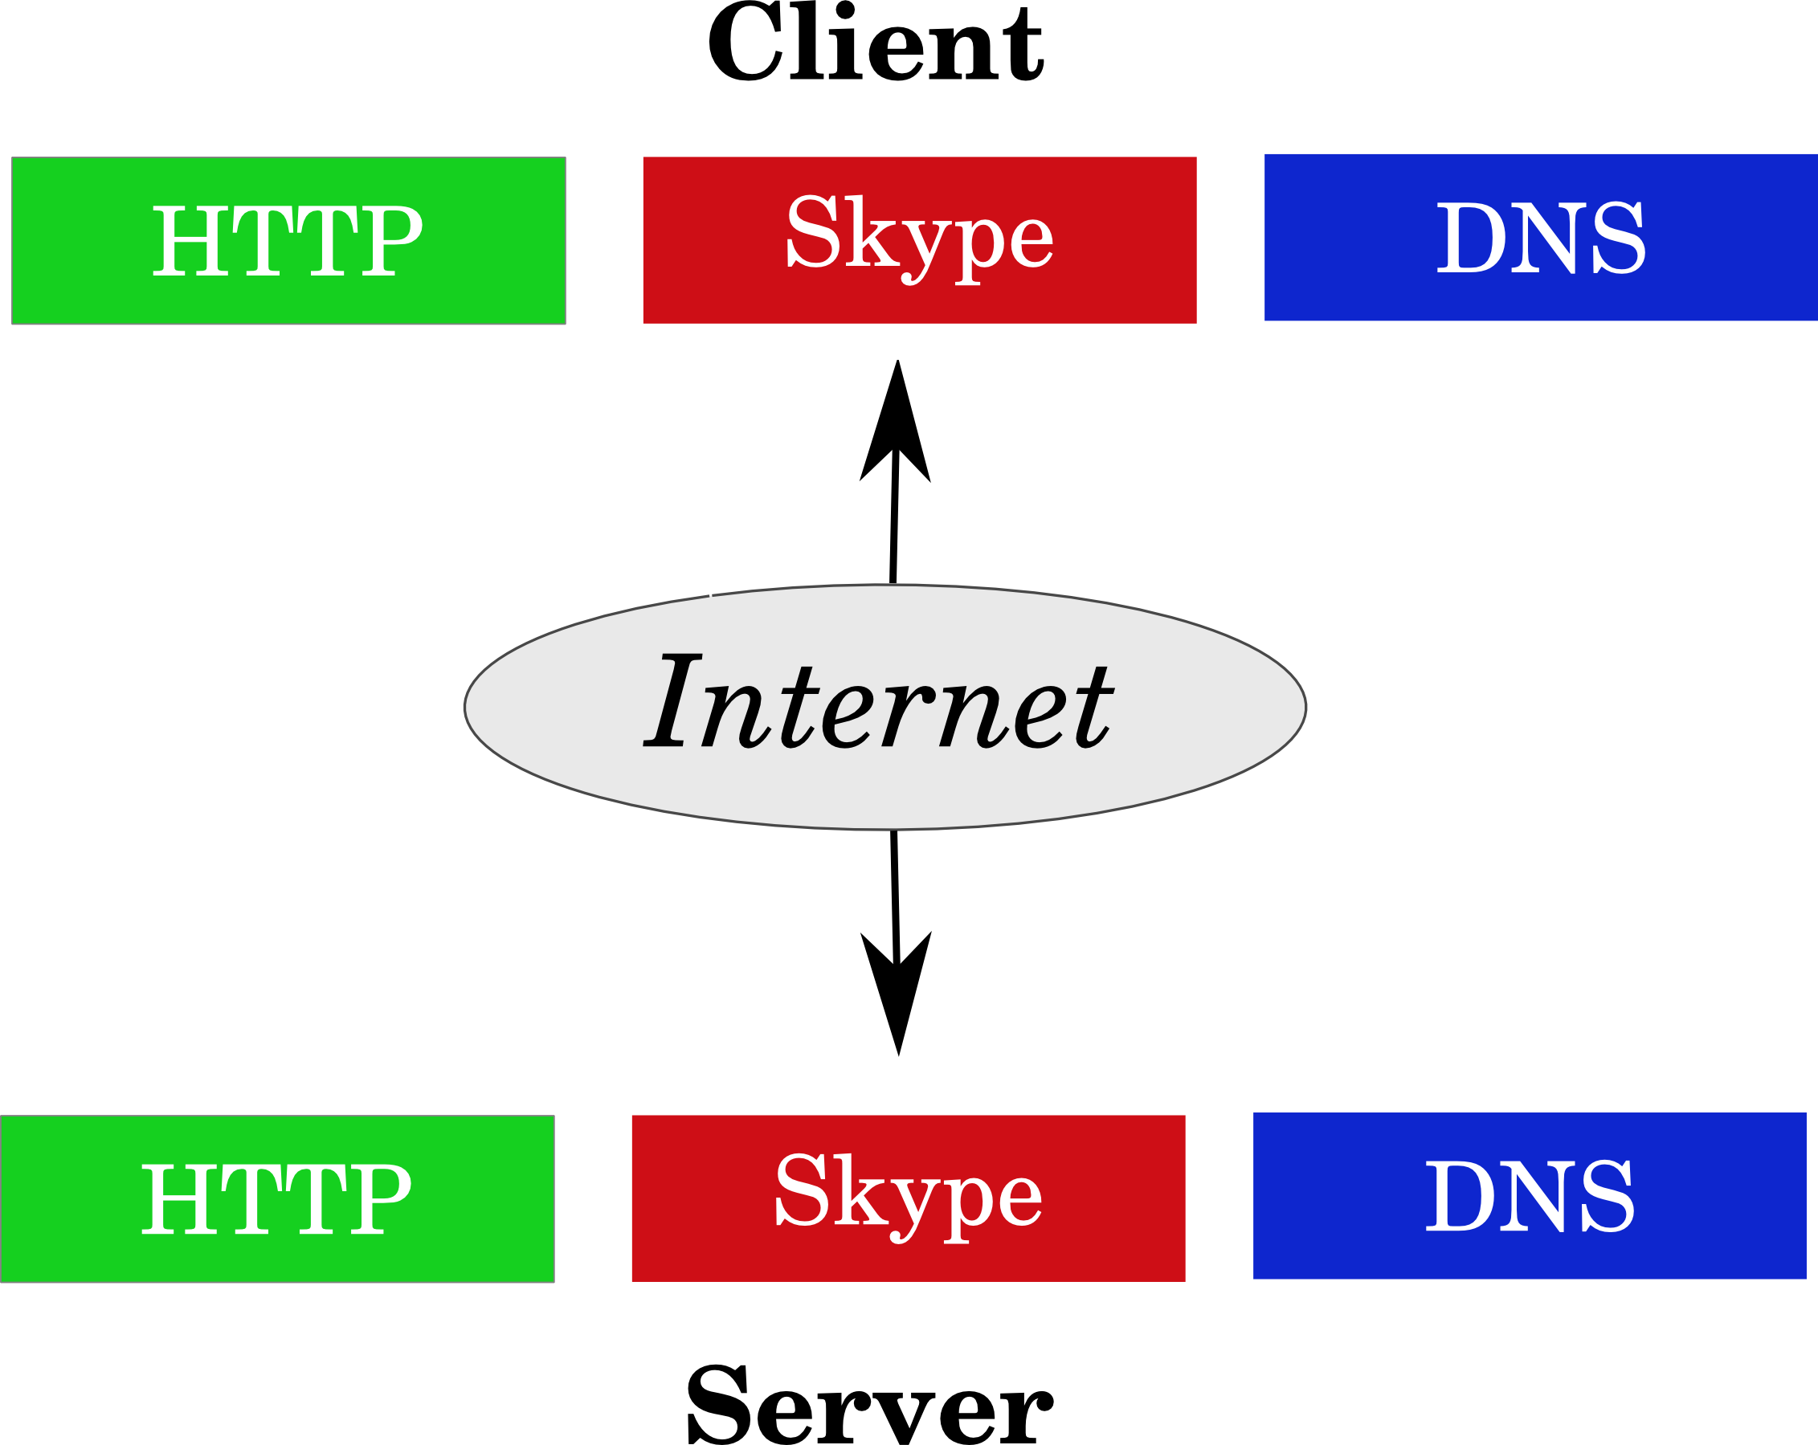
Fig. 1.1: General concept of Internet communication. Three processes (HTTP, Skype and DNS) running on “Client” host contact their respective counterparts running on remote “Server” host using the Internet.
The host Operating System (OS) provides an Application Programming Interface (API), through which a process can send (and receive) data in a simple manner, basically of arbitrary length and format.
This API facility is thus a kind of a proxy between the process and the Internet. It handles the operation of putting the data into well-formed IP packets, what often means dividing the stream of application data into many IP packets. This operation has the following implications, depicted on Fig. 1.2:
- Application identity is lost.
- Packets can go different routes.

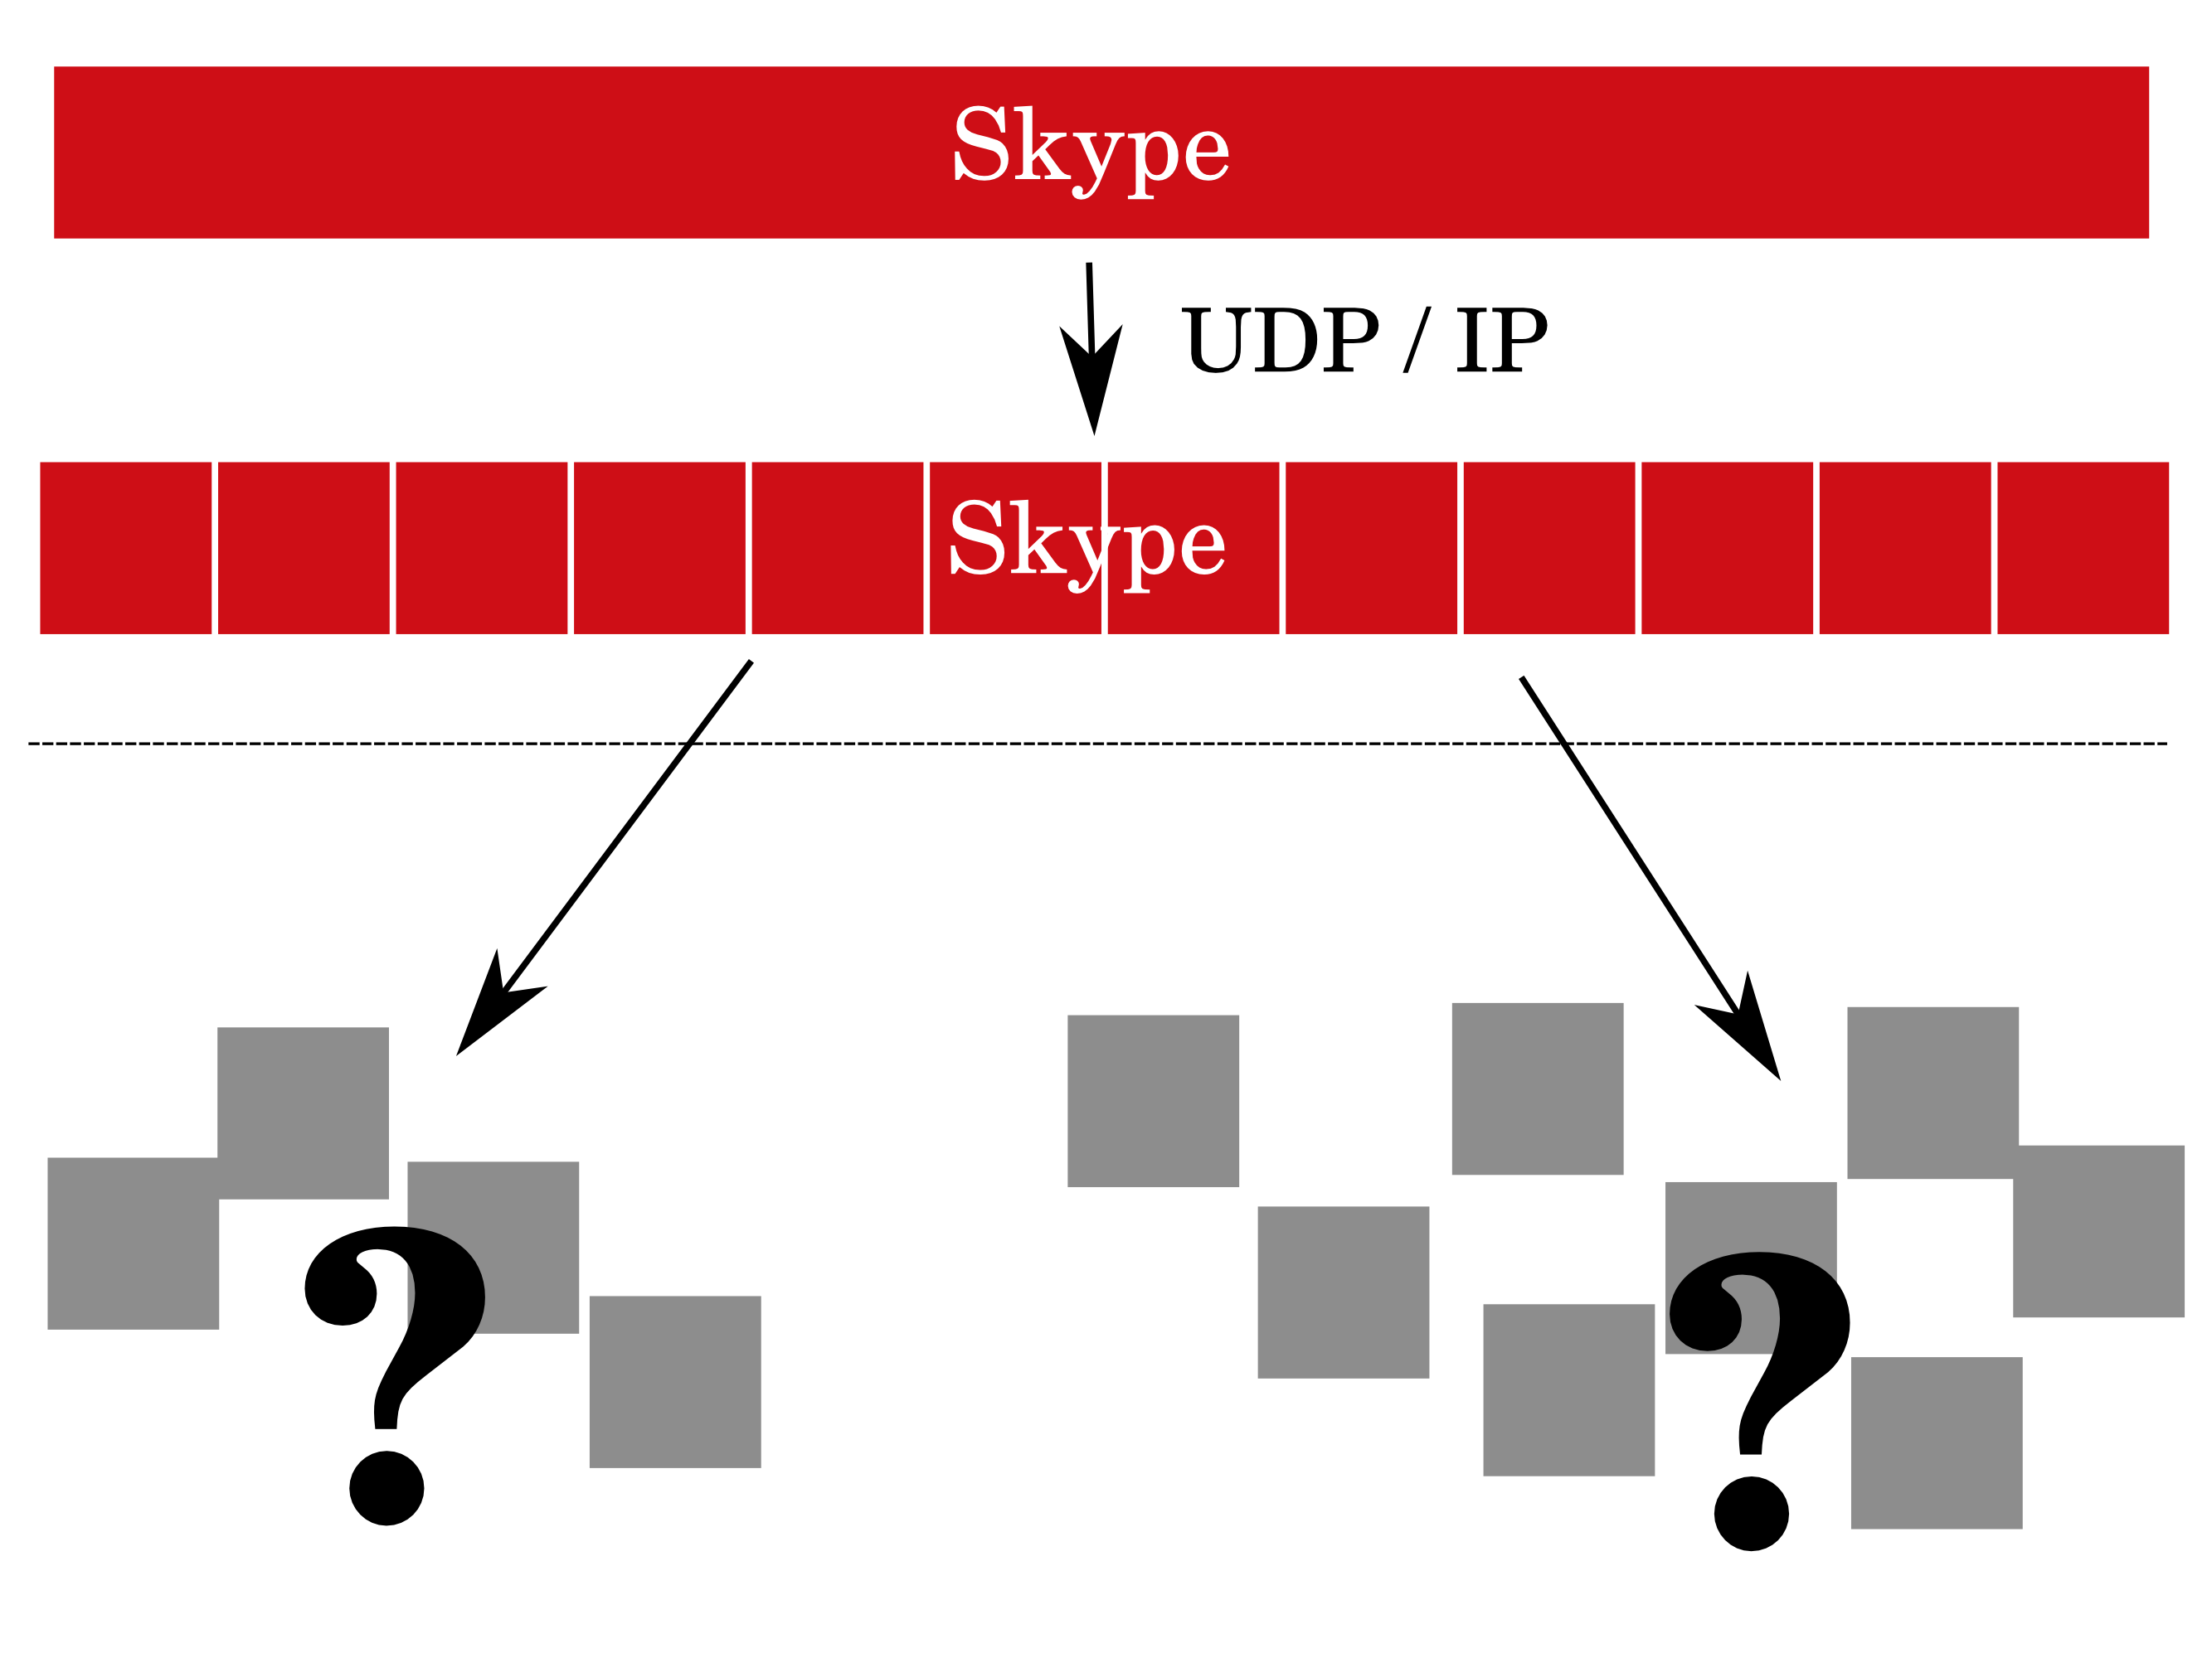
Fig. 1.2: Process data leaving the host boundary. Data of a single Skype process gets divided into IP packets and enters the Internet using two different routes.
Moreover, at a single time instant, a router has direct access only to the contents of a single packet. This all leaves Internet operators with very little information on the traffic passing through their infrastructure. For this reason, a useful approach is to look at the traffic from a more distant perspective.
The IP protocol defines a header part in its packet, having several fields, including:
- source IP address,
- destination IP address,
- desired transport protocol.
Similarly, Transport Protocol header carries:
- source port number,
- destination port number.
A group of packets having the same tuple of fields {1, 2, 3, 4, 5} is called a flow. It has a useful property, that each packet in a flow belongs to the same transmission and thus was generated by the same application (and by the same two processes). It is a convenient perspective of IP traffic analysis which lets to gather some statistical characteristics on the underlying traffic, like the average packet size, flow duration, bit rate, etc. However, application names are still unknown, as presented on Fig. 1.3.

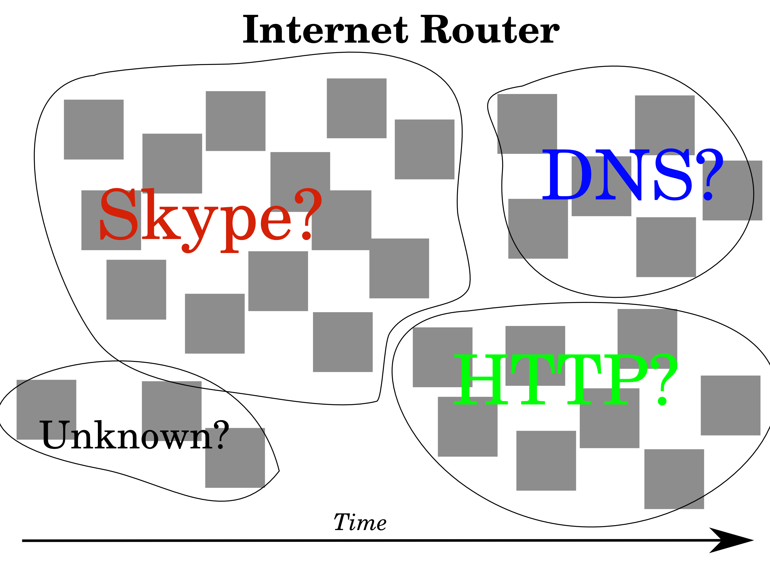Fig. 1.3: Groups of packets collected in flows. The identity of applications is still unknown.
Finally, the problem of Internet traffic classification can be formulated by the question: given IP packets, what is the identity of application that sent them?
Usually, classification verdict is issued on a whole flow – what indirectly leads to classification of single IP packets. However, limited solutions to classification based on single packets exist (see 1.3.1). The concept of application identity is quite broad. It can span from rough application type (e.g. “streaming”) to detailed program name and version (e.g. “Skype v. 2.5.3”). Identity is directly connected to information on characteristics of the traffic that it represents. Term application – apart of typical computer programs – can also include viruses, misconfigured or misbehaving software, etc.
Indeed, traffic classification is a process of associating groups of IP packets with application identities.

Thesis goals
Aim of this work is to provide a practical implementation of a traffic classifier. For the main algorithm, two novel, complementary methods will be used, published in:
- KISS: Stochastic Packet Inspection Classifier for UDP Traffic [Fin09]
- Stochastic Packet Inspection for TCP Traffic [Fin10]
Minor modifications and extensions will be made to these methods (see 2.1.3), in order to make the resultant system more suitable for practical usage as a firewall element and to increase its performance. Application of the final system will be limited to about 5% of Internet endpoints, but carrying more than 98% of bytes (see 2.1).
Result of the Thesis is a computer program, with the following characteristics:
- Support for TCP and UDP protocols.
- Written in C language.
- Operation under GNU/Linux environment.
- Simultaneous offline and real-time classification.
- Simultaneous training, classification and performance testing.
- Classification through Support Vector Machines (using libsvm [CC01a]),
- Support for the popular PCAP IP traffic format [PCAP].
For instance, using the resultant program, operator of a Linux router will be able to identify kinds of network traffic passing through his infrastructure. First, the program will be trained with traffic samples of known applications, and then the system will monitor chosen network interfaces in real-time. Finally, each time a trustworthy classification is made, the program will emit an adequate message.

Review of existing solutions

Simple methods
An Internet application has some standard, limited, subjective, non-mandatory and (to some degree) obsolete ways of putting a kind of a label on its packets. Such label can be used to determine application identity and to make assumptions and predictions on the transmission characteristics.
These standard, simple methods are 1. usage of a well-known TP port number and 2. usage of the Type of Service (ToS) field of the IP header (updated and replaced by the Differentiated Services Code Point (DSCP) [RFC2474]).
- Port number can be used for classification by using a database of port-protocol associations, e,g. destination port 80 could mean an HTTP browser.
- Value of the ToS field can tell characteristics of the transmission, e.g. value 00010000₂ is a low delay traffic (like VoIP transmission).
Both methods are limited. Port number has space of 16 bits, what is gives an upper limit of well below 10⁵. Similarly, length of the ToS field bounds number of traffic kinds well below 10³. By contrast, there are more than 2 x 10⁹ users of the Internet worldwide, as of March 2011 [IUS]. Each user has his favourite set of applications and usage patterns.
Besides, these methods base on knowledge local to the host and its close neighbourhood. For example, an application requesting a low-delay transmission for a BitTorrent download may not deserve such prioritization compared to the needs and resources of the global Internet. What is more, a frequent practice is to establish interpretations of the DSCP for a whole Autonomous System (AS) or Internet Exchange point (IX). However, the meaning of a DSCP value changes as IP packet traverses the Internet. This value may be interpreted differently in different parts of the world.
Finally, neither usage of a well-known port nor setting a DSCP value is mandatory. With above reasons, these rendered both methods obsolete. They must not be used as a source of reliable, accurate, Internet-wide source of information [Kar04]. In general, the idea of relying on the packet sender to classify its traffic contradicts with the general rule of Internet security, which is “never trust no one”.
Still, these simple methods, especially the port-based classification, have some limited application areas and can produce meaningful results under some conditions. Its greatest advantage is that it is stateless and can immediately classify each single IP packet.

Deep Packet Inspection
The growth of Peer-to-Peer traffic (P2P), streaming media applications and viruses unveiled inadequacy of relying on simple methods for traffic classification. The Internet industry had to invent better techniques.
The most straight-forward solution is to inspect the packet payload for well-known patterns. A router having a database of patterns would then search contents of each packet for a match against the database. Such approach is called Deep Packet Inspection (DPI) and real-world solutions exist both in the commercial world [Ellacoya] and in the open source community [L7], [ODPI].
DPI has a serious drawback – it is effectively useless if the application uses encryption. Moreover, analysis of packet contents brings user privacy issues. Search for a complicated pattern in each packet can be computationally expensive. The database of patterns needs to be constantly kept up-to-date, and each new protocol signature has to be manually analysed and extracted by a skilled engineer before it can be used.
However, DPI methods can be very accurate and seem to be the current industry standard. For researchers, they are often a basis for comparison of new methods [Kar05].

Modern approaches
Another approach pursued nowadays is classification based on some characteristic features – often statistical – of the traffic as a whole.
Such system could for example observe the average packet size and inter-packet time gaps. Then, an inference engine would make a decision basing on the values of these statistics – either by comparing them with thresholds or by using machine learning techniques. Research efforts in this field were started with a fundamental work dating 1994 [Cla94], with practical classification systems appearing a decade later [Rou04], [Kar05], [Moo05], [Zan05]. They all bring promising results.
Basically, each of these methods has two discriminating elements: observed traffic features and the classification algorithm.

Traffic features
IP packets have many properties. Apart of the ones already introduced, also: total packet size, time of arrival, sequence number and many more. One can aggregate packets in a flow, but by choosing different tuple elements, many kinds of such traffic aggregations are possible. Another common aggregation is host-level, e.g. by tuple of {source IP, TP}. Then, having a group of packets aggregated according to a common criterion, a several traffic features can be computed.
On the lowest packet level, features like mean packet size, observed TCP header flags, inter-packet time gaps can be computed. By looking at flow-level characteristics, one could analyse mean flow duration, mean data volume per flow, and the variance of these metrics [Rou04]. Another interesting view is a social-level view [Kar05], in which – for example – the number of remote locations a host contacts, and average volume of data exchange for each of them, could be analysed.
Finally, in the classification method used in this Thesis, traffic features are extracted from statistical analysis of the packet payload. In [Fin09], randomness of the first few bytes in UDP packet payloads is measured (see 2.1).

Classification algorithm
Modern traffic classifiers often use machine learning techniques. In a typical scenario, a classifier must be taught before it is able to distinguish one traffic kind from another. In order to do that, traffic samples of a particular application are carefully collected. Traffic features are extracted and the data is used for learning the classifier.
The number of feature vectors required for training depends on their length and the machine learning technique used, 5-10 x 10³ being a rough estimation in [Kim08]. Research efforts tend to use different classification algorithms - Naïve Bayes, Bayesian Networks, Decision Trees, k-Nearest Neighbors (k-NN), Neural Networks and Support Vector Machines (SVM), with the latter giving the best results.
The research community is lacking a common set of traffic samples [Sal07], hence comparison of different classification algorithms is hard. Even obtaining a single suitable training set can be a tough task. Researchers must fall back on DPI solutions in order to annotate datasets with “ground truth”, i.e. labels with application names [Kar05], [L7].

Thesis contents
Chapter 1 discusses the problem of traffic classification and describes Thesis goals: an introduction to the subject, basic definitions, problem statement and a review of possible solutions in the existing literature; Thesis goals and description of results.
Chapter 2 describes the resultant system in terms of algorithms and design: summary of the main KISS algorithm with modifications, general system architecture and methods for performance evaluation.
Chapter 3 gives information on software implementation: design decisions, external software libraries and detailed descriptions of the libspi library and the spid program.
Chapter 4 presents performance evaluation results.
Chapter 5 concludes the Thesis with statements about resultant program quality.
Chapter 6 is a summary on feasibility of practical traffic classification – in general, and using the Thesis software.
Chapter 7 gives Thesis bibliography.
Chapter 8 contains Thesis subject and summary in Polish and English.

SYSTEM DESCRIPTION
Thesis goal is implementation of a statistical traffic classification system capable of working in real-time.
In order to achieve this, already existing classification methods will be used as the main algorithm. It will be extended by several other, original elements required to make it a practical system capable of a real-time operation.
For the main algorithm, two complementary methods will be applied, covering TCP ([Fin10]) and UDP ([Fin09]) protocols, jointly referred to as “the KISS algorithm”. They both employ a statistical test similar to the Pearson's Chi-Square test, hence the name of “KISS”, standing for Chi-Square Signatures.
Original system elements brought by the Thesis cover obtaining IP traffic, training the system, handling the SVM library in optimal way, and presenting the results.
This Chapter describes the whole system from design point of view. Section 2.1 characterize the KISS algorithm with modifications, section 2.2 gives a more practical view on the system architecture, while the section 2.3 presents an adequate method for performance evaluation of the whole system.

Main algorithm
The KISS algorithm is a traffic classifier which observes randomness in first bytes of IP packet payloads.
As the input it takes a set of IP packets. As the output, a set of {endpoint, label} pairs is provided, where label can be used to uniquely determine application identity. Internally, the algorithm consists of two stages – feature extraction and decision process – depicted on Fig. 2.1.
KISS authors claim very good results of average 99.6% True Positives with less than 1% of False Positives. However, as it requires at least 80 packets, it is limited to about 5% of Internet endpoints, but carrying more than 98.6% of bytes.
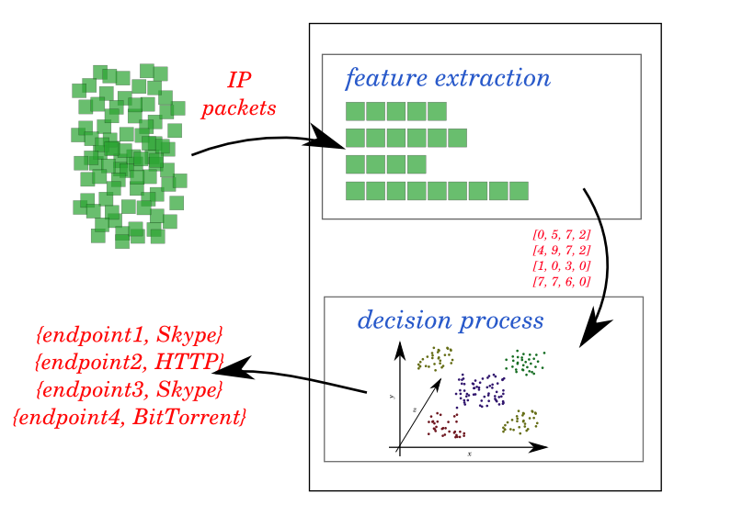Fig. 2.1: The KISS algorithm. IP packets enter feature extractor, which feeds the decision process, which produce the output.

Feature extraction
Feature extraction begins with queueing packets in endpoints, that is, groups of packets having the same tuple of {IP address, TP protocol, TP port}. For TCP, all packets except the first P=5 data segments in TCP sessions are dropped.
For each queued packet, all data except the first N=12 bytes of packet payload (past the TP header) is removed. Each of these N bytes is divided into two halves, forming G=24 groups, each of bit-length equal b=4. Once C=80 packets are gathered in an endpoint, they form a signature window, a matrix with C rows and G columns, which is further processed.
For each possible group value – which is 0 (0000₂) till 15 (1111₂) – number of its occurrences in each window column is counted. Result is denoted with , where g is column number and i is the value.
Next, each column is summarized with a single value , which is a statistical test similar to Pearson’s Chi-Square (χ²) test:
(2.1)
Reason for this is to measure the distance between distribution of observed group values and the uniform distribution. Its expected value was chosen as if all possible group values were equally probable:
(2.2)
Indeed, a small value means roughly that all out of the possible group values are equally probable in column g, hence its randomness across C packets is high. For instance, it may carry a unique query identifier chosen in a random way for each packet. On the other hand, columns carrying constant values – like protocol version numbers – will result in high values.
See Sec. III-A in [Fin09] for detailed discussion.
Finally, a signature (or a feature vector) is constructed by collecting values from all columns:
(2.3)
This 24-dimensional vector is a very accurate application fingerprint that can be used for further classification.

Decision process
Task of the decision process is to reveal the application identity behind a signature.
For this task, KISS uses Support Vector Machines (SVM) [Cor95], which is a set of machine learning techniques that can be used for classification and regression. The general idea behind SVM is to rearrange the problem space so that the training samples can be easily separated by hyper-planes. This is realized by means of translating the input N-dimensional space into possibly infinite-dimensional space, maximizing the distance between hyper-planes and training sample points.
Before it can be used, SVM needs to be trained with several signatures annotated with the target class. As a result of such training process, a model is generated, which is later used for prediction of the proper signature class, which is the output of the KISS decision process.

Modifications
A few modifications and extensions have been made to the KISS algorithm, for the needs of the Thesis.

Classification objects
Section IV-A of [Fin09] defines two classification entities – a flow and an endpoint. In the Thesis, such a modification is made, that packets are grouped in endpoints without regard to their direction. This is contrary to Sec. III-B in [Fin10].
Motivation for this is to weaken the limits mentioned in 2.1. With this modification, the requirement of C=80 packets in a signature window can be attained earlier.

Signature extension
Feature vectors can be optionally extended with 3 new coordinates:
- Average packet size.
- Average value of inter-packet time gap (IPT)
Inter-packet time gap is the time that elapses between two consecutive packets. First, an average E and a standard deviation σ of IPT values are calculated. Then, outliers are rejected by dropping all values greater than . This assumes that IPT follows the standard distribution and thus rejects about 5% of the input values. Finally, the average value is recomputed and used as the coordinate value.
- Average differences in IPT
This coordinate holds the average difference between two consecutive IPT values, after outlier detection. It is to mimic the concept of packet jitter.
Motivation behind introducing these 3 coordinates is to improve the performance of the resultant system. Undisturbed values of these flow-level characteristics are available in typical network scenarios.

Complex decision process
In the original algorithm, a single endpoint can be classified many times, once for each signature window. In the Thesis however, a three reconciliation algorithms, as suggested in sect. IV-B of [Fin09], have been implemented.
- “Simple” - uses the last classification directly, as in the original algorithm.
- “Best” - uses the classification with the highest probability so far.
- “EWMA” - tracks the Exponentially Weighted Moving Average of classification probability for each possible outcome, and uses the one with the highest value seen so far.

Unknown protocol detection
A potential drawback of KISS is that it requires a good quality “Background” traffic samples during the learning phase (sect. V-C in [Fin09]). This is in order to detect applications that are unknown to the classification system.
In the Thesis, this was solved using the classification probability output of the libsvm library. For each classification, a vector with relative class membership probability can be obtained. Unknown protocol can be detected by introducing a simple threshold mechanism. However, the sum of vector values is always equal 1, so in order to give the values an absolute meaning, the difference between the first and the second highest value is checked. If the result is below the threshold, classification is considered “not certain enough” and rejected.

System architecture
Previous section describes the main algorithm with its two stages of feature extraction and decision process. In order to implement it as a practical system, these stages have to be decomposed, and the whole algorithm needs to be complemented with a few elements, as presented on Fig. 2.2.
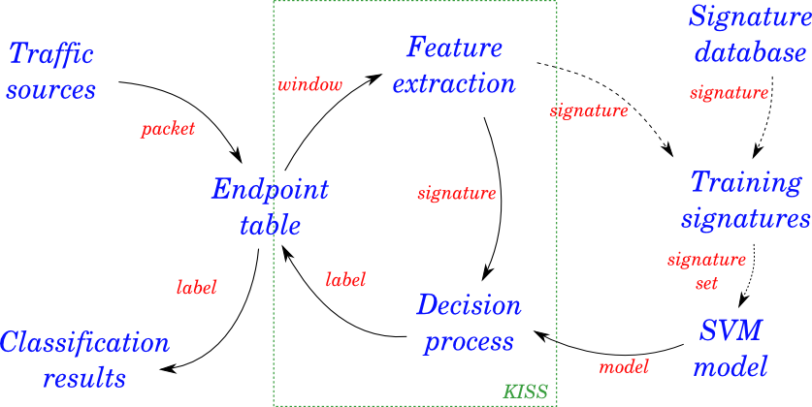
Fig. 2.2: General system architecture. System elements presented in blue. Arrows show data paths, with data kinds as red labels. Dashed arrows represent paths used for system training. Green frame roughly shows elements defined in the original KISS algorithm.
The system consists of the following elements:
- Signature database
- Training signatures
- SVM model
- Traffic sources
- Endpoint table
- Feature extraction
- Decision process
- Classification results
Following subsections describe these components.

Signature database
The process of obtaining signatures from IP packets can be computationally intensive (recall 2.1.1). For instance, if one wants to train the system so it is able to properly recognize 10 applications, for good-quality results about 1000 signatures need to be extracted for each of them, giving a total of almost 1 million packets.
This “knowledge” of the system is lost once the program is terminated. However, the process of learning it once again can be sped up by saving the extracted signatures (annotated with labels) on a hard disk. Hence, the next time the program is run, no time-consuming packet analysis is required. Signatures are immediately loaded into the program memory.
This is the task of the Signature database. It reads signatures from hard disk and feeds them into the Training signatures element. Furthermore, new signatures that will be obtained through IP packet analysis during program execution will be stored in the database, too.

Training signatures and SVM model
Before SVM is able to make classifications, it needs to be trained with samples annotated with the target class (recall 2.1.2). This is also a computationally intensive task. Moreover, the model can not be incrementally updated. Even a single new learning signature can cause the whole model to be recomputed. In a real-time system, this could happen many times per second.
Task of the Training signatures element is to be a kind of a buffer to the SVM model update process. It ensures that the model is recomputed at most once per specified amount of time, e.g. 10 seconds. Thus, there is a chance that several new signatures are buffered before the update process is run.

Traffic sources
Traffic sources supply the system with IP packets. For off-line classification, it is a file with IP packets stored in PCAP format [PCAP]. For real-time operation, it is a network interface – e.g. an Ethernet NIC – for which all the traffic passing through it is captured.
Task of this element is to provide an interface to access these underlying packet sources in a common way. At the same time, many packet sources can work simultaneously, some of which being off-line sources, and some real-time. All packets are passed to the Endpoint table.
Usually, a traffic source supplies packets of unknown application. If the application is known, packets are used for training. In such case, they do not enter the Decision process, but supplement the Training signatures. Alternatively, they follow the standard path of classification, but the Classification results element will verify if the system produced a valid answer, thus giving an insight into the system performance.

Endpoint table
The Endpoint table element is the central component of the whole system. It has two fundamental tasks of gathering IP packets in groups of endpoints and collecting classification decisions made on them.
Special care needs to be taken for off-line packet sources. It may happen, that packets stored in two files are distant in time – for instance, packets captured in year 2011 and 2008. For this reason, packets from two off-line sources can not be grouped in a single endpoint. For real-time sources, this is allowed.
For TCP packets coming from traffic sources, all segments past the first P=5 packets in TCP session are dropped (see 2.1.1). The table is periodically swept by a garbage collector, which removes all endpoints, for which the last packet is older than 5 minutes. For off-line sources, the time distance to the last packet received from this source is checked.
The Endpoint table feeds the Feature extraction element once at least C=80 packets (see 2.1.1) is collected in a single endpoint.

Feature extraction and the decision process
Task of these two elements has already been described in section 2.1. Decision process requires an already prepared, valid SVM model. If it is absent, no classification can be made.
The result is stored in the Endpoint table as an endpoint property. Whenever the value of this property changes, the Classification results element is notified.

Classification results
Task of this element is to inform the system user that an application identity has been recognized at a given Internet endpoint. The resultant numeric label used internally (e.g. “7”) is translated into string representation (e.g. “Skype”). Name of the traffic source is also given (e.g. “eth0” or “~/traces/skype.pcap”).
In case the application behind the traffic source is known, the result will be verified and used to compute the system performance metrics.

Methodology
There are two possible kinds of a traffic classifier output – its result is either valid or invalid. This will be the fundamental field of performance evaluation in the Thesis, as described below (based on [Fin09]).
Two notions of a True/False and a Positive/Negative needs to be introduced. Classification is True if it is valid, and False otherwise. All classifications belonging to the particular application identity are Positive, and others are Negative. Thus, classifier output can be either seen as a True Positive (TP) or True Negative (TN) if it is valid, and False Positive (FP) or False Negative (FN) otherwise.
Now, four metrics can be introduced:
- False Positive Percentage for application identity x
(1.1)
  - is number of False Positives for x
  - is number of samples not belonging to x
- False Negative Percentage for x
(1.2)
  - is number of False Negatives for x
  - is number of samples belonging to x
- True Positive Percentage for x is (1.3)
- True Negative Percentage for x is (1.4)
For instance, if there are 100 “Skype” endpoints and the classifier says 10 of them are “BitTorrent”, then .
Finally, system performance can be evaluated using traffic samples of applications, whose identities are already known. This knowledge of true application identities is called ground truth. It can be obtained in several ways, for instance using a DPI packet classifier like [L7].
Samples are fed into the system and the result is compared to the ground truth. Observation of two metrics – %TP and %FP – and their statistics allows to make conclusions on the performance of the system. A well-performing system is characterized by high %TP values while keeping the %FP metric as low as possible.
(TODO: sekcja prawdopodobnie do dopracowania – np. przybliżyć praktycznie metodę zastosowania tych wskaźników, może coś więcej o narzędziach użytych w projekcie)

IMPLEMENTATION
(TODO)

Architecture
The system has been entirely implemented in C language under Linux operating system, on a PC system. However, this does not pose a tight limit on the area of its possible applications. It would require little or no modification to port the system to other UNIX-like platforms, including embedded systems.
The system works as a single-threaded process with one global event loop. The loop is used for external communication and for exchange of internal messages. Such architecture lets for quasi-parallel processing. For instance, handling incoming IP packets is possible while making classification decisions at the same time.
Compared to a multi-threaded architecture, such approach greatly simplifies the whole system, but under some circumstances it might cause higher classification latency, i.e. the time that lapses between the moment in which a new packet enters the system and the event of its classification. Specifically, this would happen on a multiprocessor machine. However, in such case, each CPU could be assigned different part of the IP addressing space, as presented on Fig. 3.1.
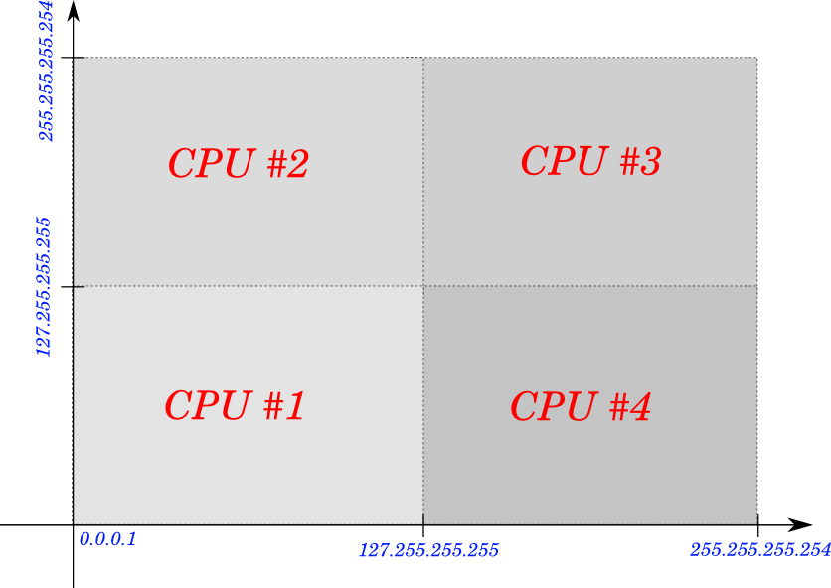
Fig. 3.1: Classification on a multiprocessor machine. Each CPU handles different part of the IPv4 addressing space.
Functionality of the system has been divided into multiple modules. In most cases, no direct procedure call is possible between the modules. Instead, a notification mechanism is used in which one functional element informs another, for example, that a new signature window is ready to be classified. This is realized by means of internal events (or messages), transported by the main program loop. The source module announces that some event happened, while there can be any number of subscribers, which will handle the event, with some time delay. Event announcements are queued, so this delay depends on the current queue length and its processing speed.
Still, program modules can write to shared memory, so there is a direct data communication path by means of variables. No locking or synchronization mechanisms are needed, as the program is single-threaded. Indeed, all modules have direct access to a common instance of the fundamental data structure: struct spi (see 3.3.2.1).
The classification system has been almost entirely implemented as a library, called libspi, where “spi” stands for Statistical Packet Inspection. A simple command-line front-end program has also been created, with a name of spid.

External libraries and facilities
The system relies on several external components.
For the implementation of the main program loop, the libevent [Pro00] library has been used. Specifically, it handles the task of monitoring traffic sources for new packets, periodically executes the endpoint table garbage collector and is used as a queue for internal events.
The network traffic is obtained via the libpcap library [PCAP]. It handles reading of packet trace files and capturing live traffic on network interfaces. However, the latter depends on packet capture facilities delivered by the operating system. Usually, the system will deny access to this data without administrator privileges.
As a general tool set, a library based on libasn [For05] has been adopted. It provides basic data structures of hashing table and linked list, memory management utilities and some mathematical functions in form of C pre-processor macros.
For realization of the SVM decision process, a popular implementation of libsvm [CC01a] has been employed. For training, its svm_train() function is used, and svm_predict_probability() for classification with probability output.

Main program: the libspi library

File list
libspi consists of the following files:
- datastructures.h : declarations of data types and structures used throughout the system and in the API
- settings.h: holds pre-processor constants to be used as main algorithm parameters and some fundamental options of the whole system
- spi.h: declarations of the API – public functions exported by the library
- spi.c: main program; implements initialization procedure, management of traffic sources, internal event system, garbage collector, training signature queues, and memory management routines
- source.h: declares source.c functions that can be called internally
- source.c: implements two traffic sources; PCAP files and network interface sniffing via the libpcap library; holds a generic IP packet parser which is the source of signature windows
- flow.h: declares flow.c functions that can be called internally
- flow.c: TCP flow table; implements the P limit (recall 2.1.1) and detects RST/FIN flags which close connections
- ep.h: declares ep.c functions that can be called internally
- ep.c: the endpoint table; implements registering new packets
- kissp.h: declares kissp.c functions and data structures that are used internally
- kissp.c: implements the extended KISS algorithm; connects to the libsvm library
- verdict.h: declares verdict.c functions and data structures that are used internally
- verdict.c: implements the complex decision process (see 2.1.3): “simple”, “best” and “EWMA” algorithms; produces final verdict on endpoint classification

Data structures and variables
The datastructures.h header file contains most data structures used in the system, with a few declarations in kissp.h and verdict.h files. This subsection gives documentation of the most important data structures, including their application as variables and internal events used for notification of changes.

Main structure: struct spi
The struct spi is a root data structure, instance of which is passed to every function. Conceptually, this is similar to the special variable this used in the C++ object-oriented programming language. Every data piece used by the program can be reached from this structure. Each instance of struct spi thus represents an instance of the whole libspi.
Structure synopsis presented on Listing 3.1:
- struct spi {
- mmatic *mm;
- struct spi_options options;
- bool running;
- bool quitting;
- struct event_base *eb;
- struct event *evgc;
- thash *subscribers;
- tlist *sources;
- thash *eps;
- thash *flows;
- tlist *traindata;
- tlist *trainqueue;
- struct spi_stats stats;
- void *cdata;
- void *vdata;
- };
Listing 3.1: struct spi. Main data structure.
Structure members:
- mm: used for memory management by the libasn ([For05]) library
- options: stores run-time program options
- running: holds true if the program is currently inside an iteration of the main loop, false otherwise
- quitting: used for breaking the main loop; if the value is true, then libspi will exit on its next iteration
- eb: a libevent [Pro00] variable holding its main instance data
- evgc: a libevent variable holding the event which schedules the libspi garbage collector execution
- subscribers: subscribers of internal events; a hash table of struct spi_subscribers (see 3.3.2.2)
- sources: traffic sources (see 2.2.3); a linked list of struct spi_source (see 3.3.2.3)
- eps: the endpoint table (see 2.2.4); a hash table of struct spi_ep (see 3.3.2.4)
- flows: TCP flow table used for the P limit (see 2.1.1); a hash table of struct spi_flow; similar to spi.eps
- traindata: training signatures (see 2.2.2); a hash table of struct spi_signature (see 3.3.2.5)
- trainqueue: signature database (see 2.2.1) queue; a has table of struct spi_signatures; it constitutes an intermediate buffer between signatures in the database and spi.trainqueue
- stats: statistical data used for calculation of system performance metrics; see 3.3.2.7
- cdata: a generic pointer to main algorithm data, in this case struct kissp; see 3.3.2.8
- vdata: a generic pointer to implementation of the complex decision process, in this case struct verdict; see 3.3.2.9

Internal events: spi.subscribers, struct spi_subscribers, spi_event_cb_t and struct spi_event
Inter-module control flow is realized by means of internal events (see 3.1). Each event is uniquely identified by its name, e.g. classifierModelUpdated. Event subscriptions are registered in the subscribers member of struct spi, which is a hashing table. For table keys, event names are used, so multiple subscriptions to the same event are stored in the same place. Each table value is an instance of struct spi_subscribers.
The main task of struct spi_subscribers is to hold references on event handler functions (so-called callbacks). Each callback address is stored in a data type of spi_event_cb_t. Synopsis of both of them given on Listing 3.2:
- struct spi_subscribers {
- tlist *hl;
- tlist *ahl;
- enum spi_aggstatus {
- SPI_AGG_DISABLED = 0,
- SPI_AGG_READY,
- SPI_AGG_PENDING
- } aggstatus;
- };

- typedef bool spi_event_cb_t(
- struct spi *spi,
- const char *evname,
- void *arg
- );
Listing 3.2: struct spi_subscribers and typedef spi_event_cb_t. Structures used for handling of internal event subscriptions.

Members of struct spi_subscribers:
- hl: list of handlers to call when event is announced; a linked list of spi_event_cb_t
- ahl: a list of handlers to call after all handlers from hl finish; a linked list of spi_event_cb_t
- aggstatus: an enumeration for tracking the current state of the event in the system; used for aggregation of multiple event announcements into one round of handler call; possible values:
  - SPI_AGG_DISABLED: state tracking disabled
  - SPI_AGG_READY: no event announcements in the system
  - SPI_AGG_PENDING: the event has been announced and its pending for being handled
Parameters of spi_event_cb_t:
- spi: reference on the global instance of struct spi
- evname: name of the event that caused the handler to be called
- arg: optional generic pointer passed during event announcement
Handler returns false if it requests to be unsubscribed from the list of event handlers. Otherwise, it returns true.
Whenever an internal event is announced, an instance of struct spi_event is created, holding data which will be later used during event handling. This instance is finally stored in an event queue managed by libevent. Synopsis given on Listing 3.3:
- struct spi_event {
- struct spi *spi;
- const char *evname;
- struct spi_subscribers *ss;
- void *arg;
- bool argfree;
- };
Listing 3.3 struct spi_event. Representation of an event announcement.

Structure members:
- spi: reference on the global instance of struct spi
- evname: name of the event that has been announced
- ss: reference on the relevant entry in spi.subscribers
- arg: optional announcement argument; a generic pointer passed to spi_event_cb_t
- argfree: decides if the memory pointed by arg should be released after event handling is finished; value of true enables this functionality

IP traffic: struct spi_source, spi_source_t and struct spi_pkt
A traffic source is represented by struct spi_source. It holds information on the underlying libpcap source of packets, packet counters, etc. Source type is represented by spi_source_t. Synopsis given on Listing 3.4:
- typedef enum {
- SPI_SOURCE_FILE = 1,
- SPI_SOURCE_SNIFF
- } spi_source_t;

- struct spi_source {
- struct spi *spi;
- spi_source_t type;
- spi_label_t label;
- bool testing;
- int fd;
- struct event *evread;
- unsigned int counter;
- unsigned int signatures;
- unsigned int learned;
- unsigned int eps;
- bool closed;
- union {
- struct {
- pcap_t *pcap;
- const char *path;
- struct timeval time;
- struct timeval gctime;
- } file;
- struct {
- pcap_t *pcap;
- const char *ifname;
- } sniff;
- } as;
- };
Listing 3.4 struct spi_source. Representation of a traffic source.
Structure members:
- spi: reference on the global instance of struct spi
- type: type of the source, either:
  - SPI_SOURCE_FILE: offline source – a packet trace file
  - SPI_SOURCE_SNIFF: online source – a network interface traffic sniffer
- label: optional application label; if the value is greater than 0, the source can be used for system training or performance testing (recall 2.2.3)
- testing: if true, this source will be used for performance testing instead of training
- fd: a UNIX file descriptor of the underlying packet source, extracted from libpcap; the file descriptor is monitored using libevent for new data available for reading, thus this is the most important, original source of activity in the system
- evread: a libevent variable representing the event of new data available for reading from fd
- counter: number of IP packets read from the source so far
- signatures: number of signatures extracted from the source so far
- learned: number of source signatures used for training so far
- eps: number of endpoints identified in the source so far
- closed: set to true when source is considered to be closed, e.g. when the end of packet trace file is encountered
- as: a union of two structures, used in interchangeable way, depending on the value of the type member
- as.file: structure used if type is SPI_SOURCE_FILE
  - pcap: an instance variable of the libpcap library
  - path: file system path to packet trace file
  - time: time-stamp of the most recently read IP packet; used as virtual current moment of time (i.e. “now”), local to the particular traffic source
  - gctime: value of the time member during last execution of the endpoint table garbage collector; used in order to schedule the garbage collector using the virtual time (e.g. once per minute), even if in the reality the file is parsed much faster (e.g. a virtual week of traffic each second)
- as.sniff: structure used if type is SPI_SOURCE_SNIFF
  - pcap: an instance variable of the libpcap library
  - ifname: name of the network interface to capture the traffic on
Incoming packets are stored in struct spi_pkt – see Listing 3.5:
- struct spi_pkt {
- uint8_t *payload;
- struct timeval ts;
- uint16_t size;
- };
Listing 3.5: struct spi_pkt. Representation of IP packet.

Structure members:
- payload: stores first N bytes of the packet payload (recall 2.1.1)
- ts: packet time-stamp; the value has a meaning relative to the traffic source (see spi_source.as.file.time)
- size: total packet size, in bytes

Endpoints: spi_epaddr_t, spi.eps, and struct spi_ep

Signatures: struct spi_signature and spi_label_t

Classification results: struct spi_classresult and spi_cprob_t

Performance evaluation: struct spi_stats

KISS algorithm: struct kissp

Complex decision process: struct verdict

  - komunikacja / datastructures.h
    - struktury danych
    - ...i ich instancje z wyjaśnionym znaczeniem: na pewno endpoint table
    - nazwy zdarzeń i ich wyjaśnienie?

Program flow and events
  - droga pakietu przez system
    - rysunek: droga pakietu z zaznaczonymi zdarzeniami
    - opisówka
      - source.c
      - ep.c + flow.c
      - kissp.c
      - verdict.c
      - obsługa wszystkiego przez spi.c

Application Programming Interface
  - external spec: spi.h

Internal specification
  - internal spec: załącznik A?

Front-end: the spid program

File list

Program flow
  - opisówka jak to działa

Communication with libspi
  - wpięcie w zdarzenia libspi

User interface
  - external spec
    - format źródła “z palca”
    - format pktdb
    - format signdb
    - opcje
    - format wyjścia klasyfikacji
    - format wyjścia performance

Internal specification
  - internal spec: załącznik B?

EVALUATION
(TODO)

Datasets
Traffic samples will be collected on a single, typical end-user computer station. However, an external, robust traffic classification system is needed in order to make the initial classification of collected IP packets. For this task, a DPI classifier will be used [L7]. (TODO)

Results
(TODO)

Discussion
(TODO, być może będzie niepotrzebne)

CONCLUSIONS
(TODO: konkretne, namacalne efekty)

SUMMARY
(TODO: ogólnie o pracy, jej wpływ w szerokim sensie)

LITERATURE
[RFC791]: J. Postel, Internet Protocol, 1981
[RFC768]: J. Postel, User Datagram Protocol, 1980
[RFC793]: J. Postel, Transmission Control Protocol, 1981
[Fin09]: A. Finamore, M. Mellia, M. Meo, D. Rossi, KISS: Stochastic Packet Inspection, 2009
[Fin10]: G. Mantia, D. Rossi, A. Finamore, M. Mellia, M. Meo, Stochastic Packet Inspection for TCP Traffic, 2010
[CC01a]: Chang, Chih-Chung and Lin, Chih-Jen, LIBSVM: A library for support vector machines, 2011
[PCAP]: TCPDUMP/LIBPCAP: public repository, Retrieved June, 2011, from <http://www.tcpdump.org/>
[RFC2474]: K. Nichols, S. Blake, F. Baker and D. Black, Definition of the Differentiated Services Field (DS Field) in the IPv4 and IPv6 Headers, 1998
[IUS]: World Internet Users and Population Statistics. Internet World Stats, Retrieved August 11, 2011, from <http://www.internetworldstats.com/stats.htm>
[Kar04]: Thomas Karagiannis, Andre Broido, Nevil Brownlee, Kimberly C. Claffy, Michalis Faloutsos, Is P2P dying or just hiding?, 2004
[Ellacoya]: Arbor Networks. Arbor eSeries: Deep Packet Inspection (DPI), Retrieved August 2011, from <http://www.arbornetworks.com/>
[L7]: Application Layer Packet Classifier for Linux, Retrieved July 2011, from <http://l7-filter.clearfoundation.com/>
[ODPI]: OpenDPI - The open source deep packet inspection engine, Retrieved August, 2011, from <http://code.google.com/p/opendpi/>
[Kar05]: Karagiannis et al., BLINC: multilevel traffic classification in the dark, 2004
[Cla94]: Kimberly Claire Claffy, Internet traffic characterization, 1994
[Rou04]: M. Roughan et. al., Class-of-service mapping for QoS: a statistical signature-based approach to IP traffic classification, 2004
[Moo05]: AW Moore et al., Internet traffic classification using bayesian analysis techniques, 2005
[Zan05]: S. Zander et al., Automated traffic classification and application identification using machine learning, 2005
[Kim08]: H. Kim, et al., Internet Traffic Classification Demystified: Myths, Caveats, and the Best Practices, 2008
[Sal07]: L. Salgarelli, et al., Comparing traffic classifiers, 2007
[Cor95]: C. Cortes, V. Vapnik, Support-vector networks, 1995
[Pro00]: libevent, Retrieved August, 2011, from <http://monkey.org/~provos/libevent/>
[For05]: libasn, Retrieved August, 2011, from <http://labs.asn.pl/asnlibs/wiki/libasn>

SUMMARY IN POLISH
STATYSTYCZNA KLASYFIKACJA RUCHU IP W CZASIE RZECZYWISTYM W SYSTEMIE OPERACYJNYM LINUX

Streszczenie: (TODO)

STATISTICAL, REAL-TIME CLASSIFICATION OF IP TRAFFIC IN LINUX OPERATING SYSTEM

Summary: (TODO)

Non-standard mode of operation for UDP. See 2.1.3.
See 2.3 for definition.
For UDP (sect. VII in [Fin09]), with similar but a bit worse results for TCP (sect. V in [Fin10]).
Sect. V-H in [Fin09].
See Sect. III-B in [Fin10].

