4. Results
This section presents findings from 1,385 simulation scenarios across 21 sweep configurations using the Warnet testing framework. Results are organized in discovery order: parameter causality (S4.2), active causal parameters and thresholds (S4.3), regime comparison and survival window mechanism (S4.4), and governance implications (S4.5). Full boundary fitting analysis, Scenario Potential analyses, and cross-network validation are reported in the companion technical report.

4.1 Scenario Overview
Scenarios were generated through two complementary methods. Latin Hypercube Sampling (LHS) spreads scenarios uniformly across the full parameter space, minimizing sampling bias and ensuring no region is systematically over- or under-represented. LHS sweeps were used at each major research phase to obtain an unbiased view of the parameter landscape before any hypothesis about structure had been formed. Targeted grid sweeps were then designed after LHS analysis identified candidate structures and contention points, varying one or two parameters at a time while holding all others fixed to confirm or falsify specific causal claims and map threshold boundaries precisely. The program alternated between the two methods: LHS to discover, targeted sweeps to confirm and quantify.
Table 1. Complete sweep inventory.
Sweep | n | Network | Status | Primary Purpose
realistic_sweep3_rapid | 50 | 60-node | Valid | Fixed-code baseline; confirms economic cascade mechanism
balanced_baseline | 27 | 24-node | Valid | Stochastic variance baseline at 50/50 starting conditions
targeted_sweep1 | 45 | 60-node | Valid | Economic x pool_committed_split grid; threshold and inversion zone
targeted_sweep2 | 42 | 60-node | Valid | Hashrate x economic grid; hashrate shown non-causal
targeted_sweep3b | 4 | 60-node | Valid | Economic friction verification on full network
targeted_sweep4 | 35 | 60-node | Valid | Pool neutral % x economic grid; neutral % has no outcome effect
targeted_sweep5 | 36 | 60-node | Valid | User ideology parameters; no causal effect detected
targeted_sweep6_pool_ideology_full | 20 | 60-node | Valid | Pool ideology x max_loss_pct diagonal threshold at econ=0.78
targeted_sweep6_econ_override | 27 | 60-node | Valid | Economic override threshold; 27/27 v27-dominant; cascade timing 700-10,920s
targeted_sweep7_esp (144-block) | 9 | 60-node | Valid | ESP = 0.74; threshold between econ=0.70 and 0.78
targeted_sweep7_esp (2016-block) | 9 | 60-node | Valid | ESP = 0.74 confirmed; retarget interval does not shift ESP
hashrate_2016_verification | 18 | 60-node | Valid | Hashrate non-causality at 2016-block; conditional causality at econ=0.50
econ_committed_2016_grid | 45 | 60-node | Valid | 5x9 economic x pool_committed_split grid at 2016-block retarget
price_divergence_sensitivity_2016 | 48 | 60-node | Valid | 4 cap levels x 12 scenarios; confirms ideology/inertia lock
lhs_2016_full_parameter | 64 | 60-node | Valid | Unbiased LHS at 2016-block; pool_committed_split dominates (sep=0.275)
lhs_2016_6param | 129 | 25-node | Valid | 6D LHS at 2016-block; confirms dominance; profitability_threshold and solo_miner_hashrate non-causal
lhs_144_6param | 130 | 25-node | Valid | Matched 144-block LHS; regime comparison; econ quantization artifact documented
lhs_2016_phase3 | 300 | 25-node | Valid | Phase 3 dense LHS within PRIM uncertainty box; two-layer outcome structure
lhs_2016_full_phase3 | 292 | 60-node | Valid | Full-network Phase 3; economic_split dominates within transition zone (sep=0.164)
targeted_sweep2b (lite) | 20 | 25-node | Partial | Pool ideology on lite network; pool params valid, economic context incorrect
targeted_sweep3/5/6 (lite) | 60 | 25-node | Invalid | Role-name bug; econ/user parameters silently ignored; results discarded
Total | 1,385
Note: Of the 1,385 scenarios executed, 1,325 are included in quantitative analysis (95.7%). The valid dataset separates into two retarget regime subsets: 144-block (n=268 full-network) and 2016-block (n=590 full-network across Phases 2 and 3). All regime comparison and boundary fitting analyses use full 60-node network scenarios only.

4.2 Parameter Causality: Separating Signal from Noise
A central contribution of this work is the systematic separation of parameters that causally influence fork outcomes from those that appeared important in early exploratory analysis but were subsequently shown to be non-causal. The elimination program proceeded in two stages: targeted grid sweeps isolated each candidate parameter while holding all others fixed; unbiased LHS sweeps across retained parameters then confirmed the final causal structure. Before presenting the elimination findings, we establish that outcome variation reflects genuine parameter effects rather than simulation noise.

4.2.1 Stochastic Noise Floor
The balanced_baseline sweep (n=27) ran a symmetric network with 47%/47% starting hashrate and no committed pool ideology, measuring pure mining stochasticity. Across 27 identically parameterized runs the economic cascade mechanism never triggered: block share variance was σ = 3.3% (mean 48.5% v27), yielding a win distribution of v27=10 (37%), v26=15 (56%), tie=2 (7%) from mining randomness alone. This establishes 3.3% as the noise floor: any block share shift exceeding this value in subsequent sweeps indicates active parameter influence. All systematic effects documented below produce shifts of 15–50%, an order of magnitude above baseline. The sweep also confirms that neither fork holds a structural simulation advantage at equal starting conditions.

4.2.2 The Hashrate Confound
Initial LHS exploratory sweeps identified hashrate_split as the apparent dominant predictor of fork outcomes (Spearman r = +0.83). Targeted isolation revealed this to be a sampling artifact: in the LHS design, higher hashrate_split scenarios co-occurred with pool configurations independently favorable to v27, specifically higher values of pool_committed_split and economic_split. When hashrate_split was varied in isolation across a 6x7 grid spanning 0.15 to 0.65 with all other parameters held at medians (targeted_sweep2, n=42, 144-block retarget), outcomes were identical across all six hashrate levels at every economic level tested (Table 3). The columns are perfectly uniform: fork outcomes are determined entirely by economic_split, with hashrate_split contributing zero independent effect.
Table 3. targeted_sweep2: fork outcomes across hashrate_split x economic_split (144-block retarget). Identical columns across all hashrate levels confirm non-causality. Green = v27 dominant; red = v26 dominant.
hash \ econ | 0.35 | 0.45 | 0.50 | 0.55 | 0.60 | 0.70 | 0.82
hash = 0.15 | v26 | v27 | v27 | v27 | v26 | v26 | v27
hash = 0.25 | v26 | v27 | v27 | v27 | v26 | v26 | v27
hash = 0.35 | v26 | v27 | v27 | v27 | v26 | v26 | v27
hash = 0.45 | v26 | v27 | v27 | v27 | v26 | v26 | v27
hash = 0.55 | v26 | v27 | v27 | v27 | v26 | v26 | v27
hash = 0.65 | v26 | v27 | v27 | v27 | v26 | v26 | v27

The mechanism underlying this result is the Difficulty Adjustment Survival Window: the minority chain's difficulty adjusts downward as blocks slow, equalizing block production rates regardless of starting hashrate split before the economic cascade resolves. Hashrate_split may become causal only at extreme values below approximately 10%, where the survival window grows long enough for price to collapse before the first adjustment epoch fires.
2016-block verification and conditional causality. A dedicated 6x3 verification sweep at the 2016-block retarget interval (hashrate_split from 0.15 to 0.65, economic_split at 0.50, 0.60, and 0.70, n=18, full 60-node network) confirms and qualifies this finding. At econ = 0.60 and econ = 0.70, all 12 cells produce v27 wins regardless of hashrate level, replicating the 144-block result. At econ = 0.50 (economic parity), hashrate is conditionally causal under the longer retarget interval, exhibiting non-monotonic behavior (Table 3b).
Table 3b. hashrate_2016_verification: fork outcomes at 2016-block retarget. Uniform v27-dominant columns at econ = 0.60 and 0.70 confirm non-causality; the econ = 0.50 column shows conditional causality. Green = v27 dominant; red = v26 dominant; gold = persistent split.
hash \ econ | econ = 0.50 | econ = 0.60 | econ = 0.70
hash = 0.15 | SPLIT | v27 | v27
hash = 0.25 | SPLIT | SPLIT* | v27
hash = 0.35 | v26 | v27 | v27
hash = 0.45 | v26 | v27 | v27
hash = 0.55 | SPLIT | v27 | v27
hash = 0.65 | SPLIT | v27 | v27
* Anomalous: 60% economic support produces a persistent split at hash = 0.25. Economic nodes shifted to 62% v27 custody but hashrate did not converge. The adjacent econ = 0.70 cell resolves cleanly to v27 dominant.
At econ = 0.50, the 2016-block survival window is wide enough that intermediate v27 hashrate levels (0.35–0.45) allow the v26 chain to build a block-length lead sufficient to push Foundry USA's accumulated loss past its 12% tolerance, forcing a switch to v26 before any difficulty relief arrives. At low or high hashrate levels the lead develops too slowly or is partially offset by neutral pool migration, producing persistent splits rather than chain capture. This conditional causality is regime-dependent and qualifies rather than reverses the non-causality result: hashrate_split is non-causal at econ ≥ 0.60, which covers the realistic range of contested forks with meaningful economic support on either side.

4.2.3 Non-Causal Parameters
Eight additional parameters were systematically tested and confirmed non-causal. Table 2 summarizes each parameter, its fixed value used in subsequent analysis, and the sweep evidence. Of particular note is the exact null result for all three user behavior parameters (user_ideology_strength, user_switching_threshold, user_nodes_per_partition): not only did the binary outcome not change across all 36 scenarios in targeted_sweep5, but no output metric showed any variation whatsoever. User nodes collectively represent a 2,197:1 economic weight disadvantage relative to institutional economic actors; they cannot exert pricing power independently of the exchanges and custodians that set miner revenue. This finding is developed further in the companion technical report's User-PRIM analysis.
Table 2. Parameters confirmed non-causal through targeted sweeps. All are fixed at the values shown in subsequent analysis.
Parameter | Fixed Value | Sweep | Evidence
hashrate_split | 0.25 | targeted_sweep2 (n=42, 144-block); hashrate_2016_verification (n=18, 2016-block) | Zero outcome effect across 0.15–0.65 at econ ≥ 0.60. Conditionally causal at econ = 0.50 under 2016-block retarget only (see §4.2.1).
pool_neutral_pct | 30% | targeted_sweep4 (n=35) | Controls cascade duration only; outcome unchanged across neutral_pct 10%–50%.
econ_inertia | 0.17 | targeted_sweep3b (n=4, full network) | No effect on full 60-node network. Earlier lite-network result invalidated by role-name bug.
econ_switching_threshold | 0.14 | targeted_sweep3b (n=4, full network) | No effect on full 60-node network.
user_ideology_strength | 0.49 | targeted_sweep5 (n=36) | Exact null: Spearman r = 0.000. No output metric varied across any user parameter.
user_switching_threshold | 0.12 | targeted_sweep5 (n=36) | Exact null: Spearman r = 0.000.
user_nodes_per_partition | 6 | targeted_sweep5 (n=36) | Exact null: Spearman r = 0.000.
pool_profitability_threshold | 0.16 | lhs_2016_6param (n=129, 2016-block) | Feature importance separation = 0.011 across [0.08, 0.28]; below detection threshold.
solo_miner_hashrate | 0.085 | lhs_2016_6param (n=129, 2016-block) | Separation ≈ 0 across [0.00, 0.15]. Solo miners follow profit signals; no independent causal pathway.

After completing the elimination program, three active causal parameters remain: economic_split, pool_committed_split, and the pool_ideology_strength x pool_max_loss_pct interaction. The structure and thresholds governing these parameters are the subject of Section 4.3.

4.3 Causal Parameters and Decision Boundary
After eliminating non-causal parameters (Section 4.2), fork outcomes are governed by three active parameters: economic_split (the fraction of Bitcoin economic activity — custody, transaction volume, exchange liquidity — denominated on the v27 fork); pool_committed_split (the fraction of non-neutral committed pool hashrate ideologically assigned to v27, with the complement assigned to v26 as the incumbent chain); and the interaction of pool_ideology_strength and pool_max_loss_pct (jointly determining whether a committed pool will capitulate under economic pressure). This section maps the joint decision boundary across these parameters and identifies the structural mechanisms governing each.

4.3.1 The Economic Threshold and Inversion Zone
Mapping fork outcomes across a 5x9 grid of economic_split x pool_committed_split (targeted_sweep1, n=45, hashrate_split fixed at 0.25, 144-block retarget) reveals a non-monotonic decision boundary with three distinct regimes (Table 4).
Table 4. targeted_sweep1: fork outcomes across economic_split x pool_committed_split. Green = v27 dominant; red = v26 dominant. Note the inversion at econ = 0.60–0.70 where the effect of pool_committed_split reverses sign.
econ \ commit | 0.20 | 0.30 | 0.38 | 0.43 | 0.47 | 0.52 | 0.58 | 0.65 | 0.75
econ = 0.35 | v26 | v26 | v26 | v26 | v26 | v26 | v26 | v26 | v26
econ = 0.50 | v26 | v27 | v27 | v27 | v27 | v27 | v27 | v27 | v27
econ = 0.60 | v27 | v26 | v26 | v26 | v26 | v26 | v26 | v26 | v26
econ = 0.70 | v27 | v26† | v26† | v26† | v26† | v26† | v26 | v26 | v26
econ = 0.82 | v27 | v27 | v27 | v27 | v27 | v27 | v27 | v27 | v27
† Partial cascade: v27 retains ~34.7% final hashrate (AntPool partially defects from v26); 7 reorgs occur but v26 maintains dominance.
Three regimes are visible. In the weak economics regime (economic_split ≤ 0.45), no cascade is possible and v26 wins across all pool configurations — the economic price signal is insufficient to move neutral pools or overcome committed v26 resistance. In the strong economics regime (economic_split ≥ 0.82), the price signal breaks even strongly committed v26 pools and v27 wins universally. The intermediate regime (economic_split 0.50–0.70) exhibits an inversion: outcomes are non-monotonic in pool_committed_split, with v27 winning only at the lowest committed level (0.20) and losing at all higher levels tested. This counter-intuitive result — where more pool commitment to v27 produces worse outcomes for v27 — is explained by the Foundry flip-point mechanism described below.

4.3.2 The Foundry Flip-Point Mechanism
The inversion in Table 4 is caused by a structural feature of the pool distribution. The largest pool, Foundry USA (representing approximately 30% of total mining hashrate), crosses from v26-preferring to v27-preferring commitment assignment at a specific pool_committed_split value: pool_committed_split x 0.70 > 0.15, giving a threshold of approximately 0.214. This is the Foundry flip-point. Its effect is asymmetric and regime-dependent.
Below the flip-point (pool_committed_split ≤ 0.20): Foundry is assigned v26-preferring ideology. At 60–70% economic support for v27, the v27 price premium exceeds Foundry's loss tolerance, making it impossible for Foundry to profitably remain on the v26 chain. Foundry is economically trapped and forced to v27, providing the committed hashrate anchor that enables the price cascade. Result: v27 wins via economic pressure.
Above the flip-point (pool_committed_split ≥ 0.30): Foundry shifts to v27-preferring ideology. However, the reassignment simultaneously strengthens the opposing committed v26 block: AntPool (~18% total hashrate) and F2Pool (~15%) remain committed to v26, creating a v26-committed bloc of approximately 33% of total hashrate. This bloc is sufficient to resist the cascade at 60–70% economic support — the price gap of ~16% stays within the committed v26 pools' loss tolerance. Result: v26 maintains dominance despite holding the economic minority.
The governance implication is direct: the decisive question in a contentious fork is not whether the upgrading fork holds an aggregate economic majority, but which specific large pools are on which side and what their switching costs are. A four-percentage-point shift in pool_committed_split — from 0.20 to 0.30 — converts Foundry from economically trapped on v27 to ideologically committed to v27 but surrounded by a now-strengthened v26 bloc, reversing the fork outcome entirely.
Figure 1. Pool assignment at the Foundry flip-point. Left panel (pool_committed_split = 0.20): Foundry is economically trapped and forced to switch to v27, leaving AntPool and F2Pool (~33%) as the v26 committed bloc. Right panel (pool_committed_split = 0.30): Foundry shifts to v27-committed; the v26 bloc is now undiluted and sufficient to resist the cascade at moderate economic support levels.
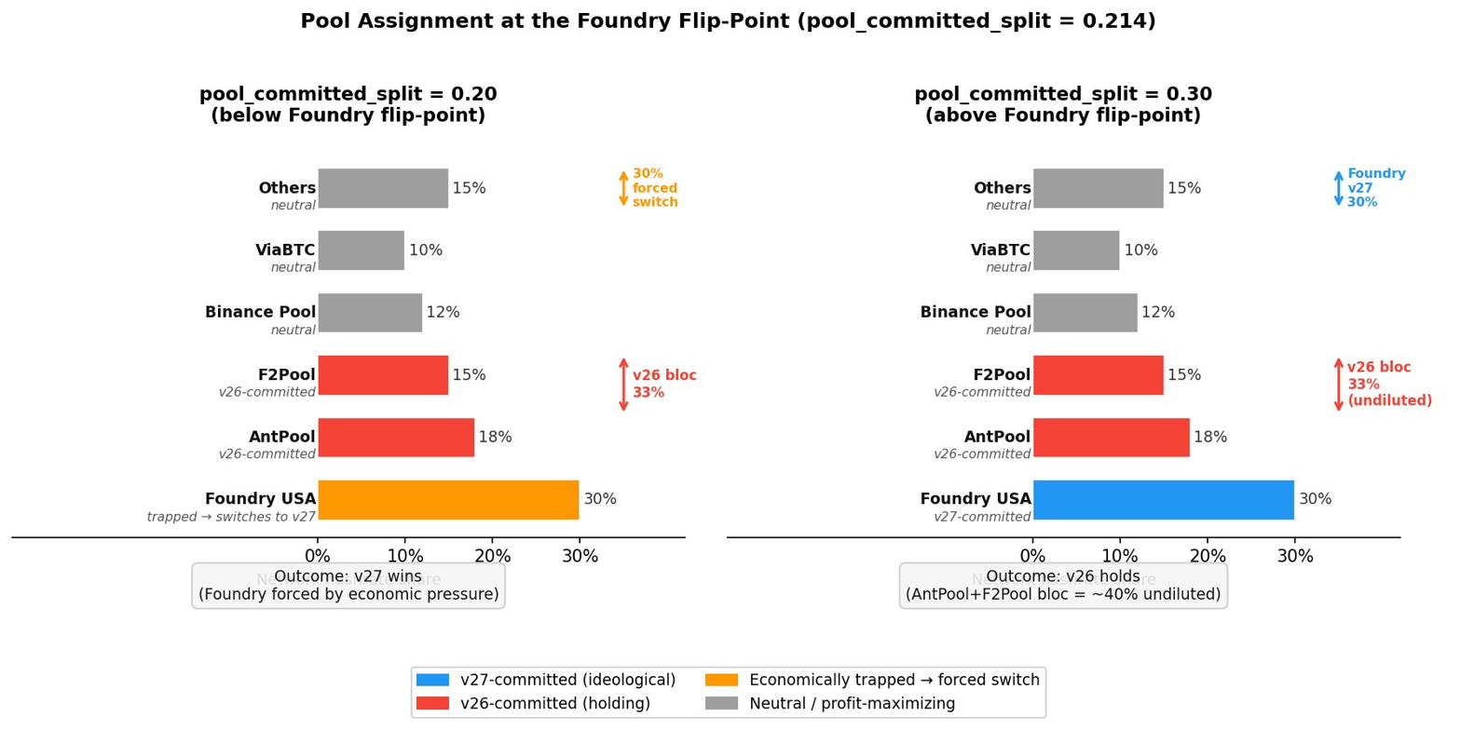

The flip-point is confirmed by unbiased Latin Hypercube Sampling at 2016-block retarget (lhs_2016_full_parameter, n=64): all 12 v26-dominant cases have pool_committed_split ≤ 0.246, and all 52 v27-dominant cases have pool_committed_split ≥ 0.260. The clean gap between 0.247 and 0.259 — with no scenarios falling in this range — confirms the structural nature of the threshold rather than a smooth probability gradient.

4.3.3 Pool Ideology Threshold
The pool_committed_split threshold governs whether the cascade can begin, but a second threshold determines whether it completes. The interaction of pool_ideology_strength and pool_max_loss_pct — whose product defines a pool's maximum acceptable loss — gates whether committed v26 pools ultimately capitulate under economic pressure or hold indefinitely. This was mapped on the full 60-node network at econ = 0.78 (targeted_sweep6_pool_ideology_full, n=20, 144-block retarget). A diagonal threshold is confirmed: committed v26 pools survive economic pressure when ideology x max_loss is approximately 0.16–0.20; below this product, pools capitulate regardless of individual ideology or loss tolerance levels (Table 5a).
Table 5a. Pool ideology x loss tolerance threshold at econ = 0.78. Green = v27 dominant (committed pools capitulate); red = v26 dominant (committed pools hold). The diagonal separates capitulation from resistance.
ideology \ max_loss_pct | 0.05 | 0.15 | 0.25 | 0.35 | 0.45
ideology = 0.2 | v27 | v27 | v27 | v27 | v27
ideology = 0.4 | v27 | v27 | v27 | v27 | v26
ideology = 0.6 | v27 | v27 | v27 | v26 | v26
ideology = 0.8 | v27 | v27 | v26 | v26 | v26

Neither parameter is sufficient individually: ideology = 0.8 with max_loss = 0.05 produces v27 dominance, as does ideology = 0.2 with max_loss = 0.45. The product is the operative quantity, governing a binary switch between committed pools that eventually capitulate and those that hold indefinitely. The threshold characterizes defender resilience: at econ = 0.78 where v27 holds the economic majority, a high ideology x max_loss product protects v26 from being swept by the price cascade. The same logic applies symmetrically to v27-committed pools at economic conditions where v26 holds the majority.

4.3.4 Economic Override
The ideology x max_loss threshold established at econ = 0.78 does not extend to higher economic levels. A dedicated override sweep (targeted_sweep6_econ_override, n=27, ideology x econ x max_loss grid at econ = 0.82, 0.90, and 0.95, 144-block retarget) produced v27-dominant outcomes in all 27 scenarios. Above econ approximately 0.82, the price signal is strong enough to force pool capitulation regardless of the ideology x max_loss product — the economic override is total and unconditional.
However, the ideology x max_loss product continues to determine cascade timing even when it cannot change the outcome. At ideology = 0.80 and max_loss = 0.35, the cascade takes 10,920 seconds — more than 15 times the fastest observed cascade at the same economic level (~680 seconds at ideology = 0.80, max_loss = 0.25). High ideology creates maximally resistant pools that delay but cannot prevent capitulation when economic pressure is sufficient. This has direct observational relevance: the duration of a contested fork period may be governed by pool ideology even when the final outcome is not.

4.3.5 Consolidated Threshold Summary
Table 5 summarizes all quantitative thresholds identified across the targeted sweep program. These thresholds represent the primary empirical contribution of Phase 1 and translate directly into monitoring guidance for researchers and operators observing a contentious fork.
Table 5. Consolidated threshold estimates with confidence ratings and data sources.
Parameter | Threshold | Interpretation | Confidence / Source
economic_split (cascade floor) | ~0.45–0.50 | Below this level no cascade is possible; v26 wins regardless of pool configuration. | High — targeted_sweep1 (n=45)
economic_split (inversion onset) | ~0.55–0.60 | Inversion zone begins; the effect of pool_committed_split reverses sign. | High — targeted_sweep1 and targeted_sweep2
economic_split (economic override) | ~0.78–0.82 | Above this level economic signal overrides all pool configurations; v27 wins universally. ESP confirmed at 0.74. | High — targeted_sweep7_esp (n=18); targeted_sweep6_econ_override (n=27)
pool_committed_split (Foundry flip-point) | ~0.214 | Crossing this boundary reassigns Foundry (~30% hashrate) and inverts outcomes at econ = 0.60–0.70. Confirmed as a hard threshold with no scenarios in the gap 0.247–0.259. | High — targeted_sweep1; confirmed lhs_2016_full_parameter (n=64)
ideology_strength x max_loss_pct (product) | ~0.16–0.20 | Below this product committed pools capitulate under economic pressure; above it committed pools hold indefinitely at econ = 0.78. Threshold vanishes at econ ≥ 0.82. | High — targeted_sweep6_pool_ideology_full (n=20); targeted_sweep6_econ_override (n=27)

For a researcher or governance actor monitoring a contentious fork, these thresholds reduce to three concrete questions. First, is economic_split above approximately 0.50? If not, the upgrading fork cannot win regardless of mining support or pool ideology. Second, is pool_committed_split above or below approximately 0.214? This determines whether the largest pool (Foundry-class, ~30% hashrate) is economically trapped on the upgrading chain or ideologically committed to it — a distinction that reverses the outcome at moderate economic levels. Third, is economic_split above approximately 0.82? If so, pool ideology and commitment structure become irrelevant to the final outcome, though they continue to determine how long resolution takes.

4.4 Regime Comparison: The Causal Rank Reversal
A second major finding emerges from comparing the causal structure of fork outcomes across retarget regimes. The dominant causal parameter changes entirely depending on which retarget interval is active: economic_split controls outcomes at the 144-block interval; pool_committed_split controls them at the 2016-block interval. The same fork, with identical actor configurations, produces different outcome logic depending only on how quickly the minority chain's difficulty adjusts. Bitcoin's operationally relevant retarget interval is 2016 blocks (~14 days), making the pool commitment finding the primary governance result.

4.4.1 The Rank Reversal
Random Forest classification was fitted separately on the full-network 144-block dataset (n=268) and the full-network 2016-block dataset (n=298), using the same four active parameters in both cases. Table 7 reports feature importance scores and out-of-bag accuracy for each regime.
Table 7. Random Forest feature importance by retarget regime. Green cells indicate the dominant parameter in each regime. Both models use the same four active parameters identified in Section 4.2.
Parameter | 144-block (n=268) | 2016-block (n=298) | Rank change
economic_split | 77.2% | 20.2% | #1 → #2
pool_committed_split | 11.3% | 52.8% | #2 → #1
pool_max_loss_pct | 5.5% | 17.1% | #4 → #3
pool_ideology_strength | 6.0% | 9.9% | #3 → #4
RF OOB accuracy | 80.0% | 83.2%

The reversal is not marginal. At 144-block, economic_split accounts for 77.2% of predictive importance — approximately four times the contribution of pool_committed_split (11.3%). At 2016-block, pool_committed_split displaces it entirely, accounting for 52.8% while economic_split falls to 20.2%. The two parameters swap rank positions, and neither holds even a plurality in the other's dominant regime.
Two secondary observations follow. First, 2016-block outcomes are more predictable overall — OOB accuracy is 83.2% versus 80.0% at 144-block. A longer retarget window creates harder, more deterministic constraints around pool commitment structure; the model extracts a cleaner signal accordingly. Second, pool_max_loss_pct rises from near-zero importance at 144-block (5.5%) to a meaningful secondary factor at 2016-block (17.1%). When committed pools must sustain losses through an entire 2016-block epoch, their individual loss tolerance becomes an independent causal factor — consistent with the ideology x max_loss threshold identified in Section 4.3.3.

4.4.2 Mechanism: The Difficulty Adjustment Survival Window
The rank reversal is a consequence of a specific mechanism in Bitcoin's difficulty adjustment algorithm. When a contentious fork creates two competing chains, the minority chain begins mining at a hashrate deficit against its full pre-fork difficulty target, producing blocks more slowly than the majority chain. Bitcoin's difficulty adjustment recalibrates each chain's target independently: when block production falls below target, difficulty adjusts downward proportionally, restoring the target block rate regardless of retained hashrate. The survival window is the period between fork inception and this first difficulty retarget — the interval during which the minority chain must absorb its hashrate disadvantage without relief.
144-block retarget — economic auction: The survival window spans approximately 24 hours at normal block rates, compressing further under minority hashrate conditions. The economic price signal operates on the same timescale. The price cascade resolves before the retarget fires, making economic alignment the binding constraint. Pool ideology is never tested to exhaustion because the outcome resolves first.
2016-block retarget — endurance contest: The survival window spans approximately 14 days at normal block rates, extending substantially under minority hashrate conditions. The economic price signal still fires within hours or days, but committed pool structure must hold through weeks of sustained losses before any difficulty relief arrives. Whether committed pools can absorb the full epoch — governed by the ideology x max_loss_pct product from Section 4.3.3 — is the binding constraint on the outcome.
This mechanism is the unifying explanation for findings across Sections 4.2 through 4.4. Hashrate is non-causal because the survival window neutralizes the majority chain's hashrate advantage before the economic cascade fully resolves. Pool commitment structure dominates at 2016-block because the long epoch forces committed pools to reveal whether their ideological tolerance exceeds their loss tolerance. Economic weight remains the primary signal at 144-block because the window closes before pool endurance is meaningfully tested.

4.4.3 The Hashrate Parity Danger Window
The survival window mechanism produces an additional counter-intuitive result under 2016-block retarget at economic parity (econ = 0.50): intermediate v27 hashrate (35–45%) is strictly worse for v27 than either low (15–25%) or high (55–65%) hashrate. At intermediate levels, the v26 chain builds a moderate block-length lead quickly enough that Foundry's accumulated mining loss on v27 crosses its 13.3% tolerance threshold within approximately one retarget cycle. Pool decision logs confirm the forced-switch event. Once Foundry exits v27, remaining v27 hashrate collapses and the outcome is v26-dominant. At low hashrate, the v26 lead builds too slowly to cross the threshold within the simulation window, producing a persistent split. At high hashrate, more symmetric competitive dynamics and neutral pool migration again prevent threshold crossing. The danger zone exists only at the 2016-block interval; the 144-block survival window closes before loss accumulation reaches any committed pool's tolerance under the same conditions (Table 3, Section 4.2.2).

4.4.4 The Decision Boundary
Figure 2 plots the full 2016-block fork outcome decision boundary across the economic_split x pool_committed_split parameter space (n=590, RF OOB=79.8%), with the Foundry flip-point (C~0.214), cascade floor (E~0.50), economic override (E~0.82), and inversion zone labeled. The three margin panels show the boundary projected onto secondary parameter pairs.
Figure 2. 2016-block fork outcome decision boundary (n=590). Main panel: P(v27 win) across economic_split x pool_committed_split. Green triangles = v27 wins; red circles = v26 wins; gold diamonds = contested outcomes. Dashed black contour = P=0.50 boundary. Dashed blue box = PRIM uncertainty region. Structural thresholds from Section 4.3 are labeled. Margin panels show the boundary projected onto E×M, C×I, and I×M parameter pairs.
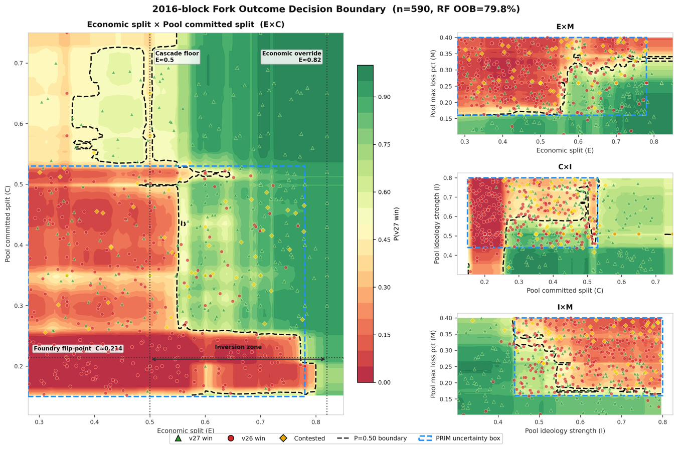

The decision boundary structure corresponds to three qualitatively distinct dynamic trajectories visible in price divergence time-series data (Figure 3). Clean v26-dominant outcomes (econ = 0.28, pool_committed = 0.18) show immediate price separation with no reorg events and rapid resolution within ~200 blocks. Cascade v27-dominant outcomes (econ = 0.60, pool_committed = 0.48) show delayed but decisive price divergence following pool switching events, with 10 reorg events concentrated in the transition period and resolution by ~6,000 blocks. Contested outcomes (econ = 0.60, pool_committed = 0.43, near the P=0.50 boundary) show sustained near-parity pricing with 5 reorg events and no clean resolution within the simulation window.
Figure 3. Price divergence time-series by outcome category. Top row: full simulation. Bottom row: zoomed view of initial switching dynamics. X-axis in simulation blocks (2-second intervals). Three outcome archetypes correspond to the three regimes identified in Section 4.3.1: weak economics, intermediate (contested), and cascade resolution.
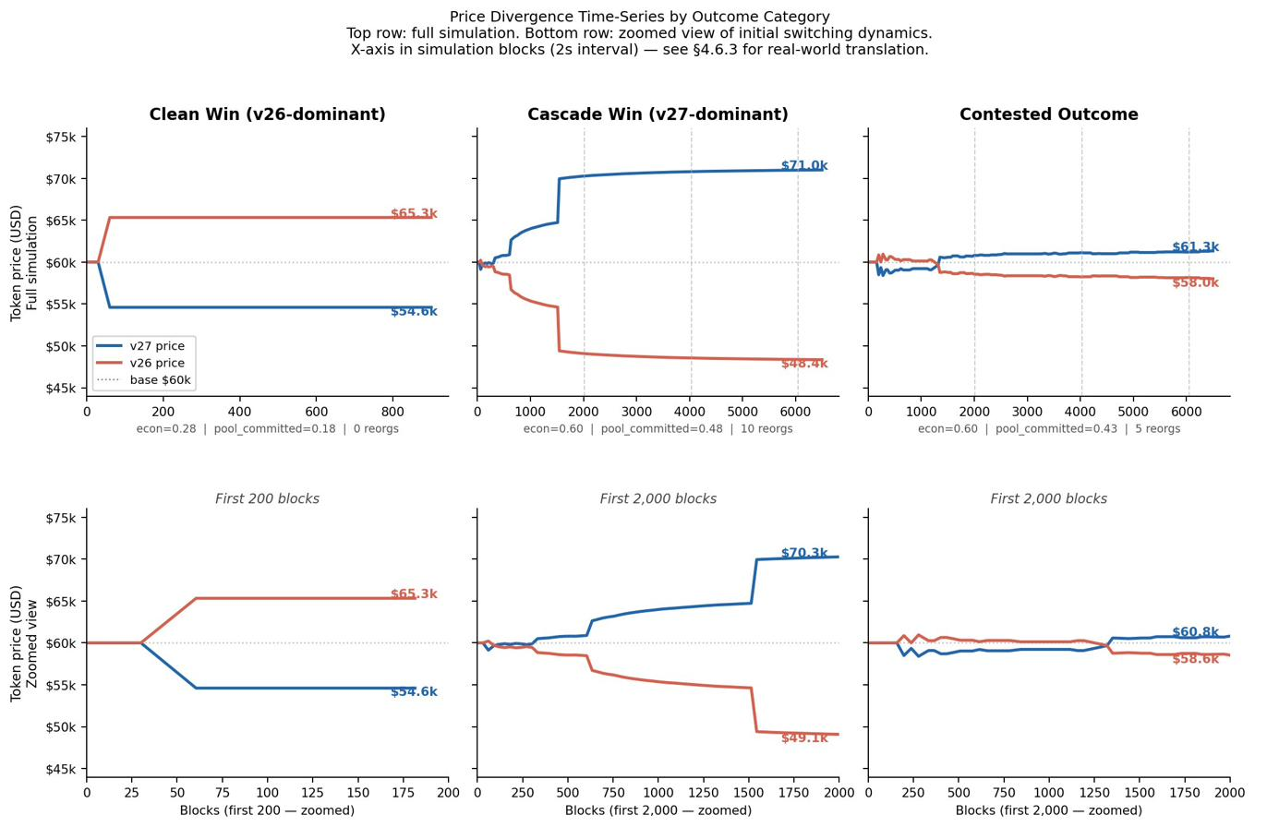

Reorg event counts provide a complementary measure of network disruption during fork resolution (Figure 4). Clean outcomes — where the economic configuration falls clearly within one regime — produce zero or near-zero reorg events regardless of which fork wins (Panel A: n=23 clean v26 wins, n=3 clean v27 wins). Contested and cascade outcomes produce median 7 reorg events across both v27-dominant and v26-dominant resolutions (Panel B), with a long tail extending to 20+ events in the most contested scenarios near the P=0.50 boundary. The symmetric reorg distribution across v27 and v26 dominant outcomes indicates that disruption is a property of the contested zone, not of which fork ultimately wins.
Figure 4. Reorg event distribution by outcome category. Panel A: scenarios with zero reorg events (clean outcomes). Panel B: reorg count distribution for scenarios with at least one reorg event. Median reorg count is 7 for both v27-dominant and v26-dominant contested outcomes. Dashed red line marks the median.
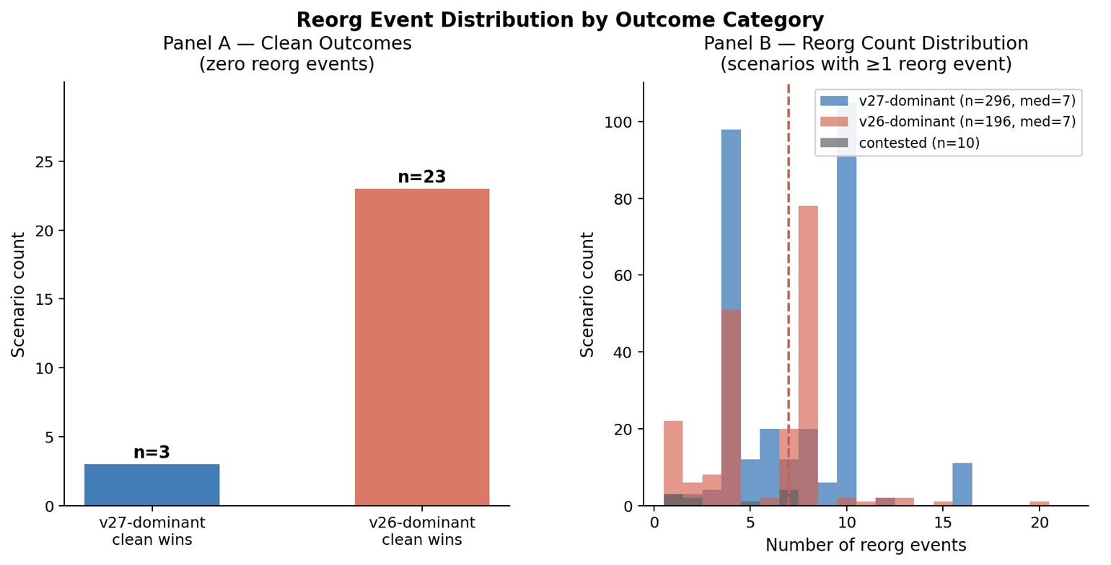

4.4.5 Regime Comparison and Governance Implications
Table 10 summarizes the two regimes across all measured dimensions. The 2016-block retarget is the operationally relevant regime for any real Bitcoin contentious fork. Under this regime, the dominant causal parameter is not economic weight but pool commitment structure — specifically whether committed pool hashrate exceeds the threshold identified in Section 4.3.2. Economic support remains relevant as a secondary amplifier and as the mechanism that forces pool switching once committed hashrate falls short, but it is not the first-order signal.
Table 10. Regime comparison summary across all measured dimensions.
Dimension | 144-block retarget | 2016-block retarget
Dominant parameter | economic_split (77.2% RF importance) | pool_committed_split (52.8% RF importance)
Secondary parameter | pool_committed_split (11.3%) | economic_split (20.2%)
Decision boundary shape | ~1-dimensional (economic threshold) | 2-dimensional (E×C interaction dominant)
Outcome predictability (OOB accuracy) | 80.0% | 83.2%
Logistic regression (CV accuracy) | 59.8% — unreliable | 77.5% ± 2.9%
Contentiousness (mean) | 0.132 | 0.271 (2.1× higher)
Governing mechanism | Economic price cascade resolves before retarget fires | Pool endurance through full epoch before retarget fires
Primary governance question | "Which fork has economic majority?" | "Which large pools can sustain losses for 14 days?"

The regime comparison reframes the questions governance actors and researchers should be asking during a contentious fork. The conventional framing — which fork has more economic support — is the dominant question at short retarget intervals where economic signals resolve the fork before pool ideology is tested. At the 2016-block interval governing real Bitcoin forks, the more consequential questions are whether large pools are committed to each side and whether they can sustain those losses through a full 14-day epoch. The higher contentiousness at 2016-block (2.1× mean, driven by extended competitive mining and more chain reorganizations) further underscores that the operationally relevant regime is also the more disruptive one: the same fork configuration is approximately twice as disruptive under real Bitcoin conditions than under a shorter retarget interval.
Note: All 144-block regime conclusions are drawn exclusively from full 60-node network scenarios (n=268). Latin Hypercube sweeps on the 25-node lite network exhibit economic weight quantization — scenarios across the full economic_split range are assigned identical numbers of economic nodes — and are excluded from all 144-block inference. This limitation does not affect 2016-block analysis, which uses full-network scenarios throughout.

4.5 Implications for Fork Assessment
The findings above support a structured reassessment of how fork risk is conventionally analyzed. The standard framing — whether the new version has majority hashrate support — addresses a parameter confirmed non-causal at realistic economic support levels (Section 4.2) and that becomes actively misleading within the inversion zone (Section 4.3.2). Three alternative questions better track the operative causal structure. This section presents those questions, identifies two observable real-time signals that follow from the model's dynamics, and states explicitly what the findings do not support.
Before turning to the monitoring questions, one data point from the cascade analysis warrants direct mention. In scenario sweep_0007 (starting hashrate = 90% v27, economic_split = 7% v27), v26 wins after 7 reorg events. A fork beginning with 90% of network hashrate on the new-rules chain is nevertheless defeated when 93% of economic activity remains on the old-rules chain. This single scenario demonstrates directly that hashrate majority is neither necessary nor sufficient for fork victory — it is the starkest illustration of why the three questions below are organized around economic weight and pool commitment structure rather than hashrate.

4.5.1 Three Operational Monitoring Questions
Question 1: What fraction of economically significant Bitcoin activity is committed to each fork? economic_split is the dominant causal parameter at 144-block retarget and a critical threshold parameter at 2016-block. The economic threshold at approximately 0.50 is a hard floor — below it, no cascade is possible. The economic override at approximately 0.82 is a hard ceiling — above it, pool ideology becomes irrelevant to the final outcome. The entire operative parameter space lies between these bounds.
Operationally this corresponds to: which exchanges have committed to listing and supporting deposits and withdrawals on each fork? Which custodians — institutional asset managers, ETF providers — are processing redemptions? Which payment processors are routing transactions? These are public or semi-public decisions. Exchanges announce chain support policies, ETF providers publish fork handling procedures, and on-chain transaction patterns reveal which UTXO sets are being spent on which chain. The fraction of circulating supply actively transacted on each fork, weighted by entity economic significance, is an estimable quantity from public data.
Question 2: Which major mining pools are ideologically committed versus profit-maximizing, and what is each committed pool's switching cost threshold? pool_committed_split is the dominant causal parameter at 2016-block retarget. Its threshold is not determined by total committed hashrate share but by the structure of which specific pools are committed and at what ideological strength. The Foundry flip-point finding (Section 4.3.2) demonstrates that the identity of the pivotal pool — the largest single actor whose ideological assignment determines cascade direction — matters more than aggregate committed shares.
Pool fork positions are partially observable from public communications, social media statements, and block attribution data. Pool operators have historically been willing to signal their fork positions publicly, as in the SegWit2x signaling period. The more difficult estimation is the ideology_strength x max_loss_pct product — how much revenue loss a committed pool will accept before switching. Calibration against observed pool behavior during BCH and BSV fork events could provide empirical bounds; this remains an open research question.
Question 3: Has the fork crossed the economic override threshold, and if not, which side does the largest committed pool occupy? This question is the operational synthesis of Questions 1 and 2. Table 11 presents the decision structure the findings support.
Table 11. Fork assessment decision structure based on economic_split threshold conditions.
Economic condition | Implication | Primary monitoring signal
economic_split ≥ 0.82 | Pool ideology is irrelevant to the final outcome. Economic override is total and unconditional. | Monitor cascade timing via ideology x max_loss — not outcome direction.
economic_split between 0.50 and 0.82 | Outcome is determined by pool commitment structure. Identify which side the largest committed pool occupies relative to the ~0.214 flip-point. | Is Foundry-class pool economically trapped on the upgrading chain, or ideologically committed to it?
economic_split ≤ 0.50 | No cascade is possible. Incumbent chain wins regardless of pool configuration or hashrate distribution. | No further monitoring required for outcome prediction.

The governance implication of the inversion zone (Section 4.3.1) is directly embedded in the middle row of Table 11. At intermediate economic support levels (0.50 to 0.82), the identity and assignment of the largest committed pool is more consequential than the aggregate pool commitment percentage. A governance actor monitoring a fork in this zone should be tracking the largest pool's assignment, not counting total committed hashrate shares.

4.5.2 Two Observable Real-Time Signals
The model identifies a consistent structural sequence in fork resolution: pool hashrate consolidation precedes economic node migration. This sequencing is the finding with direct observational relevance. Specific block-count estimates from the simulation carry timing caveats — they are mechanistically valid for block-driven model components but do not account for institutional decision cycles that operate on human timescales independent of block production. The sequence, not the specific timing, is the robust finding.
Pool cascade completion is the earlier signal and is visible on-chain: hashrate from attributed pools concentrates on one chain, and the competing chain's block production rate drops relative to its pre-fork share. Block explorers with pool attribution already provide this data in real time.
Economic adoption is the later signal and is visible at exchanges: the under-supported fork's deposit and withdrawal volumes decline, price divergence stabilizes, and custodial balance migration becomes observable in UTXO analysis.

The price gap magnitude at the time of economic switching provides a diagnostic that is robust to the timing uncertainty because it is magnitude-based, not duration-based. Price gaps of 41–47% indicate the full-switch regime is active. Gaps of 12–18% indicate the no-switch regime. A fork that resolves at the pool hashrate level but shows only 12–18% price divergence is likely in the no-switch regime — economic adoption will not complete regardless of how much additional time passes, and the winning chain will hold its hashrate advantage without full economic migration.
An additional timing observation: the question of whether the minority chain has reached its first retarget epoch marks a qualitative transition in fork dynamics. Before the retarget, committed pools are accumulating losses against full pre-fork difficulty. After it, the minority chain's block production rate equalizes and the remaining contest is primarily economic. A fork that appears to be dying may stabilize following the minority chain's first retarget. This transition is observable on-chain and provides a natural checkpoint for fork assessment.

4.5.3 What the Findings Do Not Support
The monitoring questions above are bounded by the model's structural assumptions and calibration. Several claims about Bitcoin fork governance are neither supported nor refuted by these findings, and those boundaries are worth stating explicitly.
The role of user-activated soft forks. The analysis confirms that user nodes have no structural capacity to shift outcomes in the 2016-block regime under any tested parameter configuration. This does not mean UASF campaigns are ineffective in principle — it means that the operative mechanism of user nodes refusing to relay or accept non-compliant blocks does not constitute a pivotal causal pathway given the 2,197:1 economic weight ratio between institutional actors and individual user nodes in the modeled network. A UASF campaign that successfully shifts exchange and custodian positions — raising economic_split — would be causal through the economic channel. One that operates exclusively through user node behavior under the present economic weight distribution would not. The boundary between these two cases is the economic threshold identified in Question 1.
Fork outcomes under extreme price divergence. All threshold findings are bounded by the model's maximum price divergence cap of approximately 20%. Real fork events — BCH/BTC, BCH/BSV — have produced divergences of 80–95% over months. Under larger divergences, dynamics change qualitatively: the losing chain's token may collapse before its first difficulty adjustment fires, making hashrate suddenly causal in a way the present model does not capture. The findings characterize short-to-medium-run fork dynamics under moderate economic uncertainty. Long-run dynamics under extreme price divergence remain outside scope.
Threshold values as universal quantitative predictions. The specific thresholds — approximately 0.50 economic floor, 0.82 override, 0.214 Foundry flip-point — are calibrated to the modeled 2026 Bitcoin pool distribution and price oracle weights. The mechanisms that produce these thresholds are general; the specific numbers are not. A mining landscape with a different pool size distribution shifts the flip-point. A different economic weight calibration shifts the economic thresholds. These findings establish the structure of fork dynamics and the identity of the operative parameters. Applying the quantitative values directly to a future fork with different pool composition would require recalibration. Full boundary fitting details, PRIM uncertainty bounds, and the Scenario Potential analysis supporting these scope characterizations are developed in the companion technical report.

Summary: What determines Bitcoin fork outcomes under realistic 2016-block dynamics

1. Economic weight (economic_split) sets the possibility space: below ~0.50 the upgrading fork cannot win; above ~0.82 it wins regardless of pool behavior.
2. Pool commitment structure (pool_committed_split) determines the outcome within that space: the identity and assignment of the largest committed pool — not aggregate hashrate — is the operative variable.
3. The ideology x loss tolerance product governs timing and defender resilience: committed pools can delay but not prevent capitulation once economic pressure exceeds their joint tolerance.
4. Hashrate majority is non-causal at realistic economic support levels and is actively misleading within the inversion zone.
5. User node behavior has no independent causal pathway under present economic weight distributions.

Eight scenarios from targeted_sweep3/5/6 (lite) were discarded due to a role-name parameter bug identified in March 2026. The 25-node lite network uses aggregate node roles that the parameter injection script did not handle, causing economic and user parameters to be silently ignored. All full 60-node network sweeps are unaffected. targeted_sweep2b (n=20) is partially affected; pool parameters are valid but economic context is incorrect, and it is excluded from quantitative analysis.

