SECTOR OVERVIEW
AI Infrastructure & Semiconductors
Compute, Memory, Networking, and Power for the AI Supercycle
August 25, 2026
Neutral Landscape Review — Public & Private Markets
This report is for informational purposes only and does not constitute investment, legal, or financial advice. Market size estimates vary significantly by source and methodology; figures should be treated as directional. Company financials reflect the most recently reported periods as of the data-cutoff date above; see the accompanying Excel appendix for line-item sourcing.

Contents
1. Executive Summary 3
2. Market Overview 3
2.1 Market Size & Growth 3
2.2 The Hyperscaler Capex Supercycle 4
2.3 Industry Structure & Value Chain 5
2.4 Key Trends & Drivers 6
2.5 Headwinds & Risks 7
2.6 Regional Dynamics 7
3. Competitive Landscape 8
3.1 Compute: Merchant Silicon 9
3.2 Custom Silicon (ASICs) 9
3.3 Foundry & Advanced Packaging 10
3.4 Memory (High-Bandwidth Memory) 10
3.5 Networking & Interconnect 12
3.6 Power & Cooling 12
3.7 Private & Emerging Players 12
3.8 Competitive Dynamics 13
4. Valuation Context 14
4.1 Recent M&A Activity 15
5. Investment Implications 15
5.1 Bull Case 15
5.2 Bear Case / Key Debates 16
5.3 Where the Debate Resolves 16
5.4 Catalysts to Watch (Late 2026 – 2027) 16
Glossary of Key Terms 17
6. Appendix 18

1. Executive Summary
The buildout of AI infrastructure has become the defining capital cycle in global technology, and arguably in the broader economy. Semiconductors sit at the center of it: analysts now peg 2026 global chip industry revenue anywhere from roughly $917 billion to $1.51 trillion depending on methodology, with virtually all forecasters agreeing that AI-related demand — accelerators, high-bandwidth memory (HBM), and the networking and power infrastructure around them — is the swing factor driving the wide dispersion in estimates.
The scale of spending behind this cycle is extraordinary. The four largest U.S. hyperscalers (Amazon, Microsoft, Alphabet, and Meta) are guiding to roughly $710–725 billion of combined capital expenditure in 2026, up 75–80% from about $410 billion in 2025, with the overwhelming majority earmarked for AI data centers, GPUs, custom silicon, and power. Add Oracle and the wider neocloud and sovereign-AI ecosystem, and industry trackers put total AI infrastructure capital commitments for 2026 in the $780 billion-plus range, with cumulative spending through 2028–2031 projected in the trillions.
NVIDIA remains the dominant merchant-silicon supplier, with data center revenue that grew from roughly $41 billion in a single quarter in mid-2025 to over $75 billion by Q1 fiscal 2027 (reported May 2026). But the competitive landscape is diversifying on multiple fronts simultaneously: AMD's Instinct MI350/MI400 roadmap is scaling, Broadcom and Marvell are building multi-billion-dollar custom-ASIC franchises for Google, Meta, Amazon, and Microsoft, memory suppliers (SK Hynix, Samsung, Micron) are effectively sold out of HBM capacity through 2026, and TSMC's advanced packaging (CoWoS) has emerged as the industry's binding capacity constraint. Meanwhile, a wave of private challengers — Cerebras (now public via a ~$56 billion IPO), Groq, CoreWeave, and dozens of AI-chip and neocloud startups — has raised tens of billions of dollars betting that specialized architectures or dedicated GPU clouds can carve out durable niches.
Valuations across the sector are elevated but bifurcated. TSMC and NVIDIA trade at what the market considers relatively reasonable multiples (mid-20s forward P/E) given growth rates, while custom-silicon and networking names such as Marvell, Arm, and Broadcom command premiums reflecting expectations of a multi-year share shift toward ASICs. At the same time, a growing and increasingly public debate over "circular financing" — where chip suppliers invest in or guarantee financing for their own customers — has raised questions about how much of reported AI demand is being pulled forward or artificially reinforced, with comparisons to the late-1990s telecom vendor-financing bubble now made by mainstream analysts rather than only perennial bears.
Our central view is that AI infrastructure spending is real, secularly supported, and still capacity- (not demand-) constrained across chips, HBM, and power — but the sector's valuation now embeds years of flawless execution, and the widening gap between AI infrastructure capex ($700 billion-plus in 2026 alone) and disclosed AI application revenue (a small fraction of that figure) is the single most important variable to track through 2027.

2. Market Overview

2.1 Market Size & Growth
Unlike most mature technology sectors, there is no consensus figure for the size of the AI-driven semiconductor market in 2026 — forecasts range across a roughly $600 billion band depending on scope and methodology. BNP Paribas Equity Research puts total 2026 global semiconductor sales at approximately $917 billion (+18% YoY); Deloitte's 2026 outlook projects about $975 billion (+26%); Gartner and various sell-side trackers cite figures near $1.32 trillion (+64%); IDC forecasts $1.29 trillion (+53%); and WSTS/SIA's most bullish read — driven by an outsized memory-price cycle — puts the number as high as $1.51 trillion (+90%).
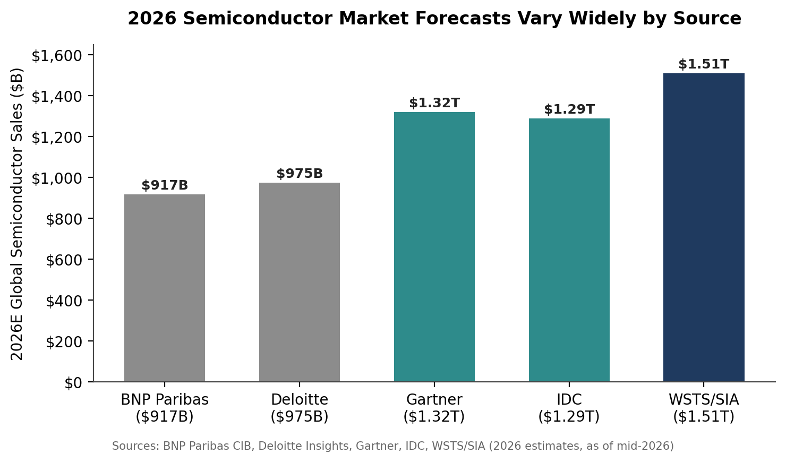
Figure 1. 2026 global semiconductor market forecasts by source. The dispersion is driven almost entirely by differing assumptions about memory (DRAM/HBM) pricing and AI accelerator unit growth.
The unifying thread across every estimate is that memory and AI data center silicon are doing virtually all of the heavy lifting. IDC, for instance, forecasts DRAM revenue alone will nearly triple in 2026 to roughly $419 billion on HBM and DDR demand, while data center semiconductor revenue is projected to reach about $477 billion in 2026 and grow to $843 billion by 2030 — very nearly half of the entire semiconductor market. Separately, narrower "AI infrastructure market" trackers (which include servers, networking, and some software-adjacent categories rather than just chips) size the segment at roughly $101 billion in 2026, growing at a mid-teens CAGR to about $202 billion by 2031 — a reminder that "AI semiconductors," "AI infrastructure," and "the AI datacenter buildout" are overlapping but distinct sizing frames that analysts and vendors sometimes conflate.
A single AI server rack today contains thousands of packaged semiconductor devices — industry estimates put the number above 4,500 per rack — and chips now account for over half of total AI data center capital expenditure. Semiconductor Industry Association (SIA) and Deloitte estimates suggest more than $4 trillion could be invested globally in AI data center infrastructure through 2028, of which a substantial majority is expected to flow to chips, packaging, and memory.

2.2 The Hyperscaler Capex Supercycle
The proximate driver of semiconductor demand is hyperscaler capital spending, which has entered what several analysts now describe as unprecedented territory. Amazon, Microsoft, Alphabet, and Meta collectively guided to roughly $410 billion of capex in 2025; for 2026, guidance has moved to a combined $710–725 billion — a 75–80% year-over-year increase — with Amazon and Microsoft each guiding toward the $190–200 billion range, Alphabet at $175–205 billion (raised twice during 2026), and Meta at $115–145 billion (also raised more than once). Including Oracle's roughly $50 billion and the broader neocloud tier (CoreWeave, Nebius, Nscale, Crusoe, Lambda), several trackers put the five- and six-company AI capex figure closer to $780 billion for 2026, with Goldman Sachs modeling a cumulative $5.3–7.6 trillion of hyperscaler capex from 2025 through 2030–2031.
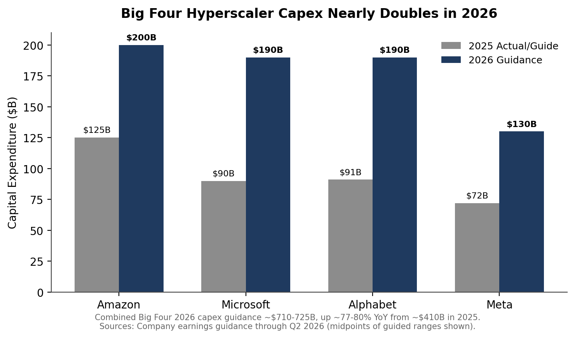
Figure 2. Big Four hyperscaler capital expenditure, 2025 vs. 2026 guidance (approximate midpoints).
Capital intensity — capex as a share of revenue — has consequently reached levels historically associated with heavy industry rather than software: some estimates put combined hyperscaler capital intensity at 45–57% of revenue in 2026, a level that has required unusual financing structures, including a reported $108 billion of hyperscaler debt issuance in 2025 alone and projections of $1.5 trillion in cumulative debt issuance over the coming years to help fund the buildout.
Importantly, the marginal constraint in 2026 has increasingly shifted from chip supply toward power. Data center electricity demand from AI is projected to approach roughly 1,000 terawatt-hours globally by 2026 — comparable to Germany's total electricity consumption — and industry surveys suggest a meaningful share of announced AI data center projects face construction delays tied to power interconnection rather than GPU availability. This dynamic explains the parallel boom in data center power and cooling infrastructure discussed in Section 3.7, and the wave of hyperscaler power purchase agreements, including nuclear (e.g., Microsoft's agreement tied to the Three Mile Island/Crane Clean Energy Center restart).

2.3 Industry Structure & Value Chain
The AI infrastructure semiconductor value chain can be usefully divided into six layers, each with distinct competitive dynamics:
- Merchant AI accelerators (GPUs): Dominated by NVIDIA, with AMD as the primary challenger and Intel a distant third via its Gaudi line. Highly concentrated, extremely high gross margins, and gated by CUDA software ecosystem lock-in.
- Custom silicon (ASICs): Hyperscalers co-designing proprietary chips (Google TPU, Amazon Trainium, Microsoft Maia, Meta MTIA) with silicon design partners — overwhelmingly Broadcom and, increasingly, Marvell. This is the fastest-growing sub-segment and the primary structural threat to NVIDIA's share, even as NVIDIA's absolute dollar volume keeps growing.
- Foundry & advanced packaging: TSMC manufactures the vast majority of leading-edge AI logic and controls the CoWoS advanced-packaging capacity that has become the industry's real bottleneck; Samsung and Intel Foundry are smaller, improving alternatives.
- Memory (HBM/DRAM): A three-player oligopoly (SK Hynix, Samsung, Micron) that has effectively sold out HBM capacity through 2026 and is transitioning to HBM4, giving all three unusual pricing power after a decade of memory-cycle volatility.
- Networking & interconnect: Arista Networks and Cisco in Ethernet switching; NVIDIA (NVLink/Spectrum-X, via its Mellanox lineage) and Marvell/Broadcom in optical/electrical interconnect (PAM4 DSPs, co-packaged optics) that stitch thousands of accelerators into a single training cluster.
- Power & cooling: Vertiv, Eaton, Modine, and nVent supply the electrical and thermal systems (UPS, switchgear, liquid cooling) that have become gating items as rack power density crosses 100–150 kW, well beyond what air cooling can dissipate.
Barriers to entry vary sharply by layer. Foundry and HBM manufacturing require decade-scale capital investment and process know-how that make new entry essentially impossible in the current cycle; merchant GPU design is gated by software ecosystem and engineering talent; custom ASIC design services are gated by design-partner relationships and TSMC capacity allocation; and power/cooling equipment is gated by certification, integration expertise, and backlog-driven customer relationships rather than pure technology moats.

2.4 Key Trends & Drivers
- Custom silicon share gains: Industry shipment-share estimates put custom ASICs at roughly 20.9% of AI accelerator shipments in 2025, rising to about 27.8% in 2026 — with ASIC shipment growth (roughly 45% YoY) nearly triple the growth rate of merchant GPUs (roughly 16% YoY), as hyperscalers seek to reduce dependence on a single supplier and optimize total cost of ownership for well-defined, high-volume workloads.
- The training-to-inference mix shift: Multiple forecasts (including Deloitte) suggest inference will represent roughly two-thirds of AI compute spending by 2026 and 70–80% by 2028–2030, a transition that favors more cost- and power-efficient architectures (custom ASICs, inference-optimized chips from Groq, Cerebras, and others) over general-purpose training GPUs, and reduces the CUDA software moat's relative importance since inference runtimes are less GPU-specific.
- Memory supercycle: HBM has moved from a commodity, cyclical business to a structurally sold-out, higher-margin product line, with all three major suppliers reporting capacity fully booked through 2026 and next-generation HBM4 (roughly doubling interface width and reaching 1.5–2 TB/s per stack) beginning to ramp in the second half of 2026.
- Advanced packaging as the bottleneck: TSMC has raised 2026 capital expenditure guidance from an initial $52–56 billion range to as high as $60–64 billion, with a growing share directed at CoWoS capacity, which is being scaled from roughly 35,000 wafers/month in late 2024 toward 125,000–140,000 wafers/month by the end of 2026 — still short of full demand satisfaction according to most trackers.
- Power as the new gating factor: As noted above, electricity availability and grid interconnection timelines — not chip supply — are increasingly cited as the binding constraint on how quickly new AI capacity can come online, driving parallel investment cycles in cooling, on-site generation, and long-term power purchase agreements.
- Sovereign AI and geographic diversification: Middle Eastern, European, and Asian government-backed AI infrastructure projects are accelerating in response to export-control uncertainty and a desire for compute sovereignty, adding a new category of hyperscaler-adjacent demand alongside the traditional U.S. cloud majors.
- Consolidation in enabling software/tools: The completed $35 billion Synopsys–Ansys merger (finalized July 2025) illustrates a broader trend of EDA and simulation-tool consolidation aimed at handling the multiphysics complexity of advanced packaging and multi-die chip design.

2.5 Headwinds & Risks
- Export controls remain a live, moving target: U.S. policy on advanced AI chip sales to China has swung materially within the past year — from a near-total ban, to a partial reopening for H200-class chips (with per-customer volume caps and a 25% tariff on qualifying chips announced in January 2026), to renewed enforcement actions in mid-2026 closing loopholes for offshore subsidiaries of Chinese firms. China represented roughly 13% of NVIDIA's revenue prior to the tightest restrictions; the net effect on 2026–2027 revenue for NVIDIA, AMD, and their foundry/memory suppliers remains genuinely uncertain and highly headline-sensitive.
- Circular financing and demand-durability concerns: A rising share of announced AI infrastructure deals (NVIDIA's investments in and financing commitments to OpenAI, SK Group, and others) involve chip suppliers financing their own customers' purchases — one tracker estimates over $800 billion in such arrangements across the AI supply chain by 2026. Mainstream commentators, not only bears, are now drawing explicit comparisons to 1990s telecom vendor financing; the deciding question is what share of downstream AI revenue comes from customers outside this financing circle.
- Capacity-driven cost inflation for buyers: HBM pricing is up an estimated 20–40% year-over-year and GPU/ASIC lead times remain extended, which raises the cost of the buildout for hyperscalers and compresses the margin cushion available if end-demand growth disappoints.
- Power and permitting bottlenecks: As detailed above, roughly 40% of announced AI data center projects reportedly face delays tied to power infrastructure rather than chip supply — a risk that shifts the constraint (and the investable value chain) toward utilities, power equipment, and grid infrastructure over time.
- Concentration risk: A small number of hyperscaler customers account for the majority of demand at NVIDIA (roughly half of data center revenue from the largest hyperscaler category), Broadcom (a handful of named ASIC customers), and Marvell — any pause, in-sourcing decision, or capex reset by one or two large buyers would have an outsized effect across the value chain.
- Execution and yield risk in the supply chain: TSMC's advanced packaging ramp, Intel's 18A foundry turnaround, and next-generation HBM4 qualification all carry meaningful execution risk on tight, publicly committed timelines.

2.6 Regional Dynamics
The AI infrastructure buildout is geographically concentrated in ways that carry distinct strategic and policy implications:
- United States: Home to essentially all hyperscaler demand (Amazon, Microsoft, Alphabet, Meta, Oracle) and the design leadership of NVIDIA, AMD, Broadcom, and Marvell. The CHIPS Act and a new pattern of direct government equity stakes (Intel) reflect an explicit industrial policy push to re-shore leading-edge manufacturing, though the U.S. still depends on Taiwan for the large majority of leading-edge fabrication.
- Taiwan: TSMC's near-monopoly on leading-edge logic manufacturing and advanced packaging (CoWoS) makes the island the single most important physical node in the entire AI hardware value chain — and its most significant geopolitical concentration risk, independent of any near-term conflict scenario.
- South Korea: SK Hynix and Samsung together control the substantial majority of global HBM supply; both are also expanding domestic fabs with meaningful state support, and South Korea's government has explicitly framed its semiconductor industry as central to its AI strategy (e.g., the >$500 billion cooperation framework reported between NVIDIA and SK Group in 2026).
- China: Restricted from the most advanced U.S.-designed chips under evolving export controls, but investing heavily in domestic alternatives (Huawei's Ascend accelerators, domestic DRAM makers such as CXMT gaining share in mainstream memory). U.S. policy toward Chinese access to H200-class and other near-leading-edge chips has swung significantly within the past 12 months and remains the single largest policy wildcard for the sector.
- Middle East & sovereign AI: Gulf state-backed AI infrastructure projects (UAE, Saudi Arabia) have become a meaningful, fast-growing demand category as governments seek compute sovereignty and diversify away from oil-dependent economies, though these deals face additional export-control scrutiny given their chip content.
- Europe & Japan: Smaller absolute AI infrastructure spenders than the U.S. or China, but both regions are expanding domestic fab capacity (TSMC's Japan fabs, European Chips Act-backed projects) aimed primarily at supply chain resilience and legacy/automotive-node capacity rather than leading-edge AI silicon specifically.

3. Competitive Landscape
The table below summarizes the ten public and private companies most central to the AI infrastructure buildout across the value chain. Figures reflect the most recently reported quarterly or fiscal-year results as of this report's data cutoff (August 25, 2026); see the accompanying Excel appendix for full detail and sourcing.
Company | Segment | Latest Revenue | AI/Data Center Growth | Market Cap (approx.) | Key Differentiator
NVIDIA | Merchant GPU | $81.6B (Q1 FY27) | Data center +92% YoY | ~$4.9–5.0T | CUDA ecosystem; ~70-85% AI accelerator share
AMD | Merchant GPU/CPU | $11.5B (Q2 2026) | Data center +107% YoY | ~$280–330B* | MI350/MI400 roadmap; EPYC CPU share gains
Broadcom | Custom ASIC/Networking | $22.2B (Q2 FY26) | AI revenue +143% YoY | ~$1.5–1.6T | Dominant ASIC design partner (Google, Meta); $73B+ backlog
Marvell | Custom ASIC/Interconnect | $8.2B (FY26) | Data center +42% YoY | ~$70–95B* | Amazon Trainium & Microsoft Maia design partner
TSMC | Foundry | $35.9B (Q1 2026) | Revenue +41% YoY | ~$1.3–1.5T* | Sole leading-edge fab for nearly all AI silicon
SK Hynix | Memory (HBM) | n/a (segment) | HBM run-rate ~$8B+ | n/a (KRX-listed) | ~50-62% HBM share; first-mover on HBM3E/HBM4
Intel | Foundry/CPU/AI | $13.7B (Q4 2025) | Data Center & AI +22% YoY | ~$150–200B* | 18A domestic foundry node; U.S. government equity stake
Vertiv | Power & Cooling | $2.65B (Q1 2026) | Revenue +30% YoY | ~$120–140B* | Liquid-cooling leader; $15B+ project backlog
Arista Networks | Networking | $9.0B (FY 2025) | AI networking target $3.25B (2026) | ~$150–180B* | Leading Ethernet switch share for AI clusters
CoreWeave | Neocloud (private→public) | $5.1B (FY2025) | 2026 guide $12–13B (+~140%) | ~$35–55B* | Largest independent NVIDIA-based GPU cloud; $66B+ backlog
*Market capitalization figures are approximate and move continuously with equity prices; treat as directional. Sources: company SEC filings (10-Q/10-K/8-K), earnings calls, and financial media cited throughout this report (see appendix for line-item citations).

3.1 Compute: Merchant Silicon

NVIDIA (NASDAQ: NVDA)
NVIDIA remains the AI infrastructure sector's center of gravity. Data center revenue — GPUs, networking (NVLink, InfiniBand, Spectrum-X Ethernet), and related systems — grew from roughly $41.1 billion in the quarter ended July 2025 to a record $75.2 billion in the quarter ended April 2026 (Q1 fiscal 2027), up 92% year-over-year, on continued Blackwell ramp. Full fiscal year 2026 (ended January 2026) revenue reached $215.9 billion, of which data center accounted for roughly $193.7 billion, or about 90% of the company total. Hyperscalers consistently represent slightly over half of data center revenue, with the remainder increasingly diversified across AI clouds, sovereign, industrial, and enterprise customers.
NVIDIA's moat remains its CUDA software ecosystem and the fact that it is the only platform running across every major cloud and virtually every frontier and open-source model. The most credible structural threat is not a single rival GPU but the broad rise of custom silicon (see Section 3.2); one industry estimate pegs custom ASICs' share of the AI accelerator market rising from roughly 21% in 2025 to 28% in 2026, cutting into NVIDIA's growth rate even as its absolute dollar volume continues to expand. NVIDIA reports Q2 fiscal 2027 results on August 26, 2026 — the day after this report's data cutoff — with consensus revenue near $91–92 billion.

AMD (NASDAQ: AMD)
AMD's data center segment—EPYC server CPUs plus Instinct MI-series GPUs—has been the company's primary growth engine, with data center revenue up 107% year-over-year to $6.7 billion in the quarter ended June 2026, and management guiding to "well over 100%" data center AI growth into 2027 on the strength of the newly launched Helios rack-scale platform (pairing EPYC "Venice" CPUs with MI400-series accelerators). AMD's software stack (ROCm) remains less mature than CUDA, but improving price-performance and multi-sourcing incentives among hyperscalers have supported design wins. AMD trades at a meaningfully higher forward earnings multiple than NVIDIA, reflecting the market's expectation of a steep acceleration from a smaller base.

Intel (NASDAQ: INTC)
Intel occupies a distinct position: a legacy IDM attempting a foundry turnaround while defending its CPU franchise and building out a modest AI accelerator business (Gaudi 3). The U.S. government's roughly 9.9% equity stake (tied to CHIPS Act funding) and reported early-stage discussions with Apple and other potential foundry customers have driven a sharp re-rating of the stock in 2026, but the investment case still hinges almost entirely on whether the 18A process node — Intel's first to combine gate-all-around transistors (RibbonFET) with backside power delivery (PowerVia) — achieves competitive yields and attracts external foundry customers at scale. Intel's Data Center and AI segment revenue grew a comparatively modest 22% year-over-year in Q1 2026, underscoring the gap to NVIDIA and AMD in AI silicon specifically.

3.2 Custom Silicon (ASICs)

Broadcom (NASDAQ: AVGO)
Broadcom has emerged as the dominant enabler of hyperscaler custom silicon, designing and helping manufacture proprietary AI accelerators for Google (TPU), Meta (MTIA), and a small number of other named and unnamed customers reported to include ByteDance, OpenAI, and Anthropic. AI semiconductor revenue reached $10.8 billion in fiscal Q2 2026 (up 143% year-over-year), and CEO Hock Tan has guided to full fiscal-year 2026 AI revenue of approximately $56 billion and reiterated a target of over $100 billion in annual AI chip revenue by fiscal 2027, backed by a disclosed AI backlog that has been reported at figures ranging from roughly $30 billion to $73 billion across different quarters of disclosure. Broadcom's VMware software business (acquired 2023) provides a high-margin, diversifying cash flow stream that helps fund continued R&D investment in the custom-silicon franchise.

Marvell (NASDAQ: MRVL)
Marvell is the clearest challenger to Broadcom's custom-ASIC dominance, holding design-partner relationships with Amazon (Trainium), Microsoft (Maia), and reportedly Meta and Google (the latter for Arm-based Axion CPUs and, per some reports, next-generation TPU-adjacent inference silicon). Data center revenue reached a record $6.1 billion in fiscal year 2026 (ended February 2026) on total company revenue of $8.2 billion, up 42% year-over-year; management has guided fiscal 2027 revenue toward roughly $11–12.7 billion and reiterated a longer-term target of a $10 billion custom-silicon run rate by fiscal 2029. Notably, Marvell's fastest-growing near-term product line is not custom silicon but optical interconnect (PAM4 DSPs for 800G/1.6T networking), guided to grow over 70% year-over-year in fiscal 2027 versus 20%-plus for custom silicon — a reminder that the "picks and shovels" opportunity in AI networking is, at the margin, outgrowing the chips themselves. NVIDIA took a $2 billion equity stake in Marvell in early 2026, tying the two companies together via the NVLink Fusion interconnect standard even as they compete in adjacent silicon categories.

3.3 Foundry & Advanced Packaging

TSMC (NYSE: TSM / TWSE: 2330)
As the sole large-scale foundry capable of manufacturing leading-edge AI logic at volume, TSMC captures value regardless of which chip design wins in the merchant-vs-custom-silicon contest. Q1 2026 revenue reached $35.9 billion (up 41% year-over-year) at a record 66.2% gross margin, with full-year 2026 revenue guided to grow "above 30%" in U.S. dollar terms. The critical constraint — and the primary lens through which to read TSMC's results — is CoWoS (chip-on-wafer-on-substrate) advanced packaging capacity, which binds a logic die to HBM stacks and has become the true bottleneck in AI chip production. TSMC has raised 2026 capital expenditure guidance twice, most recently to a $60–64 billion range (from an initial $52–56 billion), with roughly 70–80% earmarked for advanced process technology and a growing share for packaging capacity expansion, which trackers estimate will reach 125,000–140,000 CoWoS wafers per month by the end of 2026 — a roughly fourfold increase from late 2024 levels, though still short of full demand satisfaction by most estimates. NVIDIA alone is reported to have secured 60% or more of TSMC's 2026 CoWoS output, leaving Broadcom, AMD, Marvell, and Google's TPU program to compete for the remainder.

Intel Foundry Services
Intel's foundry ambitions represent the highest-optionality, highest-uncertainty story in the value chain. The company began high-volume manufacturing of its 18A node in late 2025 (first product: the Panther Lake laptop chip), backed by a $19.5 billion-plus package of U.S. government funding and additional investment from SoftBank and NVIDIA. Reported preliminary discussions with Apple regarding foundry capacity, alongside Intel's decision to open 18A to third-party leasing more broadly, have driven investor optimism, but yields, external customer commitments, and the follow-on 14A node's economics remain open questions likely to be resolved only over the next 12–24 months.

3.4 Memory (High-Bandwidth Memory)
HBM has transformed from a niche, highly cyclical DRAM sub-category into a structurally sold-out, high-margin franchise concentrated among three suppliers. Market-share estimates vary by tracker and quarter but consistently show SK Hynix in the lead (roughly 50–62% of HBM revenue share depending on source and period), with Samsung and Micron splitting the remainder (each in the 20–40% range depending on the specific quarter and definition used).
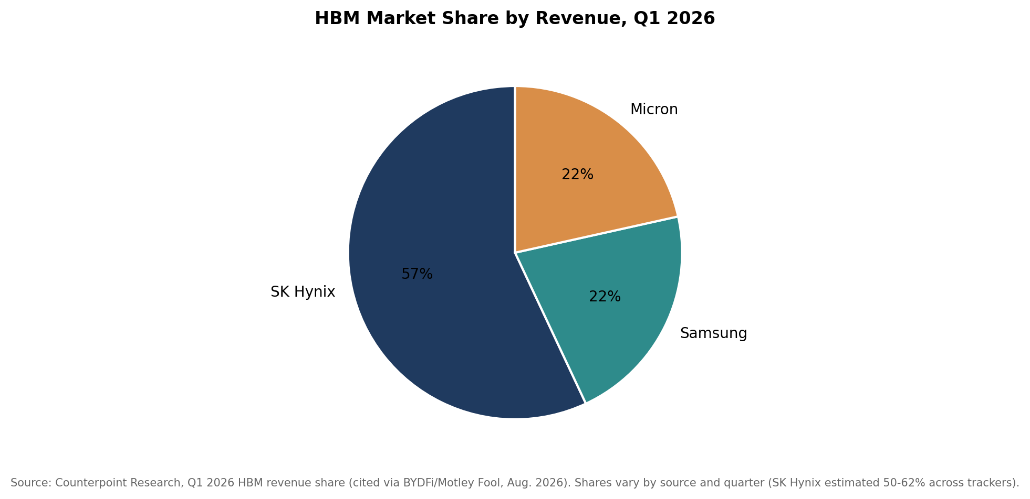
Figure 3. HBM market share by revenue, Q1 2026 (Counterpoint Research data as cited by financial media; other trackers show SK Hynix share as high as 58-62% in different periods).
All three suppliers have indicated their HBM output is effectively sold out through 2026, with Micron specifically forecasting an HBM annualized revenue run-rate of roughly $8 billion and disclosing plans to exit consumer memory and storage in favor of AI data center customers. HBM pricing is reported up 20–40% year-over-year amid this supply concentration, and the industry is transitioning to HBM4 (roughly doubling interface width versus HBM3E) during the second half of 2026, with SK Hynix reported to hold the largest initial allocation of NVIDIA's next-generation Rubin platform HBM4 supply.

SK Hynix (KRX: 000660)
SK Hynix is the HBM market leader by most trackers, having secured early qualification on NVIDIA's H100/H200/B200 platforms with HBM3 and HBM3E. Q1 2026 revenue reached roughly $37.1 billion (segment/company figures vary by reporting convention) at an approximately 72% operating margin — an extraordinary profitability level for a historically cyclical memory business, reflecting the pricing power that comes with a structurally sold-out product line. SK Hynix has completed development of HBM4, claiming a roughly 40% improvement in power efficiency and data rates up to 10 Gbps, and UBS analysts have projected the company could hold approximately 70% share of HBM4 supply for NVIDIA's next-generation Rubin platform.

Samsung Electronics (KRX: 005930)
Samsung trails SK Hynix in HBM share (estimates range from roughly 21% to 40% of the market depending on tracker and period) but leads in overall DRAM share (about 38% in Q1 2026) and is positioning HBM4 as a share-recovery opportunity, having resumed construction of its Pyeongtaek P5 fab to expand capacity. Samsung is reported to be the first HBM4 supplier to NVIDIA, with an initial allocation in the mid-20% range — a recovery position rather than outright leadership, but a meaningful step after lagging SK Hynix through the HBM3E generation.

Micron Technology (NASDAQ: MU)
Micron holds the smallest HBM share of the three (roughly 11–21% depending on tracker) but has been the most aggressive in messaging a strategic pivot, announcing plans to exit consumer memory and storage products to prioritize AI data center customers and forecasting an HBM annualized revenue run-rate near $8 billion. Micron has begun shipping HBM4 samples rated up to 11 Gbps and is investing roughly $9.6 billion in a new Hiroshima, Japan facility to diversify supply outside mainland China-adjacent geographies. Micron trades at a notably lower forward earnings multiple (analysts cite roughly 9-14x) than its memory peers or the broader AI semiconductor complex, which several analysts frame as one of the more overlooked value opportunities tied to the AI buildout.

3.5 Networking & Interconnect
As AI training clusters scale to tens of thousands of interconnected accelerators, the fabric that connects them has become a first-order determinant of both cost and performance. Arista Networks has built the leading position in high-speed Ethernet switching for AI back-end networks, with fiscal 2025 revenue of roughly $9.0 billion (up 29% year-over-year) and a 2026 AI-specific networking revenue target raised from $2.75 billion to $3.25 billion; deferred revenue of $5.4 billion gives multi-year visibility into the hyperscaler buildout. NVIDIA's own networking business (NVLink, InfiniBand, Spectrum-X Ethernet, inherited largely from the 2020 Mellanox acquisition) grew data center networking revenue 263% year-over-year to a record $11.0 billion in Q4 fiscal 2026. Marvell and Broadcom additionally supply the PAM4 optical DSPs and co-packaged optics that underpin 800G-and-beyond interconnect standards, an area several analysts flag as outgrowing even the accelerator chips themselves in percentage terms.

3.6 Power & Cooling
Vertiv has become the most closely watched pure-play name in AI data center power and thermal management, supplying uninterruptible power supplies, switchgear, and — increasingly — liquid-cooling distribution units as rack power density has risen from a historical 10–15 kW to 120–150 kW for the latest AI training clusters, a level that air cooling cannot adequately dissipate. Q1 2026 revenue reached $2.65 billion (up 30% year-over-year) with a project backlog exceeding $15 billion (roughly 12–18 months of forward revenue at current run-rates) and full-year 2026 guidance of $13.5–14.0 billion. Roughly 75% of Vertiv's revenue is tied to data center customers. Competitors and adjacent players include Eaton, Schneider Electric, Modine (which is restructuring around thermal management for data centers via a planned Reverse Morris Trust transaction), and nVent, alongside liquid-cooling specialists gaining share as immersion and direct-to-chip designs move from niche to default for new hyperscale builds.

3.7 Private & Emerging Players
A substantial private (and newly public) ecosystem has formed around both AI-optimized silicon and dedicated GPU cloud capacity. Across roughly 40-plus tracked private AI-chip and infrastructure startups, cumulative disclosed funding is estimated in the high tens of billions of dollars, with 2026 funding activity increasingly concentrated in a small number of large, capacity-scale rounds rather than broadly distributed across the long tail — a pattern consistent with investors converging on a narrower set of perceived category leaders as the buildout matures.

Cerebras Systems (NASDAQ: CBRS)
Cerebras makes the Wafer Scale Engine (WSE), the largest single chip manufactured commercially, designed to eliminate the chip-to-chip communication bottleneck that limits conventional GPU clusters by keeping an entire large model's compute on one piece of silicon. The company went public on May 14, 2026, closing its first day of trading at a roughly $56 billion fully diluted valuation — one of the largest U.S. technology IPOs since Snowflake in 2020, and a significant step-up from its approximately $23 billion valuation in a private round earlier in the funding cycle. Cerebras primarily targets inference workloads where its architecture's low-latency characteristics are most differentiated.

Groq
Groq designs the LPU (Language Processing Unit), an inference-specific architecture emphasizing deterministic, ultra-low-latency token generation. In December 2025, Groq's intellectual property and senior technical leadership — including its CEO — became the subject of a reported ~$20 billion licensing and talent transaction with NVIDIA, a structure several analysts read as NVIDIA pre-emptively neutralizing a credible inference-architecture competitor rather than a conventional acquisition. The standalone Groq entity reportedly continues operating independently, retaining a separate ~$6.9 billion valuation from its last priced funding round.

CoreWeave (NASDAQ: CRWV)
CoreWeave is the largest independent NVIDIA-based GPU cloud provider, having gone public in March 2025 in the largest U.S. tech IPO since 2021. The company generated $5.1 billion of revenue in fiscal 2025 and has guided to $12–13 billion in 2026 (roughly 140% growth) against a contracted revenue backlog reported above $66 billion, giving unusually long revenue visibility for a company of its scale and age. CoreWeave's model — renting dedicated NVIDIA GPU capacity to AI labs and enterprises rather than competing directly with the hyperscalers' general-purpose cloud offerings — has attracted both customer and equity investment interest from NVIDIA itself, again raising the circular-financing questions discussed in Section 5.2.

Other Notable Private Players
- Etched — designing transformer-specific inference ASICs (the Sohu chip); raised a $300 million Series C at a ~$10.3 billion valuation in July 2026, betting that dedicating silicon exclusively to the transformer architecture (rather than general-purpose flexibility) delivers a decisive cost/performance advantage for as long as transformers remain the dominant model architecture.
- SambaNova, Together AI, Lambda, Crusoe, and Nscale — a mix of AI-optimized chip designers and dedicated GPU/AI cloud operators that have each raised multi-billion-dollar rounds during 2025-2026, with Nscale and CoreWeave each announcing roughly $2 billion transactions in a single quarter of 2026.
- Lightmatter, Ayar Labs, and Celestial AI — photonic and optical-interconnect specialists attacking the chip-to-chip and rack-to-rack communication bottleneck, collectively representing several billion dollars of invested capital betting that optical interconnect becomes the next structural bottleneck after compute and HBM.

3.8 Competitive Dynamics
Three structural contests define competitive positioning across the sector:
- Merchant GPU vs. custom ASIC: NVIDIA's CUDA ecosystem and general-purpose flexibility remain unmatched for training frontier models, but the shift toward inference-heavy workloads and hyperscalers' desire to control cost and reduce single-supplier dependence are structurally favorable to Broadcom- and Marvell-designed custom silicon. This is a share-of-growth argument, not (yet) a share-of-installed-base argument — NVIDIA's absolute dollar revenue continues to grow even as ASICs capture a rising share of incremental shipments.
- Compute vs. the rest of the stack: Several analysts now argue the more attractive risk-adjusted exposure to AI infrastructure sits not in the chips themselves — where competition, capital intensity, and customer concentration are most acute — but in power, cooling, and interconnect, where backlogs are long, competitive sets are narrower, and pricing power has proven more durable through 2026.
- Consolidation vs. fragmentation: While the largest players (NVIDIA, Broadcom, TSMC) continue to consolidate value, a genuinely fragmented and well-funded private layer of challengers (Cerebras, Groq, and dozens of narrower-focus startups) suggests the market does not yet consider the current architecture (GPU-centric, HBM-attached, Ethernet/InfiniBand-networked) a permanent equilibrium — a meaningful share of venture and growth capital is explicitly betting on architectural discontinuities (wafer-scale integration, optical interconnect, analog/photonic compute) over the next three to five years.

4. Valuation Context
Valuation multiples across AI infrastructure semiconductors span an unusually wide range for what the market treats as a single "AI trade," reflecting differing views on growth durability, margin structure, and customer concentration risk. TSMC and NVIDIA — the two companies with arguably the most durable, diversified demand — trade at the lowest forward multiples in the group, while narrower, faster-growing custom-silicon and IP-licensing names (Marvell, Arm) command the richest multiples.
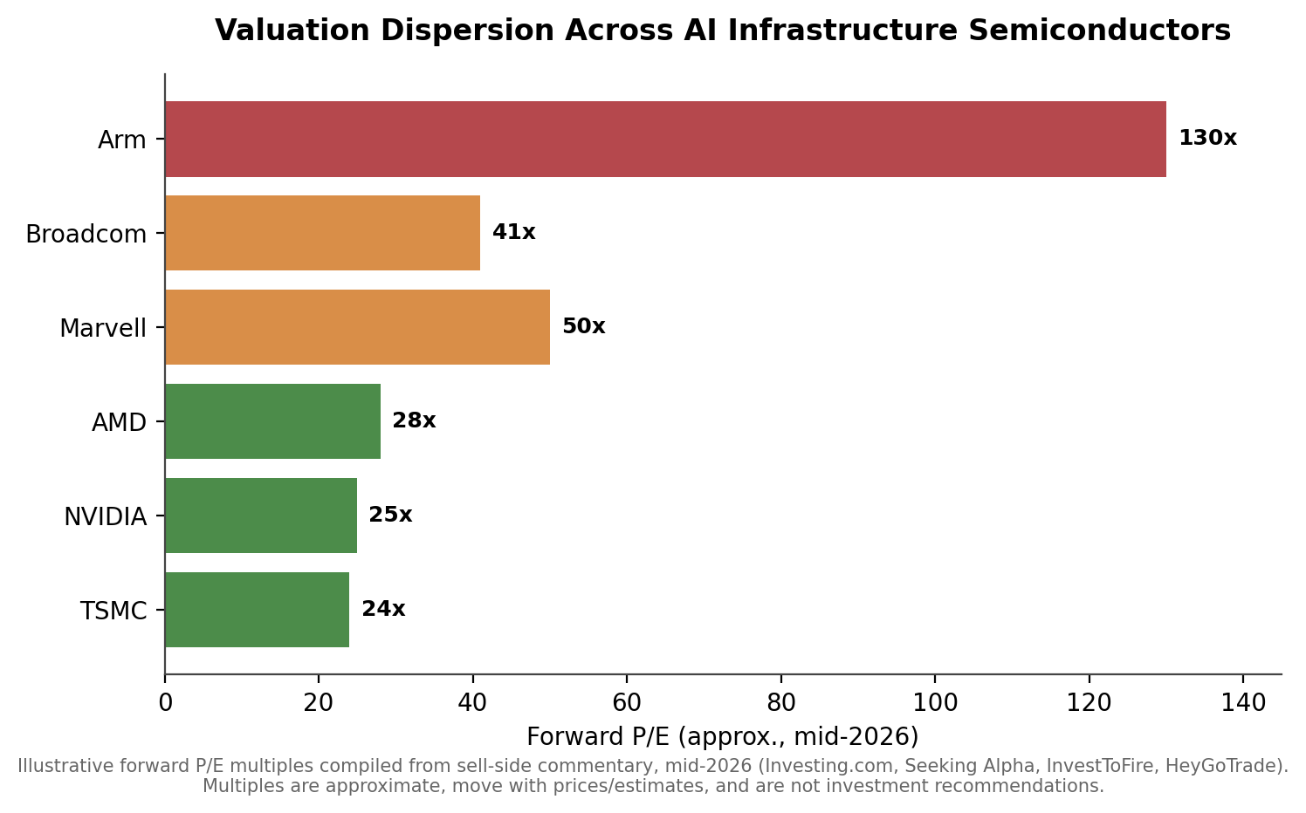
Figure 4. Illustrative forward P/E multiples across AI infrastructure semiconductor names, mid-2026. Multiples move continuously with prices and estimate revisions; treat as a snapshot rather than a current quote.
Company | Fwd P/E (approx.) | Revenue Growth | Gross Margin | Valuation Read
TSMC | ~24x | +30-41% YoY | ~66% | Cheapest large-cap AI-exposed name; growth not fully credited
NVIDIA | ~25x | +65-85% YoY | ~72% | Reasonable multiple for growth rate, but scale limits further re-rating
AMD | ~28-84x* | +35-50% YoY | ~54% | Wide range across sources; priced for steep data-center AI acceleration
Broadcom | ~33-41x | +29-48% YoY (co.) / AI seg. +106-180% | ~76% | Premium reflects AI custom-silicon mix shift and VMware cash flow
Marvell | ~50x | +34-42% YoY | n/a | Priced for custom-silicon and interconnect share gains
Arm Holdings | ~130x | +23% YoY | ~97% | Royalty/IP model; richest multiple, most growth-dependent
*Cited forward P/E for AMD ranged from ~28x to ~84x across sources reviewed in mid-2026, reflecting rapid estimate revisions and price moves; treat single-point multiples for any fast-moving name as approximate. Sources: Investing.com, Seeking Alpha, HeyGoTrade, InvestToFire, company filings (compiled June-August 2026).
Two additional valuation dynamics are worth flagging. First, reported backlog and bookings figures — Broadcom's AI backlog (reported at various points between roughly $30 billion and $73 billion), Vertiv's $15 billion-plus project backlog, CoreWeave's $66 billion contracted backlog, and Arista's $5.4 billion of deferred revenue — are increasingly used by both bulls and sell-side analysts as a substitute for traditional forward earnings visibility in a sector where reported revenue is growing so quickly that trailing multiples are close to meaningless. Second, private-market valuations for AI infrastructure and chip startups (Cerebras's ~$56 billion IPO valuation, CoreWeave's rise from a ~$23 billion private round to public markets, Groq's ~$6.9 billion mark) suggest public and private valuation frameworks have converged during 2026, reducing the historical "IPO discount" that characterized earlier hardware cycles.

4.1 Recent M&A Activity
- Synopsys–Ansys ($35 billion, completed July 2025): Combined EDA design leadership with multiphysics simulation, targeting a $31 billion total addressable market in silicon-to-systems design — directly relevant to the increasing complexity of multi-die AI chip packaging.
- GlobalFoundries–Synopsys ARC IP business: GlobalFoundries acquired Synopsys's ARC processor IP portfolio (ARC-V, ARC-Classic, and associated tools), consolidating embedded-processor IP as foundries increasingly bundle design services with manufacturing.
- NVIDIA–Groq (~$20 billion, December 2025): Structured as an IP licensing and talent transaction rather than a straightforward acquisition, moving Groq's CEO and senior technical leadership to NVIDIA while the standalone Groq entity continued to operate — an unusual structure that several analysts read as NVIDIA pre-empting a credible inference-architecture competitor.
- NVIDIA–Marvell ($2 billion equity investment, early 2026): A minority stake tying the companies together via the NVLink Fusion interconnect standard even as Marvell competes with Broadcom (and indirectly NVIDIA's own roadmap) in custom silicon.
- Numerous hyperscaler-to-supplier financing arrangements (discussed in Section 5.2) increasingly blur the line between commercial contracts, strategic investment, and outright M&A, and should be read alongside traditional deal activity when assessing consolidation in the sector.

5. Investment Implications
The central debate for the sector is not whether AI infrastructure spending is large — it plainly is — but whether the pace of capital deployment is being validated by end-demand at a rate that justifies current capital intensity and valuations, or whether a meaningful share of that spending is circular, pulled forward, or dependent on financing structures that could unwind quickly if growth expectations reset.

5.1 Bull Case
- Capacity, not demand, remains the binding constraint across chips, HBM, and (increasingly) power — suppliers across the value chain report backlogs measured in years, not quarters, at every layer from foundry to cooling equipment.
- Multiple independent forecasting methodologies (SIA/WSTS, IDC, Deloitte, Gartner, BNP Paribas) all point to substantial semiconductor market growth in 2026, even though they disagree sharply on magnitude — directional agreement across independent methodologies is itself informative.
- The shift toward inference workloads, sovereign AI investment, and enterprise AI adoption represents demand sources genuinely outside the "circular" hyperscaler-to-hyperscaler financing loop, and the degree to which this external demand materializes is the key variable bulls are watching.
- Custom silicon, HBM, networking, and power/cooling all show evidence of genuine multi-year contracted revenue (backlogs, long-term supply agreements, capacity reservations) rather than speculative, cancellable order books.
- Historical precedent exists for vendor-financed capital cycles (railroads, telecom, earlier compute buildouts) eventually validating genuine, durable end markets even when the financing structures used to bootstrap them look unusual in real time.

5.2 Bear Case / Key Debates
- Circular financing has become large and increasingly explicit: reported/discussed arrangements include NVIDIA's up-to-$100 billion investment commitment to OpenAI, a reported $250 billion NVIDIA guarantee under discussion to backstop OpenAI's lease of a $500 billion, 10-gigawatt Ohio data center campus (as of an August 2026 signed guarantee reported near $105 billion — a fraction of earlier headline figures), and a broader $500 billion-plus cooperation framework between NVIDIA and South Korea's SK Group. One tracker estimates cumulative circular-financing-style arrangements across the AI supply chain have exceeded $800 billion.
- The revenue-to-capex gap is stark: by one widely cited estimate, the AI industry is burning roughly $400 billion per year in aggregate while generating $50-60 billion in external revenue, and OpenAI specifically is reported on track to lose approximately $14 billion in 2026 — nearly triple its 2025 loss — even while targeting $100 billion of revenue by 2029.
- Mainstream, non-bearish commentators (CNBC's Jim Cramer among them) have begun drawing explicit parallels to the dot-com-era telecom vendor-financing collapse, where companies bought each other's capacity to inflate reported growth until real-world usage failed to keep pace and the financing unwound rapidly.
- Capital intensity at 45-57% of hyperscaler revenue is historically unprecedented for technology companies and would, in almost any prior cycle, be associated with a capital-intensive industrial business rather than software-like returns on capital — a reset in growth expectations could pressure free cash flow and balance sheets simultaneously across several large, interconnected companies.
- Export-control policy remains genuinely unpredictable quarter to quarter, creating episodic revenue risk (NVIDIA's $4.5 billion H20 inventory charge in Q1 fiscal 2026 is a concrete recent example) that is difficult for investors to model with confidence.

5.3 Where the Debate Resolves
Bulls and bears substantially agree on the deciding question, even if they weight the probable answer differently: what share of AI infrastructure revenue is ultimately paid for by end customers outside the small, interconnected circle of AI labs, hyperscalers, and chip suppliers currently financing one another. The practical indicators to monitor include: (1) enterprise and consumer AI application revenue growth relative to infrastructure capex growth; (2) utilization rates on already-built AI compute capacity (as opposed to headline capacity announcements); (3) credit-default-swap spreads and debt issuance terms for infrastructure providers (CoreWeave, Oracle, and neocloud operators) as an early market-based signal of financial strain; and (4) whether hyperscaler capex guidance for 2027 continues to rise or begins to plateau as 2026 actuals are reported.

5.4 Catalysts to Watch (Late 2026 – 2027)
- NVIDIA Q2 FY2027 earnings (August 26, 2026, the day after this report's data cutoff) and subsequent quarters, for data center growth trajectory and any further China/export-control commentary.
- TSMC's continued CoWoS capacity ramp and any further capital expenditure guidance revisions, which function as a real-time read on whether the packaging bottleneck is easing or persisting.
- HBM4 qualification and ramp across SK Hynix, Samsung, and Micron in the second half of 2026, and whether pricing power persists as new capacity comes online.
- Broadcom and Marvell's ability to convert disclosed AI backlog into recognized revenue on the timelines management has guided, and any commentary on additional named ASIC customers beyond the currently disclosed set.
- Resolution (or further escalation) of U.S.-China AI chip export policy, including enforcement of the loophole-closing guidance issued in mid-2026 covering offshore subsidiaries of Chinese firms.
- Hyperscaler 2027 capex guidance, expected to begin emerging in Q4 2026/Q1 2027 earnings calls, as the first forward-looking data point on whether the current capex growth rate is sustained, decelerating, or accelerating further.
- Progress (or setbacks) in Intel's 18A yield ramp and any confirmed external foundry customer wins, which would materially change the competitive dynamics of leading-edge manufacturing beyond TSMC.

Glossary of Key Terms
Term | Definition
ASIC | Application-Specific Integrated Circuit — a chip custom-designed for a narrow set of workloads (e.g., a hyperscaler's own AI training/inference tasks), trading general-purpose flexibility for cost and power efficiency at scale.
CoWoS | Chip-on-Wafer-on-Substrate — TSMC's dominant 2.5D advanced packaging technology, used to connect a logic die (GPU/ASIC) to stacks of HBM. Currently the tightest capacity constraint in AI chip production.
HBM | High-Bandwidth Memory — DRAM stacked vertically and placed adjacent to a processor to deliver far higher bandwidth than conventional memory; essential for feeding data to AI accelerators fast enough to keep them utilized.
Hyperscaler | A company operating cloud infrastructure at global scale — in this report, primarily Amazon (AWS), Microsoft (Azure), Alphabet (Google Cloud), and Meta, plus Oracle.
Neocloud | A cloud infrastructure provider (e.g., CoreWeave, Crusoe, Lambda, Nscale) that rents GPU/AI compute capacity, typically built on NVIDIA hardware, as an alternative to the traditional hyperscalers.
Merchant GPU | A general-purpose graphics processing unit sold commercially to any customer (as opposed to a custom ASIC built for one company) — NVIDIA and AMD are the primary merchant GPU vendors for AI.
LPU | Language Processing Unit — Groq's term for its inference-optimized chip architecture, emphasizing deterministic low latency over general-purpose flexibility.
Wafer-Scale Engine (WSE) | Cerebras's chip architecture, which uses an entire silicon wafer as a single chip to eliminate inter-chip communication bottlenecks.
TCO | Total Cost of Ownership — the full cost of deploying and operating compute infrastructure (chips, power, cooling, networking, facility) rather than just the sticker price of the chip itself; increasingly the basis on which hyperscalers evaluate custom silicon versus merchant GPUs.
Circular financing | An arrangement in which a supplier (e.g., NVIDIA) invests in, lends to, or guarantees financing for a customer (e.g., an AI lab or data center developer) that in turn uses the funds to purchase the supplier's own products — raising questions about how much resulting revenue reflects independent end-demand.
Export controls / BIS | U.S. Commerce Department (Bureau of Industry and Security) rules restricting the sale of advanced AI chips and related technology to certain countries, primarily China, for national security reasons; policy has changed multiple times since 2022 and remains a major source of sector uncertainty.
CUDA | NVIDIA's proprietary software platform and programming model for its GPUs; widely considered the company's deepest competitive moat due to the scale of software written and optimized specifically for it.

6. Appendix
A detailed Excel workbook accompanies this report (see the file shared alongside this document) with line-item company financials, segment revenue detail, valuation multiples, capex guidance by hyperscaler, and full source citations for every figure used in this overview. The workbook is organized into the following tabs:
- Company Financials — revenue, segment detail, growth rates, and margins for the ten companies profiled in Section 3, with source citations.
- Hyperscaler Capex Tracker — 2025 actual and 2026 guided capital expenditure by company, with quarterly detail where available.
- Valuation Comps — forward and trailing multiples (P/E, EV/Sales where available) across covered names.
- Market Size Estimates — the full set of 2026 semiconductor and AI infrastructure market-size forecasts cited in Section 2.1, by source and methodology.
- Sources — a consolidated list of every source referenced in this report, with publication dates.
All figures in this report and the accompanying workbook reflect publicly available information as of August 25, 2026. Given the pace of change in this sector — earnings are reported quarterly, export-control policy has changed materially multiple times within a single year, and private-company valuations move with each funding round — readers should treat any specific figure as a point-in-time estimate and verify against primary sources (company filings, investor relations pages) before relying on it for decision-making.

