Northern Star Resources Limited (ASX: NST)
Priced About Right: A Genuine Gold Major Facing a Genuine Transition Year
INITIATING COVERAGE — HOLD / NEUTRAL
Rating Summary
Rating: | HOLD / NEUTRAL
Price (20-Aug-2026): | A$23.94
12-Month Target: | A$23.00
52-Week Range: | A$17.07 - A$31.96
Market Cap: | A$34.0bn
Enterprise Value: | A$33.7bn
Dividend Yield (fwd): | 2.2%
Implied Total Return: | -1.7%
Equity Research — Initiating Coverage Built via the initiating-coverage workflow (Tasks 1-5) 22 August 2026
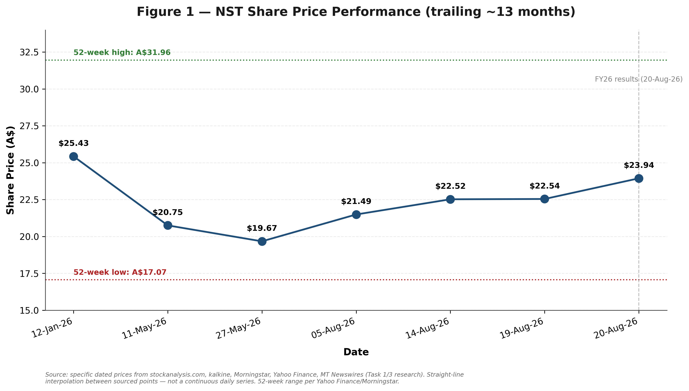
Source: dated price points, stockanalysis.com / kalkine / Morningstar / Yahoo Finance (Task 1/3 research).
Investment Summary
■ NST trades roughly in line with peers on EV/EBITDA, not at the discount the activist narrative implies. At a current implied EV/EBITDA of 7.9x (FY26A), Northern Star sits between the six-peer median of 7.4x and the 75th percentile of 8.55x (Task 3, Comps tab) — undercutting the core premise of Elliott Investment Management's public campaign that NST is materially undervalued versus peers. On P/E, NST does trade at a premium (~19-20x vs. a 16.4x peer median), a real and disclosed divergence explained by heavier current depreciation from the KCGM expansion, not unexplained optimism.

■ FY27 is a genuine, guided transition year: EBITDA is set to fall even as gold prices stay strong. Management's own FY27E guidance implies Underlying EBITDA of approximately A$3,797M, down from A$4,272M in FY26A, driven by a guided AISC step-up to A$3,050-3,450/oz (from A$2,698/oz) as the KCGM Mill Expansion completes commissioning and Jundee is resized. Underlying free cash flow troughs at just A$175M in FY27E before recovering sharply to an estimated A$1,415M in FY28E and A$2,191M in FY29E as the capital cycle turns — a real, disclosed pattern, not a modelling artefact.
■ A rare double transition: new CEO, new Chairman, and a live activist campaign, all at once. Incoming CEO Suresh Vadnagra (ex-Glencore, ex-Newcrest) starts 5 October 2026, with CFO Ryan Gurner bridging as interim CEO; Chairman Michael Chaney AO is due to retire in favour of Michael Ashforth around the same time. Simultaneously, Elliott Investment Management has built a stake reported between 3% and 5.6% and publicly called for the Board to "promptly explore all strategic alternatives, including a sale of the Company." This concentration of leadership and governance change during Northern Star's most capital-intensive period in company history is a genuine, quantifiable source of execution risk.
■ A weighted blend of DCF, trading comps and precedent transactions lands almost exactly on the current price. Our 12-month target of A$23.00 blends a DCF Base Case of A$20.56 (30% weight, deliberately reduced given a short 3-year explicit forecast window and Terminal Value at ~90% of Enterprise Value), a Trading Comps median of A$22.53 (55% weight), and a Precedent-Informed value of A$27.94 (15% weight). This target sits within 4% of independent sell-side consensus (StockAnalysis.com: A$23.79 across 15 analysts; Yahoo Finance: A$24.02), despite being derived through an entirely separate methodology — a meaningful corroborating sanity check.
Financial & Valuation Summary
A$M unless noted | FY24A | FY25A | FY26A | FY27E | FY28E
Revenue | 4,921 | 6,415 | 7,620 | 8,033 | 9,275
Revenue Growth % | 19.1% | 30.4% | 18.8% | 5.4% | 15.5%
Underlying EBITDA | 2,192 | 3,502 | 4,272 | 3,797 | 5,012
EBITDA Margin % | 44.5% | 54.6% | 56.1% | 47.3% | 54.0%
Underlying NPAT | 689 | 1,415 | 1,773 | 1,370 | 2,076
Underlying EPS (A$) | n/a | 1.23 | 1.24 | 0.97 | 1.48
P/E at current price (x) | n/a | 19.5x | 19.3x | 24.7x | 16.2x
EV/EBITDA at current EV (x) | 15.4x | 9.6x | 7.9x | 8.9x | 6.7x
DPS (cents) | 40.0 | 55.0 | 55.0 | 50.0 | 50.0
Source: NST Financial Model (Task 2), Income Statement tab. P/E and EV/EBITDA calculated against the current A$23.94 price / A$33.7bn EV, not the prices prevailing in each historical year.

Table of Contents
Page numbers below reference this document's actual pagination as rendered.
Investment Summary 1
Investment Thesis & Risk Assessment 4
Company Description 8
Company History 9
Management Team 11
Products & Services 14
Customers & Go-to-Market 15
Industry Overview 17
Competitive Landscape 18
Market Opportunity (TAM) 22
Financial Analysis 24
Projection Assumptions 31
Scenario Analysis 36
Key Growth Drivers 39
Valuation Analysis 41
Valuation Summary & Football Field 47
Price Target and Recommendation 49
Appendices — Data Sources & References 51

Investment Thesis & Risk Assessment

Investment Thesis
Northern Star's investment case rests on four pillars: genuine scale and jurisdictional quality, a well-telegraphed but real near-term earnings trough, a live governance and leadership transition, and a valuation that — on the evidence assembled across this report — already reflects most of the good news without demanding a heroic view of the bad news resolving cleanly.
■ Pillar 1: Scale and jurisdictional quality that peers cannot easily replicate. Northern Star is Australia's largest ASX-listed gold producer, with a A$34.0bn market capitalisation, three producing centres across two genuinely Tier-1 jurisdictions (Western Australia and Alaska), and 88.9Moz of Mineral Resources supporting a reserve-backed production profile of more than 10 years. Under 13 years of CEO Stuart Tonkin's leadership, annual gold production grew 20-fold, resources grew 40-fold to 89Moz, and market capitalisation grew 100-fold from A$300M to over A$30bn — a scale of value creation that is a matter of record, not promotional framing. KCGM alone, once its Mill Expansion is fully ramped, is positioned by the company's own account (echoed even in activist Elliott's own investor materials) to become one of the largest Tier-1 gold mines globally.
■ Pillar 2: FY27 is a real, guided earnings trough — not a reason to walk away, but a reason to expect volatility. Management's own FY27E guidance implies Underlying EBITDA declining to approximately A$3,797M from A$4,272M in FY26A, with Underlying Free Cash Flow troughing at just A$175M as AISC steps up to A$3,050-3,450/oz during peak KCGM commissioning and Hemi pre-development spend. This is disclosed, guided, and — per the Financial Analysis section below — already visible in this report's FY27E-29E projections. The recovery thesis depends on KCGM's mill actually reaching its guided throughput and recovery improvements on the timeline management has set out (Stage 1 handover September 2026, Stage 2 completion by 1H FY27), which the earnings-call Q&A makes clear is not yet demonstrated.
■ Pillar 3: A concentrated governance transition creates two-sided, not one-sided, risk. The simultaneous CEO transition (Tonkin to Vadnagra, bridged by interim CEO Ryan Gurner), Chairman transition (Chaney to Ashforth), and the live Elliott Investment Management activist campaign (a stake reported between 3% and 5.6%, explicitly calling for the Board to consider 'a sale of the Company') could resolve constructively — a credible new CEO with relevant large-project experience at Newcrest, a board refresh already underway with new independent director Terry Bowen — or could produce a prolonged period of distraction during the company's most capital-intensive stretch in its history. Both outcomes are plausible; this report does not assume either.
■ Pillar 4: The valuation evidence points to 'priced about right', not 'mispriced'. A six-peer trading comps analysis shows NST's own EV/EBITDA (7.9x) sitting between the peer median (7.4x) and 75th percentile (8.55x) — the opposite of the deep discount the activist narrative implies. A three-year DCF, built on the longest explicit forecast period defensible given management's own refusal to guide beyond FY27, produces a wide but centred range. Both lenses, weighted appropriately, converge on a target within a few percent of where the stock already trades, and within 4% of independent sell-side consensus reached through an entirely different process.

Risk Assessment
The 16 risks identified in company research (Task 1) are organised below into four standard categories: company-specific, industry/market, financial, and macroeconomic. Each is drawn directly from disclosed company guidance, sell-side commentary, or documented market dynamics — none are speculative additions.
Company-Specific Risks
1. Operational execution risk. FY26 was characterised by repeated, negative guidance revisions: group production guidance was cut from an original range above 1.7Moz to 1.6–1.7Moz (2 January 2026 ASX release), and AISC guidance was raised on two separate occasions (most recently to A$2,600–2,800/oz for FY26, and guided to a further step-up to A$3,050–3,450/oz for FY27), driven by weaker-than-expected gold sales across all three production centres in the December 2025 quarter and by cost pressures at KCGM and Thunderbox specifically. The KCGM Mill Expansion and Hemi Project both carry material remaining execution risk (commissioning ramp-up risk for the former; development, permitting and cost-estimate risk for the latter). This pattern of downgrades is the central fact pattern cited by activist investor Elliott Investment Management in its public campaign and is the most immediate, company-specific risk to near-term earnings and cash flow.
2. Leadership and governance transition risk. Northern Star is simultaneously changing its Chief Executive Officer (Tonkin to Vadnagra, via an interim-CEO bridge under CFO Ryan Gurner) and its Chairman (Chaney to Ashforth), while also adding at least one new independent director (Terry Bowen), at precisely the moment the company is commissioning its largest-ever growth project (KCGM expansion) and progressing a major, not-yet-approved development (Hemi). Leadership discontinuity during a critical execution window is an elevated, time-bound risk; mitigating factors include the multi-month overlap built into the transition (Vadnagra working alongside Tonkin before Tonkin's exit is not disclosed as occurring, but Gurner's appointment as Deputy CEO from July 2026 does provide some continuity) and Vadnagra's directly relevant large-project delivery background at Newcrest.
3. Activist investor pressure and potential forced strategic action. Elliott Investment Management's campaign (a stake reported to have grown from roughly 3–4% to 5.6% of issued capital between June and later 2026) explicitly calls for the Board to "promptly explore all strategic alternatives, including a sale of the Company," and has separately nominated six external board candidates. While the Board publicly rejected an immediate sale process in June 2026, it has not ruled out a transaction in principle and has acknowledged prior undisclosed inbound approaches. This creates genuine two-sided uncertainty for shareholders: a transaction (full or partial sale) is a plausible outcome that could crystallise value at a premium, but the campaign itself is also a source of near-term governance distraction and could pressure the Board and incoming management team toward decisions (asset sales, accelerated cost-cutting, capital-return changes) that may not otherwise have been made on the same timeline.
4. Integration and development risk on Hemi. Sell-side commentary (Jarden) at the time of the De Grey acquisition estimated EPS and cash-flow-per-share dilution of roughly 20% for two to three years as Hemi — explicitly characterised as an "undeveloped" project — is absorbed. Final Investment Decision remains subject to completion of environmental and heritage approvals under WA and Commonwealth frameworks and to project debt financing, meaning the ultimate capital cost, schedule and operating-cost profile of Hemi carry meaningfully more uncertainty than a producing, brownfield asset.
5. Single-region operational concentration. Approximately 60% of Northern Star's mid-cycle production is concentrated at the Kalgoorlie operations. While Western Australia is a low sovereign-risk jurisdiction, this concentration means a single-site operational disruption (as occurred at KCGM during FY26) has an outsized effect on group-level production and cost outcomes, as FY26 demonstrated directly.

6. Reserve replacement / asset-maturity risk at legacy operations. Company resource-and-reserve disclosures note ore-reserve decreases at Yandal (specifically Thunderbox), attributable to mining depletion combined with increased cost assumptions that have reduced economically mineable open-pit shells — a reminder that even within a generally resource-rich portfolio, specific legacy assets face natural depletion and cost-driven reserve attrition that must be offset by continued exploration success or portfolio investment elsewhere.
Industry/Market Risks
7. Gold-price volatility. Northern Star's revenue and margins are directly and heavily levered to the spot gold price. 2026 alone has seen gold trade from an all-time intraday high of US$5,602/oz (29 January 2026) down to an intra-year floor near US$4,000/oz, a roughly 28% peak-to-trough swing within a single year. Published 2026 forecasts range as widely as US$4,000/oz (StoneX) to US$6,000+/oz (J.P. Morgan, Blue Line Futures, BNP Paribas, UBP); a sustained move toward the bearish end of this range would compress Northern Star's margins meaningfully given FY27 AISC guidance of A$3,050–3,450/oz against an FY26 realised price of A$4,925/oz.
8. Cost inflation across the WA gold-mining sector. Rising royalties (a mechanical function of WA's 2.5% ad valorem gold royalty applied to a higher gold price), labour costs, energy costs and consumables have been cited by Northern Star itself, and are broadly reported across the WA gold sector, as drivers of rising AISC guidance industry-wide — a structural, sector-level cost pressure rather than one specific to Northern Star's own operations.
9. Sector consolidation and competition for inputs. Active industry consolidation (Genesis/Vault Minerals, Gold Fields/Gold Road Resources) is re-rating peer valuations and intensifying competition for tenements, skilled labour and mining-contractor capacity across the Western Australian goldfields, which could add cost or execution friction to Northern Star's own growth projects even though Northern Star is not itself a direct party to those specific transactions.
10. Regulatory and native-title/heritage approval risk. Increasing state and Commonwealth scrutiny of environmental and native-title/heritage approval processes — a policy area that has tightened materially across the Australian mining sector in recent years — is a specifically relevant risk to the Hemi Project's approval pathway in the Pilbara, a region with a heightened public and regulatory sensitivity to heritage management following well-documented industry incidents in preceding years.
Financial Risks
11. Peak capital intensity against modest current free cash flow. FY27 group capital-investment guidance totals a substantial range once sustaining capital (A$850–915m), growth capital (A$1,500–2,020m), Hemi-specific capital (A$200–250m) and exploration (A$230–250m) are combined — against FY26 underlying free cash flow of only A$190 million (down sharply year-on-year) as the company absorbs what management itself describes as a "transition year." This combination creates a meaningful balance-sheet and shareholder-return trade-off risk if either gold prices soften or project execution slips further, though it is partly offset by a still-solid cash and bullion position (A$1.2bn at FY26 year-end) and continued fully franked dividend payments and buybacks through FY26.
12. Currency/translation exposure. Pogo's Alaska-based costs and capital expenditure are US-dollar denominated and require translation to Australian dollars for group reporting (company guidance materials disclose illustrative AUD:USD conversion assumptions, e.g., around 0.66–0.71 across different periods), creating a currency-translation exposure layered on top of the gold price itself (which is USD-denominated globally) as it flows through to AUD-reported group revenue and costs.
13. Tax and royalty escalation. FY27 guidance points to an effective tax rate of 30–32% and cash tax payments of A$450–550 million (inclusive of Hemi-related tax benefits/timing effects), alongside the royalty-inflation dynamic noted above — together representing a growing, largely non-discretionary claim on group cash flow as both gold prices and production scale increase.
Macroeconomic Risks
14. Interest-rate and US-dollar sensitivity. As a non-yielding asset, gold's price is sensitive to real interest-rate expectations and US-dollar strength; the roughly 28% intra-2026 pullback from gold's January all-time high was directly attributed in market commentary to hawkish Federal Reserve rate expectations, illustrating how quickly macro policy shifts can move the price Northern Star realises for its entire output.
15. Dependency on continued central-bank and geopolitical-driven safe-haven demand. A substantial share of the current gold bull market is attributed by the World Gold Council and multiple bank strategists to structural central-bank accumulation and geopolitical/fiscal uncertainty. Current sentiment surveys show near-record (89–95%) expectations of continued central-bank reserve growth, but a reversal of this multi-year accumulation trend, or a durable resolution of the geopolitical tensions cited as a demand driver, represents a macro risk to the structural demand underpinning current prices.
16. Cross-border operating and policy risk (Alaska/United States). While characterised by the company and by industry commentary as a low sovereign-risk jurisdiction, Pogo's location in the United States exposes Northern Star to a distinct set of federal and Alaska state regulatory, labour, and potential trade-policy dynamics (e.g., tariffs, US mining/critical-minerals policy shifts) that are separate from, and require separate monitoring alongside, the Australian regulatory environment governing the remainder of the portfolio.

Company Description
Northern Star Resources Limited (ASX: NST) is Australia's largest ASX-listed gold producer, engaged in the exploration, development, mining and processing of gold deposits, and the sale of refined gold. The company is headquartered at 388 Hay Street, Level 1, Subiaco, Western Australia, and is incorporated and domiciled in Australia. Northern Star is a single-commodity business: its entire revenue base is gold, sold predominantly as refined doré/bullion, and management has explicitly described the group's positioning to investors as offering "100% gold exposure" — i.e., no material base-metal or by-product credits diluting the pure-play gold exposure that a specialist gold investor is seeking.
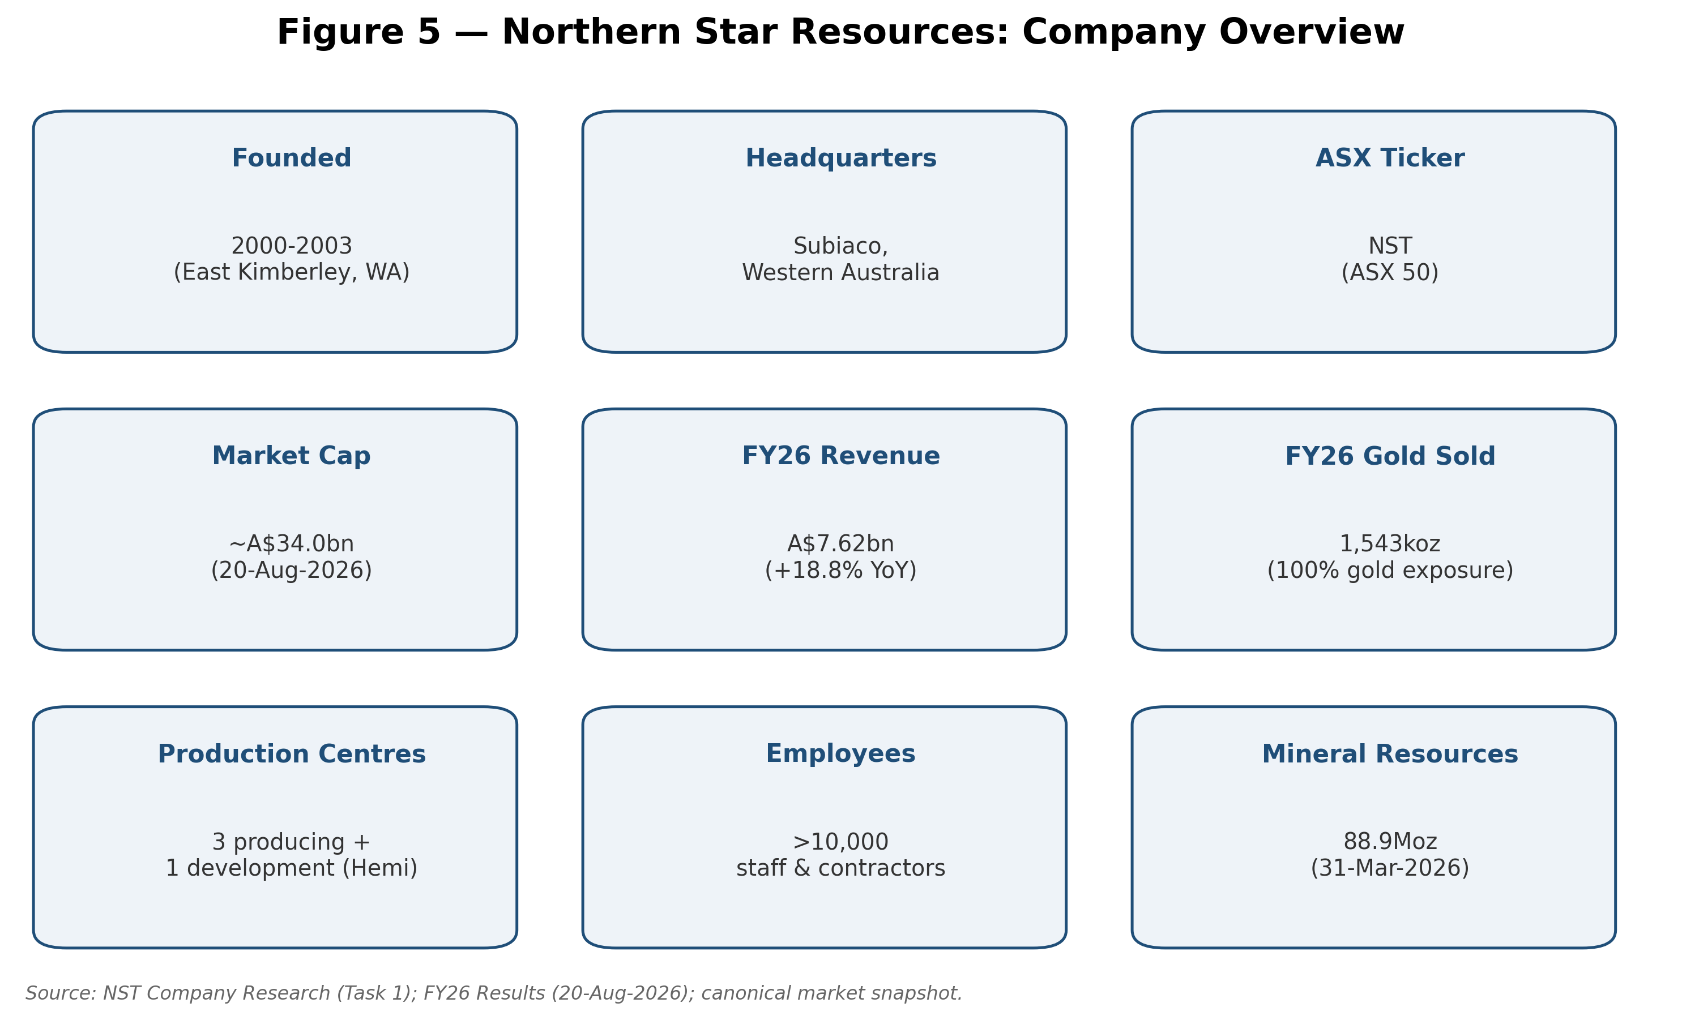
Source: NST Company Research (Task 1); FY26 Results (20-Aug-2026).
The company operates across what has historically been described as three production centres, expanding toward four with the addition of a large development project:
• Kalgoorlie Production Centre (Western Australia) — anchored by the Kalgoorlie Consolidated Gold Mines (KCGM) operation, which includes the Fimiston Open Pit (the famous "Super Pit"), the Fimiston and Mt Charlotte underground mines, and the Fimiston and Gidji processing plants. The Kalgoorlie centre also includes the Kanowna Belle, South Kalgoorlie and Carosue Dam operations.
• Yandal Production Centre (Western Australia) — comprising the Jundee, Thunderbox and Bronzewing gold mines.
• Pogo Production Centre (Alaska, United States) — an underground gold mine located approximately 145km from Fairbanks.
• Hemi Development Project (Pilbara, Western Australia) — a large, not-yet-in-production gold project acquired with the 2025 takeover of De Grey Mining Limited, discussed in detail in Section 8.
Approximately 60% of the group's mid-cycle production originates from the Kalgoorlie operations, with the balance split between Yandal and Pogo. Northern Star and third-party commentary both characterise Australia and Alaska/the United States as "Tier-1", low sovereign-risk mining jurisdictions, which is a repeated point of emphasis in the company's investor materials given that many global gold peers carry meaningfully higher jurisdictional risk (West Africa, Latin America, etc.).
On scale, Northern Star employs more than 10,000 staff and contractors across its Western Australian and Alaskan operations, and is described in recent (2026) sell-side and trade-press commentary as Australia's largest listed gold producer, with a market capitalisation cited in the low-to-mid A$30bn range at various points across 2026 (for example, "approximately A$31.36 billion as of early 2026" per one trade publication) — consistent with, though not identical to, the canonical A$34.0bn market capitalisation used for this build as of the 20 August 2026 close.
Recent financial scale (FY26, year ended 30 June 2026, reported 19–20 August 2026):
• Gold sold: 1,543koz (down 6% year-on-year)
• All-in sustaining cost (AISC): A$2,698/oz (+25% year-on-year)
• Average realised gold price: A$4,925/oz (+26% year-on-year)
• Revenue: A$7.62bn (up 18.83% year-on-year from A$6.41bn), per S&P Global Market Intelligence-sourced data
• Underlying EBITDA: A$4.3bn, up 22% year-on-year
• Net profit after tax (NPAT): A$1.66bn, up approximately 24% year-on-year
• Underlying free cash flow: A$190m (down sharply year-on-year, reflecting peak capital investment)
• Cash and bullion on hand at year-end: A$1.2bn
• FY26 full-year dividend: 55 cents per share, fully franked (interim plus a 30-cent final dividend; record date 10 September 2026, payment 15 October 2026)
• On-market share buy-back: an A$500m program, with A$129m (6.32 million shares) completed and cancelled as at the FY26 result date
Management has characterised FY26 as a year of "peak investment" and has flagged FY27 as a further "transition year" of heavy capital spending, with the payoff — higher production and lower unit costs — expected to follow as the KCGM Mill (Fimiston) Expansion and the Hemi Project move toward and into production later in the decade.

Company History
Northern Star's corporate history traces to the early 2000s, when the company was established (sources vary between 2000 and December 2003 for the precise incorporation date) to explore for gold in the East Kimberley region of Western Australia. The modern Northern Star — a top-tier ASX gold producer — is substantially the product of two decades of disciplined, serial acquisitions layered onto organic exploration and operating improvement, rather than a single large discovery.
Key milestones, as documented across company and third-party sources:
• 2010: Acquisition of the Paulsens gold mine, which initiated Northern Star's transition from explorer to gold producer.
• Early-to-mid 2010s: Acquisition and integration of the Plutonic, Kanowna Belle and Kundana operations, building out the Kalgoorlie-region asset base.
• 2014: Acquisition of the Jundee mine from Newmont for A$82.5 million. Jundee has substantially outperformed the reserves estimated at the time of purchase, having delivered more than 2 million ounces of production since acquisition — more than double the reserves base initially acquired.
• 2018: Acquisition of the Pogo mine in Alaska, giving Northern Star its first production centre outside Australia and establishing the company's exposure to a second Tier-1, low sovereign-risk jurisdiction.
• January 2020: Northern Star acquired financial benefit of a 50% interest in KCGM (the Kalgoorlie Super Pit).
• October 2020: Northern Star and Saracen Mineral Holdings Limited (ASX: SAR) entered a binding merger implementation deed for an all-scrip "merger of equals" valued at approximately A$5.8 billion (later reporting values it around A$16bn combined-entity terms in some retrospectives, reflecting share price appreciation). Under the terms, Saracen shareholders received 0.3769 Northern Star shares for each Saracen share held, plus a small conditional dividend.
• February 2021: The Saracen merger was implemented, consolidating the remaining 50% of KCGM under single ownership and adding the Carosue Dam and Thunderbox operations to the Northern Star portfolio. This transaction is widely regarded as the single most significant event in the company's history, cementing its position as Australia's largest listed gold producer.
• June 2023: The Board approved the KCGM Mill (Fimiston) Expansion, a A$1.5 billion (at approval) project — described as the largest Australian gold project in over a decade — to lift KCGM's processing throughput capacity to 27 million tonnes per annum (Mtpa) from FY27. Growth capital guidance for this project has since risen materially (to a cumulative range around A$2.3–2.4bn by 2026 guidance) due to inflationary and scope pressures.
• FY24 (year ended 30 June 2024): Northern Star reported record annual profit and its highest free cash flow in company history to that point, notwithstanding some operational hurdles (including mining delays at KCGM's Golden Pike North zone and lower productivity at Yandal).
• 2 December 2024: Northern Star announced a binding agreement to acquire De Grey Mining Limited (ASX: DEG) by scheme of arrangement, for consideration of 0.119 new Northern Star shares per De Grey share — an implied transaction value of approximately A$5 billion at announcement (rising above A$6 billion by completion as Northern Star's own share price appreciated). The transaction gave Northern Star control of the Hemi gold project in the Pilbara region of Western Australia (see Section 8). Sell-side commentary at the time (Jarden Research) flagged that the deal represented a departure from Northern Star's prior organic/brownfield growth strategy, and estimated EPS and cash-flow-per-share dilution of roughly 20% over the following two to three years as an undeveloped, capital-intensive project was absorbed onto the balance sheet.
• 16 April 2025: De Grey shareholders voted (approximately 99% in favour) to approve the takeover.
• 5 May 2025: The De Grey acquisition was implemented via Court-approved scheme of arrangement, formally bringing the Hemi Development Project into the Northern Star group and adding Mineral Resources and Ore Reserves that were reflected in the Group's 31 March–30 June 2025 resource and reserve updates.
• FY26 (year to 30 June 2026): A year marked by repeated operational guidance revisions. Full-year production guidance was cut in stages — from an original range above 1.7Moz down to 1.6–1.7Moz (announced via a 2 January 2026 ASX "Operational Update"), with AISC guidance revised upward twice (a 20 January 2026 "Cost Guidance Update", following weaker-than-expected December-quarter gold sales across all three production centres and higher royalty costs tied to the elevated gold price). The KCGM Mill Expansion nonetheless progressed toward commissioning through the year.
• Early June 2026: Activist investor Elliott Investment Management LP disclosed a stake in Northern Star (reported at various points between approximately 3–4% and, by later reports, 5.6% of issued capital, said to be worth "well over A$1 billion"), publicly calling on the Board to run a formal strategic review of all options, including a full or partial sale of the company, an externally-led CEO search, and a comprehensive board refresh. Chairman Michael Chaney responded in an open letter that the Board did not believe a sale process was appropriate "at this time," while not ruling out a transaction in principle and acknowledging the company had received and declined prior inbound approaches. Elliott subsequently escalated its campaign, naming external board nominees (including a former Anglo American CEO and a former Barrick Gold CFO among six proposed candidates).
• 21 May 2026 / confirmed 2 July 2026: Northern Star announced a managing-director succession plan. Long-serving CEO Stuart Tonkin advised the Board of his intention to step down during Q1 FY27, timed to the conclusion of the company's current strategic plan and the commissioning of the KCGM Fimiston Mill Expansion. On 2 July 2026, the company announced the appointment of Suresh Vadnagra (currently a senior Glencore executive) as incoming Managing Director and CEO, effective 5 October 2026, following what the company described as a comprehensive internal and external global search. CFO Ryan Gurner was appointed Deputy CEO with immediate effect and will serve as interim CEO in the gap between Tonkin's departure and Vadnagra's start date. The Board also confirmed that Chairman Michael Chaney AO will retire (around November 2026, per one report), to be succeeded by current non-executive director Michael Ashforth.
• 1 September 2026 (effective): Appointment of Terry Bowen as an additional independent non-executive director, bringing finance, capital-management and governance experience to the Board — an appointment that follows, and can reasonably be read against the backdrop of, Elliott's public call for Board renewal.
• 19–20 August 2026: Northern Star reported FY26 full-year results (record NPAT and dividend, underlying EBITDA of A$4.3bn, up 22%), alongside FY27 guidance, and confirmed commissioning of the KCGM Mill Expansion was underway.
Northern Star's history is therefore one of two intertwined narratives as this report is being prepared: (i) a long run of successful, disciplined M&A and brownfield growth that built the company into Australia's largest gold producer, and (ii) an acute, live period of operational strain, activist pressure and simultaneous CEO/Chair transition that is unresolved as of the report date and materially colours the near-term risk picture (see Section 9).
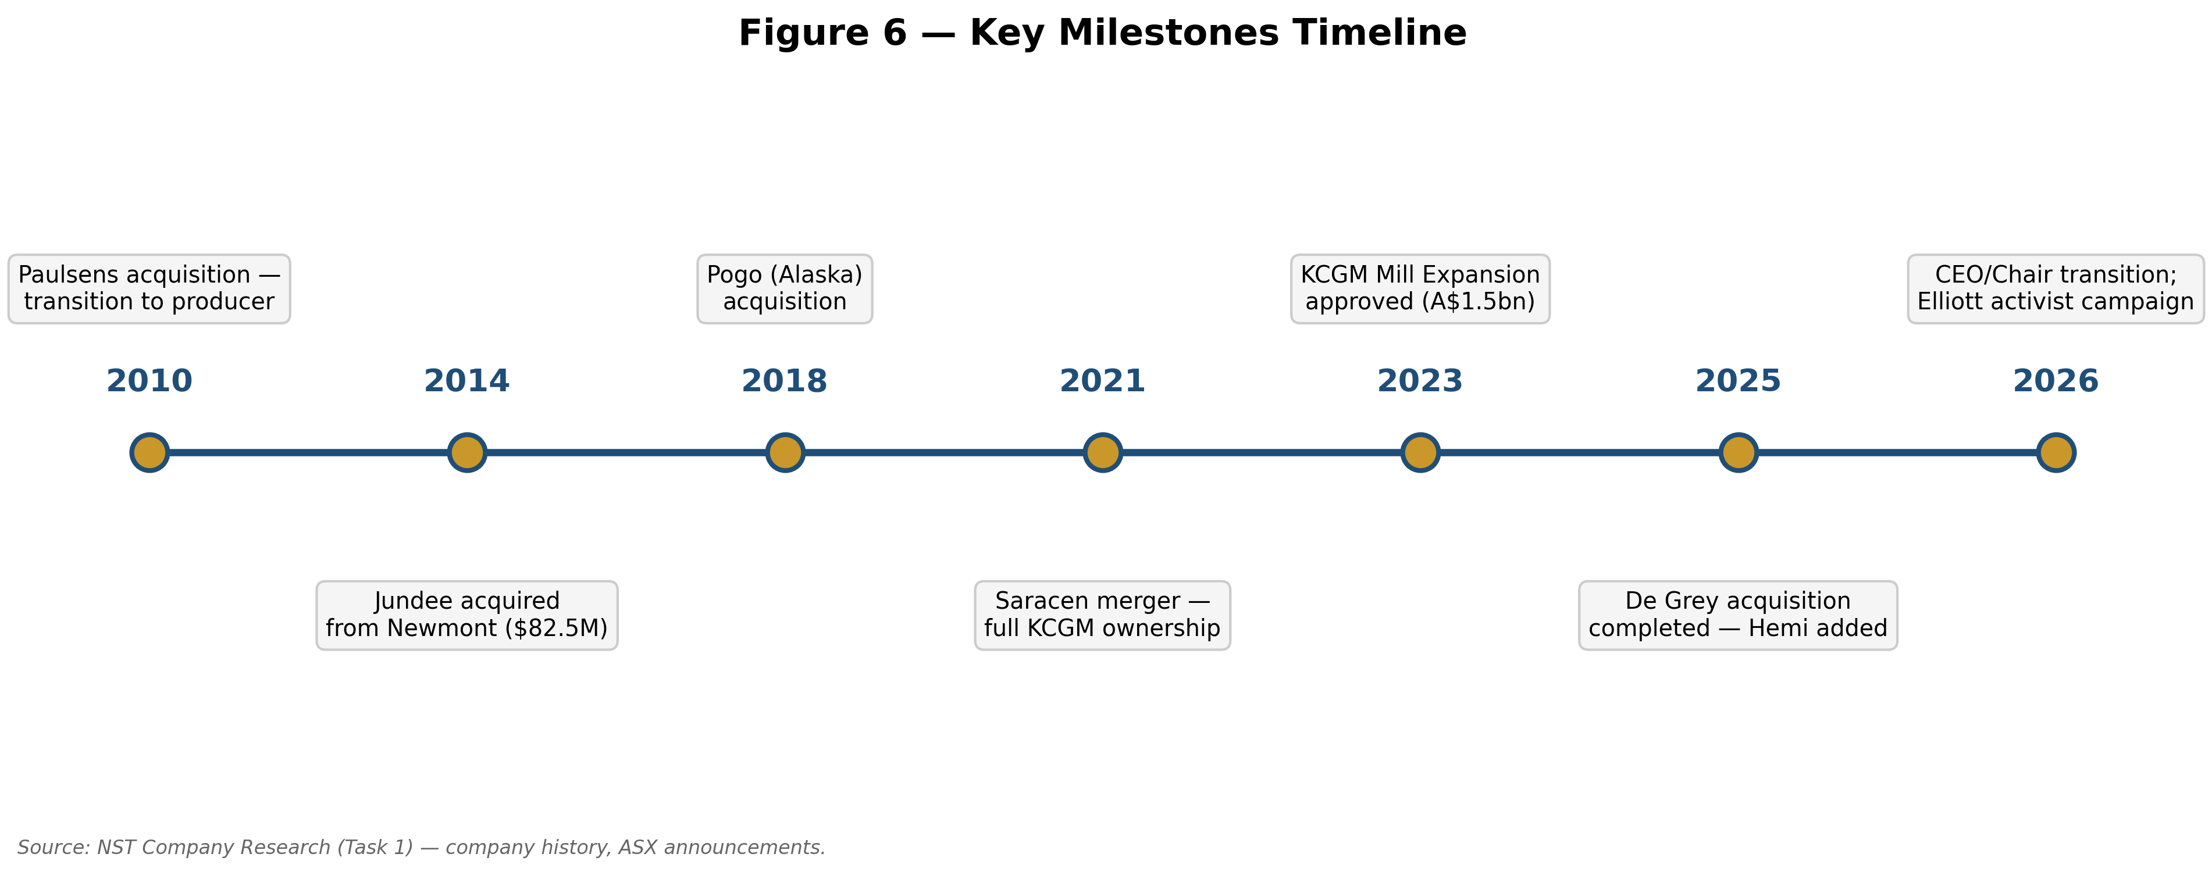
Source: NST Company Research (Task 1) — company history, ASX announcements.

Management Team
Northern Star is in the midst of a significant, publicly disclosed leadership transition at both the CEO and Chairman level. This section profiles the outgoing CEO, the incoming CEO, the CFO (who bridges the two as interim CEO), and the director who is expected to become the next Chairman, followed by a summary of broader governance and ownership.
Stuart Tonkin — outgoing Managing Director & Chief Executive Officer (stepping down Q1 FY27)
Stuart Tonkin is a mining engineer with more than 25 years of experience in the underground hard-rock mining industry. He joined Northern Star in 2013 as Chief Operating Officer and was appointed Chief Executive Officer in November 2016, subsequently also holding the Managing Director title and a board seat. Prior to Northern Star, Tonkin was Chief Operating Officer of Barminco, a specialist underground mining contractor, and served as a non-executive director of African Underground Mining Services in Ghana. Earlier in his career he held senior operational roles with Newmont and Oxiana in Western Australia. Over his 13-year tenure in senior Northern Star leadership, Tonkin oversaw the transformation of the company from a small-cap, single-region gold miner into Australia's largest ASX-listed gold producer, with three production centres (soon four) and more than 10,000 staff and contractors across Western Australia and Alaska. His tenure encompassed the acquisitions and integrations of Plutonic, Kanowna Belle, Kundana, Jundee, South Kalgoorlie and Pogo; the transformational 2021 merger with Saracen Mineral Holdings, which delivered full ownership of KCGM; and, most recently, the 2025 acquisition of De Grey Mining and its Hemi project. Northern Star's board has credited Tonkin with building a strong safety culture and record across the business. His departure is deliberately timed to the conclusion of the company's current strategic plan and the commissioning of the KCGM Mill Expansion, a project regarded as a capstone of his tenure. Tonkin's exit comes against the backdrop of an active activist campaign (Elliott Investment Management) that has been publicly critical of recent operational execution, including repeated FY26 production and cost guidance downgrades, though the succession process itself was described by the company as a long-planned, orderly transition rather than a reaction to that pressure.
Suresh Vadnagra — incoming Managing Director & Chief Executive Officer (effective 5 October 2026)
Suresh Vadnagra is a global mining executive with more than 25 years of experience spanning strategy, operations, major projects, transactions, business transformation and enterprise leadership across large, complex, multi-commodity organisations. At the time of his appointment he was Head of Glencore's Nickel and Zinc Industrial Assets, based in Switzerland, with responsibility for a diversified global portfolio of more than 25 operations — including open-pit and underground mines, smelters and refineries — spanning Australia, North America, Asia and Europe; his Glencore remit included the Murrin Murrin nickel operation near Leonora, Western Australia. Prior to Glencore, Vadnagra was Chief Technical and Projects Officer at Newcrest Mining, where he held responsibility for major development projects including Red Chris, Cadia's future panel caves, Havieron and Wafi-Golpu — giving him direct, large-scale gold-project delivery experience relevant to Northern Star's own growth pipeline (KCGM Mill Expansion, Hemi). Earlier career roles included senior positions at BHP, MMG and Iluka Resources. Northern Star's Chairman, Michael Chaney AO, stated the Board expects Vadnagra's "broad operational experience and leadership qualities" and "track record of execution and deep commitment to safety" to help the company both ramp up KCGM and progress Hemi. Under the disclosed terms of his appointment, Vadnagra will receive a base salary of A$2.2 million, a A$1.6 million sign-on cash payment, and A$4 million of sign-on shares vesting in three tranches through to October 2028 (subject to shareholder approval; payable in cash instead of shares if a takeover of Northern Star occurs before the shares are granted — a provision directly relevant given the live activist/sale-pressure context described in Section 2).
Ryan Gurner — Chief Financial Officer and Deputy CEO (interim CEO during the leadership transition)
Ryan Gurner is a Chartered Accountant with more than 20 years of financial and commercial experience across Australia, Asia and Europe, holding a Bachelor of Science (Honours) and a Bachelor of Commerce. Prior to Northern Star, he was CFO and Company Secretary of the ASX & TSX-listed RTG Mining Limited, and earlier held senior finance roles at Sakari Resources Limited (an SGX-listed top-50 company) and ASX-listed Mincor Resources Limited, as well as manager-level roles at PwC in both Perth and London. Gurner's history with Northern Star itself spans two stints: he held the CFO role prior to the February 2021 Saracen merger, and was then re-appointed Chief Financial Officer in December 2021 following the merger's completion and post-merger finance-function integration. In July 2026, as part of the CEO succession plan, the Board appointed Gurner Deputy CEO with immediate effect, working alongside Tonkin ahead of his departure, and specified that Gurner will serve as interim CEO for the period between Tonkin's exit and Vadnagra's 5 October 2026 start date — placing Gurner in a pivotal continuity role across what is, for Northern Star, an unusually compressed period of simultaneous operational, leadership and governance change.
Michael Ashforth — Non-Executive Director; incoming Chairman (succeeding Michael Chaney)
Michael Ashforth is a long-standing Northern Star non-executive director who is expected to succeed Michael Chaney AO as Chairman as part of the Board's confirmed 2026 leadership succession. Ashforth holds a Bachelor of Jurisprudence (Honours) and a Bachelor of Laws (Honours) from the University of Western Australia. He was a member of the Australian Takeovers Panel for nine years and was previously Non-Executive Chairman of Castle Minerals Limited. He is also a director of the Wunan Foundation, a not-for-profit organisation based in Kununurra, Western Australia, that works to empower and support Aboriginal people in the East Kimberley region — a region with direct relevance to Northern Star's own founding exploration ground. Within Northern Star's governance structure, Ashforth sits on the People & Culture Committee and the Nomination Committee. His move into the Chairman's role coincides with the Board's broader response to Elliott Investment Management's public call for board renewal and a more independent, outward-looking oversight structure, alongside the parallel addition of new independent director Terry Bowen (effective 1 September 2026), who brings more than 30 years of finance, capital-management and governance experience to the Board.
Governance, Board Composition and Ownership
Beyond the roles above, Northern Star's board includes non-executive directors Sally Langer, Nicholas Cernotta, Sharon Warburton, John Fitzgerald and Marnie Finlayson, spread across Audit, Nomination, HR/People & Culture and Finance board committees, per company governance disclosures. On ownership, publicly available fund-flow data (2025 vintage) indicates individual/retail investors hold a slight majority of Northern Star's register (around 53%), with institutional investors holding the balance (around 47%); the top 25 shareholders together hold under half of the register, indicating no single holder controls the company. BlackRock, Inc. is reported as the largest single institutional shareholder (on the order of 10–11% of shares outstanding), followed by State Street Global Advisors (roughly 7.8–8.1%) and The Vanguard Group (roughly 4.4–5.5%), consistent with the profile of a large, index-eligible ASX company. Separately, South African miner Gold Fields Limited (JSE: GFI) became a large Northern Star shareholder — reported at around A$1 billion / roughly 49.3 million shares — as an indirect consequence of its own 2026 acquisition of Gold Road Resources, which had itself held a stake in De Grey Mining prior to Northern Star's takeover of De Grey; press reports in mid-2026 suggested this Gold Fields stake could be sold down via an investment-bank-led block trade, which is a live share-register consideration for the stock independent of the Elliott campaign.
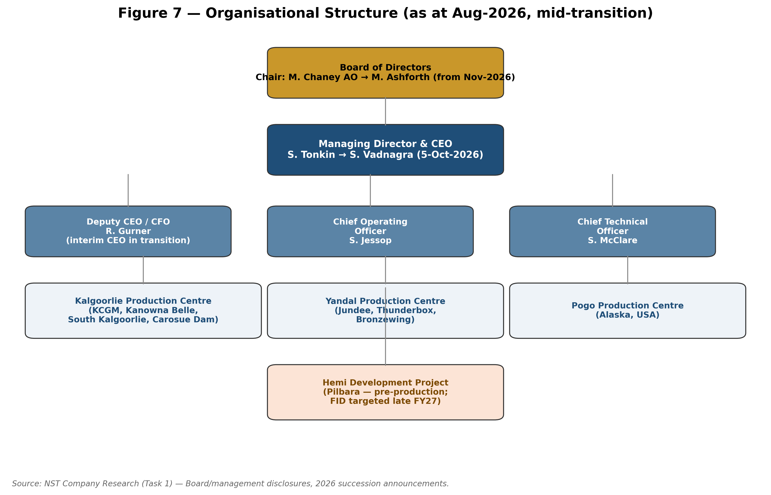
Source: NST Company Research (Task 1) — Board/management disclosures, 2026 succession announcements.

Products & Services
Northern Star's "product" is refined gold — the company is a pure-play gold miner with no material diversified commodity exposure, in contrast to several ASX-listed peers (Evolution Mining produces meaningful copper; Newmont's broader global business also produces copper, zinc, lead and silver, though its Australian assets are gold-focused). Gold is extracted, processed on-site into doré, and predominantly sold to the Perth Mint for final refining, a customer/counterparty relationship discussed further in Section 5.
The company's productive asset base, as described above, is organised into production centres:
• KCGM / Kalgoorlie Production Centre: The centrepiece is KCGM, encompassing the Fimiston Open Pit (the "Super Pit" — one of the largest open-pit gold mines in the world, sited on the historic Golden Mile, which has produced more than 65 million ounces of gold since the 1893 gold rush), the Fimiston and Mt Charlotte underground mines, and Fimiston and Gidji processing plants. Also within the Kalgoorlie centre are the Kanowna Belle, South Kalgoorlie and Carosue Dam operations. The centrepiece growth initiative here is the KCGM Mill (Fimiston) Expansion — described by the company as the largest Australian gold project in over a decade — which is lifting processing throughput capacity to 27Mtpa from FY27. The expansion scope includes new tailings-dam facilities, a new thermal power station, additional maintenance equipment and tooling, and a new accommodation camp, reflecting the scale of the build-out. Commissioning of the new Fimiston plant was underway as of the FY26 result (August 2026).
• Yandal Production Centre: Comprises Jundee, Thunderbox and Bronzewing, all in Western Australia's Yandal and Agnew-Wiluna greenstone belts. Jundee in particular has been a standout organic-growth asset since its 2014 acquisition. Thunderbox has been a source of recent operational softness (ore-reserve decreases tied to mining depletion and higher cost assumptions shrinking economic open-pit shells), contributing to FY26 group guidance downgrades.
• Pogo Production Centre: An underground gold mine in Alaska, roughly 145km from Fairbanks. Pogo gives Northern Star geographic diversification away from Western Australia into a second Tier-1 jurisdiction, though it introduces US-dollar cost/capex exposure that must be translated back to Australian-dollar reporting (guidance materials disclose an illustrative AUD:USD conversion rate, e.g., 0.66, used for Pogo AISC and capex translation).
• Hemi Development Project (Pilbara): Not yet in production, but the single largest addition to the company's future output profile; discussed fully under Market Opportunity (Section 8) given its status as a growth project rather than a current producing "product" line.
On production economics, Northern Star's FY26 group AISC was A$2,698/oz against an average realised gold price of A$4,925/oz — implying a substantial cash margin per ounce even after a year of guidance downgrades and cost inflation, underscoring how strongly the current gold-price environment (see Section 6) is currently supporting group profitability despite operational execution challenges. FY27 guidance points to a further step-up in AISC (A$3,050–3,450/oz), which the company attributes to inflation, higher royalties (a function of the higher gold price itself), oil-price assumptions embedded in mining-fleet cost forecasts, and increased processing of lower-grade stockpiled ore — with management guiding to cost improvement through the course of the financial year as the KCGM expansion ramps up and normalises unit costs.
Northern Star does not, on the basis of information reviewed for this report, operate a meaningfully diversified secondary product line (e.g., no material silver or base-metal by-product stream is highlighted in company materials as a distinct "product"); the investment case is a leveraged, high-quality play on the gold price and on execution of two large growth projects (KCGM expansion, Hemi).
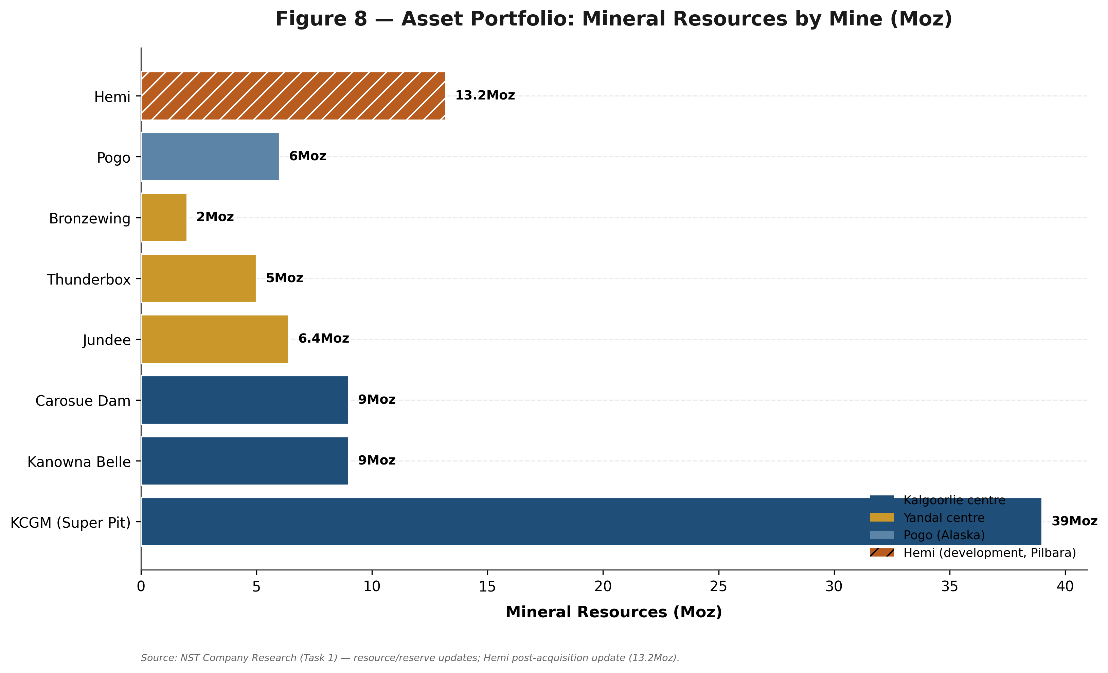
Source: NST Company Research (Task 1) — resource/reserve updates.

Customers & Go-to-Market
Northern Star's go-to-market model differs structurally from most operating businesses because gold is a fungible, globally priced commodity: the company does not sell differentiated products to a portfolio of named commercial customers in the way an industrial or consumer company would. Instead:
• Primary sales channel: Northern Star's investor and sustainability disclosures state the company sells most of its physical gold to the Perth Mint, Australia's government-owned bullion refiner, for final refining into internationally tradeable bullion form. The Perth Mint then on-sells or certifies the refined gold for domestic and international bullion markets; ultimate end-users purchase this refined gold for a range of uses (investment bars/coins, jewellery, central bank reserves, industrial/technology applications).
• Pricing mechanism: Revenue per ounce is a function of the prevailing spot (or near-spot) gold price at the time of sale, not negotiated customer contracts or differentiated product pricing. This means Northern Star's realised gold price closely tracks benchmark pricing (e.g., LBMA gold price, translated to AUD), as evidenced by the FY26 average realised price of A$4,925/oz cited above, which is consistent with the broadly elevated gold-price environment described in Section 6.
• Customer concentration: In the conventional sense used for industrial or consumer businesses (top-10 customer revenue concentration, contract renewal risk, etc.), Northern Star does not carry meaningful customer-concentration risk, because gold is sold into a deep, liquid global market rather than to a small number of price-setting counterparties. The closer analogue to a "concentration risk" is counterparty/logistics dependency on the Perth Mint as the primary refining and sales conduit for the company's doré output — an operational dependency rather than a commercial-negotiation risk, and one common to essentially all Western Australian gold producers given the Mint's role in the state's gold industry.
• Distribution: Doré bars are transported from each mine site's processing plant to the Perth Mint for final refining; this is a logistics and security function rather than a marketing or sales function in the traditional sense.
• No consumer-facing brand or retail distribution: Unlike some royalty, ETF-sponsor or bullion-retail businesses, Northern Star has no consumer-facing brand exposure; its "customer" relationship is fundamentally a wholesale/refining relationship with the Perth Mint, downstream of which the gold enters the global commodity market anonymously.
Given this structure, the appropriate lens for evaluating Northern Star's commercial position is not customer diversification or sales-channel risk, but operational reliability (can the company deliver the ounces it guides to, at the AISC it guides to) and gold-price sensitivity (Section 6) — both of which are addressed in detail elsewhere in this report.
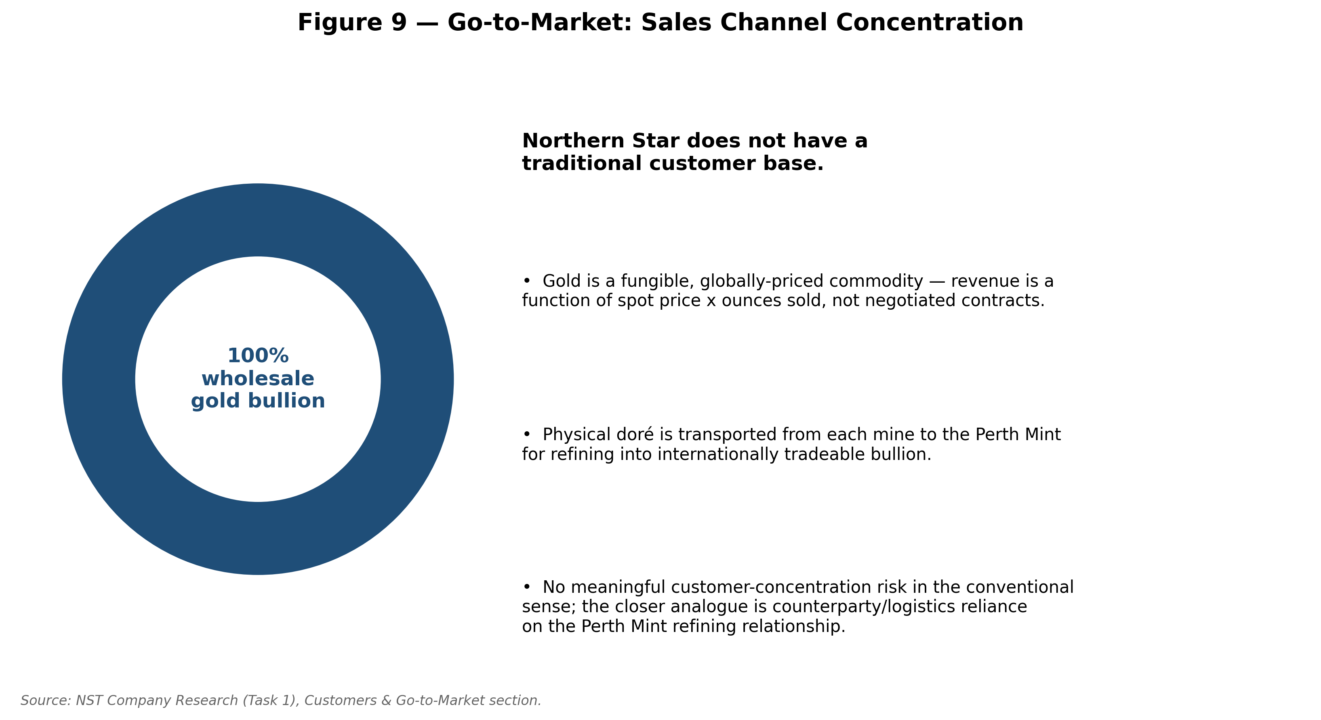
Source: NST Company Research (Task 1), Customers & Go-to-Market section.

Industry Overview
Global gold market. According to the World Gold Council's Gold Demand Trends data, total global gold supply reached a record 5,002 tonnes in 2025 (the highest level in the WGC's data series dating back to 1970), composed of mine production of approximately 3,672 tonnes (about 73% of supply, itself a fresh record, narrowly surpassing the prior 3,663-tonne record set in 2018) and recycled gold of approximately 1,404 tonnes (about 27% of supply, a comparatively muted 3% increase despite a 67% rise in the US-dollar gold price over the year). On the demand side, 2025 total gold demand (including OTC investment) exceeded 5,000 tonnes for the first time on record, with the value of that demand reaching an unprecedented US$555 billion (up 45% year-on-year), driven by record ETF inflows (801 tonnes, the second-strongest year on record), a 12-year high in bar-and-coin buying, and sustained central-bank purchasing. The LBMA (PM) gold price set 53 new all-time highs during 2025, averaging US$3,431/oz for the full year (+44% year-on-year) and US$4,135/oz in the fourth quarter alone (+55% year-on-year).
Central-bank demand has been repeatedly identified across multiple 2026-dated sources as the single most important structural support for gold prices: the World Gold Council's 2026 Central Bank Gold Reserves Survey found 89% of surveyed reserve managers expect global central-bank gold reserves to rise over the next 12 months, and a record 45% expect their own institution's holdings to increase (up from single digits in 2019); a separate industry survey cited in CME Group's 2026 outlook found a near-majority 95% expecting global reserves to increase. Reserve managers cited gold's crisis performance, long-term store-of-value characteristics, and portfolio-diversification benefits as the leading reasons to hold it, alongside a majority expectation that the US dollar's share of global reserves will decline over the next five years as gold's share rises.
2026 price action and forecasts. Gold set an all-time intraday high of US$5,602/oz on 29 January 2026, before falling roughly 28% into an intra-year floor near US$4,000/oz on hawkish Federal Reserve rate expectations, then partially recovering; even after that round trip, gold remained up roughly 31% year-on-year as of mid-2026 commentary. Forecasts for the remainder of 2026 and into 2027 vary meaningfully by institution and by publication date: J.P. Morgan (as of its 9 June 2026 note) forecast gold reaching US$6,000/oz by end-2026 and a possible US$6,300/oz in 2027; the World Bank raised its 2026 average forecast to US$4,700/oz (from US$3,575/oz) in an April 2026 update; UBS lifted its year-end 2026 target to US$4,800/oz; Standard Chartered's Q4 2026 forecast (3 August 2026) was US$4,650/oz; by contrast, StoneX held a more bearish view, expecting a retreat toward roughly US$4,000/oz by end-2026. This spread of outcomes is directly relevant to Northern Star: FY27 AISC guidance of A$3,050–3,450/oz means group cash margins remain healthy under most published 2026–27 gold-price scenarios, but the bearish tail of forecasts (e.g., StoneX) would compress margins meaningfully relative to the FY26 realised price of A$4,925/oz.
Australian and Western Australian gold industry. Western Australia is the dominant Australian gold-producing state and, per Wikipedia's compilation of Western Australian government data, gold mining is WA's third-largest commodity sector behind iron ore and LNG, with a value of roughly A$17 billion in 2021–22 and roughly A$18.6 billion in 2022–23; WA gold production of around 6.27–6.9 million troy ounces (approximately 195–215 tonnes) in recent reported years represented on the order of 6% of world gold supply and around 70% of all gold sold in Australia. Gold in Western Australia is regulated principally under the Mining Act 1978 (WA) and the Mining (Royalties) Regulations 2025 (superseding the earlier 1981 Regulations), administered by the WA Department of Mines, Industry Regulation and Safety / RevenueWA. Under Section 9 of the Mining Act 1978, gold, silver and other precious metals existing in their natural condition are property of the Crown; producers pay an ad valorem royalty on gold — currently 2.5% of the royalty value of gold produced, based on the Australian-dollar London Bullion Market gold price — a royalty first introduced in 1997 (prior to which gold had been the sole mineral exempted from WA royalties). As the gold price has risen sharply through 2025–26, this ad valorem structure has mechanically increased the dollar royalty burden on WA producers including Northern Star, a point the company itself has cited as a driver of rising AISC guidance.
Sector dynamics and consolidation. The ASX gold sector has seen a wave of consolidation through 2025–26 as elevated gold prices and strong producer free cash flow have made scale-driven M&A attractive: Gold Fields Limited (JSE: GFI) agreed to acquire Gold Road Resources for roughly A$3.6 billion (A$3.29/share); Genesis Minerals (ASX: GMD) agreed to merge with Vault Minerals (ASX: VAU) — the largest Australian gold-sector deal of 2026 at the time it was reported, expected to close around November 2026 and projected to unlock around A$2 billion of synergies given the proximity of the companies' Leonora-district Western Australian operations (as close as 35km apart) — a deal that emerged after Regis Resources' earlier, smaller (roughly A$500 million synergy) competing proposal was withdrawn. Sector participants describe an environment in which "all the companies in the [Australian gold] space are always looking at each other" for inorganic opportunities. Regulatory and social themes cited across 2026 industry commentary include increasing resource-nationalism/regulatory scrutiny, native-title and heritage-approval requirements (a live consideration for Northern Star's Pilbara Hemi project specifically, discussed in Section 8), and a broader industry shift toward automation, digital exploration tools (AI/satellite-based prospectivity mapping) and supply-chain/refining security.
Net assessment for this build: Northern Star operates in a highly favourable macro-price environment for gold (record demand value, near-consensus expectation of continued central-bank accumulation, and a wide but generally constructive spread of 2026–27 price forecasts), within a well-established, transparent Western Australian regulatory and royalty framework, in a sector experiencing active scale-consolidation — all of which forms useful context for the valuation work in later tasks, but none of which offsets the company-specific execution and governance risks detailed in Section 9.
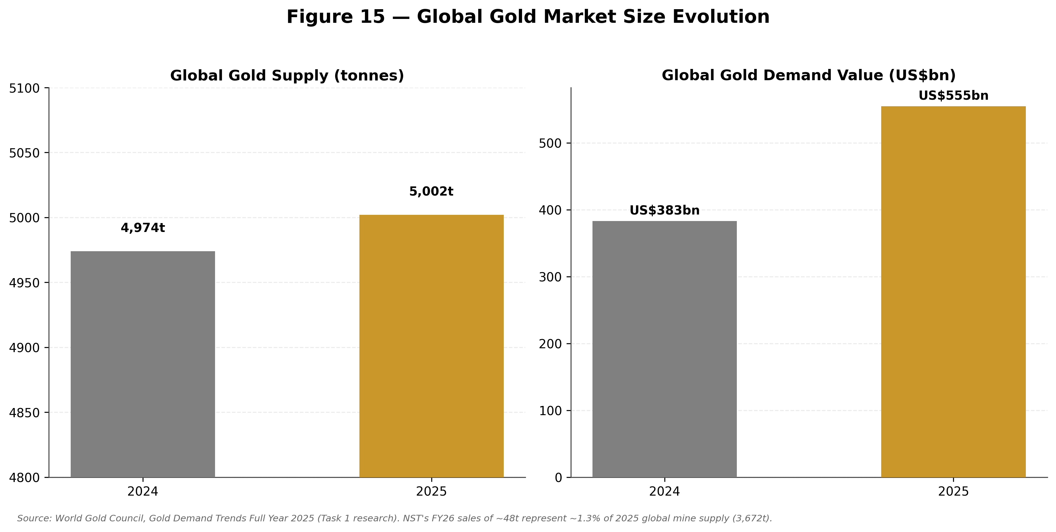
Source: World Gold Council, Gold Demand Trends Full Year 2025 (Task 1 research).

Competitive Landscape
Northern Star is the largest of a group of "Tier-1" ASX-listed gold producers that also includes Evolution Mining (ASX: EVN), Newmont Corporation's ASX-quoted CDIs (ASX: NEM), Greatland Resources (ASX: GGP), Perseus Mining (ASX: PRU), Ramelius Resources (ASX: RMS), Genesis Minerals (ASX: GMD), Westgold Resources (ASX: WGX), Regis Resources (ASX: RRL) and Capricorn Metals (ASX: CMM) — together representing the majority of the ASX gold sector's total market capitalisation and a significant share of Australia's annual gold output.
Evolution Mining (ASX: EVN) is, alongside Northern Star, one of the two dominant domestic Australian gold producers and is Northern Star's closest large-cap peer for comparative purposes. Evolution operates five mines across Queensland, New South Wales and Western Australia, plus the Red Lake gold mine in Ontario, Canada, giving it a broader geographic spread than Northern Star (which is concentrated in WA plus Alaska). Evolution has also been reported as one of the lowest-cost producers in the sector — AISC of roughly A$1,616/oz in its March 2025 quarter — materially below Northern Star's FY26 group AISC of A$2,698/oz, though the two companies' asset mixes and reporting periods are not perfectly comparable. Evolution's share price appreciated by around 87% into mid-2025 on the back of gold-price leverage and operating performance, and is frequently cited in 2026 sector commentary as the standard against which Northern Star's recent operational underperformance is benchmarked — a comparison central to the Elliott Investment Management activist thesis described in Section 2.
Newmont Corporation (ASX CDI: NEM) is the world's largest gold miner by production, with a globally diversified portfolio across Africa, Australia, Latin America and the Caribbean, North America, and Papua New Guinea. Its Australian assets include Boddington (Western Australia — a large, long-life operation industry commentary has directly compared to Hemi as one of the most significant Australian gold discoveries of recent decades) and Tanami (Northern Territory). Newmont is generally regarded by sell-side commentary (e.g., Macquarie, mid-2026) as the preferred large-cap pick in the sector, citing strong free cash flow generation (around 10% per annum over three years, per that research), a large approved buyback (US$6 billion, with US$1.9 billion already spent in a recent quarter cited), and a strong net cash position (around US$3.2 billion) — underscoring the scale of balance-sheet firepower against which Northern Star, itself carrying substantial growth capex commitments, is implicitly compared.
Genesis Minerals (ASX: GMD) operates the Leonora district gold operations in Western Australia (Admiral open pit, Orient Well and Puzzle deposits, Gwalia and Ulysses underground mines, and a 3Mtpa Leonora mill), plus Laverton operations (Hub open pit, Laverton mill), and runs its own in-house mining services arm rather than outsourcing. Genesis's pending merger with Vault Minerals (see Section 6) will meaningfully increase its scale and is a direct example of the consolidation dynamic reshaping the mid-tier ASX gold space around Northern Star.
Perseus Mining (ASX: PRU) offers a useful risk-profile contrast: it operates all three of its producing mines in West Africa (Ghana and Côte d'Ivoire, including the Edikan mine), giving it materially higher jurisdictional/political risk than Northern Star's Australia/Alaska footprint, which is a differentiator Northern Star and its peers with Tier-1 jurisdiction exposure emphasise to investors.
Regis Resources (ASX: RRL) holds a 30% joint-venture stake in the Tropicana gold mine in Western Australia (with AngloGold Ashanti, NYSE: AU, holding the balance and reportedly having considered selling its stake), and was an unsuccessful bidder for Vault Minerals, losing out to Genesis Minerals' higher offer.
Other named Tier-1 or near-Tier-1 peers include Ramelius Resources (RMS) and Westgold Resources (WGX), both cited in multiple 2026 sector round-ups as leading ASX gold names, and Capricorn Metals (CMM), identified by Macquarie mid-2026 (alongside Genesis) as a preferred mid-cap pick given a comparatively low ~5x forward EV/EBITDA multiple. Gold Road Resources was itself a significant sector participant (and, via its prior 17.3%-plus stake in De Grey Mining, an indirect beneficiary of the Northern Star/De Grey deal) until its 2026 acquisition by South Africa's Gold Fields Limited for approximately A$3.6 billion — removing Gold Road as an independent competitor but leaving Gold Fields as a newly significant Northern Star shareholder (see Section 3).
Competitive positioning assessment. Northern Star's principal competitive advantages are scale (largest ASX gold producer by market capitalisation), a long-life, multi-decade resource base concentrated in genuinely Tier-1 jurisdictions (Western Australia and Alaska), and a growth pipeline (KCGM expansion, Hemi) that, if delivered on plan, would extend its production and cost-curve leadership for years. Its principal competitive vulnerability, repeatedly emphasised in 2026 commentary, is execution: a pattern of guidance downgrades through FY26 (production cut from an original range above 1.7Moz to 1.6–1.7Moz; AISC guidance raised twice) has caused the stock to trade, in the words of one activist-focused analysis, "at a material discount to global peers" despite what that same analysis (echoing Elliott's own investor presentation) describes as a genuinely "world-class" asset base — KCGM framed as having the potential to become the world's second-largest Tier-1 gold mine post-expansion, Hemi framed as "the largest gold development project in Australia," and Pogo framed as a high-grade, decade-plus-life, cash-generative asset. Closing that execution/perception gap — whether under continuing independent management following the CEO/Chair transition, or under some alternative structure Elliott continues to advocate for — is arguably the central strategic question facing the company as this report is prepared.
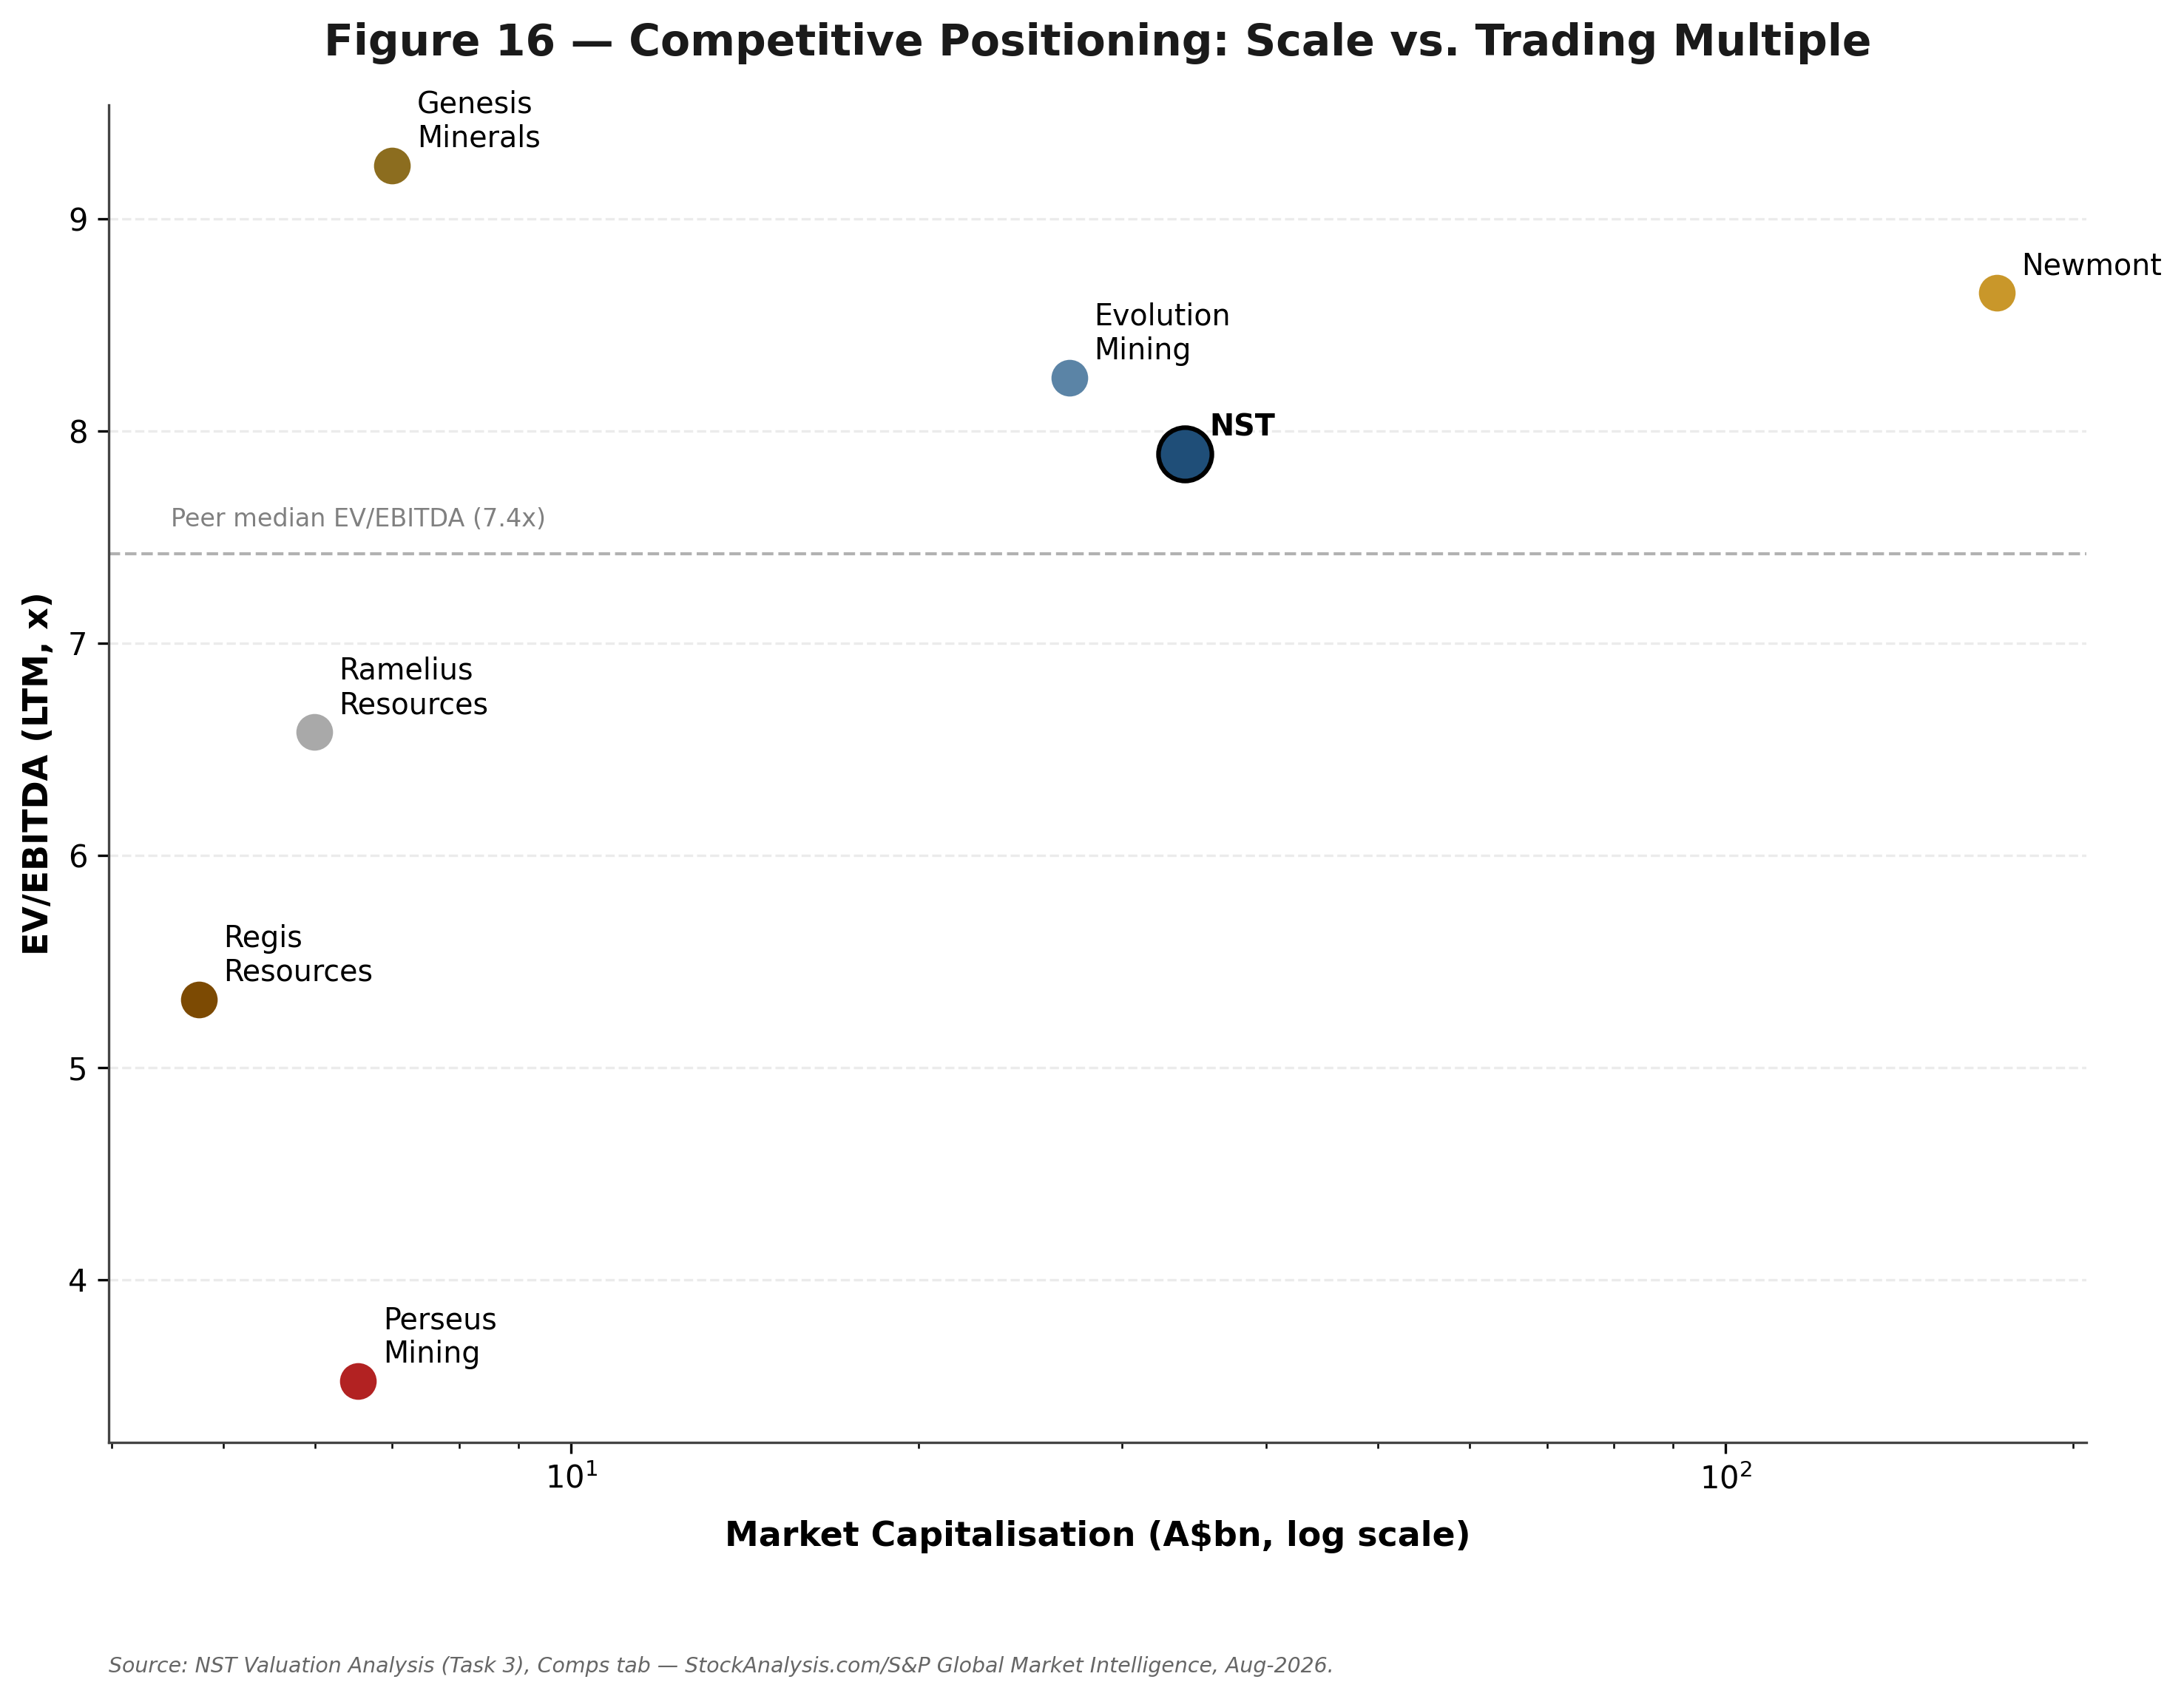
Source: NST Valuation Analysis (Task 3), Comps tab.
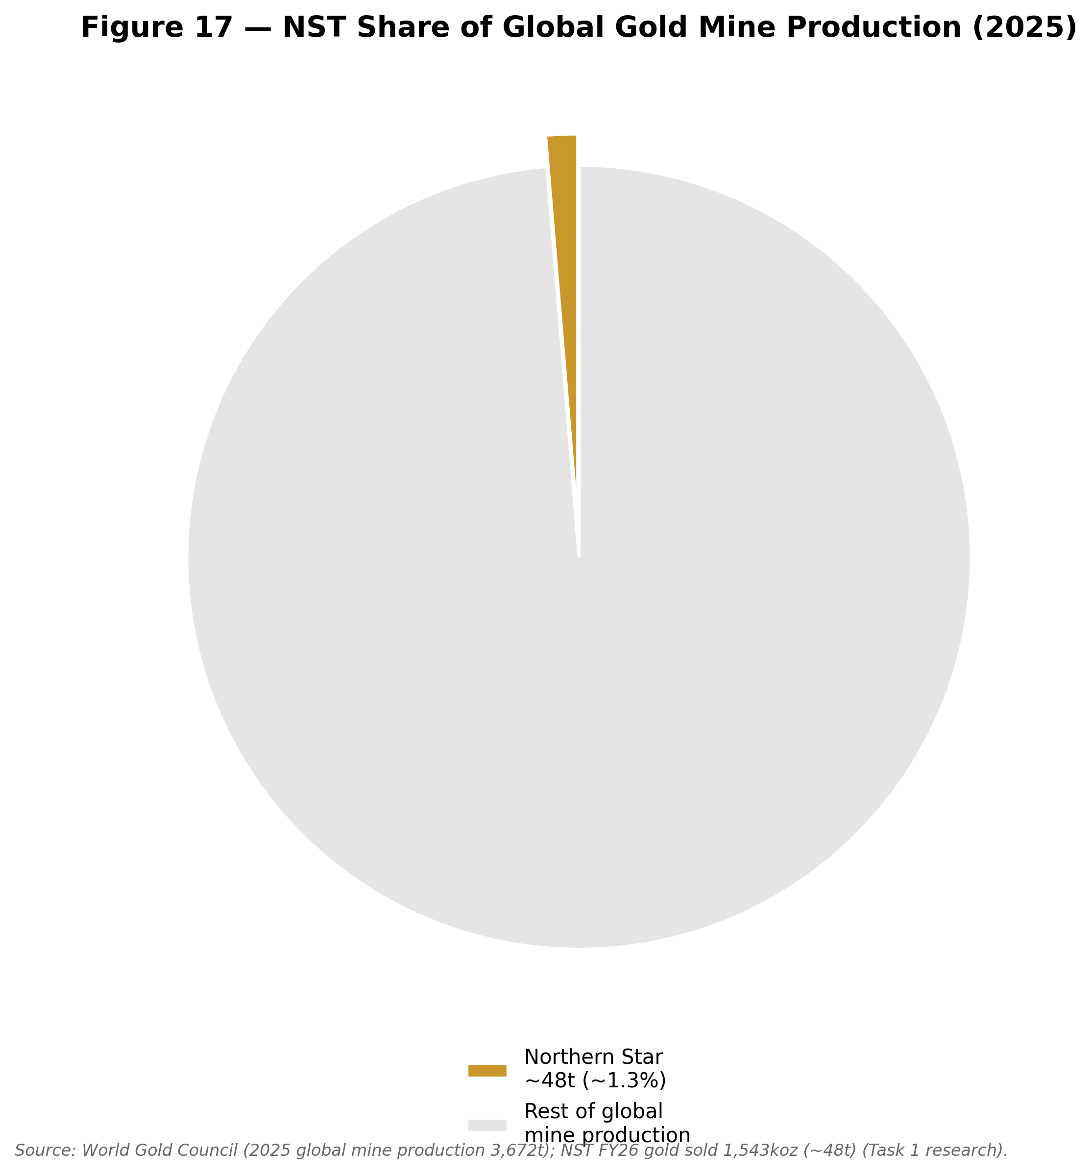
Source: World Gold Council 2025 global mine production; NST FY26 gold sold (Task 1 research).
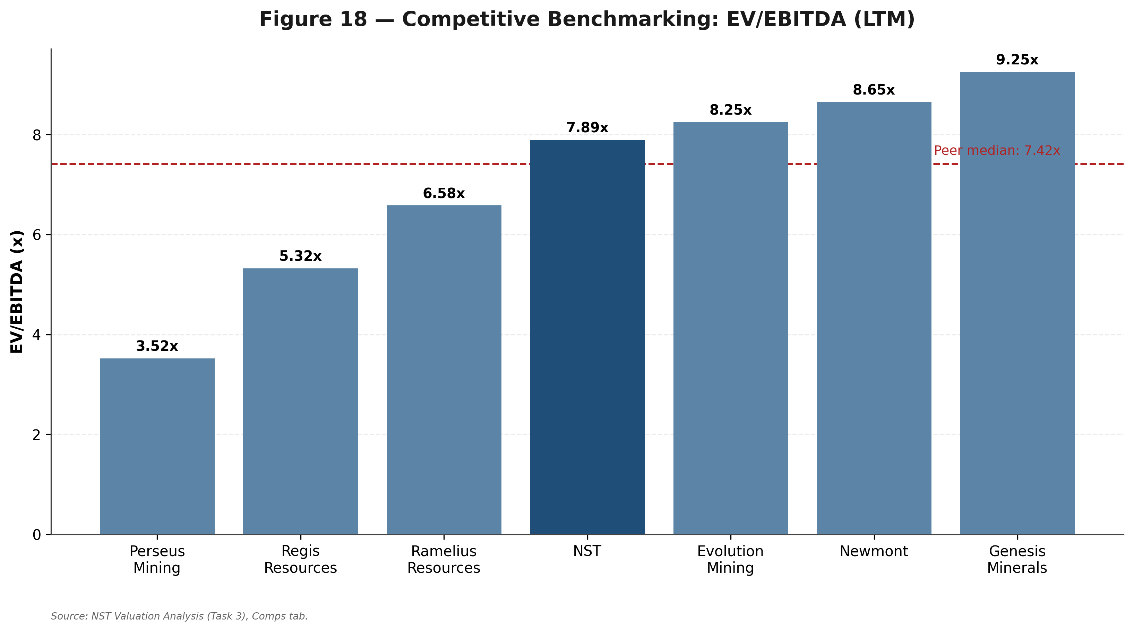
Source: NST Valuation Analysis (Task 3), Comps tab.

Market Opportunity (TAM)
Because Northern Star sells into a single, globally fungible commodity market rather than a differentiated product market, the relevant "TAM" framing is the global gold market itself, together with Northern Star's specific, identifiable avenues for growing its share of physical gold production.
Total addressable market — global gold. As detailed in Section 6, global gold demand (including OTC investment) exceeded 5,000 tonnes for the first time in 2025, with an aggregate value of US$555 billion — a useful proxy for the annual "flow" market Northern Star's output is sold into. On a stock basis, the world's total above-ground gold supply stood at 216,265 tonnes as of year-end 2024, which one widely cited data visualisation (based on a gold price of US$4,166/oz) valued at approximately US$29 trillion; including identified below-ground (reserve/resource) gold, total identified gold reaches roughly 348,375 tonnes, valued at a combined US$47 trillion-plus at that reference price. These figures illustrate that gold mining is a large but fundamentally fragmented global industry — no single producer, including giants like Newmont or Barrick, holds more than a low single-digit percentage share of annual mine supply.
Northern Star's serviceable share. Against 2025 global mine production of approximately 3,672 tonnes (roughly 118 million ounces), Northern Star's FY26 gold sales of 1,543koz (approximately 48 tonnes) represent roughly 1.3% of global annual mine supply — a small share of a very large market, consistent with the fragmented, multi-producer structure of the industry. This framing implies that Northern Star's growth is realistically driven not by "market share capture" in a competitive-displacement sense, but by (a) organic reserve growth and throughput expansion at existing assets, and (b) development of new production centres — both levers the company is actively pulling via the two projects below.
Growth avenue 1 — KCGM Mill (Fimiston) Expansion. Approved in June 2023 at an initial A$1.5 billion, this project lifts KCGM processing capacity to 27Mtpa from FY27, and is described by the company as the largest Australian gold project in over a decade. Cumulative growth capital guidance for the project had risen to a range around A$2.3–2.4 billion by 2026 disclosures, reflecting inflationary pressure. Commissioning of the new Fimiston plant was underway as of the August 2026 FY26 result, positioning KCGM — per Elliott's own investor materials, cited for context rather than endorsement — as a potential second-largest Tier-1 gold mine globally post-expansion, atop a resource base described in company materials as approximately 39 million ounces at KCGM alone.
Growth avenue 2 — Hemi Development Project (Pilbara). Acquired via the A$5 billion (rising above A$6 billion by completion) De Grey Mining takeover completed 5 May 2025, Hemi is located in the Pilbara region of Western Australia, roughly 85km south of Port Hedland. Discovered in 2019, Hemi is an intrusion-hosted gold system — geologically distinct from the shear-hosted deposits typical of the Western Australian goldfields — and has been described in trade commentary as "the most significant Australian gold discovery since Boddington" (Newmont's 22-million-ounce WA deposit). At the time of the De Grey transaction, Hemi carried a Mineral Resource estimate of 264 million tonnes at 1.3g/t gold for 11.2 million ounces, and Ore Reserves of approximately 6.0 million ounces, with a Definitive Feasibility Study (completed September 2023 by De Grey) forecasting average annual production of approximately 530,000oz over the project's first 10 years, at an initial AISC estimate of roughly A$1,200–1,300/oz (based on a A$2,700/oz gold-price assumption at the time of that study — since roughly doubled), an estimated development capital cost in the order of A$1.3 billion (with the Australian Government's Australian Industry Participation Plan filing citing a broader A$1–2 billion capex range), and a projected post-tax project value of approximately A$2.9 billion at a 36% internal rate of return under the original DFS assumptions. Construction was reported to have started in mid-2024 (under De Grey's ownership, pre-acquisition), with first gold originally targeted for mid-2026; however, subsequent sell-side commentary (Jarden, at the time of the acquisition announcement) flagged permitting as a schedule risk and pushed its own first-production expectation to around FY27, and 2026-dated industry commentary confirms that environmental and heritage approvals under Western Australian and Commonwealth frameworks, and a Definitive Feasibility Study specific to Northern Star's own updated mine plan, remain necessary preconditions to a formal Final Investment Decision — meaning Hemi's precise production start date and updated capital/operating cost estimates should be treated as not yet fully locked in as of this report's date, an important flag for the valuation and modelling tasks that follow.
Combined, absent Hemi, the company's own historical strategic-plan materials (2021 Investor Day; 2023 KCGM Mill Expansion FID presentation) had targeted group production of approximately 2.0 million ounces per annum by FY26 and, including Hemi's contribution post-ramp-up, approximately 2.5 million ounces per annum by FY29 — though these targets pre-date the FY26 guidance downgrades described in Section 2 and should be treated as directional rather than current guidance; updated multi-year production targets, if any, should be sourced from the most recent FY26 results materials and any subsequent strategic-plan update (particularly relevant given the pending CEO transition) before being relied upon in financial modelling.

Financial Analysis

Historical Performance
Northern Star's revenue grew from A$4,131M in FY23A to A$7,620M in FY26A, a 23% compound annual growth rate, though the path was uneven: FY24A grew a modest 19.1% as Kalgoorlie absorbed East Wall remediation costs and Yandal faced maintenance headwinds, before FY25A accelerated to 30.4% growth as the gold price rose sharply (average realised price up from A$3,031/oz to A$3,922/oz) and KCGM's operational recovery took hold. FY26A growth moderated to 18.8% even as the realised gold price rose a further 25.6% to A$4,925/oz, because gold sold fell 5.6% to 1,543koz — the direct result of the guidance downgrades detailed below. This is the central historical pattern investors need to understand: Northern Star's revenue growth over the past three years has been driven overwhelmingly by price, not volume, and FY26A was the first year in this window where rising prices could not fully offset a genuine production shortfall.
Underlying EBITDA tells a similarly price-driven story, growing from A$1,537M (FY23A, 37.2% margin) to A$4,272M (FY26A, 56.1% margin) — margin expansion of nearly 19 percentage points over three years. Cash margin per ounce (realised price less AISC, the mining-sector analogue of gross margin) expanded from A$884/oz in FY23A to A$2,227/oz in FY26A, even as AISC itself rose from A$1,759/oz to A$2,698/oz (+53%). The message is unambiguous: cost inflation has been real and persistent across the period, but it has been comfortably outpaced by gold-price appreciation. That relationship is exactly what FY27E guidance signals is about to change, at least temporarily — AISC is guided to a further A$3,050-3,450/oz (peak, +19% at the midpoint vs. FY26A) precisely as the realised-price tailwind, while still expected to be positive, is assumed in this report to moderate to more modest single-digit growth.
Underlying free cash flow has been volatile and, on a standalone basis, unimpressive relative to the strength of the P&L: A$359M in FY23A, A$462M in FY24A, A$536M in FY25A, and just A$190M in FY26A — a decline of 64% year-on-year despite EBITDA growing 22%. The entire gap is capital expenditure: Northern Star is mid-way through the largest Australian gold project in over a decade (the KCGM Mill Expansion) while simultaneously funding early-stage Hemi development spend, and management has been explicit that FY26A represented 'the peak investment phase' of the KCGM project specifically. Cash Earnings — the company's own defined metric, calculated as EBITDA less sustaining capital, net interest and cash tax — held up far better, at A$2,900M in FY26A (up from A$2,873M in FY25A), because it excludes growth capital. The 27-percentage-point gap between Cash Earnings growth (+1%) and Underlying EBITDA growth (+22%) is fully explained by rising sustaining capital and tax, not by a deterioration in the underlying cash-generative quality of the business.
Underlying EPS grew from an implied historical base to A$1.24 in FY26A (+5% year-on-year per the company's own disclosure), a far more modest rate of growth than the 22% EBITDA increase would suggest, reflecting both the heavier current depreciation charge from capitalised KCGM expansion spend and share-count dilution from the scrip-funded De Grey acquisition (weighted average shares rose from approximately 1,148M in the FY25A comparative period to approximately 1,430M by FY26A). Return on Capital Employed nonetheless improved to 13.4% in FY26A, up 18% year-on-year, evidence that the growth capital being deployed is, to date, generating incremental returns rather than simply diluting the existing asset base.
Balance sheet capacity remains a genuine strength through this investment phase: Northern Star held A$1.2bn in cash and bullion at FY26A year-end (down from A$1.9bn in FY25A, reflecting the capital cycle), against a single US$600M (approximately A$883-901M) Senior Guaranteed Notes issue at a fixed 6.125% coupon, maturing April 2033. Three investment-grade credit ratings (Baa3/BBB-/BBB-) have been maintained throughout the current investment cycle, and management reports gearing, leverage and liquidity metrics 'all comfortably within' internal financial targets — a claim this report has no basis to dispute given the disclosed net cash position of approximately A$317M at FY26A year-end.
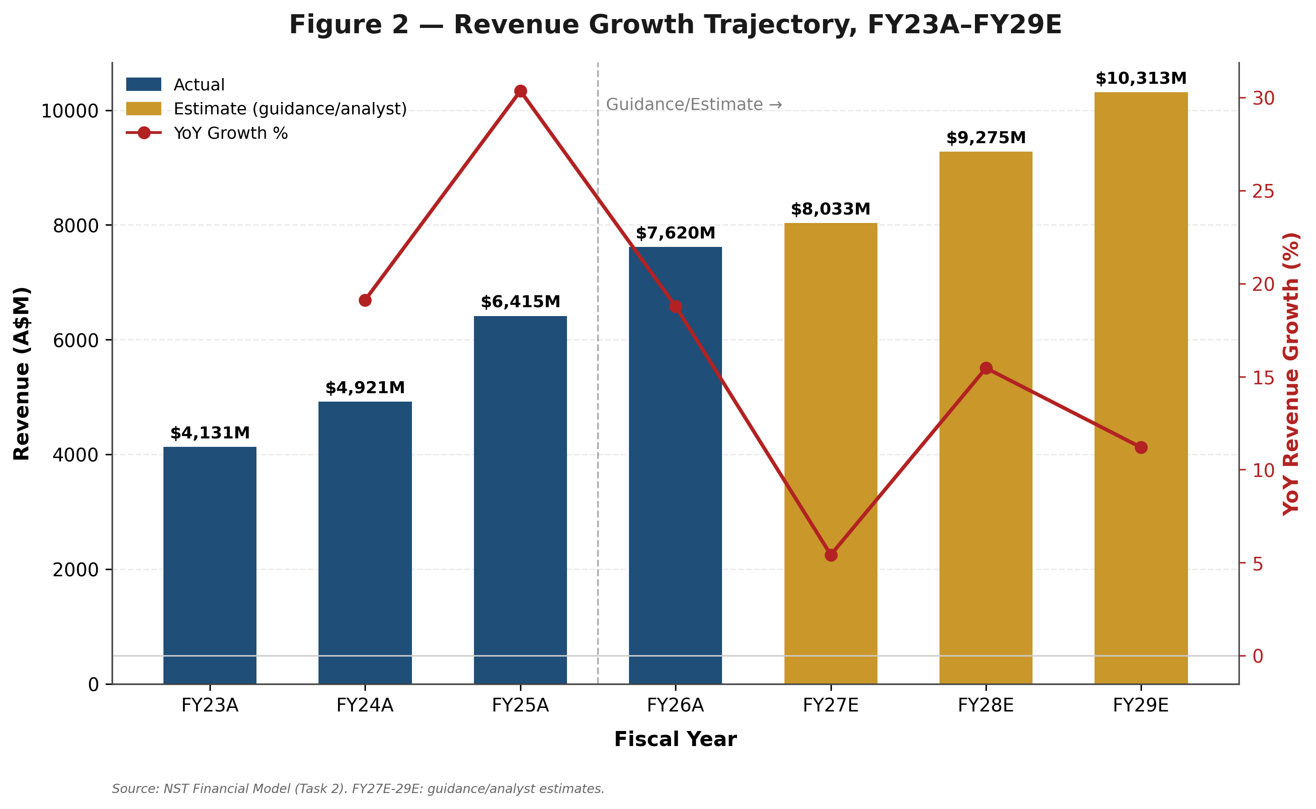
Source: NST Financial Model (Task 2). FY27E-29E: guidance/analyst estimates.
Table: Summary Income Statement, FY23A-FY29E
A$M unless noted | FY23A | FY24A | FY25A | FY26A | FY27E | FY28E | FY29E
Total Revenue | 4,131 | 4,921 | 6,415 | 7,620 | 8,033 | 9,275 | 10,313
Revenue growth | n/a | 19.1% | 30.4% | 18.8% | 5.4% | 15.5% | 11.2%
Group AISC | 1,759 | 1,853 | 2,163 | 2,698 | 3,250 | 2,950 | 2,800
Total AISC Cost | 2,749 | 3,004 | 3,534 | 4,163 | 5,119 | 5,163 | 5,250
Underlying EBITDA | 1,537 | 2,192 | 3,502 | 4,272 | 3,797 | 5,012 | 5,983
EBITDA margin % | 37.2% | 44.5% | 54.6% | 56.1% | 47.3% | 54.0% | 58.0%
Depreciation & Amortisation | n/a — not sourced | 1,132 | 1,365 | 1,427 | 1,733 | 1,925 | 2,025
Underlying EBIT | 1,537 | 2,192 | 3,502 | 4,272 | 3,797 | 5,012 | 5,983
Underlying pre-tax profit | n/a | n/a | 2,061 | n/a | 1,986 | 3,009 | 3,880
Underlying NPAT | 585 | 689 | 1,415 | 1,773 | 1,370 | 2,076 | 2,677
NPAT margin % | 14.2% | 14.0% | 22.1% | 23.3% | 17.1% | 22.4% | 26.0%
Weighted average shares | n/a — not sourced | n/a — not sourced | 1,148 | 1,430 | 1,416 | 1,402 | 1,388
Underlying EPS (A$) | n/a | n/a | 1.23 | 1.24 | 0.97 | 1.48 | 1.93
Source: NST Financial Model (Task 2), Income Statement tab. FY23A-FY26A actuals sourced to company filings/presentations (see Task 2 README for full citations); FY27E from company guidance; FY28E-29E are Task 2 analyst assumptions, not company guidance.

Revenue by Production Centre
Northern Star does not disclose segment revenue directly; the split shown below is derived from disclosed segment EBITDA and EBITDA margin (Segment Revenue = Segment EBITDA ÷ Segment Margin), and is only available for FY25A and FY26A. FY23A-FY24A are not shown, consistent with this report's governing accuracy protocol, which requires omitting unsupported figures rather than estimating them without a disclosed basis.
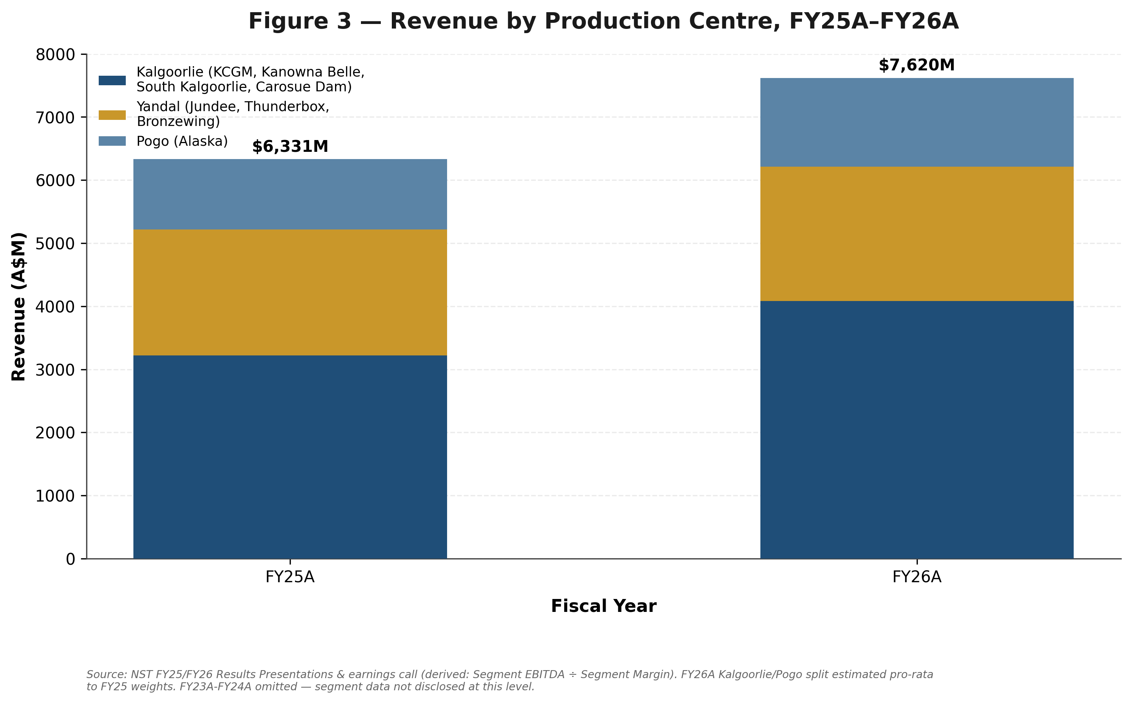
Source: NST FY25/FY26 Results Presentations & earnings call transcript (derived: Segment EBITDA ÷ Segment Margin). FY26A Kalgoorlie/Pogo split estimated pro-rata to FY25 weights.
Table: Revenue by Production Centre, FY25A-FY26A (A$M, derived)
Production Centre | FY25A | % of Total | FY26A | % of Total
Kalgoorlie (KCGM, Kanowna Belle, South Kalgoorlie, Carosue Dam) | 3,220 | 50.9% | 4,090 | 53.7%
Yandal (Jundee, Thunderbox, Bronzewing) | 2,000 | 31.6% | 2,128 | 27.9%
Pogo (Alaska) | 1,111 | 17.6% | 1,402 | 18.4%
Total | 6,331 | 100.0% | 7,620 | 100.0%

Revenue by Geography
Geographic revenue maps directly onto production centre location: Kalgoorlie and Yandal are both located in Western Australia; Pogo is located in Alaska, United States. On this basis, Australia represented approximately 83-84% of group revenue in both FY25A and FY26A, with the United States (Alaska) contributing the balance.
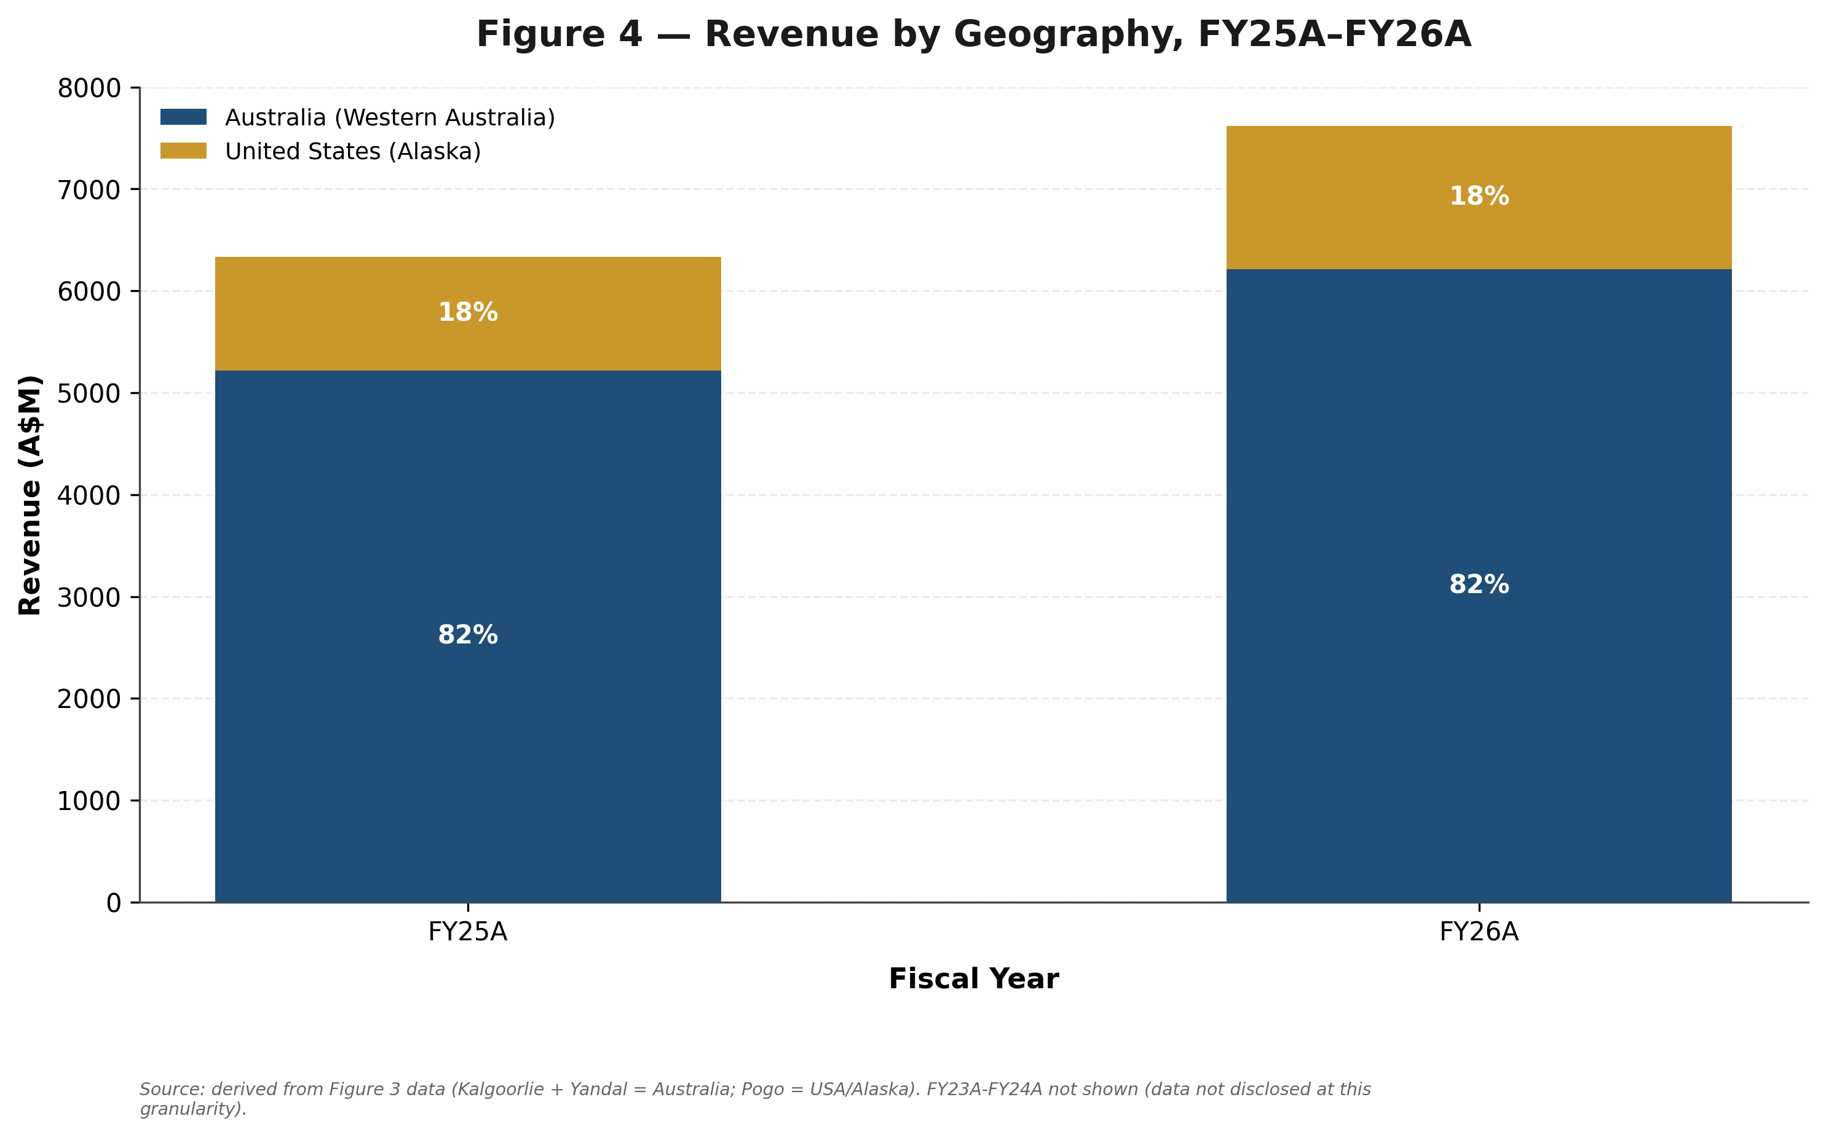
Source: Derived from Figure 3 data (Kalgoorlie + Yandal = Australia; Pogo = USA/Alaska).
Table: Revenue by Geography, FY25A-FY26A (A$M, derived)
Geography | FY25A | % of Total | FY26A | % of Total
Australia (Western Australia) | 5,220 | 82.4% | 6,218 | 81.6%
United States (Alaska) | 1,111 | 17.6% | 1,402 | 18.4%
Total | 6,331 | 100.0% | 7,620 | 100.0%

Margins, Cash Flow & Operating Metrics
Cash margin per ounce — realised price less AISC, this report's mining-sector analogue of gross margin — expanded from A$884/oz in FY23A to a peak A$2,227/oz in FY26A before guidance implies compression to an estimated A$1,850/oz in FY27E as AISC peaks, then recovering to an estimated A$2,700/oz by FY29E as the KCGM mill reaches fuller utilisation.
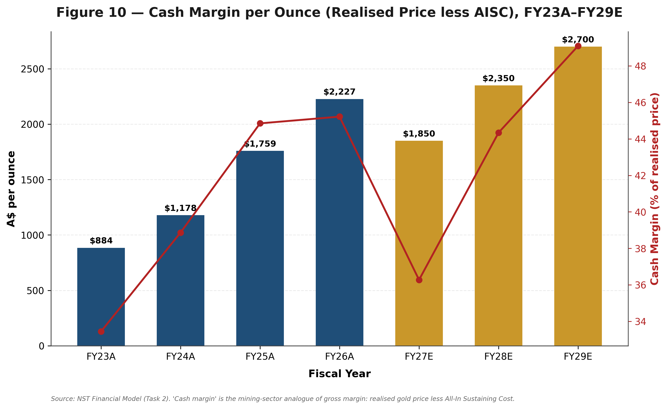
Source: NST Financial Model (Task 2).
Underlying EBITDA margin follows the same pattern: 54.6% (FY25A), 56.1% (FY26A), an estimated dip to 47.3% (FY27E), before recovering to an estimated 58.0% by FY29E as volumes scale against a largely fixed cost base.
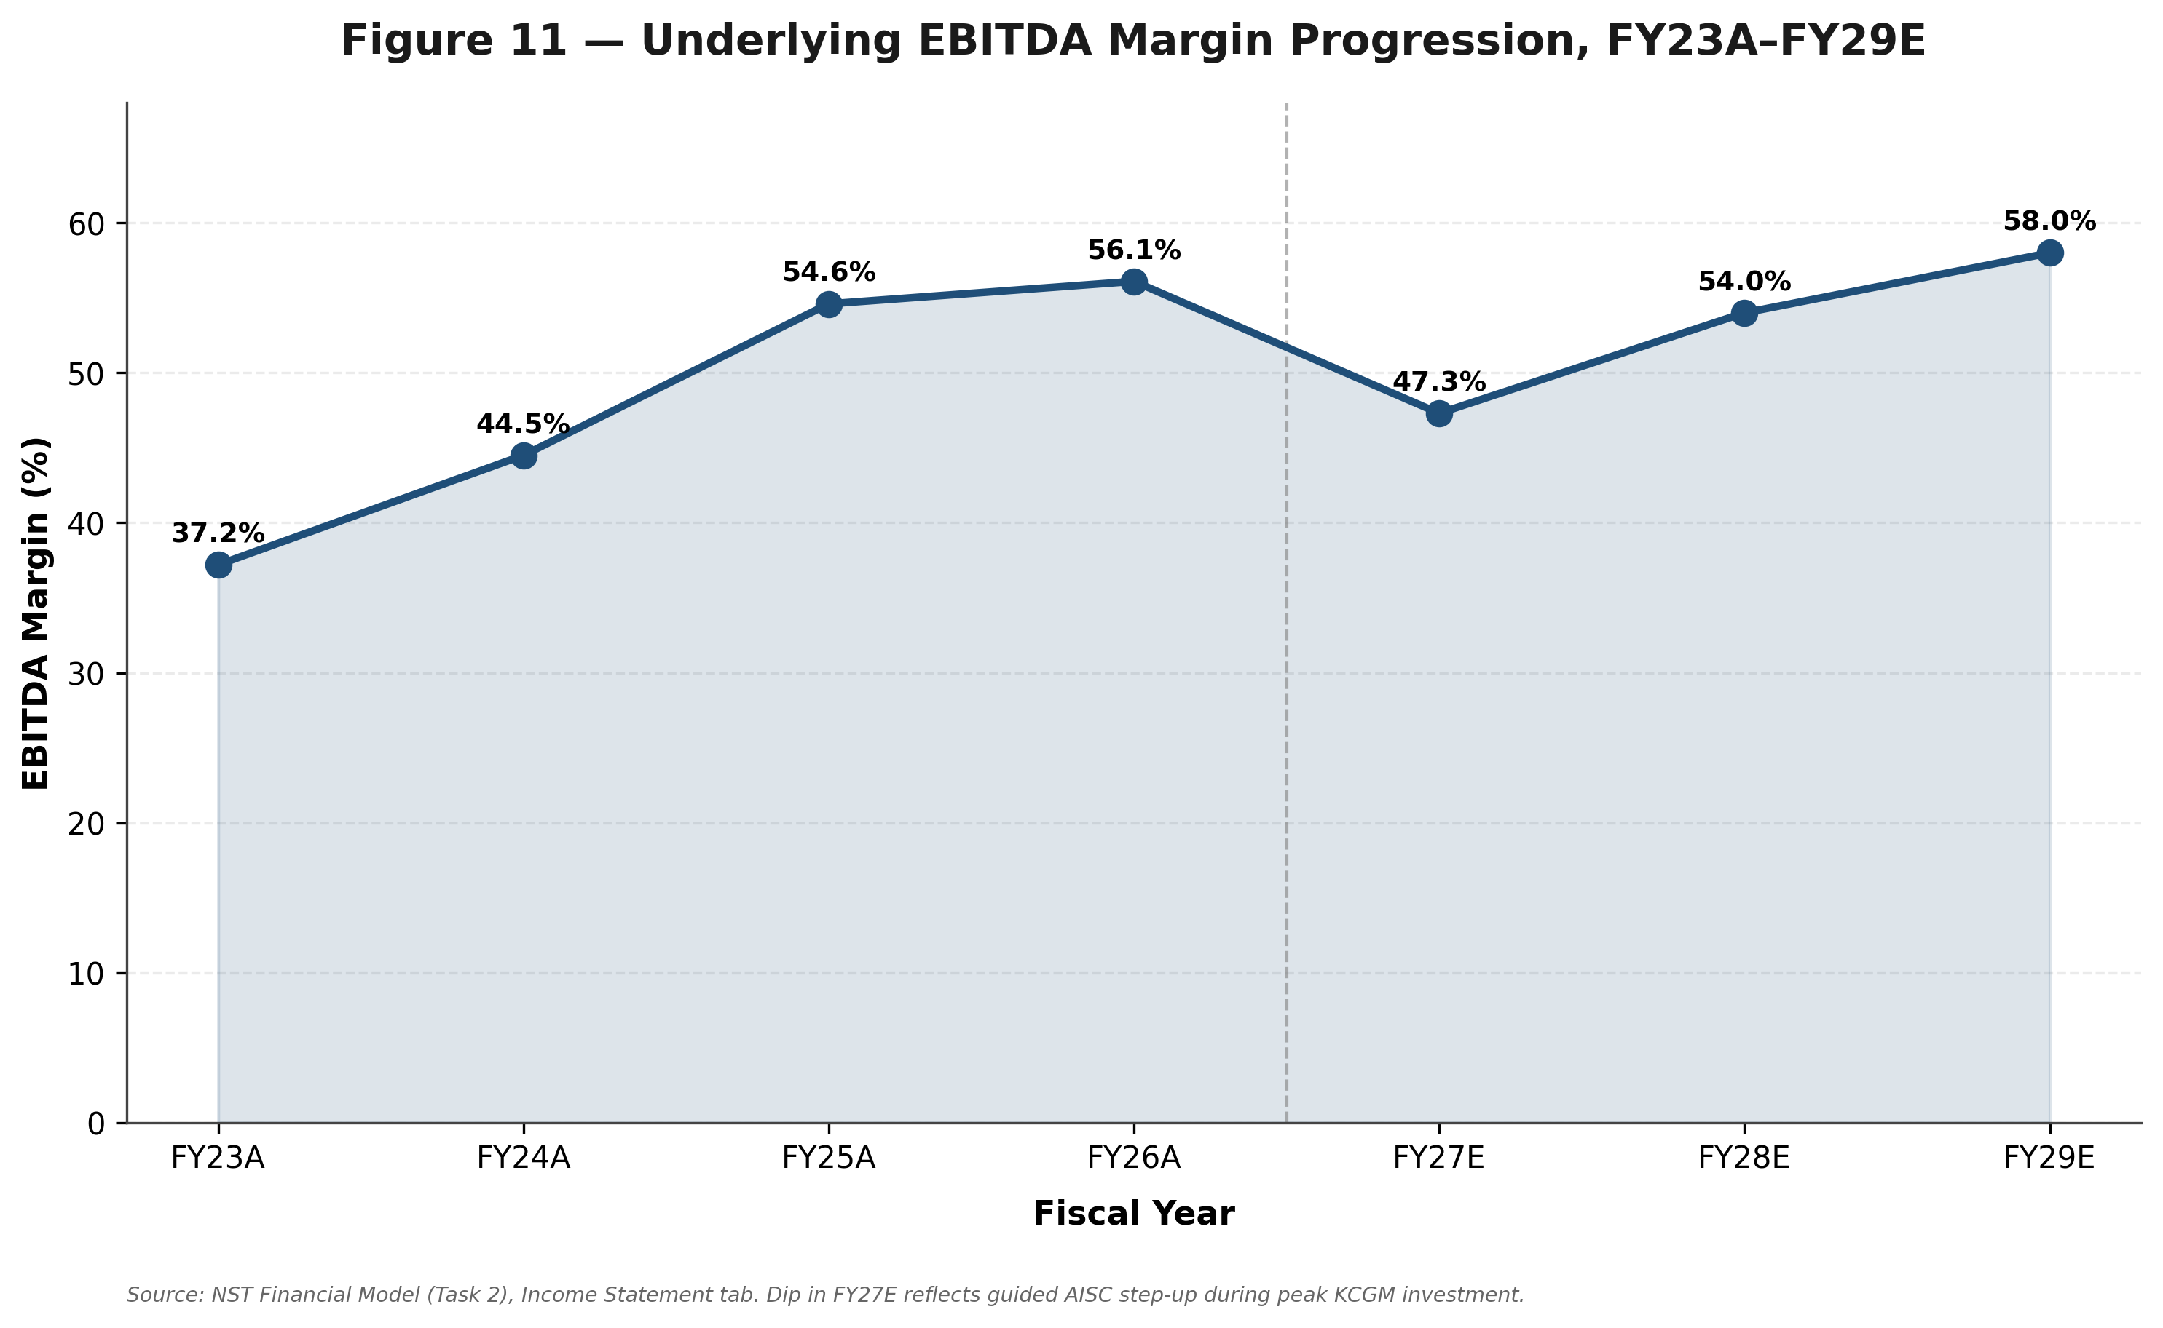
Source: NST Financial Model (Task 2), Income Statement tab.
Underlying Free Cash Flow is this report's clearest single illustration of the FY27 trough thesis: from A$536M (FY25A) to A$190M (FY26A) to an estimated trough of just A$175M (FY27E), before an estimated sharp recovery to A$1,415M (FY28E) and A$2,191M (FY29E) as growth capital moderates post-KCGM-completion.
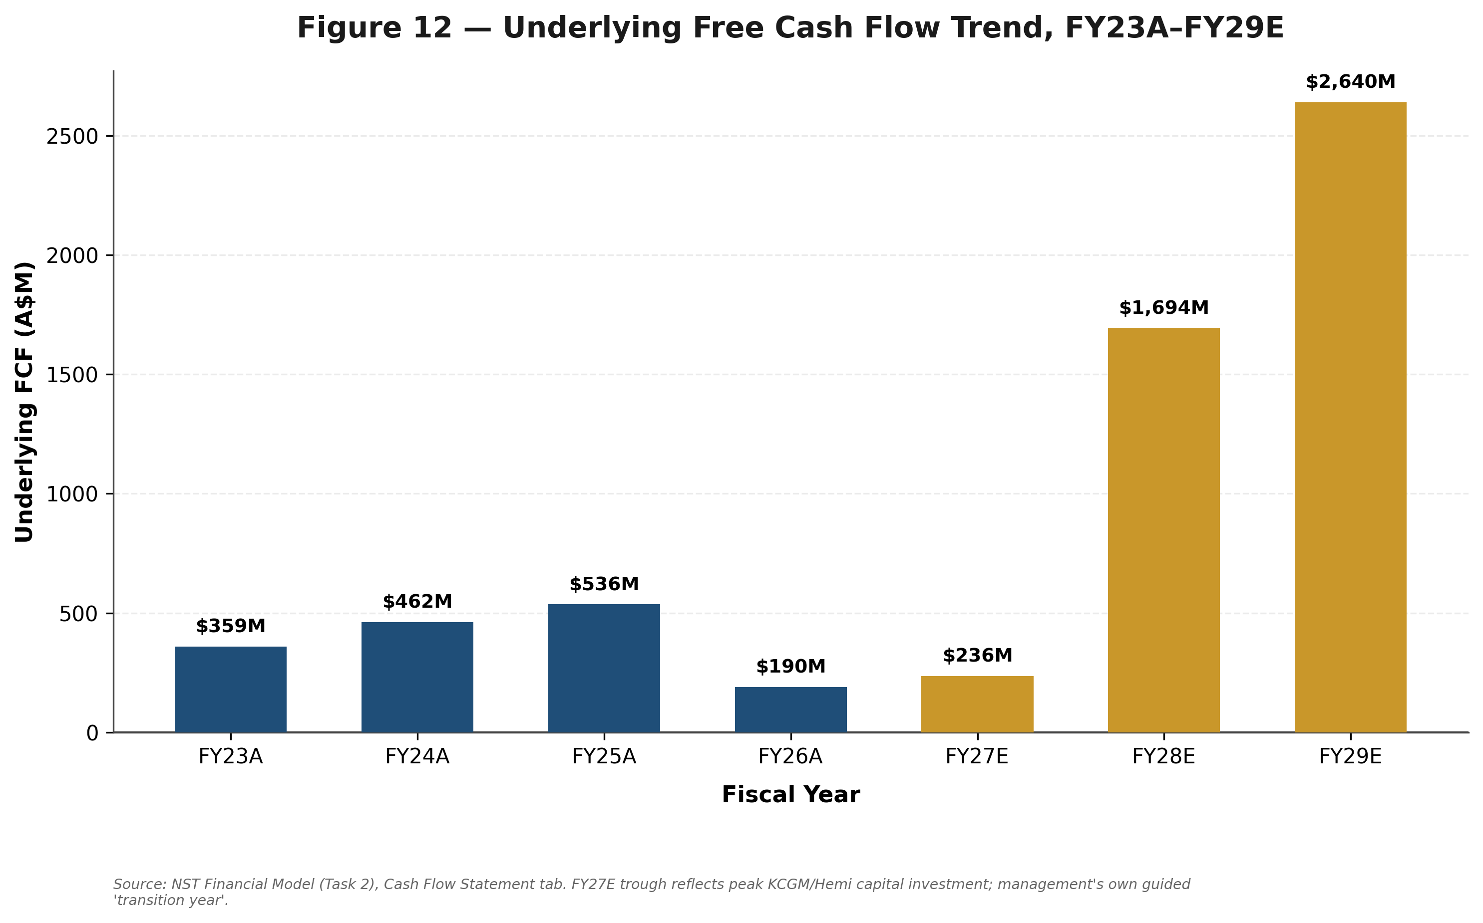
Source: NST Financial Model (Task 2), Cash Flow Statement tab.
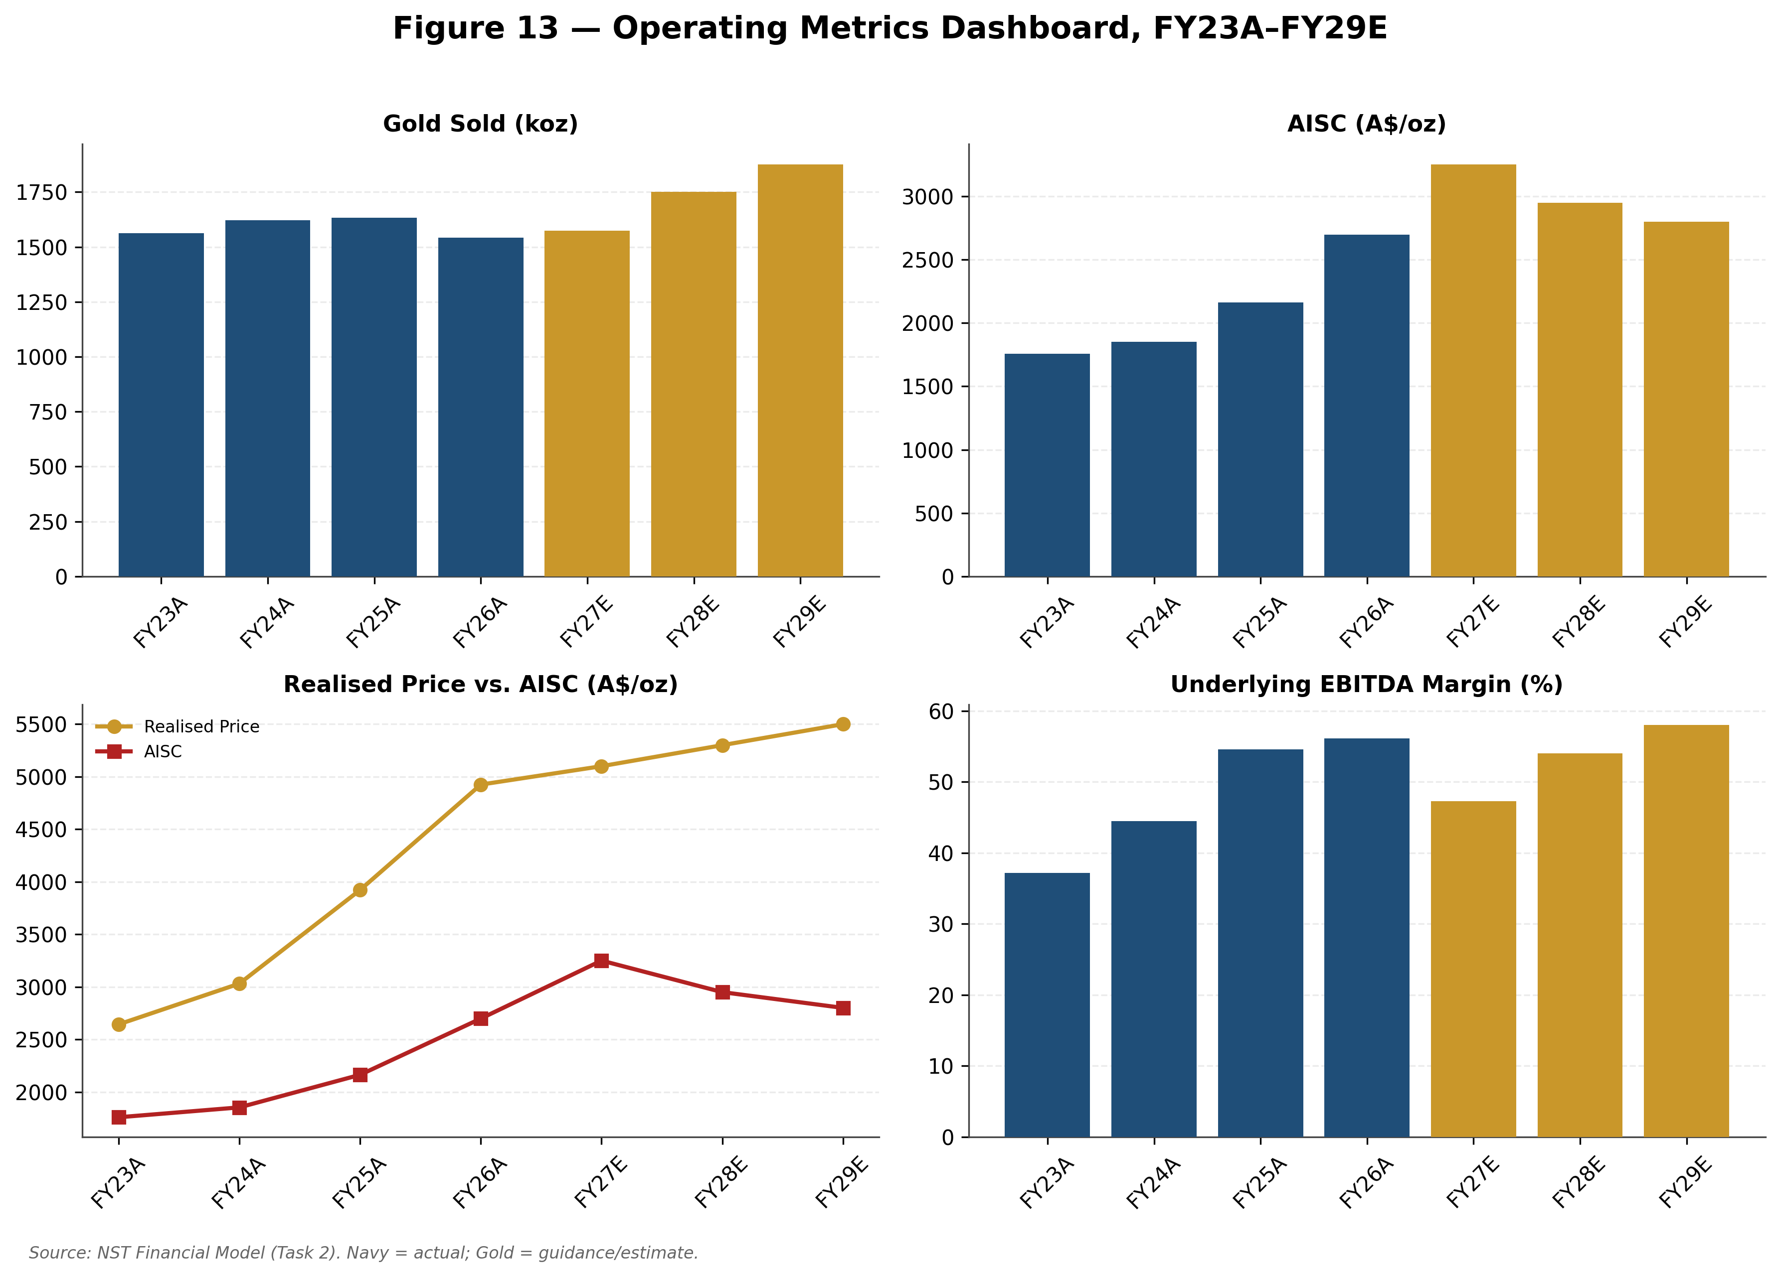
Source: NST Financial Model (Task 2). Navy = actual; Gold = guidance/estimate.

Projection Assumptions
This section sets out, in detail, the basis for every FY27E-29E figure in this report's financial model. Consistent with the report's governing accuracy protocol, FY27E figures are Northern Star's own disclosed guidance (20 August 2026 results call and accompanying materials); FY28E-29E figures are this report's own analyst assumptions, built on management's qualitative commentary but not confirmed by management, since Northern Star explicitly declined to provide guidance beyond FY27E, deferring that to incoming CEO Suresh Vadnagra. Assumptions are organised by production centre (Northern Star's natural 'segment' as a single-commodity producer) and then by geography, followed by cross-cutting assumptions on margins, tax, capital expenditure, working capital and capital returns.

Revenue Assumptions by Production Centre

Kalgoorlie Production Centre
Kalgoorlie Production Centre (KCGM, Kanowna Belle, South Kalgoorlie, Carosue Dam) — approximately 54% of FY26A group revenue on this report's derived basis, and the single most important driver of both the near-term earnings trough and the medium-term recovery.
1. KCGM Mill Expansion is the central swing factor. The 27Mtpa expansion — described by management as the largest Australian gold project in over a decade — completed its peak capital investment phase in FY26A. Stage 1 commissioning is underway, with handover from project team to operations targeted for September 2026 and the existing Fimiston SAG mill tying into the expanded circuit at that point.
2. Stage 2 completion, targeted for the second half of the first half of FY27 ('late 1H FY27' per management), is guided to deliver a further 1-2 percentage point recovery improvement and to eliminate concentrate haulage between KCGM and Gidgee — a real, quantified operational efficiency gain layered on top of the throughput increase itself.
3. FY27E KCGM production is specifically guided at 550,000-650,000oz (600,000oz used at the midpoint in this report's projections), with management explicit that the range reflects 'a balanced assessment of ramp-up expectations and associated risks during the early stages of commissioning', informed by external benchmarking and an independent technical assessment — i.e., the range itself is a disclosed acknowledgement of execution uncertainty, not a confident point estimate dressed up as a range.
4. The ramp-up timeline is explicitly guided at approximately two years to reach the full 27Mtpa nameplate denominator, meaning this report's FY28E-29E production assumptions (which build toward, but do not assume completion of, that ramp) are directionally consistent with management's own qualitative framing even though the specific tonnage figures beyond FY27E are this report's own analyst construction, not company guidance.
5. KCGM underground ore is guided at 3.5-4.0Mtpa for FY27E, with open-pit mining continuing at Golden Pike North; combined with the Fimiston South cutback (targeting 60-65Mt of total material movement), this represents the bulk of the A$895-945M FY27E KCGM operational growth capital guided by management.
6. Carosue Dam is guided to 150,000-160,000oz for FY27E, with two new ore sources — Kiena (a 2 million tonne, 3+ gram underground project close to the existing mill, targeted at approximately 200,000oz) and Twin Peaks — explicitly flagged by management as additive 'from FY28', supporting this report's assumption of continued, gradually increasing Kalgoorlie-centre production through FY28E-29E.
7. Cost inflation at Kalgoorlie is real and acknowledged: management's FY27E guidance embeds approximately 5% portfolio-wide inflation, higher royalties (a mechanical consequence of Western Australia's 2.5% ad valorem gold royalty applied to a higher gold price), higher oil-price assumptions feeding into mining-fleet costs, and drawdown of lower-grade stockpiles at KCGM specifically during the ramp period.
8. Management addressed a direct analyst question on non-cash stockpile drawdown charges during the FY26 results call, clarifying that KCGM's roughly 1 million tonnes of high-grade stockpiled material carries no cash cost when drawn down, but does carry a non-cash P&L charge — a nuance this report's simplified AISC-based cost build does not separately capture, and a modest source of potential variance between this report's EBITDA estimates and the eventual reported figures.
9. Kalgoorlie's FY26A EBITDA margin of 64% (up from 59% in FY25A) is the highest of the three production centres and management's own commentary attributes this specifically to Kalgoorlie's scale and the operating leverage already being realised even before the mill expansion's full benefit is captured — supporting this report's assumption that Kalgoorlie's margin should continue to lead group-level margins as volumes scale further.

Yandal Production Centre
Yandal Production Centre (Jundee, Thunderbox, Bronzewing) — approximately 28% of FY26A group revenue on this report's derived basis, and the centre most directly affected by asset-maturity dynamics.
1. Jundee, in production since well before Northern Star's 2014 acquisition, has completed a formal operational review in FY26A. Management's own characterisation is candid: Jundee has faced 'grade decline and increasing development [costs] to achieve the same profile against a backdrop... of rising costs'. The response has been to right-size the operating footprint, focus on core ore zones, and reduce equipment and headcount to 'slow down activity and focus on quality' rather than chase volume.
2. The practical FY27E consequence is an H1-weighted 'set-up' half (lower primary ore, supplemented by low-grade stockpiles) followed by an H2 shift to higher-grade ore sources as development work completed in H1 opens up access — meaning Jundee's FY27E production is expected to be flat year-on-year in volume terms but with a materially different, more back-half-weighted grade and cost profile than FY26A.
3. Bannockburn, part of the Thunderbox operation, entered commercial production during FY26A/27E, which has a direct and disclosed accounting consequence: stripping costs and associated equipment costs at Bannockburn are now classified within sustaining capital rather than treated as a separate pre-production cost, adding approximately A$85-95M to FY27E Yandal sustaining capital.
4. Yandal's FY26A EBITDA margin of 47% (down from 55% in FY25A) is the most direct evidence of the maturity/cost pressures described above, even as the centre still contributed approximately A$1.0bn of EBITDA and over A$300M of net mine cash flow — Yandal remains a materially profitable, cash-generative business even in a period of relative underperformance versus its own history and versus its peer centres.
5. This report assumes Yandal's margin stabilises rather than continues declining through FY27E-29E, on the basis that the Jundee resizing and Bannockburn's transition to commercial production are both one-off adjustments rather than the start of a structural deterioration — a judgement call flagged explicitly as an analyst assumption, not a guaranteed outcome.
6. No FY27E Yandal-specific production guidance (in koz) was disclosed by management in the sources reviewed for this report, beyond the qualitative commentary above; this report's FY27E-29E production assumptions for Yandal are therefore embedded within the group-level guidance range (1,500-1,650koz for FY27E) rather than independently derived bottom-up, an important granularity limitation to flag.

Pogo Production Centre (Alaska)
Pogo Production Centre (Alaska, USA) — approximately 18% of FY26A group revenue on this report's derived basis, and the group's sole exposure to a non-Australian operating and currency environment.
1. Pogo's FY26A EBITDA margin of 60% represents a continuation of what management describes as an 'improvement trajectory', up from 54% in FY25A and 42% in FY24A — the most consistent multi-year margin improvement of the three production centres, reflecting several years of underground development rate and plant performance work that Task 1's company research documents in detail.
2. Pogo's costs and capital expenditure are US-dollar denominated, requiring translation to Australian dollars for group reporting; NST's own disclosures show the AUD:USD conversion assumption used for this purpose has varied between 0.64 and 0.71 across different reporting periods in FY25-26, creating a currency-translation variable in Pogo's contribution to group AISC and capital expenditure that is layered on top of operational performance itself.
3. This report assumes Pogo's margin improvement trajectory continues at a more modest pace through FY27E-29E (rather than assuming either a plateau or a continuation of the same rate of improvement seen in FY24A-26A), reflecting the general principle that multi-year operational turnarounds tend to deliver diminishing incremental improvement as the easier gains are captured first — again, an explicit analyst judgement rather than a guided figure.
4. No Pogo-specific FY27E production or cost guidance (in koz or US$/oz terms) was disclosed by management in the sources reviewed; Pogo's contribution is embedded within group-level FY27E guidance rather than independently derived.

Hemi Development Project (Pre-Production)
Hemi Development Project (Pilbara, Western Australia) — not yet in production, and deliberately modelled with zero revenue and zero production contribution through this report's FY29E window.
1. Hemi's resource base has been updated since the De Grey acquisition completed in May 2025: 13.2 million ounces of Mineral Resources and 5.5 million ounces of Ore Reserves as most recently disclosed (versus 11.2Moz/6.0Moz at the time of acquisition), reflecting continued exploration and re-estimation work.
2. Final Investment Decision is explicitly targeted for late FY27, with management confirming on the FY26 results call that 'state and federal permitting is progressing... tracking to plan', that a managed aquifer recharge trial (described as 'common industry practice' for open-pit water management) is underway and progressing to plan, and that no approvals-related constraint currently threatens the FID timeline.
3. Post-FID, management guides to an estimated build period of approximately two and a half years — meaning that even a perfectly on-schedule late-FY27 FID would not be expected to deliver first gold production until roughly calendar 2030, well beyond this report's explicit FY27E-29E forecast window. This is the specific, disclosed reason Hemi contributes capital expenditure only (not production or revenue) throughout this report's projections.
4. FY27E Hemi capital expenditure is guided at A$200-250M, described by management as 'primarily for ongoing engineering design, NPI works, and commitments for long lead items' — i.e., FID-preparation spend rather than construction spend, consistent with the FID not yet having been taken.
5. This report's FY28E-29E Hemi capital assumptions (a step-up to reflect early construction-phase spending in a post-FID scenario) are explicit analyst constructions built on the disclosed ~2.5-year build timeline, not company guidance, and are among the most uncertain single line items in this report's entire projection set given that FID itself has not yet occurred.

Geographic Assumptions
Geographic assumptions map directly onto the production-centre assumptions above, since Northern Star's only geographic split of consequence is Australia (Kalgoorlie plus Yandal, and prospectively Hemi) versus the United States (Pogo, Alaska).
1. Australia is expected to remain approximately 80-85% of group revenue throughout the FY27E-29E forecast window on this report's assumptions, essentially unchanged from the FY25A-26A derived split, because none of the three production centres' relative growth trajectories implies a material shift in this mix within the explicit forecast period — Hemi's eventual production (post-FY29E) would, if and when it arrives, further increase Australia's share.
2. Western Australia's regulatory and royalty framework is well-established and, in this report's assessment, a source of manageable rather than escalating structural risk: the Mining Act 1978 and Mining (Royalties) Regulations 2025 apply a transparent 2.5% ad valorem royalty on gold, calculated against the London Bullion Market gold price in Australian dollars — meaning royalty costs rise mechanically (and predictably) with the gold price, which management's own FY27E cost guidance explicitly acknowledges as a driver of higher AISC, rather than representing a new or unexpected regulatory burden.
3. Alaska's regulatory environment is distinct from Australia's and is monitored separately by this report as a discrete risk factor (see Risk Assessment), given its exposure to US federal and Alaska state mining, environmental and (potentially) trade-policy dynamics that are structurally unrelated to the Western Australian framework governing the majority of the group's asset base.
4. Currency exposure is asymmetric: Pogo's US-dollar cost base is translated to Australian dollars using conversion assumptions that have moved between 0.64 and 0.71 across recent reporting periods; a stronger Australian dollar (i.e., a higher AUD:USD rate) would modestly reduce the AUD-translated cost of Pogo's operations, all else equal, while a weaker Australian dollar would increase them — a real, if secondary, sensitivity this report does not separately stress-test beyond the Bull/Base/Bear gold-price scenarios themselves.

Other Key Assumptions: Margins, Tax, Capital Expenditure, Working Capital, Capital Returns
AISC and margin evolution: Group AISC is guided at A$3,050-3,450/oz for FY27E (versus A$2,698/oz FY26A actual), with management explicit that 'cost per ounce [is] expected to improve through the year' as the KCGM ramp progresses; this report's FY28E-29E AISC assumptions (A$2,950/oz and A$2,800/oz respectively, Base Case) reflect continued improvement at a moderating pace, not a return to FY25A-26A's lower absolute cost levels, since several of the FY27E cost pressures (higher royalties at elevated gold prices, general portfolio inflation) are structural rather than transitory.
Depreciation & Amortisation: guided at A$1,000-1,200/oz for FY27E (versus an estimated A$925/oz for FY26A, itself estimated from a guided range since no precise FY26A actual D&A dollar figure was disclosed in the sources reviewed), reflecting the capitalised KCGM expansion cost base entering its depreciation phase as assets are commissioned; this report assumes D&A per ounce remains elevated through FY28E-29E rather than declining, since the expansion assets' depreciable base does not shrink simply because the ramp-up period ends.
Tax: Northern Star's own guided effective tax rate of 30-32% is used throughout this report's explicit forecast period. FY27E cash tax is guided at A$450-550M, which management discloses includes 'approximately AUD 300-350 million of cash tax benefits associated with the acquisition of the Hemi Project' — a one-off or at least front-loaded benefit that this report assumes does not recur at the same scale in FY28E-29E, consistent with cash tax payments in this report's Base Case scenario stepping up materially in those years even as the effective P&L tax rate remains flat.
Capital expenditure: FY27E total group capital investment is guided at A$2.6-2.9bn (sustaining A$850-915M, growth capital A$1,500-1,770M excluding Hemi, Hemi-specific A$200-250M, exploration A$230-250M). Management has been explicit that 'a portion of capital expenditure remains discretionary' — evidenced by FY26A's actual sustaining capital outturn of approximately A$650M against an approximately A$750M guided figure the prior year — meaning this report's capital expenditure assumptions, while anchored to company guidance for FY27E, should be treated as a ceiling that could flex downward under operational or capital-allocation pressure, not a fixed commitment.
Working capital: this report makes a simplifying assumption of zero net working-capital change across the explicit forecast period. Northern Star's own disclosures make clear this understates real-world variability — management specifically discussed non-cash stockpile inventory movements at KCGM, Jundee and Carosue Dam as a live FY27E dynamic during the earnings call Q&A — but the specific magnitude of these movements was not disclosed with enough precision to forecast reliably, and this report accordingly flags (rather than papers over) the resulting simplification.
Capital returns: this report's Base Case assumes a flat 50 cents per share dividend through FY27E-29E (below the 55 cents per share paid in both FY25A and FY26A), reflecting the heavier capital investment phase management has explicitly flagged for FY27E, alongside continued share buybacks at approximately A$125M per annum, broadly consistent with the pace implied by the announced A$500M buyback program (of which A$129M had been completed as at the FY26A year-end).

Scenario Analysis
This section sets out Bull, Base and Bear scenarios for FY29E, the terminal year of this report's explicit forecast period. All FY28E-29E figures across all three scenarios are this report's own analyst assumptions — Northern Star has not provided, and has explicitly declined to provide, guidance beyond FY27E.

Bull Case: Clean Execution Across KCGM, Hemi and Gold Price
Probability: 20%. This report assigns a relatively modest probability to the Bull Case, reflecting genuine, disclosed execution risk in the KCGM ramp-up and the fact that Hemi's FID has not yet been taken.
Key assumptions (FY29E vs. Base Case): Group gold sold of 2,050koz (vs. 1,875koz Base); average realised gold price of A$6,600/oz (vs. A$5,500/oz Base) — consistent with the more bullish end of published 2026-27 gold price forecasts summarised in this report's Industry Overview (J.P. Morgan, BNP Paribas and UBP have all published targets at or above US$6,000/oz, translated at historical AUD:USD conversion assumptions); Group AISC of A$2,550/oz (vs. A$2,800/oz Base), reflecting a cleaner, faster KCGM ramp with fewer of the stockpile-grade and recovery headwinds management flagged as risks; FY29E Underlying EBITDA of A$9,123M (vs. A$5,983M Base) and an EBITDA margin of 67.4% (vs. 58.0% Base).
Production-centre detail: under the Bull Case, KCGM would need to reach or exceed the top of its FY27E guided range (650koz) and continue growing through FY28E-29E as Stage 2's recovery uplift and the full 27Mtpa throughput combine with minimal stockpile-grade drag; Carosue Dam's Kiena and Twin Peaks ore sources would need to ramp faster than the 'gradual' pace management has guided; and Yandal's Jundee resizing would need to deliver the higher H2 FY27 grades management has flagged without further downward revision. None of these individually is implausible — each is simply the upper end of a range management itself has already disclosed — but all three occurring simultaneously, alongside a top-of-range Hemi and gold-price outcome, is why this scenario is assigned a minority rather than a base-rate probability.
Catalysts required: (1) KCGM Stage 2 completing on or ahead of the guided 1H FY27 timeline, with recoveries at or above the guided 1-2 percentage point uplift — expected timing, calendar H1 2027; (2) a positive Hemi Final Investment Decision on or ahead of the guided late-FY27 timeline, with capital and schedule metrics in line with or better than the original De Grey-era feasibility work — expected timing, FY27; (3) continued central-bank gold accumulation at or above the near-record pace the World Gold Council's 2026 survey found (89-95% of reserve managers expecting continued reserve growth) sustaining gold prices toward the upper end of published 2026-27 forecasts; (4) a constructive resolution of the Elliott Investment Management campaign — either a well-received new strategic plan under incoming CEO Suresh Vadnagra, or a takeover approach at a premium valuation — removing the current governance overhang entirely.
Detailed rationale: the Bull Case does not require anything Northern Star has not already told the market is possible — it requires the guided ranges to be hit at their better end, consistently, across three separate work streams (KCGM ramp, Hemi approvals, gold price) that management itself has flagged as carrying genuine execution and external risk. Given Northern Star's own disclosed history of guidance downgrades through FY26A, this report treats simultaneous best-case execution across all three as a meaningful but distinctly minority outcome.
Valuation implications: DCF Bull Case value of approximately A$36.42 per share (using the peer 75th-percentile EV/EBITDA multiple of 8.55x as the terminal exit multiple, per the Valuation Analysis section); this would represent approximately 52% upside from the current A$23.94 share price.

Base Case: Guidance Delivered, Moderate Ongoing Recovery
Probability: 55%. This report treats the Base Case — essentially, Northern Star delivering its own FY27E guidance and then continuing a moderate, unspectacular KCGM ramp and cost recovery through FY28E-29E without either a breakthrough or a further setback — as the single most likely outcome, consistent with the weight of evidence in this report's Financial Analysis and Valuation sections.
Key assumptions: Group gold sold of 1,875koz by FY29E; average realised gold price of A$5,500/oz; Group AISC of A$2,800/oz; FY29E Underlying EBITDA of A$5,983M at a 58.0% margin.
Rationale: the Base Case assumes management's own FY27E guidance is met at the midpoint, that the two-year KCGM ramp timeline management has repeatedly cited plays out roughly as described, that Hemi's FID proceeds on the guided late-FY27 timeline without derailing the balance sheet, and that gold prices remain firm but do not require either the most bullish or the most bearish published 2026-27 forecasts to be correct.
Valuation: DCF Base Case value of approximately A$20.56 per share (averaging the perpetuity-growth and exit-multiple Terminal Value methods); Trading Comps median value of approximately A$22.53 per share; overall weighted Base Case price target of A$23.00 per share, essentially in line with the current share price.

Bear Case: Persistent Execution Risk Meets a Gold Price Reversal
Probability: 25%. This report assigns a meaningfully higher probability to the Bear Case than is typical for an initiating-coverage Bear scenario, reflecting the genuine, disclosed pattern of guidance downgrades through FY26A and the fact that three separate sources of execution risk (KCGM, Hemi, leadership transition) are live simultaneously.
Key assumptions (FY29E vs. Base Case): Group gold sold of 1,650koz (vs. 1,875koz Base); average realised gold price of A$4,300/oz (vs. A$5,500/oz Base) — consistent with StoneX's more bearish published 2026 forecast of a pullback toward US$4,000/oz; Group AISC of A$3,100/oz (vs. A$2,800/oz Base), reflecting persistent ramp delays and continued stockpile/grade headwinds; FY29E Underlying EBITDA of just A$2,980M (vs. A$5,983M Base) at a 42.0% margin.
Production-centre detail: under the Bear Case, KCGM's ramp would need to stall closer to the bottom of its FY27E guided range (550koz) and fail to build meaningfully through FY28E-29E — plausible given management's own acknowledgement that the guided range already embeds 'downside scenarios relating to ramp-up performance, stockpile grade variability, and recovery performance'; Jundee's resized footprint would need to fail to deliver the guided H2 FY27 grade improvement, extending the current period of underperformance; and Hemi's FID would need to slip beyond late FY27, pushing the project's already-distant (circa-2030) production start even further out and tying up capital with no offsetting production benefit within any reasonable forecast horizon.
Downside triggers: (1) further KCGM ramp delays beyond the guided two-year timeline — likelihood assessed as moderate-to-high given FY26A's own guidance-cut pattern; (2) a Hemi FID delay or material cost escalation, given permitting approvals sit outside management's direct control — likelihood assessed as moderate; (3) a disorderly or prolonged Elliott Investment Management campaign outcome that distracts management during the critical KCGM ramp window — likelihood assessed as moderate; (4) a sustained gold price reversal toward the bearish end of published 2026 forecasts — likelihood assessed as moderate, given gold's own 28% intra-2026 peak-to-trough swing already demonstrates this is well within recent historical experience, not a tail scenario.
Rationale: importantly, this report's Bear Case DCF output of approximately A$6.88 per share should be read with a specific, disclosed caveat — it is built assuming growth and Hemi capital expenditure continue at a broadly similar pace even as prices and volumes disappoint, which is not how Northern Star's own management has behaved historically (FY26A sustaining capital already came in roughly A$100M below guidance as management exercised the 'discretion' it has explicitly said exists in parts of the capital program). A real-world Bear Case would very likely see capital expenditure cut materially in response to the same conditions that produce the Bear Case's depressed cash flows, meaningfully improving the realistic downside outcome relative to this report's mechanically-calculated figure. Put differently: the A$6.88 figure is a useful stress-test of what happens if capital discipline does NOT kick in during a downturn, not this report's central estimate of what would actually happen.
Valuation implications: DCF Bear Case value of approximately A$6.88 per share (using the peer 25th-percentile EV/EBITDA multiple of 5.64x as the terminal exit multiple) — best read as a stress-test of capital inflexibility rather than a probability-weighted forecast, per the explicit caveat above.

Scenario Comparison
Across all three scenarios, the spread in outcomes (DCF-implied price of A$6.88 to A$36.42) is wide even by the standards of early-cycle mining names, and is driven overwhelmingly by two factors this report can isolate explicitly: gold price (a A$2,300/oz spread between Bull and Bear FY29E assumptions) and the pace of KCGM's ramp-up (a 400koz spread in Bull vs. Bear FY29E group production). Both factors are observable in real time well before FY29E arrives — gold price through the ordinary course of markets, and KCGM's ramp through Northern Star's own quarterly production reporting — meaning investors do not need to wait until FY29E to substantially re-weight the probability distribution across these three scenarios as evidence accumulates through FY27E and FY28E.
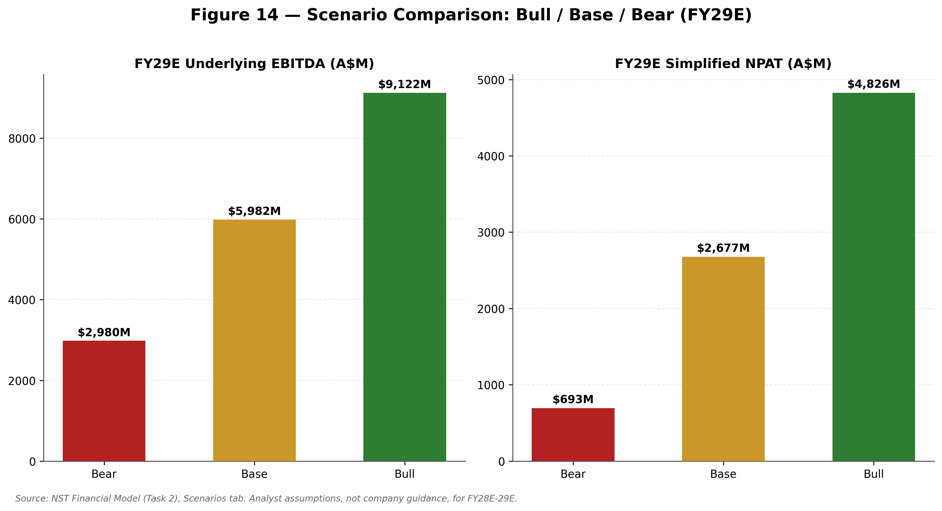
Source: NST Financial Model (Task 2), Scenarios tab. Analyst assumptions, not company guidance, for FY28E-29E.
Table: Scenario Comparison (FY29E)
Metric | Bear | Base | Bull
Probability (this report's assessment) | 25% | 55% | 20%
Group Gold Sold (koz) | 1,650 | 1,875 | 2,050
Realised Gold Price (A$/oz) | 4,300 | 5,500 | 6,600
Group AISC (A$/oz) | 3,100 | 2,800 | 2,550
Underlying EBITDA (A$M) | 2,980 | 5,983 | 9,123
EBITDA Margin | 42.0% | 58.0% | 67.4%
Implied DCF Price/Share | A$6.88 | A$20.56 | A$36.42
Source: NST Financial Model (Task 2), Scenarios tab; NST Valuation Analysis (Task 3), DCF tab.
Probability-weighted, using this report's own assigned probabilities (25% Bear, 55% Base, 20% Bull), the scenario set above implies an expected DCF value of approximately A$20.31 per share (0.25 × A$6.88 + 0.55 × A$20.56 + 0.20 × A$36.42) — modestly below both the pure DCF Base Case and the final blended A$23.00 price target, which is weighted only 30% to DCF and 70% to the Trading Comps and Precedent-Informed methods (see Valuation Analysis section) precisely because this report has less confidence in the DCF's absolute level than in its usefulness for illustrating relative scenario sensitivity. The practical takeaway for investors is a genuinely two-sided risk/reward setup: a plausible, disclosed-guidance-consistent path to material upside exists alongside a plausible, equally disclosed-guidance-consistent path to material downside, and neither dominates the other strongly enough to justify a directional BUY or SELL call at the current price.

Key Growth Drivers
■ 1. KCGM Mill Expansion — the single largest identifiable value driver over the next three years. The expansion to 27Mtpa processing capacity, once fully ramped (management's own guided timeline: approximately two years from FY27 commissioning), represents the largest single increase in Northern Star's processing capacity in over a decade. Elliott Investment Management's own investor materials — cited here for factual content, not as an endorsement of the broader activist campaign — describe KCGM post-expansion as having the potential to become the world's second-largest Tier-1 gold mine. This report's Base Case FY29E group EBITDA of A$5,983M implicitly assumes meaningful but not complete realisation of this opportunity; full realisation is the central driver of this report's Bull Case.
■ 2. Hemi — a genuine, quantifiable option value not captured in this report's explicit FY27E-29E forecasts. Hemi's 13.2 million ounces of Mineral Resources and 5.5 million ounces of Ore Reserves represent, by trade-press description, one of the largest gold development projects in Australia. Because Hemi's guided ~2.5-year post-FID build timeline places first production beyond this report's FY29E forecast window, none of Hemi's eventual production or cash flow is captured in this report's Base Case valuation — meaning a successful, on-time FID and construction outcome represents pure upside optionality not yet reflected in the A$23.00 price target, separate from and additive to the Bull Case scenario modelled above.
■ 3. Exploration-funded reserve replacement — a proven, multi-decade track record specific to Northern Star. Northern Star's cost of resource additions has averaged approximately A$18-23/oz in FY26A, funding continued extension of a reserve-backed production profile already exceeding 10 years. Task 1's company research documents a specific, quantified precedent: the Jundee mine, acquired in 2014 for A$82.5 million, has since delivered more than 2 million ounces of production — more than double the reserves base estimated at the time of acquisition. This is not a generic assertion about exploration upside; it is a company-specific, historically demonstrated capability that supports confidence in the multi-decade production profile underpinning this report's Terminal Value assumptions.
■ 4. Gold price macro tailwinds remain constructive, if less extreme than 2025's record pace. The World Gold Council's 2026 Central Bank Gold Reserves Survey found 89% of surveyed reserve managers expect global central-bank gold reserves to rise over the next 12 months, with a record 45% expecting their own institution's holdings to increase — sentiment that has remained near or above 80% for three consecutive years. Combined with 2025's record US$555 billion in global gold demand value (+45% year-on-year) and a published 2026-27 forecast range that, even at its more conservative end (Standard Chartered's US$4,650/oz Q4 2026 forecast), remains well above Northern Star's FY26A realised price of A$4,925/oz on a like-for-like basis, the macro backdrop supports continued strong realised pricing through this report's forecast window even under Base Case assumptions.
■ 5. Capital returns should re-accelerate materially once the FY27E investment peak passes. This report's Base Case Underlying Free Cash Flow recovers from an estimated A$175M trough in FY27E to an estimated A$1,415M in FY28E and A$2,191M in FY29E as growth capital expenditure moderates post-KCGM-completion. On an unchanged approximately 27% cash-earnings payout ratio (the ratio management applied to the FY26A dividend), this recovery implies materially greater capacity for dividends and buybacks from FY28E onward than the flat 50 cents per share and A$125M per annum buyback this report's Base Case conservatively assumes throughout the forecast period — a further source of potential upside surprise not fully captured in the headline price target.
■ 6. New CEO Suresh Vadnagra brings directly relevant large-project delivery experience, not a generic leadership change. Vadnagra's immediately prior role — Chief Technical and Projects Officer at Newcrest Mining — carried direct responsibility for major development projects including Red Chris, Cadia's future panel caves, Havieron and Wafi-Golpu, giving him large-scale, technically-grounded project delivery experience of exactly the kind Northern Star's KCGM ramp-up and prospective Hemi construction require. His subsequent role leading Glencore's global nickel and zinc industrial assets (a portfolio of more than 25 operations spanning open-pit and underground mines, smelters and refineries across four continents) adds multi-site operational management experience at a scale comparable to Northern Star's own three-to-four-centre portfolio. This is a specific, evidence-based reason for constructive rather than purely cautious framing of the leadership transition risk discussed elsewhere in this report.
■ 7. Sustainability performance supports continued social licence to operate across all three jurisdictions. Northern Star's most recent disclosed safety performance (Serious Lost Time Injury Frequency Rate below industry average, per Task 1's company research) and its stated target of a 35% reduction in Scope 1 and 2 carbon emissions by 2030 (against a 1 July 2020 baseline) support continued regulatory and community support for the KCGM expansion, Hemi's Pilbara approvals process, and ongoing Pogo operations in Alaska — a less quantifiable but nonetheless real precondition for realising the other six growth drivers listed above, particularly given the heightened scrutiny of heritage and environmental management across the Western Australian mining sector following well-documented industry-wide incidents in recent years.

Valuation Analysis
This report derives its 12-month price target from three methods — a discounted cash flow analysis, a trading comparables analysis against six ASX/global gold-producer peers, and a precedent-transactions-informed valuation — weighted to reflect this report's honest assessment of each method's reliability given Northern Star's specific circumstances, rather than a generic default weighting.

Discounted Cash Flow Analysis

WACC
Component | Value | Source
Risk-free rate (AU 10-Year Govt Bond) | 5.04% | TradingEconomics, 21-Aug-2026
Beta (5-year monthly, levered) | 1.37 | Yahoo Finance, NST.AX
Equity Risk Premium — Australia | 4.2% | Damodaran (NYU Stern), July 2026 update
Cost of Equity (CAPM) | 10.79% | = 5.04% + 1.37 × 4.2%
Pre-tax cost of debt | 5.2% | NST US$600m 6.125% Notes, current YTM
Tax rate | 31% | NST guidance (midpoint 30-32%)
After-tax cost of debt | 3.59%
Capital structure (E/V, D/V) | 97.5% / 2.5% | A$34.0bn equity vs. A$890M debt
WACC | 10.6%
Northern Star is very lightly levered (near-net-cash), so WACC sits close to pure cost of equity — reasonable for an investment-grade (Baa3/BBB-/BBB-), mature, low-leverage gold producer, and within the 8-14% range typically observed for companies of this risk profile.

Unlevered Free Cash Flow and a Disclosed Limitation
The explicit forecast period is three years (FY27E-29E) — FY27E from company guidance, FY28E-29E from this report's analyst-assumption Scenarios — because management explicitly declined to give multi-year guidance on the 20 August 2026 earnings call. Extending the explicit period further would compound unsupported assumptions rather than add rigour.
(A$M) | FY27E | FY28E | FY29E
Unlevered FCF (Base Case) | 175 | 1,415 | 2,191
Discount factor @ 10.6% WACC | 0.904 | 0.817 | 0.739
PV of Unlevered FCF | 158 | 1,157 | 1,619
Sum of PV of explicit FCF: A$2,934M. The short explicit window has a direct, material consequence: Terminal Value ends up representing roughly 90% of Enterprise Value in the Base Case, well above the 60-70% ceiling normally used as a DCF quality warning sign — disclosed prominently here rather than concealed, because it is the single most important caveat on this report's DCF output.

Terminal Value — Two Methods, and Why They Diverge
Perpetuity growth (g = 2.0%, modest given gold mines are depleting assets): Terminal Value A$25,956M → PV A$19,180M → implied price A$15.82.
Exit multiple (7.4x FY29E EBITDA, the actual peer median LTM EV/EBITDA from the Comps analysis below): Terminal Value A$44,274M → PV A$32,716M → implied price A$25.94.
These two outputs disagree by nearly A$10 per share, and that disagreement is informative, not noise: FY29E cash flow in this model is still mid-ramp — KCGM has not yet reached nameplate throughput and Hemi has not yet produced an ounce — so a perpetuity formula applied directly to that still-depressed cash flow understates a genuine steady-state value, while the exit-multiple method (anchored to what the market actually pays today for comparable, more mature gold-producer cash flows) is arguably the more reliable of the two here.
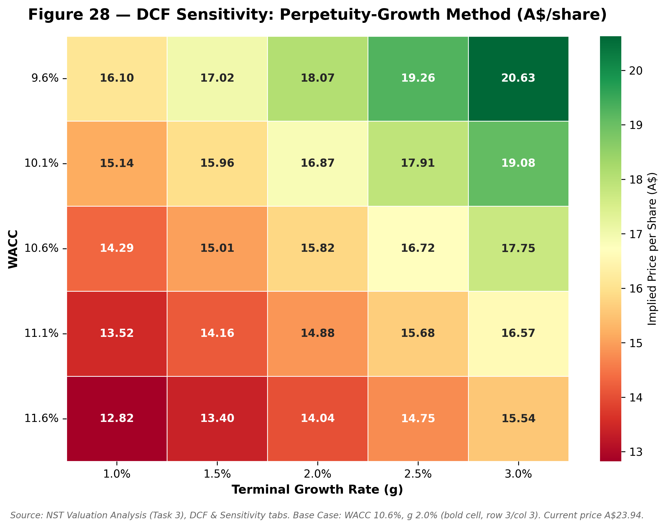
Source: NST Valuation Analysis (Task 3), DCF & Sensitivity tabs. Base Case: WACC 10.6%, g 2.0%. Current price A$23.94.
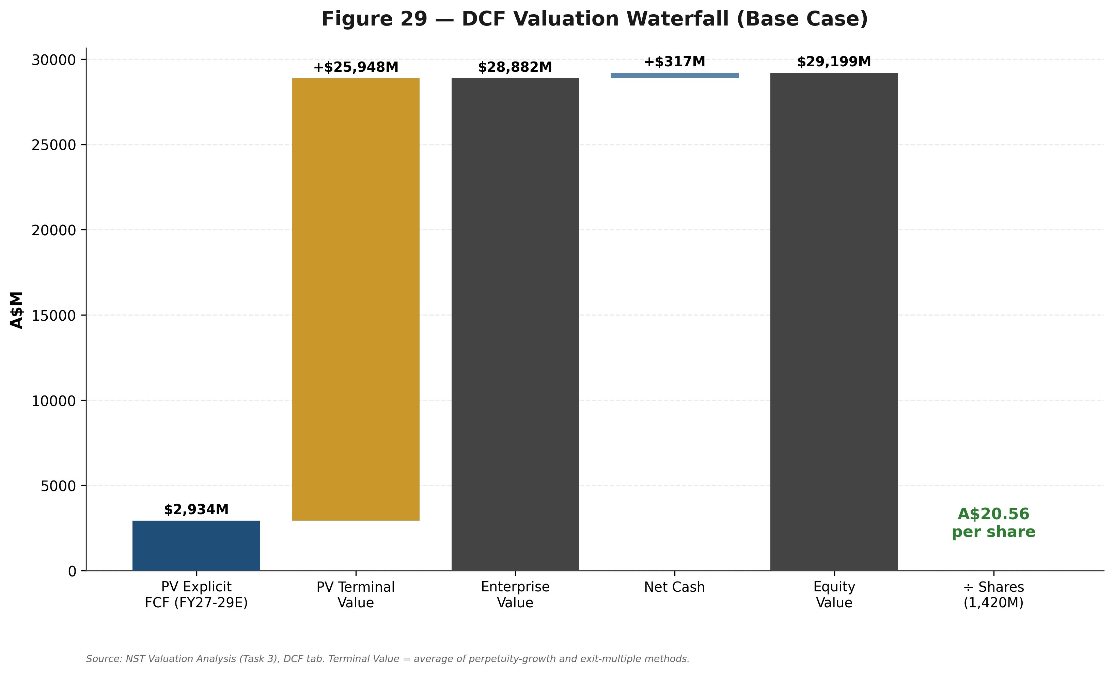
Source: NST Valuation Analysis (Task 3), DCF tab. Terminal Value = average of perpetuity-growth and exit-multiple methods.

DCF Base Case, and Bull/Bear
 | Bear | Base | Bull
Implied price per share | A$6.88 | A$20.56 | A$36.42
vs. current price (A$23.94) | -71% | -14% | +52%
Bull and Bear cases scale the Base Case's unlevered FCF path by the ratio of each scenario's FY29E cash flow to the Base Case's FY29E cash flow, then apply the same two Terminal Value methods using scenario-appropriate exit multiples (peer 75th percentile for Bull, 25th percentile for Bear). The Bear case in particular should be read as a stress test of capital inflexibility rather than a probability-weighted forecast: it assumes growth and Hemi capital expenditure continue at a broadly similar pace even as gold prices fall, which is not how management has behaved historically.
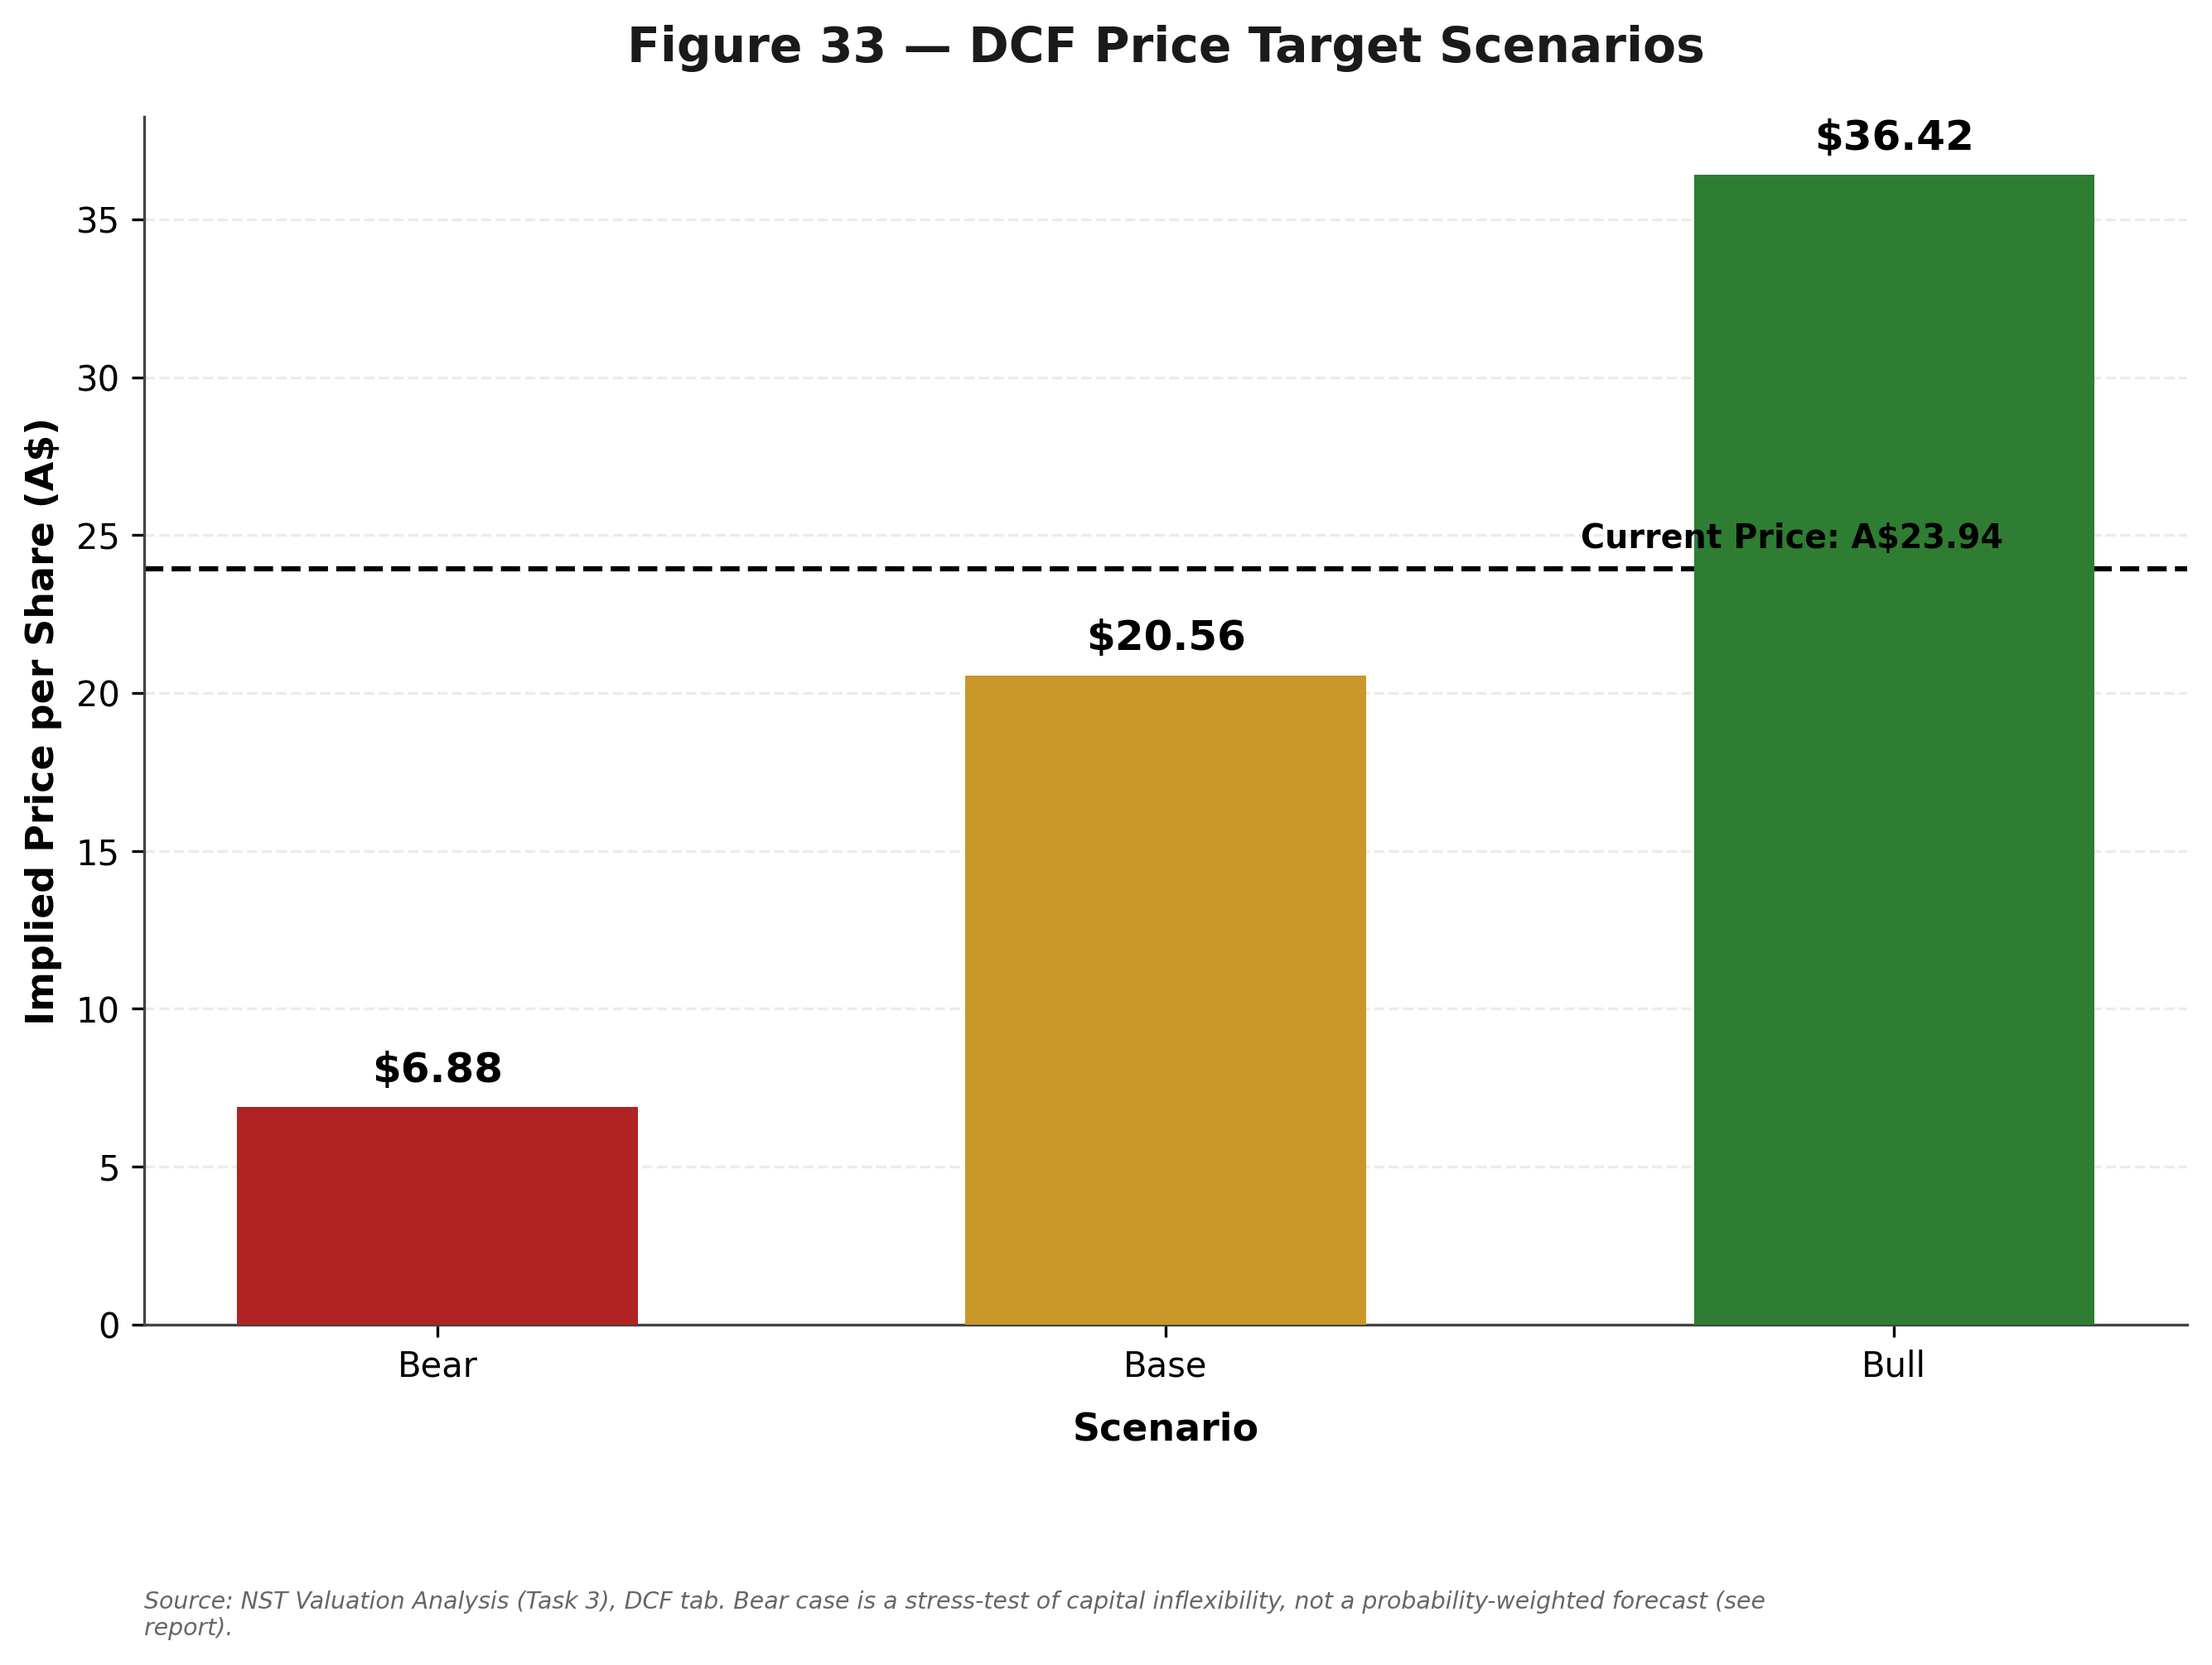
Source: NST Valuation Analysis (Task 3), DCF tab.

Comparable Companies Analysis
Six ASX/global gold producers were selected: direct domestic peers of comparable or larger scale (Evolution Mining, Newmont's ASX-quoted CDIs), Western Australian mid-tier producers in the same goldfields Northern Star operates in (Genesis Minerals, Regis Resources, Ramelius Resources), and one geographically distinct peer included for balance (Perseus Mining, West Africa) to illustrate how jurisdictional risk is priced. Data is primarily StockAnalysis.com (S&P Global Market Intelligence), cross-checked against Yahoo Finance, dated within August 2026.
Table: Comparable Companies Analysis
Company | Ticker | Mkt Cap (A$B) | EV/EBITDA (LTM) | P/E (TTM) | P/E (fwd) | Beta
Newmont Corp. | NEM | 171.72 | 8.65x | 15.80x | 13.96x | 0.43
Evolution Mining | EVN | ~27.0 | 8.25x | 18.95x | 14.99x | 1.60
Genesis Minerals | GMD | ~7.0 | 9.25x | 16.94x | 10.21x | 1.17
Regis Resources | RRL | 4.76 | 5.32x | 12.90x | 7.33x | 1.29
Ramelius Resources | RMS | 5.99 | 6.58x | n/a | n/a | 1.27
Perseus Mining | PRU | ~6.54 | 3.52x | 7.82x | 8.20x | 0.76
Northern Star (NST) | NST | 34.0 | 7.89x | ~20.3x | ~24.8x | 1.37
Table: Statistical Summary (peer set only, excludes NST)
Statistic | EV/EBITDA (LTM) | P/E (TTM) | P/E (fwd)
Maximum | 9.25x | 18.95x | 14.99x
75th Percentile | 8.55x | 18.45x | 14.99x
Median | 7.42x | 16.37x | 10.21x
25th Percentile | 5.64x | 13.63x | 8.20x
Minimum | 3.52x | 7.82x | 7.33x
A genuine, useful nuance emerges from comparing bases: NST's own current implied EV/EBITDA (7.89x) sits between the peer median (7.42x) and 75th percentile (8.55x) — i.e., NST already trades roughly in line with, to modestly above, the peer group on the sector-standard EBITDA multiple, not at the material discount that Elliott Investment Management's public campaign materials emphasise. On a P/E basis, however, NST does trade at a premium to the peer median — a real, sourced divergence most plausibly explained by NST's heavier current depreciation/capex burden from the KCGM expansion suppressing reported earnings relative to cash EBITDA more than at most peers.
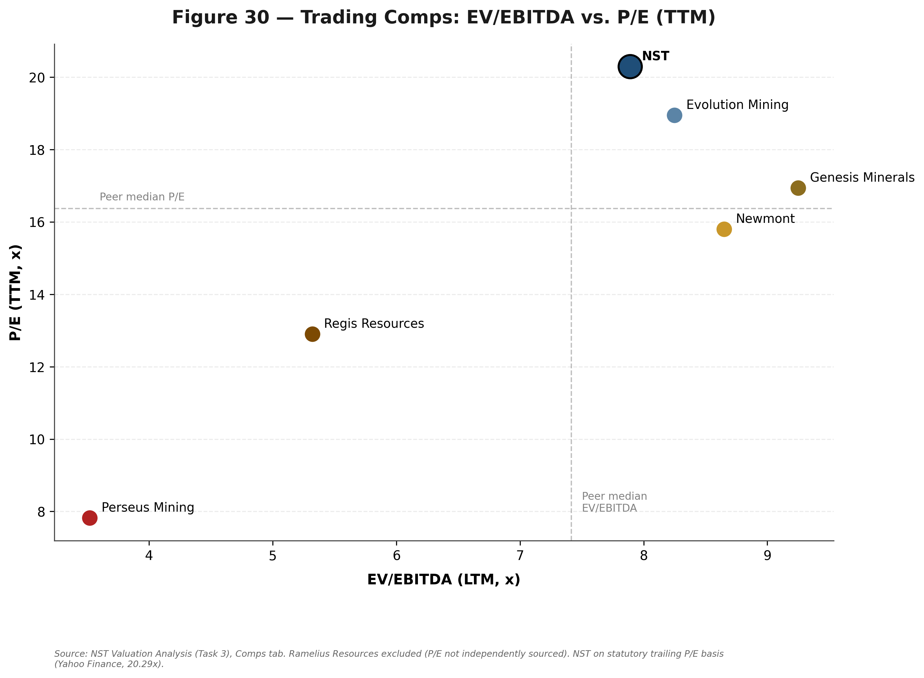
Source: NST Valuation Analysis (Task 3), Comps tab.
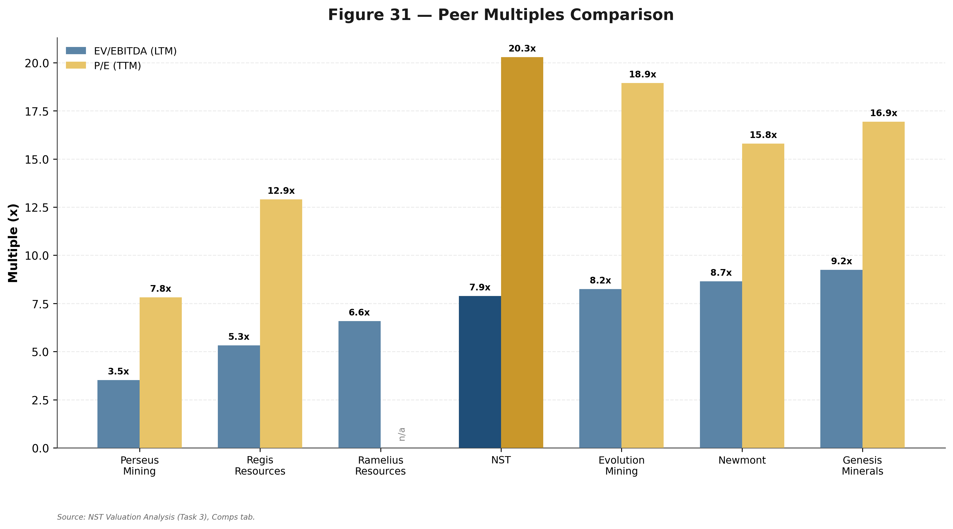
Source: NST Valuation Analysis (Task 3), Comps tab.
Table: Applying Peer EV/EBITDA Multiples to NST
 | 25th %ile (Low) | Median (Base) | 75th %ile (High)
Multiple applied | 5.64x | 7.42x | 8.55x
Implied EV (A$M) | 24,073 | 31,677 | 36,526
Implied price per share | A$17.18 | A$22.53 | A$25.95

Precedent Transactions
Precedent transactions are genuinely relevant given the active 2024-26 wave of ASX gold-sector consolidation, but the data available for precise multiples is uneven: three of the four most relevant deals either involve a pre-revenue/developer target (De Grey, where EV/Resource rather than EV/EBITDA is the relevant metric) or lack a cleanly-sourced EV/EBITDA multiple. Rather than fabricate precision the sources do not support, this report uses the one clean, sourced data point available — De Grey's disclosed 37.1% premium to undisturbed price — as a qualitative control-premium reference applied to the Comps-implied trading range.
Table: Precedent Transactions
Date | Target | Acquirer | Deal Value | Premium
Feb-2021 | Saracen Mineral Holdings | Northern Star (merger) | ~A$5.8bn | n/a
Dec-2024/May-2025 | De Grey Mining | Northern Star | ~A$5.0-6.0bn+ | +37.1%
2026 | Gold Road Resources | Gold Fields Ltd | ~A$3.6bn | n/a
2026 | Vault Minerals | Genesis Minerals (merger) | n/a | n/a
Table: Precedent-Informed Valuation
 | Low | Base | High
Comps-implied price per share | A$17.18 | A$22.53 | A$25.95
Illustrative control premium | 15% | 24% | 35%
Precedent-informed implied price | A$19.75 | A$27.94 | A$35.03
This range is deliberately treated as a qualitative reference reflecting live M&A optionality — most directly, Elliott Investment Management's explicit public call for the Board to 'promptly explore all strategic alternatives, including a sale of the Company' — rather than as a precisely derived multiple-based valuation.

Valuation Summary & Football Field
Table: Valuation Summary
Method | Low | Base | High | Weight | Weighted Value
DCF Analysis | A$6.88 | A$20.56 | A$36.42 | 30% | A$6.17
Trading Comps (LTM EV/EBITDA) | A$17.18 | A$22.53 | A$25.95 | 55% | A$12.39
Precedent-Informed | A$19.75 | A$27.94 | A$35.03 | 15% | A$4.19
Weighted Average Target |  |  |  | 100% | A$22.75
Rounded 12-Month Price Target |  |  |  |  | A$23.00
Weighting rationale — a deliberate departure from generic default weightings, explained rather than merely asserted: DCF receives just 30% (below a typical 40-60% default) given its own acknowledged limitations — a three-year explicit window forced by management's guidance silence beyond FY27, Terminal Value at ~90% of Enterprise Value, and a near-A$10/share gap between its two Terminal Value methods. Trading Comps receives 55% (above a typical 25-40% default) given a real, current, consistent-methodology six-peer set that brackets the current price sensibly, and where NST's own implied multiple checks out as internally consistent with observable market pricing. Precedent-Informed receives 15%, reflecting genuine relevance given live sector M&A activity and the specific, disclosed Elliott campaign, but held to the lower end of typical ranges given how little clean multiple data was available to ground it precisely.
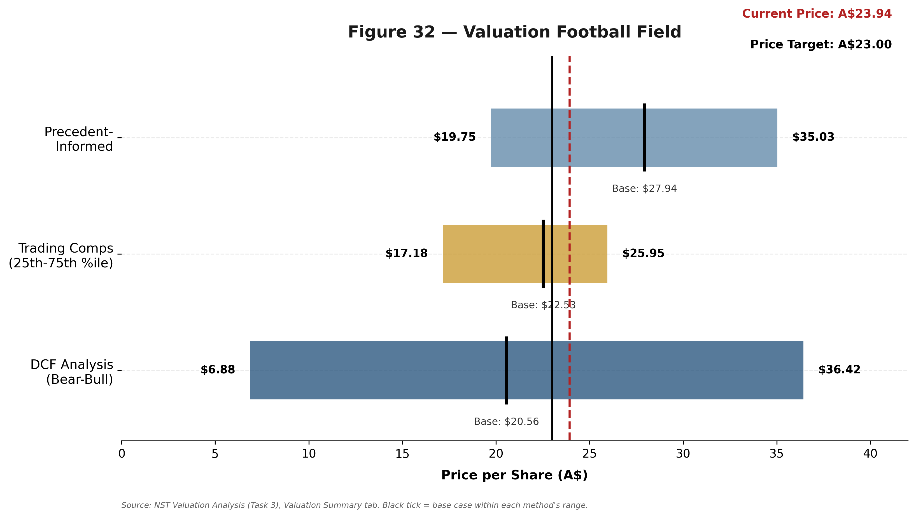
Source: NST Valuation Analysis (Task 3), Valuation Summary tab. Black tick = base case within each method's range.
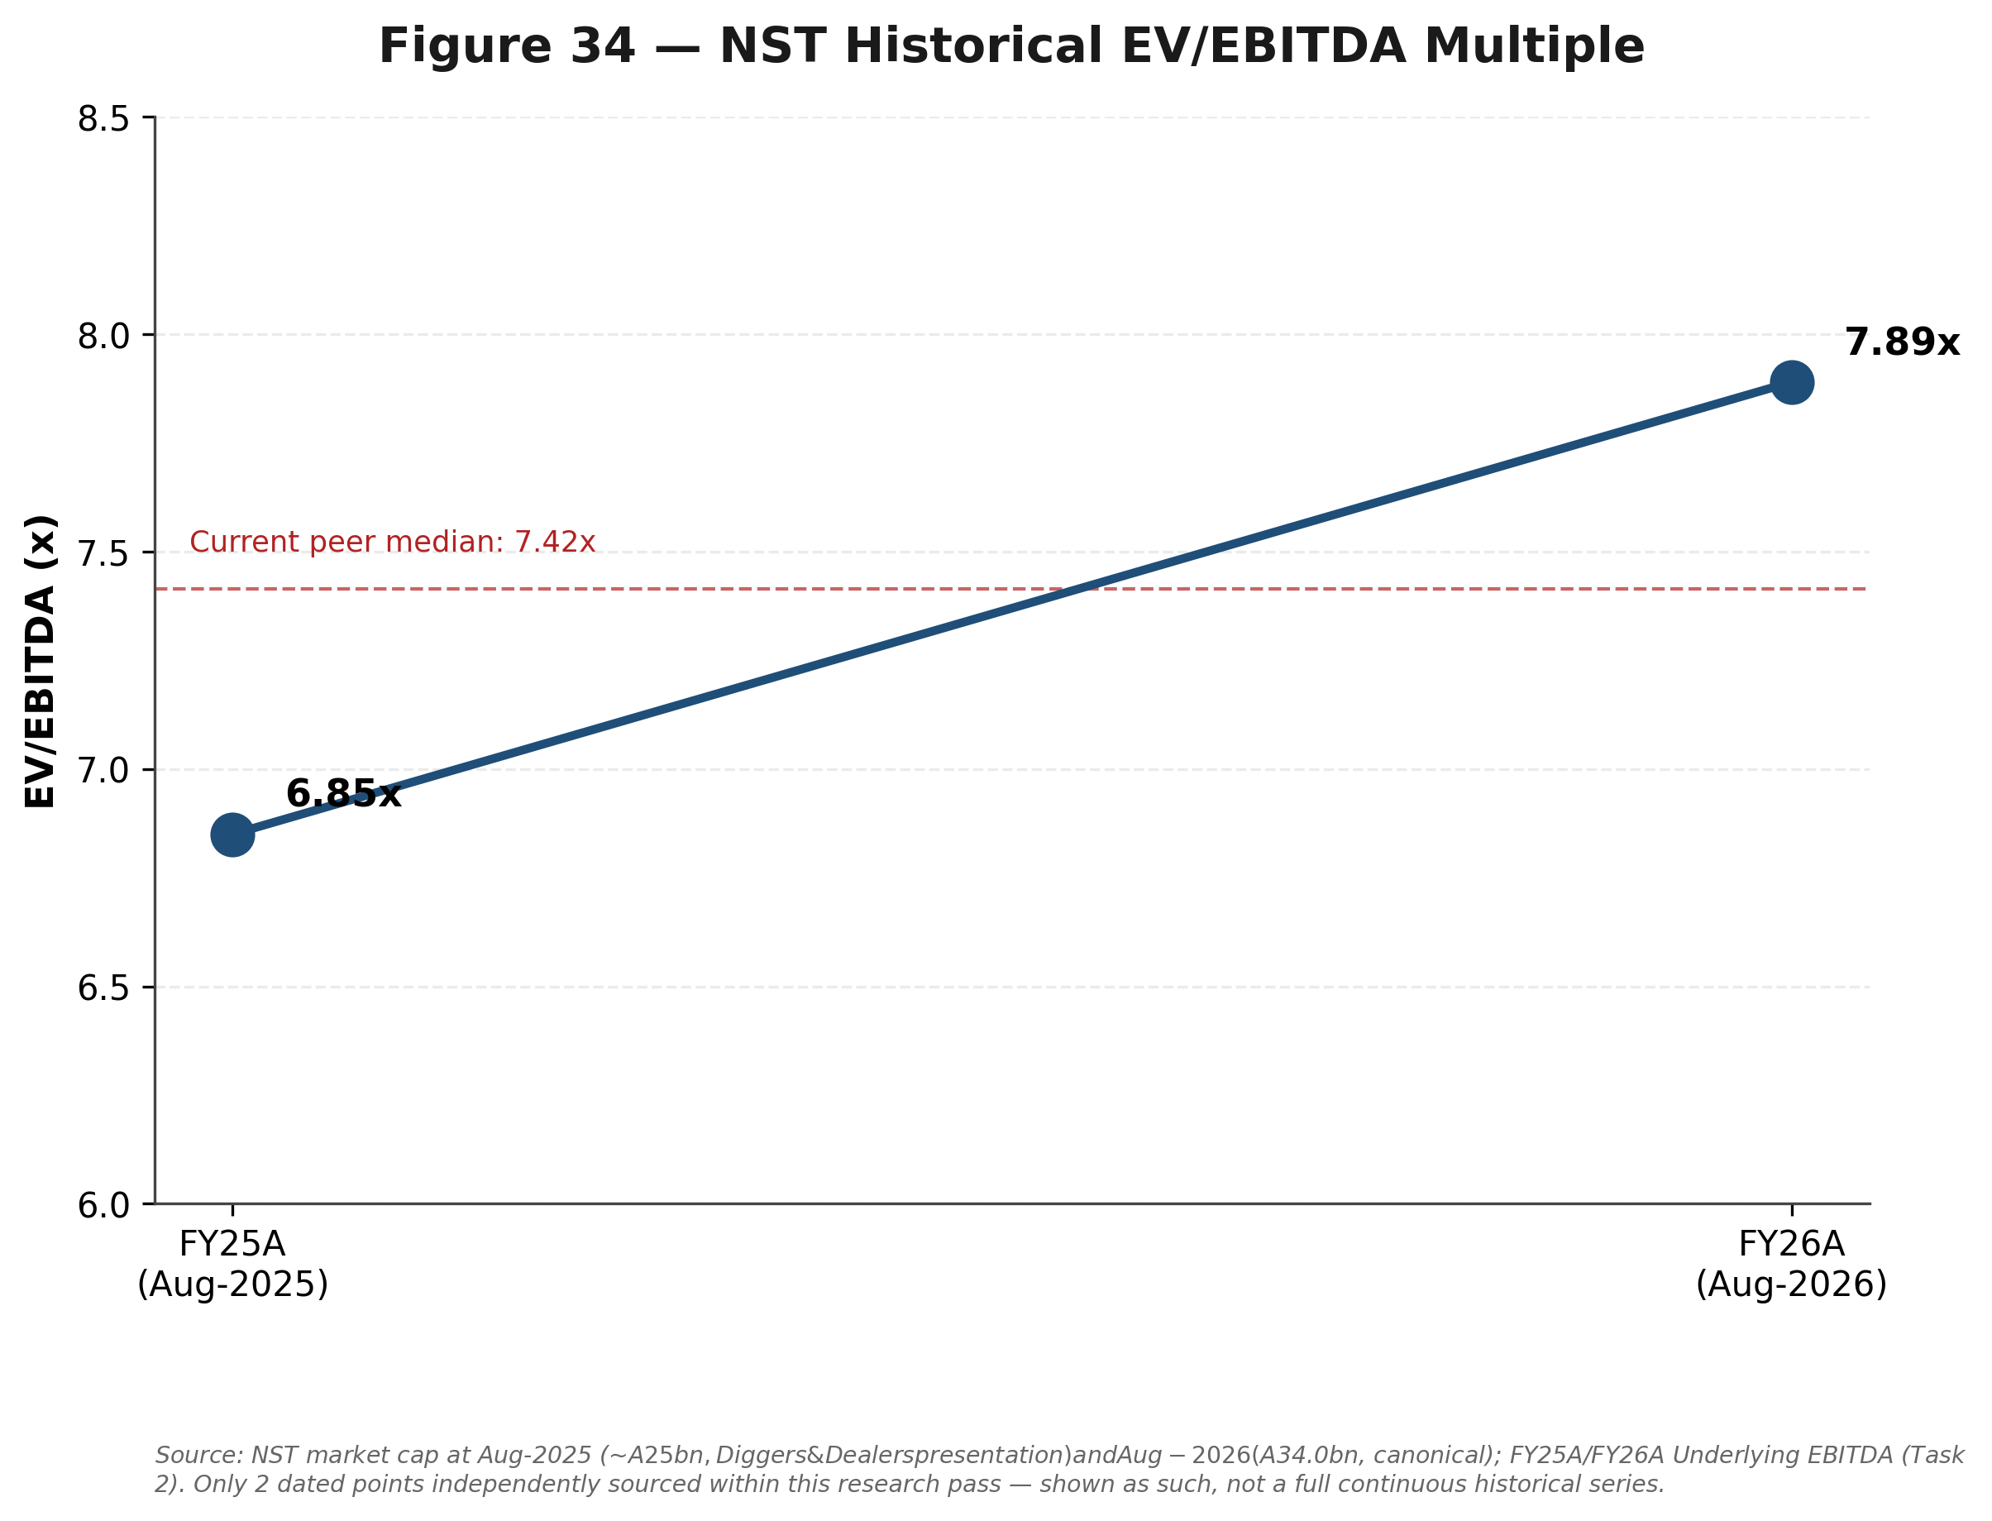
Source: NST market cap at Aug-2025 (~A$25bn) and Aug-2026 (A$34.0bn); FY25A/FY26A Underlying EBITDA. Only 2 dated points sourced — not a full continuous historical series.
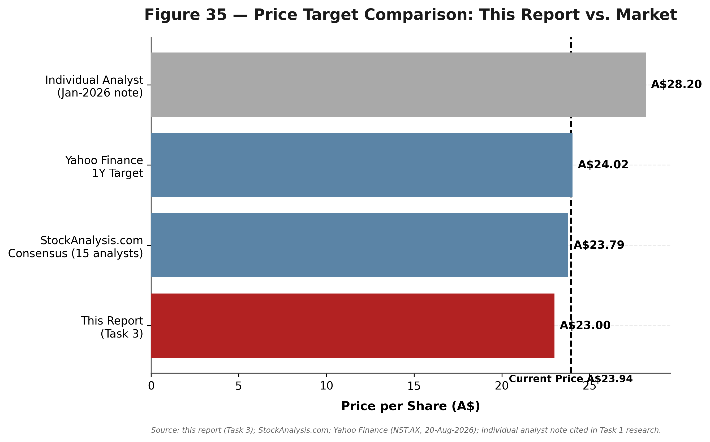
Source: This report (Task 3); StockAnalysis.com; Yahoo Finance (NST.AX, 20-Aug-2026); individual analyst note cited in Task 1 research.

Price Target and Recommendation
Rating: HOLD / NEUTRAL. Price Target: A$23.00 (12-month). Current Price: A$23.94 (20-Aug-2026). Implied price return: -3.9%. Trailing dividend yield: 2.2%. Implied 12-month total return: -1.7%.
The case for HOLD rather than BUY or SELL: Northern Star's asset base is genuinely high-quality and appropriately valued, not mispriced in either direction on the evidence assembled here. The market is not currently underpricing NST's Tier-1-jurisdiction, multi-decade-reserve-life portfolio the way Elliott's campaign materials suggest — comps show NST at or above peer median on EV/EBITDA. Nor does the DCF, even with its own acknowledged limitations, suggest meaningful undervaluation once the FY27 cost/capex peak is properly reflected. At the same time, nothing in this analysis supports a SELL: the comps and precedent-informed ranges both sit at or above the current price at their base case, gold-price fundamentals remain broadly constructive, and real M&A optionality exists. This is a case where the honest answer, arrived at through the work rather than asserted, is 'priced about right, with two-sided risk.'
This conclusion is independently corroborated — not derived from, but consistent with — sell-side consensus: Yahoo Finance's 1-year target for NST is A$24.02, and StockAnalysis.com (aggregating 15 analysts, S&P Global Market Intelligence) shows a 12-month consensus target of A$23.79. Both sit within roughly 4% of this report's own A$23.00 target, despite having been produced through an entirely separate methodology.

Key Catalysts (12 Months)
1. New CEO (Suresh Vadnagra, from 5-Oct-2026) sets medium-term strategic plan and, potentially, updated multi-year guidance.
2. KCGM Mill Expansion Stage 2 completion (targeted late 1H FY27) — recoveries +1-2%, eliminates Fimiston-Gidgee concentrate haulage.
3. Hemi Final Investment Decision (targeted late FY27) — a positive, on-time FID with clear cost/schedule metrics would resolve a major overhang.
4. Resolution of the Elliott Investment Management campaign — a strategic review outcome or clarified Board position either way removes uncertainty.
5. Continued gold-price strength (record central-bank buying) supporting realized prices above FY27E guidance assumptions.

Key Risks to the Price Target
Downside risks:
1. KCGM ramp-up disappoints further (High probability given FY26's repeated guidance cuts).
2. Leadership-transition disruption — simultaneous CEO and Chairman changes during the most capital-intensive period in company history.
3. Gold price reversal — published 2026 forecasts range as low as ~US$4,000/oz; FY27E AISC guidance leaves less margin cushion than FY25-26.
4. Hemi FID delay or cost escalation — approvals are explicitly outside management's direct control.
5. Structural cost inflation (WA royalty, labour, energy) continuing to outpace guided cost improvements.
Upside risks:
1. A takeover approach or forced strategic-alternatives outcome from the Elliott campaign, potentially at a premium closer to the Precedent-Informed range's high end (A$35.03).
2. Faster-than-guided KCGM ramp-up — management's FY27 guidance was explicitly built with conservatism.
3. Sustained gold-price strength beyond this analysis's Base Case assumptions.
4. An early, well-received Hemi FID with better-than-DFS-era economics.

Appendices

Data Sources & References

Company Filings & ASX Announcements
Northern Star Resources Ltd, FY23-FY26 Results Presentations and ASX releases — https://www.nsrltd.com
Northern Star Resources Ltd, FY26 Earnings Call Transcript, 19-20 August 2026 — https://www.investing.com/news/transcripts/earnings-call-transcript-northern-star-posts-strong-fy2026-as-kcgm-ramps-up-93CH-4868462
Northern Star Resources Ltd, Appointment of Managing Director and CEO, 2 July 2026 — https://www.nsrltd.com/media/tcthuz2b/appointment-of-managing-director-and-ceo-02-07-2026.pdf

Financial & Market Data Providers
StockAnalysis.com (S&P Global Market Intelligence), NST/EVN/NEM/GMD/RRL/RMS/PRU statistics pages — https://stockanalysis.com/quote/asx/NST/
Yahoo Finance, NST.AX quote and key statistics — https://finance.yahoo.com/quote/NST.AX/
TradingView, Northern Star Resources Ltd 6.125% 11-Apr-2033 bond page (ISIN USQ6951UAA9) — https://www.tradingview.com/symbols/DUS-USQ6951UAA9
TradingEconomics, Australia 10-Year Government Bond Yield — https://tradingeconomics.com/australia/government-bond-yield

Industry & Macro Data
World Gold Council, Gold Demand Trends Full Year 2025 — https://www.gold.org/goldhub/research/gold-demand-trends/gold-demand-trends-full-year-2025
Aswath Damodaran (NYU Stern), Country Risk: Determinants, Measures and Implications — The 2026 Edition — https://aswathdamodaran.substack.com/p/country-risk-determinants-measures
Government of Western Australia, Mineral royalties in WA fact sheet — https://www.wa.gov.au/government/publications/mineral-royalties-wa

Activist Campaign & M&A Context
Bloomberg, Activist Elliott Hits Back at Gold Miner Northern Star Over Sale, 11 June 2026 — https://www.bloomberg.com/news/articles/2026-06-11/activist-elliott-hits-back-at-gold-miner-northern-star-over-sale
MINING.COM, Northern Star rejects Elliott push to sell company, 11 June 2026 — https://www.mining.com/northern-star-rejects-elliott-push-to-sale-company/
ABC News, Hemi discovery the prize as Northern Star completes $5bn takeover of De Grey Mining, 16 April 2025 — https://www.abc.net.au/news/2025-04-16/gold-miner-northern-star-completes-5-billion-takeover-of-de-grey/105184288
Full source lists with dates for every figure in this report are provided in the companion Task 1 (Company Research), Task 2 (Financial Model README tab) and Task 3 (Valuation Analysis) documents.

