INITIATING COVERAGE
Riot Platforms, Inc. (Nasdaq: RIOT)
Contracted AI Landlord in the Making: 241 MW and $9.8bn of Backlog Meet a Bitcoin Bear Market and a $4.5bn Build-Out
Rating: NEUTRAL / MARKET PERFORM  Price (17-Aug-2026): $20.04  Target Price: $22.00  Implied Upside: 9.8%  52-Week Range (approx.)*: $12.30 – $27.00  Market Cap: $7.52B  Enterprise Value: $7.15B  Shares Outstanding: 375.26M  RESEARCH ANALYST  Claude, Research Analyst (AI-generated research)  Prepared for: Paulie, Equity Research  Anthropic, PBC | 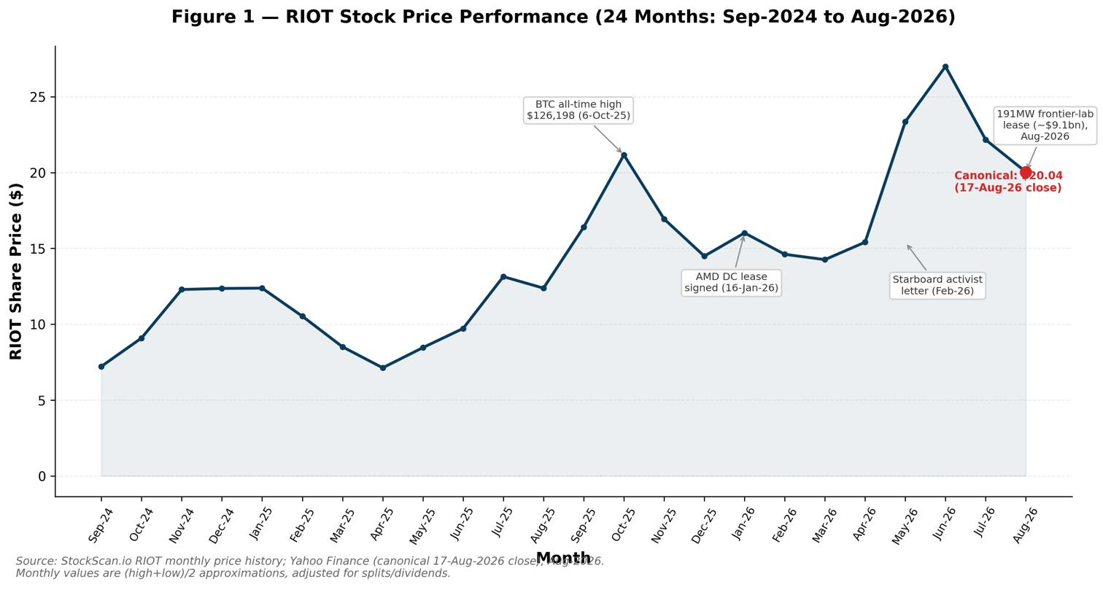

NEUTRAL / MARKET PERFORM — INITIATING COVERAGE
■ 241 MW and ~$9.8 billion of contracted data-center revenue signed in seven months validate the AI-landlord pivot, but the cash has not yet arrived.
Between January and August 2026 Riot moved from zero contracted data-center capacity to 241 MW under 20-year and 10-year leases with AMD and an unnamed "leading frontier AI lab" (widely reported, though unconfirmed, to be Anthropic). Management's own disclosures put cumulative contracted revenue at ~$9.8bn and estimated average annual NOI from the 191 MW frontier-lab lease alone at $365–411M. Our model shows Data Center revenue growing from $118M in 2026E to $580M by 2030E, a 55.8% share of total revenue by then vs. 18.7% in 2026E — but the ramp is back-loaded, with the frontier-lab lease not commencing until roughly June 2028.
■ The legacy Bitcoin-mining business is being squeezed by a bear market at precisely the moment the company must fund a multibillion-dollar build-out.
Bitcoin fell from an October 2025 all-time high of $126,198 to roughly $63,000 by 17-Aug-2026, and Riot's Q2 2026 fully burdened cost to mine one Bitcoin ($90,631, including depreciation) exceeded the $71,667 production value. GAAP net losses of $237.2M in Q2 2026 and $737.6M for H1 2026 were driven heavily by non-cash Bitcoin mark-to-market moves. Our model does not assume any recovery in the fair value of Bitcoin holdings, and projects Mining revenue declining from $576.3M in 2025A to $285.2M by 2030E (a -13.1% CAGR) as Rockdale power increasingly shifts to higher-value data-center leasing.
■ We value the shares on a sum-of-the-parts basis, not a conventional DCF, because ~$4.5bn of 2026E–2030E capex precedes the revenue it funds.
A standard 5-year unlevered DCF yields just ~$1.48/share because terminal value exceeds enterprise value by more than 20x — a textbook signal the explicit window is too short for a 20-year contracted-lease asset. Our SOTP (50% weight) capitalizes stabilized data-center NOI at a 7.0% base cap rate, values the mining business at 4.0–6.5x normalized EBITDA, marks the Bitcoin treasury near spot, and applies a heavily risk-adjusted ~$1.8M/MW to ~1.6 GW of un-leased power, producing a base value of $20.94/share. Trading comparables (40% weight, per-MW basis against six transitioning miner/AI-infrastructure peers) imply $28.64/share; the DCF cross-check (10% weight) contributes just $1.48/share.
■ Our $22 price target and Neutral rating sit well below the Street's ~$30 consensus mean, reflecting a more conservative cap rate and a heavier discount on unsigned optionality.
Blending SOTP (50%), trading comps (40%), and DCF (10%) produces a weighted fair value of $22.07/share, rounded to a $22 target (+9.8% from the $20.04 canonical price) — within the ~21-analyst consensus range of $20–$45 but roughly 27% below the ~$30 mean. The single largest re-rating catalyst is conversion of the non-binding letter of intent for the entire 1 GW Corsicana site, which we estimate could add $2–3bn of equity value; the largest risk is execution slippage across multiple simultaneous gigawatt-scale construction projects.
Table 1 – Riot Platforms, Inc. Summary Financials & Valuation Metrics
($M unless noted) | 2024A | 2025A | 2026E | 2027E | 2028E
Total Revenue | 376.7 | 647.4 | 630.4 | 701.3 | 918.5
Revenue Growth (%) | 34.2% | 71.9% | -2.6% | 11.2% | 31.0%
Gross Margin (%) | 51.0% | 48.9% | 24.2% | 25.7% | 33.3%
Adj. EBITDA (ex-BTC FV) | 463.2 | 13.0 | -7.4 | 30.4 | 151.1
Adj. EBITDA Margin (%) | 123.0% | 2.0% | -1.2% | 4.3% | 16.4%
Diluted EPS ($) | $0.40 | -$1.95 | -$1.49 | -$1.18 | -$0.82
EV / Revenue (x) | 19.0x | 11.0x | 11.3x | 10.2x | 7.8x
EV / Adj. EBITDA (x) | 15.4x | NM | NM | 235.3x | 47.3x
Note: "A" = actual (reported); "E" = Anthropic Equity Research estimate. EV/EBITDA marked NM (not meaningful) where Adj. EBITDA is below $20M. Source: Company filings, Anthropic Equity Research estimates.
*52-week range is an approximation derived from monthly (high+low)/2 price observations in Figure 1 (Aug-2025–Aug-2026) and may not reflect exact intraday extremes; RIOT does not appear to have a company-disclosed 52-week range in the sources reviewed.

Table of Contents
Investment Summary 1
Investment Thesis & Risk Assessment 4
Company Overview 6
Company History 8
Management Team 9
Products & Services 11
Customers & Go-to-Market 13
Industry Overview 14
Competitive Landscape 16
Market Opportunity (TAM) 17
Financial Analysis 19
Projection Assumptions 26
Scenario Analysis 30
Key Growth Drivers 33
Valuation Analysis 34
Appendices 42

Investment Thesis & Risk Assessment

Investment Thesis

1. Already-energised power is the scarce asset in the AI build-out, and Riot controls roughly 1.9 GW of it.
Grid interconnection for new large loads can take years to secure, which has made Riot's grandfathered, already-energised capacity across Rockdale (~700 MW developed), Corsicana (400 MW built toward a 1 GW target), and Kentucky (~232 MW target) unexpectedly valuable to AI/HPC developers. Of this roughly 1.9 GW portfolio, only 241 MW is currently contracted (the AMD and frontier-AI-lab leases), leaving approximately 1.4–1.6 GW of developable capacity that is not yet reflected in consensus numbers at anything like full value. Sector-wide, more than $70bn of AI/HPC contracts had been signed by public miners as of mid-2026 (CoinShares), evidence that the power-for-AI trade is being priced across the group, not just at Riot. We give this optionality a heavily risk-adjusted ~$1.8M/MW in our base case (versus Starboard Value's February-2026 estimate of $9–21bn for Corsicana and Rockdale combined) — a deliberately conservative starting point that leaves room for upside as capacity is signed.

2. A 241 MW, ~$9.8bn contracted backlog — anchored by an on-time, on-budget AMD delivery — provides two decades of revenue visibility from creditworthy counterparties.
The AMD lease (10 years, ~$311M initial contract value, up to 200 MW under options) and the 191 MW frontier-AI-lab lease (20 years through June 2048, ~$9.1bn of contract revenue, up to ~$16.1bn with extensions) together represent 241 MW and roughly $9.8bn of long-term contracted revenue. Management estimates the frontier-lab lease alone will generate average annual NOI of $365–411M and cumulative NOI of $7.3–8.2bn over its term. Riot has already delivered AMD's initial 25 MW on time and on budget, with 10 MW due November 2026 and 15 MW due May 2027 — the single best available proof point that CDCO Jonathan Gibbs's team (more than 15 years and $17bn of prior data-center delivery experience) can execute at the pace the frontier-lab lease requires (96 MW by December 2027; the full 191 MW by June 2028).

3. In-house engineering (ESS Metron/E4A) lowers build cost and cycle time versus peers who must outsource construction, and is becoming a standalone growth business.
Riot's Engineering segment designs and manufactures the switchgear and power-distribution equipment its own data centers require, and increasingly sells that capability to third parties. Engineering revenue grew from $10.6M in Q2 2025 to $37.3M in Q2 2026, and the segment's order backlog reached approximately $177.1M at quarter-end, of which roughly 90% is data-center related — an increasingly important leading indicator of near-term construction activity. Our model projects Engineering revenue growing from $64.7M in 2025A to $175M by 2030E (a 22.0% CAGR), making it a modestly growing, higher-visibility complement to the two capital-intensive core businesses.

4. Multiple embedded options — the 1 GW Corsicana LOI and the Terrestrial Energy nuclear MOU — offer upside optionality not required to underwrite the base case.
Riot has signed a non-binding letter of intent for the entire 1 GW Corsicana site with a single tenant, which management has suggested could generate over $1bn of annual rent if converted; we estimate conversion could add $2–3bn of equity value and treat it as a bull-case catalyst rather than a base-case assumption. Separately, a May-2026 non-binding MOU with Terrestrial Energy contemplates studying up to 4 GW of small-modular molten-salt nuclear capacity at Riot's sites — a call option on a substantially larger long-term power position that requires no capital commitment today. Neither is in our base-case SOTP; both represent real, uncapitalized upside.

5. The valuation is asymmetric: a base case close to today's price, a credible bull case in the low-$30s, and a bear case that still leaves a going concern with contracted assets.
Our SOTP produces a low/base/high range of $9.76/$20.94/$29.58 per share, and blending it with trading comps and a down-weighted DCF yields a $22.07 weighted fair value (12-month target $22, +9.8%). The bear case ($11–13) assumes DC lease-up slips, cap rates widen to 9%, Bitcoin falls to $45–55k, and Riot must dilute to fund the build — a real but not existential outcome, since 241 MW of revenue is already contracted regardless of Bitcoin price. The bull case ($30–32) requires Corsicana conversion, cap-rate compression toward 6%, and a Bitcoin recovery to $90–120k. We rate the shares Neutral because the market, at $20.04, already prices in a meaningful share of this optionality — but the risk/reward skews modestly positive from here.
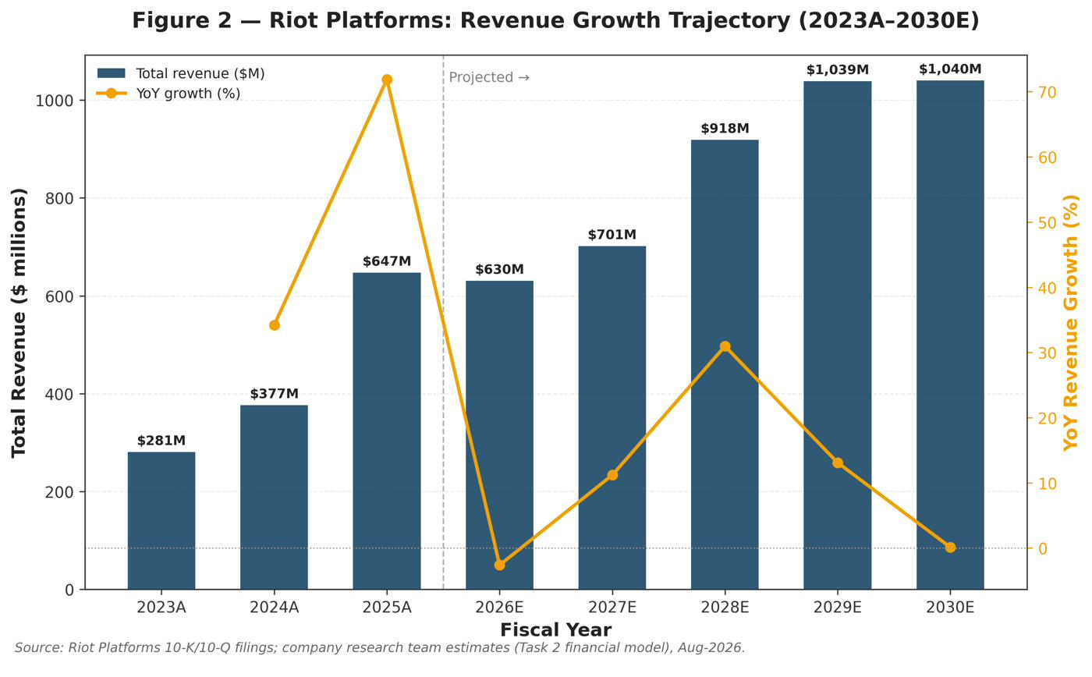

Risk Assessment
We identify twelve material risks across four categories: company-specific, industry/market, financial, and macroeconomic. Investors should weigh these against the contracted-revenue visibility discussed above before drawing conclusions about the shares' risk/reward.

Company-Specific Risks
Execution and construction risk. Riot must build multiple gigawatt-scale, Tier 3 data centers simultaneously (241 MW contracted plus a potential 1 GW Corsicana lease), each requiring complex procurement, permitting, and construction on tight schedules (96 MW due December 2027; full 191 MW by June 2028). Delays, supply-chain issues (e.g., long-lead substation equipment, which has already pushed out timelines historically), or cost overruns would erode contracted NOI and strain financing. This is arguably the single most important risk, because the entire AI thesis depends on converting contracts into delivered, revenue-generating capacity on time and on budget.
Tenant/counterparty concentration. The data-center business rests on a very small number of large tenants — AMD and one unnamed frontier AI lab (reported, unconfirmed, to be Anthropic) — with a potential single-tenant 1 GW Corsicana lease adding further concentration. The failure, renegotiation, or non-renewal of any single tenant, or a deterioration in a tenant's credit, would materially affect long-term cash flows and the value ascribed to the portfolio.
Bitcoin-price and treasury exposure. Despite the pivot, Riot's near-term results remain dominated by Bitcoin: it mines ~1,500+ BTC per quarter and holds 11,380 BTC. Mark-to-market moves in Bitcoin drove the bulk of the $237 million Q2 2026 and $737.6 million H1 2026 net losses. A prolonged Bitcoin bear market depresses both mining cash flow and the value of the treasury used to fund the build-out.
Capital-intensity and funding risk. Building out the portfolio requires billions of dollars. Riot is funding this through interim facilities (e.g., $573 million Morgan Stanley), asset-level debt, and Bitcoin sales, while pursuing investment-grade credit backstops. If financing markets tighten, backstops fail to finalise, or terms prove expensive, the pace and profitability of the build-out could suffer, and equity dilution (via at-the-market issuance) could increase.
Key-person and organisational-transition risk. The pivot depends heavily on a small group of leaders (Les, Gibbs, Chung) and on rapidly scaling a new data-center organisation. Loss of key personnel, or failure to build institutional data-center operating capability quickly enough, would jeopardise execution.

Industry/Market Risks
Competitive intensity for tenants and power. Numerous well-capitalised peers (Core Scientific, TeraWulf, Cipher, IREN, Hut 8, MARA, CleanSpark) are chasing the same AI tenants, some with hyperscaler credit backstops enabling cheaper financing. Competition could compress lease economics or divert tenants and capital away from Riot.
Rising Bitcoin network hash rate. Global hash rate continues to grow — some of it opaque and reportedly concentrated in China and Russia — steadily diluting Riot's share of block rewards and pressuring mining margins even if Bitcoin prices stabilise.
Regulatory, grid, and permitting risk. ERCOT's tightening interconnection and demand-response rules, potential changes to power-market participation, environmental scrutiny of energy-intensive operations, and evolving cryptocurrency regulation could all raise costs or constrain operations — although stricter interconnection rules can also benefit incumbents by increasing the scarcity value of existing approvals.
Technology and demand-cycle risk. A slowdown in AI compute demand, a shift in data-center design requirements, or faster-than-expected obsolescence of mining hardware would undermine the value of Riot's assets and contracts.

Financial Risks
Profitability timeline / current losses. Riot is currently loss-making on a GAAP and adjusted-EBITDA basis (Q2 2026 adjusted EBITDA of –$69.7 million; fully burdened cost to mine of $90,631 exceeded the $71,667 production value per Bitcoin). Meaningful data-center revenue does not ramp until 2027–2028, creating an extended period of losses and cash outflow that the market must underwrite.
Leverage and financing-cost risk. As Riot shifts from an equity-and-Bitcoin-funded model toward debt-financed data-center construction, it takes on interest-rate and refinancing exposure; the sector's peers already carry multibillion-dollar debt loads, and Riot's cost of capital relative to hyperscaler-backstopped competitors will influence returns.

Macroeconomic Risks
Cyclicality and risk-asset sensitivity. Both Bitcoin and AI-infrastructure equities are high-beta, risk-on assets. A broad market downturn, recession, or reduced risk appetite would likely depress Bitcoin prices, Riot's share price, and financing availability simultaneously.
Interest-rate sensitivity. Higher-for-longer interest rates raise the cost of the debt financing central to the build-out and increase the discount rate applied to Riot's long-dated contracted cash flows, pressuring valuation. Conversely, rate cuts would support both financing and valuation.
Power-price and energy-market risk. Riot's core input is electricity. Sustained increases in ERCOT power prices, or reduced availability of favourable curtailment/demand-response economics, would raise mining and data-center operating costs and compress margins.

Company Overview
Riot Platforms, Inc. (Nasdaq: RIOT) is a vertically integrated digital-infrastructure company headquartered in Castle Rock, Colorado. For most of its recent history Riot has been one of the largest publicly traded Bitcoin miners in North America; since early 2025 it has been executing a deliberate pivot from a pure-play Bitcoin miner into a developer and operator of large-scale data centers serving artificial-intelligence (AI) and high-performance-computing (HPC) tenants, while retaining a substantial self-mining business. Management now describes the company as "a vertically-integrated industry leader in digital infrastructure, specializing in the development of large-scale data centers and bitcoin mining applications."
Riot makes money today through three reportable segments, a structure the company formalised in the first half of 2026 after its first data-center lease with AMD generated material revenue. In the second quarter of 2026 (three months ended 30 June 2026, all figures "A"), the segments contributed as follows: Bitcoin Mining revenue of $113.7 million, Engineering revenue of $37.3 million, and Data Center revenue of $23.2 million (comprising $4.9 million of operating-lease revenue and $18.3 million of tenant fit-out services), for total revenue of $174.2 million, up 14% from $153.0 million in Q2 2025. The Bitcoin Mining segment earns Bitcoin block subsidies and transaction fees by operating a large fleet of application-specific integrated-circuit (ASIC) miners. The Engineering segment (built around the acquired ESS Metron and E4A Solutions businesses) designs and manufactures electrical equipment and provides power-infrastructure engineering to third parties and to Riot itself. The Data Center segment leases critical IT capacity ("megawatts") to hyperscale and enterprise tenants under long-term contracts and provides associated development and fit-out services.
Geographically, Riot operates Bitcoin-mining and digital-infrastructure facilities in central Texas (its flagship Rockdale campus and its 1-gigawatt Corsicana development site) and in Kentucky, plus engineering and fabrication facilities in Denver, Colorado, and Houston, Texas. Its Texas positioning is strategically important: the ERCOT grid offers low-cost power, demand-response revenue opportunities, and — increasingly — scarce, already-energised interconnection capacity that is highly valuable to AI data-center developers.
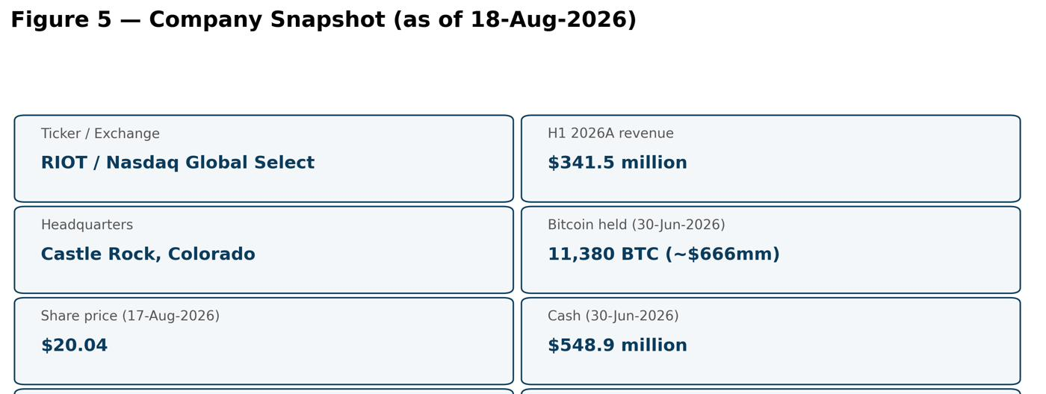
Source: Riot Platforms company filings and investor materials; Anthropic Equity Research.
On scale: in full-year 2025 (A) Riot generated record revenue of $647.4 million (up 72% year-over-year) and mined 5,686 Bitcoin. Its deployed self-mining hash rate grew from 31.5 exahash per second (EH/s) at the end of 2024 to roughly 40 EH/s by the end of 2025, and realised hash rate reached approximately 42.3 EH/s in Q1 2026 — equivalent to roughly 4% of the global Bitcoin network. As of 30 June 2026 the company held 11,380 Bitcoin (of which 5,821 were pledged as collateral), worth approximately $666.0 million at the 30 June 2026 Bitcoin price of $58,527, plus $548.9 million of cash, for over $1.2 billion of total liquidity.
The defining feature of the current Riot story is the speed of its data-center lease-up. In roughly seven months (January–August 2026) Riot moved from zero contracted data-center capacity to 241 megawatts (MW) of critical IT capacity under 20-year and 10-year leases with two significant AI-ecosystem counterparties — Advanced Micro Devices (AMD) and an unnamed "leading frontier AI lab" (reported by Bloomberg and CNBC to be Anthropic; unconfirmed). Management states these two leases represent approximately $9.8 billion of long-term contracted revenue. Riot has also signed a non-binding letter of intent (LOI) for the entire 1-gigawatt Corsicana site with a single tenant. This transformation has come at a financial cost: with Bitcoin prices roughly half their October 2025 all-time high, Riot reported a GAAP net loss of $237.2 million in Q2 2026 and $737.6 million for the first half of 2026, driven heavily by non-cash mark-to-market losses on its Bitcoin holdings, depreciation, and an impairment tied to repurposing mining capacity for data-center use.
In short, Riot today is a company with two identities held in tension: a mature, scale Bitcoin miner whose economics are currently squeezed by a Bitcoin bear market and rising network difficulty, and an emerging AI/HPC data-center landlord whose contracted backlog implies multibillion-dollar future cash flows that have only just begun to be recognised. The investment debate centers on how much credit to give the contracted-but-not-yet-built data-center revenue versus the near-term losses in the legacy mining business.

Company History
Riot's corporate lineage stretches back well before its Bitcoin era. The entity now known as Riot Platforms was previously a biotechnology company; in October 2017 it rebranded as Riot Blockchain to pursue cryptocurrency and blockchain opportunities — a pivot that, at the time, drew regulatory and media scrutiny (including a well-publicised CNBC investigation into the name change and share-price behaviour). It was during this period, in October/November 2017, that Jason Les — a professional poker player and computer-science graduate active in Bitcoin since 2013 — joined the board of directors.
The company's transformation into a serious industrial-scale operator accelerated under new leadership. Jason Les became Chief Executive Officer on 8 February 2021, and Benjamin Yi became Chairman in May 2021. The single most important event in Riot's history followed shortly after: in May 2021 Riot completed the acquisition of Whinstone US from Germany's Northern Data for consideration of $80 million in cash plus 11.8 million Riot shares — an implied value of approximately $651 million based on Riot's then-share price of $48.37. Whinstone owned and operated the Rockdale, Texas facility — built on part of the site of a former Alcoa aluminium smelter and, at the time, North America's largest Bitcoin hosting facility as measured by developed capacity (300 MW developed, with plans toward 750 MW). The Rockdale campus, with its large, already-approved power interconnection, would become the cornerstone asset underpinning both Riot's mining scale and — a half-decade later — its AI data-center pivot.
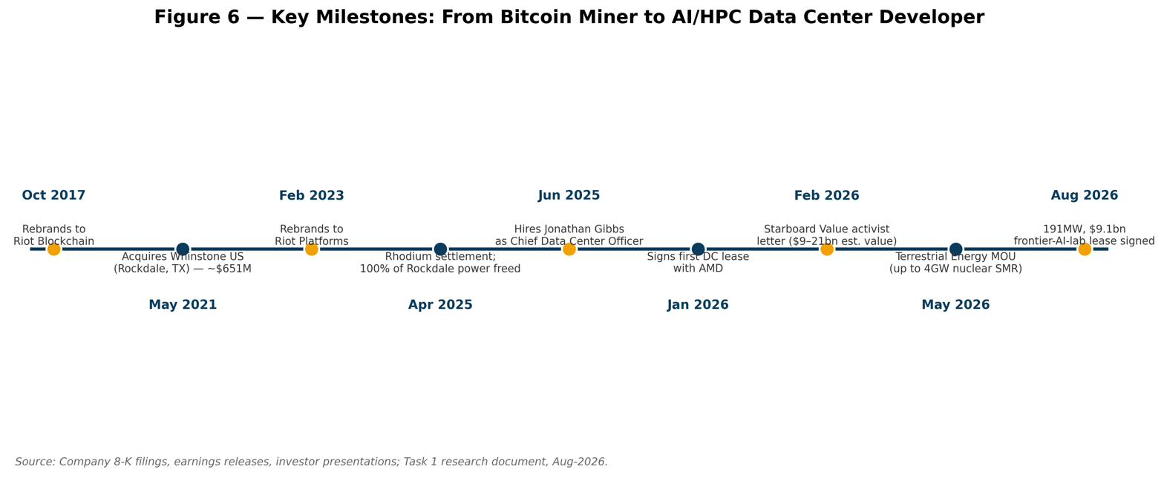
Riot pursued vertical integration to control its two largest inputs, power infrastructure and mining hardware supply-chain resilience. In 2021 it acquired ESS Metron, an electrical-equipment engineering and manufacturing firm, for approximately $50 million, giving Riot in-house capability to build the electrical infrastructure its mines require. In early 2023 the company rebranded from Riot Blockchain to Riot Platforms to reflect this broader industrial scope. During 2023–2024 Riot scaled aggressively: it energised the first phase of its Corsicana Facility (a greenfield 1-gigawatt-target site), acquired Block Mining (a Kentucky-based miner) and E4A Solutions (electrical engineering services), and grew its mined-Bitcoin output to 4,828 coins in 2024 at an average direct cost of $32,216 per coin, generating FY2024 record revenue of $376.7 million, net income of $109.4 million, and adjusted EBITDA of $463.2 million.
A recurring theme was the cleanup of legacy contracts inherited with Whinstone. In April 2025 Riot reached a settlement with Rhodium — a hosting customer at Rockdale — under which Whinstone acquired specific Rhodium assets for $185.0 million, terminated the legacy hosting agreements, assumed roughly 125 MW of associated power capacity for Riot's own use, and dismissed all outstanding litigation. This eliminated a money-losing contract (nearly $15 million of operating losses in 2024 alone) and dedicated 100% of Rockdale's power to Riot.
The pivotal strategic inflection came in January 2025, when Riot announced it had engaged financial advisors to pursue AI/HPC opportunities for the power assets at Corsicana, followed by a feasibility study (Altman Solon) validating the site's attractiveness. Through 2025 Riot assembled a data-center team, hiring hyperscale veteran Jonathan Gibbs as Chief Data Center Officer in June 2025, and in Q3 2025 initiated core-and-shell construction of the first two buildings (112 MW of critical IT capacity) at Corsicana.
The pace of execution in 2026 has been remarkable. On 16 January 2026 Riot announced its first data-center lease, with AMD, alongside a Rockdale land acquisition; the initial 5 MW deployed in January, and AMD later exercised an expansion option toward 50 MW total. In February 2026 activist investor Starboard Value — one of Riot's largest shareholders — publicly pressed the company to accelerate AI/HPC monetisation, arguing its Texas sites could hold $9–21 billion in equity value. In March 2026 Riot began funding its build-out partly by selling Bitcoin (3,778 BTC sold in Q1 2026 at an average $76,626, for $289.5 million). In May 2026 Riot signed a non-binding MOU with Terrestrial Energy to study co-locating up to 4 gigawatts of small-modular molten-salt nuclear capacity at its sites (the stock rose sharply on the news). Finally, subsequent to Q2 2026 quarter-end, Riot executed the 20-year, 191 MW Rockdale lease with a "leading frontier AI lab" (reported, unconfirmed, to be Anthropic) worth approximately $9.1 billion, and disclosed a non-binding LOI for the entire 1 GW Corsicana site. In roughly 18 months, Riot repositioned from "Bitcoin miner exploring AI" to "contracted AI data-center developer that also mines Bitcoin."

Management Team
Jason Les — Chief Executive Officer & Director. Les, born in 1985, has led Riot as CEO since 8 February 2021 and has served as a director since October/November 2017. He holds a Bachelor of Science in Information & Computer Science from the University of California, Irvine (attended 2005–2010). Before his corporate career, Les was a professional poker player (approximately 2004–2018) specialising in Heads-Up No-Limit Hold'em, and he became internationally known as one of the elite human players selected as a "human benchmark" against Carnegie Mellon University's poker AI systems in the 2015 and 2017 "Man vs. Machine"/"Brains vs. AI" (Libratus) challenges — an experience frequently cited as sharpening his approach to game theory, risk, and decision-making under uncertainty. He has been active in Bitcoin since 2013, founded Binary Digital SG (2017–2020), and co-founded ZKX, a decentralised derivatives exchange built on StarkNet. As CEO, Les has overseen the Whinstone integration, the vertical-integration strategy (ESS Metron, E4A Solutions), the FY2024–FY2025 scale-up in mining, and — most consequentially — the strategic pivot into AI/HPC data centers, culminating in the AMD and frontier-AI-lab leases. His long tenure and technical fluency give him credibility with both the Bitcoin community and, increasingly, institutional data-center counterparties; his principal execution test now is delivering large, capital-intensive data-center construction on time and on budget across multiple sites simultaneously.
Jason Chung — Chief Financial Officer. Chung, age 44, became CFO effective 1 March 2026, succeeding Colin Yee. He joined Riot in June 2022, serving as Head of Corporate Development & Strategy and then Executive Vice President, Head of Corporate Development & Strategy from July 2023, where he led capital-markets strategy, investor relations, and M&A. He brings roughly two decades of investment-banking and corporate-finance experience: prior to Riot he was Managing Director, M&A at Nomura Holdings (March 2017–June 2022) and Executive Director, Mergers & Acquisitions (2014–2016), advising global clients on cross-border technology transactions. His appointment was explicitly framed by the company as aligning the finance function with the data-center growth strategy, and it coincided with a compensation-plan overhaul that eliminated a legacy "bitcoin yield" performance metric and introduced new metrics tied to data-center revenue and net operating income. Chung's banking background is directly relevant to the financing challenges ahead — Riot must fund billions of dollars of data-center construction, and his early tenure has already involved arranging non-recourse and interim facilities (e.g., the $573 million Morgan Stanley facility) and pursuing investment-grade credit backstops on leased assets. He also continues to oversee corporate development and investor relations.
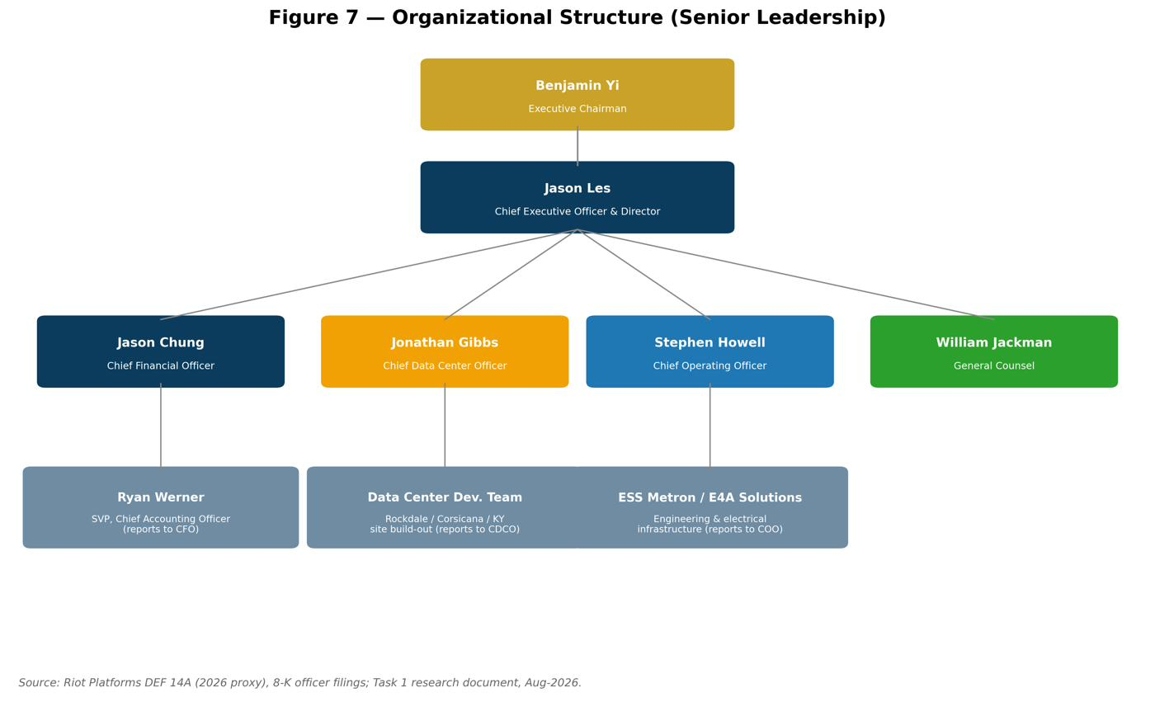
Benjamin Yi — Executive Chairman. Yi, age 40, has been Chairman since May 2021 and serves in an executive capacity, active in the company's capital-allocation and strategic messaging (including public appearances on "monetizing megawatts"). Before Riot, from January 2017 to May 2021 he led capital markets and corporate development at IOU Financial, a fintech-enabled small-business lender in North America and an investee company of Neuberger Berman. Yi and Les are the two executives to whom Starboard Value addressed its February 2026 activist letter, positioning them as the primary decision-makers on the AI/HPC monetisation strategy. As part of the January 2026 compensation changes, Yi's and Les's base salaries were each raised from $600,000 to $900,000, with the elimination of a legacy annual grant of 10 Bitcoin each and an increase in target annual-incentive award levels — changes designed to re-orient leadership incentives toward data-center execution rather than Bitcoin accumulation.
Jonathan Gibbs — Chief Data Center Officer. Gibbs was appointed CDCO in June 2025 to lead the strategic development and operation of Riot's data-center platform for hyperscale and enterprise tenants — the single most important operational hire for the pivot. He brings more than 15 years of experience designing and building large-scale data centers, having led the development of facilities totalling more than one gigawatt of capacity across North America, Europe, and Asia, and having overseen infrastructure design, procurement, construction, and sustainability initiatives representing more than $17 billion of investment over his career. Gibbs's mandate is to convert Riot's power assets and in-house engineering into Tier 3, build-to-suit data centers that meet the demanding requirements of investment-grade AI tenants; the on-time, on-budget delivery of AMD's initial 25 MW is the first public evidence of his team's execution capability.
Other key officers and governance. Stephen Howell (age 50) has served as Chief Operating Officer and SVP since June 2024, having previously been CEO of ESS Metron (the engineering business Riot acquired). Colin Yee, CFO from 2022 to March 2026, transitioned to a Senior Advisor role to support continuity. Other named officers include William Jackman (General Counsel), Ryan Werner (SVP, Chief Accounting Officer), and Phil McPherson (VP/Capital Markets). On governance, the board includes independent directors such as Hubert Marleau; Starboard Value, one of the company's largest shareholders (reported at roughly 12.7 million shares in early 2026), is an active engaged investor influencing strategic direction. Overall, the management team blends deep Bitcoin/technology roots (Les), institutional finance (Chung, Yi), and hyperscale data-center expertise (Gibbs) — a combination well-matched to the company's hybrid model, though the leadership is being asked to execute an unusually rapid and capital-intensive transformation.
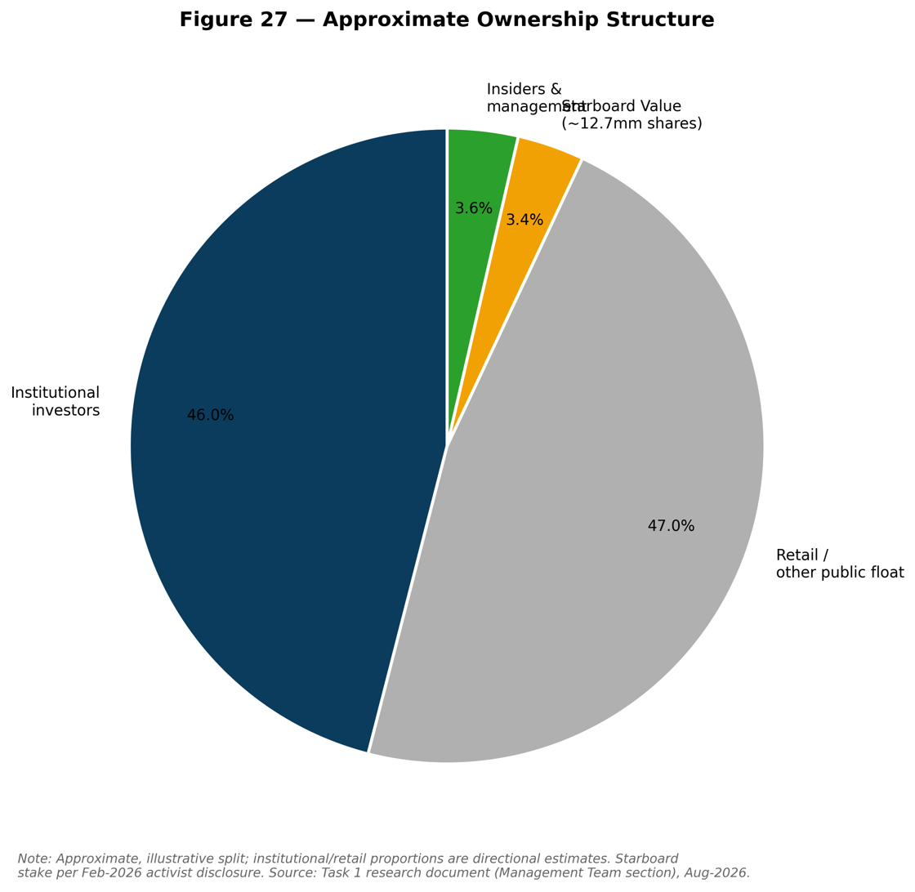

Products & Services
Riot's offering spans three integrated activities that share a common foundation: large-scale, low-cost, already-energised electrical power capacity.
Bitcoin mining (self-mining). Riot operates a large ASIC fleet — principally MicroBT machines (e.g., M60/M60S series) deployed at Rockdale and Corsicana — to earn Bitcoin block rewards and transaction fees. The economic "product" is newly minted Bitcoin. Riot's competitive differentiators in mining are its scale, low power cost (all-in Texas power cost was approximately 4.2 cents/kWh as of September 2025), improving fleet efficiency (roughly 20.5 joules per terahash by late 2025, down from ~23 J/TH a year earlier), and its ability to monetise grid flexibility. Because its Texas power contracts allow strategic curtailment, Riot participates in ERCOT demand-response programs and earns power-curtailment credits that materially reduce its cost to mine (for example, $10.1 million of curtailment credits in Q2 2026 alone). Deployed hash rate reached roughly 40 EH/s at the end of 2025 and ~42.3 EH/s realised in Q1 2026, around 4% of the global network. However, the current Bitcoin bear market has pressured mining economics sharply: in Q2 2026 the production value of one mined Bitcoin was $71,667 (A), while the cost to mine one Bitcoin was $49,912 excluding miner depreciation and $90,631 including depreciation — meaning mining was profitable on a cash-cost basis but loss-making on a fully burdened basis.
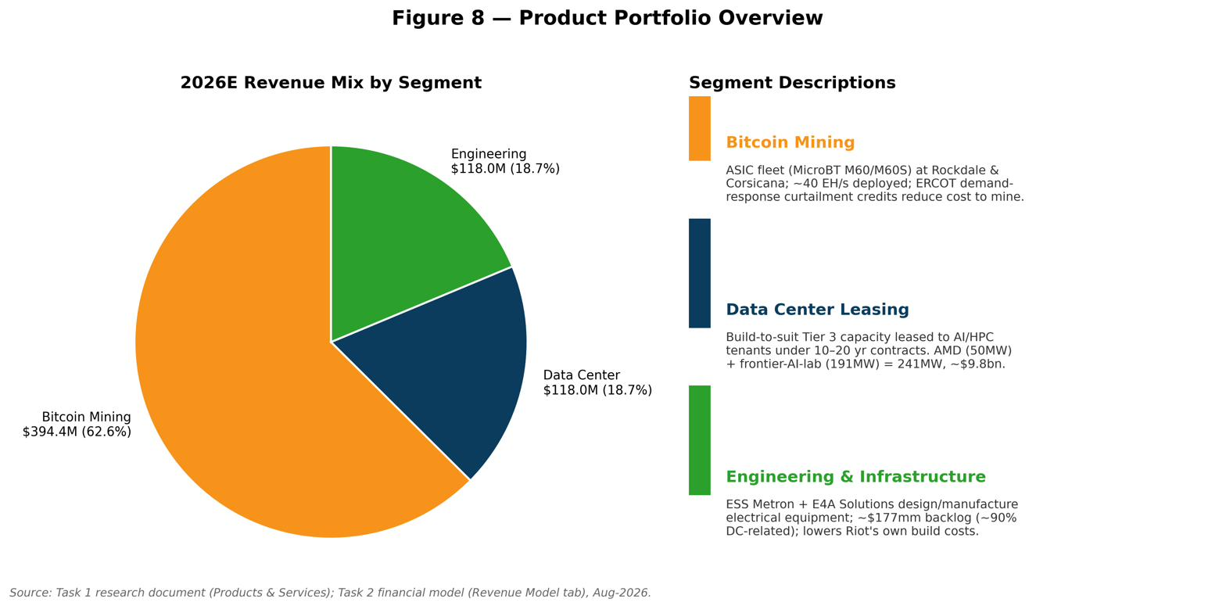
Data-center leasing and development. Riot's newest and strategically most valuable product is build-to-suit, Tier 3 data-center capacity leased to AI/HPC tenants under long-duration contracts. The company converts its megawatts of approved power into critical IT capacity, designs and constructs the facilities using in-house engineering, and earns (i) recurring operating-lease revenue and (ii) tenant fit-out/development-services revenue. Two anchor contracts define this business: the AMD lease (announced 16 January 2026; a 10-year lease with roughly $311 million of initial contract value, 50 MW currently contracted with up to 200 MW available under options; 25 MW commissioned, with 10 MW due November 2026 and 15 MW due May 2027) and the 191 MW "frontier AI lab" lease at Rockdale (20-year term through June 2048; approximately $9.1 billion of total contract revenue, up to ~$16.1 billion with two five-year extension options; estimated cumulative NOI of $7.3–8.2 billion and average annual NOI of $365–411 million; phased delivery of 96 MW by December 2027 and the full 191 MW by June 2028). Together these represent 241 MW and ~$9.8 billion of contracted revenue. These figures are company forecasts of future contract revenue, not revenue already earned.
Engineering and electrical infrastructure. Through ESS Metron and E4A Solutions, Riot designs and manufactures custom electrical equipment (switchgear, power-distribution infrastructure) and provides engineering services. Engineering revenue reached $37.3 million in Q2 2026 (up from $10.6 million a year earlier), and its order backlog — approximately $177.1 million at Q2 2026, of which ~90% is data-center related — is an increasingly important leading indicator. This segment lowers Riot's own build costs and cycle times (a competitive edge in delivering data centers quickly) and captures third-party revenue from the broader electrification and data-center construction boom.
Bitcoin treasury and power-market participation. Riot also historically held mined Bitcoin as a treasury asset (a policy it has partly reversed, selling coins to fund the AI build-out) and monetises its power position through curtailment/demand-response credits. Pricing across the portfolio is thus a blend of Bitcoin-network economics (variable, commodity-like), long-term contracted lease rates (stable, escalating), and engineering project margins. The unifying value proposition to customers and shareholders is Riot's control of scarce, grid-connected power at scale — the input that both Bitcoin mining and AI compute most fundamentally require.
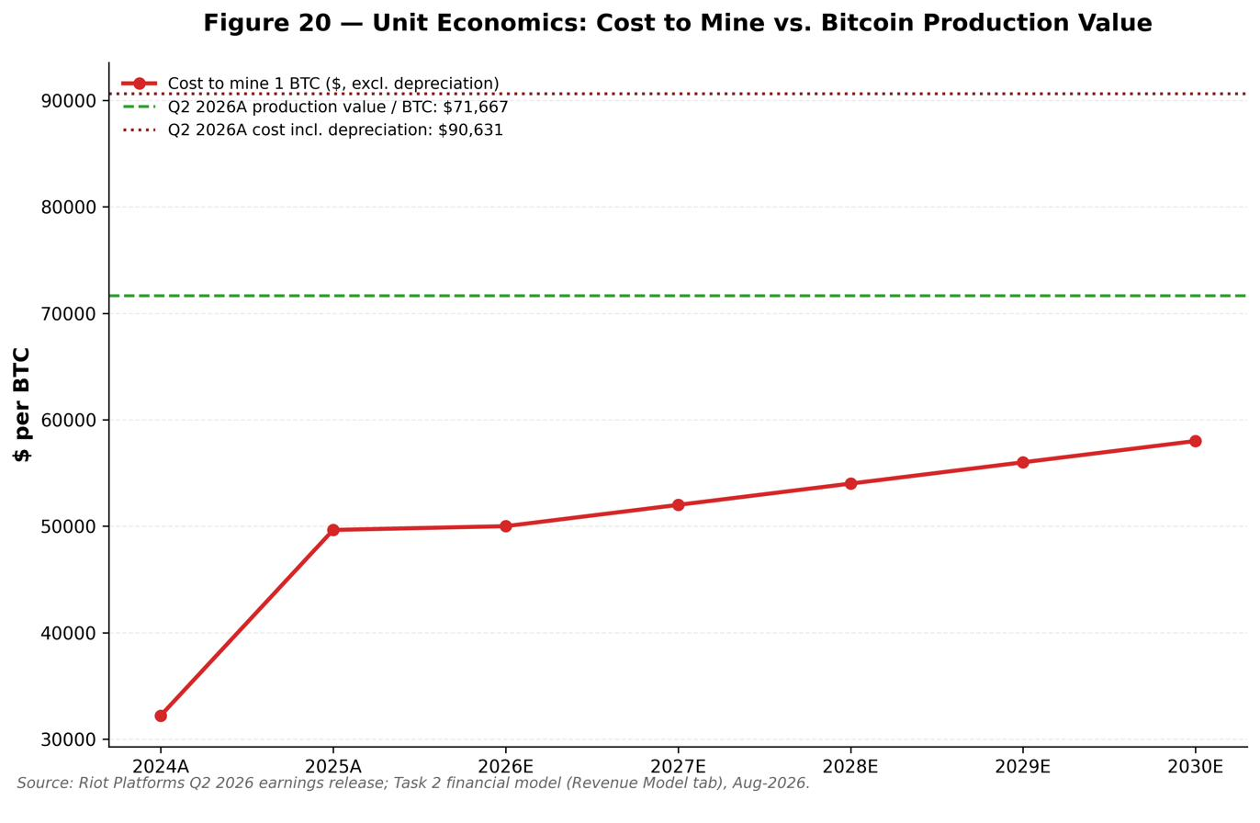

Customers & Go-to-Market
Riot's customer base differs sharply by segment. In Bitcoin mining, there is effectively no "customer": Riot sells mined Bitcoin into liquid global markets, so its counterparty is the market itself, and revenue is a function of Bitcoin price, network difficulty, and its own hash-rate share rather than any customer relationship or sales cycle.
In the Data Center segment, by contrast, customers are few, very large, and creditworthy — the go-to-market is a small number of high-value, negotiated, long-duration leases rather than a volume sales motion. The two disclosed tenants are AMD (a global semiconductor leader) and an unnamed "leading frontier AI lab" (reported by Bloomberg and CNBC to be Anthropic; unconfirmed by either party). When pressed on the tenant's identity on the Q2 2026 earnings call, CEO Jason Les declined to comment. This concentration is a double-edged characteristic: it delivers extraordinary revenue visibility and duration (20-year terms), but it also concentrates counterparty and re-leasing risk in a handful of names. Riot mitigates this partly through structure — for example, pursuing investment-grade credit backstops and non-recourse financing (the $573 million Morgan Stanley interim facility is structured as non-recourse to Riot). The disclosed non-binding LOI for the entire 1 GW Corsicana site with a single tenant would, if converted, further concentrate — but also dramatically expand — the contracted base (management has suggested it could generate over $1 billion of annual rent).
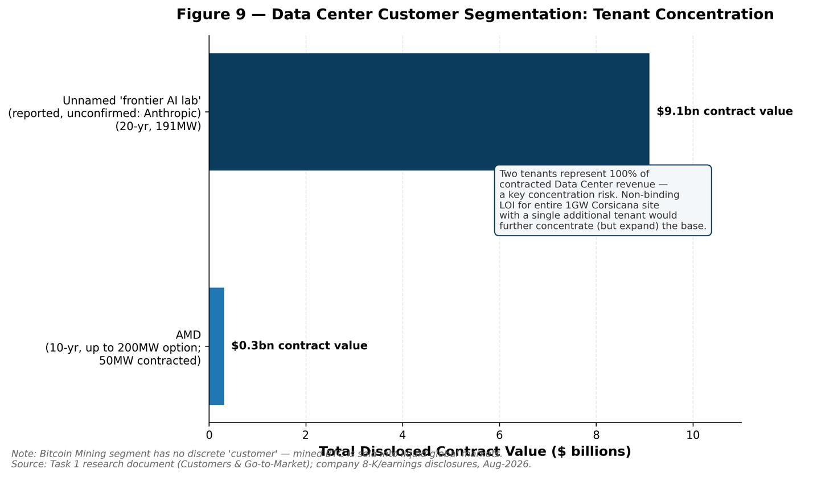
Riot's data-center go-to-market rests on three differentiators that management repeatedly emphasises: (1) multi-gigawatt-scale power capacity that is already fully approved and energised — increasingly the binding constraint for AI build-outs, particularly as ERCOT tightens interconnection requirements for new large loads (Riot argues its grandfathered, active interconnections are a growing scarcity advantage); (2) in-house data-center development expertise (the Gibbs-led team plus ESS Metron/E4A engineering), enabling faster, lower-cost, custom builds; and (3) the financial resources to deploy capacity, secured through interim facilities and asset-level financings. The proof point most cited to prospective tenants is the on-time, on-budget delivery of AMD's initial 25 MW.
Partnerships and channels extend the model: the Terrestrial Energy MOU (up to 4 GW of small-modular nuclear) is a forward-looking power-supply partnership aimed at future AI sites; Morgan Stanley provides financing; and Riot's engineering subsidiaries function as both an internal supplier and an external-revenue channel into the broader data-center and electrification market. The Engineering segment's own customers are third-party industrial and data-center clients requiring electrical equipment and services, giving Riot a modest but growing B2B channel independent of Bitcoin. Finally, Riot's shareholder base itself is a strategic "customer" of sorts: activist Starboard Value has actively shaped the go-to-market thesis, publicly arguing that Riot should prioritise converting its power assets into AI/HPC leases — a message that has aligned management incentives (via revised compensation metrics) with data-center lease-up rather than Bitcoin accumulation.

Industry Overview
Riot sits at the intersection of two industries: (1) Bitcoin mining, and (2) AI/HPC data-center infrastructure. Both are being reshaped by the same underlying scarcity — grid-connected electrical power.
Bitcoin mining. Bitcoin mining is the process of validating transactions and securing the Bitcoin network in exchange for newly issued Bitcoin (the block subsidy) and transaction fees. The industry is fundamentally driven by three variables: the Bitcoin price, the global network hash rate (which determines each miner's share of rewards and rises as competitors add machines), and the block subsidy, which halves roughly every four years. The most recent halving in April 2024 cut the subsidy from 6.25 to 3.125 BTC per block, structurally compressing miner revenue per unit of hash rate. Since then, economics have been squeezed further by a rising network hash rate and, in 2026, a sharp Bitcoin price decline. Bitcoin reached an all-time high of $126,198 on 6 October 2025 but had fallen to roughly $63,000 by 17 August 2026 — approximately half its peak and down about $54,000 year-over-year — a bear market that has rendered fully burdened mining (including depreciation) unprofitable for many operators, Riot included. The Bitcoin network's average hash rate was estimated at roughly 957 EH/s in Q2 2026. Regulatory and grid dynamics matter greatly: in Texas, ERCOT has implemented more stringent demand-response and interconnection requirements for large loads, which simultaneously pressures new entrants and increases the scarcity value of existing, approved interconnections held by incumbents like Riot.
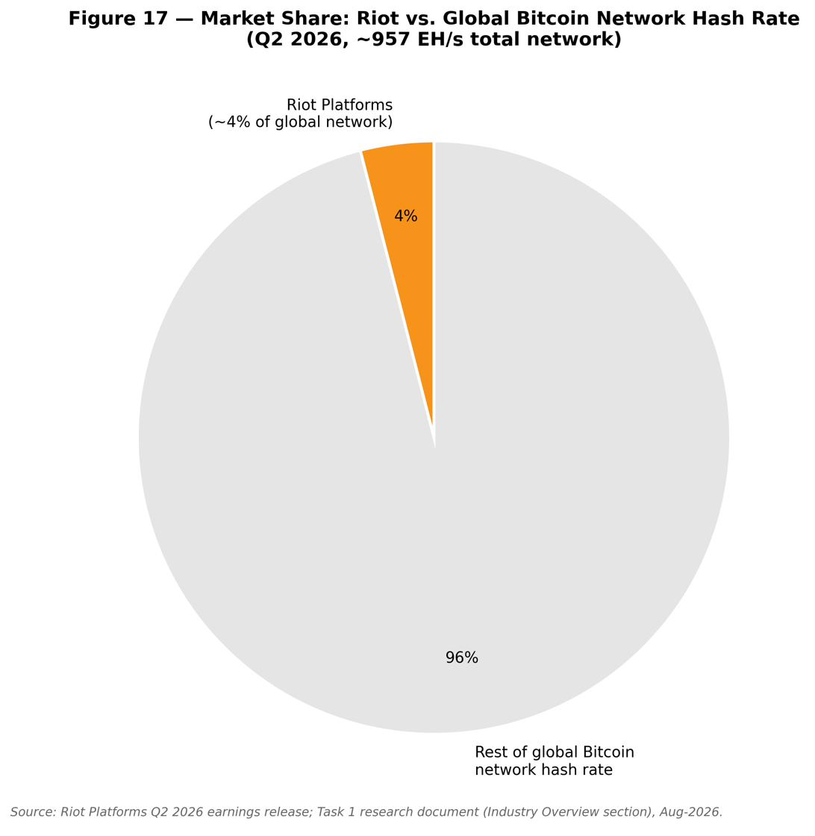
AI/HPC data-center infrastructure. The explosive growth of AI compute demand has created a land-grab for power-dense data-center capacity. Because building new grid interconnection can take many years, already-energised power has become the scarce, securitisable asset — a dynamic that has made Bitcoin miners, who control gigawatts of approved power, unexpectedly attractive as AI landlords. This has triggered a sector-wide "AI pivot." According to a CoinShares Q1 2026 mining report cited across the industry, more than $70 billion of cumulative AI/HPC contracts had been announced across the public mining sector by mid-2026. The financing structure of these deals has matured rapidly, with hyperscaler/AI-lab "backstops" effectively converting miner-lease risk into big-tech credit risk, enabling investment-grade-style debt issuance (for example, senior secured notes priced around 7.125% at one peer). The result is a bifurcation: some operators are dismantling mining fleets entirely to convert sites to HPC, while others (including Riot) pursue a hybrid model, monetising a portion of their power via AI leases while continuing to mine with the balance.
Industry structure, barriers, and drivers. Both industries are capital-intensive and increasingly consolidated around operators with (a) large, low-cost, approved power, (b) construction and engineering capability, and (c) access to capital markets. Barriers to entry are high and rising, chiefly because new large-load grid interconnection is scarce and slow. Key growth drivers are the secular expansion of AI compute demand, the continued institutionalisation of Bitcoin, and — for miners — any recovery in Bitcoin price/hash-price. Key headwinds are Bitcoin-price volatility, relentless network-hash-rate growth (some of it opaque, reportedly concentrated in China and Russia), rising power demand and prices, and regulatory/permitting friction. The overarching industry thesis — that "grid-connected power, not silicon, is now the scarce asset being securitised on 20-year terms" — is precisely the trend Riot is monetising.

Competitive Landscape
Riot competes against a well-defined cohort of publicly traded North American Bitcoin miners, most of which are pursuing their own AI/HPC pivots. The competitive dynamic has two dimensions: competition for Bitcoin-network share (hash rate) and competition for AI/HPC tenants (contracted power).
MARA Holdings (Nasdaq: MARA) is the largest miner by hash rate and Bitcoin treasury, and — like Riot — has expanded mining to absorb hash rate shed by peers pivoting to AI, while itself moving into AI/HPC. MARA reported a large net loss in Q2 2026 (approximately $611 million), reflecting the same Bitcoin-price mark-to-market pressures affecting Riot. CleanSpark (Nasdaq: CLSK) is a large, efficient miner with a growing ERCOT pipeline (585 MW) that has signalled a more selective AI approach; it reportedly secured a multibillion-dollar (~$6.6 billion) lease, though for much of 2026 the market treated it as a high-beta miner pending a marquee hyperscale deal. Core Scientific (Nasdaq: CORZ) is among the furthest along in conversion, with colocation revenue ($136.7 million in Q2 2026) already exceeding its mining revenue; it has been a bellwether for the miner-to-AI transition. TeraWulf (Nasdaq: WULF) has aggressively converted to HPC, carrying roughly $5.7 billion of debt and signing very long-duration AI hosting contracts (including a 25-year deal), benefiting from hyperscaler credit backstops. IREN reduced realised hash rate (from ~43 to ~36 EH/s in early 2026) as it repurposed capacity for AI, funded by roughly $3.7 billion of convertible notes. Cipher Mining (Nasdaq: CIFR) decommissioned mining at its Black Pearl site to retrofit for HPC, issuing ~$1.7 billion of senior secured notes supported by a hyperscaler backstop.
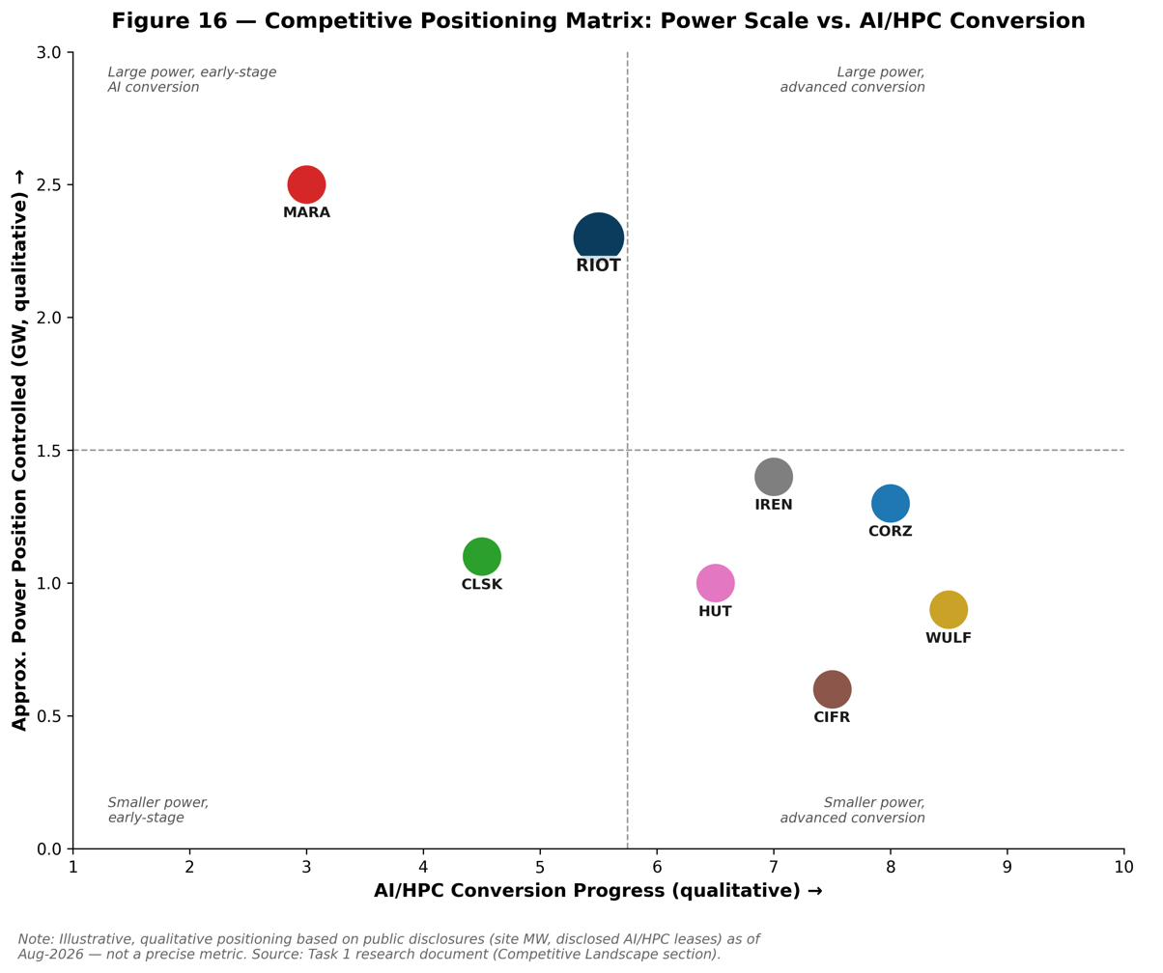
Other relevant competitors include Bitdeer (Nasdaq: BTDR), which (like Riot and MARA) expanded mining share; Hut 8 (Nasdaq: HUT), which announced its own large AI lease (a 15-year, 245 MW River Bend, Louisiana deal reported at $7.0 billion base and up to $17.7 billion with renewals — notably also linked in reporting to Anthropic); American Bitcoin (Nasdaq: ABTC), an aggressive mining expander; Keel Infrastructure (Nasdaq: KEEL, formerly Bitfarms), winding down legacy mining to build North American AI infrastructure; and HIVE Digital, pursuing a GPU-cloud model.
Riot's competitive positioning is distinctive on several axes. On power, Riot controls a large portfolio of approved, energised capacity across Rockdale (~700 MW developed), Corsicana (400 MW built toward 1 GW), and Kentucky (~232 MW target) — roughly 1.4 GW available to monetise beyond current mining and the AMD lease — much of it with grandfathered ERCOT interconnections increasingly difficult for peers to replicate. On vertical integration, Riot's in-house ESS Metron/E4A engineering distinguishes it from miners that must outsource construction. On execution proof, Riot's on-time, on-budget AMD delivery and its rapid signing of two anchor tenants (241 MW / ~$9.8 billion) in seven months compare favourably against peers still awaiting a first marquee deal. On the other hand, Riot is less far along in recognised data-center revenue than Core Scientific or TeraWulf, remains more exposed to Bitcoin-price swings than fully converted peers, and — as a hybrid — must fund both a mining fleet and a data-center build-out simultaneously. Its principal competitive vulnerabilities are the capital intensity of building multiple gigawatt-scale campuses, tenant concentration, and the risk that peers with hyperscaler backstops secure cheaper financing.
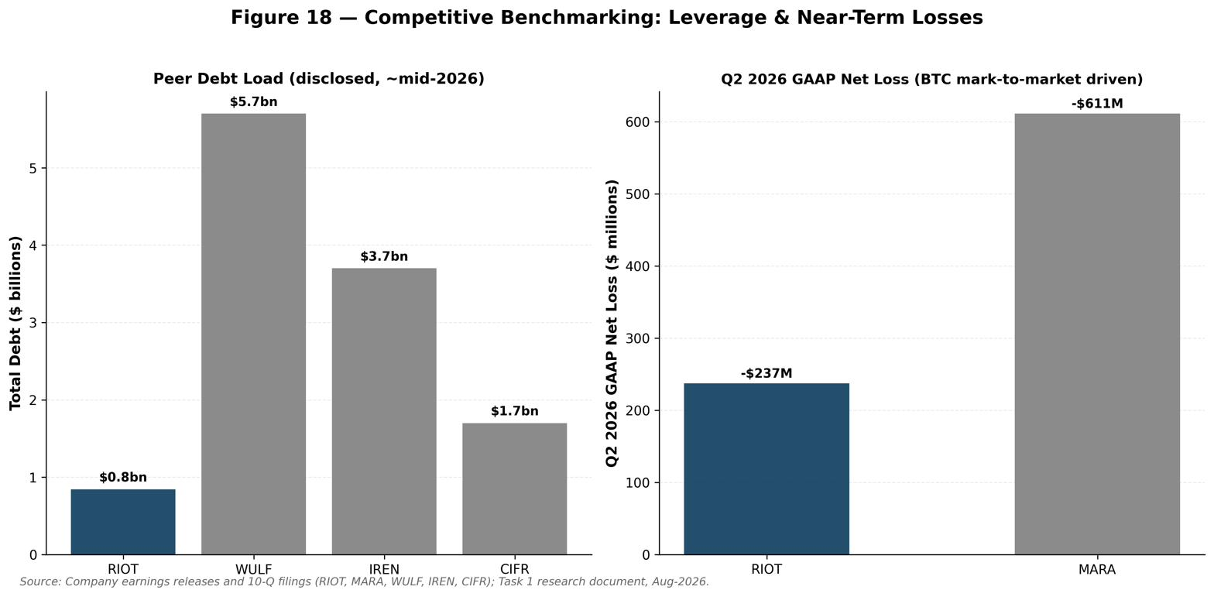

Market Opportunity (TAM)
Riot's addressable opportunity is best understood as the value that can be unlocked from its power portfolio, split between Bitcoin mining and AI/HPC leasing.
AI/HPC data-center opportunity (the core of the current thesis). The scarce input for AI compute is grid-connected power, and Riot controls a large, approved position. The most concrete framing of Riot's opportunity comes from activist investor Starboard Value, whose February 2026 letter estimated that Riot's Corsicana and Rockdale campuses could hold $9–21 billion in potential equity value if monetised through AI/HPC leases. Management's own disclosures give quantitative substance to this: the two signed leases already represent 241 MW and ~$9.8 billion of contracted revenue; the 191 MW frontier-AI-lab lease alone implies estimated average annual NOI of $365–411 million and cumulative NOI of $7.3–8.2 billion over 20 years. Riot's earnings materials have referenced a total-portfolio NOI range of roughly $1.6–2.1 billion at full build-out across its sites, and management has stated that the non-binding LOI for the full 1 GW Corsicana site could generate over $1 billion of annual rent if converted. Beyond currently developed capacity, Riot has roughly 1.4 GW of additional capacity to monetise, and the Terrestrial Energy MOU contemplates studying up to 4 GW of small-modular nuclear for future sites — an option on a much larger long-term power position. Against a backdrop of $70 billion-plus of AI/HPC contracts already signed sector-wide and continued strong AI compute demand, the serviceable opportunity for a well-located, power-rich developer is large and growing, though realising it requires successful, on-schedule construction and continued tenant demand.
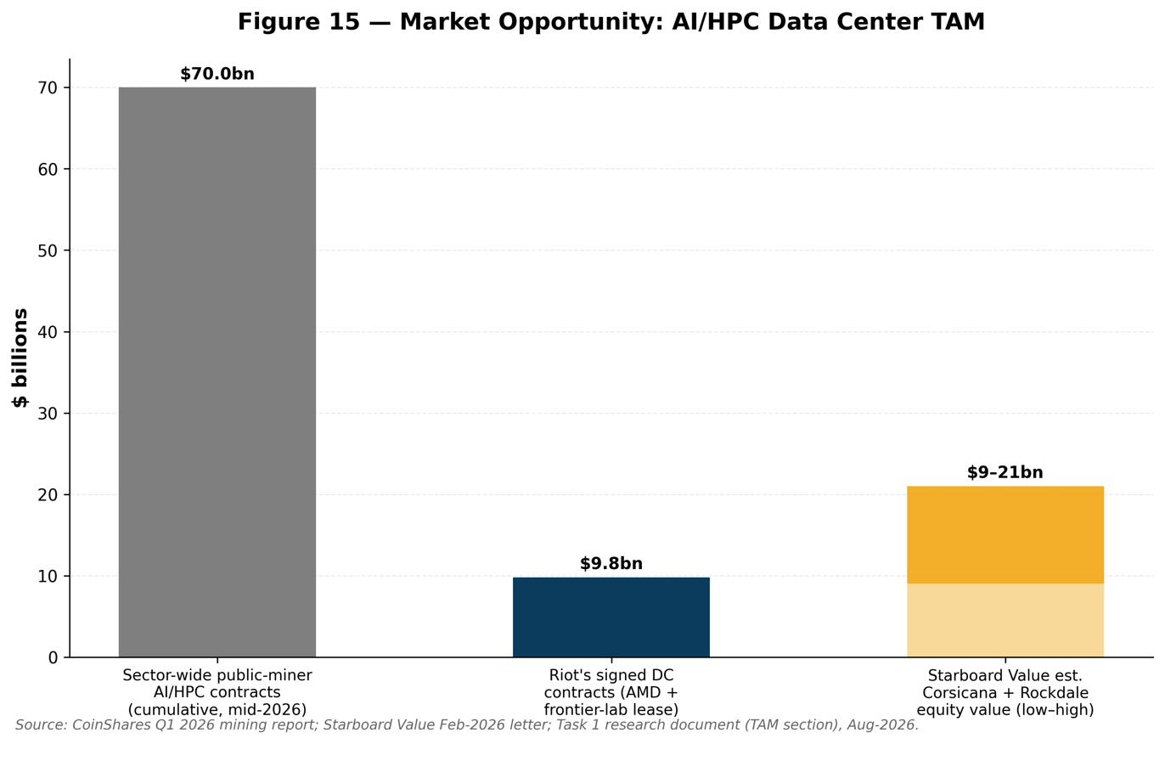
Bitcoin-mining opportunity. As a mature market, Bitcoin mining is a share-of-network game. Riot targets roughly a 4% share of the global network in the near-to-medium term. The economic value of this share is highly sensitive to the Bitcoin price and hash price: management has previously indicated that if hash price were to recover toward ~$60, run-rate adjusted EBITDA from mining could expand materially (by more than 70% on prior guidance framings). At current depressed Bitcoin prices, however, the incremental value of adding mining capacity is low relative to leasing that same power to AI tenants — precisely the calculus driving Riot (and the sector) to reallocate power toward HPC. Mining therefore functions today less as a growth engine and more as (a) a cash-generative use of un-leased power and (b) an option on Bitcoin-price recovery, with the associated Bitcoin treasury providing balance-sheet liquidity.
Penetration strategy. Riot's path to capturing this opportunity is to (1) deliver its contracted 241 MW on schedule to establish an institutional-grade operating track record, (2) convert the Corsicana LOI and lease additional Rockdale/Kentucky capacity, (3) finance construction efficiently via non-recourse and asset-level facilities plus selective Bitcoin sales, and (4) preserve optionality on future power (nuclear MOU, additional land) for a multi-gigawatt long-term footprint. The central uncertainty is timing: substantial data-center revenue does not ramp until 2027–2028, so the market must underwrite a multi-year build-out before the bulk of the contracted NOI is realised.
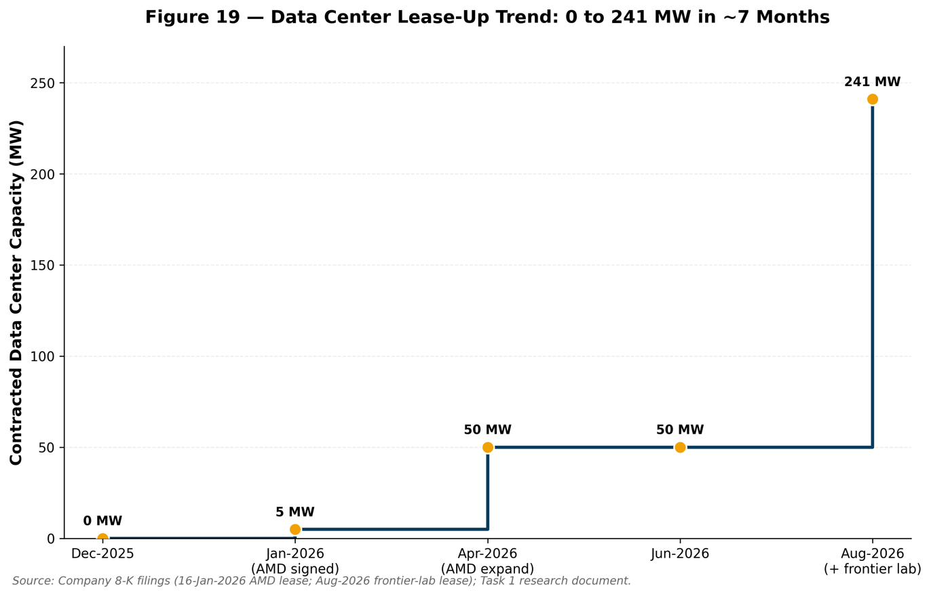

Financial Analysis

Historical & Projected Performance
Riot's revenue base has been transformed twice over in three years — first by a Bitcoin bull market, then by the AI/HPC data-center pivot — and our model shows a third transformation now underway as the mix shifts from mining toward contracted leasing. Total revenue grew from $280.7M in 2023A to $376.7M in 2024A (+34.2% YoY) and then to a record $647.4M in 2025A (+71.9% YoY), driven almost entirely by Bitcoin Mining, which alone contributed $576.3M, or 89.0% of 2025A revenue. We project total revenue to dip modestly to $630.4M in 2026E (-2.6% YoY) as Mining revenue declines faster than Data Center and Engineering revenue can offset it, before re-accelerating to $701.3M in 2027E (+11.2%), $918.5M in 2028E (+31.0%) as the frontier-AI-lab lease begins phasing in, $1,038.8M in 2029E (+13.1%), and $1,040.2M in 2030E (+0.1%, essentially flat as the Data Center ramp completes and Mining continues to decline). The resulting 2025A–2030E revenue CAGR is 9.9% — a deceptively modest headline number that masks a dramatic underlying mix shift: Data Center revenue grows from zero in 2025A to $580.0M by 2030E (55.8% of total), while Mining revenue nearly halves from $576.3M to $285.2M (a -13.1% CAGR) as Rockdale capacity increasingly migrates from self-mining to higher-value AI leasing.
Table 2 – Riot Platforms, Inc. Historical & Projected Income Statement, 2023A–2030E ($M)
($M unless noted) | 2023A | 2024A | 2025A | 2026E | 2027E | 2028E | 2029E | 2030E
Bitcoin Mining revenue | 189.0 | 321.0 | 576.3 | 394.4 | 374.4 | 335.4 | 306.0 | 285.2
Data Center revenue | 0.0 | 0.0 | 0.0 | 118.0 | 196.9 | 438.1 | 572.8 | 580.0
Engineering revenue | 64.3 | 38.5 | 64.7 | 118.0 | 130.0 | 145.0 | 160.0 | 175.0
Other / legacy revenue | 27.4 | 17.2 | 6.4 | 0.0 | 0.0 | 0.0 | 0.0 | 0.0
Total revenue | 280.7 | 376.7 | 647.4 | 630.4 | 701.3 | 918.5 | 1,038.8 | 1,040.2
YoY growth (%) | — | 34.2% | 71.9% | -2.6% | 11.2% | 31.0% | 13.1% | 0.1%
Mining direct cost, net of curtailment | — | 155.5 | 282.3 | 290.0 | 270.4 | 232.2 | 201.6 | 179.8
Data center operating costs | 0.0 | 0.0 | 0.0 | 99.3 | 153.0 | 271.5 | 178.6 | 147.1
Engineering cost of revenue | 48.2 | 28.9 | 48.5 | 88.5 | 97.5 | 108.8 | 120.0 | 131.3
Total cost of revenue (excl. D&A) | 48.2 | 184.4 | 330.8 | 477.8 | 520.9 | 612.4 | 500.2 | 458.2
Gross profit (excl. D&A, segment basis) | 232.5 | 192.3 | 316.6 | 152.6 | 180.4 | 306.1 | 538.6 | 582.1
Gross margin (%) | 82.8% | 51.0% | 48.9% | 24.2% | 25.7% | 33.3% | 51.8% | 56.0%
SG&A (excl. SBC) | — | — | — | 160.0 | 150.0 | 155.0 | 160.0 | 165.0
Stock-based compensation | — | 125.2 | 125.7 | 150.0 | 135.0 | 125.0 | 115.0 | 105.0
Adjusted EBITDA (ex-BTC FV, operating) | — | 463.2 | 13.0 | -7.4 | 30.4 | 151.1 | 378.6 | 417.1
Adj EBITDA margin (%) | 0.0% | 123.0% | 2.0% | -1.2% | 4.3% | 16.4% | 36.4% | 40.1%
Depreciation & amortization | — | 212.1 | 346.8 | 328.1 | 303.7 | 253.1 | 283.1 | 338.8
EBIT (operating income) | — | 85.0 | -653.2 | -485.5 | -408.3 | -227.0 | -19.5 | -26.8
EBIT margin (%) | — | 22.6% | -100.9% | -77.0% | -58.2% | -24.7% | -1.9% | -2.6%
Interest income | — | 27.2 | 14.0 | 9.3 | 22.8 | 6.0 | 6.0 | 6.0
Interest expense | — | 2.0 | 24.1 | 58.9 | 58.9 | 96.4 | 187.0 | 222.3
Pre-tax income (loss) | — | 110.1 | -663.3 | -535.0 | -444.4 | -317.5 | -200.5 | -243.1
Net income (loss) | — | 109.4 | -663.2 | -535.0 | -444.4 | -317.5 | -200.5 | -243.1
Net margin (%) | — | 29.0% | -102.4% | -84.9% | -63.4% | -34.6% | -19.3% | -23.4%
Diluted shares (M) | — | 272.0 | 340.0 | 360.0 | 375.0 | 385.0 | 395.0 | 400.0
Diluted EPS ($) | — | $0.40 | -$1.95 | -$1.49 | -$1.18 | -$0.82 | -$0.51 | -$0.61
Anthropic Equity Research financial model. 2023A–2025A per company filings; 2026E–2030E are Anthropic Equity Research estimates.
Segment-level detail (Figure below) shows this rotation clearly. Bitcoin Mining revenue is a function of three variables our model tracks explicitly: average realized Bitcoin price (down from $101,350 in 2024A to an assumed $68,000 in 2026E before recovering modestly to $92,000 by 2030E), Bitcoin mined (peaking near 5,800 coins in 2026E as legacy capacity is still largely online, then declining to 3,100 coins by 2030E as Rockdale megawatts shift to data-center use), and realized hash rate (43 EH/s in 2026E, roughly 4% of the global network, declining to 34 EH/s by 2030E). Data Center revenue is built from disclosed contract terms: AMD capacity online rises from 25 MW (2026E) to a steady 50 MW from 2027E, generating $20.0M of base/operating-lease revenue in 2026E rising to $60.0M by 2030E; the frontier-AI-lab lease contributes zero revenue until it begins phasing in at 96 MW in 2028E (30% phase-in, $136.5M of base lease revenue) and reaches the full 191 MW and $455.0M of annual base rent by 2029E–2030E. Tenant fit-out and development-services revenue — a lumpier, construction-linked revenue stream — peaks at $220.0M in 2028E as the frontier-lab buildout is substantially complete, then falls to $15.0M by 2030E as build activity winds down. Engineering revenue, the smallest but steadiest segment, grows from $64.7M in 2025A to $175.0M in 2030E (a 22.0% CAGR) as the $177.1M order backlog (90% data-center related, per Q2 2026 disclosure) converts to revenue.
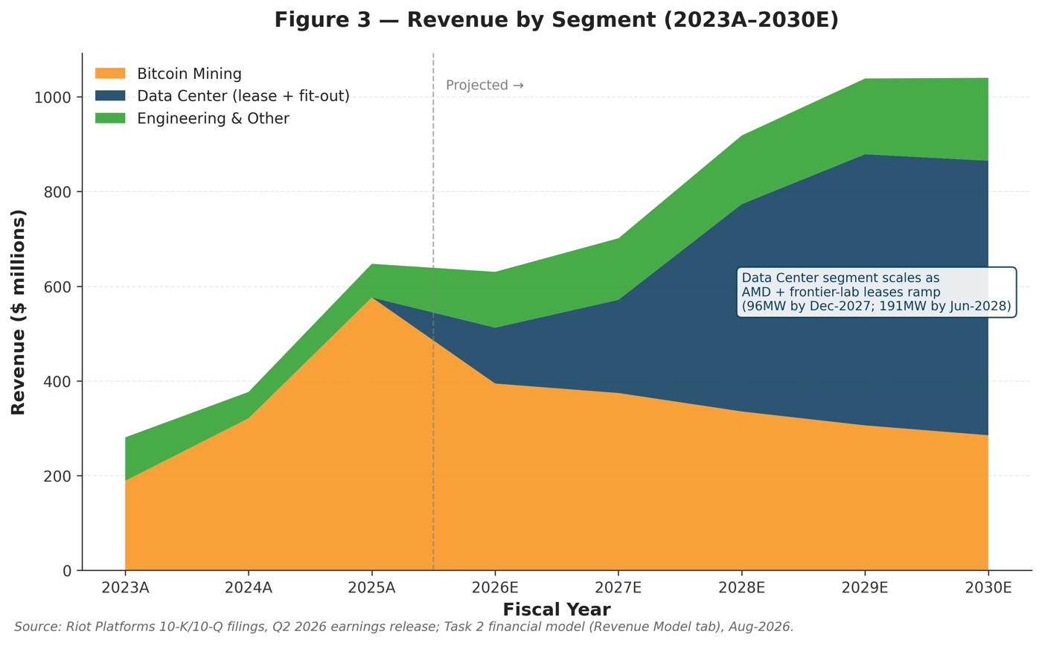
Table 3 – Riot Platforms, Inc. Revenue Build by Segment and Key Operating Driver, 2023A–2030E
Driver / Metric | 2023A | 2024A | 2025A | 2026E | 2027E | 2028E | 2029E | 2030E
BITCOIN MINING SEGMENT
Avg operating hash rate (EH/s) | — | 31.5 | 40.0 | 43.0 | 44.0 | 42.0 | 38.0 | 34.0
Bitcoin mined (#) | — | 4,828.0 | 5,686.0 | 5,800.0 | 5,200.0 | 4,300.0 | 3,600.0 | 3,100.0
Avg realized price / BTC ($) | — | 66,488.0 | 101,350.0 | 68,000.0 | 72,000.0 | 78,000.0 | 85,000.0 | 92,000.0
Bitcoin Mining revenue ($M) | 189.0 | 321.0 | 576.3 | 394.4 | 374.4 | 335.4 | 306.0 | 285.2
Power curtailment credits, memo ($M) | — | 33.7 | 56.7 | 55.0 | 55.0 | 50.0 | 45.0 | 42.0
DATA CENTER SEGMENT
AMD capacity online (MW, avg) | — | — | — | 25.0 | 50.0 | 50.0 | 50.0 | 50.0
Frontier AI lab capacity online (MW) | — | — | — | 0.0 | 0.0 | 96.0 | 191.0 | 191.0
AMD base/operating lease revenue ($M) | 0.0 | 0.0 | 0.0 | 20.0 | 48.9 | 56.6 | 58.3 | 60.0
Frontier lab avg annual base rent ($M) | — | — | — | 455.0 | 455.0 | 455.0 | 455.0 | 455.0
Frontier lab phase-in (%) | — | — | — | 0.0% | 0.0% | 30.0% | 90.0% | 100.0%
Frontier lab base lease revenue ($M) | 0.0 | 0.0 | 0.0 | 0.0 | 0.0 | 136.5 | 409.5 | 455.0
Tenant fit-out / dev. services ($M) | 0.0 | 0.0 | 0.0 | 95.0 | 140.0 | 220.0 | 60.0 | 15.0
Power & other reimbursements ($M) | 0.0 | 0.0 | 0.0 | 3.0 | 8.0 | 25.0 | 45.0 | 50.0
Data Center revenue ($M) | 0.0 | 0.0 | 0.0 | 118.0 | 196.9 | 438.1 | 572.8 | 580.0
ENGINEERING & OTHER
Engineering revenue ($M) | 64.3 | 38.5 | 64.7 | 118.0 | 130.0 | 145.0 | 160.0 | 175.0
Other / legacy revenue ($M) | 27.4 | 17.2 | 6.4 | 0.0 | 0.0 | 0.0 | 0.0 | 0.0
TOTAL
Total revenue ($M) | 280.7 | 376.7 | 647.4 | 630.4 | 701.3 | 918.5 | 1,038.8 | 1,040.2
YoY growth (%) | — | 34.2% | 71.9% | -2.6% | 11.2% | 31.0% | 13.1% | 0.1%
Mining % of total | 67.3% | 85.2% | 89.0% | 62.6% | 53.4% | 36.5% | 29.5% | 27.4%
Data Center % of total | 0.0% | 0.0% | 0.0% | 18.7% | 28.1% | 47.7% | 55.1% | 55.8%
Engineering % of total | 22.9% | 10.2% | 10.0% | 18.7% | 18.5% | 15.8% | 15.4% | 16.8%
Anthropic Equity Research financial model. Section headers shown in bold rows have no standalone value.
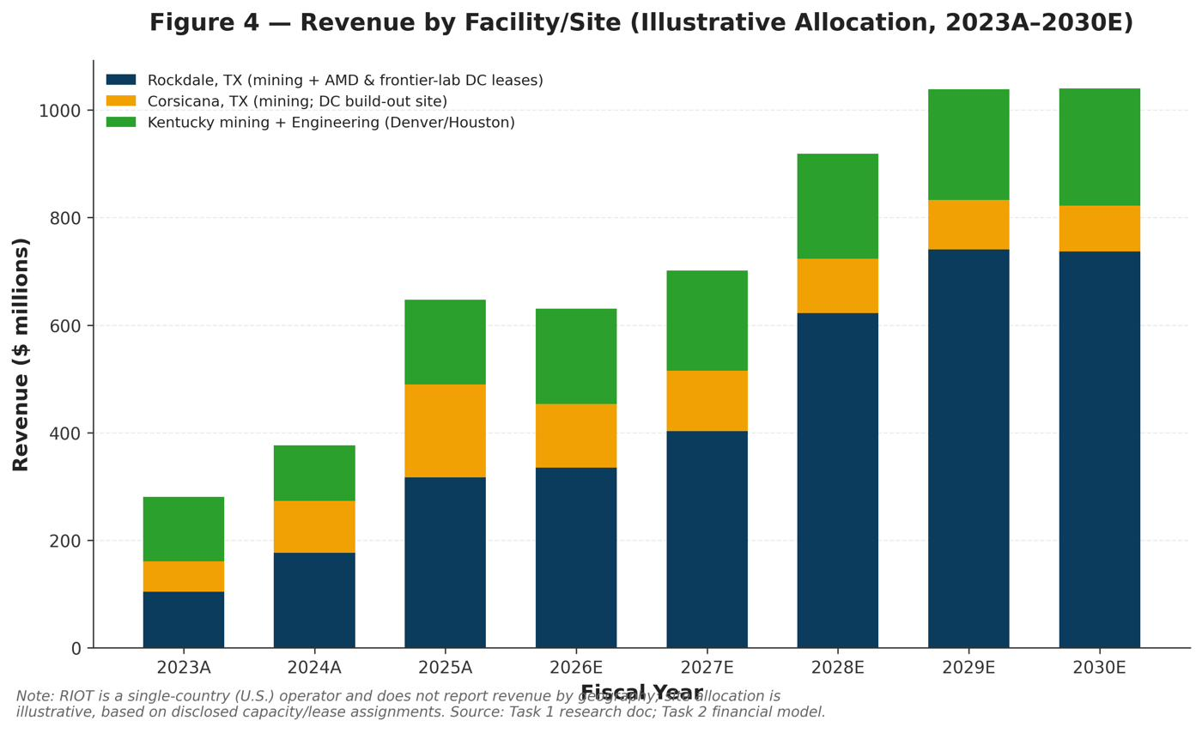
Table 4 – Riot Platforms, Inc. Illustrative Revenue Allocation by Facility/Site, 2023A–2030E ($M)
Site | 2023A | 2024A | 2025A | 2026E | 2027E | 2028E | 2029E | 2030E
Rockdale, TX | 112.4 | 161.7 | 265.7 | 196.9 | 271.8 | 505.2 | 634.0 | 637.0
Corsicana, TX | 47.2 | 80.2 | 144.1 | 157.8 | 149.8 | 134.2 | 122.4 | 114.1
Kentucky + Engineering (Denver/Houston) | 121.0 | 134.8 | 237.6 | 275.8 | 279.8 | 279.2 | 282.4 | 289.1
Rockdale, TX — % of total | 40% | 43% | 41% | 31% | 39% | 55% | 61% | 61%
Corsicana, TX — % of total | 17% | 21% | 22% | 25% | 21% | 15% | 12% | 11%
Kentucky + Engineering (Denver/Houston) — % of total | 43% | 36% | 37% | 44% | 40% | 30% | 27% | 28%
Total Revenue ($M) | 280.7 | 376.7 | 647.4 | 630.4 | 701.3 | 918.5 | 1,038.8 | 1,040.2
Anthropic Equity Research estimates. RIOT is a single-country (U.S.) operator and does not disclose revenue by geography; this table allocates modeled segment revenue across RIOT's three principal U.S. site clusters using developed-capacity weights as a proxy, and is illustrative rather than company-reported data. All years tie to total consolidated revenue in the financial model.

Margin Evolution
Gross margin tells the story of a business absorbing near-term cost before the revenue that justifies it arrives. Segment gross margin (excluding D&A) was an unusually strong 82.8% in 2023A — reflecting a period of low mining direct costs relative to a rising Bitcoin price — before normalizing to 51.0% in 2024A and 48.9% in 2025A as mining costs rose with network difficulty. We project gross margin troughs at 24.2% in 2026E as Data Center operating costs ($99.3M) are recognized well ahead of the segment's revenue ramp ($118.0M, mostly low-margin fit-out work), before recovering steadily to 25.7% (2027E), 33.3% (2028E), 51.8% (2029E), and 56.0% by 2030E as the higher-margin frontier-lab base-rent revenue scales against a largely fixed operating-cost base. Adjusted EBITDA (ex-Bitcoin fair-value change, operating) follows a similar but more volatile path: the Company's reported 2024A Adjusted EBITDA of $463.2M implies a 123.0% margin on $376.7M of revenue — a figure that exceeds total revenue and, per the Cover-tab data-integrity note, is consistent with the Company's reported Adjusted EBITDA not fully excluding Bitcoin fair-value gains embedded in a year when Bitcoin prices rose sharply; we present it as reported rather than adjust it further, since we cannot independently decompose the exact non-operating component. Adjusted EBITDA collapsed to $13.0M (2.0% margin) in 2025A as Bitcoin's second-half 2025 decline pressured mining economics, and we project it turns slightly negative (-$7.4M, -1.2% margin) in 2026E — the trough year — before inflecting to $30.4M (4.3%) in 2027E, $151.1M (16.4%) in 2028E as the frontier-lab lease begins contributing, $378.6M (36.4%) in 2029E, and $417.1M (40.1%) in 2030E.
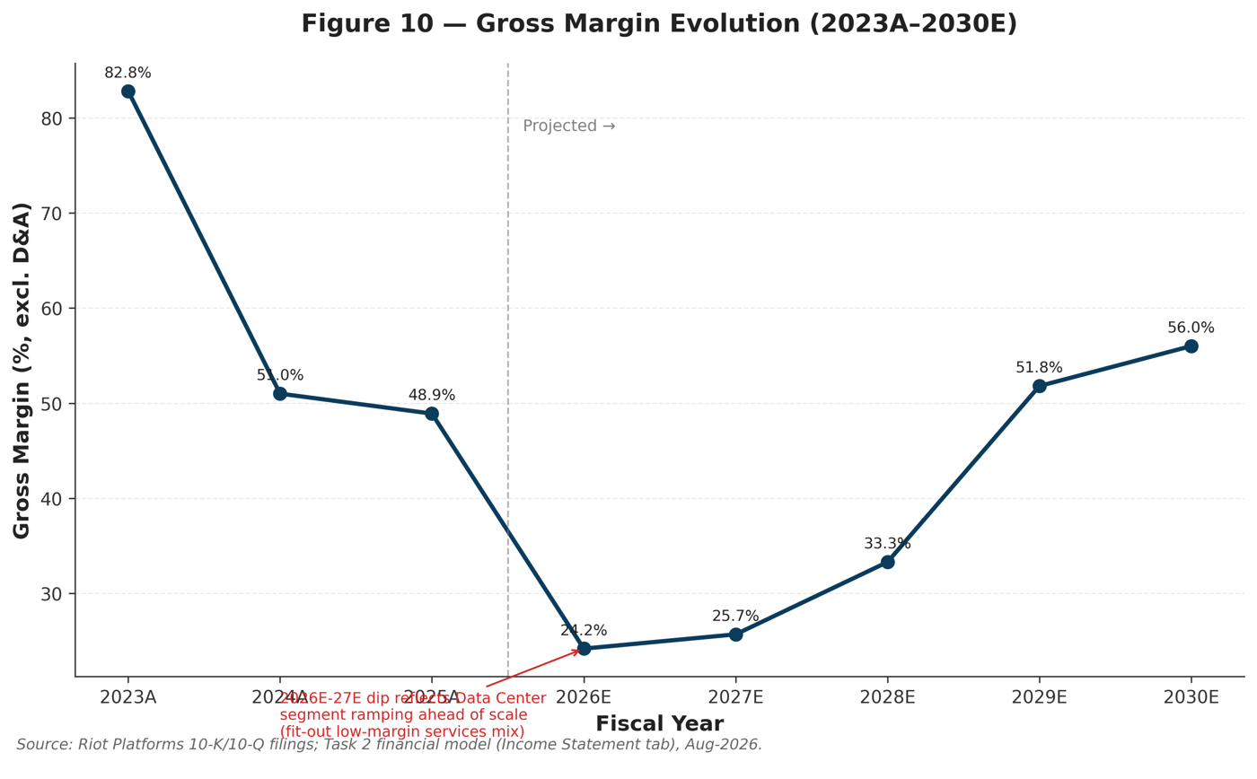
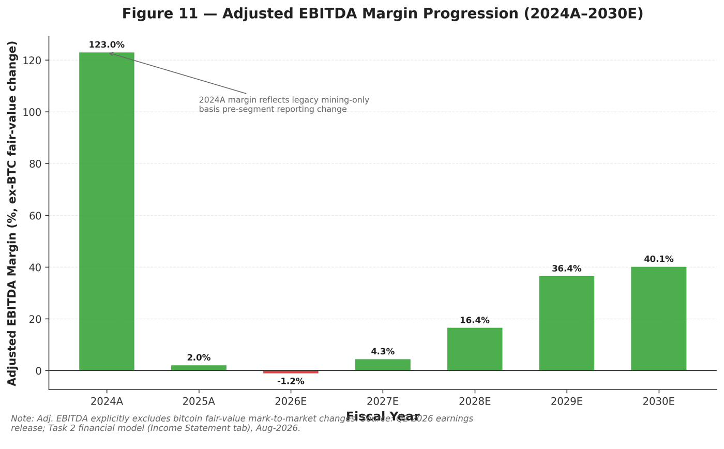

Profitability, Cash Flow & Financing
Riot is loss-making at the GAAP level throughout our explicit forecast window, and this is a feature of the model's conservatism rather than an oversight: we project GAAP net losses of $535.0M (2026E), $444.4M (2027E), $317.5M (2028E), $200.5M (2029E), and $243.1M (2030E), following the $663.2M net loss already reported for 2025A. Two large, largely non-cash or financing-related items dominate the bridge from Adjusted EBITDA to net loss: depreciation and amortization, which we project between $253.1M and $338.8M annually as the data-center build-out is placed into service, and interest expense, which rises from $58.9M (2026E) to $222.3M (2030E) as total debt — the model's funding plug for capital expenditure — grows from $840.8M (2025A) to $3,425.4M (2030E). Notably, 2030E's net loss of $243.1M is larger than 2029E's $200.5M despite higher revenue and EBITDA that year, because interest expense ($222.3M) grows faster than operating profitability improves — a dynamic investors should watch as the balance sheet re-levers. On a cash basis, unlevered free cash flow (cash flow from operations less capital expenditure) is negative in every year of our explicit forecast: -$563.1M (2026E), -$1,207.1M (2027E), -$1,443.7M (2028E, the peak capex year at $1.5bn), -$604.8M (2029E), and -$299.3M (2030E), for cumulative 2026E–2030E free cash flow of -$4,118.1M against cumulative capital expenditure of $4.5bn. This is financed through a combination of debt issuance (the model's plug, totaling roughly $2.58bn of net draws over 2027E–2030E) and Bitcoin-sale proceeds, which we model declining from $900.0M in 2026E to $50.0M by 2030E as the treasury is progressively drawn down (consistent with the $289.5M of Bitcoin already sold in Q1 2026 at an average $76,626/coin) to fund early construction before debt capacity is fully established.
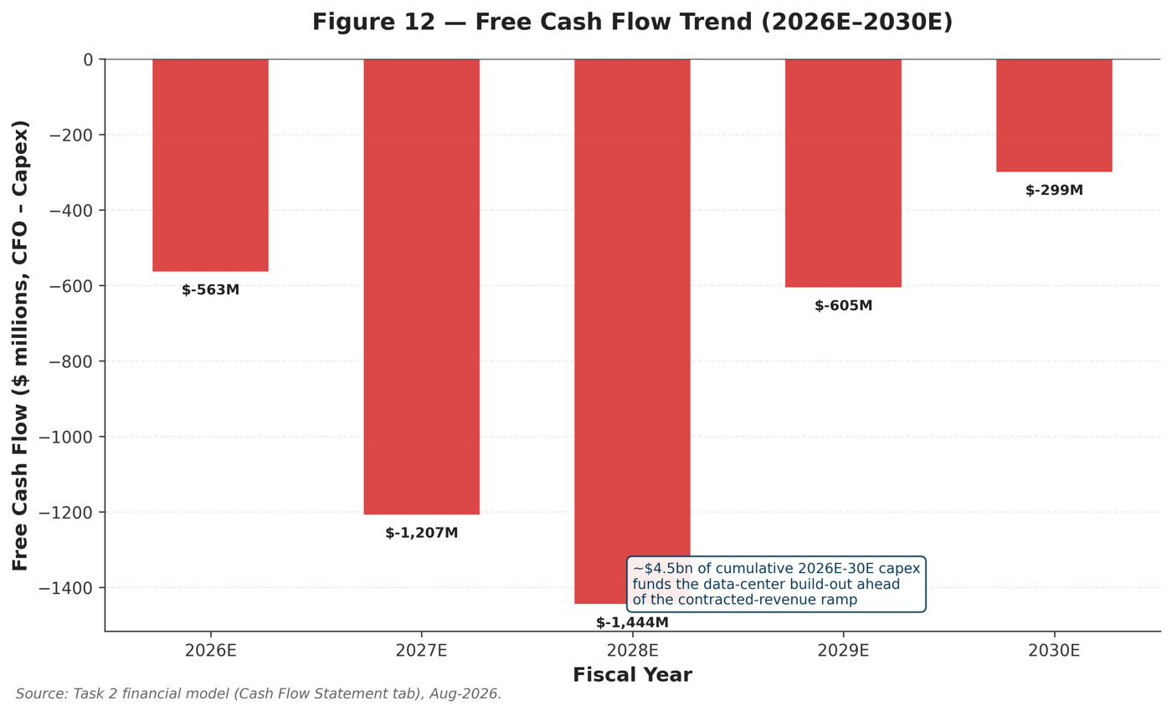
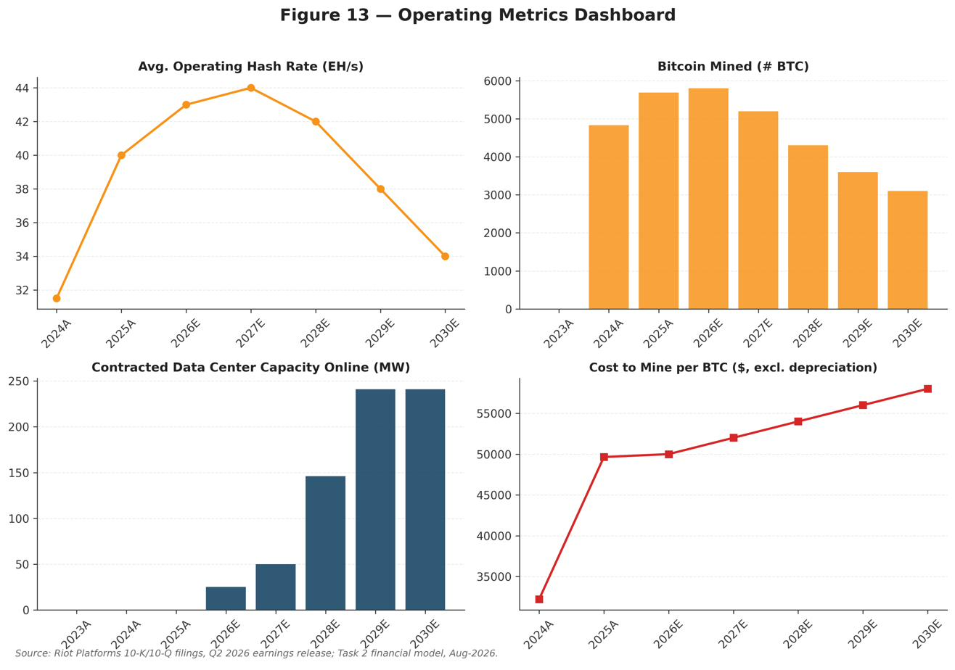
The balance sheet reflects this financing strategy directly. Total assets grow from $3,547.4M (2026E) to $5,418.8M (2030E), driven almost entirely by property & equipment, which rises from $1,704.4M to $4,540.9M as data-center construction is capitalized, while Bitcoin holdings on the balance sheet fall from $675.5M to $125.5M as coins are sold to fund the build. On the liability side, total debt nearly quadruples from $840.8M (2025A) to $3,425.4M (2030E); we model interest on beginning-of-year balances specifically to avoid the circularity that would otherwise arise from computing interest on a still-unknown current-year debt plug. Total equity declines modestly from $2,473.6M (2026E) to $1,748.1M (2030E) as the accumulated deficit widens from $1,888.4M to $3,093.9M faster than paid-in capital grows from equity issuance (which we hold conservative in the base case, at roughly $115–125M per year of at-the-market activity). The balance sheet balances by construction in every projected year (Assets less Liabilities & Equity = $0), and net debt (gross debt less cash less Bitcoin holdings) stood at just -$371.9M — i.e., a net cash-and-Bitcoin position — as of 30-Jun-2026A, the balance-sheet date underlying our valuation work in Section 5.
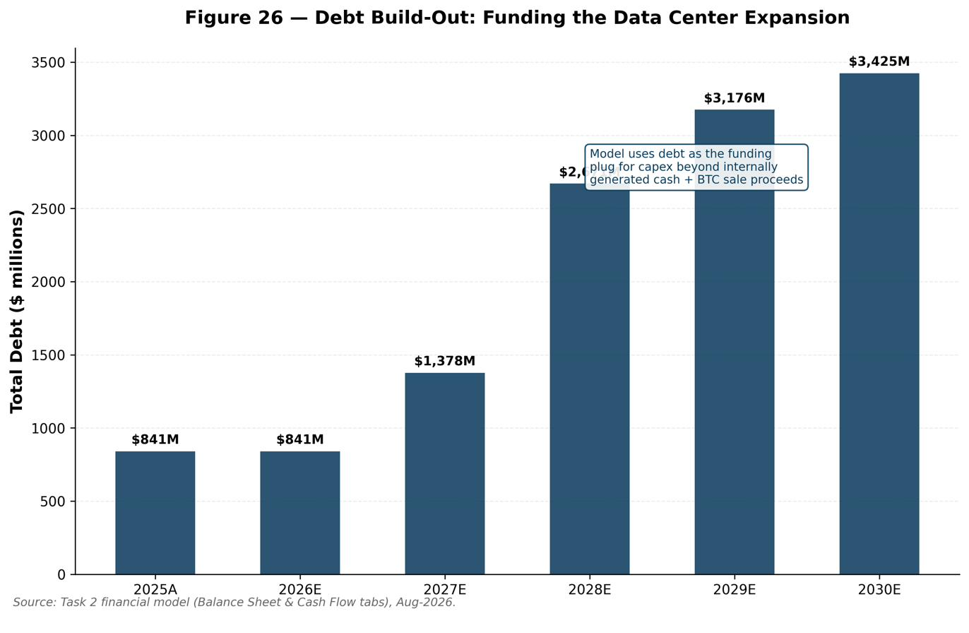

Projection Assumptions
The following section details, product by product and site by site, the assumptions underlying our five-year financial projections. We deliberately show our work: every material driver below ties directly to a labeled row in the accompanying financial model (Revenue Model, Income Statement, Cash Flow, and Balance Sheet tabs), and every assumption is either sourced to a specific company disclosure or clearly flagged as an Anthropic Equity Research estimate.

Revenue Assumptions by Product / Segment

Bitcoin Mining Segment
We project Bitcoin Mining revenue declining from $576.3M in 2025A to $285.2M by 2030E, a -13.1% CAGR, as Rockdale power is progressively reallocated from self-mining to higher-value data-center leasing. This is a deliberate economic choice by management, not a projection of business failure: at current Bitcoin prices, the same megawatt earns substantially more as contracted data-center rent than as mining capacity. Specific drivers:
- Bitcoin price path. We assume average realized price per Bitcoin of $68,000 in 2026E (down from $101,350 in 2024A and an implied ~$101k realized in the strong 2025A print, reflecting the 2026 bear market), recovering gradually to $72,000 (2027E), $78,000 (2028E), $85,000 (2029E), and $92,000 (2030E) — a conservative, roughly 6%/year recovery that remains well below the October-2025 all-time high of $126,198.
- Bitcoin mined. We model 5,800 coins mined in 2026E (roughly in line with the 5,686 mined in 2025A, reflecting still-substantial deployed capacity early in the year), declining to 5,200 (2027E), 4,300 (2028E), 3,600 (2029E), and 3,100 (2030E) as megawatts shift to Rockdale's data-center leases and as global network hash rate continues to rise, diluting Riot's per-EH/s share of block rewards.
- Hash rate. Average operating hash rate is assumed at 43 EH/s in 2026E (in line with the ~42.3 EH/s realized in Q1 2026), peaking at 44 EH/s in 2027E before declining to 34 EH/s by 2030E as capacity is repurposed.
- Cost to mine. We hold the cost to mine per Bitcoin, excluding depreciation, rising modestly from $49,645 (2025A) to $58,000 by 2030E (roughly 3%/year), reflecting rising network difficulty and a partial offset from continued fleet-efficiency gains (roughly 20.5 J/TH by late 2025, down from ~23 J/TH a year earlier) and demand-response/curtailment credits, which we hold at $55M/year (2026E–2027E) declining to $42M by 2030E as fewer megawatts remain in the mining fleet to curtail.
- Network dynamics. The April 2024 halving cut the block subsidy from 6.25 to 3.125 BTC, and we assume no further halving occurs within our 2026E–2030E window (the next halving is not expected until 2028), so unit economics are driven by price and difficulty rather than a further subsidy step-down.
- Risks to these assumptions include a deeper or more prolonged Bitcoin bear market (which would pressure both price and the economics of continued mining), a faster-than-modeled reallocation of Rockdale power to data-center use (which would accelerate the mining decline but likely be margin-accretive), and network hash-rate growth outpacing our assumptions (some of it reportedly opaque and concentrated in China and Russia), which would dilute Riot's share faster than modeled.

Data Center Segment
Data Center revenue is the single most important driver of the investment case, growing from zero in 2025A to $118.0M in 2026E, $196.9M (2027E), $438.1M (2028E), $572.8M (2029E), and $580.0M by 2030E — a 55.8% share of total revenue by the terminal year, up from 18.7% in 2026E. We build this from the two disclosed contracts rather than a top-down assumption:
- AMD lease. A 10-year lease with an initial contract value of approximately $311M; we model 25 MW of average capacity online in 2026E (the initial commissioned tranche), stepping to a steady 50 MW from 2027E onward as the 10 MW (November 2026) and 15 MW (May 2027) expansion tranches complete. Base/operating-lease revenue rises from $20.0M (2026E) to $60.0M by 2030E.
- Frontier-AI-lab lease. A 20-year lease through June 2048 for 191 MW, with total contract revenue of approximately $9.1bn (up to ~$16.1bn including two five-year extension options) and management-disclosed average annual NOI of $365–411M. We model zero capacity online through 2027E (construction phase), 96 MW online in 2028E (the disclosed December-2027 delivery milestone, generating a 30% revenue phase-in and $136.5M of base lease revenue), and the full 191 MW online from 2029E (100% phase-in, $455.0M of annual base rent, in line with the $9.1bn/20-year run-rate) sustained through 2030E.
- Tenant fit-out and development-services revenue is modeled as a temporary, construction-linked revenue stream: $95.0M (2026E), $140.0M (2027E), peaking at $220.0M (2028E) as the frontier-lab build reaches its most capital-intensive phase, then falling to $60.0M (2029E) and $15.0M (2030E) as construction activity substantially completes. This revenue carries materially lower margins than base lease rent, which is the primary driver of the gross-margin trough we model in 2026E.
- Power and other reimbursements grow from $3.0M (2026E) to $50.0M (2030E) as the tenant base and recognized capacity scale.
- Data-center operating costs rise from $99.3M (2026E) to a peak of $271.5M (2028E, coinciding with peak fit-out activity) before falling to $147.1M by 2030E as the business reaches a more efficient, stabilized operating cost base relative to its now-larger revenue.
- Corsicana optionality is explicitly excluded from the base case. The non-binding letter of intent for the full 1 GW Corsicana site — which management has suggested could generate over $1bn of annual rent if converted — contributes zero revenue in our base-case model; we treat it as a bull-case catalyst (see Scenario Analysis) rather than underwriting it before it is signed.
- Timing risk is the key swing factor. A delay in the frontier-lab's 96 MW December-2027 or full 191 MW June-2028 delivery milestones — plausible given the segment's dependence on long-lead substation equipment, which has historically pushed out data-center timelines across the industry — would shift several hundred million dollars of revenue recognition later than modeled, with a disproportionate impact on 2028E–2029E Adjusted EBITDA given the lease's high incremental margin.
- Financing structure supports, but does not guarantee, the build schedule. Riot has arranged a $573M Morgan Stanley interim facility structured as non-recourse to the parent, and is pursuing an investment-grade credit backstop on the frontier-lab lease — a structure increasingly common across the sector (peers have priced hyperscaler-backstopped senior secured notes around 7.125%). Our base case assumes this backstop is finalized on a timeline consistent with the disclosed construction schedule; failure to finalize it on favorable terms would not change the contracted revenue itself but could raise the effective cost of the debt funding the build, a risk we capture separately in our WACC and cap-rate sensitivity (Section 5).
- Counterparty concentration is embedded, not modeled away. Because the Data Center segment rests on two tenants — AMD and the unnamed frontier AI lab — our revenue build is mechanically exposed to either counterparty's credit or operational performance. We do not haircut the contracted lease revenue for counterparty risk in the base case (both are large, well-capitalized organizations), but this concentration is the primary reason we apply a 7.0% base-case capitalization rate to this revenue stream in our SOTP valuation (Section 5) rather than the ~6.0–6.5% at which stabilized, diversified-tenant data centers trade.

Engineering & Other
Engineering revenue, built around the ESS Metron and E4A Solutions businesses, grows from $64.7M in 2025A to $175.0M by 2030E, a 22.0% CAGR — the steadiest and most predictable of the three segments given its order-backlog visibility.
- We model revenue of $118.0M (2026E), reflecting the sharp step-up already visible in the run-rate (Q2 2026 Engineering revenue of $37.3M, up from $10.6M in Q2 2025), then $130.0M (2027E), $145.0M (2028E), $160.0M (2029E), and $175.0M (2030E).
- The $177.1M order backlog disclosed at Q2 2026 (approximately 90% data-center related) provides roughly 18 months of forward revenue visibility at the current run-rate and is the primary basis for our near-term (2026E–2027E) estimates.
- Engineering cost of revenue is held at a roughly 75% ratio to Engineering revenue throughout the forecast (consistent with the segment's historical cost structure), implying a stable ~25% segment gross margin that does not meaningfully re-rate the consolidated margin profile on its own, but does provide a growing, less-cyclical revenue base that reduces Riot's blended dependence on Bitcoin-price-sensitive mining economics.
- We do not model material third-party Engineering revenue beyond the current backlog-implied trajectory, and see potential upside if Riot's in-house electrical-equipment capability wins meaningful external market share as the broader data-center and electrification construction boom continues (management has not disclosed a specific target here, so we treat any acceleration as upside to the base case rather than a base-case assumption).

Revenue Assumptions by Site
Because Riot is a single-country (U.S.) operator, we do not build a traditional geographic revenue model; instead, consistent with Figure 4, we allocate modeled segment revenue across Riot's three principal site clusters as an illustrative proxy for the underlying capacity build-out.
- Rockdale, TX (mining plus both the AMD and frontier-AI-lab data-center leases) is the anchor site and captures effectively all Data Center segment revenue, given both signed leases are located there; we model its allocated revenue growing from $265.7M (2025A) to $637.0M (2030E) as the frontier-lab lease scales, even as the mining share of that revenue declines from roughly 45% of Rockdale-mining-eligible capacity historically to approximately 20% by the 2026E–2030E period as power is reallocated to leasing.
- Corsicana, TX (the 1 GW-target greenfield site, currently used for mining while core-and-shell construction proceeds and pending conversion of the non-binding LOI) is allocated a declining share of mining revenue in absolute terms as the site's capacity increasingly awaits its data-center conversion decision; we model allocated revenue of $144.1M (2025A) rising modestly to $157.8M (2026E) before declining to $114.1M by 2030E under the base case, which — we stress again — assumes the Corsicana LOI does not convert. A signed Corsicana lease would be additive to this base case rather than already embedded in it.
- Kentucky mining plus Engineering (Denver/Houston) captures the Kentucky mining fleet (acquired via Block Mining) together with the Engineering segment's Denver and Houston operations; this bucket grows from $237.6M (2025A) to $289.1M (2030E), reflecting Engineering's steady growth more than offsetting a declining Kentucky mining contribution.
- We caution that this site-level split is Anthropic Equity Research's own estimate, not a company disclosure, and should be read as illustrative of the underlying capacity dynamics rather than as precise site-level guidance.

Other Key Assumptions
Gross margin evolution and bridge. Consolidated segment gross margin (excluding D&A) troughs at 24.2% in 2026E — down from 48.9% in 2025A — as Data Center operating costs ($99.3M) are recognized well ahead of that segment's still-small revenue base ($118.0M, much of it lower-margin fit-out work), while Mining gross margin also compresses as Bitcoin price assumptions decline. The subsequent recovery to 56.0% by 2030E is driven overwhelmingly by Data Center mix: base lease revenue (at an estimated ~84% incremental operating-lease margin once stabilized) becomes an increasing share of segment revenue as fit-out work — which carries materially thinner margins — declines from its 2028E peak.
Operating expense assumptions. We hold SG&A (excluding stock-based compensation) at approximately $150–165M annually across the forecast (2026E: $160M; 2027E: $150M as certain transition costs roll off; 2028E–2030E: $155M, $160M, $165M, growing modestly with the scale of the business), reflecting the compensation-plan overhaul completed in January 2026 that re-oriented incentives toward data-center execution. Stock-based compensation is modeled declining from $150M (2026E) to $105M (2030E) as legacy equity grants (including the eliminated annual 10-Bitcoin grants to the CEO and Chairman) roll off and are replaced by the revised, more moderate incentive structure.
Working capital assumptions. Given Riot's relatively simple working-capital profile (accounts receivable and accounts payable scale modestly with revenue; the model does not assume material inventory), we project a net working-capital build of roughly $1.4–6.2M per year across the forecast — immaterial relative to the ~$4.5bn of cumulative capital expenditure and not a meaningful swing factor in our valuation.
Capital expenditure. We model capital expenditure of $500M (2026E), $1,200M (2027E), a peak of $1,500M (2028E) coinciding with the frontier-lab lease's most intensive construction phase, $800M (2029E), and $500M (2030E) as the build-out substantially completes — cumulative 2026E–2030E capex of $4.5bn. This is funded through a combination of debt (the model's plug, drawn only in years where cash flow before financing is negative — no draw is needed in 2026E given the year's Bitcoin-sale proceeds), Bitcoin-sale proceeds (declining from $900.0M to $50.0M annually as the treasury is progressively monetized), and a minimal assumed level of at-the-market equity issuance embedded in the diluted share count (rising from 360M in 2026E to 400M by 2030E).
Tax rate. We model a 0% cash tax rate throughout the forecast, reflecting Riot's substantial net operating loss carryforwards (the Company reported a near-zero effective tax rate historically, with a small $0.7M tax expense in 2024A and a de minimis benefit in 2025A) and the fact that the Company remains loss-making on a GAAP basis in every projected year through 2030E.
Capex phasing and the avoidance of circularity. We deliberately phase capital expenditure to lag, rather than lead, each lease milestone by roughly one to two years — for example, the $1,500M 2028E capex peak funds the 191 MW frontier-lab shell that goes into service that same year and ramps to full contribution in 2029E–2030E — because data-center construction spend is recognized as the facility is built, while lease revenue is recognized as capacity is delivered and accepted by the tenant. This phasing, combined with our convention of charging interest expense on beginning-of-year debt balances (rather than the current year's still-unknown ending balance), avoids the circular-reference problem common in build-out models where capex determines debt, debt determines interest, and interest determines net income and therefore the capex-funding cash flow available in the same period. We regard this as a modeling-integrity choice rather than a substantive assumption, but flag it because it does modestly understate near-term interest expense relative to a model that charges interest on average or ending balances.
Diluted share count. We model diluted shares outstanding rising from 360M (2026E) to 400M (2030E), an increase of roughly 11% over five years, reflecting continued but moderate at-the-market equity issuance to supplement debt funding of the build-out. This is a conservative-to-neutral assumption: more aggressive equity issuance would reduce per-share leverage to the upside case but dilute existing holders, while a debt-heavier funding mix (which management has signaled it prefers, given the emphasis on non-recourse and asset-level financing) would concentrate more of the build-out's risk and reward in the existing share count.

Scenario Analysis
We model three scenarios — Bull, Base, and Bear — that flex the key value drivers identified in the Projection Assumptions above. The Base case is the scenario embedded in the financial model and valuation throughout this report; Bull and Bear are standalone sensitivities computed on the Scenarios tab of the accompanying model and are not separately built up line-by-line in the primary Income Statement.

Bull Case: Corsicana Converts, Cap Rates Compress, Bitcoin Recovers
Probability: 25%
Our bull case models the 1 GW Corsicana LOI converting to a binding lease, data-center capitalization rates compressing toward 6.0% as Riot establishes an institutional operating track record, and a Bitcoin recovery to the $90,000–$120,000 range as risk appetite for digital assets improves.
Key assumptions (2030E): - Bitcoin price: $120,000/BTC (vs. $92,000 base) and 3,300 coins mined (vs. 3,100 base), reflecting management's willingness to slow the mining wind-down if a Bitcoin recovery makes marginal mining capacity attractive again. - Frontier-AI-lab base rent realized in full at $455M (matching base case — the bull case does not assume better terms on the signed lease, only that Corsicana converts on top of it). - Corsicana incremental rent of $400M, reflecting a partial first-year contribution from a converted 1 GW lease (management has suggested over $1bn of annual rent at full stabilization; we conservatively model roughly 40% of that as realized within our explicit window given construction lead time). - Engineering revenue of $200M (vs. $175M base), reflecting a faster-growing order backlog as Corsicana construction adds incremental third-party-relevant scale. - Total 2030E revenue of $1,591M (vs. $1,040M base, +53%) and Adjusted EBITDA of approximately $802M (vs. $397M base), an EBITDA margin of 50.4%.
Catalysts required: 1. A signed, binding Corsicana lease — the single largest value driver — plausibly announced within 12–18 months given the LOI is already in place. 2. On-schedule delivery of the frontier-lab's 96 MW (Dec-2027) and 191 MW (Jun-2028) milestones, demonstrating the execution capability needed to underwrite a second gigawatt-scale project. 3. Finalization of an investment-grade credit backstop on the frontier-lab lease, which would both lower Riot's cost of capital and provide a template for financing Corsicana.
Detailed rationale: The bull case does not require heroic assumptions — it requires the pipeline Riot has already partially built (the Corsicana LOI, the Terrestrial Energy nuclear MOU, and a 1.4–1.6 GW inventory of developable power) to convert into signed, financeable contracts at a pace consistent with the 241 MW already delivered in seven months. A Bitcoin recovery is a supporting, not necessary, condition: even at a flat Bitcoin price, Corsicana conversion and cap-rate compression alone could deliver most of the upside, since 2030E EBITDA in this scenario is overwhelmingly a data-center, not mining, outcome (data-center revenue of $995M vs. mining's $396M).
Valuation implications: Applying a 6.0% cap rate to a larger, Corsicana-inclusive stabilized NOI base in our SOTP framework, alongside a modestly higher trading-comps multiple reflecting re-rated sector sentiment, implies a bull-case value of approximately $30–32 per share (+50–60% from the $20.04 canonical price).

Base Case: 241 MW Delivered on Plan
Probability: 50%
Our base case is the scenario embedded throughout this report's financial model: the 241 MW already under contract is delivered on the disclosed schedule (96 MW by December 2027; full 191 MW by June 2028), the data-center capitalization rate normalizes at 7.0%, Bitcoin trades in a $70,000–$90,000 range on average across the forecast, and Corsicana optionality is only partially credited through our conservative ~$1.8M/MW power-optionality valuation rather than assumed to convert.
Key assumptions: 2030E revenue of $1,040.2M, Adjusted EBITDA (ex-Bitcoin fair-value change) of $417.1M (40.1% margin), Data Center revenue of $580.0M (55.8% of total), and Mining revenue of $285.2M (27.4% of total) — the full detail is set out in the Financial Analysis and Projection Assumptions sections above.
Rationale: We weight this scenario at 50% because it requires no unsigned contract to convert and no unusual Bitcoin-price recovery — only execution against commitments Riot has already made publicly and, in the case of the AMD lease's initial tranche, already delivered on time and on budget. The base case is not a rosy scenario: it embeds five consecutive years of GAAP losses, a near-quadrupling of total debt, and a genuine trough in profitability in 2026E. It is, in our view, the single most probable outcome precisely because it requires the least from things Riot does not yet control.
Valuation: SOTP base value of $20.94/share, trading-comps base value of $28.64/share, and DCF cross-check of $1.48/share, blending to a $22.07 weighted fair value and our $22 twelve-month price target (+9.8%).
Why we do not weight this scenario higher than 50%. A single base case with no distribution around it would imply false precision for a company this early in a multi-year, multi-billion-dollar transformation; a 50% weight (rather than, say, 60–70%) reflects our view that the next 12–24 months are genuinely more likely than not to bring at least one meaningful deviation from plan — whether a positive one (early Corsicana progress, a stronger Bitcoin tape) or a negative one (a construction delay, a tenant renegotiation) — even if the eventual multi-year outcome still resembles the base case in expected value. We would revisit this weighting toward Bull on confirmation of a signed Corsicana lease or evidence of on-schedule 2027E construction milestones, and toward Bear on any disclosed delay to the frontier-lab's phased delivery schedule.

Bear Case: Lease-Up Slips, Cap Rates Widen, Bitcoin Falls Further
Probability: 25%
Our bear case models data-center lease-up slipping — either a delay in the frontier-lab's construction milestones or a renegotiation of terms — combined with capitalization rates widening to 9.0% as investors demand a larger risk premium for single-tenant-concentrated, delayed contracted assets, a deeper Bitcoin decline to the $45,000–$55,000 range, and equity dilution beyond our base-case assumption as Riot is forced to raise additional capital to complete the build on a delayed timeline.
Key assumptions (2030E): Bitcoin price of $50,000/BTC and just 2,600 coins mined (vs. 3,100 base) as depressed prices accelerate the shutdown of marginal mining capacity; frontier-lab base rent realized at only $330M (vs. $455M base), consistent with a delay that leaves the lease short of full 191 MW stabilization even by 2030E; Engineering revenue of $150M (vs. $175M base) as the segment's third-party pipeline slows alongside the broader data-center capex cycle; and SG&A held higher, at $300M, as fixed costs fail to leverage against a smaller revenue base. The result is 2030E total revenue of $705M (vs. $1,040M base, -32%) and Adjusted EBITDA of approximately $205M (vs. $397M base), a 29.1% margin — still positive, but well short of base-case scale.
Downside triggers: 1. Construction delay or cost overrun on the frontier-lab build — likelihood we would characterize as meaningful (perhaps 30–40% over a multi-year, multi-site buildout of this scale) given the segment's history of long-lead substation-equipment delays industry-wide, though a full-scenario-level delay of the magnitude modeled here is a lower-probability tail within that range. 2. Deterioration in a tenant's credit or a renegotiation of lease economics — lower likelihood (perhaps 10–15%) given both counterparties' scale, but high impact given the two-tenant concentration. 3. A resumed, deeper Bitcoin bear market that also tightens capital-markets access for the sector broadly, raising Riot's cost of both debt and equity simultaneously.
Rationale: We do not regard the bear case as an existential scenario. Even under these assumptions, 241 MW of revenue remains contracted (the underlying leases are 20-year and 10-year agreements, not options), Riot retains a meaningful Bitcoin treasury and mining cash flow, and the Company's roughly 1.9 GW power position retains option value regardless of near-term execution. The bear case is best understood as "the AI pivot takes longer and costs more than the base case assumes," not as "the AI pivot fails."
Valuation implications: A 9.0% cap rate applied to a smaller, delayed stabilized-NOI base, combined with a discount-to-median trading-comps multiple reflecting execution concerns, implies a bear-case value of approximately $11–13 per share (-35% to -45% from the $20.04 canonical price), with the SOTP low case of $9.76/share representing a still-more-conservative floor.
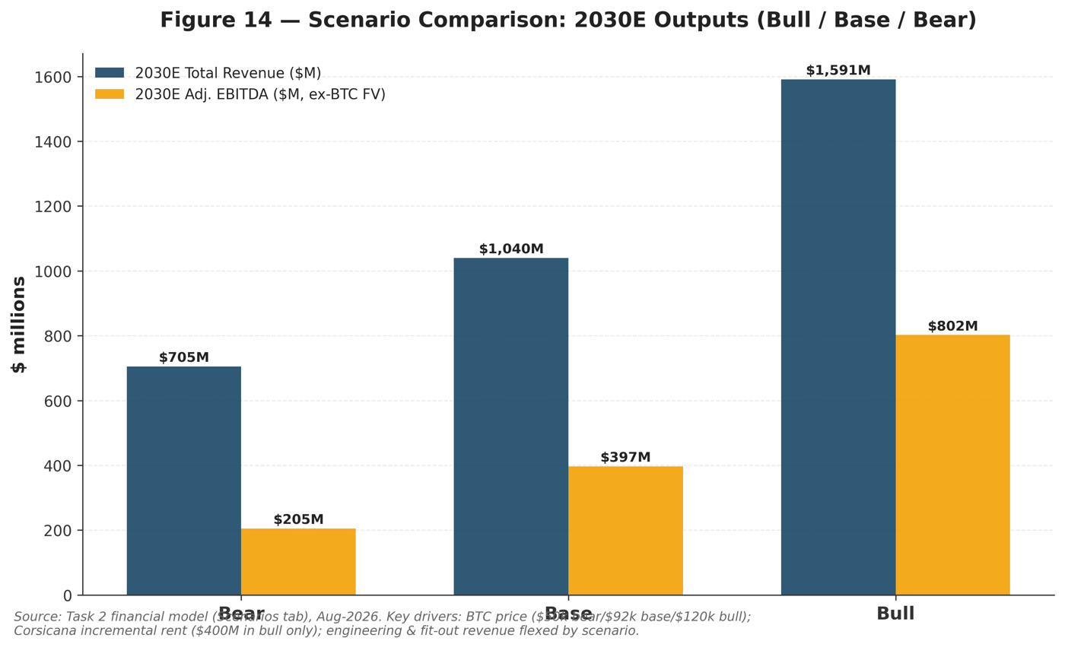
Table 5 – Riot Platforms, Inc. Scenario Comparison: Key Assumptions & Outputs (2030E)
Metric | Bull | Base | Bear
Bitcoin price, 2030E ($/BTC) | 120,000.0 | 92,000.0 | 50,000.0
Bitcoin mined, 2030E (#) | 3,300.0 | 3,100.0 | 2,600.0
Frontier lab base rent realized ($M) | 455.0 | 455.0 | 330.0
AMD base rent ($M) | 60.0 | 60.0 | 55.0
Corsicana incremental rent ($M) | 400.0 | 0.0 | 0.0
Engineering revenue ($M) | 200.0 | 175.0 | 150.0
SG&A incl. SBC ($M) | 240.0 | 270.0 | 300.0
Mining revenue ($M) | 396.0 | 285.2 | 130.0
Data center revenue ($M) | 995.0 | 580.0 | 425.0
Total revenue ($M) | 1,591.0 | 1,040.2 | 705.0
Adj. EBITDA, ex-BTC FV ($M) | 802.4 | 396.9 | 204.9
Adj. EBITDA margin (%) | 50.4% | 38.2% | 29.1%
Implied share value ($) | $30–32 | $21–23 | $11–13
Anthropic Equity Research financial model, Scenarios tab. Scenario outputs are standalone sensitivities and do not flow through the primary Income Statement; implied share values are from the Valuation Analysis (Section 5).

Scenario Comparison & Risk/Reward
Across all three scenarios, the probability-weighted outcome (25% bull / 50% base / 25% bear) centers almost exactly on our $22 point target, with a modest positive skew: the bull case's $30–32 upside is larger in absolute terms than the bear case's $11–13 downside is painful relative to the $20.04 canonical price, because 241 MW of revenue is already contracted regardless of which scenario plays out, providing a partial floor that a pure-mining peer would lack. A simple probability-weighted average of the three point estimates — 0.25 × $31 + 0.50 × $22 + 0.25 × $12 — computes to approximately $21.75, close to but modestly below our $22 target, consistent with our view that the distribution is close to symmetric around the base case with only a slight positive skew rather than a strongly convex one.
The scenarios are also not purely independent: Bitcoin price and data-center cap rates tend to move together in a "risk-on/risk-off" pattern for digital-infrastructure equities broadly, which is why we pair a higher Bitcoin price with a lower cap rate in the bull case and vice versa in the bear case, rather than varying each independently. This correlation assumption is itself a modeling choice investors should stress-test: a scenario in which Bitcoin recovers sharply while data-center cap rates simultaneously widen (for example, on a broad increase in long-term interest rates that hurts risk assets generally but specifically re-rates yield-sensitive infrastructure) is not well captured by our three named scenarios and would require a separate sensitivity.
The primary path dependency in this analysis is timing: because the frontier-lab lease does not reach full 191 MW stabilization until 2029E in the base case, a one-year delay pushes the bulk of the EBITDA inflection from 2028E–2029E into 2029E–2030E without necessarily changing the eventual bull/base/bear framing — meaning near-term (2026E–2027E) results are likely to look similar across scenarios, and the scenarios will only become clearly distinguishable in the data once 2028E construction-delivery data begins to arrive. We would treat any 2027E disclosure confirming or denying on-schedule progress toward the 96 MW December-2027 milestone as the single most informative near-term data point for updating these scenario weights, ahead of quarterly Bitcoin-mining metrics, which we view as a second-order consideration for the equity story at this stage of the Company's transformation.

Key Growth Drivers
We highlight five specific, quantifiable growth drivers, ranked roughly by near-term financial impact. The first two are already contracted and embedded (to varying degrees) in our base case; the latter three represent optionality that sits outside the base case and would be additive if realized.

1. Frontier-AI-lab lease phase-in: the single largest identifiable driver of 2027E–2030E EBITDA growth.
The 191 MW frontier-AI-lab lease moves from zero revenue through 2027E to $136.5M (30% phase-in) in 2028E and the full $455.0M annual base rent by 2029E–2030E. Because this revenue carries an estimated ~84% incremental operating-lease margin once stabilized, it is disproportionately responsible for our projected Adjusted EBITDA inflection from -$7.4M (2026E) to $417.1M (2030E). Milestones to track: 96 MW online by December 2027; full 191 MW by June 2028.

2. AMD lease expansion toward its full 200 MW option.
The AMD lease is contracted at 50 MW currently, but includes options for up to 200 MW. Our base case does not assume expansion beyond 50 MW; each incremental 50 MW exercised, at economics comparable to the current lease (~$60M of annual base rent per 50 MW), would add on the order of $60–70M of high-margin annual revenue without requiring a new counterparty relationship — among the lowest-risk upside levers available to the Company.

3. Corsicana LOI conversion — the largest single swing factor in our SOTP valuation.
A binding lease for the full 1 GW Corsicana site, which management has suggested could generate over $1bn of annual rent at stabilization, sits entirely outside our base case. We estimate conversion could add $2–3bn of equity value (see Scenario Analysis, Bull Case), making it the single most consequential near-term catalyst we track, ahead of Bitcoin price itself.

4. Engineering segment scale-up as a third-party revenue stream, independent of Riot's own capital cycle.
The $177.1M order backlog (90% data-center related) provides an unusually clear window into 18 months of forward Engineering revenue. If Riot's in-house ESS Metron/E4A capability wins share in the broader electrification and data-center-construction boom beyond its own projects — plausible given the segment's demonstrated cost and speed advantages — Engineering could grow faster than our modeled 22.0% CAGR without consuming any of Riot's own capital.

5. Terrestrial Energy nuclear MOU: an early-stage option on a substantially larger long-term power position.
The May-2026 non-binding MOU to study up to 4 GW of small-modular molten-salt nuclear capacity is a multi-year-dated option, not a near-term revenue driver — but it signals a credible path to a power position an order of magnitude larger than Riot's current ~1.9 GW, at a moment when grid interconnection scarcity is the binding constraint across the AI-infrastructure sector. We assign this zero value in our base-case SOTP but flag it as the longest-dated source of optionality in the story.

Valuation Analysis

Valuation Methodology
A conventional single-stage DCF is unreliable for Riot at this moment in its life cycle. The company is in the capital-intensive phase of a data-center build-out: our model shows cumulative 2026E–2030E capital expenditure of roughly $4.5bn against a data-center revenue stream that does not reach scale until the frontier-lab lease commences (~June 2028) and ramps through 2029–2030. As a result, unlevered free cash flow is deeply negative across the entire explicit forecast (2026E–2030E), and the economic value of the assets being built shows up only in the terminal period. We therefore lead with a sum-of-the-parts (SOTP) that capitalises the 20-year contracted NOI directly, use trading comparables (per-MW) as the principal market cross-check, and retain a DCF only as a down-weighted sanity check.
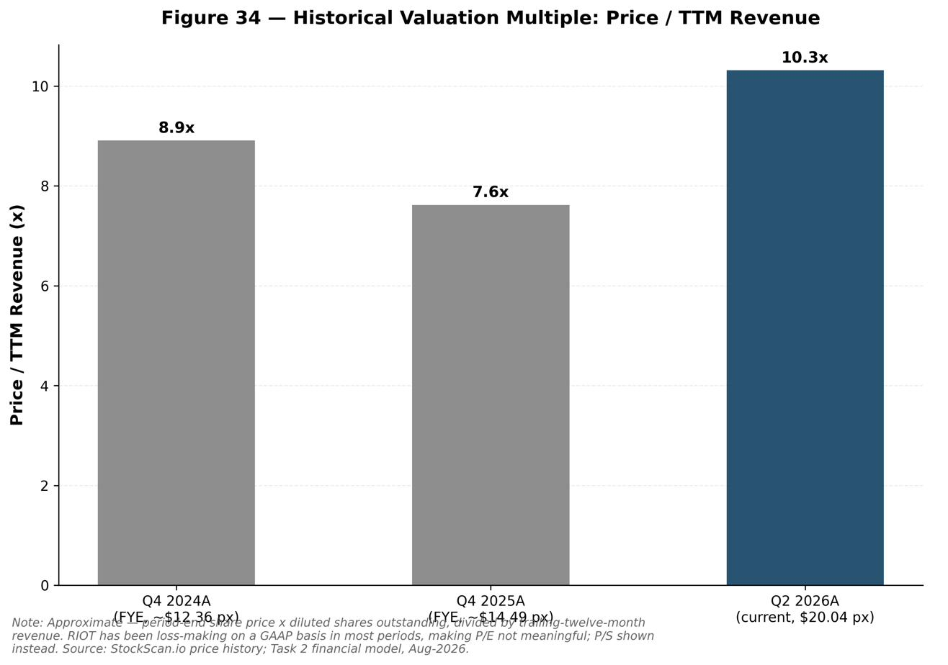

Sum-of-the-Parts Analysis (Primary Method, 50% Weight)
The SOTP values each of Riot's distinct asset pools on the basis most appropriate to it. All figures in US$ millions unless noted; full build is in the model's SOTP tab.
Data-center segment. We capitalise stabilised contracted NOI of ~$438M (frontier-lab ~$388M, the midpoint of management's disclosed $365–411M average annual NOI; plus AMD ~$50M at an 84% operating-lease margin on ~$60M base rent) at a 7.0% base cap rate — a premium to the ~6.0–6.5% at which stabilised, investment-grade-leased data centers change hands, reflecting lease-up, construction, and single-tenant concentration risk. We then subtract the remaining equity-funded build capex. The base case implies ~$26M per contracted MW on a gross-asset basis, in line with the operating-peer median (§4). The bull case uses a 6.0% cap rate; the bear case 9.0%.
Mining business. Now a cash-generative use of un-leased power and an option on bitcoin rather than a growth engine; capacity declines in our model as Rockdale megawatts shift to data-center use. We value normalised mining EBITDA (~$110M) at 4.0–6.5x, well within the miner peer range.
Power optionality. Riot controls roughly 1.4–1.6 GW of developable power beyond its 241 contracted MW. The non-binding LOI for the entire 1 GW Corsicana site is the single largest swing factor: Bernstein has publicly ascribed ~$3bn (~$3M/MW) to Corsicana alone. We apply a blended, heavily risk-adjusted ~$1.8M/MW in the base case (versus Starboard Value's February-2026 estimate of $9–21bn of AI/HPC equity value for Corsicana + Rockdale), reflecting that this capacity is unsigned and unbuilt.
The SOTP base of ~$21/share is essentially in line with the current price; the spread from $9.76 (bear) to $29.58 (bull) captures the wide range of credible outcomes.
Table 6 – Riot Platforms, Inc. Sum-of-the-Parts Valuation ($M except per-share)
Component | Low | Base | High
Stabilized contracted DC NOI ($M) | 438.0 | 438.0 | 438.0
Cap rate | 9.0% | 7.0% | 6.0%
Gross stabilized DC value | 4,866.7 | 6,257.1 | 7,300.0
(–) Remaining build capex (equity) | -3,200.0 | -2,257.0 | -1,800.0
Data Center segment value | 1,666.7 | 4,000.1 | 5,500.0
memo: implied $/contracted MW ($M) | 20.2 | 26.0 | 30.3
Mining business (EV/EBITDA) | 440.0 | 550.0 | 715.0
Bitcoin holdings | 650.0 | 700.0 | 780.0
Power optionality (Corsicana + KY + Rockdale) | 1,200.0 | 2,900.0 | 4,400.0
(–) Net debt (30-Jun-2026A) | -294.0 | -294.0 | -294.0
Equity value ($M) | 3,662.7 | 7,856.1 | 11,101.0
Value per share ($) | $9.76 | $20.94 | $29.58
Anthropic Equity Research financial model, SOTP tab.

Trading Comparables Analysis (Cross-Check, 40% Weight)
Riot's peers are all mid-transition from bitcoin mining to AI/HPC and most are pre-profit, so EV/EBITDA is noisy; enterprise value per operating megawatt is the cleaner metric the market itself uses. The peer set below is drawn from a June-2026 per-MW study (AIB Data Centers 8-K) and August-2026 media/company data.
Statistical summary: Max $56M · 75th pct $47M · Median $35.5M · 25th pct $27M · Min $19M (per operating MW).
Applying a median-level ~$30M/MW to Riot's 241 contracted MW (a slight discount to reflect that the capacity is still building, offset by its investment-grade-backstopped 20-year leases), plus ~$1.6M/MW on ~1.6 GW of developable power, plus mining (~$550M) and bitcoin (~$700M) and less net debt, implies ~$28.6/share. The comps therefore sit toward the upper end of our methods, reflecting the market's willingness to pay operating-peer multiples for contracted-but-unbuilt capacity. We flag that these are EV-per-operating-MW multiples applied to contracted MW; the premium the market ascribes to power scale is real but sentiment-driven.
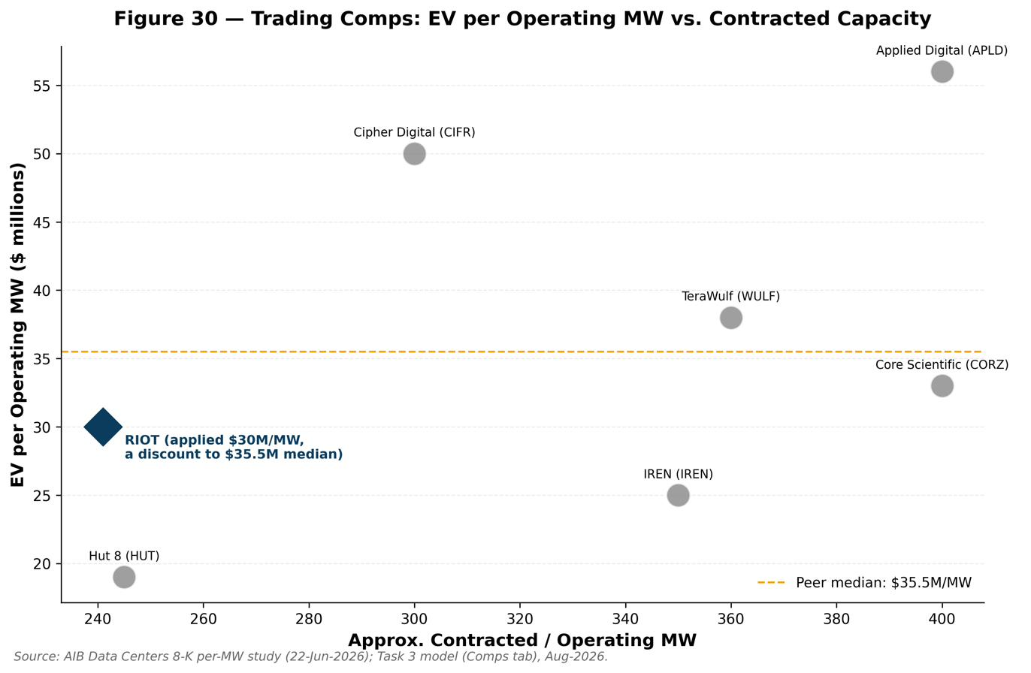
Table 7 – Trading Comparables: EV per Operating Megawatt, Miner-to-AI/HPC Peer Cohort
Company (Ticker) | EV / Operating MW ($M) | Note
Hut 8 (HUT) | 19 | 245MW Anthropic-linked River Bend deal
IREN (IREN) | 25 | ~5x 2028E adj EBITDA; Microsoft AI cloud
Core Scientific (CORZ) | 33 | Colocation > mining; CoreWeave ties
TeraWulf (WULF) | 38 | ~$13bn backlog; Google backstop
Cipher Digital (CIFR) | 50 | Exited mining; AWS 300MW + Fluidstack
Applied Digital (APLD) | 56 | CoreWeave 400MW leases
Maximum | 56
75th Percentile | 47
Median | 35.5
25th Percentile | 27
Minimum | 19
AIB Data Centers 8-K per-MW study (22-Jun-2026); Motley Fool/Bitcoin.com (IREN, peers), Aug 2026. Peer figures are EV per energized/operating MW.
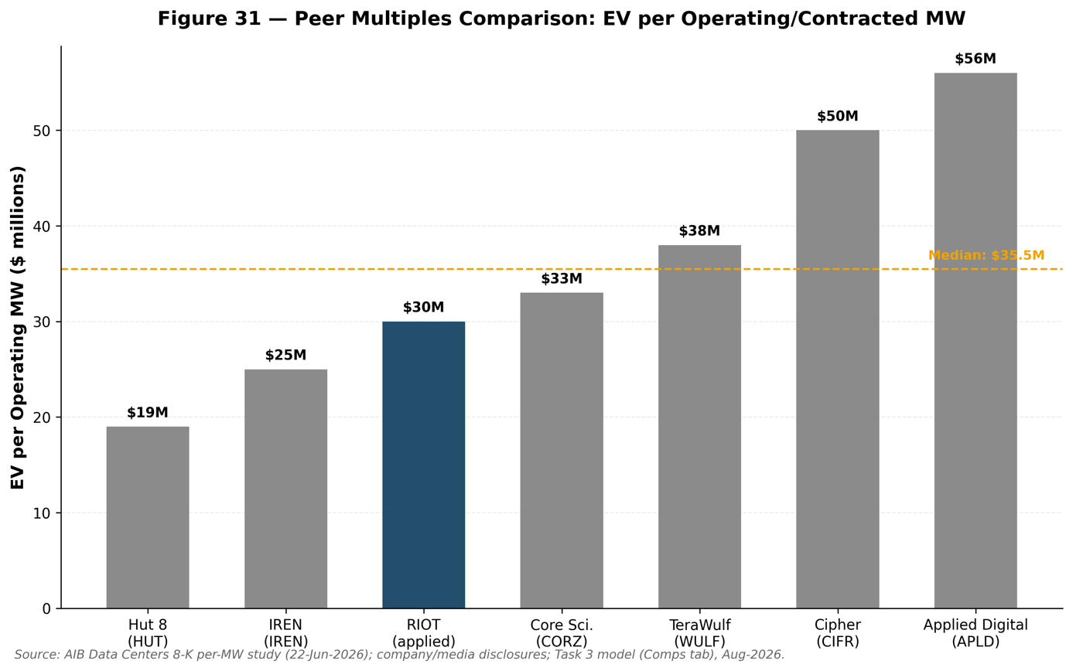

Discounted Cash Flow Analysis (Down-Weighted Cross-Check, 10% Weight)
WACC. Using CAPM with a risk-free rate of 4.7% (10-year U.S. Treasury, 17-Aug-2026), an equity risk premium of 5.5%, and a forward blended beta of 1.5 — deliberately below Riot's trailing pure-miner beta (~2.5–3.0) to reflect the growing weight of contracted, backstopped cash flows — gives a cost of equity of ~13.0%. Blending with an after-tax cost of debt of ~7.0% at market weights (equity ~90%, debt ~10%) yields a WACC of ~12.0%.
Result. Discounting the model's unlevered FCF (2026E–2030E) at 12.0% gives a sum of PV of explicit FCF of –$3.1bn; even adding a terminal value based on 2030E adjusted EBITDA (~$417M) at a 14x exit multiple, enterprise value is only ~$0.15bn, for a DCF value of ~$1.50/share. The sensitivity table (WACC 9–14% × exit 10–18x) shows per-share values that stay in the ~$0–5 range across the grid.
This is not a bearish signal so much as a structural one: the 5-year DCF mechanically understates value because it front-loads ~$4.5bn of build capex while excluding the ~15 years of contracted NOI beyond the horizon and the Corsicana optionality. Terminal value exceeds enterprise value many times over — a textbook flag that the explicit window is too short for the asset's cash-flow profile. We therefore weight the DCF at just 10% and rely on the SOTP.
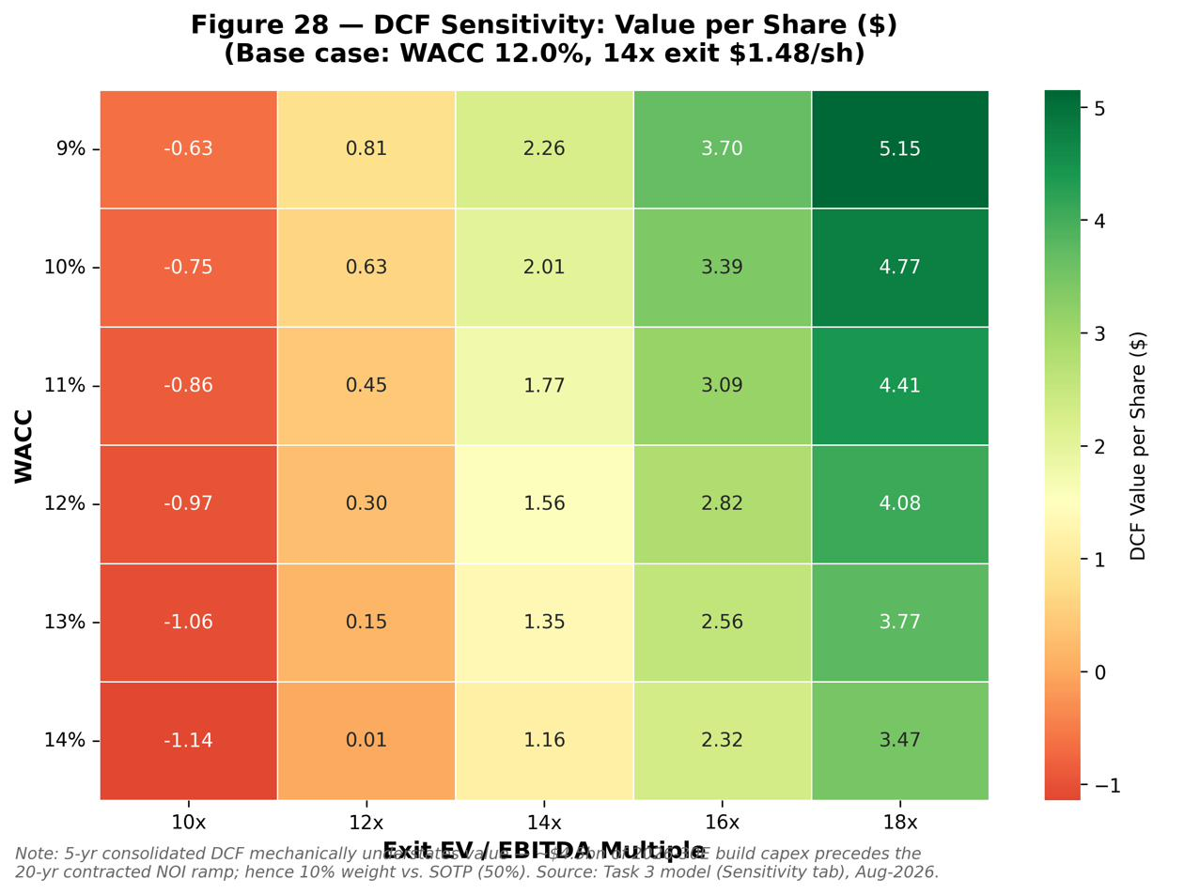
Table 8 – WACC Build-Up & DCF Key Assumptions
Assumption | Value
Risk-free rate (10Y UST) | 4.7%
Equity risk premium | 5.5%
Beta (forward, blended) | 1.50
Cost of equity | 13.0%
Pre-tax cost of debt | 7.0%
Tax rate | 0.0%
After-tax cost of debt | 7.0%
Weight of equity | 89.9%
Weight of debt | 10.1%
WACC | 12.4%
Exit EV/EBITDA multiple | 14.0
Sum PV of explicit UFCF ($M) | -3,110.97
PV of terminal value ($M) | 3,261.7
Enterprise value ($M) | 150.7
PV(TV) / EV (%) | 2164%
DCF value per share ($) | $1.48
Anthropic Equity Research financial model, WACC & DCF tab. Risk-free rate: tradingeconomics/FRED, 17-Aug-2026.
Table 9 – DCF Sensitivity Matrix: Value per Share
WACC \ Exit × | 10x | 12x | 14x | 16x | 18x
9% | -$0.63 | $0.81 | $2.26 | $3.70 | $5.15
10% | -$0.75 | $0.63 | $2.01 | $3.39 | $4.77
11% | -$0.86 | $0.45 | $1.77 | $3.09 | $4.41
12% | -$0.97 | $0.30 | $1.56 | $2.82 | $4.08
13% | -$1.06 | $0.15 | $1.35 | $2.56 | $3.77
14% | -$1.14 | $0.01 | $1.16 | $2.32 | $3.47
Anthropic Equity Research financial model, Sensitivity tab. Base case (WACC 12%, 14x exit) highlighted.
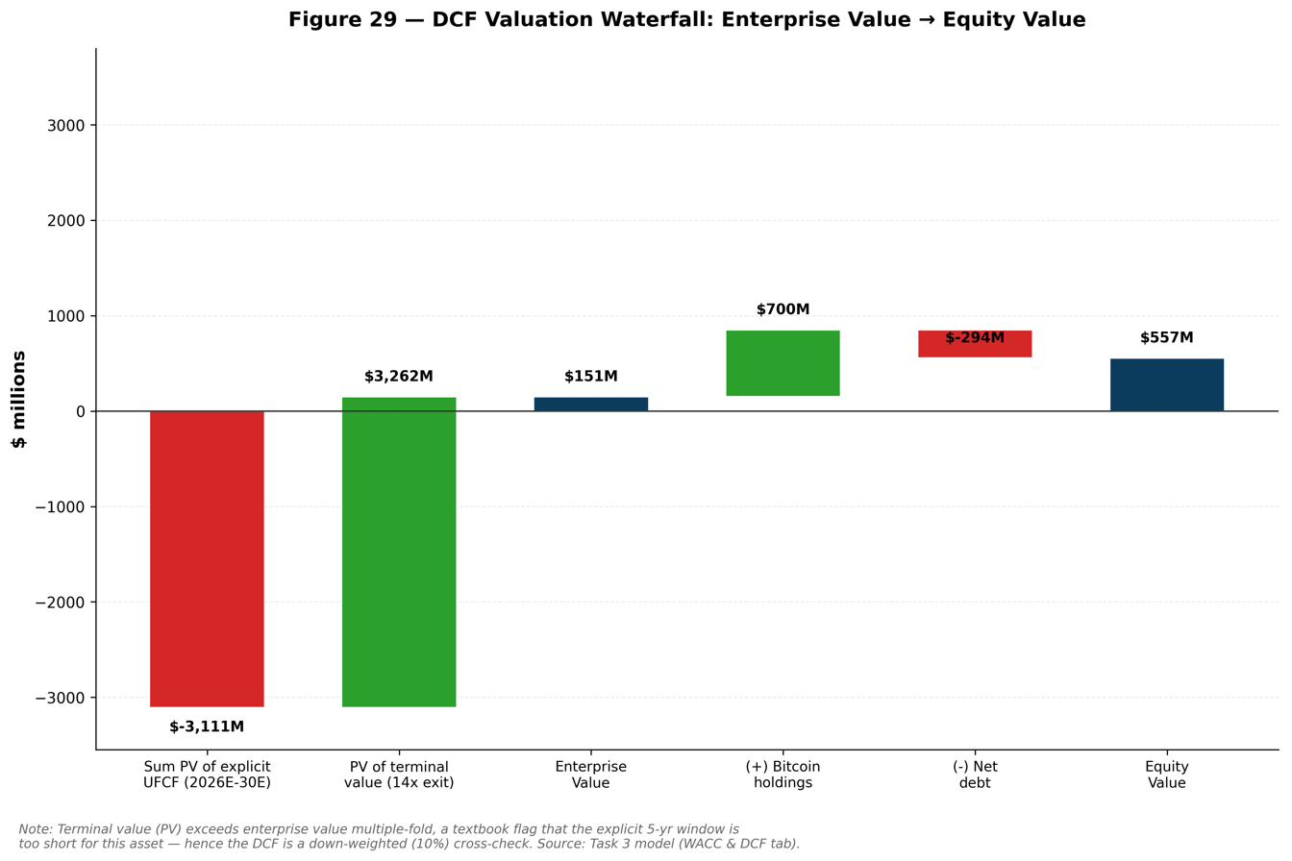

Valuation Summary & Football Field
Football field (per share):
Rounding the $22.07 weighted average, we set a 12-month price target of $22 (+9.8%).
Table 10 – Valuation Summary: Method Weighting & Weighted Fair Value
Method | Low | Base | High | Weight | Weighted
Sum-of-the-parts | $9.76 | $20.94 | $29.58 | 50% | $10.47
Trading comps (per-MW) | $22.91 | $28.64 | $34.36 | 40% | $11.45
DCF (cross-check) | $0.74 | $1.48 | $2.97 | 10% | $0.15
Weighted Average Fair Value |  |  |  | 100% | $22.07
Anthropic Equity Research financial model, Valuation Summary tab.
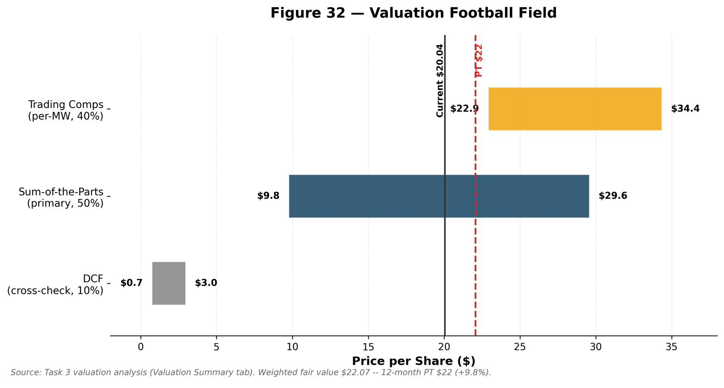

Cross-Check vs. Street Consensus
Our target sits below the Street mean by design. The gap is almost entirely attributable to two conservative choices: (1) a 7.0% base data-center cap rate versus the ~6% or richer per-MW multiples the bulls apply, and (2) a heavier haircut on unsigned optionality (Corsicana). The Street is, in effect, capitalising the Corsicana conversion and cap-rate compression that we treat as upside rather than base case. Notably, even the bullish Street continues to model GAAP losses near-term (Simply Wall St shows a consensus ~$2.58 loss per share next year), consistent with our model — the debate is about asset value and optionality, not earnings.
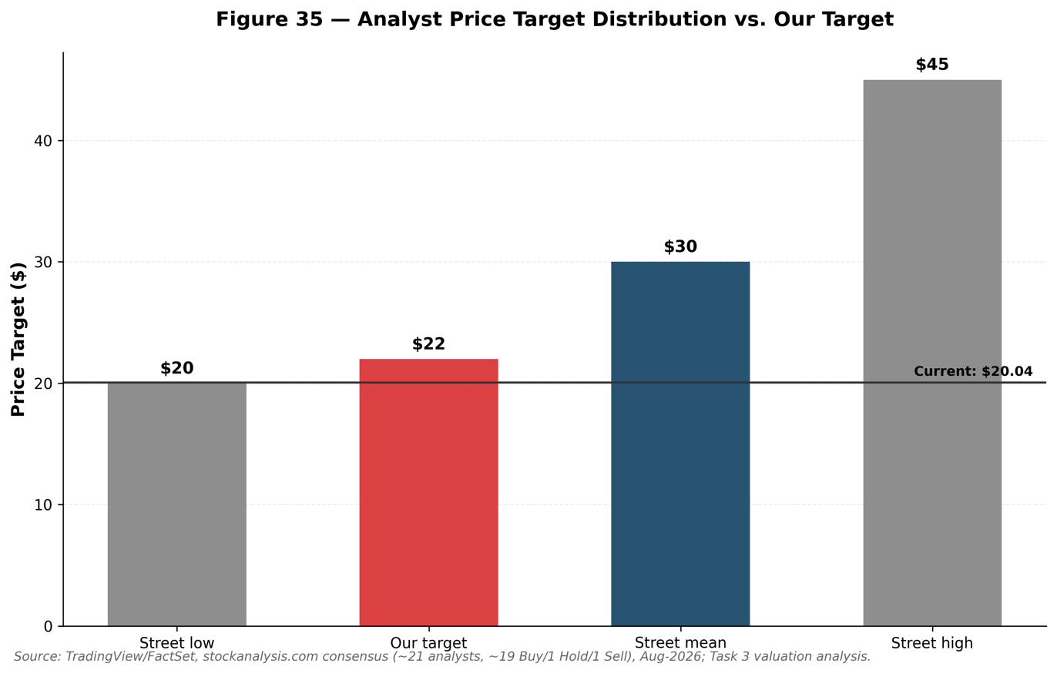

Price Target & Recommendation
Rating: NEUTRAL / MARKET PERFORM. Price target $22 (+9.8%). The contracted backlog and power position are genuinely valuable and the AMD delivery de-risks execution, but at ~$20 the base case is roughly fairly valued and the incremental upside is contingent on events (Corsicana, cap-rate compression, BTC) we prefer to see confirmed. We would upgrade on a signed Corsicana lease or clear evidence of on-time frontier-lab construction.
Key catalysts (upside): 1. Conversion of the 1 GW Corsicana LOI into a binding lease — the single largest value driver (~$2–3bn potential). 2. On-schedule delivery of the frontier-lab capacity (96 MW by Dec-2027; 191 MW by Jun-2028) and finalisation of the investment-grade credit backstop. 3. Data-center cap-rate compression as Riot establishes an institutional operating track record, re-rating the contracted NOI toward core-infrastructure multiples. 4. Bitcoin price recovery from ~$63k, lifting mining cash flow and treasury value. 5. Additional leasing of the ~1.4 GW of remaining developable power (Kentucky, Rockdale) and progress on the Terrestrial Energy nuclear MOU.
Key risks (downside): 1. Execution/construction risk — delays or cost overruns on multiple simultaneous gigawatt-scale builds. 2. Tenant/counterparty concentration — value rests on AMD and one unnamed frontier AI lab; single-tenant Corsicana would deepen this. 3. Capital intensity & dilution — ~$4.5bn of forecast capex; funding via debt (the model's plug) and equity (ATM) pressures the cost of capital and per-share value. 4. Bitcoin-price risk — near-term results and treasury remain bitcoin-sensitive; GAAP losses are amplified by mark-to-market swings. 5. Interest-rate / financing risk — higher-for-longer rates raise build financing costs and the discount rate on long-dated contracted cash flows.
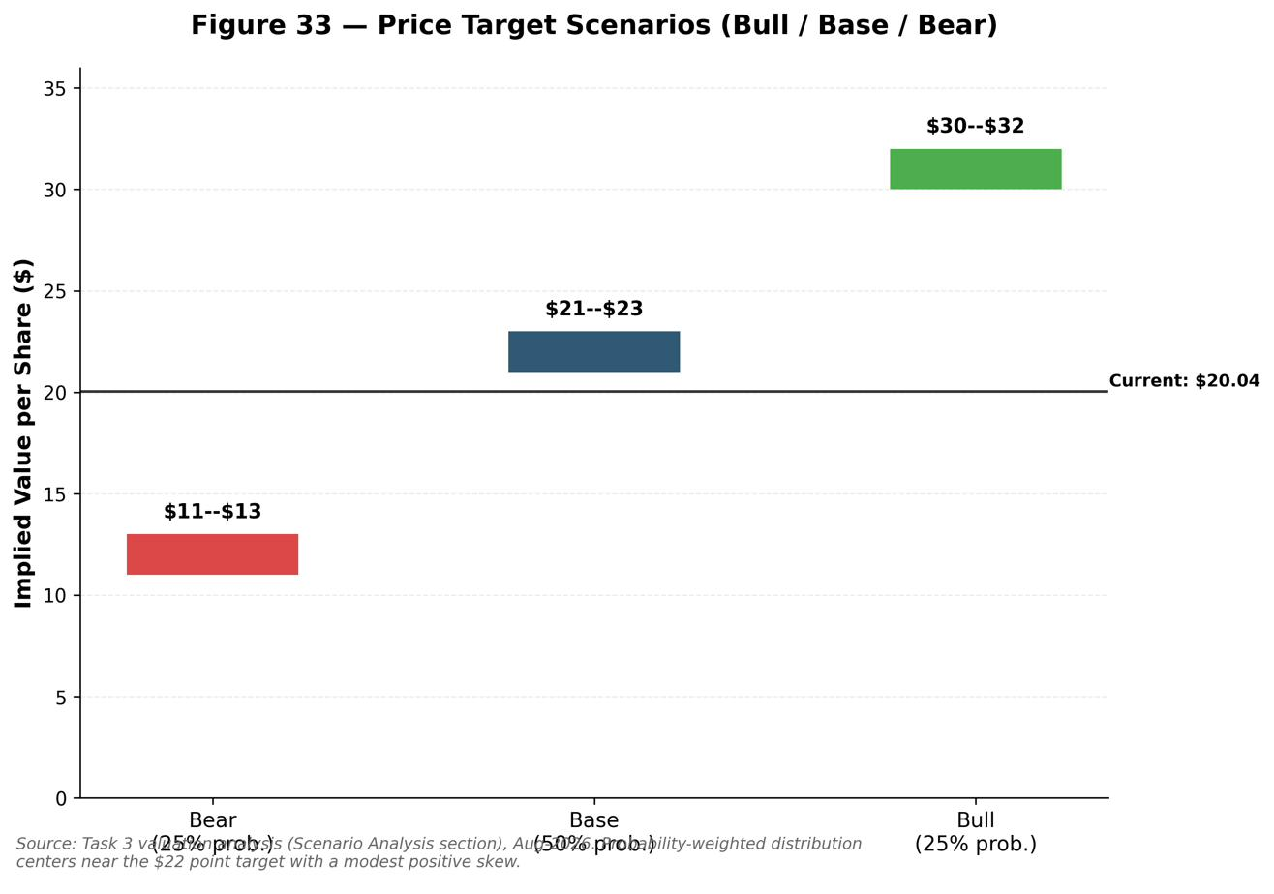

Consistency Tests & Sanity Checks
- Market-cap cross-check: computed $20.04 × 375.26M = $7.52bn; provider figure (Q2'26 call) $7.42bn → +1.3% variance, within the ±2% tolerance. Canonical share count confirmed against the 10-Q cover (375,258,935 as of 7-Aug-2026).
- Terminal-value check: DCF terminal value exceeds enterprise value (>100%), which correctly flags the single-stage DCF as unreliable here — hence its 10% weight and the SOTP-led approach.
- WACC reasonableness: 12.0% sits in the appropriate range for a high-beta, transitioning issuer; sensitivity spans 9–14%.
- Per-MW cross-check: SOTP base implies ~$26M per contracted MW (gross), consistent with the operating-peer median of ~$35.5M/MW (a modest discount for lease-up) — the SOTP and comps triangulate.
- Implied-growth / market-pricing check: at $20.04 the market is already capitalising meaningful Corsicana/optionality value; our base case says today's price largely reflects contracted assets plus partial optionality, leaving limited base-case upside but a real bull skew.
- Range, not point: every method is expressed low/base/high; the recommendation rests on a range ($11–$32) with a $22 point target.
All valuation figures are computed in, and tie to, the Excel tabs (WACC & DCF, Sensitivity, Comps, SOTP, Valuation Summary) added to the Task 2 model. Current market inputs (risk-free rate, consensus, peer multiples) were verified as of the 18-Aug-2026 cut-off. Prepared by Claude (Anthropic); the reported 191 MW tenant, Anthropic, is Claude's maker and is treated strictly neutrally, on the basis of Riot's own disclosures and independent sources.

Appendices

Appendix A: Data Sources & References
All time-sensitive facts in this report were verified against sources as of the 18-August-2026 research cut-off. Reported historicals are labelled "A" (actual); company forecasts and analyst/consensus estimates are identified as such and are not presented as reported fact. Figures that could not be independently verified were omitted rather than estimated.

SEC Filings & Company Investor Relations
• Riot Platforms, Form 8-K / Exhibit 99.1, Q2 2026 earnings release, 10 August 2026
• Riot Platforms, Form 8-K cover, 10 August 2026
• Riot Platforms, Form 10-Q, period ended 30 June 2026
• Riot Platforms, Form 8-K / Exhibit 99.1, Full-Year 2025 results, 2 March 2026
• Riot Platforms, Form DEF 14A (proxy), 2026
• Riot Platforms, Q1 2026 8-K / earnings deck
• Riot Platforms, Q1 2025 earnings release, 1 May 2025
• Riot Platforms, Full-Year 2024 earnings release, 24 February 2025 (via Seeking Alpha PR)
• Riot Blockchain, Whinstone acquisition 8-K / Exhibit 99.1, 26 May 2021
• Riot Blockchain, Jason Les appointment 8-K (CEO bio/education), 2021
• Riot Platforms Investor Relations — Q2 2026, Q3 2025 results; Rhodium settlement (April 2025)

Financial Media, Market-Data Providers & Industry Research
• CNBC (David Faber), Riot–Anthropic deal confirmation, 11 August 2026
• Data Center Dynamics, 191 MW lease reported as Anthropic
• Fortune, Bitcoin price 17 August 2026 (~$63,260)
• Yahoo Finance, Bitcoin/ETH prices & all-time high ($126,198 on 6 Oct 2025), 17 August 2026
• Bitcoin.com News / MinerWeekly, public-miner hash-rate & AI-pivot analysis (Q1–Q2 2026)
• MinerWeekly, how AI is reshaping Bitcoin's hashrate
• CFO Dive, CFO transition (Chung/Yee), January 2026
• stockanalysis.com, RIOT analyst consensus (Aug 2026)
• Simply Wall St, RIOT management & financial history
• Bitget / BlockchainReporter, Starboard Value activist details & Q1 2026 BTC sales
• CryIP.co, 191 MW lease detail, Starboard thesis, Hut 8/Anthropic comparison
• Clay, Jason Les biography & education
Consensus snapshot (as of ~mid-August 2026; provider-dependent): approximately 21–22 covering analysts; rating distribution roughly 19–20 Buy, 1 Hold, 1 Sell; consensus label "Buy"/"Strong Buy"; average 12-month price target approximately $29.5–$33.3; range approximately $20 (low) to $45 (high). Sources: TradingView/FactSet and stockanalysis.com.

Appendix B: Full Cash Flow Statement & Balance Sheet Detail
Table 11 – Riot Platforms, Inc. Projected Cash Flow Statement, 2026E–2030E ($M)
($M) | 2026E | 2027E | 2028E | 2029E | 2030E
Net income (loss) | -535.0 | -444.4 | -317.5 | -200.5 | -243.1
(+) Depreciation & amortization | 328.1 | 303.7 | 253.1 | 283.1 | 338.8
(+) Stock-based compensation | 150.0 | 135.0 | 125.0 | 115.0 | 105.0
(-) Increase in net working capital | -6.2 | -1.4 | -4.3 | -2.4 | -0.0
Cash flow from operations | -63.1 | -7.1 | 56.3 | 195.2 | 200.7
Capital expenditures | -500.0 | -1,200.0 | -1,500.0 | -800.0 | -500.0
Bitcoin sale proceeds | 900.0 | 250.0 | 150.0 | 100.0 | 50.0
Cash flow from investing | 400.0 | -950.0 | -1,350.0 | -700.0 | -450.0
Debt draw (funding plug) | 0.0 | 536.7 | 1,293.7 | 504.8 | 249.3
Equity issuance | 0.0 | 0.0 | 0.0 | 0.0 | 0.0
Cash flow from financing | 0.0 | 536.7 | 1,293.7 | 504.8 | 249.3
Net change in cash | 336.9 | -420.4 | 0.0 | 0.0 | 0.0
Ending cash | 570.4 | 150.0 | 150.0 | 150.0 | 150.0
Free cash flow (CFO - capex) | -563.1 | -1,207.1 | -1,443.7 | -604.8 | -299.3
Anthropic Equity Research financial model.
Table 12 – Riot Platforms, Inc. Projected Balance Sheet, 2025A–2030E ($M)
ASSETS
($M) | 2025A | 2026E | 2027E | 2028E | 2029E | 2030E
Cash & equivalents | 233.5 | 570.4 | 150.0 | 150.0 | 150.0 | 150.0
Restricted cash | 76.3 | 76.3 | 76.3 | 76.3 | 76.3 | 76.3
Accounts receivable | 29.8 | 31.5 | 35.1 | 45.9 | 51.9 | 52.0
Prepaid & other current assets | 59.4 | 59.4 | 59.4 | 59.4 | 59.4 | 59.4
Contract assets | 8.3 | 8.3 | 8.3 | 8.3 | 8.3 | 8.3
Derivative assets | 148.1 | 148.1 | 148.1 | 148.1 | 148.1 | 148.1
Bitcoin holdings | 1,575.5 | 675.5 | 425.5 | 275.5 | 175.5 | 125.5
Property & equipment, net | 1,528.7 | 1,704.4 | 2,604.5 | 3,855.2 | 4,375.9 | 4,540.9
Deposits | 76.5 | 76.5 | 76.5 | 76.5 | 76.5 | 76.5
Intangible assets, net | 30.2 | 26.4 | 22.6 | 18.8 | 15.0 | 11.2
ROU & other long-term assets | 48.1 | 48.1 | 48.1 | 48.1 | 48.1 | 48.1
Goodwill | 122.5 | 122.5 | 122.5 | 122.5 | 122.5 | 122.5
Total assets | 3,936.9 | 3,547.4 | 3,776.9 | 4,884.6 | 5,307.5 | 5,418.8
LIABILITIES
($M) | 2025A | 2026E | 2027E | 2028E | 2029E | 2030E
Accounts payable | 23.4 | 18.9 | 21.0 | 27.6 | 31.2 | 31.2
Accrued & other liabilities | 142.9 | 142.9 | 142.9 | 142.9 | 142.9 | 142.9
Contract liabilities | 37.1 | 37.1 | 37.1 | 37.1 | 37.1 | 37.1
Contingent consideration | 8.2 | 8.2 | 8.2 | 8.2 | 8.2 | 8.2
Total debt | 840.8 | 840.8 | 1,377.5 | 2,671.2 | 3,176.1 | 3,425.4
Operating lease liabilities | 25.9 | 25.9 | 25.9 | 25.9 | 25.9 | 25.9
Total liabilities | 1,078.3 | 1,073.8 | 1,612.6 | 2,912.9 | 3,421.3 | 3,670.7
EQUITY
($M) | 2025A | 2026E | 2027E | 2028E | 2029E | 2030E
Common stock & additional paid-in capital | 4,212.0 | 4,362.0 | 4,497.0 | 4,622.0 | 4,737.0 | 4,842.0
Accumulated deficit | -1,353.4 | -1,888.4 | -2,332.8 | -2,650.3 | -2,850.8 | -3,093.9
Total equity | 2,858.6 | 2,473.6 | 2,164.2 | 1,971.7 | 1,886.2 | 1,748.1
Anthropic Equity Research financial model. Balance sheet balances by construction in every projected year.

Appendix C: Analyst Certification & Important Disclosures
Analyst Certification: The views expressed in this report accurately reflect the personal views of the preparer about the subject securities. No part of the preparer's compensation was, is, or will be directly or indirectly related to the specific recommendations or views expressed in this report.
Preparation Disclosure: This report was prepared by Claude, an AI system developed by Anthropic, at the request of the user ("Paulie") as part of an equity-research workflow exercise. It is an AI-generated research work product and has not been reviewed or approved by a FINRA-registered research analyst or investment bank. It should not be relied upon as the sole basis for an investment decision.
Material Conflict Disclosure: Multiple media outlets (CNBC, Data Center Dynamics, and others cited in Appendix A) have reported, without confirmation from either party, that the unnamed "leading frontier AI lab" counterparty to Riot's 191 MW Rockdale data-center lease is Anthropic — the developer of the Claude AI models used to prepare this report. Because Anthropic is the reported (unconfirmed) counterparty to a transaction material to the subject company, this report treats that tenant identity strictly as reported-but-unconfirmed throughout and applies no favorable or unfavorable interpretation on that basis; all conclusions rest on Riot's own disclosures and independent third-party sources. Readers should independently weigh this disclosure when assessing the report's objectivity.
General Disclosures: This report is for informational purposes only and does not constitute investment advice or an offer or solicitation to buy or sell any security. Estimates and price targets are inherently uncertain and actual results may differ materially. Past performance is not indicative of future results. This report does not take into account the specific investment objectives, financial situation, or needs of any particular recipient.

