AZURE DISASTER RECOVERY
WITH RESTIC
Infrastructure as Code • Encrypted Backups • Tested Recovery

Technical Project Report
Payman Ghorbani
MSc Cybersecurity
Cloud Operations and Management
September 2026

Portfolio version prepared for GitHub and LinkedIn evidence.

1. Project Overview
I designed and implemented a practical disaster recovery (DR) solution in Microsoft Azure to test how a small Linux-based workload could be rebuilt after infrastructure loss and its application data recovered from an independent backup repository. The project combined Azure Bicep for repeatable infrastructure deployment with Restic for encrypted, snapshot-based backup and recovery. Azure Blob Storage was used as the backup target so that the protected data was separated from the virtual machine being recovered.
The recovery exercise was deliberately kept small enough to be reproducible, while still covering the main parts of a real DR workflow: infrastructure definition, secure access to backup storage, creation of a recovery point, simulated server loss, infrastructure rebuild, data restoration, integrity checking, validation and final decommissioning. The main protected workload was a simple web application data directory at /srv/app-data on an Ubuntu 22.04 virtual machine.
My target recovery objectives were an RTO of 60 minutes and an RPO of 1 hour. Microsoft defines RPO as the maximum acceptable duration of data loss and RTO as the maximum acceptable downtime (Microsoft, 2026a). These targets therefore acted as design requirements rather than guaranteed service levels. The exercise successfully restored the latest available Restic snapshot, but the exact failure timestamp was not independently captured, so I have not claimed a fabricated measured RPO or exact end-to-end RTO.

2. Architecture and Design
The environment was deployed in Azure UK South inside a dedicated resource group. Bicep defined the virtual network, subnet, network security group, public IP address, network interface, Ubuntu virtual machine, storage account, private Blob container and identity/RBAC configuration. A user-assigned managed identity was used so the rebuilt VM could authenticate to Azure Storage without embedding a storage account key in the recovery workflow. This approach supports a repeatable recovery design in which infrastructure and data recovery are treated as complementary parts of disaster recovery planning (Microsoft, 2026c).
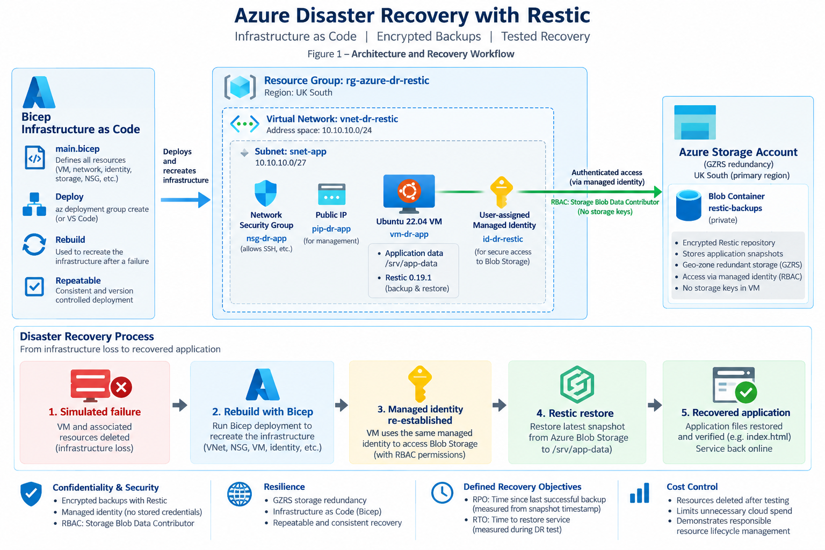
Figure 1. Azure DR architecture and recovery workflow.
The storage account used geo-zone-redundant storage (GZRS). Microsoft documents that GZRS replicates data across availability zones in the primary region and asynchronously to a secondary geographic region (Microsoft, 2026b). In this project I used GZRS to improve the durability of the backup repository; I did not treat it as proof of a tested regional failover because the exercise tested VM/application recovery rather than a full Azure region failover.
Component | Implementation | Purpose
Infrastructure as Code | Azure Bicep | Repeatable deployment and rebuild
Compute | Ubuntu 22.04 VM | Hosts the protected application data
Backup tool | Restic 0.19.1 | Encrypted snapshot backup and restore
Backup target | Azure Blob Storage | Independent persistent repository
Storage resilience | Standard GZRS | Zone and geo-redundant durability
Authentication | User-assigned managed identity | Avoids storage keys on the VM
Authorization | Storage Blob Data Contributor | Least-purpose RBAC access to Blob data
Protected path | /srv/app-data | Application data restored during DR test

3. Backup Strategy
I installed Restic on the VM and upgraded it to version 0.19.1. The repository was initialized in the private Azure Blob container named restic-backups. The repository password was held separately from the repository location and was not included in the Bicep source or screenshots intended for publication. The VM authenticated to Blob Storage through its managed identity and Azure RBAC.
For the test workload I backed up /srv/app-data. The successful snapshot had ID bd699b68 and was created at 14:29:20 UTC on 21 September 2026. The snapshot contained the application data required for recovery, including index.html. Restic supports restoring a selected or latest snapshot and provides repository checking to identify structural or data-integrity problems (Restic, 2026a; Restic, 2026b).
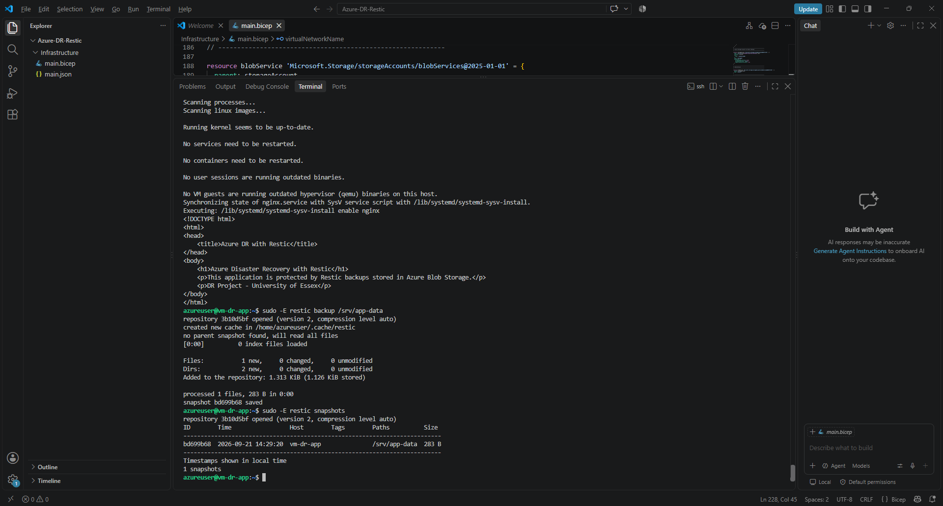
Figure 2. Successful Restic backup and snapshot evidence.

4. Disaster Recovery Test
The failure scenario represented loss of the application server and the need to reconstruct the Azure infrastructure before restoring application data. I used the Bicep template to recreate the required Azure resources. Azure Activity Log evidence recorded the VM create/update operation starting at 15:00:53 UTC and succeeding at 15:01:00 UTC, showing that the Azure VM resource itself was provisioned in approximately 7.5 seconds. This figure is infrastructure provisioning time only and is not presented as the complete RTO.
After the VM was available, I re-established access, authenticated with the user-assigned managed identity and reconnected Restic to the persistent Blob repository. I then restored the latest snapshot to the original path, following Restic's documented snapshot restore approach (Restic, 2026a). Restic reported that three files/directories (283 B) were restored. I verified the recovered /srv/app-data/index.html directly on the rebuilt VM and confirmed that the expected application content had returned.
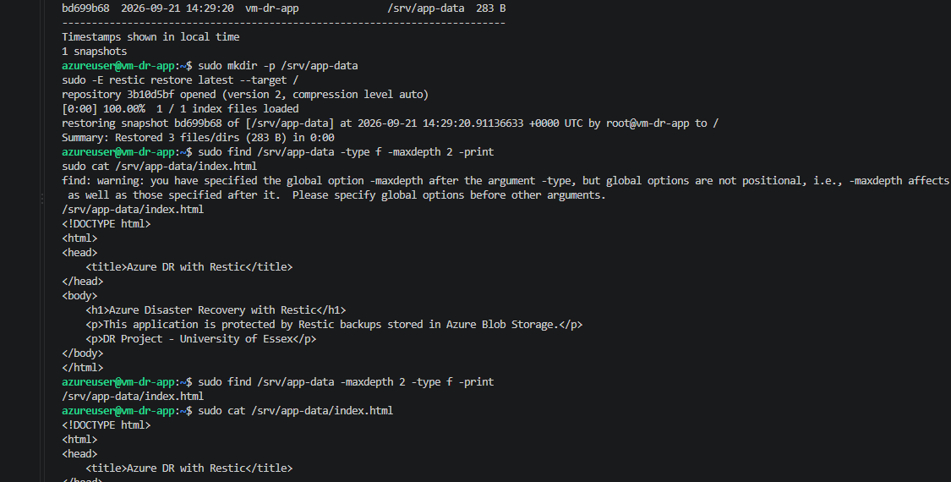
Figure 3. Restic restore and recovered application-data verification (cropped to remove unrelated configuration details).

5. Recovery Objectives and Results
Metric | Target | Observed evidence | Assessment
RPO | 1 hour | Latest recoverable snapshot: 14:29:20 UTC | Latest available recovery point restored; exact failure-to-snapshot interval not claimed because the failure timestamp was not independently captured.
RTO | 60 minutes | Recovery was underway by 14:52 UTC; restored data was verified around 15:24-15:25 UTC. | Recovery was completed within the planned 60-minute objective based on the available evidence, but an exact failure-to-service-restoration duration was not captured.
VM provisioning | N/A | 15:00:53 to 15:01:00 UTC | Approximately 7.5 seconds for the Azure VM create/update operation; this is not the full RTO.
The key result is that the recovery procedure worked: the infrastructure could be recreated and the latest Restic recovery point could be accessed from the rebuilt VM. I have deliberately separated measured evidence from assumptions. This is important in DR testing because an RTO or RPO should be supported by repeatable timing evidence rather than inferred after the event.

6. Security and Resilience Decisions
The design avoided storing Azure Storage account keys on the VM. A user-assigned managed identity and the Storage Blob Data Contributor role provided the VM with the data-plane permissions needed for the Restic repository. This also made the identity independent of the lifecycle of the individual VM, which is useful when the compute resource has to be recreated.
The Restic repository remained separate from the protected compute workload. This separation is central to the recovery design: losing the application VM should not also remove the recovery copy. Restic encrypted the repository, while Azure Storage provided the durable Blob backend. NIST contingency-planning guidance emphasizes recovery strategies, testing and maintaining recovery capability as part of system resilience (Swanson et al., 2010), which is consistent with the practical approach used here.

7. Validation
Recovery was validated at several levels rather than stopping after the restore command completed. I listed the restored files, displayed index.html to confirm the application content, inspected the recovered file metadata, and ran restic check. The repository check completed with 'no errors were found', providing evidence that Restic considered the repository structure consistent at the time of testing. Repository checking is also recommended in Restic's repository guidance (Restic, 2026b).
The restored index.html retained an original modification timestamp of 14:28:04 UTC, while the snapshot was recorded at 14:29:20 UTC. This demonstrated preservation of the backed-up file state. It does not by itself establish the RPO because RPO is measured relative to the failure point.

8. Cost and Resource Lifecycle Management
Once the recovery test and evidence collection were complete, I deleted the dedicated Azure resource group rather than leaving the lab environment running. The Azure Portal showed the resources being removed progressively until the project resource group disappeared from the resource-group list. This final step reduced unnecessary cloud spend and demonstrated that resource lifecycle and cost control were considered as part of the practical exercise.
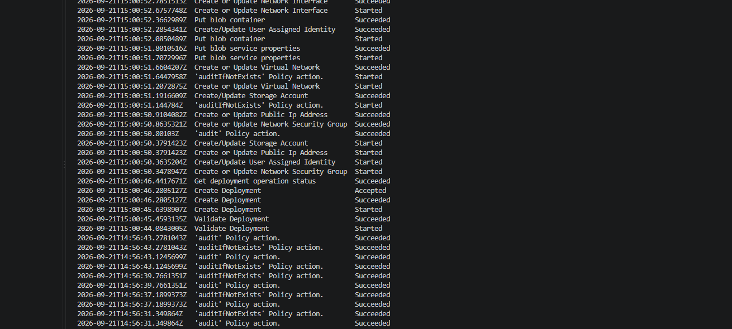
Figure 4. Project resources removed after completion of the DR test.

9. Limitations and Improvements
The exercise was intentionally focused on a small static application workload. Restic provided file-level recovery and the test did not include a transactional database, so database-consistency techniques were outside the scope of this implementation. The GZRS storage configuration improved durability but I did not perform an Azure Storage regional failover, so the project should not be described as a tested multi-region application failover (Microsoft, 2026b; Microsoft, 2026c). However, I have previously implemented a separate Azure Failover and Load Balancing project (April-May 2017), which explored Azure failover and service availability in greater depth. The project is available on my LinkedIn profile: https://www.linkedin.com/in/paymanghorbani/details/projects/
A further improvement would be to automate the backup schedule and record machine-generated timestamps at the exact start of the failure and the exact point at which the recovered application passes a health check. That would allow an exact measured RPO and end-to-end RTO to be reported. For a production implementation I would also store the Restic repository credential in a recovery-accessible secrets system such as Azure Key Vault, because the recovery password must remain available even when the original VM is lost.

10. What I Demonstrated
- Designed a small Azure disaster-recovery architecture rather than relying only on high availability.
- Used Bicep to define and recreate cloud infrastructure as code.
- Implemented Restic 0.19.1 with Azure Blob Storage as an independent backup repository.
- Used a user-assigned managed identity and Azure RBAC instead of embedding storage keys.
- Created and restored a real recovery snapshot of application data.
- Validated the restored file and checked the Restic repository for errors.
- Evaluated RTO/RPO using the evidence actually captured, including measurement limitations.
- Decommissioned the Azure lab after testing to control cloud cost.

11. Repository Structure for GitHub
The public GitHub repository should contain the Bicep source, a README based on this report, the architecture diagram, a concise DR runbook and selected redacted evidence images. Generated deployment output may be included only where it adds value. Private SSH keys, the Restic repository password, personal email addresses, Azure subscription/tenant identifiers and other unnecessary account information must not be committed.
Azure-DR-Restic/
├── Infrastructure/
│ └── main.bicep
├── docs/
│ ├── architecture.png
│ └── DR-RUNBOOK.md
├── evidence/
│ ├── backup-snapshot.png
│ ├── restore-verification.png
│ └── teardown.png
└── README.md

12. Conclusion
This project gave me a practical way to connect infrastructure recovery and data recovery instead of treating them as separate ideas. Bicep recreated the Azure environment, while Restic recovered the application data from Blob Storage. The managed-identity design reduced reliance on stored Azure credentials, and the final restore demonstrated that the backup repository remained usable after the application server was rebuilt. This reflects the broader DR principle of planning for recovery of both infrastructure and workload data rather than relying only on availability controls (Microsoft, 2026a; Microsoft, 2026c).
The test also highlighted the importance of measurement discipline. The recovery itself was successful, but the exact failure timestamp was not captured independently, so I have reported the evidence conservatively rather than presenting an artificial RPO/RTO result. For a future iteration I would automate both backup scheduling and recovery timing so that the complete DR process can be repeated and measured consistently.

References
Microsoft (2026a) What are business continuity, high availability, and disaster recovery? Microsoft Learn. Available at: https://learn.microsoft.com/en-us/azure/reliability/concept-business-continuity-high-availability-disaster-recovery (Accessed: 21 September 2026).
Microsoft (2026b) Azure Storage redundancy. Microsoft Learn. Available at: https://learn.microsoft.com/en-us/azure/storage/common/storage-redundancy (Accessed: 21 September 2026).
Microsoft (2026c) Develop a disaster recovery plan for multi-region deployments. Azure Well-Architected Framework. Available at: https://learn.microsoft.com/en-us/azure/well-architected/design-guides/disaster-recovery (Accessed: 21 September 2026).
Restic (2026a) Restoring from backup - restic 0.19.1 documentation. Available at: https://restic.readthedocs.io/en/stable/050_restore.html (Accessed: 21 September 2026).
Restic (2026b) Working with repositories - restic 0.19.1 documentation. Available at: https://restic.readthedocs.io/en/stable/045_working_with_repos.html (Accessed: 21 September 2026).
Swanson, M., Bowen, P., Phillips, A.W., Gallup, D. and Lynes, D. (2010) Contingency Planning Guide for Federal Information Systems. NIST Special Publication 800-34 Rev. 1. Gaithersburg, MD: National Institute of Standards and Technology. doi:10.6028/NIST.SP.800-34r1.

