Unit 11 Formative Activity: AI and Cloud Computing
TensorFlow and Keras Image Recognition – Technical Reflection
Activity | Build and deploy a simple AI image-recognition model in a cloud environment
AI tools | TensorFlow 2.21.0 and Keras 3.15.1
Dataset | CIFAR-10
Cloud platform | Microsoft Azure Container Apps (UK South)

1. Overview
For this formative activity, I built a small convolutional neural network (CNN) for image recognition using TensorFlow and Keras, evaluated it locally, exposed the trained model through a FastAPI web API, containerised the application with Docker, and deployed it to Microsoft Azure Container Apps. The purpose was not to create a state-of-the-art classifier, but to complete and understand the full AI lifecycle from model development to a working cloud inference endpoint.
I used CIFAR-10 because it provides 60,000 colour images across 10 mutually exclusive classes, divided into 50,000 training and 10,000 test images (TensorFlow, n.d.). This made it suitable for a compact educational CNN and gave me a separate test set for evaluating generalisation.

2. How I built and evaluated the model
I prepared a Python 3.12 virtual environment on Windows and installed TensorFlow 2.21.0 and Keras 3.15.1. Before implementation, I checked platform compatibility and Azure prerequisites so that the local and cloud stages followed a viable deployment path. I normalised CIFAR-10 pixel values from 0–255 to 0–1 and created a Sequential CNN with two Conv2D layers, MaxPooling layers, a Flatten layer, a Dense hidden layer and a 10-unit softmax output layer. CNNs are well suited to image data because convolutional layers learn spatial features from local receptive fields (LeCun et al., 1998).
The model was compiled with the Adam optimiser, sparse categorical cross-entropy loss and accuracy as the evaluation metric. I trained for five epochs using a 10% validation split. Keras defines an epoch as one iteration over the supplied training data, while validation data is held out from training and evaluated at the end of an epoch (Keras, 2026). After training, I evaluated the model against the unseen CIFAR-10 test set. The final test accuracy was 0.6671 (66.71%). For this simple model and short training run, I considered this sufficient to demonstrate the workflow, although it also shows clear scope for model improvement.
I saved the trained network as image_classifier.keras and reloaded it to verify that the model artifact was usable. I then tested inference locally. A selected CIFAR-10 ship image was correctly classified as “ship”. This local verification was important because it separated model problems from later container or cloud deployment problems.

3. How I deployed the model
I wrapped the model in a FastAPI application with a POST /predict endpoint. Uploaded images are converted to RGB, resized to 32×32 pixels, normalised, passed to the model, and returned as a predicted class with a confidence value. I then created a Docker image containing the API, its Python dependencies and the saved Keras model. The container listened on port 8000 and was tested locally before cloud deployment.
For Azure deployment, I created an Azure Container Registry (ACR), pushed the versioned Docker image tensorflow-image-api:1.0, and created an Azure Container Apps Consumption environment in UK South. The Container App used a system-assigned managed identity with the AcrPull role to retrieve the private image. This avoided placing registry usernames or passwords in the application configuration. Microsoft documents managed identity as a supported way for Container Apps to authenticate to ACR without administrative credentials (Microsoft, 2026a).
External HTTPS ingress was configured to target port 8000. I verified the deployed root endpoint and then used the automatically generated API documentation to upload the same test_ship.png image to the cloud /predict endpoint. Azure returned HTTP 200 with the prediction “ship” and confidence 0.9247. This demonstrated that the same trained model operated successfully after containerisation and cloud deployment.

4. Cloud resource management and optimisation
A useful part of the exercise was observing serverless scaling directly. I configured the Container App with a minimum of 0 replicas and a maximum of 1. After the service became idle, the Azure portal showed the revision scaled to 0 with no running replicas. When I accessed the public endpoint again, Azure started a replica and the revision changed to Running (at max) with 1 replica. Microsoft states that Container Apps can scale to zero and that usage charges are not incurred while an application is scaled to zero (Microsoft, 2026b). This was a practical example of matching compute consumption to demand rather than keeping capacity permanently active.
More broadly, AI can enhance cloud operations by using workload and telemetry data to support demand forecasting, anomaly detection, capacity planning and automated scheduling. Research has demonstrated that learned policies can be applied to resource-management decisions in computing systems (Mao et al., 2016). In a cloud environment, such techniques could complement rule-based autoscaling by identifying patterns that are difficult to capture with fixed thresholds. However, AI-driven optimisation should still be monitored because poor training data, concept drift or incorrect objectives could produce inefficient decisions.

5. Reflection and limitations
The main lesson from this activity was that an AI model is only one component of a deployable AI service. I had to consider model evaluation, API design, dependency management, containerisation, registry authentication, cloud ingress, scaling and cost. Testing each layer before moving to the next made faults easier to isolate.
The model itself remains deliberately simple. A 66.71% test accuracy means that it should not be treated as a production-quality image classifier. CIFAR-10 images are only 32×32 pixels, and the API resizes arbitrary uploads to that format, so performance on real-world photographs is not established. Future work could compare a deeper CNN or transfer learning, use data augmentation, evaluate per-class precision/recall and a confusion matrix, and perform load testing with more than one replica. Security could also be strengthened with authenticated API access, rate limiting and tighter network controls.
Overall, the activity achieved the required end-to-end objective: I built and evaluated an image-recognition model with TensorFlow/Keras, deployed it as a containerised cloud API, verified remote inference, and observed automatic resource scaling. It also showed how cloud-native elasticity can support AI inference while reducing idle compute.

6. Implementation Evidence
The following selected screenshots provide direct evidence of the model training, local inference, API implementation, cloud deployment and resource-scaling behaviour described above.
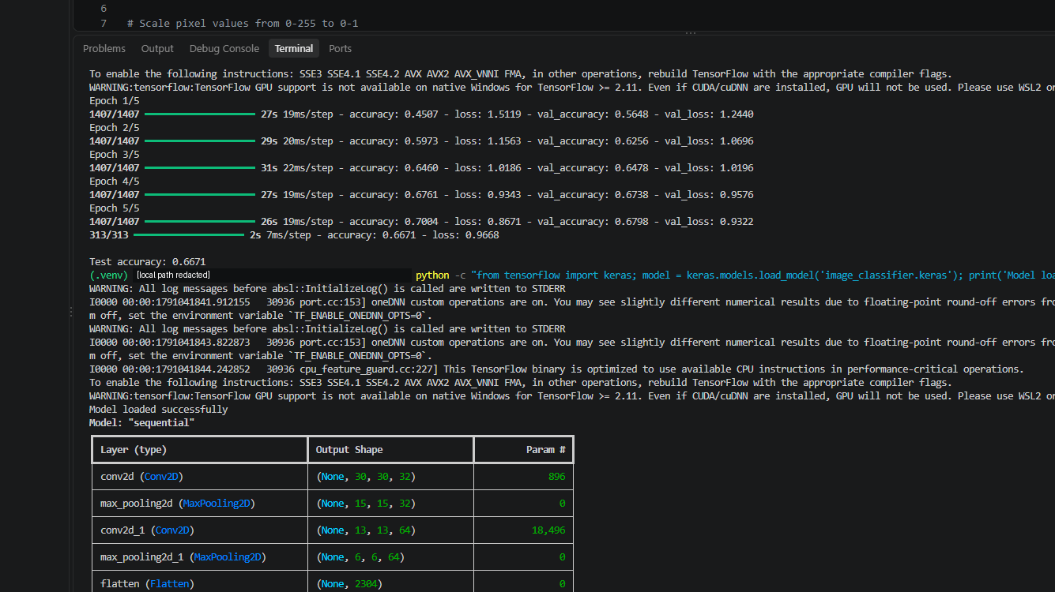
Figure 1. TensorFlow/Keras CNN training, test accuracy (0.6671) and successful saved-model verification.
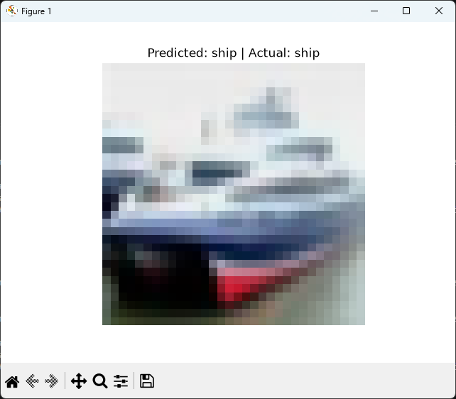
Figure 2. Local inference test: the CIFAR-10 ship image was correctly predicted as “ship”.
Figure 3. Local FastAPI verification showing the TensorFlow Image Recognition API running on 127.0.0.1:8000.
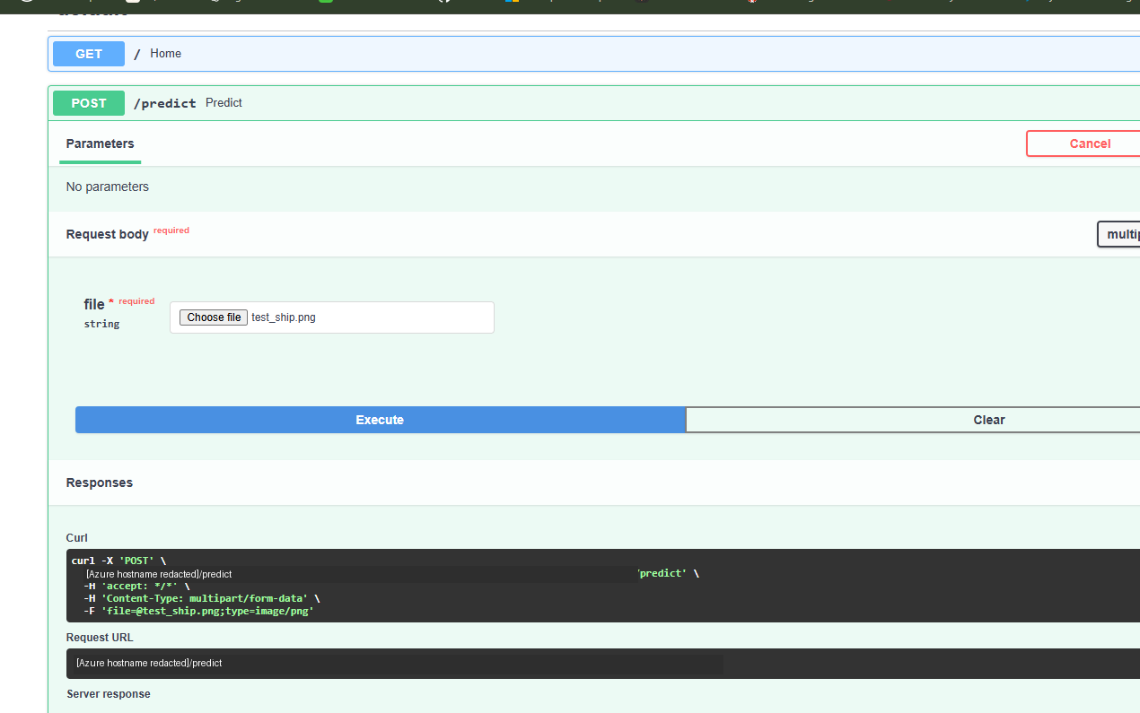
Figure 4. Azure-hosted /predict endpoint returning HTTP 200 with “ship” and confidence 0.9247.
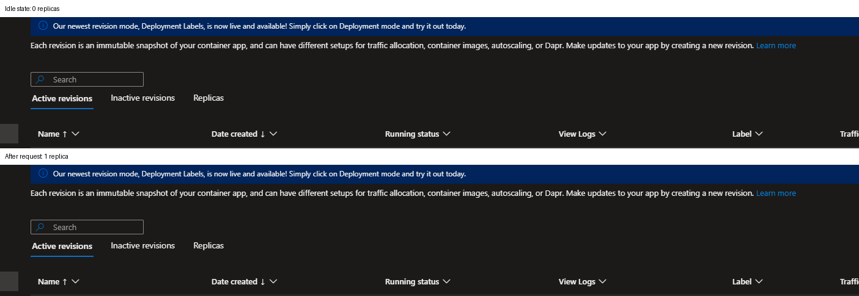
Figure 5. Azure Container Apps scaling evidence: the revision at 0 replicas while idle and at 1 replica after a request.

References
Keras (2026) ‘Model training APIs’. Keras 3 API documentation. Available at: https://keras.io/api/models/model_training_apis/ (Accessed: 3 October 2026).
LeCun, Y., Bottou, L., Bengio, Y. and Haffner, P. (1998) ‘Gradient-based learning applied to document recognition’, Proceedings of the IEEE, 86(11), pp. 2278–2324. doi:10.1109/5.726791.
Mao, H., Alizadeh, M., Menache, I. and Kandula, S. (2016) ‘Resource management with deep reinforcement learning’, Proceedings of the 15th ACM Workshop on Hot Topics in Networks, pp. 50–56. doi:10.1145/3005745.3005750.
Microsoft (2026a) ‘Azure Container Apps image pull from Azure Container Registry with managed identity’. Microsoft Learn. Available at: https://learn.microsoft.com/en-us/azure/container-apps/managed-identity-image-pull (Accessed: 3 October 2026).
Microsoft (2026b) ‘Scaling in Azure Container Apps’. Microsoft Learn. Available at: https://learn.microsoft.com/en-us/azure/container-apps/scale-app (Accessed: 3 October 2026).
TensorFlow (n.d.) ‘Convolutional Neural Network (CNN)’. TensorFlow Core Tutorials. Available at: https://www.tensorflow.org/tutorials/images/cnn (Accessed: 3 October 2026).

